ETE-GOLANG
Name: Akashdeep Dey
Class :3MCA B
Reg No:2547206
Subject : Go Programmming
Domain: SheildRate API (API Rate Limiter Service)
Question1
According to Question 1
Changes done:
- Converted backend project into a full-stack application
- Integrated frontend with backend APIs
- Served frontend directly using Go server (./frontend at /)
- Added interactive UI with API communication
- Implemented JWT-based authentication (HS256, 1-hour expiry)
- Replaced demo token system with secure token handling
- Created custom JWT middleware for request validation
- Added new API endpoint /api/status for frontend interaction
- Implemented asynchronous logging using goroutines and channels
- Introduced non-blocking background worker (asyncLogger)
- Improved concurrency usage beyond basic implementation
- Enabled real-time UI updates based on API responses
- Unified deployment on a single server (port 8081)
- Enhanced overall system design, integration, and user experience
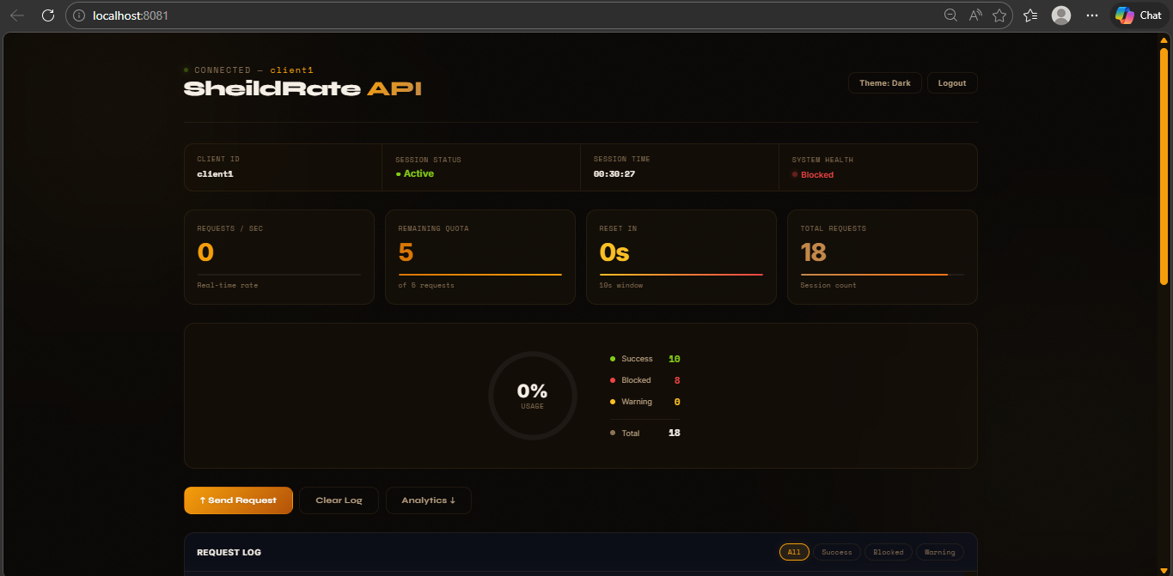
Ovrerall UI
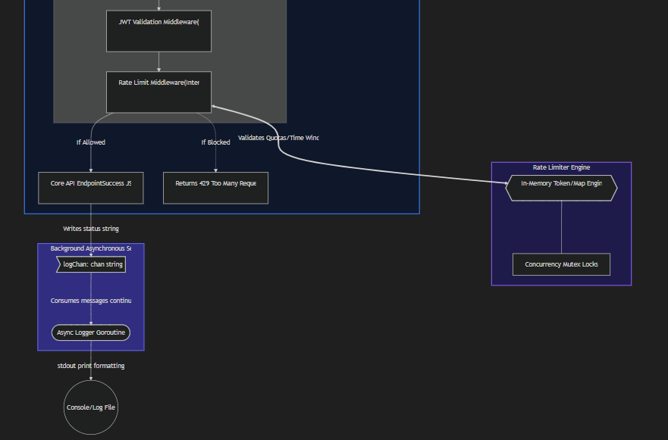
Architectural Design
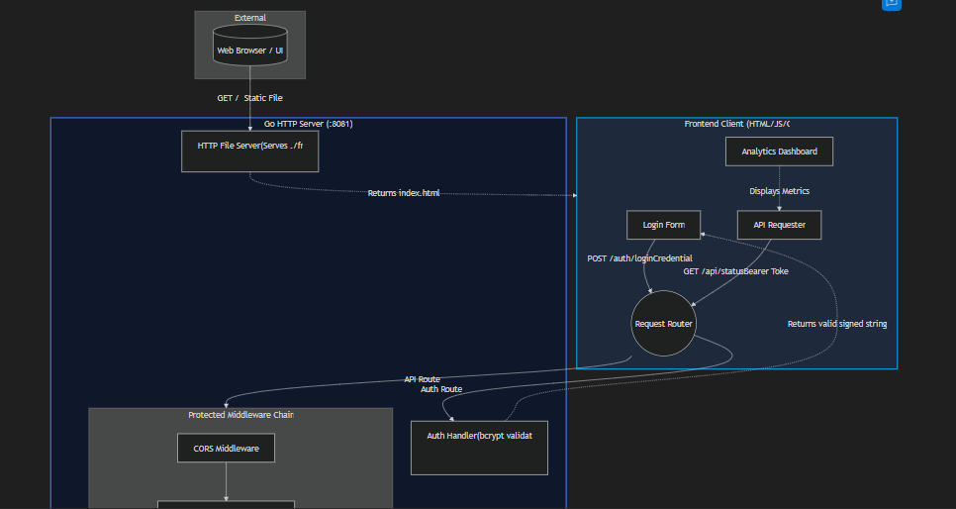
Question 2
Changes according to Question2

Advanced Go Enhancements

Analytics Engine
- Added analytics module (analytics/analytics.go)
- Implemented thread-safe Collector using sync.Mutex
- Recorded API request latency data
- Added statistical computations:
  - Mean
  - Median
  - Standard Deviation
  - Percentiles (P95, P99)
  - Throughput per second
  - Coefficient of Variation
- Created background decay worker goroutine (runs every 10s)
- Exposed analytics via JWT-protected endpoint /api/analytics
- Clear Structured Explantion of Question 2
- Analytics Engine
- Why each metric matters (Mean for baseline, P95/P99 for tail latency, StdDev for instability detection, Coefficient of Variation for cross-comparison)
- Why a sliding window instead of cumulative stats (freshness over history)
- Why sync.RWMutex (concurrent readers for Snapshot(), exclusive writer for Record())
- Why a decay goroutine (bounded memory, producer-consumer pattern with graceful shutdown)
- String Utilities
- Why regexp.MustCompile at init (compile-once performance pattern)
- Why strings.Builder over + concatenation (O(n) vs O(n²) allocation)
- Why strings.Map for sanitization (single-pass, Unicode-correct)
- Why rune-based reversal (multi-byte UTF-8 safety)
- Why validation before bcrypt (defense-in-depth at the API boundary)
Screenshots
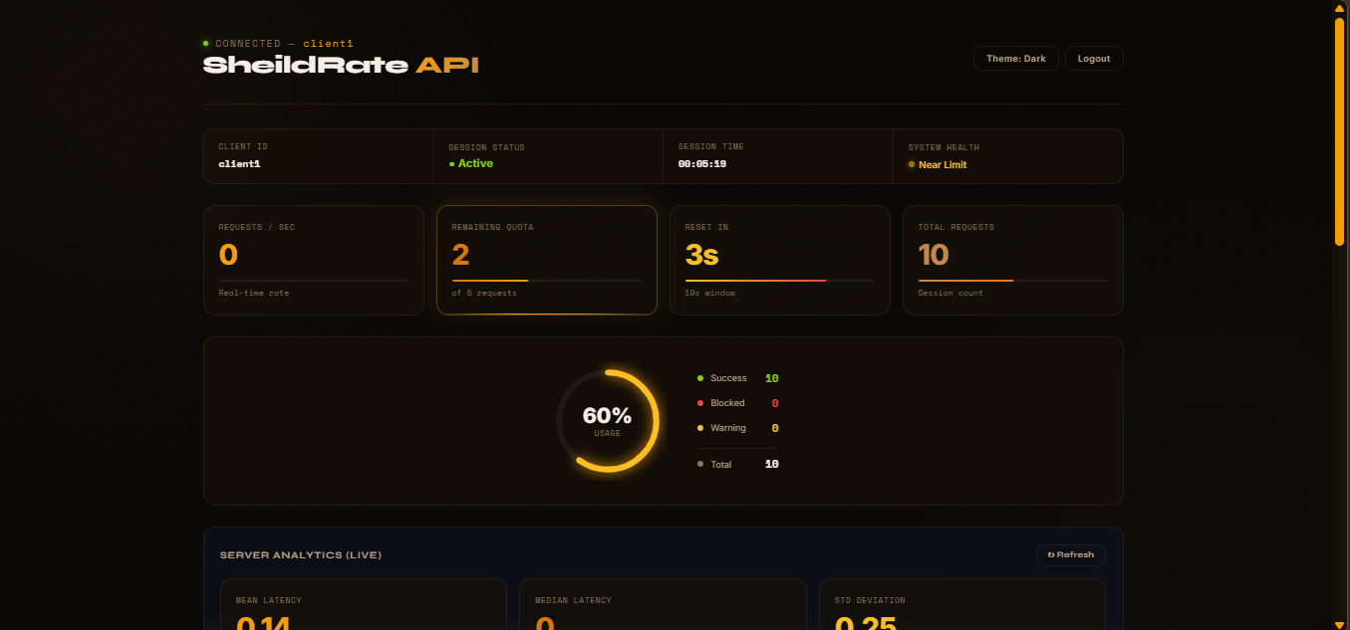
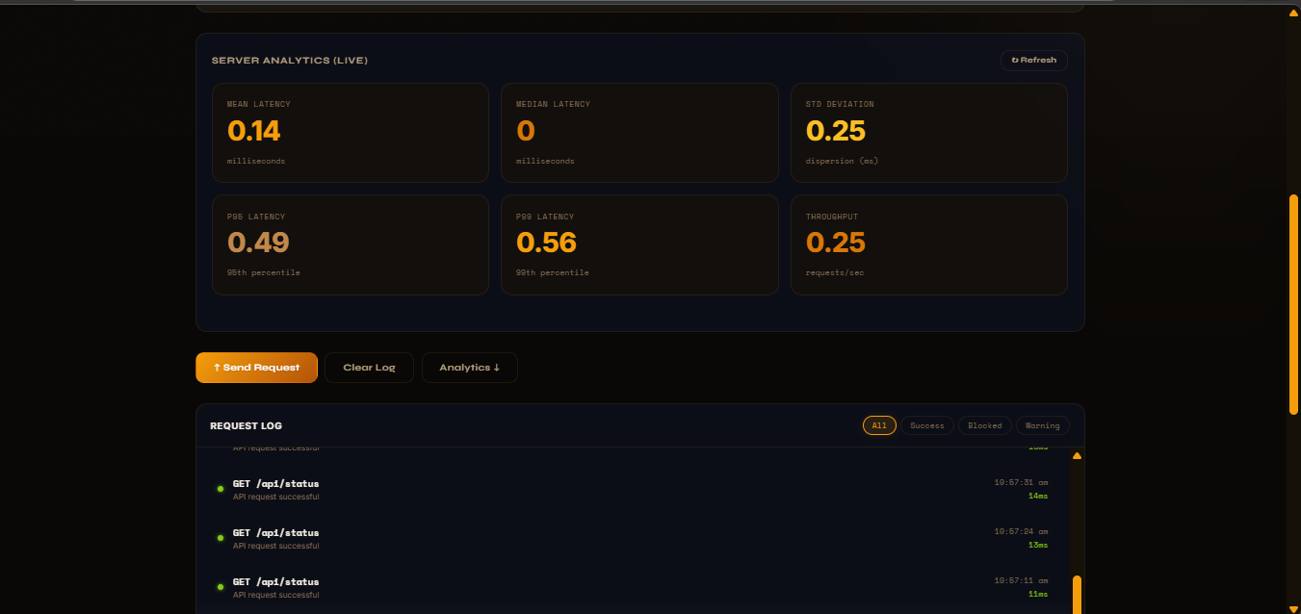
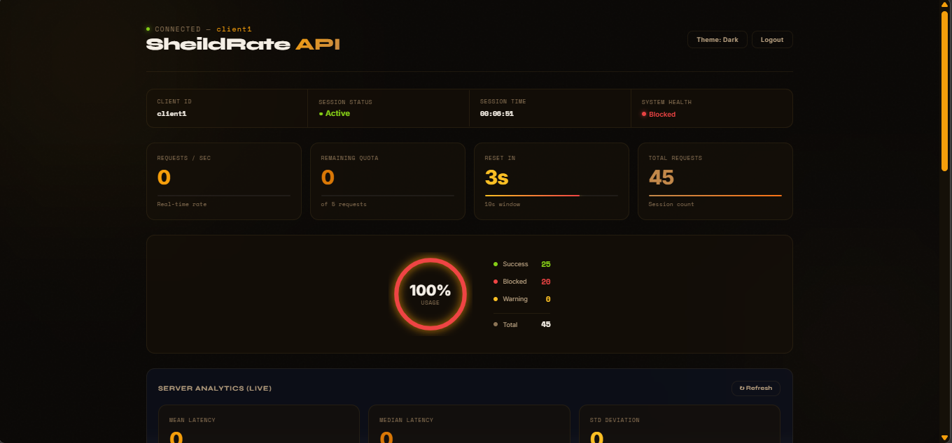
After refreshing the Analytics
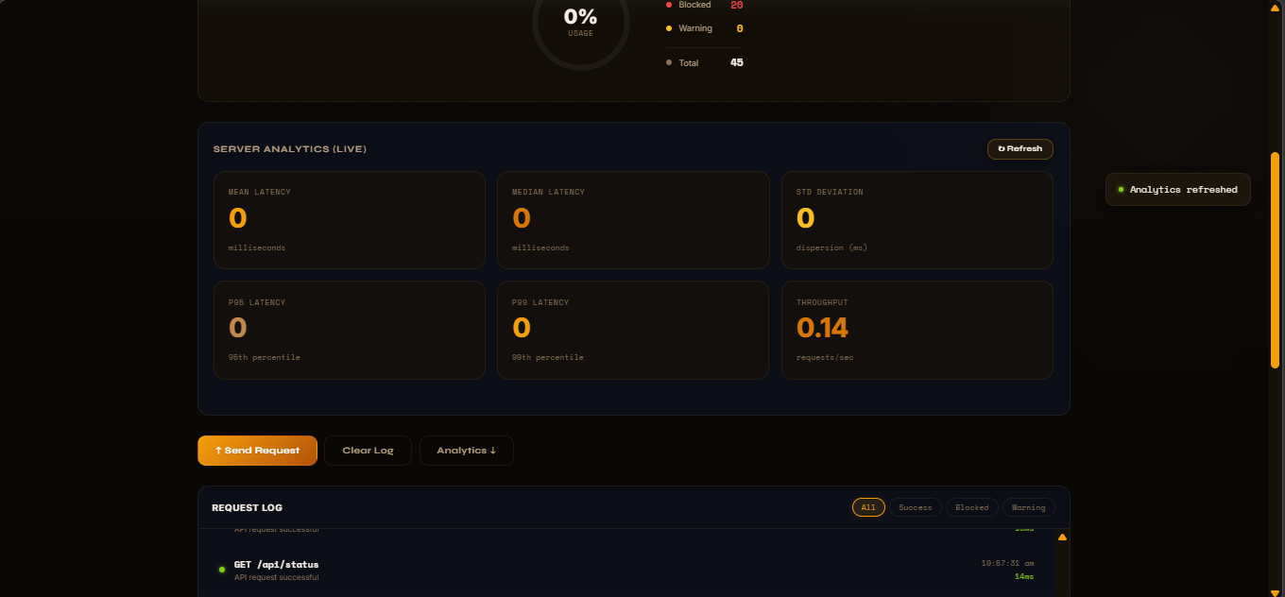
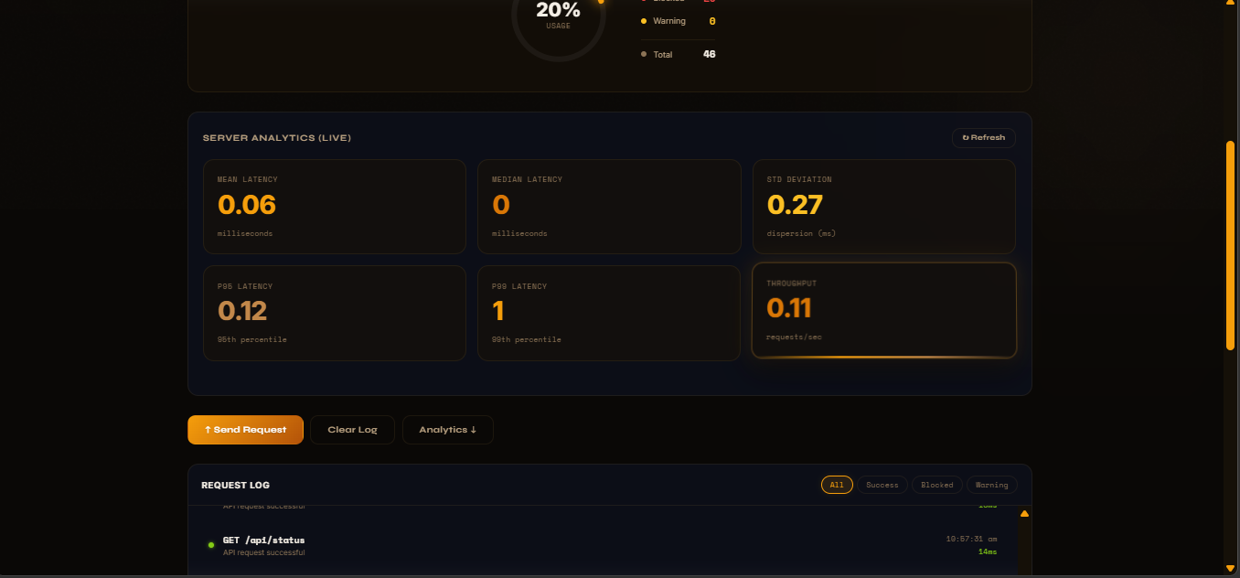

Advanced String Utilities
- Created string utility module (stringutil/stringutil.go)
- Implemented:
  - ValidateClientID() using regex
  - MaskToken() for secure token display
  - FormatLogEntry() for structured logs
  - SanitizeInput() with Unicode-safe filtering
  - Slugify() for clean string formatting
  - ReverseString() (Unicode-safe)
  - CamelToSnake() case conversion

Backend Integration
- Integrated analytics collector in request lifecycle
- Added input sanitization & validation during login
- Enhanced logging using:
  - Masked tokens
  - Structured formatted logs
- Added new API route: /api/analytics

Frontend Enhancements
- Added Live Analytics Dashboard
- Displayed 6 metrics:
  - Mean
  - Median
  - StdDev
  - P95
  - P99
  - Throughput
- Implemented Refresh button to fetch real-time data from /api/analytics

Codes:
Cors.go
package middleware

import "net/http"

func CORSMiddleware(next http.Handler) http.Handler {
return http.HandlerFunc(func(w http.ResponseWriter, r *http.Request) {

// Allow all origins (safe for demo/project)
w.Header().Set("Access-Control-Allow-Origin", "*")
w.Header().Set("Access-Control-Allow-Headers", "Content-Type, X-Client-ID, Authorization")
w.Header().Set("Access-Control-Allow-Methods", "GET, POST, OPTIONS")

// Handle preflight request
if r.Method == http.MethodOptions {
w.WriteHeader(http.StatusOK)
return
}

next.ServeHTTP(w, r)
})
}

ratelimiter.go
package middleware

import (
"encoding/json"
"fmt"
"net/http"

"api-rate-limiter/config"
ratelimiter "api-rate-limiter/rate-limiter"
)

func RateLimitMiddleware(rl *ratelimiter.RateLimiter, next http.Handler) http.Handler {
return http.HandlerFunc(func(w http.ResponseWriter, r *http.Request) {

clientID := r.Header.Get("X-Client-ID")

// Check if client is authenticated
if clientID == "" {
clientID = r.RemoteAddr
}

// token validation is handled by jwtMiddleware

allowed, err := rl.Allow(clientID, config.MaxRequests, config.WindowDuration)

if err != nil {
fmt.Println("Error:", err)
respondWithError(w, err.Error(), http.StatusBadRequest)
return
}

// Anonymous struct - JSON marshalling
response := struct {
ClientID string `json:"client_id"`
Allowed bool `json:"allowed"`
Message string `json:"message"`
}{}

if !allowed {
fmt.Println("Rate limit exceeded for:", clientID)
response.ClientID = clientID
response.Allowed = false
response.Message = "Rate limit exceeded"
w.WriteHeader(http.StatusTooManyRequests)
json.NewEncoder(w).Encode(response)
return
}

fmt.Println("Request allowed for:", clientID)
next.ServeHTTP(w, r)
})
}

// Helper function to respond with error (JSON marshalling)
func respondWithError(w http.ResponseWriter, message string, statusCode int) {
w.Header().Set("Content-Type", "application/json")
w.WriteHeader(statusCode)

errorResponse := struct {
Error string `json:"error"`
Status int `json:"status"`
Message string `json:"message"`
}{
Error: http.StatusText(statusCode),
Status: statusCode,
Message: message,
}

json.NewEncoder(w).Encode(errorResponse)
}

authtest.go
package ratelimiter

import "testing"

func TestPasswordHashing(t *testing.T) {

password := "secure123"

hash, err := HashPassword(password)
if err != nil {
t.Fatalf("Hashing failed: %v", err)
}

err = CheckPassword(hash, password)
if err != nil {
t.Errorf("Password should match")
}

err = CheckPassword(hash, "wrong")
if err == nil {
t.Errorf("Password should not match")
}
}

Auth.go
package ratelimiter

import (
"time"

"golang.org/x/crypto/bcrypt"
)

// Hash password
func HashPassword(password string) (string, error) {
hash, err := bcrypt.GenerateFromPassword(
[]byte(password),
bcrypt.DefaultCost,
)
if err != nil {
return "", err
}
return string(hash), nil
}

// Check password
func CheckPassword(hash, password string) error {
return bcrypt.CompareHashAndPassword(
[]byte(hash),
[]byte(password),
)
}

// Register client
func (rl *RateLimiter) RegisterClient(clientID, password string) error {

hash, err := HashPassword(password)
if err != nil {
return err
}

rl.Mutex.Lock()
defer rl.Mutex.Unlock()

now := time.Now()

rl.Clients[clientID] = &Client{
Metadata: Metadata{ClientID: clientID},
RequestCount: 0,
WindowStart: now,
LastSeen: now,
RequestLog: make([]time.Time, 0),
PasswordHash: hash,
}

return nil
}

// Authenticate client
func (rl *RateLimiter) Authenticate(clientID, password string) error {

rl.Mutex.RLock()
client, exists := rl.Clients[clientID]
rl.Mutex.RUnlock()

if !exists {
return bcrypt.ErrMismatchedHashAndPassword
}

err := CheckPassword(client.PasswordHash, password)
if err != nil {
return err
}

rl.Mutex.Lock()
if existingClient, ok := rl.Clients[clientID]; ok {
existingClient.LastSeen = time.Now()
}
rl.Mutex.Unlock()

return nil
}

Json.go
package ratelimiter

import "encoding/json"

// Marshal struct to JSON
func ToJSON(client Client) ([]byte, error) {
return json.Marshal(client)
}

// Unmarshal JSON to struct
func FromJSON(data []byte) (Client, error) {
var client Client
err := json.Unmarshal(data, &client)
return client, err
}

Logic.go
package ratelimiter

import "encoding/json"

// Marshal struct to JSON
func ToJSON(client Client) ([]byte, error) {
return json.Marshal(client)
}

// Unmarshal JSON to struct
func FromJSON(data []byte) (Client, error) {
var client Client
err := json.Unmarshal(data, &client)
return client, err
}

Pointer.go
package ratelimiter

import "fmt"

// Call by value
func IncrementByValue(count int) {
count++
fmt.Println("Inside IncrementByValue:", count)
}

// Call by pointer (reference)
func IncrementByPointer(count *int) {
*count++
fmt.Println("Inside IncrementByPointer:", *count)
}

Stringutil.go
// Package stringutil provides advanced string manipulation utilities
// for input validation, secure logging, and text processing.
// Demonstrates Go-specific string handling: rune iteration, strings.Builder,
// regexp compilation, and Unicode-aware transformations.
package stringutil

import (
"fmt"
"regexp"
"strings"
"time"
"unicode"
)

// clientIDPattern enforces that client IDs are alphanumeric with underscores,
// between 3 and 32 characters long. Compiled once for performance.
var clientIDPattern = regexp.MustCompile(`^[a-zA-Z0-9_]{3,32}$`)

// slugUnsafe matches any character that is not alphanumeric or a hyphen.
var slugUnsafe = regexp.MustCompile(`[^a-z0-9-]+`)

// multiHyphen collapses consecutive hyphens into a single one.
var multiHyphen = regexp.MustCompile(`-{2,}`)

// ValidateClientID checks that a client ID conforms to the allowed pattern.
// Returns an error message string if invalid, or empty string if valid.
// Uses regexp for pattern matching and strings functions for normalization.
func ValidateClientID(id string) (string, bool) {
trimmed := strings.TrimSpace(id)
if trimmed == "" {
return "client ID cannot be empty", false
}
if len(trimmed) < 3 {
return fmt.Sprintf("client ID '%s' is too short (min 3 chars)", trimmed), false
}
if len(trimmed) > 32 {
return fmt.Sprintf("client ID exceeds maximum length of 32 characters (got %d)", len(trimmed)), false
}
if !clientIDPattern.MatchString(trimmed) {
return fmt.Sprintf("client ID '%s' contains invalid characters (only alphanumeric and underscores allowed)", trimmed), false
}
return "", true
}

// MaskToken obscures the middle portion of a token string for safe logging.
// Shows the first `reveal` and last `reveal` characters, replacing the middle
// with dots. Handles edge cases for very short tokens gracefully.
//
// Example: MaskToken("eyJhbGciOiJIUzI1NiJ9.payload.signature", 6)
// → "eyJhbG...nature"
func MaskToken(token string, reveal int) string {
runes := []rune(token)
n := len(runes)

if n <= reveal*2 {
// Token is too short to mask meaningfully
return strings.Repeat("*", n)
}

var b strings.Builder
b.Grow(reveal*2 + 3)
for i := 0; i < reveal; i++ {
b.WriteRune(runes[i])
}
b.WriteString("...")
for i := n - reveal; i < n; i++ {
b.WriteRune(runes[i])
}
return b.String()
}

// FormatLogEntry builds a structured, padded log line using strings.Builder
// for efficient string concatenation. Demonstrates advanced formatting with
// fixed-width columns and ANSI-style structure.
//
// Format: [TIMESTAMP] | CLIENT_ID (padded) | STATUS | MESSAGE
func FormatLogEntry(clientID, status, message string) string {
const clientPadWidth = 16

var b strings.Builder
b.Grow(128)

// Timestamp block
b.WriteString("[")
b.WriteString(time.Now().Format("2006-01-02 15:04:05.000"))
b.WriteString("]")

// Separator
b.WriteString(" │ ")

// Client ID — right-padded to fixed width using strings.Builder + Repeat
b.WriteString(padRight(clientID, clientPadWidth))

// Status indicator
b.WriteString(" │ ")
b.WriteString(padRight(strings.ToUpper(status), 8))

// Message
b.WriteString(" │ ")
b.WriteString(message)

return b.String()
}

// SanitizeInput removes potentially dangerous characters from user input
// using strings.Map with a custom rune-filtering function. Allows only
// printable, non-control Unicode characters, explicitly blocking common
// injection vectors.
func SanitizeInput(s string) string {
return strings.Map(func(r rune) rune {
// Block control characters, null bytes, and common injection chars
if r == '<' || r == '>' || r == '&' || r == '"' || r == '\'' {
return -1 // Drop the rune
}
if !unicode.IsPrint(r) || unicode.IsControl(r) {
return -1
}
return r
}, s)
}

// Slugify converts an arbitrary string into a URL-safe, lowercase slug.
// Uses Unicode-aware lowercasing, regexp replacement, and multi-pass
// string transformation.
//
// Example: Slugify("Hello World! (2024)") → "hello-world-2024"
func Slugify(s string) string {
// Step 1: Lowercase the entire string (Unicode-aware)
slug := strings.ToLower(strings.TrimSpace(s))

// Step 2: Replace spaces with hyphens
slug = strings.ReplaceAll(slug, " ", "-")

// Step 3: Remove unsafe characters via compiled regexp
slug = slugUnsafe.ReplaceAllString(slug, "")

// Step 4: Collapse multiple hyphens
slug = multiHyphen.ReplaceAllString(slug, "-")

// Step 5: Trim leading/trailing hyphens
slug = strings.Trim(slug, "-")

return slug
}

// ReverseString reverses a Unicode-safe string by iterating over runes.
// This handles multi-byte characters correctly, unlike naive byte reversal.
func ReverseString(s string) string {
runes := []rune(s)
n := len(runes)
for i, j := 0, n-1; i < j; i, j = i+1, j-1 {
runes[i], runes[j] = runes[j], runes[i]
}
return string(runes)
}

// CamelToSnake converts a CamelCase or PascalCase string to snake_case.
// Uses rune iteration and Unicode category detection.
//
// Example: CamelToSnake("RateLimiterService") → "rate_limiter_service"
func CamelToSnake(s string) string {
var b strings.Builder
b.Grow(len(s) + 4)

runes := []rune(s)
for i, r := range runes {
if unicode.IsUpper(r) {
if i > 0 {
// Insert underscore before uppercase if previous char was lowercase
// or next char is lowercase (handles acronyms like "HTTPServer")
prev := runes[i-1]
if unicode.IsLower(prev) || (i+1 < len(runes) && unicode.IsLower(runes[i+1])) {
b.WriteRune('_')
}
}
b.WriteRune(unicode.ToLower(r))
} else {
b.WriteRune(r)
}
}
return b.String()
}

// padRight pads a string to the specified width with spaces on the right.
// If the string is longer than width, it is truncated.
func padRight(s string, width int) string {
runes := []rune(s)
if len(runes) >= width {
return string(runes[:width])
}
return s + strings.Repeat(" ", width-len(runes))
}

Main.go
package main

import (
"encoding/json"
"fmt"
"net/http"
"strings"
"time"

"api-rate-limiter/analytics"
"api-rate-limiter/middleware"
ratelimiter "api-rate-limiter/rate-limiter"
"api-rate-limiter/stringutil"

"github.com/golang-jwt/jwt/v5"
)

var jwtKey = []byte("my_secret_key_change_in_production") // JWT Secret

func main() {
rl := ratelimiter.NewRateLimiter()
defer rl.Shutdown()

// Pointer demonstration
value := 5
ratelimiter.IncrementByValue(value)
fmt.Println("After call by value:", value)
ratelimiter.IncrementByPointer(&value)
fmt.Println("After call by pointer:", value)

// JSON demonstration
client := ratelimiter.Client{RequestCount: 3}
jsonData, _ := ratelimiter.ToJSON(client)
fmt.Println("JSON:", string(jsonData))
parsedClient, _ := ratelimiter.FromJSON(jsonData)
fmt.Println("Parsed RequestCount:", parsedClient.RequestCount)

// bcrypt demo - register test client
err := rl.RegisterClient("client1", "mypassword")
if err != nil {
fmt.Println("Registration error:", err)
}

// Register multiple clients
clients := []string{"client1", "client2", "client3"}
for _, c := range clients {
err := rl.RegisterClient(c, "mypassword")
if err != nil {
fmt.Println("Registration error:", err)
}
}

// [ASYNC WORKFLOW] Setup asynchronous logger
logChan := make(chan string, 100)
go asyncLogger(logChan)

// [ANALYTICS] Initialize the statistical analytics collector (5-minute window)
collector := analytics.NewCollector(5 * time.Minute)
defer collector.Shutdown()

// API handler (Protected endpoint)
apiHandler := http.HandlerFunc(func(w http.ResponseWriter, r *http.Request) {
t0 := time.Now()
w.Header().Set("Content-Type", "application/json")

// Extract claims to show personalized response
var clientID string
tokenStr := extractBearerToken(r.Header.Get("Authorization"))
claims := &jwt.RegisteredClaims{}
if tokenStr != "" {
_, _ = jwt.ParseWithClaims(tokenStr, claims, func(token *jwt.Token) (interface{}, error) { return jwtKey, nil })
clientID = claims.Subject
}

response := struct {
Message string `json:"message"`
Status string `json:"status"`
User string `json:"user"`
}{
Message: "API request successful",
Status: "ok",
User: clientID,
}
json.NewEncoder(w).Encode(response)

// [ANALYTICS] Record latency for statistical analysis
latencyMs := float64(time.Since(t0).Microseconds()) / 1000.0
collector.Record(clientID, latencyMs)

// [STRING UTIL] Use structured log formatting and masked token
maskedToken := stringutil.MaskToken(tokenStr, 8)
logChan <- stringutil.FormatLogEntry(clientID, "success", fmt.Sprintf("API ok | latency=%.2fms | token=%s", latencyMs, maskedToken))
})

// Analytics handler — returns real-time statistical snapshot (JWT-protected)
analyticsHandler := http.HandlerFunc(func(w http.ResponseWriter, r *http.Request) {
w.Header().Set("Content-Type", "application/json")
json.NewEncoder(w).Encode(collector.Snapshot())
})

protectedAnalytics := middleware.CORSMiddleware(jwtMiddleware(analyticsHandler))

// Wrap apiHandler with JWT and Rate Limiter Middlewares
protectedAPIHandler := middleware.CORSMiddleware(
jwtMiddleware(middleware.RateLimitMiddleware(rl, apiHandler)),
)

// Authentication handler
authHandler := http.HandlerFunc(func(w http.ResponseWriter, r *http.Request) {
var authRequest struct {
ClientID string `json:"clientID"`
Password string `json:"password"`
}

err := json.NewDecoder(r.Body).Decode(&authRequest)
if err != nil {
w.Header().Set("Content-Type", "application/json")
w.WriteHeader(http.StatusBadRequest)
json.NewEncoder(w).Encode(map[string]string{
"error": "Invalid request format",
})
return
}

// [STRING UTIL] Sanitize and validate client ID
authRequest.ClientID = stringutil.SanitizeInput(authRequest.ClientID)
if errMsg, valid := stringutil.ValidateClientID(authRequest.ClientID); !valid {
w.Header().Set("Content-Type", "application/json")
w.WriteHeader(http.StatusBadRequest)
json.NewEncoder(w).Encode(map[string]string{"error": errMsg})
return
}

// Authenticate using bcrypt
err = rl.Authenticate(authRequest.ClientID, authRequest.Password)
if err != nil {
w.Header().Set("Content-Type", "application/json")
w.WriteHeader(http.StatusUnauthorized)
json.NewEncoder(w).Encode(map[string]string{
"error": "Invalid credentials",
})
return
}

fmt.Println("Authentication successful for client:", authRequest.ClientID)

tokenString, err := generateJWT(authRequest.ClientID)
if err != nil {
w.Header().Set("Content-Type", "application/json")
w.WriteHeader(http.StatusInternalServerError)
json.NewEncoder(w).Encode(map[string]string{"error": "Failed to generate token"})
return
}

tokenResponse := struct {
Token string `json:"token"`
ClientID string `json:"clientID"`
Message string `json:"message"`
ExpiresAt time.Time `json:"expiresAt"`
}{
Token: tokenString,
ClientID: authRequest.ClientID,
Message: "Authentication successful",
ExpiresAt: time.Now().Add(1 * time.Hour),
}

w.Header().Set("Content-Type", "application/json")
w.WriteHeader(http.StatusOK)
json.NewEncoder(w).Encode(tokenResponse)
})

authFinalHandler := middleware.CORSMiddleware(authHandler)

// [STRING UTIL DEMO] Handler to showcase all stringutil functions via API
stringUtilHandler := http.HandlerFunc(func(w http.ResponseWriter, r *http.Request) {
w.Header().Set("Content-Type", "application/json")

// Accept input from query param or JSON body
var input string
if r.Method == http.MethodGet {
input = r.URL.Query().Get("input")
} else {
var body struct{ Input string `json:"input"` }
json.NewDecoder(r.Body).Decode(&body)
input = body.Input
}
if input == "" {
input = "Hello_World ExampleCamelCase <script>alert('xss')</script>"
}

// Run all string utility functions and collect results
validateMsg, isValid := stringutil.ValidateClientID(input)
result := struct {
OriginalInput string `json:"original_input"`
ValidateID struct {
Valid bool `json:"valid"`
Message string `json:"message"`
} `json:"validate_client_id"`
MaskToken string `json:"mask_token"`
FormatLog string `json:"format_log_entry"`
Sanitized string `json:"sanitize_input"`
Slugified string `json:"slugify"`
Reversed string `json:"reverse_string"`
CamelToSnake string `json:"camel_to_snake"`
}{}

result.OriginalInput = input
result.ValidateID.Valid = isValid
result.ValidateID.Message = validateMsg
if isValid {
result.ValidateID.Message = "Valid client ID"
}
result.MaskToken = stringutil.MaskToken(input, 6)
result.FormatLog = stringutil.FormatLogEntry("demo_client", "info", input)
result.Sanitized = stringutil.SanitizeInput(input)
result.Slugified = stringutil.Slugify(input)
result.Reversed = stringutil.ReverseString(input)
result.CamelToSnake = stringutil.CamelToSnake(input)

json.NewEncoder(w).Encode(result)
})

protectedStringUtil := middleware.CORSMiddleware(jwtMiddleware(stringUtilHandler))

// Static file server for the frontend
fs := http.FileServer(http.Dir("./frontend"))

// Register routes
http.Handle("/api/status", protectedAPIHandler)
http.Handle("/api/analytics", protectedAnalytics)
http.Handle("/api/stringutil", protectedStringUtil) // [NEW] String utilities demo
http.Handle("/auth/login", authFinalHandler)
http.Handle("/", fs) // Serve frontend at root

fmt.Println("Server running at http://localhost:8081")
fmt.Println("Rate limiter service with JWT authentication and Async Logger enabled")
if err := http.ListenAndServe(":8081", nil); err != nil {
fmt.Println("Server failed:", err)
}
}

// asyncLogger runs in an isolated goroutine to handle logging asynchronously.
// It now receives pre-formatted structured log entries from stringutil.FormatLogEntry.
func asyncLogger(logChan <-chan string) {
for msg := range logChan {
time.Sleep(50 * time.Millisecond)
fmt.Printf("[ASYNC LOG] %s\n", msg)
}
}

// generateJWT creates a new token with signed claims
func generateJWT(clientID string) (string, error) {
expirationTime := time.Now().Add(1 * time.Hour)
claims := &jwt.RegisteredClaims{
Subject: clientID,
ExpiresAt: jwt.NewNumericDate(expirationTime),
IssuedAt: jwt.NewNumericDate(time.Now()),
}

token := jwt.NewWithClaims(jwt.SigningMethodHS256, claims)
return token.SignedString(jwtKey)
}

// jwtMiddleware validates the provided JWT token before allowing access
func jwtMiddleware(next http.Handler) http.Handler {
return http.HandlerFunc(func(w http.ResponseWriter, r *http.Request) {
// Ignore OPTIONS for CORS preflight
if r.Method == http.MethodOptions {
next.ServeHTTP(w, r)
return
}

authHeader := r.Header.Get("Authorization")
tokenString := extractBearerToken(authHeader)

if tokenString == "" {
http.Error(w, "Missing authorization token", http.StatusUnauthorized)
return
}

claims := &jwt.RegisteredClaims{}
token, err := jwt.ParseWithClaims(tokenString, claims, func(token *jwt.Token) (interface{}, error) {
if _, ok := token.Method.(*jwt.SigningMethodHMAC); !ok {
return nil, fmt.Errorf("unexpected signing method")
}
return jwtKey, nil
})

if err != nil || !token.Valid {
http.Error(w, "Invalid or expired token", http.StatusUnauthorized)
return
}

next.ServeHTTP(w, r)
})
}

// extractBearerToken extracts the token from the "Bearer <token>" string
func extractBearerToken(authHeader string) string {
if authHeader == "" {
return ""
}
parts := strings.Split(authHeader, " ")
if len(parts) == 2 && strings.ToLower(parts[0]) == "bearer" {
return parts[1]
}
return ""
}

Config.go
package config

import "time"

// Configuration variables (var keyword)
var MaxRequests int = 5
var WindowDuration time.Duration = 10 * time.Second

analyitcs.go
// Package analytics provides a real-time statistical engine for API request
// latency analysis. It uses goroutines for background sample decay and
// mutex-based synchronization for thread safety.
package analytics

import (
"math"
"sort"
"sync"
"time"
)

// Sample represents a single recorded latency measurement.
type Sample struct {
Latency float64 // Response time in milliseconds
Timestamp time.Time // When the request was recorded
ClientID string // Which client made the request
}

// Snapshot holds the computed statistics at a point in time.
type Snapshot struct {
Mean float64 `json:"mean_ms"`
Median float64 `json:"median_ms"`
StdDev float64 `json:"std_dev_ms"`
P95 float64 `json:"p95_ms"`
P99 float64 `json:"p99_ms"`
Min float64 `json:"min_ms"`
Max float64 `json:"max_ms"`
TotalSamples int `json:"total_samples"`
Throughput float64 `json:"throughput_rps"`
WindowSeconds float64 `json:"window_seconds"`
VarianceCoeff float64 `json:"variance_coefficient"`
}

// Collector gathers latency samples and computes statistics on demand.
// It is safe for concurrent use by multiple goroutines.
type Collector struct {
mu sync.RWMutex
samples []Sample
window time.Duration // Only consider samples within this window
stop chan struct{}
done chan struct{}
}

// NewCollector creates a Collector with a specified analysis window duration.
// Samples older than the window are periodically pruned by a background worker.
func NewCollector(window time.Duration) *Collector {
c := &Collector{
samples: make([]Sample, 0, 256),
window: window,
stop: make(chan struct{}),
done: make(chan struct{}),
}
go c.startDecayWorker(10 * time.Second)
return c
}

// Record adds a new latency sample to the collector.
func (c *Collector) Record(clientID string, latencyMs float64) {
c.mu.Lock()
defer c.mu.Unlock()
c.samples = append(c.samples, Sample{
Latency: latencyMs,
Timestamp: time.Now(),
ClientID: clientID,
})
}

// Snapshot computes and returns current statistical metrics from active samples.
func (c *Collector) Snapshot() Snapshot {
c.mu.RLock()
defer c.mu.RUnlock()

cutoff := time.Now().Add(-c.window)
active := make([]float64, 0, len(c.samples))
var earliest time.Time

for _, s := range c.samples {
if s.Timestamp.After(cutoff) {
active = append(active, s.Latency)
if earliest.IsZero() || s.Timestamp.Before(earliest) {
earliest = s.Timestamp
}
}
}

n := len(active)
if n == 0 {
return Snapshot{WindowSeconds: c.window.Seconds()}
}

// Sort for median and percentile calculations
sorted := make([]float64, n)
copy(sorted, active)
sort.Float64s(sorted)

mean := Mean(active)
stddev := StdDev(active, mean)

// Calculate throughput (requests per second)
elapsed := time.Since(earliest).Seconds()
if elapsed < 1 {
elapsed = 1
}
throughput := float64(n) / elapsed

// Coefficient of variation: stddev / mean (unitless measure of dispersion)
varCoeff := 0.0
if mean > 0 {
varCoeff = math.Round((stddev/mean)*10000) / 10000
}

return Snapshot{
Mean: math.Round(mean*100) / 100,
Median: math.Round(Median(sorted)*100) / 100,
StdDev: math.Round(stddev*100) / 100,
P95: math.Round(Percentile(sorted, 95)*100) / 100,
P99: math.Round(Percentile(sorted, 99)*100) / 100,
Min: math.Round(sorted[0]*100) / 100,
Max: math.Round(sorted[n-1]*100) / 100,
TotalSamples: n,
Throughput: math.Round(throughput*100) / 100,
WindowSeconds: c.window.Seconds(),
VarianceCoeff: varCoeff,
}
}

// Shutdown gracefully stops the background decay worker.
func (c *Collector) Shutdown() {
select {
case <-c.done:
return
default:
close(c.stop)
<-c.done
}
}

// startDecayWorker periodically removes samples older than the analysis window.
func (c *Collector) startDecayWorker(interval time.Duration) {
ticker := time.NewTicker(interval)
defer ticker.Stop()
defer close(c.done)

for {
select {
case <-ticker.C:
c.decay()
case <-c.stop:
return
}
}
}

// decay removes expired samples from the collector's buffer.
func (c *Collector) decay() {
cutoff := time.Now().Add(-c.window)
c.mu.Lock()
defer c.mu.Unlock()

// Find first valid index using binary-style scan
kept := c.samples[:0]
for _, s := range c.samples {
if s.Timestamp.After(cutoff) {
kept = append(kept, s)
}
}
c.samples = kept
}

// ─── MATH FUNCTIONS ──────────────────────────────────────────────────────────

// Mean computes the arithmetic mean of a slice of float64 values.
func Mean(data []float64) float64 {
if len(data) == 0 {
return 0
}
sum := 0.0
for _, v := range data {
sum += v
}
return sum / float64(len(data))
}

// Median returns the middle value of a pre-sorted slice.
// For even-length slices, it returns the average of the two middle values.
func Median(sorted []float64) float64 {
n := len(sorted)
if n == 0 {
return 0
}
if n%2 == 1 {
return sorted[n/2]
}
return (sorted[n/2-1] + sorted[n/2]) / 2.0
}

// StdDev computes the population standard deviation given data and its mean.
// Uses the formula: sqrt( Σ(xi - mean)² / N )
func StdDev(data []float64, mean float64) float64 {
if len(data) == 0 {
return 0
}
sumSqDiff := 0.0
for _, v := range data {
diff := v - mean
sumSqDiff += diff * diff
}
return math.Sqrt(sumSqDiff / float64(len(data)))
}

// Percentile computes the p-th percentile of a pre-sorted slice using
// linear interpolation between closest ranks.
func Percentile(sorted []float64, p float64) float64 {
n := len(sorted)
if n == 0 {
return 0
}
if n == 1 {
return sorted[0]
}

// Rank calculation using linear interpolation
rank := (p / 100.0) * float64(n-1)
lower := int(math.Floor(rank))
upper := int(math.Ceil(rank))
fraction := rank - float64(lower)

if upper >= n {
upper = n - 1
}

return sorted[lower] + fraction*(sorted[upper]-sorted[lower])
}

Final Screenshots
