Lab Exercise Report: Collaborative Git Workflow Using a Simple Web Application
Team Size: 3 students
Application: Simple Student Information Web App
Repository: https://github.com/sudeeepaa/student-info-app

1. Team Members and Roles
Student | Role | Responsibility
Student 1 | Team Lead / Developer | Repository creation, base application, integration
Student 2 | UI Developer | Improve HTML/CSS
Student 3 | JavaScript Developer | Add simple JavaScript functionality

- Student 1 – Sudeepa Santhanam – Team Lead / Developer
- Student 2 – Akashdeep Dey – UI Developer
- Student 3 – Albin – JavaScript Developer

2. Project Description
The Student Information System is a simple web application built to practice a collaborative Git workflow. It displays basic student details such as Name, Register Number, and Programme, and includes a button to show additional details. No database or backend was required; the focus of the exercise was learning Git and GitHub collaboration, not building a complex application.

3. Technologies Used
- HTML5
- CSS3
- JavaScript
- Git
- GitHub
- Visual Studio Code

4. Git Branching Strategy
The project used a main branch that always held the stable version of the application, along with separate feature branches for each piece of work. Developers never worked directly on main; instead, each change was made on its own branch and merged in through a Pull Request after review.
Feature branches created during the exercise:
- feature/ui
- feature/javascript
- feature/contact
- feature/student-name
- feature/app-title

5. Steps Performed

5.1 Repository Setup
Student 1 created the GitHub repository student-info-app, initialized it with a README, cloned it locally, and configured Git with a username and email.
git clone <repository-url>
cd student-info-app
git config --global user.name "Your Name"
git config --global user.email "your-email@example.com"

5.2 Base Application
Student 1 created the initial index.html, style.css, and script.js files showing the student's Name, Register Number, and Programme, then committed and pushed this base version to main.
git add .
git commit -m "Initial student information app"
git push origin main

5.3 Feature Branches
Student 2 created feature/ui to improve the layout — adding a card around the student information, spacing, better headings, and button styling. The branch was committed and pushed to GitHub:
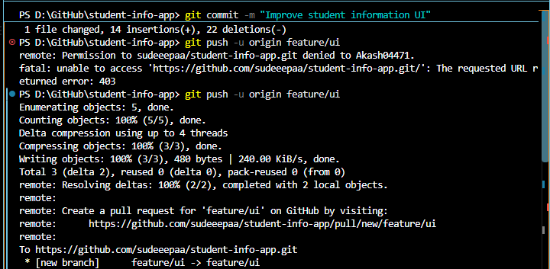
Figure 1: Pushing the feature/ui branch to GitHub and generating the Pull Request link
Student 3 created feature/javascript to add the "Show Details" button functionality. Both students opened Pull Requests, which Student 1 reviewed and merged into main.
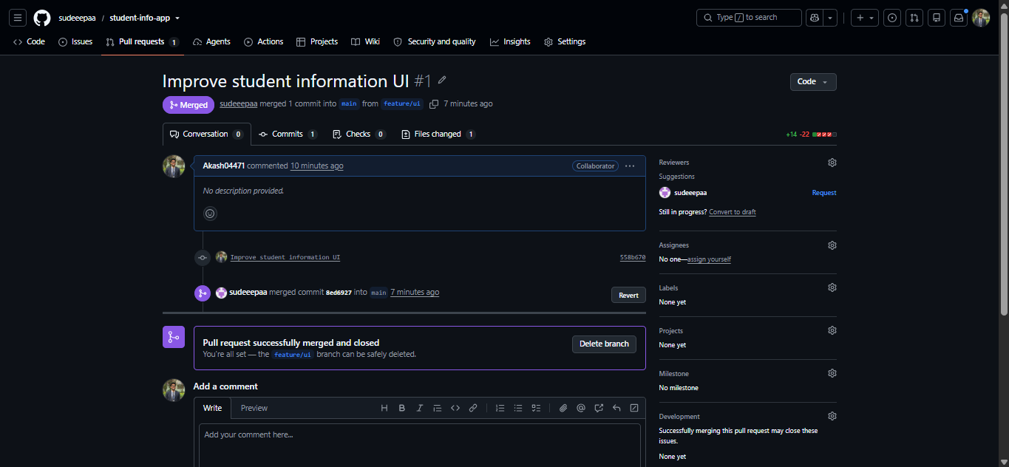
Figure 2: Pull Request #1 'Improve student information UI' merged into main

5.4 Second Feature Branch
Before starting new work, the team pulled the latest main branch to stay up to date:
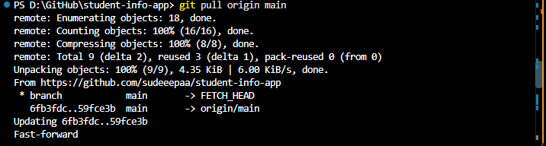
Figure 3: Pulling the latest changes from origin/main (fast-forward)
Student 2 then created feature/contact to add a Contact Information section (Email and Phone), committed the change, and pushed the branch. When opening the Pull Request, GitHub showed that the branch could not be merged automatically, so the conflict was reviewed before merging:
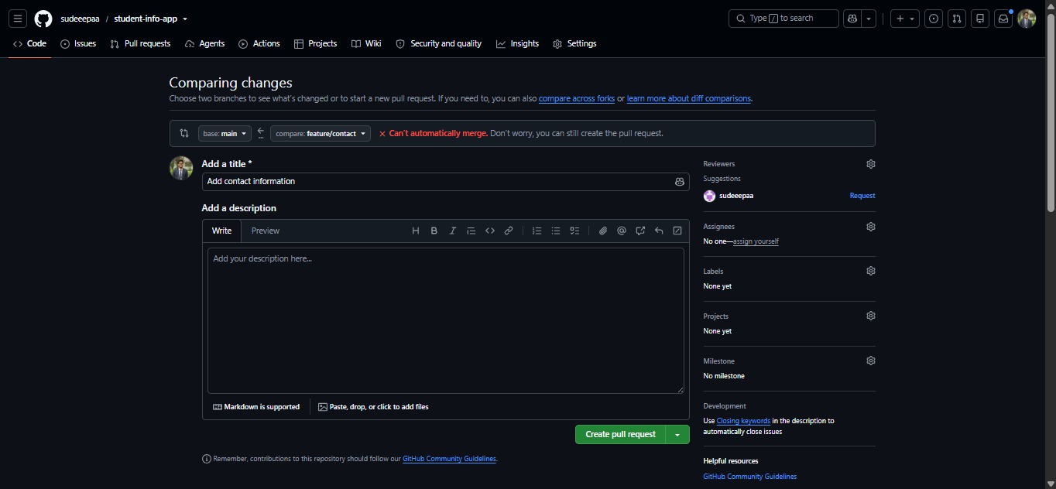
Figure 4: Creating the Pull Request for feature/contact → main

5.5 Creating a Merge Conflict Intentionally
To understand conflict resolution, two branches were created from the same version of main and both modified the same heading line in index.html:
- feature/student-name changed the heading to "Student Management System"
- feature/app-title changed the same heading to "MCA Student Information Portal"
After pulling main, Student 2 created the feature/student-name branch, updated the heading in index.html, and committed and pushed the change:
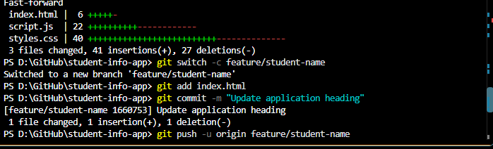
Figure 5: Fast-forwarding main, then creating feature/student-name and committing 'Update application heading'
This branch was merged first without any issue:
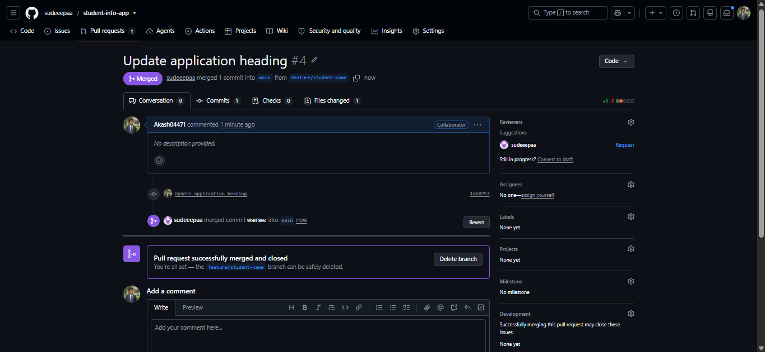
Figure 6: Pull Request #4 'Update application heading' merged into main
When feature/app-title was then merged, GitHub reported a merge conflict because both branches had changed the same line differently.

5.6 Resolving the Conflict
Student 3 pulled the latest main, switched back to feature/app-title, and merged main into the branch locally. Git marked the conflicting section in index.html with conflict markers:
<<<<<<< HEAD
<h1>MCA Student Information Portal</h1>
=======
<h1>Student Management System</h1>
>>>>>>> main
The conflict was resolved by combining both changes into a single heading, then removing the conflict markers:
<h1>Student Management System - MCA</h1>
The resolved file was staged, committed, and pushed, after which the Pull Request became mergeable and was approved by Student 1.
git add index.html
git commit -m "Resolve merge conflict in application title"
git push origin feature/app-title

6. Pull Requests Created
# | Pull Request | Status
1 | feature/ui → main | Reviewed and merged by Student 1
2 | feature/javascript → main | Reviewed and merged by Student 1
3 | feature/contact → main | Reviewed and merged by Student 1
4 | feature/student-name → main | Merged first (no conflict)
5 | feature/app-title → main | Conflicted with feature/student-name; resolved and merged

All five Pull Requests were opened, reviewed, and merged successfully, as shown in the closed Pull Requests list on GitHub:
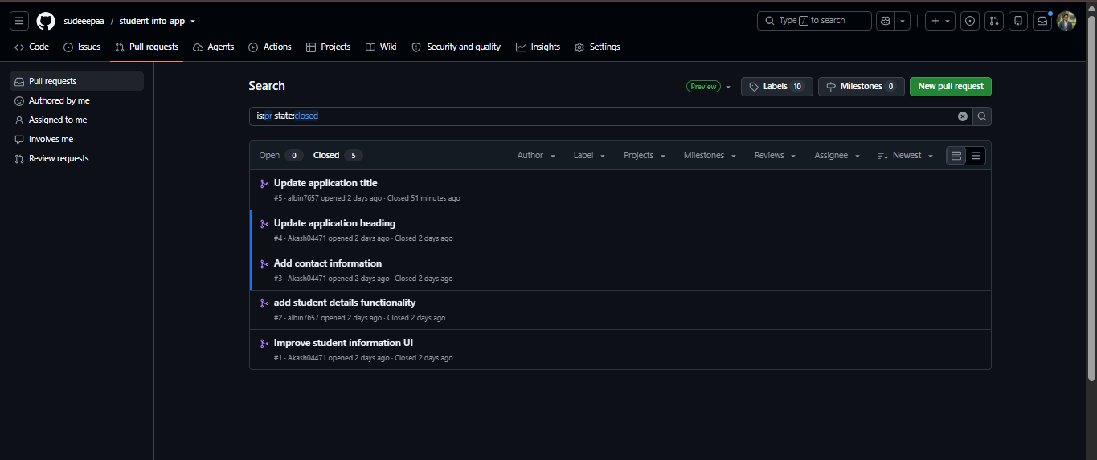
Figure 7: All five Pull Requests, closed and merged, in the repository

7. Commit History
At least five meaningful commits were made throughout the exercise, each describing the change clearly rather than using vague messages like "update" or "final".
Commit Message
Initial student information app
Improve student information UI
Add student details functionality
Add contact information
Update application heading
Update application title
Resolve merge conflict in application title

Running the following command shows the full branching and merge history of the project:
git log --oneline --graph --all

8. Merge Conflict Evidence
Screenshots demonstrating the conflict and its resolution are included below.

8.1 Screenshot of the Conflict
GitHub flagged that feature/app-title could not be merged automatically into main because both feature/student-name and feature/app-title had changed the same heading line in index.html (see Figure 4, which shows the same 'Can't automatically merge' warning pattern encountered during this stage of the exercise).

8.2 Screenshot of the Resolved Conflict
The conflict was resolved locally by combining both heading changes into a single line, removing the conflict markers, and committing the resolution as 'Resolve merge conflict in application title'.

8.3 Pull Request Showing Successful Merge
Figure 6 above shows Pull Request #4 successfully merged into main. The same pattern was followed for the feature/app-title Pull Request once the conflict was resolved, and it is included in the closed Pull Requests list in Figure 7.

9. How to Run the Application
git clone https://github.com/sudeeepaa/student-info-app.git
cd student-info-app
Then simply open index.html in any web browser. No backend or database setup is required.

10. Learning Outcomes
This exercise helped the team understand how to configure Git locally, create and clone a repository, work with branches, write meaningful commit messages, push branches to a remote repository, create and review Pull Requests, merge branches, and — most importantly — resolve a merge conflict without losing anyone's work. It also demonstrated how a team can collaborate on the same codebase without overwriting each other's changes.

11. Conclusion
By completing this exercise, the team successfully built a simple Student Information Web App while practicing a realistic collaborative Git workflow, including branching, Pull Requests, code review, and merge conflict resolution — the core skills needed for working on any real-world software team.

