Tailwind Traders
Sales & Profitability Analysis
An End-to-End Power BI Business Intelligence Case Study
Prepared by Akash Kaliramna
Data Analyst | Power BI · SQL · Python · Excel · Tableau
Tools: Power BI Desktop · Power Query · DAX · Python (Pandas) · Power BI Service

1. Project Overview
Tailwind Traders is a fictional global retail company selling products across multiple countries and product categories. The objective of this project was to build an end-to-end Business Intelligence solution in Microsoft Power BI that transforms raw sales, purchase, country, and currency data into meaningful business insights.
The project covers the complete analytics workflow:
Raw Data → Data Extraction → Data Cleaning → Data Transformation → Data Modeling
→ DAX Calculations → Data Analysis → Interactive Reports → Power BI Service
→ Executive Dashboard
The final solution contains two interactive report pages — Sales Performance Overview and Profit Performance Overview. The completed report was then published to Power BI Service, where selected KPIs and analytical visuals were combined into an Executive Dashboard designed to give management a concise view of overall business performance.

2. Business Problem
Tailwind Traders needed a consolidated reporting solution that could help business stakeholders understand:
- Overall sales and profitability performance
- Revenue generated from different products
- Geographic differences in sales and profitability
- Customer loyalty patterns across countries
- Product demand and units sold
- Sales trends over time
- Gross and net revenue performance
- Profit margins across markets
- Inventory levels
- Which products contribute the most revenue
- Whether profitability differs significantly between countries
The goal was not simply to visualize data, but to create an analytical reporting solution that allows decision-makers to quickly identify business performance, trends, product drivers, and geographic patterns.

3. Project Objectives
- Prepare and clean the raw Tailwind Traders datasets.
- Integrate multiple business datasets into one analytical model.
- Incorporate foreign exchange rates so international transactions could be compared in USD.
- Build a structured Power BI data model.
- Create DAX measures for revenue, profit, margins, sales, and other KPIs.
- Analyze sales performance by country, product, and time.
- Analyze profitability by country and product.
- Design interactive Power BI reports for business stakeholders.
- Publish the analytical solution to Power BI Service.
- Build an executive-level dashboard containing the most important business KPIs and performance drivers.

4. Dataset
The project uses multiple datasets representing different parts of the Tailwind Traders business.

4.1 Sales Data
The primary Sales dataset contains 55 transaction-level records and 22 fields, including:
Field group | Fields
Transaction | Order ID, Sales Representative, Customer ID
Customer | Customer Name, Customer Address, Zip Code, Phone, Email, Loyalty Points
Product | Product Name, Product Description, Product Category, SKU Number, Weight, Color, Size, Rating
Financial | Gross Product Price, Tax Per Product, Quantity Purchased
Geography / Inventory | Country ID, Stock

4.2 Purchase Data
The Purchases dataset contains transaction and purchase-date information, used to connect sales transactions with time-based analysis — including quarterly performance, year-to-date analysis, revenue trends, and profit margin trends.

4.3 Country Data
A Countries table connects transactions with geographical information. The analysis covers five markets: United Kingdom, United States, Australia, France, and United Arab Emirates.

4.4 Exchange Rate Data
Because Tailwind Traders operates internationally, transactions needed to be standardized into a common currency before meaningful comparisons could be performed.
Currency | Exchange Rate
USD | 1.00
GBP | 0.75
EUR | 0.85
AED | 3.67
AUD | 1.30
These rates allowed revenue and tax calculations to be converted into USD for consistent financial reporting.

5. Tools & Technologies
Tool | Purpose
Microsoft Power BI Desktop | Data modeling, DAX, analysis and report development
Power Query | Data cleaning and transformation
DAX | Measures, calculated fields and time-intelligence calculations
Python | Extraction / preparation of exchange-rate information
Pandas | Processing structured data within the Python workflow
Microsoft Excel | Source business data
Power BI Service | Publishing, sharing and dashboard creation
Power BI Dashboard | Executive-level KPI and performance monitoring

6. End-to-End Analytics Workflow

6.1 Data Collection and Import
The project started with multiple business datasets rather than a single flat table: Sales, Purchases, Countries, and currency/exchange-rate information. The Excel-based business datasets were imported into Power BI using Get Data, and each dataset was reviewed individually before creating relationships between them.

6.2 Python Data Extraction
Python was incorporated into the project to support the preparation of foreign exchange-rate data. Python and Pandas were used to prepare the currency information in a tabular structure suitable for Power BI:
import pandas as pd
exchange_data = {
"Currency": ["USD", "GBP", "EUR", "AED", "AUD"],
"Exchange Rate": [1.00, 0.75, 0.85, 3.67, 1.30]
}
exchange_df = pd.DataFrame(exchange_data)
print(exchange_df)
Using Python demonstrated how an external data-processing step can be incorporated into a Power BI workflow when analytical information is not already available in the main source system.

6.3 Data Cleaning
Before analysis, the datasets were inspected and cleaned to ensure the values could be used reliably. The cleaning process included:
- Checking column names and data types
- Identifying missing or inconsistent values
- Validating numeric fields
- Confirming country identifiers
- Checking transaction identifiers
- Verifying quantity and revenue-related fields
- Reviewing currency and exchange-rate values
- Ensuring date fields were recognized as dates
- Removing unnecessary fields where appropriate
- Standardizing column naming for reporting
One important issue occurred with the exchange-rate data: some rates containing decimals were initially interpreted incorrectly because of decimal/comma formatting. The data types and decimal formats were corrected before the exchange-rate information was used in financial calculations — this was important because incorrect exchange rates would have produced incorrect revenue, tax, and profitability figures throughout the report.

6.4 Data Transformation with Power Query
Power Query provided the ETL layer of the solution (Extract → Transform → Load), separating data preparation from the analytical calculations performed later in DAX. Transformations included correcting data types, renaming columns, validating date fields, preparing country and exchange-rate lookup information, and ensuring consistent identifiers across tables.

6.5 Data Modeling
Relationships were created between the tables to build an integrated analytical model: Sales → Purchases → Countries → Exchange Data → Calendar, using business keys including Order ID, Country ID, Exchange ID, and Purchase Date. A dedicated Calendar table supports time-intelligence calculations. The objective was to avoid analyzing from unrelated flat tables and instead build a structured model where filters propagate correctly between dimensions and transactional data.

6.6 Currency Standardization
A calculated table, Sales in USD, extends the Sales data with country information, exchange rate, exchange currency, and Gross/Net Revenue and Total Tax in USD. This allowed transactions from the UK, USA, France, UAE, and Australia to be compared using the same monetary unit.

6.7 DAX Calculations
DAX was used to create the business calculations and KPIs required for the analysis.
CalendarTable
CalendarTable =
ADDCOLUMNS(
CALENDAR(DATE(2020, 1, 1), DATE(2023, 12, 31)),
"Year", YEAR([Date]),
"Month Number", MONTH([Date]),
"Month", FORMAT([Date], "MMMM"),
"Quarter", QUARTER([Date]),
"Weekday", WEEKDAY([Date]),
"Day", DAY([Date])
)
Sales in USD
Sales in USD =
ADDCOLUMNS(
Sales,
"Country Name", RELATED(Countries[Country]),
"Exchange Rate", RELATED('Exchange Data'[Exchange Rate]),
"Exchange Currency", RELATED('Exchange Data'[Exchange Currency]),
"Gross Revenue USD", [Gross Revenue] * RELATED('Exchange Data'[Exchange Rate]),
"Net Revenue USD", [Net Revenue] * RELATED('Exchange Data'[Exchange Rate]),
"Total Tax USD", [Total Tax] * RELATED('Exchange Data'[Exchange Rate])
)
Profit in USD
Profit in USD =
'Sales in USD'[Net Revenue USD]
- 'Sales in USD'[Total Tax USD]
This measures the remaining amount after subtracting tax from net revenue.
Yearly Profit Margin
Yearly Profit Margin =
DIVIDE(
SUM('Sales in USD'[Profit in USD]),
SUM('Sales in USD'[Net Revenue USD])
)
DIVIDE() was used instead of the / operator because it provides safer handling of divide-by-zero situations.
Quarterly Profit
Quarterly Profit =
CALCULATE(
SUM('Sales in USD'[Profit in USD]),
DATESQTD(CalendarTable[Date])
)
This measure combines CALCULATE() and DATESQTD() to evaluate cumulative profit for the current quarter.
YTD Profit
YTD Profit =
TOTALYTD(
SUM('Sales in USD'[Profit in USD]),
CalendarTable[Date]
)
This calculation enables cumulative profit analysis from the beginning of the year through the selected date.
Median Sales
Median Sales =
MEDIAN('Sales in USD'[Gross Revenue USD])
Median was used to represent a typical transaction value while reducing the effect of unusually high or low sales values.
Additional KPIs were calculated throughout the report for Units Sold, Gross Revenue, Net Revenue, Total Tax, Stock, Customer Loyalty Points, Profit, and Profit Margin.

6.8 Data Analysis
After the model and DAX calculations were prepared, the data was analyzed across several business dimensions.

Sales Analysis
Sales performance was evaluated by country, product, date, units sold, median sales, customer loyalty, and inventory — answering questions such as which countries generate larger transaction values, which products sell the most units, how sales performance changes over time, which countries show the strongest customer loyalty activity, and what the company's current stock position is.

Profitability Analysis
Profitability was analyzed through gross revenue, net revenue, product-level net revenue, country-level profit margin, time-based profit margin, and YTD profit margin — distinguishing between sales volume and financial performance, since a product selling frequently is not automatically the product creating the highest financial contribution.

7. Report Development
Two dedicated Power BI report pages were created.

7.1 Sales Performance Overview
Subtitle: Revenue, product performance and geographic sales analysis. The page focuses on operational sales performance.
KPI Cards
- Total Stock: 14K
- Units Sold: 152
- Median Sales: $222.50
Visualizations
- Customer Loyalty Points by Country — a horizontal bar chart comparing customer loyalty activity across markets (UK 315, USA 305, Australia 262, France 197, UAE 151)
- Median Sales by Country — comparing typical transaction values between markets (UAE ~$680.79, Australia $234.00, USA $230.00, France $221.85, UK $144.00)
- Top-Selling Products by Units Sold — a Top N filter focuses the visual on the products generating the greatest unit volume
- Median Sales Trend — a time-series line chart with a trend line showing changes in median sales across the reporting period
A Country slicer allows users to dynamically filter the report and investigate individual geographic markets.
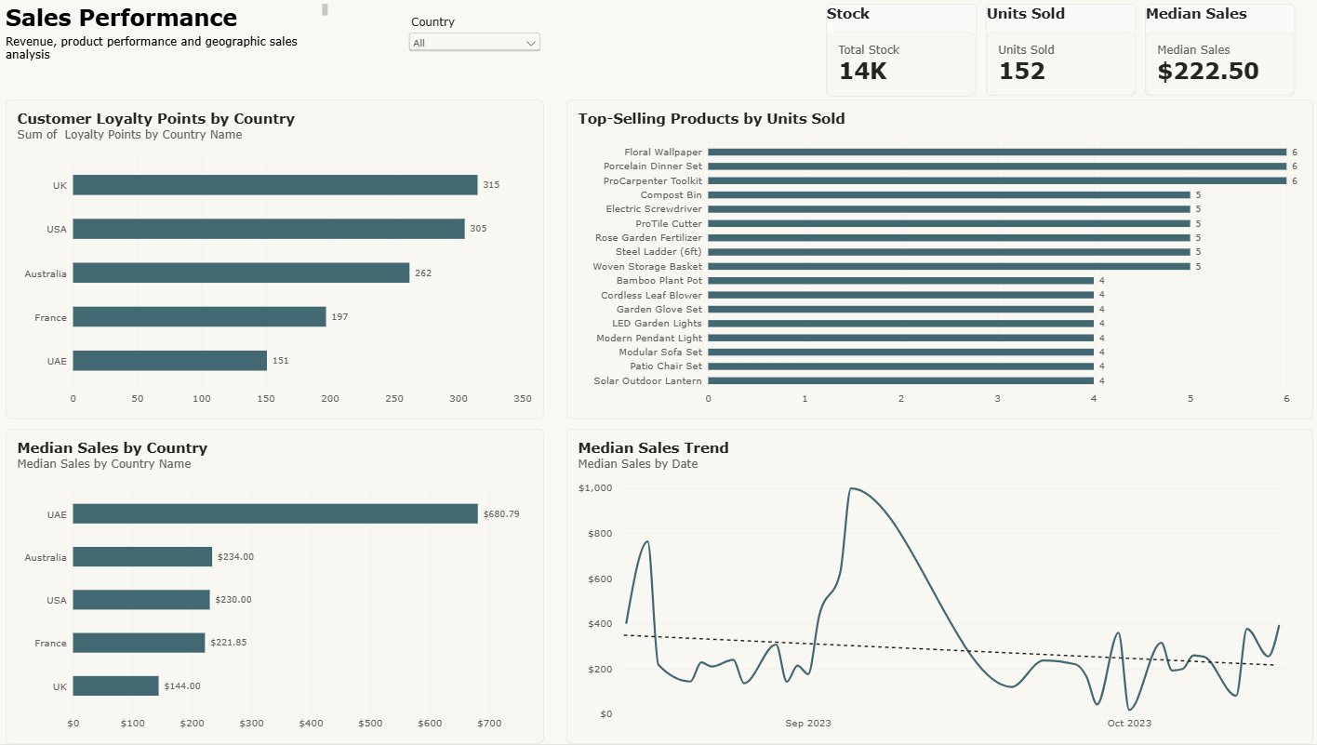
Sales Performance Overview report page

7.2 Profit Performance Overview
Subtitle: Profitability, revenue performance and geographic margin analysis. This page focuses specifically on profitability.
KPI Cards
- YTD Profit Margin: 62.27%
- Gross Revenue: $14.97K
- Net Revenue: $13.89K
Visualizations
Top Products by Net Revenue — a horizontal ranking chart (Top 10 filter) identifying the products generating the greatest net revenue:
Rank | Product | Net Revenue (USD)
1 | Modular Sofa Set | $928.36
2 | Motion Sensor Alarm | $716.75
3 | Bamboo Plant Pot | $709.92
4 | LED Garden Lights | $682.62
5 | Organic Potting Soil | $583.64
6 | Vintage Wall Mirror | $580.23
7 | Luxury Chandelier | $471.01
8 | Electric Screwdriver | $409.57
9 | Brass Coat Rack | $398.97
10 | Velvet Cushion Cover | $374.79
Yearly Profit Margin by Country — a column chart comparing profitability across international markets. Margins were extremely consistent: Australia ~62.37%, UAE ~62.37%, UK ~62.37%, USA ~62.17%, France ~62.12% — a narrow range indicating profitability is maintained consistently across markets rather than concentrated in one country.
Profit Margin Trend — an area chart tracking profitability across the reporting period. Most periods remained close to the overall ~62% margin, though several temporary declines occurred, letting management identify periods where profitability differed from normal operating levels.
A Year, Quarter, Month slicer allows time-based filtering of the page.
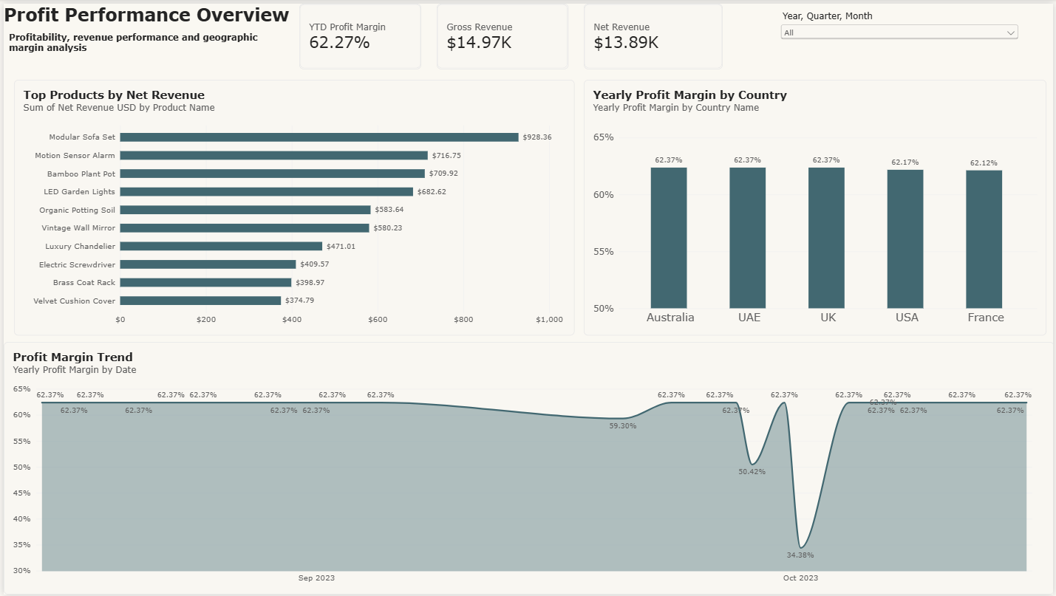
Profit Performance Overview report page

8. Report Design
The report was designed using a consistent executive-style visual system, built on the Accessible Tidal Power BI theme.
Design principles included:
- Consistent dark-teal analytical color on a light report background
- Consistent KPI card formatting
- Equal spacing and alignment
- Limited use of decorative elements
- Consistent typography
- Clear visual hierarchy and business-focused visual titles
- Currency and percentage formatting
- Data labels where precise comparisons are useful
- Top-N filtering to reduce clutter
Visual types were selected based on the analytical question rather than simply creating visual variety: horizontal bars for long product names and ranked comparisons, column charts for a small number of geographic categories, line charts for sales trends, area charts to emphasize changes in profitability over time, and cards for executive KPIs.

9. Publishing to Power BI Service
Once development and validation were complete, the report was published from Power BI Desktop to Power BI Service, moving the analytical solution from a development environment into a cloud-based BI environment where reports and dashboards can be consumed by business users. The published solution retained all report pages, the data model, DAX calculations, interactive visuals, filters, slicers, and formatting.

10. Executive Dashboard
After publishing the report, selected visuals were pinned to a Power BI dashboard. While the report provides deeper interactive analysis, the dashboard gives management a single-page summary of the most important performance indicators and business drivers.
The final dashboard is organized around four areas:
Area | Contents
Executive KPIs | Gross Revenue $14.97K · Net Revenue $13.89K · Units Sold 152 · YTD Profit Margin 62.27%
Geographic Performance | Customer Loyalty Points by Country · Yearly Profit Margin by Country
Product Performance | Top Products by Net Revenue · Top-Selling Products by Units Sold
Trend Analysis | Median Sales Trend · Profit Margin Trend
This structure allows a stakeholder to move logically from Overall Performance → Geographic & Product Drivers → Trends.
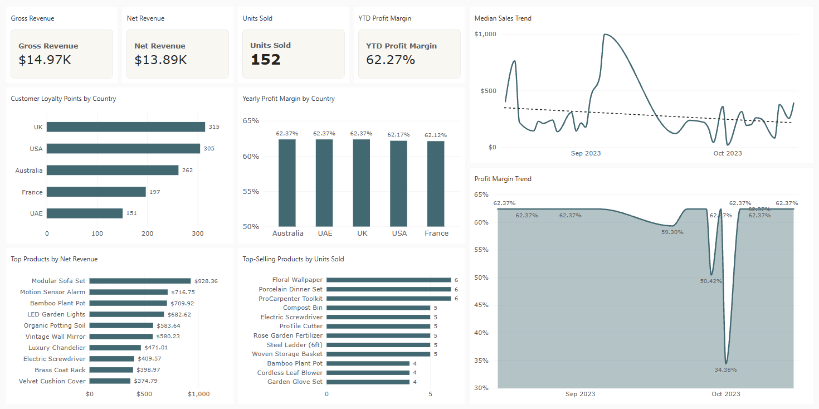
Executive Dashboard published to Power BI Service

11. Key Business Insights

Insight 1 — UAE Has the Highest Typical Sales Value
The UAE recorded a median sales value of approximately $680.79, substantially higher than every other market (Australia $234.00, USA $230.00, France $221.85, UK $144.00). This suggests transactions in the UAE tend to involve significantly higher-value purchases.

Insight 2 — Profitability Is Extremely Consistent Across Countries
Country profit margins ranged only from approximately 62.12% to 62.37%. This narrow range suggests the company's profitability model remains relatively consistent across its international markets, with no individual country materially underperforming on margin.

Insight 3 — Product Revenue Is Concentrated Among Several Leading Products
The Modular Sofa Set generated the highest net revenue at approximately $928.36. The product-ranking analysis makes it possible to identify which products contribute disproportionately to financial performance and therefore deserve additional attention in merchandising, inventory planning, and promotional decisions.

Insight 4 — Sales and Profitability Are Not Constant Over Time
The time-series visuals show meaningful variation in sales activity throughout the reporting period. Profit margins remained near approximately 62% during most periods, but temporary declines occurred — highlighting the importance of monitoring performance over time rather than relying solely on aggregated annual KPIs.

12. Business Recommendations

Prioritize High-Revenue Products
Products generating the highest net revenue should receive particular attention for inventory, product-placement, promotional, and replenishment decisions. High-volume and high-revenue products should be analyzed separately, since the product selling the greatest number of units may not generate the greatest financial contribution.

Investigate UAE Customer Behavior
Because UAE median sales are substantially higher than other markets, further analysis should investigate product mix, average quantity purchased, customer segments, pricing, and order composition — understanding why UAE transaction values are higher could reveal strategies transferable to other markets.

Continue Monitoring Geographic Margin Stability
Profit margins are currently very similar across countries. Management should monitor this KPI over time, since significant divergence could indicate changes in pricing, tax, currency effects, product mix, or operational costs.

Investigate Temporary Profit-Margin Declines
The profit-margin trend contains several periods where profitability falls below its normal level. Future analysis should drill into those dates to determine whether the decline was caused by product mix, lower-value transactions, tax impact, currency movements, or unusual purchasing behavior.

13. Dashboard Design Decisions

Top-N Product Analysis
Rather than displaying every product, the product visualizations focus on the Top 10 products, improving readability and directing attention toward the products with the greatest business impact.

Median Instead of Average Sales
Median sales were used because the median is less affected by unusually large transactions, providing a more useful representation of a typical sales value.

Standardized Currency
International transactions were converted to USD before comparison, preventing misleading conclusions caused by different currencies.

Separate Sales and Profit Pages
Sales activity and profitability answer different business questions. Separating them into two report pages reduces visual clutter and creates a clearer analytical narrative.

14. Challenges and Solutions

Exchange-Rate Formatting
Challenge: Exchange rates containing decimal values were initially interpreted incorrectly due to decimal-format differences.
Solution: The data types and decimal formatting were reviewed and corrected before using the values in financial calculations.

International Revenue Comparison
Challenge: Transactions across different countries could not be directly compared because they used different currencies.
Solution: A currency-conversion layer was incorporated into the model, standardizing financial calculations into USD.

Dashboard Custom Visual Compatibility
Challenge: A custom lollipop visual initially used for country profit-margin comparison required an additional commercial license when the report was viewed in Power BI Service.
Solution: The custom visual was replaced with a native Power BI column chart, improving deployment reliability and ensuring the portfolio project did not depend on a paid third-party visual. This was an important real-world lesson: a visual that works in Power BI Desktop is not automatically the best choice for a production Power BI Service environment.

15. Skills Demonstrated
Microsoft Power BI · Power BI Desktop · Power BI Service · Power Query · DAX · Data cleaning · Data transformation · Data modeling · Table relationships · Calendar tables · Time intelligence · Currency conversion · Python · Pandas · KPI development · Sales analysis · Profitability analysis · Product analysis · Geographic analysis · Trend analysis · Top-N analysis · Interactive slicers · Data visualization · Dashboard design · Business storytelling · Publishing BI assets · Executive dashboard development

16. Project Workflow
Excel Business Data
↓
Data Import
↓
Python / Exchange-Rate Preparation
↓
Power Query
↓
Data Cleaning & Transformation
↓
Data Modeling & Relationships
↓
DAX Measures
↓
Sales & Profitability Analysis
↓
Power BI Report Development
↓
Sales Performance Overview + Profit Performance Overview
↓
Publish to Power BI Service
↓
Executive Dashboard
↓
Business Insights & Recommendations

17. Final Outcome
The final output is an end-to-end Power BI Business Intelligence solution that transforms multiple raw business datasets into an integrated analytical model and executive reporting environment.
The project demonstrates not only the ability to create Power BI visuals, but the complete workflow required of a Data Analyst: understanding the business problem, preparing the data, building the model, developing analytical calculations, finding insights, designing reports, publishing the solution, and communicating results to decision-makers.

18. Repository Structure
tailwind-traders-power-bi-analysis/
│
├── README.md
├── Case_Study_Complete.docx
├── Tailwind-Traders-Power-BI.pbix
│
├── dax/
│ ├── 01_calendar_table.dax
│ ├── 02_sales_in_usd_table.dax
│ ├── 03_profit_measures.dax
│ └── 04_additional_measures.dax
│
├── python/
│ └── exchange_rate_extraction.py
│
├── screenshots/
│ ├── sales-performance-overview.png
│ ├── profit-performance-overview.png
│ └── executive-dashboard.png
│
├── data/
│ └── README.md
│
└── documentation/
└── project-notes.md

19. Author
Akash Kaliramna
Data Analyst | Power BI · SQL · Python · Excel · Tableau
GitHub: github.com/Akash06-09-96/tailwind-traders-power-bi-analysis

