SYNOPSIS ON

# E-Commerce Website

SUBMITTED TO

## UNIVERSITY OF RAJASTHAN



**In the partial fulfillment of the requirements of MASTER OF COMPUTER APPLICATION**

**Project guide: Submitted by**

#### Mr. Bhanu Pratap Singh Akash Rai

**MCA VI Semester 2017-2020 Batch**

**Synopsis on**

E-Commerce Website

Submitted by:-

AKASH RAI



For the award of the degree of

MCA

Under the supervision of

**Mr Bhanu Pratap**

Faculty Internship Guide

**Table of Contents**

|  |  |  |
| --- | --- | --- |
| **S.No.** | **Title** | **Page No.** |
| 1. | Company Profile | 1-2 |
| 2. | Introduction | 3-4 |
| 3. | Problem Statement | 4 |
| 4. | Aim and Objective | 5 |
| 5. | Research Methodology | 5-7 |
| 5.1 | Framework used | 7-8 |
| 5.2 | Proposed Contents of the Thesis | 9-11 |
| 6. | Future Enhancements | 12 |

**Company Profile**



**About C-DAC ATC NETCOM Jaipur**

Centre for Development of Advanced Computing (C-DAC) is the premier R&D organization of the Department of Electronics and Information Technology (DeitY), Ministry of Communications & Information Technology (MCIT) for carrying out R&D in IT, Electronics and associated areas. Different areas of C-DAC, had originated at different times, many of which came out as a result of identification of opportunities.While C-DAC was being setup for the indigenous design, development and delivery of the supercomputing technologies for the country, the mandate given was to not only develop the supercomputing technologies in the shortest possible time, but also continue to develop the high quality human resource, which will continue to develop such advanced technologies. C-DAC's Advanced Computing Training School (ACTS) is dedicated to creating high quality manpower for C-DAC in particular and the IT industry in general through the designing and delivering various courses.

NETCOM is having its own Software Development Company “NetParam Technologies Pvt. Ltd.” which is completely involved in IT products and service delivery. NTPL develops world class Websites, Android Apps, Iphone Apps, Cloud Based Application, Hybrid Mobile Apps & Big Data and Analysis. It works for the government and private projects and here the resources are placed from the top of the world. It is one of the most comprehensive and global leader in IT services that helps its clients to simplify, strengthen and transform their businesses. NETCOM is equipped with the latest infrastructure which provides a congenial and a healthy learning environment to the students. In Netcom, Experts and Developers mentors the students and develops the professional quality in them.

**About Netparam Technologies Pvt. Ltd.**

Innovation and proper aim are key factors in the growth of technology for any ICT solutions provider companies. Here at Netparam Technologies Private Limited encourage innovation throughout the organization and emphasizes strategic planning in starting and developing operations.

We start with the data. We conduct independent research and draw on the latest technology to develop new insights and recommendations. Our rigorous analysis identifies risks, unveils opportunities, and informs smart strategies. We focus our efforts on influential and emerging economies where the future of sustainability will be determined.

We use our research to influence government policies, business strategies, and civil society action. We test projects with communities, companies, and government agencies to build a strong evidence base. Then, we work with partners to deliver change on the ground that alleviates poverty and strengthens society. We hold ourselves accountable to ensure our outcomes will be bold and enduring.



**2.Introduction:-**

The online food ordering system is one of the latest servicers most fast foodrestaurants in the western world are adopting. With this method, food is ordered online and delivered to the customer. The development of online food ordering system involved many phases. The approach used is a top-down one concentrating on *what* first, then *how* and moving to successive levels of details. The first phase startedwith a detailed study of the problems and prospects of ordering in Breakfast.com. In the course of this study, many problems were discovered to have hindered the effectiveness of the existing manual system. These problems, information needs and activities were documented and later used as the basis for system design, which immediately followed the first phase. The design phase was concerned primarily with the specification of the system elements in manner that best met the organization’s business needs. During this phase, strict adherence was made on proven software engineering principles and practices. To implement this design, a computer program was then written and tested in Django environment. It is hoped that effective implementation of this software product would eliminate many problems discovered during systems investigation.

It is a project on python Django framework to order food online to providē ease for users.Due to the great increase in the awareness of internet and the technologies associated with it, several opportunities are coming up on the web. So many businesses and companies now venture into their business with ease because of the internet. One of such business that the internet introduced is an online food ordering system. In today’s age of fast food and take out, many restaurants have chosen to focus on quick preparation and speedy delivery of orders rather than offering a rich

dining experience. Until recently, most of this delivery orders were placed over the phone, but

there are many disadvantages to this system.

It is possible for anybody to order any goods via the internet and have the goods delivered at his/her doorsteps. But while trying to discuss the transfer method of the goods and services, attention is focused on the payment mode. In other words, how possible is it to pay for goods and services via the internet? This then leads to the discussion of the economic consequences of digital cash. What are the implementations from the view point of economic? Since the world is fast becoming a global village, the necessary tool for this process is communication of which telecommunication is a key player. A major breakthrough is the wireless telephone system which comes in either fixed wireless telephone lines or the Global System of Mobile communication (GSM).

**3.Problem Statement:-**

As industries are fast expanding, people are seeking for more ways to purchase products with much ease and still maintain cost effectiveness. The vendors need to purchase the products in order to sell to end users. The manual method of going to their local food sales outlets to purchase food is becoming obsolete and more tasking. Food can be ordered through the internet and payment made without going to the restaurant or the food vendor. So there is need for a wide range of publicity and enabling direct order, processing and delivering of food through online system. For this system, there will be a system administrator who will have the rights to enter the menu with current prevailing prices.

**4.Aim and Objective :**

The development of online food ordering system involved many phases. The approach used is a top-down one concentrating on *what* first, then *how* and moving to successive levels of details. The first phase started with a detailed study of the problems and prospects of ordering in Breakfast.com. In the course of this study, many problems were discovered to have hindered

the effectiveness of the existing manual system.A project on django web framework website to to improve the skill of the user and make them learn about the different technology and enhance the knowledge by of the user by studying from it.

E-Commerce website include the different subjects ,login ,feedback and etc. The subject have easy to understand language. So the user can understand it easily and that will help them to get the goals of life.

**5.Research methodology:-**

**5.1 Framework Used:**

Django is a free and open source web application framework written in Python. A framework is nothing over a collection of modules that make development easier. They are grouped together, and permit you to form applications or websites from an existing source, instead of from scratch.

This is how websites - even simple ones designed by an single person - can still include advanced functionality like authentication support, management and admin panels, contact forms, comment boxes, file upload support, and more. In other words, if you were creating a

website from scratch you had have to develop these components yourself. By employing a framework instead, these components are already built, you only have to configure them properly to match your site. The official project site describes Django as "a high-level Python Web framework that encourages rapid development and clean, pragmatic design. Built by experienced developers, it takes care of much of the effort of Web development, so you may consider writing your app with no need to reinvent the wheel. It’s free and open source."

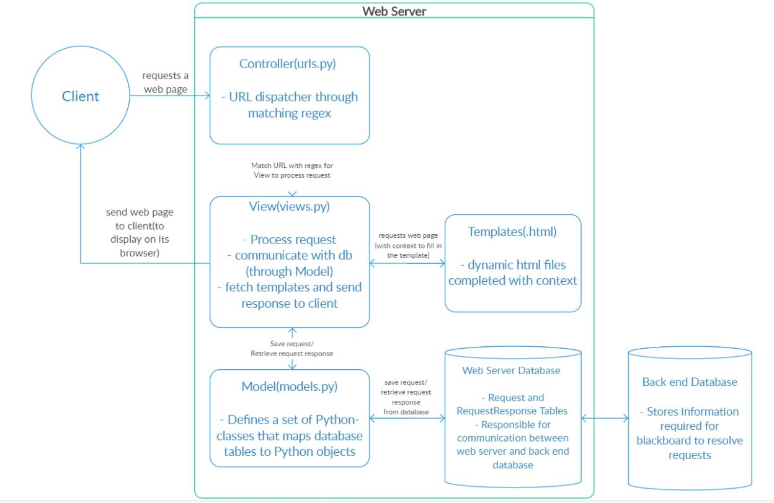

**Figure 1 : Biffurcations in django**

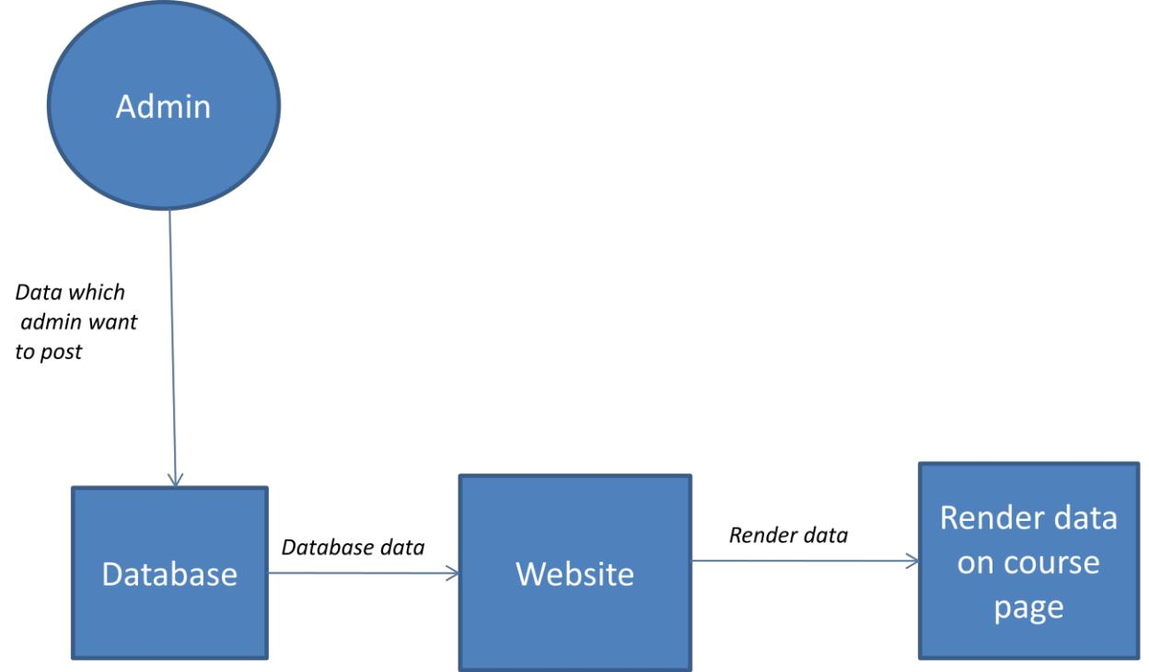

**Figure 2:Flowchart**

**5.2 Proposed Contents of the Thesis:-**

**Writing views**

A view function, or view for short, is a Python function that takes a Web request and returns a Web response. This response can be the HTML contents of a Web page, or a redirect, or a 404 error, or an XML document, or an image . . . or anything, really. The view itself contains whatever arbitrary logic is necessary to return that response. This code can live anywhere you want, as long as it’s on your Python path. There’s no other requirement–no “magic,” so to speak. For the sake of putting the code somewhere, the convention is to put views in a file called views.py, placed in your project or application directory.

Form data sent back to a Django website is processed by a view, generally the same view which published the form. This allows us to reuse some of the same logic.

To handle the form we need to instantiate it in the view for the URL where we want it to be published:

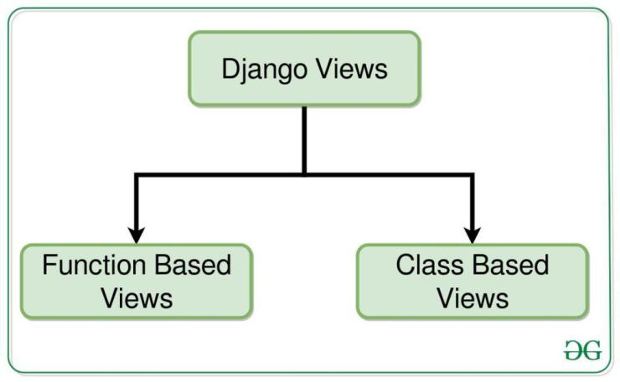

**Templates:-**

The Django template language is Django’s own template system. Until Django 1.8 it was the only built-in option available. It’s a good template library even though it’s fairly opinionated and sports a few idiosyncrasies. If you don’t have a pressing reason to choose another backend, you should use the DTL, especially if you’re writing a pluggable application and you intend to distribute templates. Django’s contrib apps that include templates, like django.contrib.admin, use the DTL.

**Admin**

One of the most powerful parts of Django is its automatic admin interface. It reads metadata in your models to provide a powerful and production-ready interface that content producers can immediately use to start managing content on your site. It’s easy to set up and provides many hooks for customization.

from django.contrib import admin

from bands.models import Band, Member

class MemberAdmin(admin.ModelAdmin):

"""Customize the look of the auto-generated admin for the Member model"""

list_display = ('name', 'instrument')

list_filter = ('band',)

admin.site.register(Band) # Use the default options

admin.site.register(Member, MemberAdmin) # Use the customized options

**6.Future Enhancements :-**

User requirements keep changing as the project is being used. Some of the future enhancements that can be done to this project are :

* As the technology emerges, it’s possible to upgrade the project and may be adaptable to desired environment.
* Based on the future security issues, security may be improved using emerging technologies.
* Sub admin module may be added.