**HEALTH AI: INTELLIGENT HEALTHCARE ASSISTANT**

**DOCUMENATATION**

**1.Introduction**

• **PROJECT TITLE:** Health Ai: Intelligent Healthcare Assistant

• **TEAM LEADER:** BARADHAN.G

• **TEAM MEMBER:** AJITH KUMAR.S

• **TEAM MEMBER:** ARCHUNAN.P

• **TEAM MEMBER:** AKASH.V

2.PROJECT OVEREVIEW

This project focuses on developing an Artificial Intelligence (AI) system designed to improve healthcare services by enabling faster diagnosis, personalized treatment, efficient patient management, and data-driven decision-making.

**Objectives:**

* Enhance diagnostic accuracy using AI and machine learning.
* Provide personalized treatment recommendations.
* Support remote monitoring and telehealth.
* Automate clinical tasks and documentation.
* Analyze large-scale healthcare data for predictive insights.

### **3.** **Healthcare AI Architecture**

1. **Data Sources:**  
   EHRs, medical images, wearables, lab reports.
2. **Data Ingestion:**  
   APIs and secure pipelines (HL7/FHIR).
3. **Storage:**  
   Cloud or on-premise, HIPAA/GDPR compliant.
4. **Processing:**  
   Data cleaning, NLP for text, image preprocessing.
5. **AI/ML Layer:**  
   Models for prediction, diagnosis, image analysis, NLP.
6. **Application Layer:**  
   Clinical decision support, alerts, dashboards.
7. **User Interface:**  
   Web/mobile apps for doctors and patients.
8. **Security:**  
   Encryption, access control, compliance.

4. 🗂️ **Folder Structure: Health AI Project**

health-ai-project/

├── data/

│ ├── raw/

│ └── processed/

│

├── models/

│ └── checkpoints/

│

├── notebooks/

│

├── src/

│ ├── data_preprocessing/

│ ├── training/

│ ├── inference/

│ └── utils/

│

├── app/

│ ├── api/

│ └── ui/

│

├── config/

│

├── tests/

│

├── reports/

│

├── docs/

│

├── requirements.txt

└── README.md

### 5.**Setup Instructions**

**1.Clone the repo**

git clone <repo_url>&& cd health-ai-project

1. **Create & activate virtual environment**

python –m venv venv && source venv/bin/activate

1. **Install dependencies**

pip install -r requirements.txt

1. **Set environment variables**  
   Create a .env file with keys like API_KEY, DB_URI, MODEL_PATH.
2. **Prepare data & run app**

python src/data_preprocessing/preprocess.py

uvicorn app.api.main:app --reload # or streamlit run app/ui/app.py

**6.Running the Application**

1. **Activate your virtual environment**

source venv/bin/activate

1. **Start the backend (API)**

uvicorn app.api.main:app --reload

1. **(Optional) Start the frontend/UI**

streamlit run app/ui/app.py

1. **Access the app:**

* API: http://localhost:8000
* UI: http://localhost:8501

**7. API Documentation**

**1. GET /**

**Description:** Health check endpoint  
**Response:**

{ "status": "ok" }

**2. POST /predict**

**Description:** Get disease prediction or diagnosis from input data  
**Request Body (JSON):**

{

"age": 45,

"gender": "male",

"symptoms": ["chest pain", "shortness of breath"],

"vitals": {

"heart_rate": 110,

"bp": "140/90"

}

}

**Response:**

{

"prediction": "High risk of heart disease",

"confidence": 0.92

}

**3. POST /upload-image**

**Description:** Upload medical image (e.g., X-ray) for AI analysis  
**Request:** multipart/form-data  
**Response:**

{

"diagnosis": "Possible pneumonia",

"confidence": 0.87

}

**4. GET /docs**

**Description:** Interactive API docs (Swagger UI)

**8.Authentication in Healthcare AI**

* **Purpose:** Secure user access to sensitive patient data and AI services.
* **Methods:**
  + **JWT (JSON Web Tokens):** For stateless, scalable authentication.
  + **OAuth2:** Allows secure third-party access and single sign-on (SSO).
  + **Multi-Factor Authentication (MFA):** Adds extra security layer (e.g., SMS or authenticator apps).
* **User Roles:** Role-based access control (RBAC) to restrict permissions (e.g., doctor, nurse, admin).
* **Encryption:** Passwords stored hashed (e.g., bcrypt), secure token storage.
* **Compliance:** Adhere to HIPAA/GDPR for protecting health data privacy.

### **9. Interface in Healthcare AI**

* **Purpose:** Provide intuitive access for doctors, patients, and staff to AI-powered tools and insights.
* **Key Features:**
  + **Dashboard:** Real-time patient data, alerts, and AI predictions.
  + **Data Input Forms:** For symptoms, vitals, and patient history.
  + **Medical Image Viewer:** To display AI-analyzed scans (X-rays, MRIs).
  + **Reports & Visualizations:** Easy-to-understand charts and summaries.
  + **Multi-Platform:** Web and mobile apps for accessibility anywhere.
* **Technologies:** React, Angular, Flutter, or Streamlit for rapid UI development.
* **Focus:** Usability, accessibility, data privacy, and seamless integration with backend AI services

**10. Testing**

* **Types of Testing:**
  + **Unit Testing:** Verify individual functions/modules (e.g., data preprocessing, model functions).
  + **Integration Testing:** Check interactions between components like data pipeline and model inference.
  + **Model Validation:** Evaluate AI model accuracy, precision, recall on test datasets.
  + **Performance Testing:** Ensure responsiveness and scalability under load.
  + **Security Testing:** Test data privacy, authentication, and compliance with regulations.
  + **User Acceptance Testing (UAT):** Validate UI/UX with end-users (clinicians, patients).
* **Tools:**
  + pytest, unittest (Python)
  + Postman (API testing)
  + TensorBoard, MLflow (model monitoring)
* **Importance:** Ensures reliability, safety, and compliance of AI in critical healthcare environments.

**11. SCREEN SHOTS**



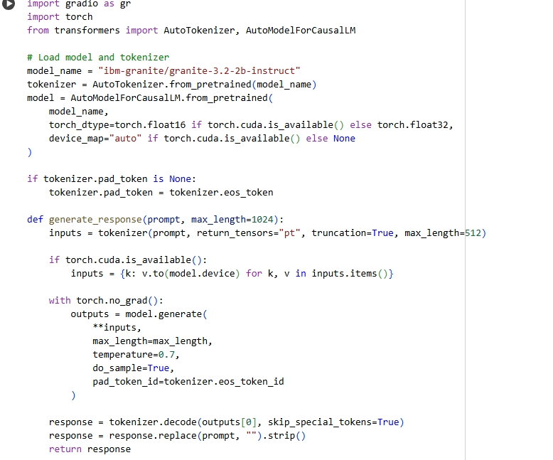

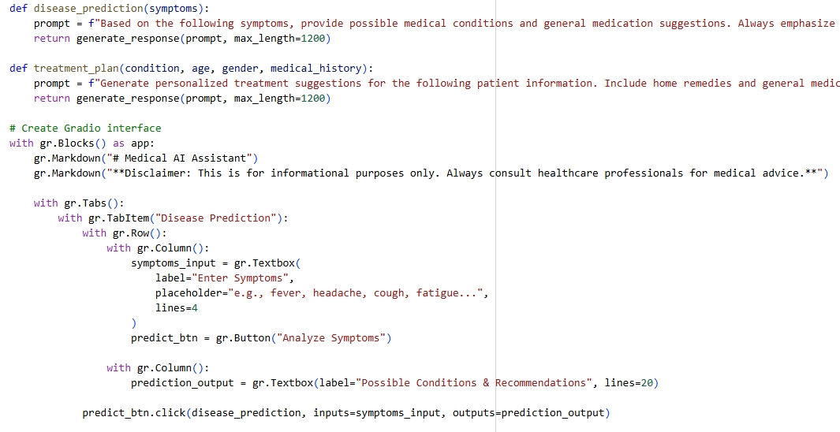

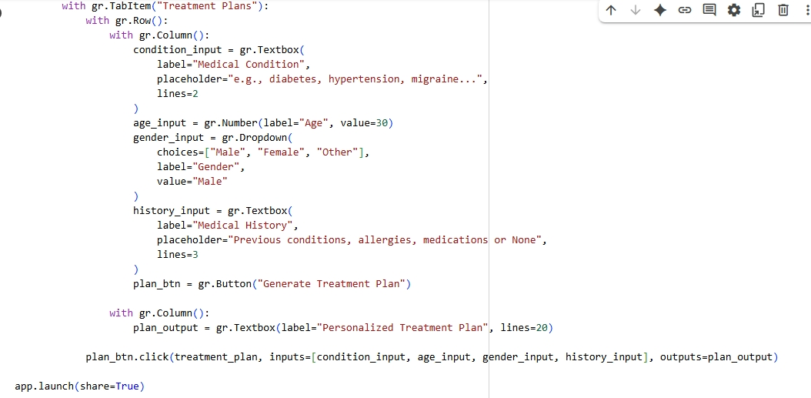

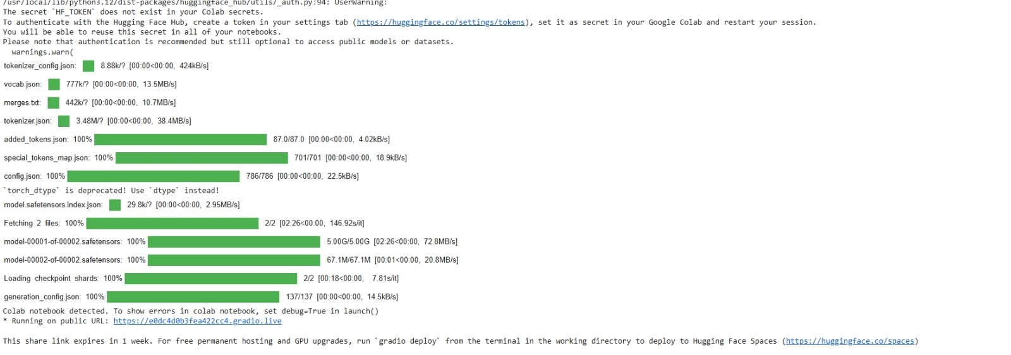

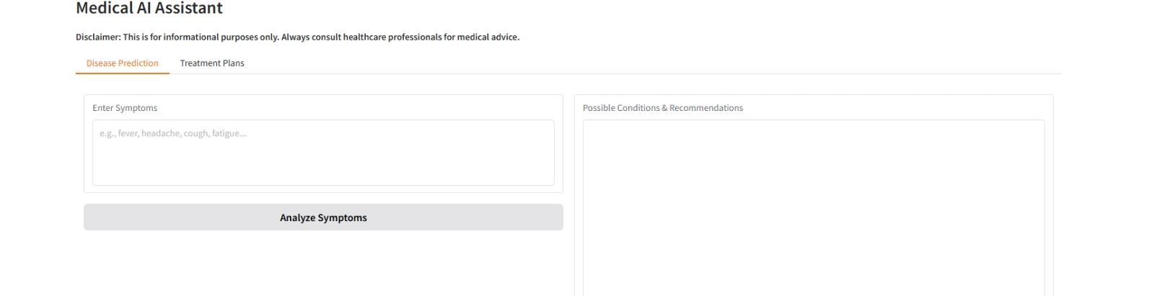

### **12. Known Issues in Healthcare AI**

* **Data Quality & Bias:** Incomplete, inconsistent, or biased medical data can lead to inaccurate predictions.
* **Interpretability:** AI models often act as “black boxes,” making it hard for clinicians to trust decisions.
* **Privacy & Security:** Handling sensitive health data requires strict compliance (HIPAA/GDPR) and robust security measures.
* **Regulatory Challenges:** Navigating healthcare regulations slows deployment and innovation.
* **Integration Complexity:** Difficulties in integrating AI tools with existing hospital systems (EHRs, PACS).
* **Generalization:** Models trained on specific populations may not perform well across diverse groups.
* **Clinical Validation:** Extensive testing and validation are needed before clinical adoption.

### **13. Future Enhancements in Healthcare AI (Brief)**

* **Explainable AI:** Improve transparency to build clinician trust and meet regulatory needs.
* **Personalized Medicine:** Tailor treatments using genomics and real-time patient data.
* **Advanced Multi-modal AI:** Combine imaging, clinical notes, and sensor data for richer insights.
* **Real-time Remote Monitoring:** Enhance telehealth with continuous AI-powered vitals tracking.
* **Integration with Robotics:** Support surgeries and patient care through AI-driven robotics.
* **Federated Learning:** Enable collaborative model training across hospitals without sharing sensitive data.
* **Improved Data Privacy:** Use techniques like differential privacy and homomorphic encryption.