REAL-WORLD DATASET
ANALYSIS PROJECT
Student Performance — Mathematics Dataset
Prepared by: Akash Yadav
BCA Artificial Intelligence and Machine Learning
Galgotias University

1. Introduction
This project explores a real-world student performance dataset from the UCI Machine Learning Repository. The analysis uses the Mathematics records in student-mat.csv. The dataset contains student demographic, family, school, lifestyle and academic information, along with grades from three assessment periods. The purpose is to understand the structure and quality of the data, examine patterns related to final grades, and communicate findings through clear visualizations.

2. Dataset Overview
The selected file contains 395 student records and 33 attributes. The target outcome examined in this report is G3, the final Mathematics grade. G1 and G2 represent earlier period grades. Other variables include studytime, absences, age, school, family support and several categorical student characteristics. The CSV file is semicolon-separated and was loaded using pandas with sep=';'.

3. Data Inspection and Preprocessing
Initial inspection found 0 missing values and 0 duplicate rows. The column names were stripped of any surrounding whitespace and a validated copy of the dataset was exported. Since no missing values or duplicate rows were detected, no imputation or row deletion was required. The original grade and category values were retained. This avoids introducing unsupported changes to the source data.

4. Exploratory Data Analysis
The mean final grade (G3) is 10.42, while the median is 11. Using G3 >= 10 as a simple pass threshold for this analysis, 265 students (67.1%) meet the threshold and 130 students fall below it. This threshold is an analytical convention for this report and should not be treated as a claim about every school's formal grading policy.
The average study-time category is 2.04, and the average number of absences is 5.71. The Pearson correlation between studytime and G3 is 0.098, indicating a weak positive linear relationship in this dataset. The correlation between absences and G3 is 0.034, which is close to zero in this sample. Correlation does not establish causation.
Earlier grades show stronger linear relationships with the final grade: G1 and G3 correlate at 0.801, while G2 and G3 correlate at 0.905. This suggests that previous assessment performance is more closely associated with the final grade than the study-time category or absence count in this dataset.

5. Visualizations and Interpretation
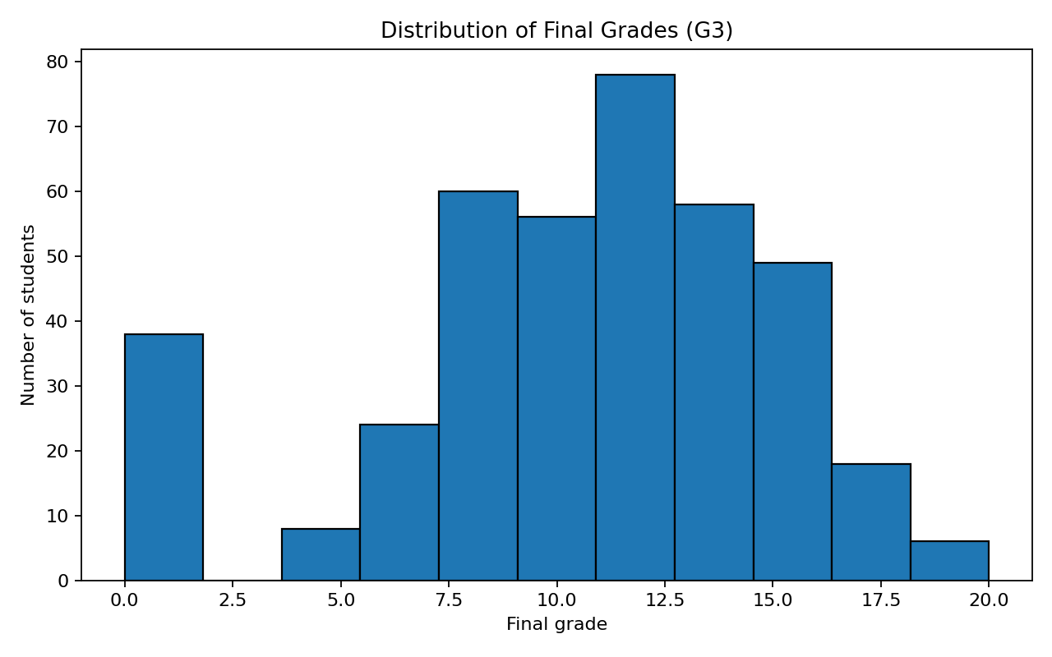
Figure 1. Distribution of final Mathematics grades (G3).
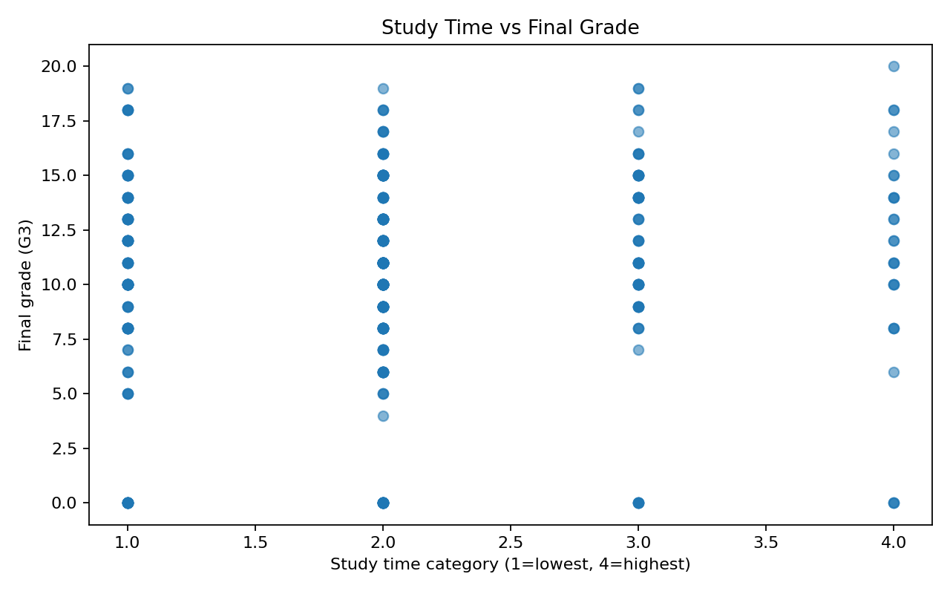
Figure 2. Study-time category compared with final grade.
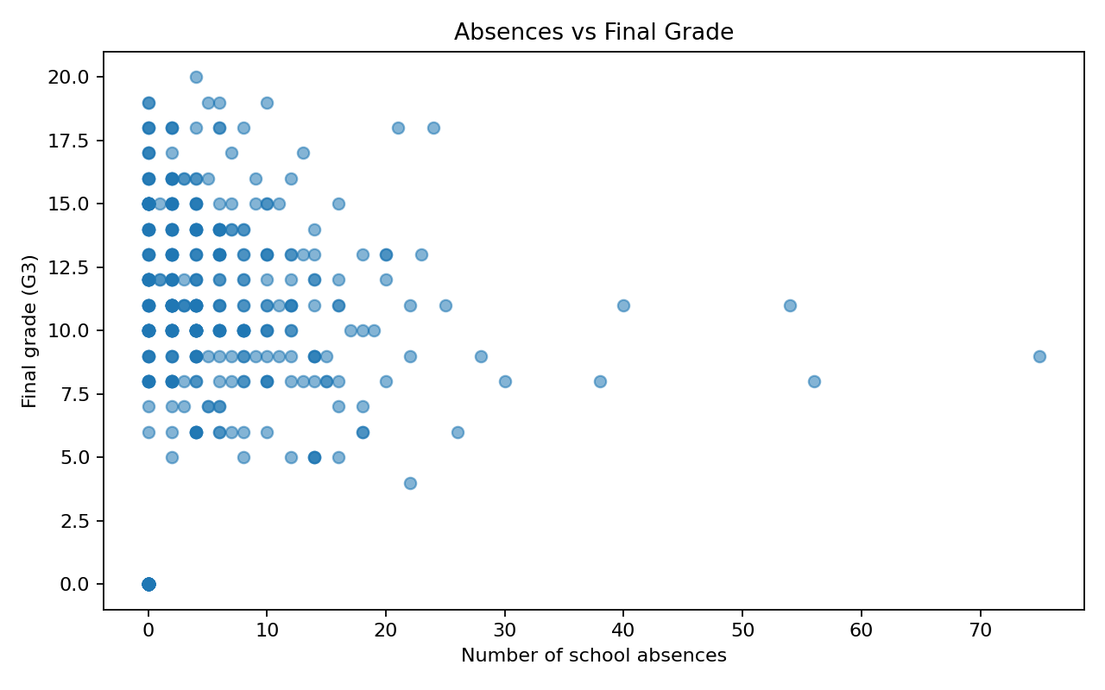
Figure 3. Absence count compared with final grade.
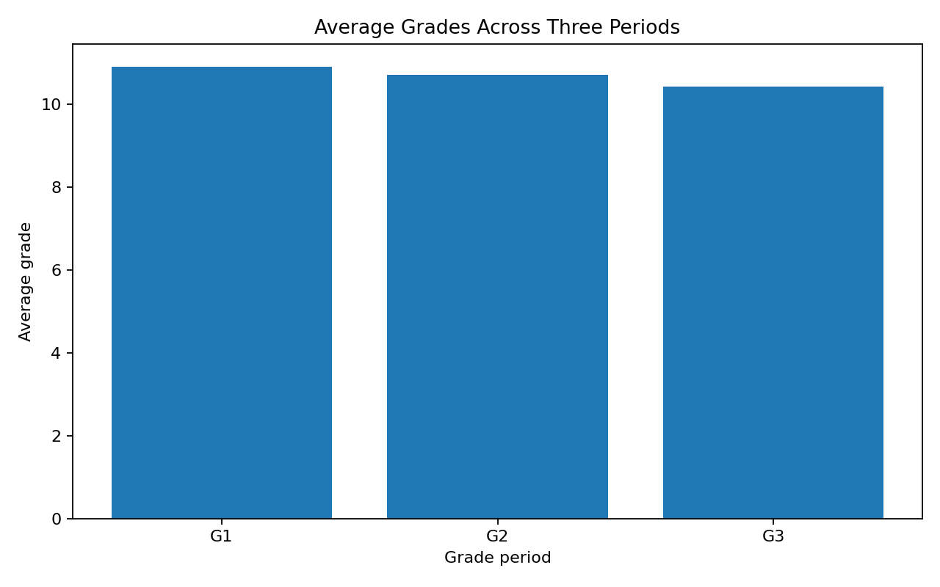
Figure 4. Mean grades across G1, G2 and G3.

6. Key Findings
- The dataset includes 395 Mathematics students and 33 attributes.
- No missing values or duplicate records were detected in the supplied file.
- The mean final grade is 10.42; 67.1% of records have G3 >= 10.
- G2 has the strongest examined correlation with G3 (0.905), followed by G1 (0.801).
- Study time has a weak positive correlation with G3 (0.098); this does not prove that study time causes higher grades.
- Absences have a very weak linear correlation with G3 in this sample (0.034).

7. Conclusion
This project demonstrates a complete introductory data-analysis workflow: loading a public dataset, checking its quality, preparing a validated copy, calculating descriptive statistics, examining relationships and producing visualizations. The strongest observed association with the final grade is the previous-period grade G2. Study time and absences show much weaker linear relationships with G3 in this sample. These results describe the selected Mathematics dataset only and should not be generalized to all students or interpreted as causal effects. Further work could compare Mathematics with the Portuguese-subject records, investigate interactions among features, and build carefully validated predictive models.

8. Tools and Technologies
Python, Pandas, Matplotlib, Jupyter Notebook and Microsoft Word.

9. Dataset Reference
Cortez, P. and Silva, A. (2008). Using Data Mining to Predict Secondary School Student Performance. UCI Machine Learning Repository: Student Performance. Dataset file: student-mat.csv.

