Retail Business Analytics Report
Task 5 — Analytics Report & Insights Documentation
Prepared by: Akash Yadav

1. Executive Summary
This project examines the UCI Online Retail transaction dataset, which contains 541,909 transaction lines from 2010-12-01 to 2011-12-09. After removing 5,268 exact duplicate rows and applying a clearly defined positive-sales filter, the analysis records £10,642,110.80 in sales across 19,960 unique invoices. Average order value is £533.17. The United Kingdom contributes 84.6% of filtered sales revenue, so the business is strongly concentrated in its home market. The highest monthly sales total in the available period is 2011-11, at £1,503,866.78. These figures describe sales revenue, not profit, because the dataset does not include product costs or operating expenses.

2. Business Objective and Questions
The objective is to turn transaction-level records into practical information for a retail manager. The analysis asks: How much positive sales revenue is represented? Which months, countries and products contribute most? What data-quality issues affect confidence in the results? What operational actions are supported by the observed patterns?

3. Dataset Overview
Source: UCI Machine Learning Repository, Online Retail dataset (https://archive.ics.uci.edu/dataset/352/online-retail). The workbook contains eight original fields: InvoiceNo, StockCode, Description, Quantity, InvoiceDate, UnitPrice, CustomerID and Country. The source has 541,909 rows, 4,070 distinct stock codes and 38 countries. Invoice dates run from 2010-12-01 08:26:00 to 2011-12-09 12:50:00.
The source is historical and ends on 9 December 2011. December 2011 is therefore only a partial month and should not be compared with full months without this qualification.

4. Data Quality and Preprocessing
- Missing Description values: 1,454 (0.27%). These rows are retained in the source but are not used in product-name ranking.
- Missing CustomerID values: 135,080 (24.93%). These transactions can still contribute to overall sales, but are excluded from customer-specific counts and repeat-customer analysis.
- Exact duplicate rows: 5,268. Exact duplicates are removed before calculating the sales KPIs.
- Cancellation invoice rows (InvoiceNo begins with C): 9,288. They are excluded from the positive-sales KPI.
- Rows with negative quantity: 10,624; rows with UnitPrice <= 0: 2,517. These are not treated as positive sales.
Sales analysis filter: remove exact duplicates; exclude cancellation invoices; keep only Quantity > 0 and UnitPrice > 0; calculate line revenue as Quantity × UnitPrice. This produces a consistent positive-sales measure. It is intentionally not labelled net revenue because returns/cancellations are excluded rather than reconciled as a complete accounting ledger.

5. Key Performance Indicators
KPI | Result
Filtered positive-sales revenue | £10,642,110.80
Unique invoices / orders | 19,960
Identified customers | 4,338
Distinct stock codes | 3,922
Countries in filtered sales | 38
Average order value | £533.17
United Kingdom revenue share | 84.6%
Identified customers with 2+ invoices | 65.6%

6. Findings and Visualization Interpretation

Monthly revenue peaks in 2011-11.
The month records £1,503,866.78 in filtered sales, the highest monthly total in this dataset. A retailer could review the campaign calendar, product availability and fulfilment capacity around this period. The data shows a peak, but does not identify its cause.

The United Kingdom is the dominant market.
UK sales total £9,001,744.09, or 84.6% of the filtered revenue. The next-largest country is Netherlands with £285,446.34. International expansion may be worth testing, but should be evaluated against delivery cost, customer acquisition cost and local demand.

The highest-revenue product description is DOTCOM POSTAGE.
It contributes £206,248.77 in the filtered sales measure. This is a revenue ranking, not a profit ranking; unit margins are unavailable.

Customer identity is incomplete.
135,080 source rows do not contain CustomerID. The repeat-customer rate is calculated only among customers with an ID, so it should not be generalized to every buyer.
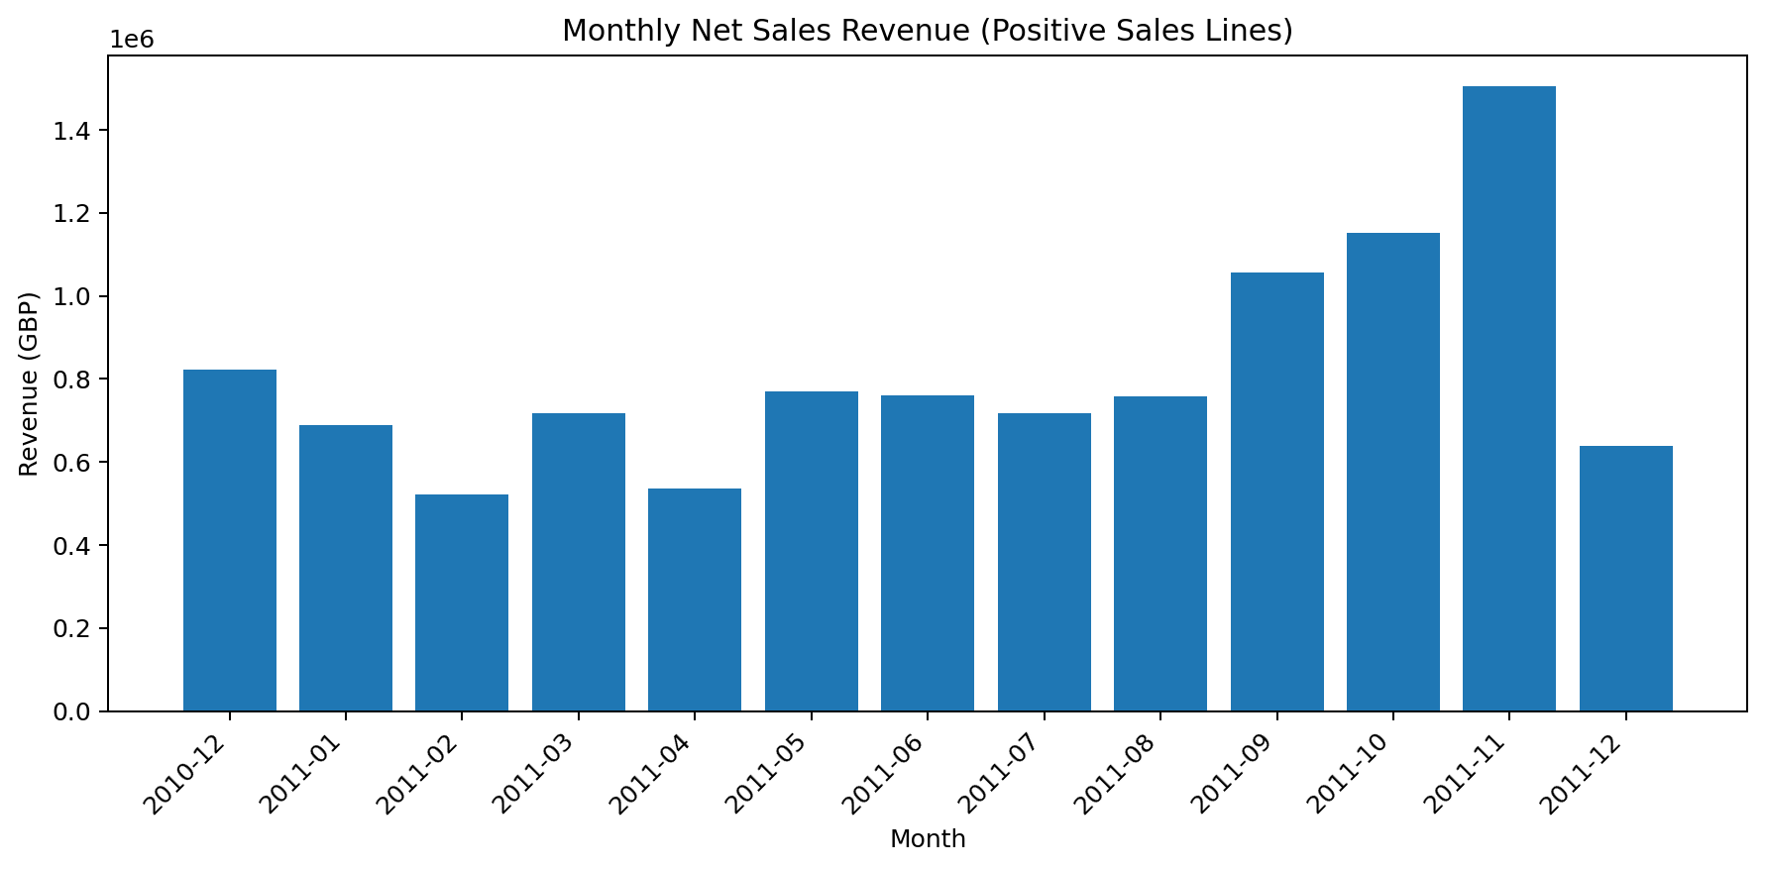
Figure 1. Monthly sales revenue. December 2011 is partial because the source ends on 9 December.
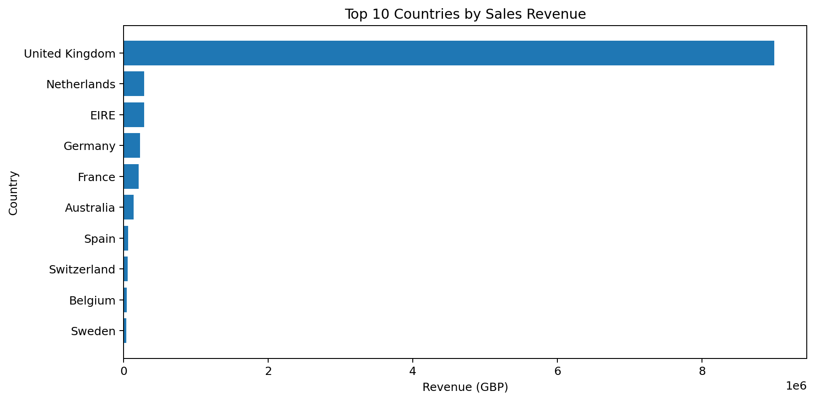
Figure 2. Ten countries with the highest filtered sales revenue.
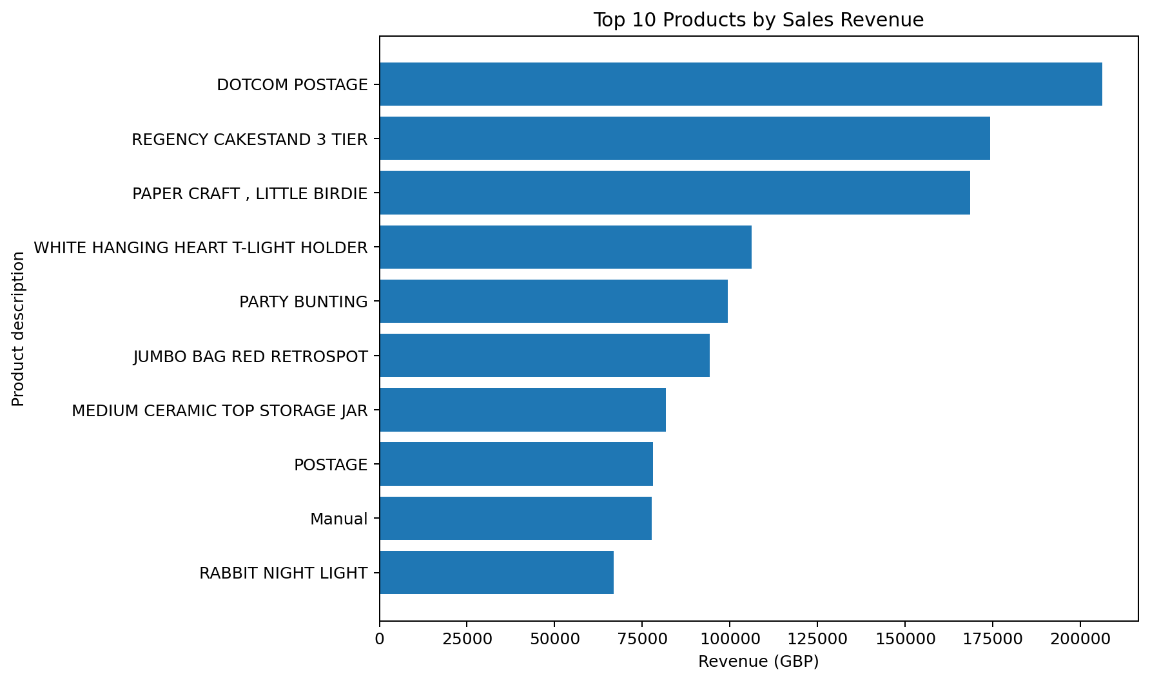
Figure 3. Ten product descriptions with the highest filtered sales revenue.
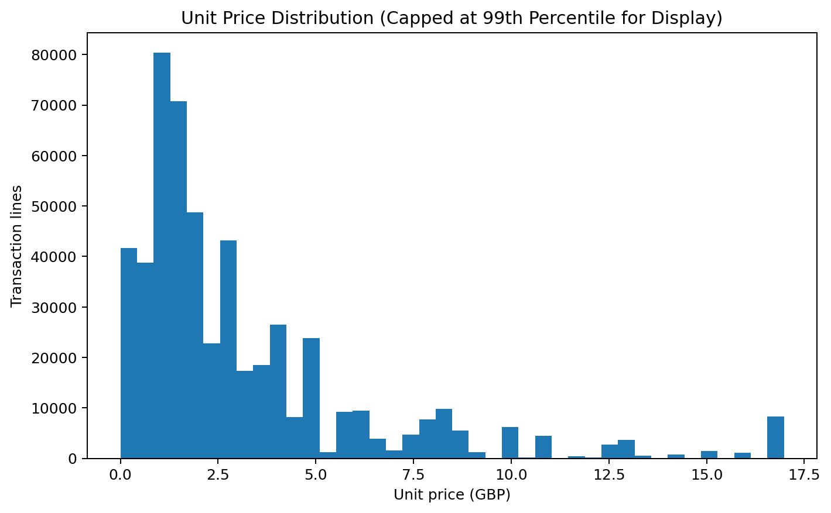
Figure 4. Unit-price distribution; the display caps values at the 99th percentile so the central pattern remains readable.
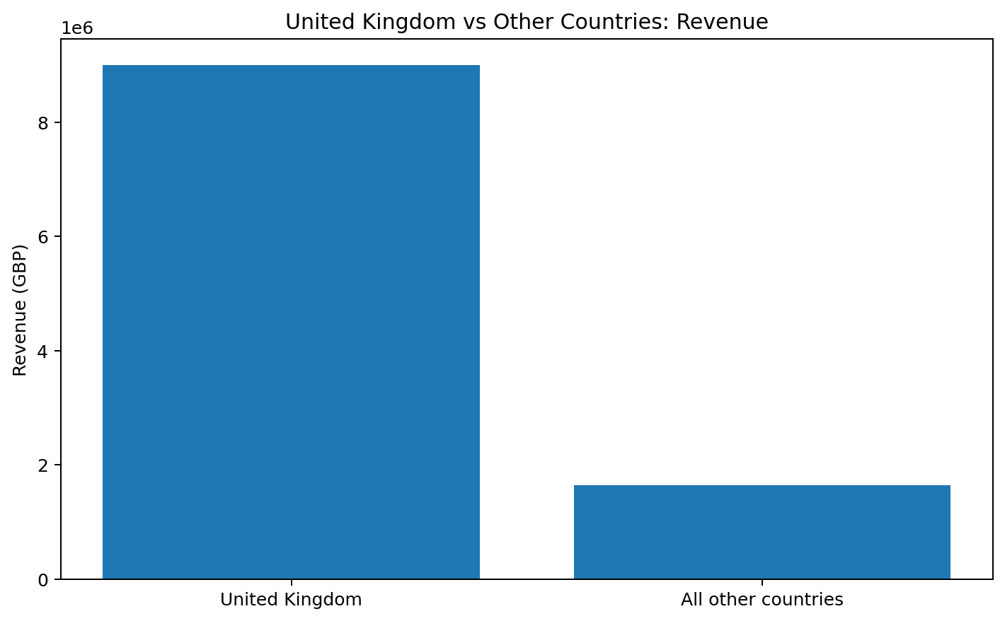
Figure 5. Comparison of UK sales revenue with the combined revenue of all other countries.

7. Actionable Business Recommendations
- Protect availability of high-revenue products. Use the top-product list as an input to stock planning, while checking stockout history and supplier lead times before changing reorder quantities.
- Plan capacity around observed monthly peaks. Review staffing, inventory and dispatch capacity ahead of the high-revenue months; investigate promotions and seasonality separately before attributing the peak to a cause.
- Use a controlled international-market test. Since revenue is concentrated in the UK, select a small number of non-UK markets for targeted campaigns and compare incremental revenue with shipping and marketing costs.
- Improve customer data capture. Missing CustomerID limits retention analysis. Add validation to checkout and monitor the proportion of orders with a usable customer identifier.
- Track returns and cancellations as a separate KPI. Report cancellation count and value alongside gross positive sales so management can monitor the impact of refunds and operational issues.
- Add cost and margin data in the next reporting cycle. Revenue alone cannot identify the most profitable products or markets.

8. Limitations
- The dataset covers 2010–2011 and may not represent current retail behaviour.
- The final month is incomplete; December 2011 ends on 9 December.
- Revenue is calculated from quantity multiplied by unit price. Costs, discounts at order level, shipping costs and operating expenses are not sufficient to calculate profit or margin.
- CustomerID is missing for a substantial share of rows, limiting customer-level conclusions.
- The positive-sales KPI excludes cancellations and non-positive lines; it should not be interpreted as an audited net-revenue figure.
- A high sales value does not establish why a product, country or month performed well. The dataset is observational and does not establish causation.

9. Conclusion
The analysis converts a large transaction workbook into a set of understandable retail KPIs and visual findings. The filtered sales measure is £10,642,110.80 across 19,960 invoices, with the UK accounting for 84.6% of revenue. The most useful next steps are stronger customer-data capture, peak-period inventory planning, and better cost and returns reporting. These actions are grounded in the observed dataset while respecting its historical coverage and data-quality limitations.

10. Reproducibility and Attribution
The accompanying main.py script reproduces the principal cleaning, KPI and chart-generation steps. Install the packages listed in requirements.txt, place Online Retail.xlsx in the project directory, and run python main.py. Dataset attribution: UCI Machine Learning Repository, Online Retail dataset, https://archive.ics.uci.edu/dataset/352/online-retail. The dataset is distributed under the Creative Commons Attribution 4.0 International (CC BY 4.0) license; credit the source when redistributing or presenting derived work.

