Telecom Customer Churn Prediction
Final Data Science Capstone Project
Prepared by: Akash Yadav

1. Executive Summary
This capstone builds and evaluates a binary classification workflow to identify telecom customers who may churn. The supplied dataset contains 7,043 customers and 21 columns. The target distribution is 1,869 churned customers (26.5%) and 5,174 non-churned customers (73.5%). Four models were compared using the same stratified 80:20 holdout split. The Decision Tree achieved 79.4% churn recall and 0.619 F1. Gradient Boosting achieved the highest accuracy (80.6%) and ROC-AUC (0.843). The selected model depends on business priorities: a retention team may prefer catching more likely churners, while a team with limited outreach capacity may prefer fewer false alarms.

2. Problem Definition and Business Objective
Customer churn means a customer stops using the telecom service. The business objective is to flag customers with elevated churn risk so a retention team can investigate and, where appropriate, offer support or suitable retention options. The model is a decision-support tool; it does not prove why an individual customer leaves.

3. Dataset Overview
The project uses the IBM Telco Customer Churn sample CSV supplied for this capstone. It contains 7,043 rows and 21 columns, including customer profile, service subscriptions, contract, payment method, tenure, monthly charges, total charges and the Churn target. CustomerID is an identifier and is excluded from model predictors.

4. Data Quality and Preprocessing
The raw CSV has no conventional null cells in the initial pandas missing-value scan. However, TotalCharges contains 11 whitespace-only values. These are converted to missing numeric values during preprocessing. The modelling pipeline imputes numeric fields with the training-set median, scales numeric fields, imputes categorical fields with the training-set most frequent category and one-hot encodes categorical features. Preprocessing is fitted within each model pipeline after the train/test split to reduce information leakage.
The target is encoded as 1 for Churn=Yes and 0 for Churn=No. The customer identifier is removed. A stratified 80:20 split with random_state=42 preserves the target proportions. The test set contains 1,409 records, including 374 churn cases.

5. Exploratory Data Analysis
The churn rate in the full dataset is 26.5%. The chart below shows the target-class distribution. Contract groups show materially different observed churn rates in this sample; month-to-month contracts have the highest observed churn rate. This is an association in the historical dataset, not proof that contract type alone causes churn.
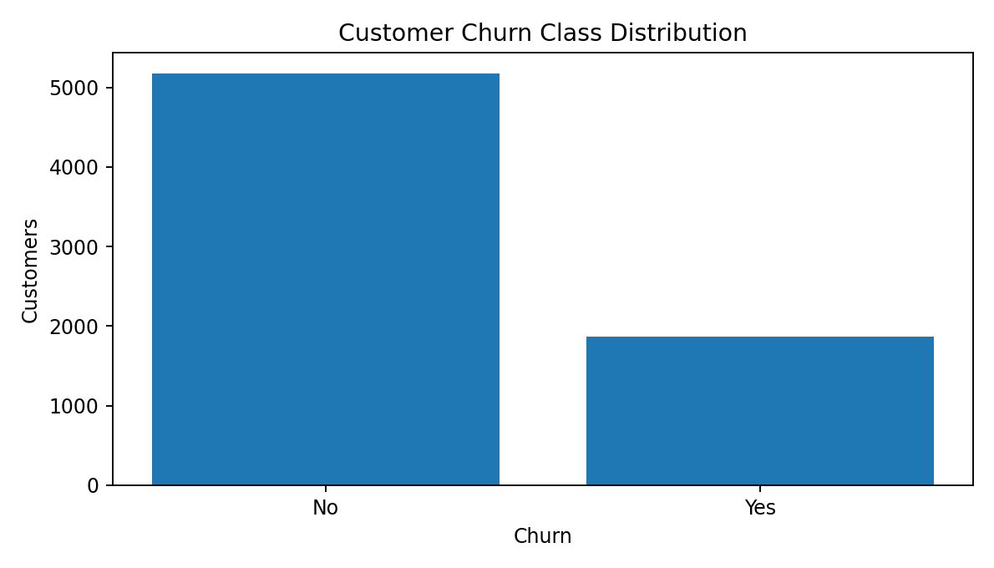
Figure 1. Churn target distribution in the full dataset.
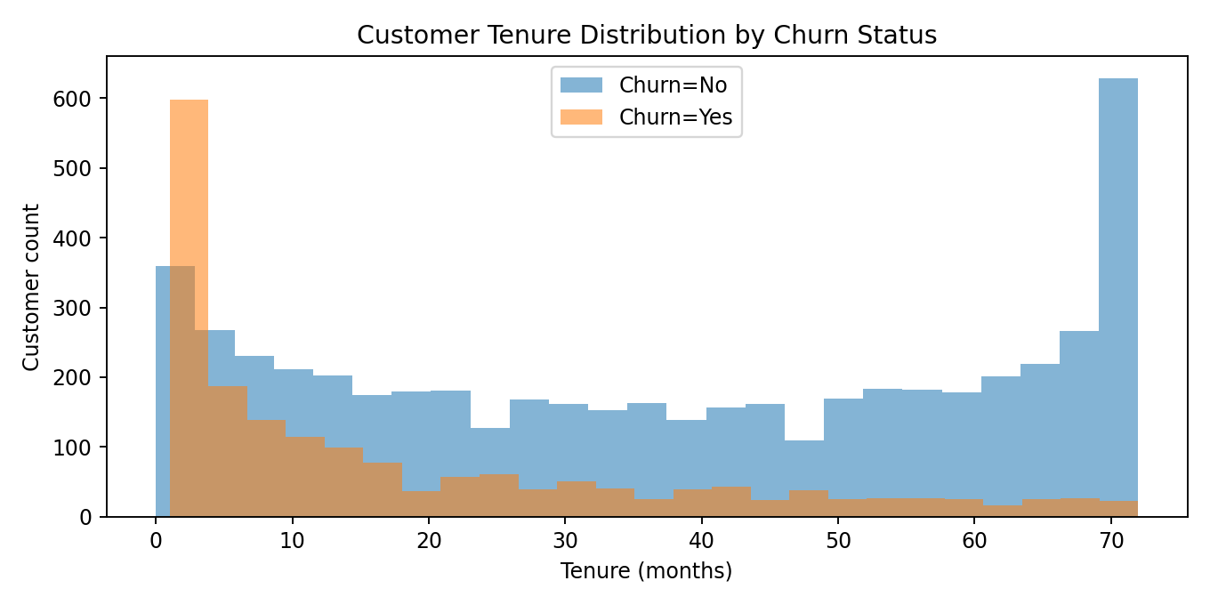
Figure 2. Tenure distributions by churn status; the plot helps compare customer lifecycle patterns.
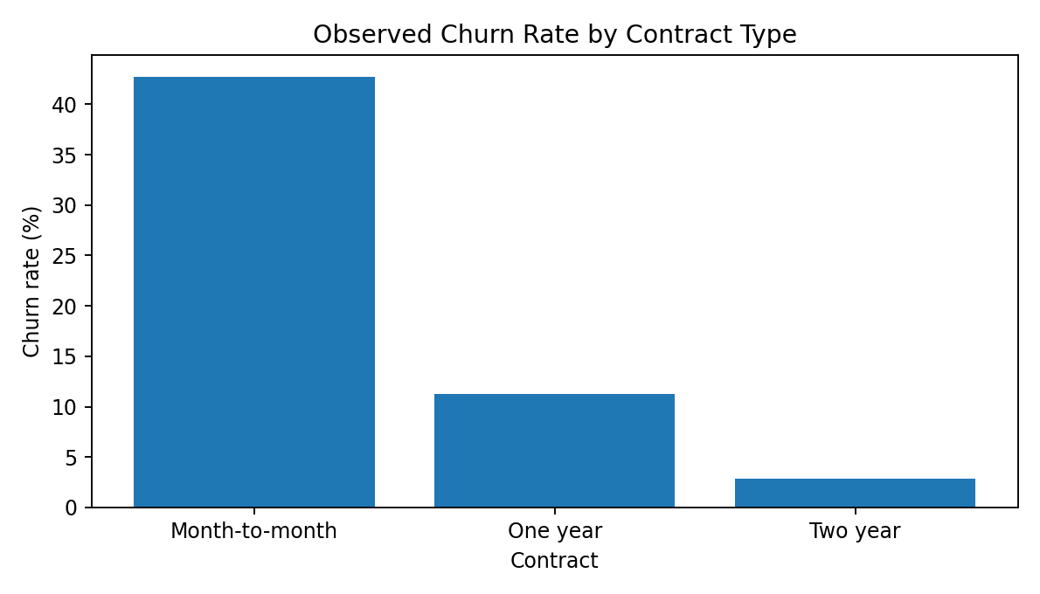
Figure 3. Observed churn rate by contract type in the supplied sample.

6. Modelling Methodology
Four classifiers were trained: Logistic Regression, Decision Tree, Random Forest and Gradient Boosting. All models used the same training/test partition and preprocessing design. Class weighting was used for Logistic Regression, Decision Tree and Random Forest to give the minority churn class more influence during fitting. Gradient Boosting was evaluated with its default class weighting. All headline results use the default 0.5 probability threshold.

7. Model Evaluation and Comparison
Model | Accuracy | Precision | Recall | F1 | ROC-AUC | PR-AUC
Logistic Regression | 0.738 | 0.504 | 0.783 | 0.614 | 0.841 | 0.633
Decision Tree | 0.740 | 0.507 | 0.794 | 0.619 | 0.834 | 0.624
Random Forest | 0.774 | 0.560 | 0.684 | 0.616 | 0.839 | 0.646
Gradient Boosting | 0.806 | 0.674 | 0.524 | 0.589 | 0.843 | 0.664
Accuracy measures the share of all test predictions that are correct. Precision measures how many predicted churners actually churned. Recall measures how many actual churners were found. F1 balances precision and recall. ROC-AUC measures ranking discrimination across thresholds; PR-AUC is useful when the positive class is less common.
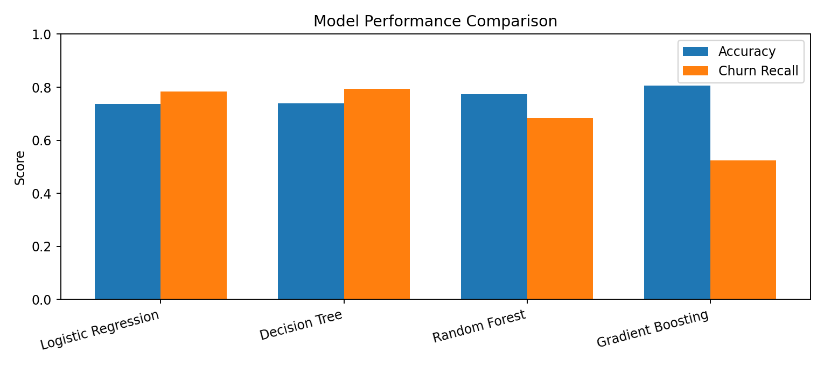
Figure 4. Accuracy and churn recall comparison across the four classifiers.

8. Selected Model and Confusion Matrix
The Decision Tree is selected for the retention-focused demonstration because it achieved the highest churn recall among the tested models (79.4%). On the 1,409-record test set, it correctly identified 297 churners (true positives), missed 77 churners (false negatives), correctly identified 746 non-churners (true negatives), and incorrectly flagged 289 non-churners (false positives). This means the model finds more potential churners but also creates a substantial review workload. It should not be deployed without a threshold and outreach-capacity review.
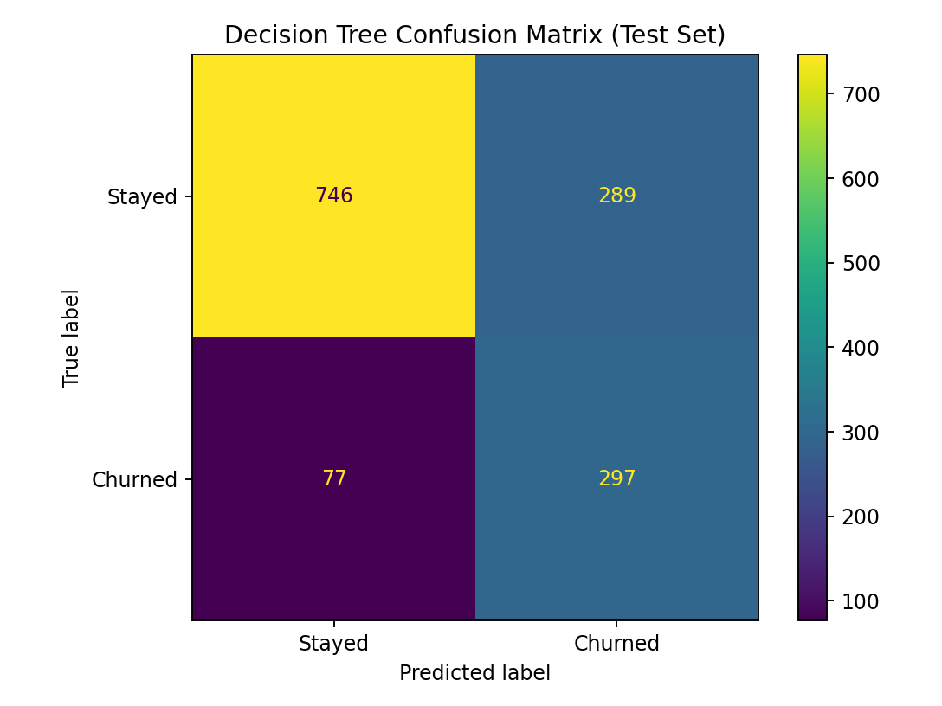
Figure 5. Decision Tree confusion matrix on the held-out test set.

9. Business Insights and Recommendations
- Use churn scores to prioritize human review, not to automatically penalize or restrict customers. Contact customers with helpful, relevant service check-ins.
- Review month-to-month customers and early-tenure customers as potential retention segments. Test support and onboarding interventions rather than assuming contract type causes churn.
- Use a pilot campaign with a holdout group. Compare incremental retention, contact cost and offer cost before scaling.
- Tune the probability threshold to match the retention team's weekly contact capacity and the relative cost of missed churners versus false alarms.
- Track model performance over time. Monitor recall, precision, PR-AUC, calibration and subgroup performance as customer behaviour changes.
- Collect intervention outcomes and customer lifetime value in future data so the business can optimize for incremental profit rather than churn prediction alone.

10. Limitations and Responsible Use
- The data is a historical sample; performance may not generalize to current customers, other telecom providers or future periods.
- The test set is a single random holdout, not a time-based validation. Future work should test on later time periods.
- The default 0.5 threshold is not necessarily optimal for business operations.
- False positives can waste outreach resources and annoy customers; false negatives mean some churners are missed.
- The model learns associations and does not establish causation. Retention offers should be tested with controlled experiments.
- Sensitive or demographic attributes require careful fairness review before operational use.

11. Conclusion
The capstone demonstrates an end-to-end, reproducible churn prediction workflow. On the held-out test set, the Decision Tree achieved 79.4% churn recall, while Gradient Boosting achieved the highest accuracy (80.6%). The results show why model selection must reflect business objectives rather than accuracy alone. A carefully monitored pilot, threshold tuning and ongoing fairness and performance checks are recommended before real-world use.

12. Reproducibility and Source
Install dependencies using `pip install -r requirements.txt`, keep `Telco-Customer-Churn.csv` beside `main.py`, then run `python main.py`. The script regenerates model_comparison.csv and the confusion matrix, and saves the selected pipeline. Dataset source: IBM Telco Customer Churn sample repository, https://github.com/IBM/telco-customer-churn-on-icp4d

