DATA SCIENCE TOOL MASTERY PROJECT
Wine Quality Analysis using Python
Submitted by: Akash Yadav | BCA AI & ML | Galgotias University

1. Introduction
This project demonstrates practical use of industry-relevant data science tools. Red and white wine datasets were analyzed to explore how physicochemical measurements relate to quality scores. Python, Pandas, NumPy, Matplotlib, Jupyter Notebook and Scikit-learn were used in a reproducible workflow.

2. Dataset Overview
The red dataset contains 1599 records and 12 columns. The white dataset contains 4898 records and 12 columns. Features include acidity, residual sugar, chlorides, sulfur dioxide, density, pH, sulphates and alcohol. The target column is the wine quality score. The source CSV files use semicolon separators.

3. Tools and Libraries
- Python: core programming language.
- Pandas: loading, inspecting, cleaning and summarizing tabular data.
- NumPy: numerical operations.
- Matplotlib: charts and visual exploration.
- Scikit-learn: train-test split, Random Forest regression and evaluation metrics.
- Jupyter Notebook: interactive and reproducible analysis.

4. Data Inspection and Preprocessing
No missing cells were found in either dataset. The red dataset contains 240 duplicate rows and the white dataset contains 937 duplicate rows. Duplicate records were removed from analysis copies, leaving 1359 red and 3961 white records. Original files remain unchanged.

5. Exploratory Analysis
Average quality was 5.64 for red wine and 5.88 for white wine. Average alcohol content was 10.42 for red wine and 10.51 for white wine. Quality scores cluster mainly around 5 and 6.
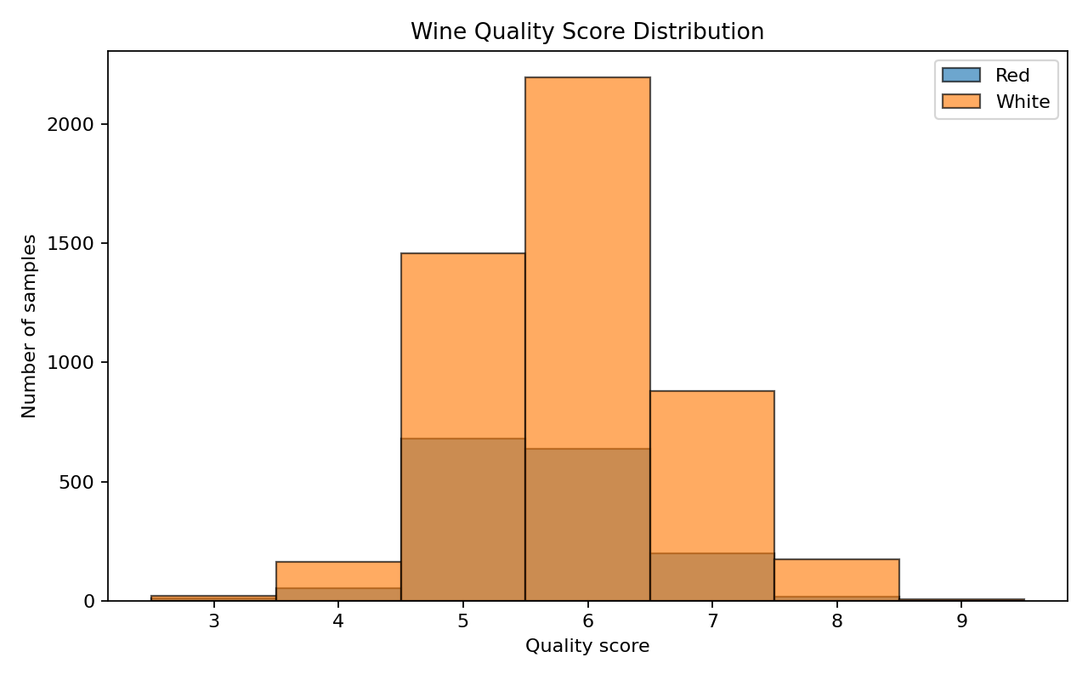
Figure 1. Distribution of wine quality scores.
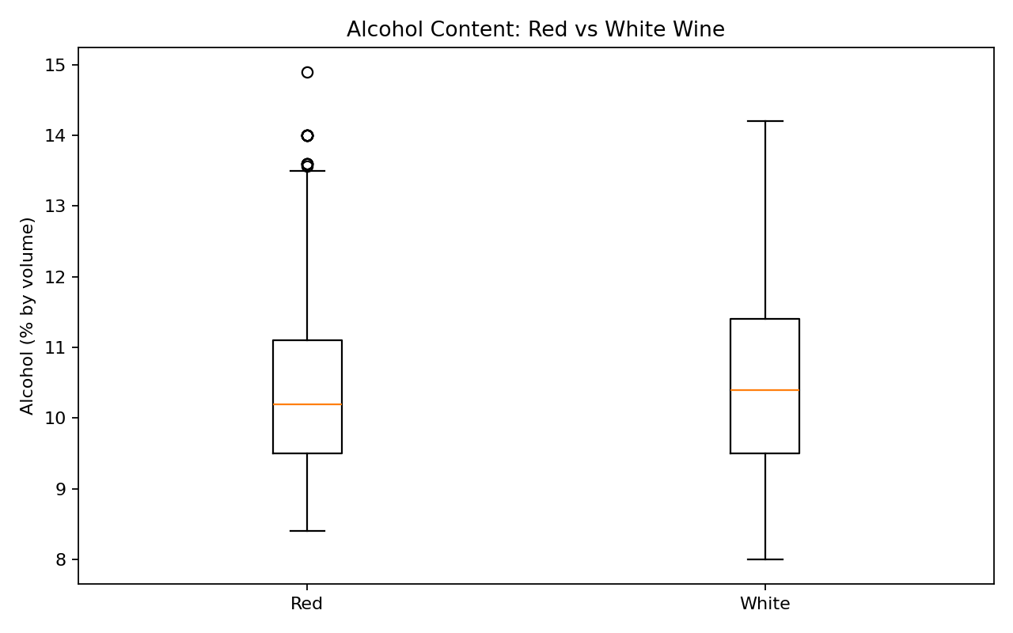
Figure 2. Alcohol content comparison.
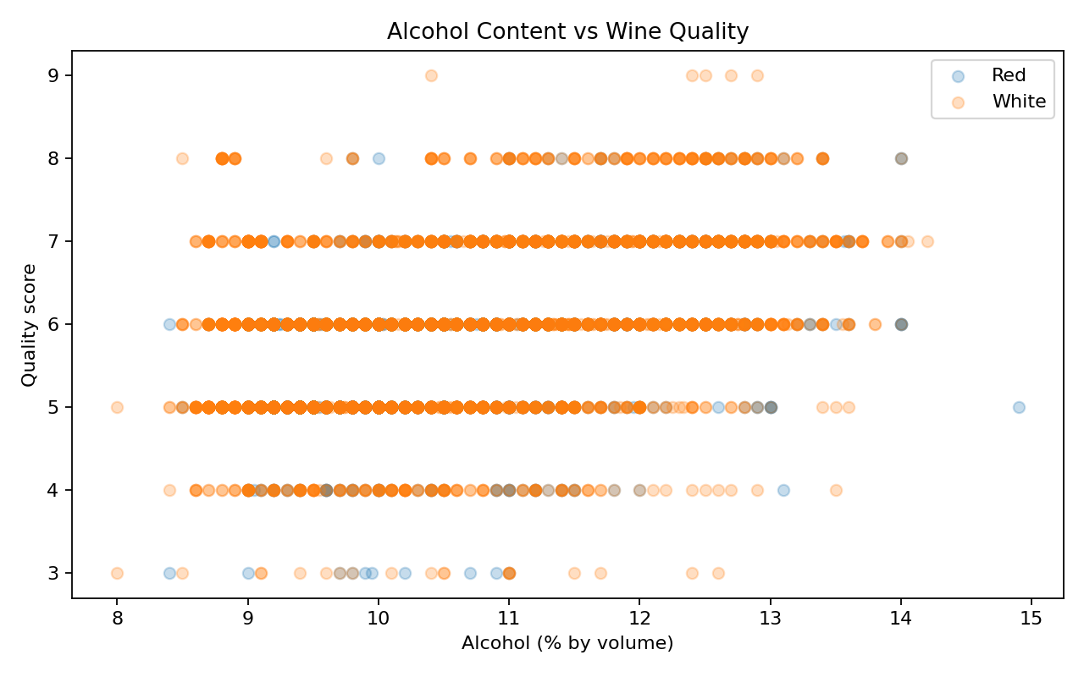
Figure 3. Alcohol content versus quality score.
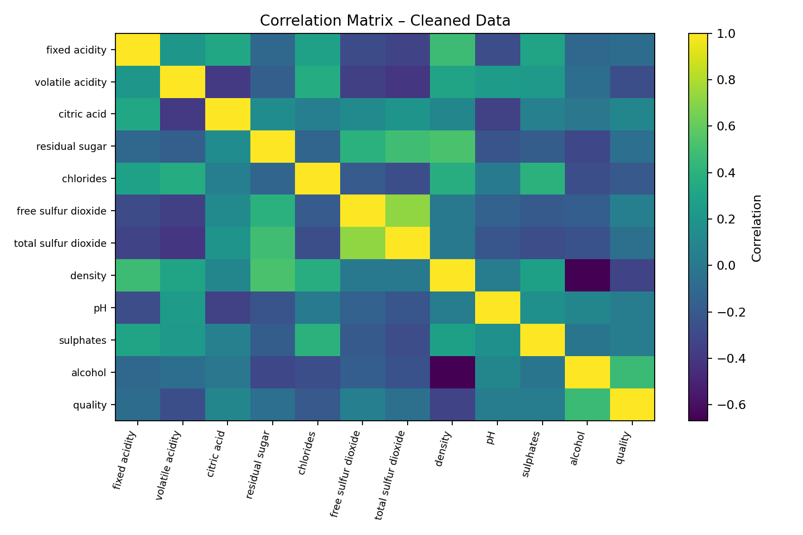
Figure 4. Correlation matrix of physicochemical features.
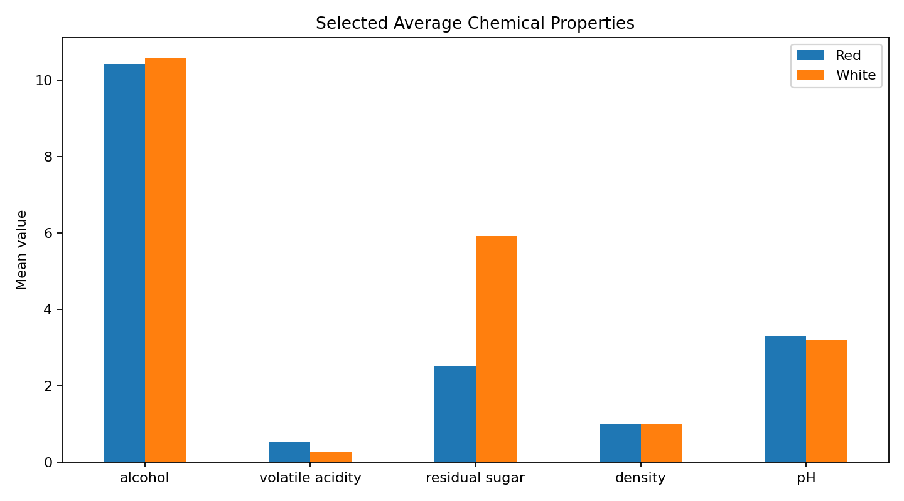
Figure 5. Average selected chemical properties.

6. Machine Learning Exercise
A Random Forest Regressor was trained separately for red and white wine. Each cleaned dataset was split into 80% training and 20% testing data with random_state=42. MAE and RMSE measure prediction error, while R-squared indicates explained variance on the test set. These are baseline educational results, not production-grade predictions.
Dataset | Rows | MAE | RMSE | R²
Red | 1359 | 0.467 | 0.617 | 0.462
White | 3961 | 0.564 | 0.739 | 0.335

7. Key Findings
Alcohol had the strongest positive correlation with quality among the measured features in both raw datasets (red: 0.476; white: 0.436). This is an association and does not prove causation. Most samples received quality scores of 5 or 6. The duplicate checks demonstrate the importance of data validation.

8. Conclusion
The project covers data loading, inspection, duplicate handling, descriptive analysis, visualization and a baseline machine-learning model. It provides practical experience with common Python data science tools and creates a portfolio-ready, reproducible project.

9. Dataset Source
UCI Machine Learning Repository – Wine Quality dataset. The two CSV files supplied for this project were used as the source data.

