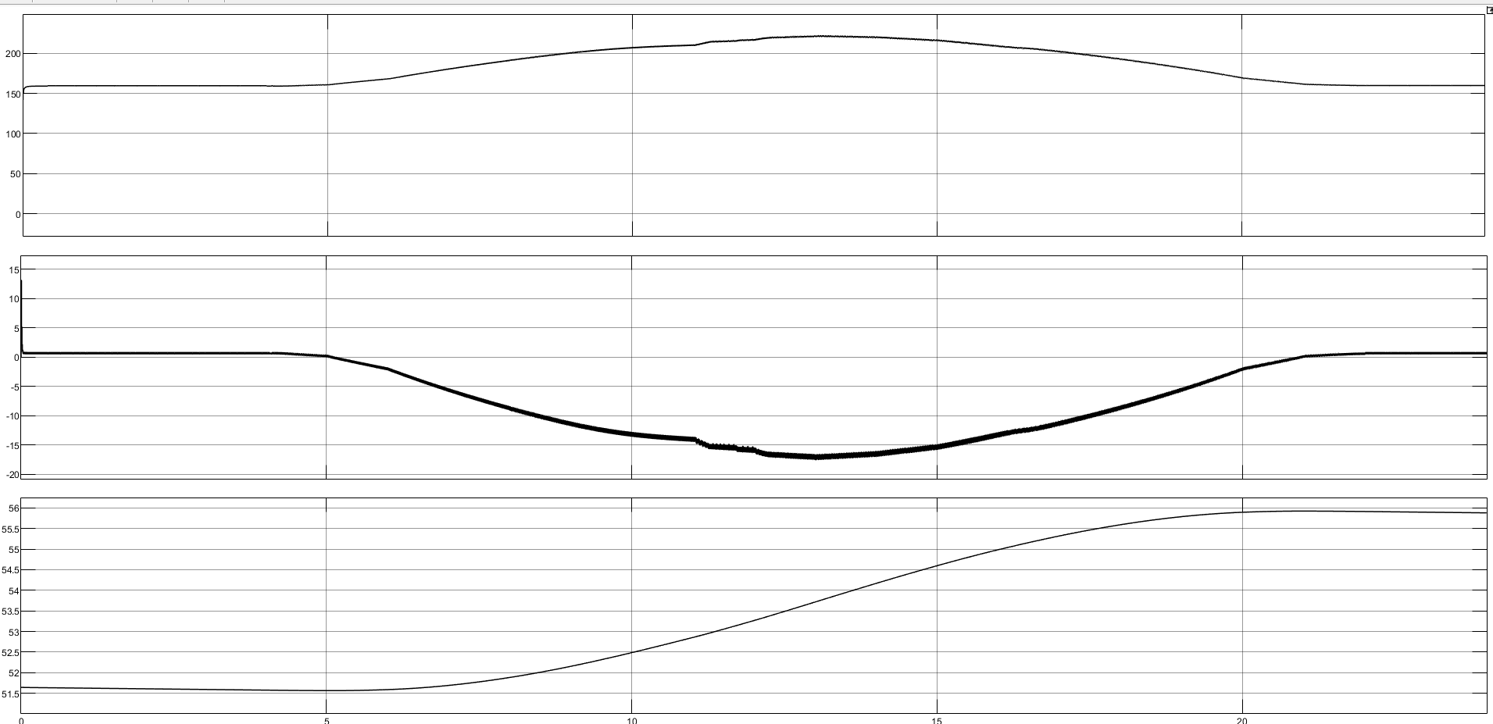

(OUTPUT VOLTAGE AND INPUT VOLTAGE) – Y AXIS ->W.R.T-> (TIME) – X AXIS

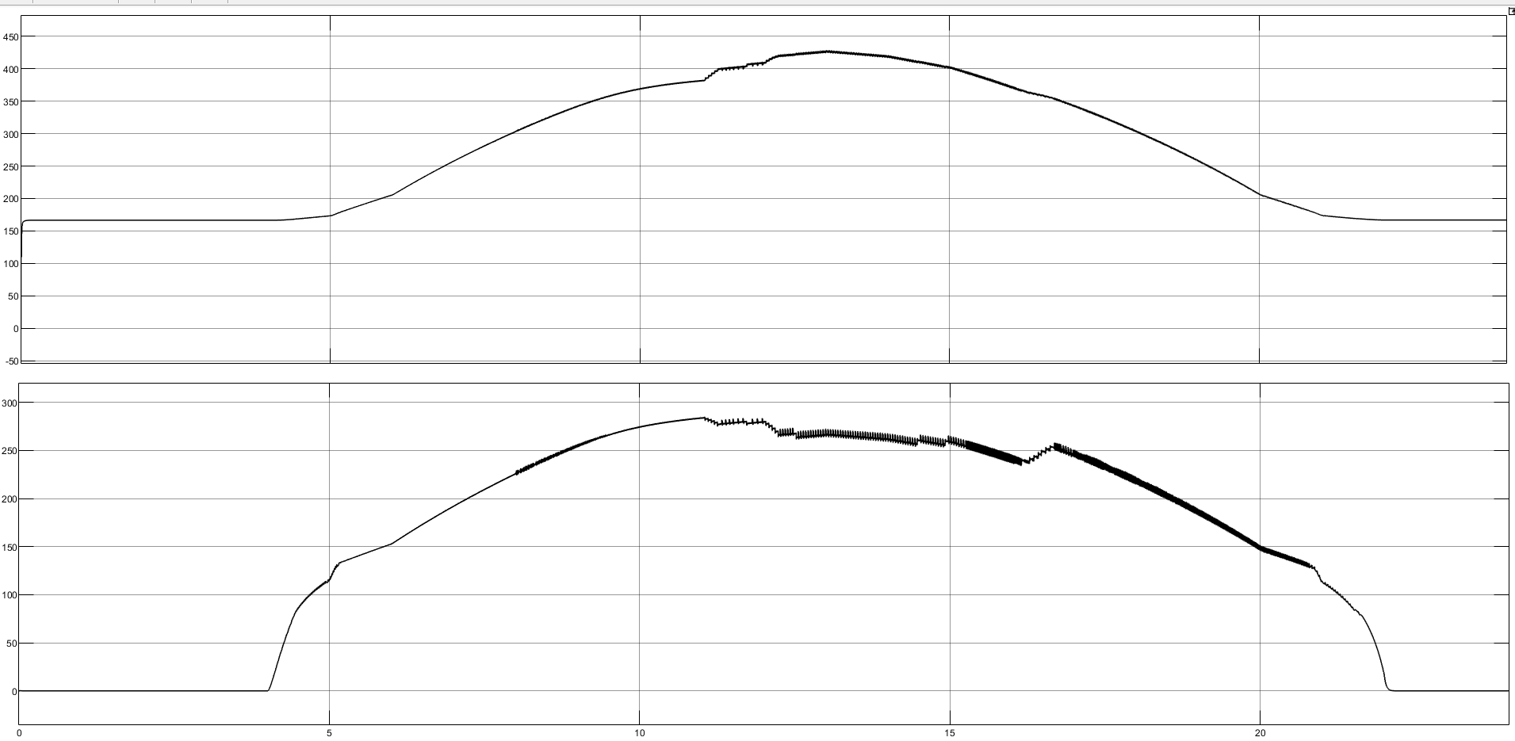

OUTPUT OF DUTY RATIO GENERATED FROM MPPT
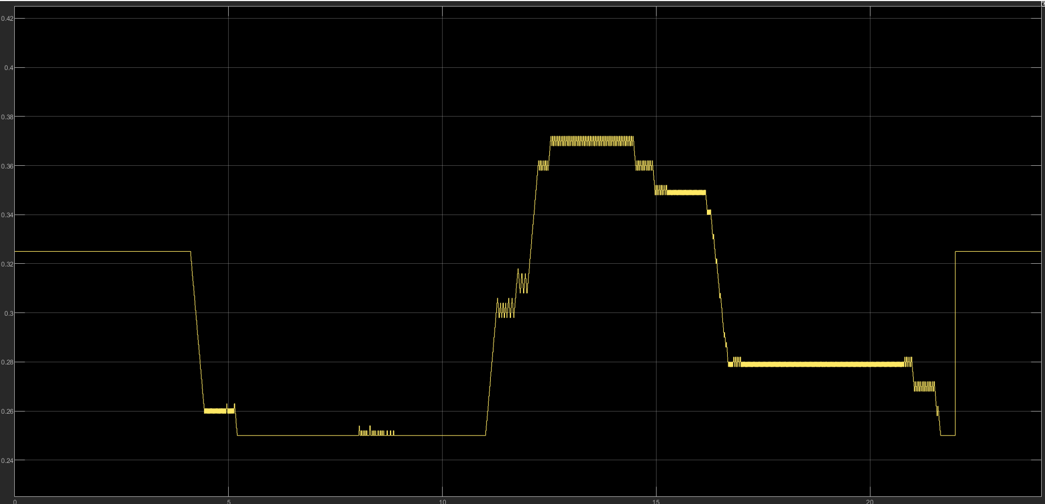

OUTPUT CURRENT AND INPUT CURRENT W.R.T TO TIME
