Northwind Catalog – Week 15 Assessment
Name: Akash Pandey

The solution consists of three projects:
• NorthwindCatalog.Services → Web API + Business Logic + EF Core
• NorthwindCatalog.Web → MVC UI (API Consumption)
• NorthwindCatalog.Tests → Unit Testing using xUnit

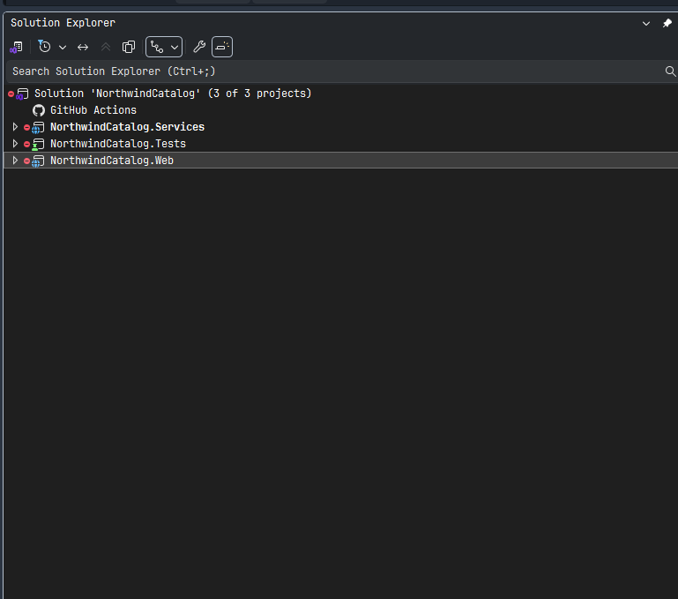

Fluent Api for scaffolding:
Use following commands in Package Manager:
Scaffold-DbContext "Connection_String" Microsoft.EntityFrameworkCore.SqlServer -OutputDir Models -Tables Categories,Products

The connection string will be present in the appsettings.json file.
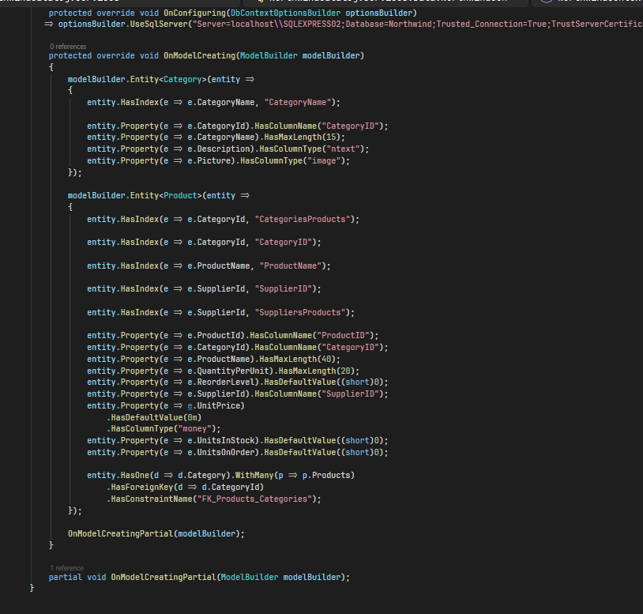

Services Project Folder structure (Repository Based):
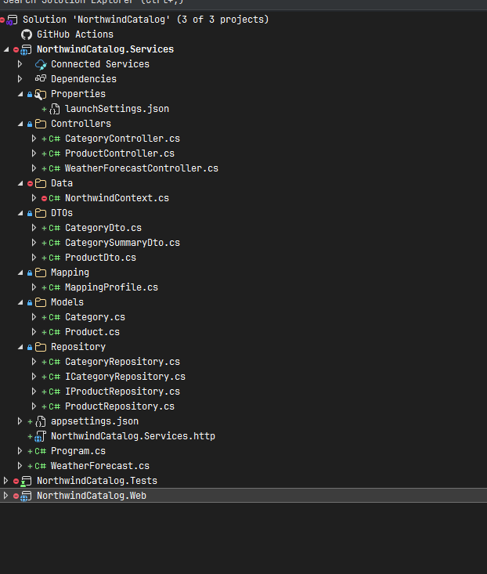

Services API Swagger:
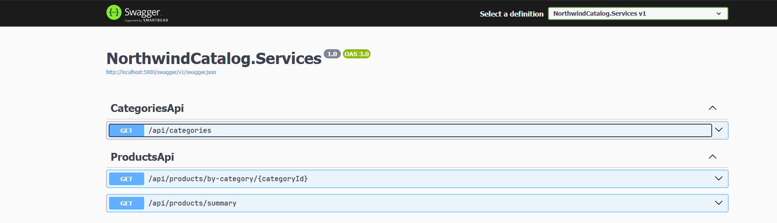

MVC Controllers:
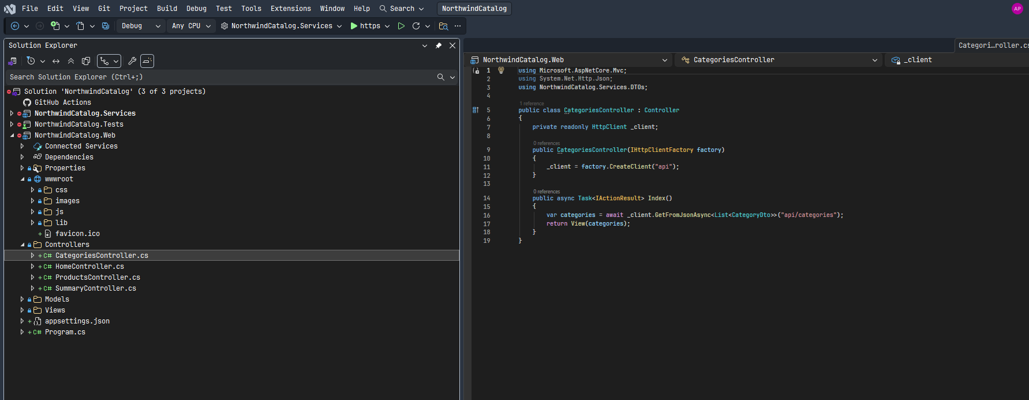

- Save the images in the wwwroot/images folder so that it can be used by the automapper.

Categories Page:
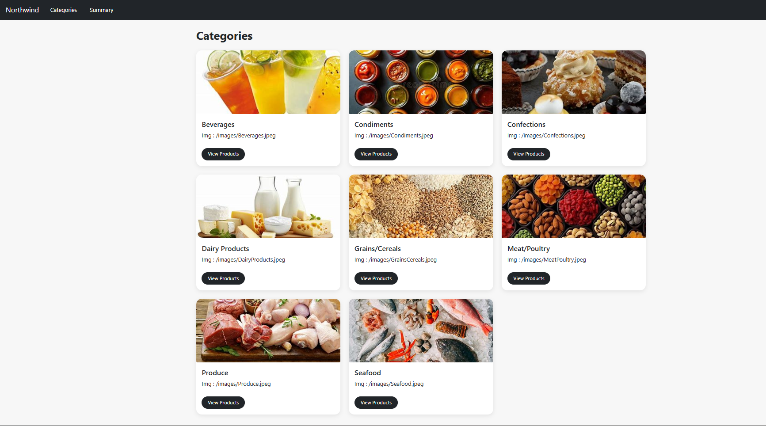

Product Detail Page:

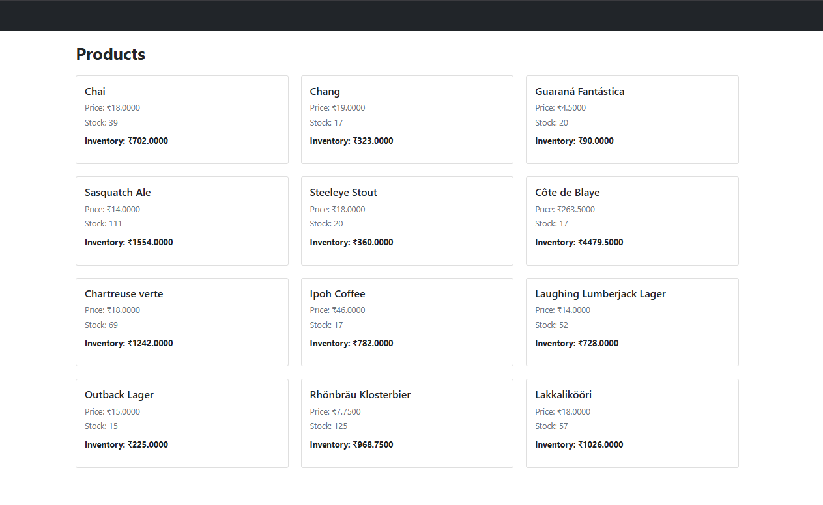

Summary Page:

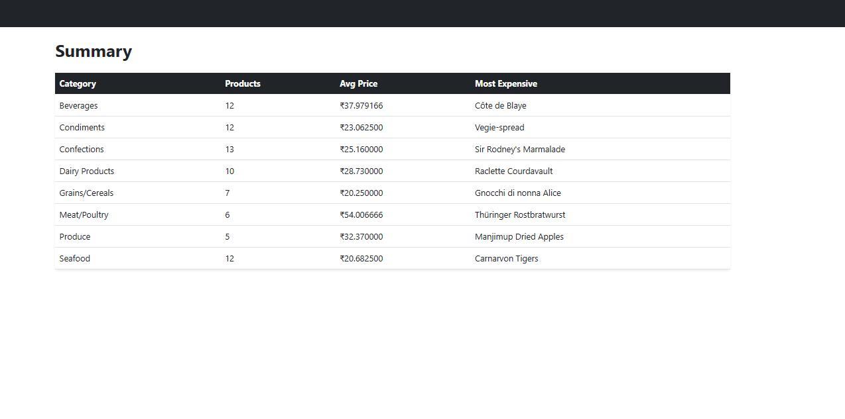

Testing:
