Upon running the index.jsp file on the server

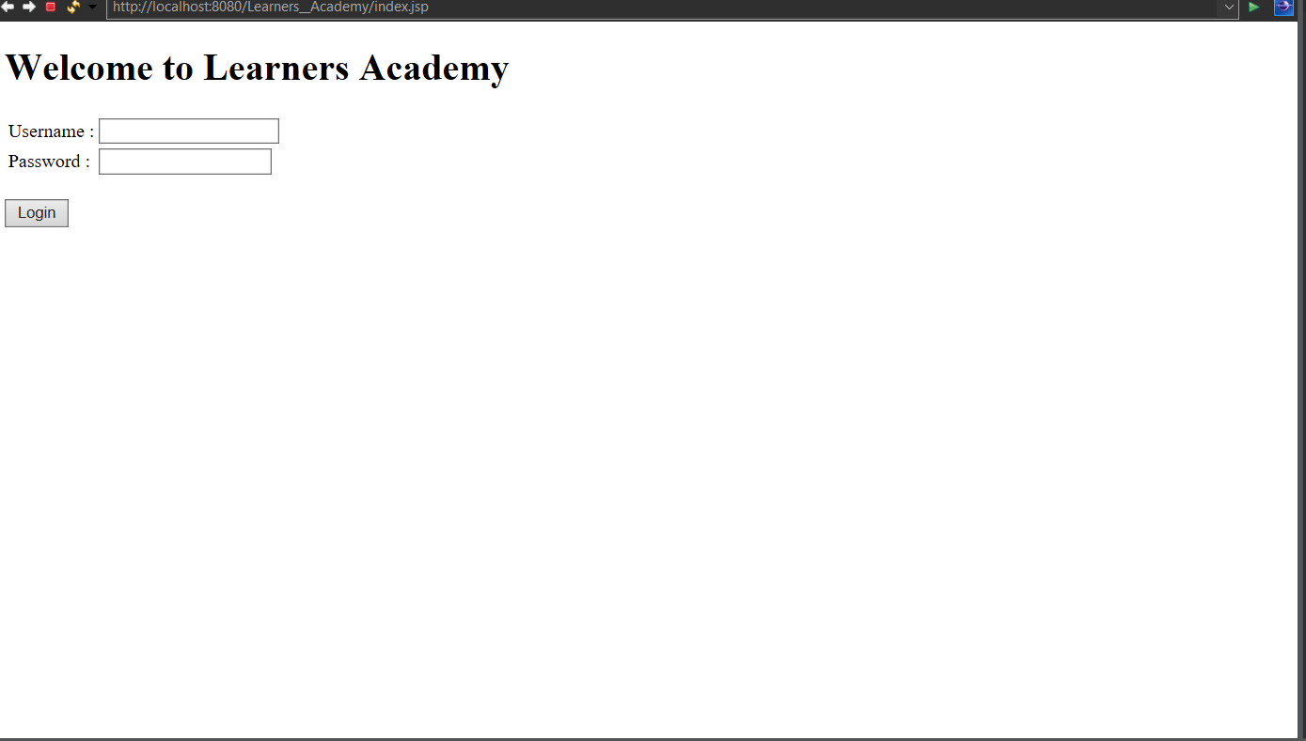

Username and Password are mandatory fields.

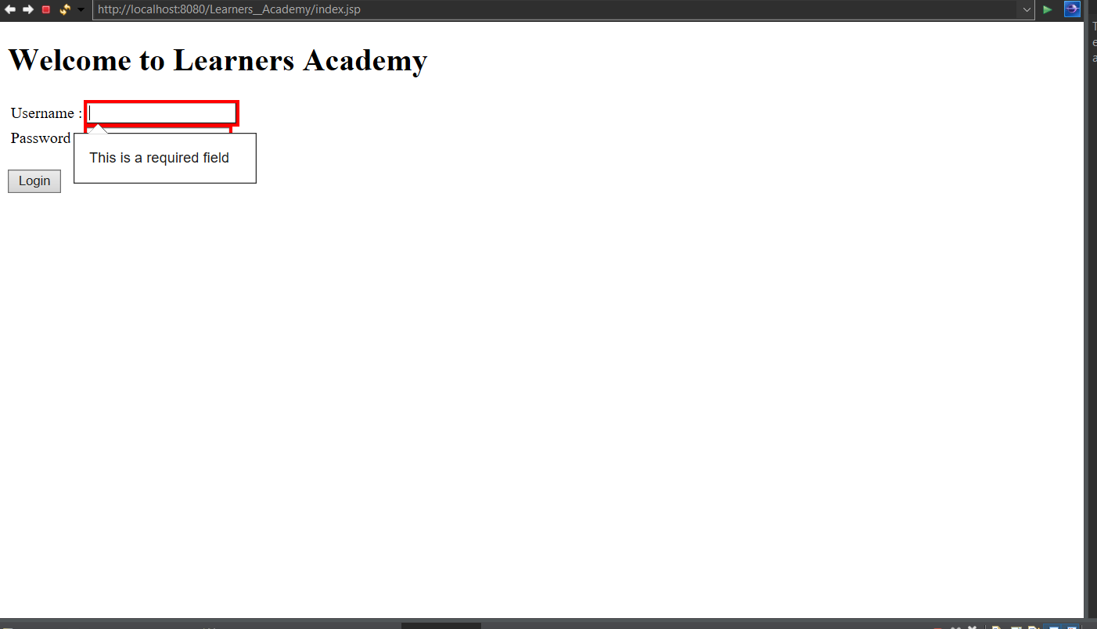

If username and password is wrong

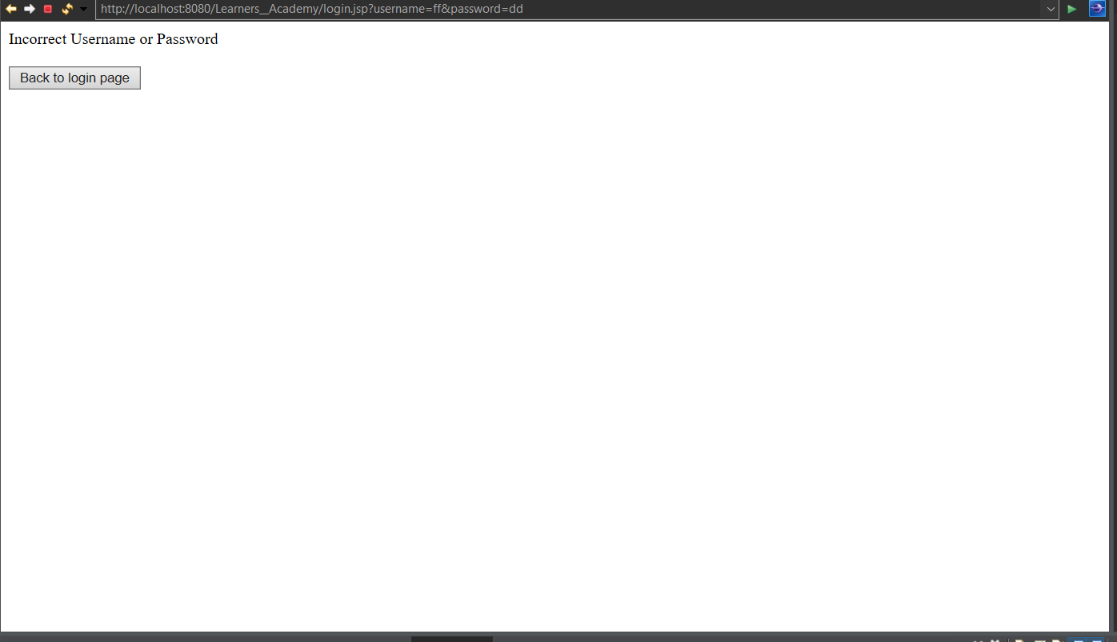

If username and password is correct

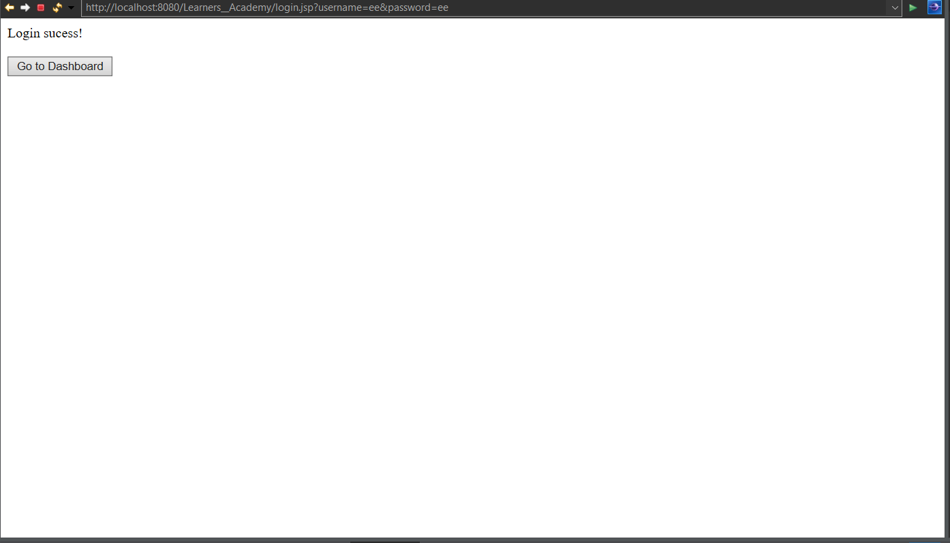

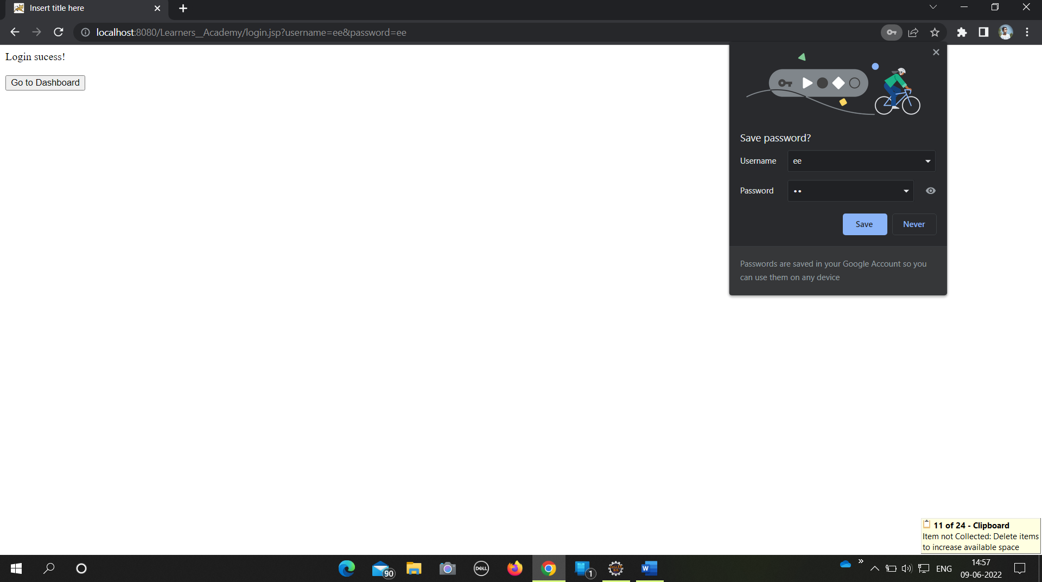

Home screen (after successful login if user click on Dashboard button)

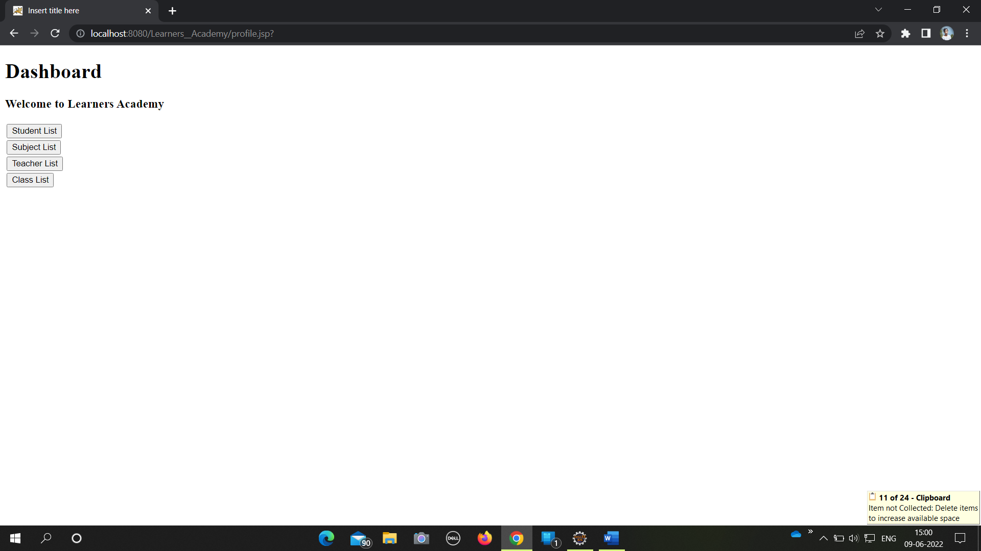

Student Operations

If user click on Student List button , then below List of students will be generate

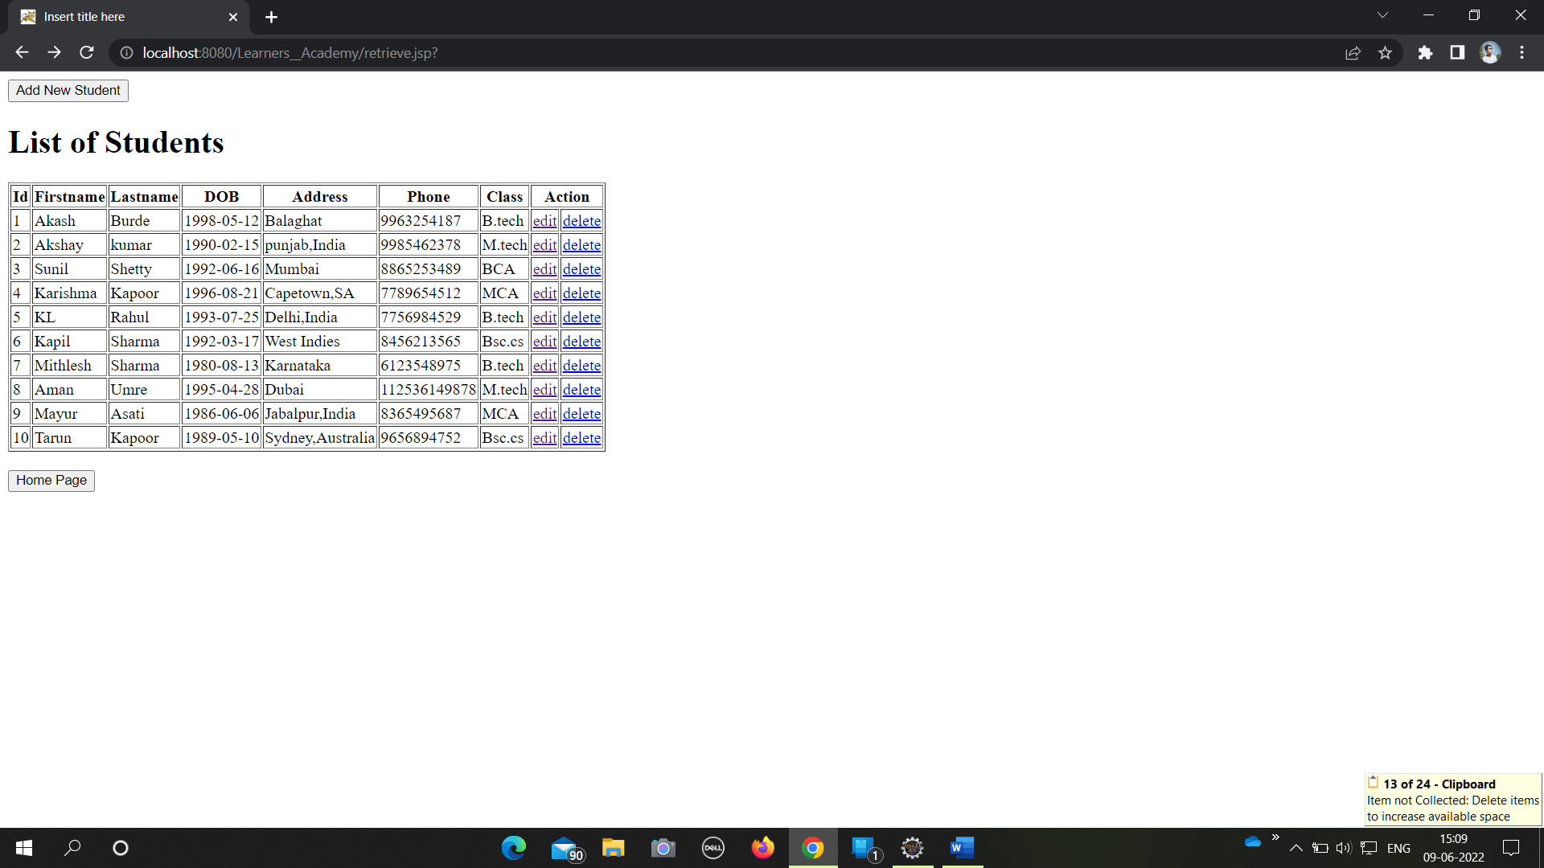

Click on edit to update the Student details.

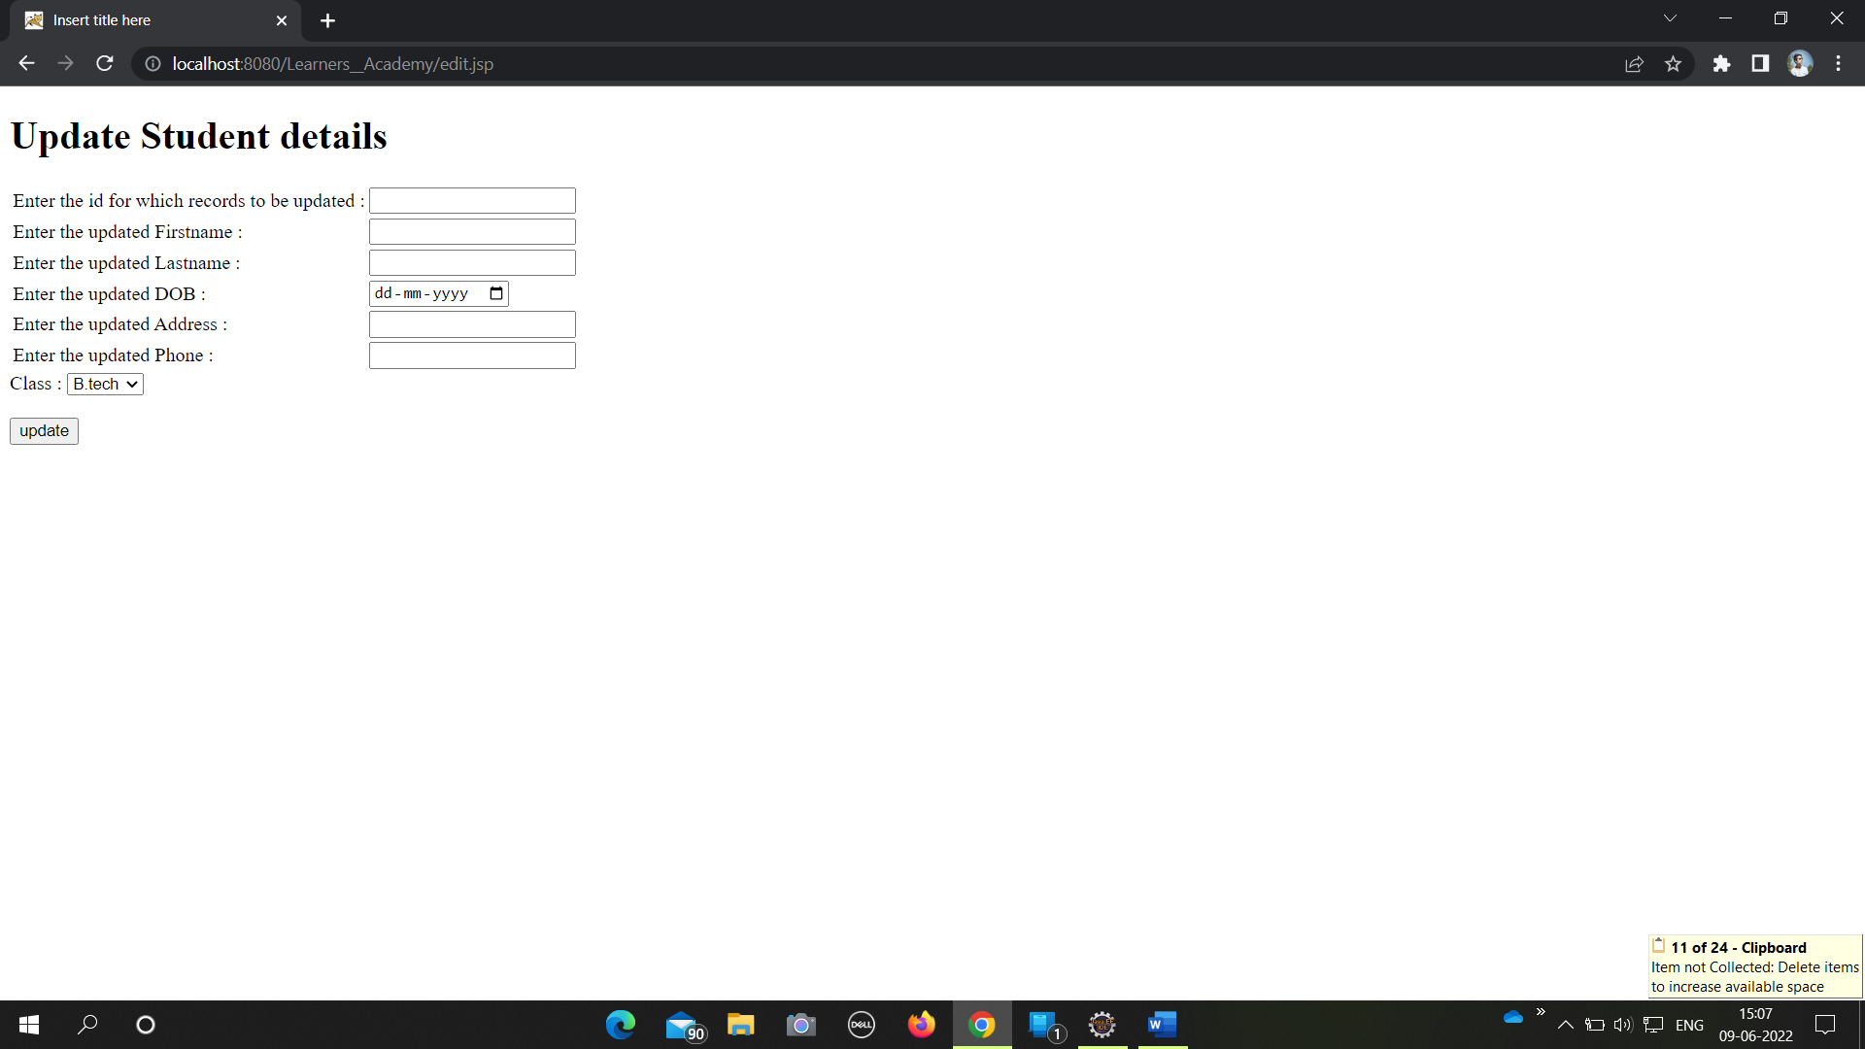

For delete the student details click on delete

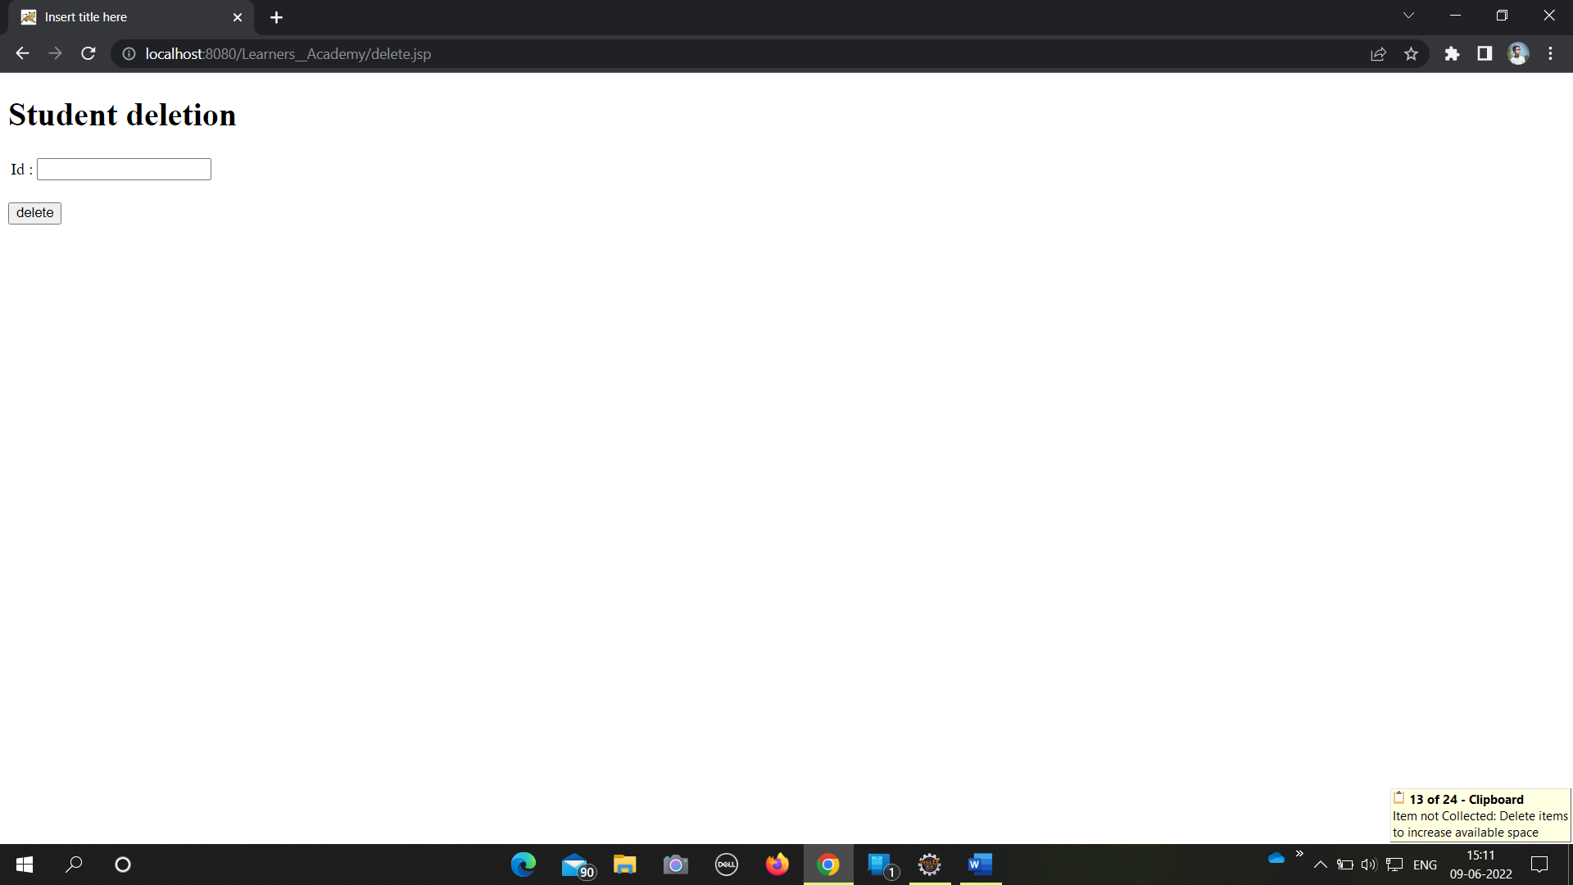

For adding a new student click on (Add new Student).

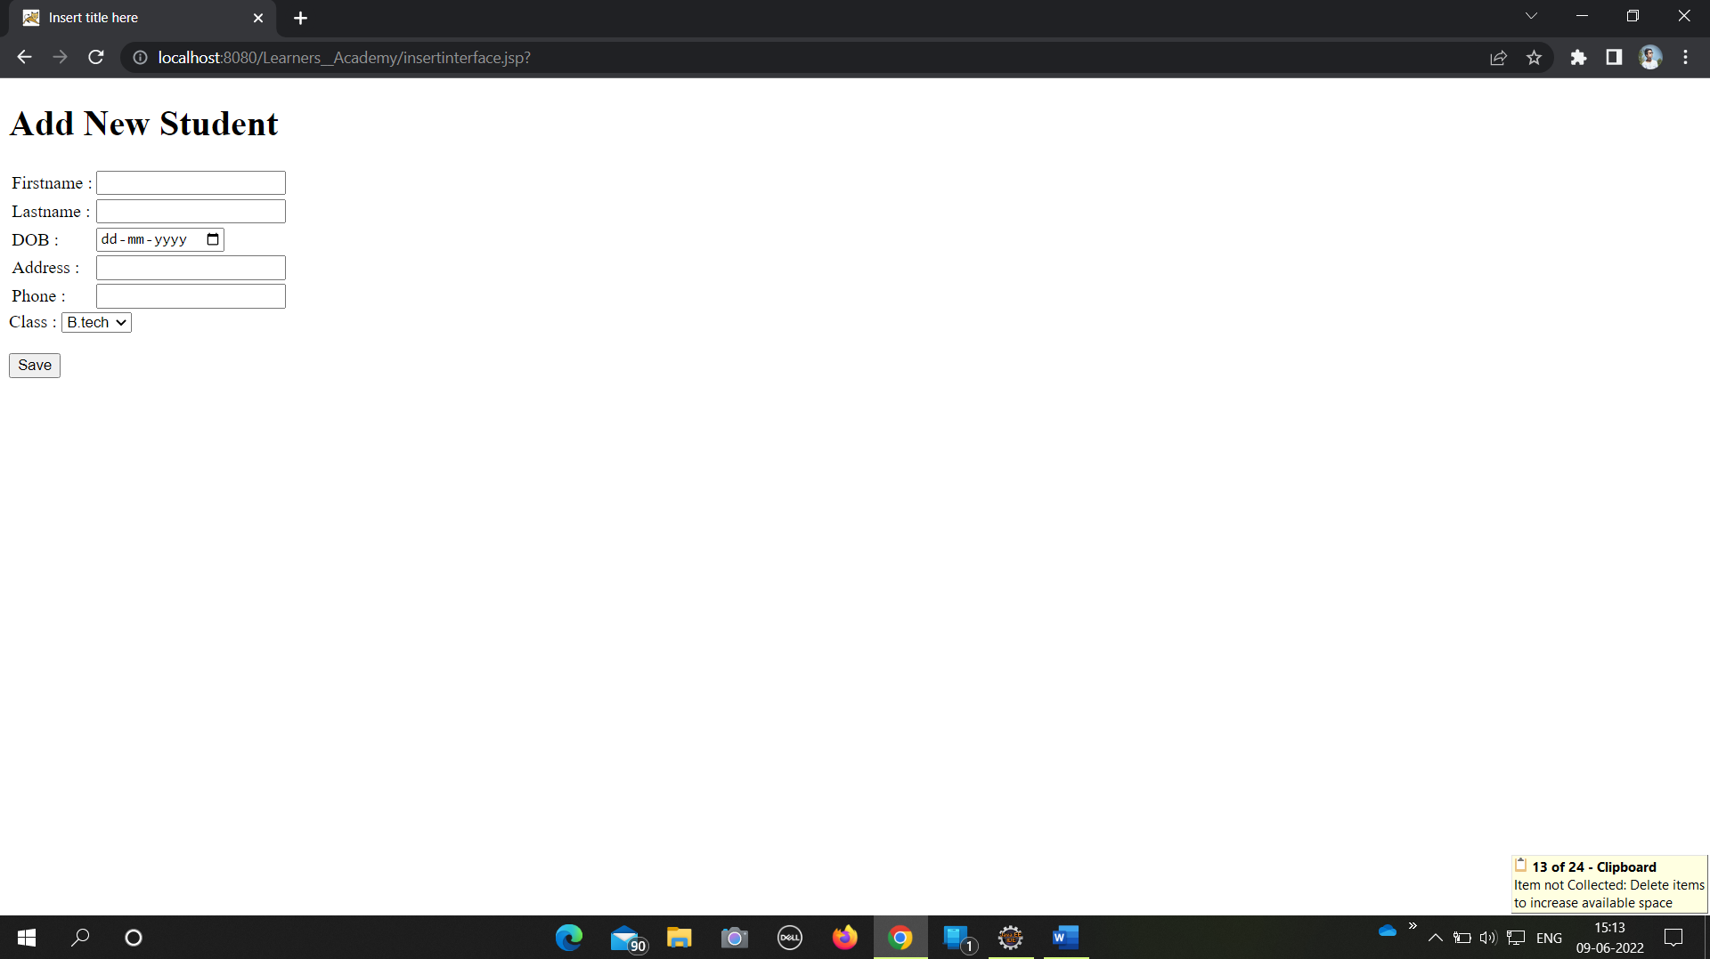

Subject Operations

If user click on subject list button from the dashboard , then below list of subjects will be generated.

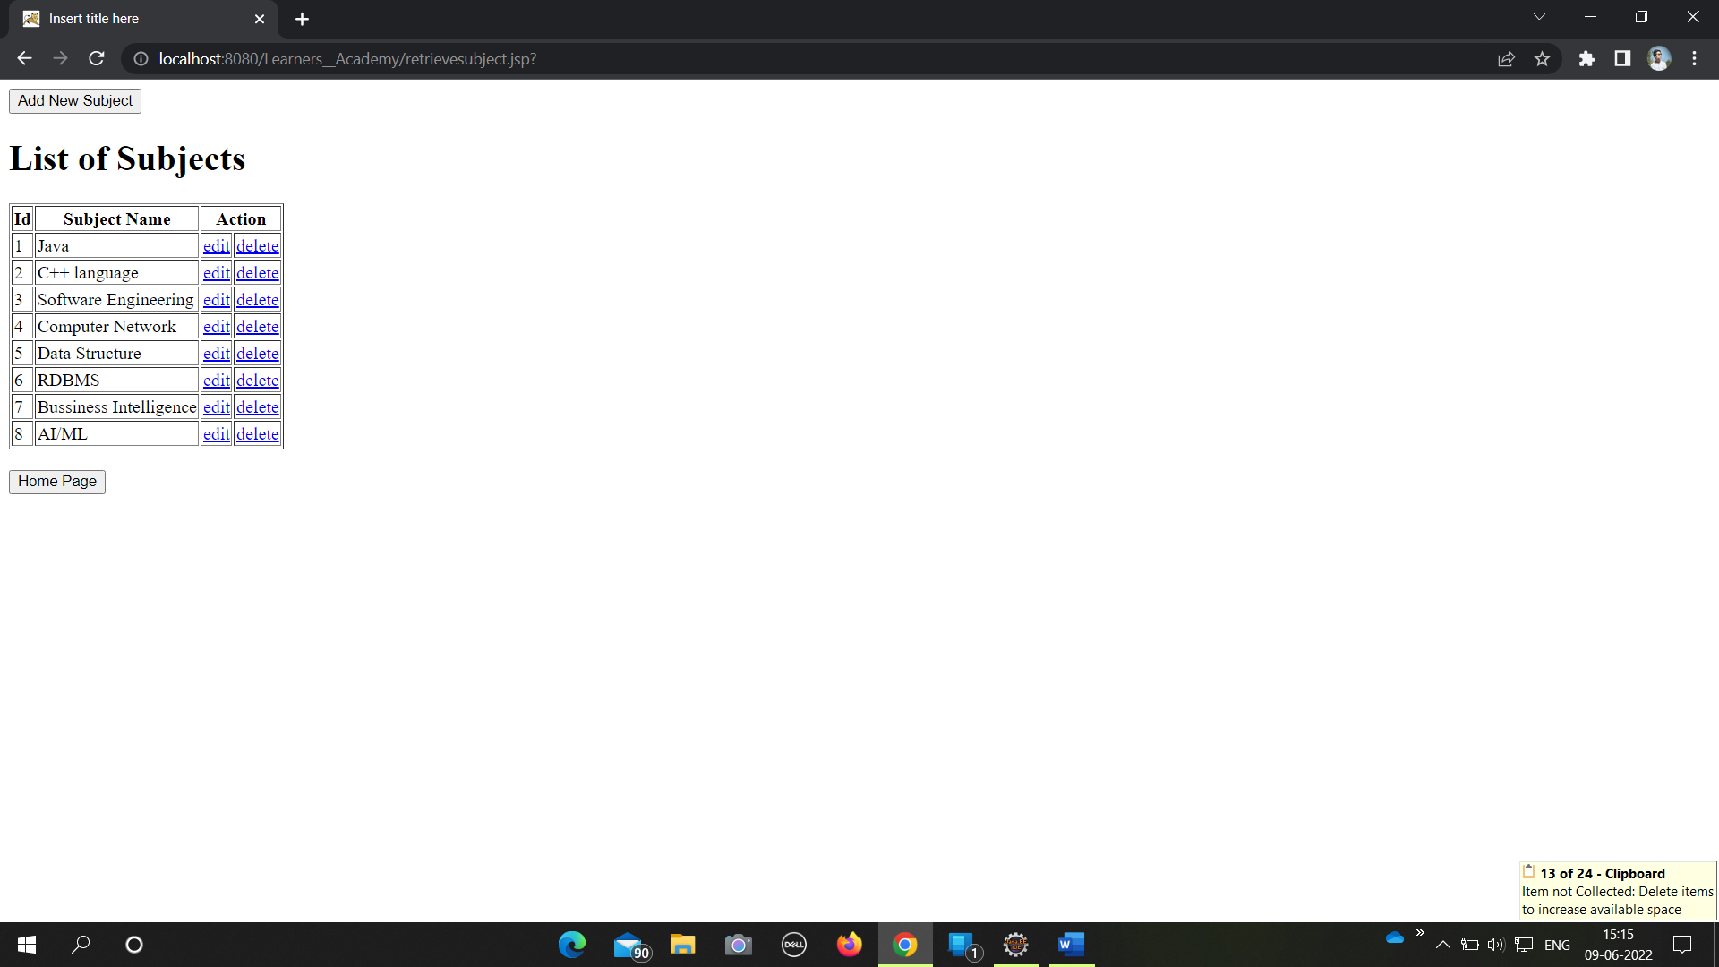

For update the subject details click on edit.

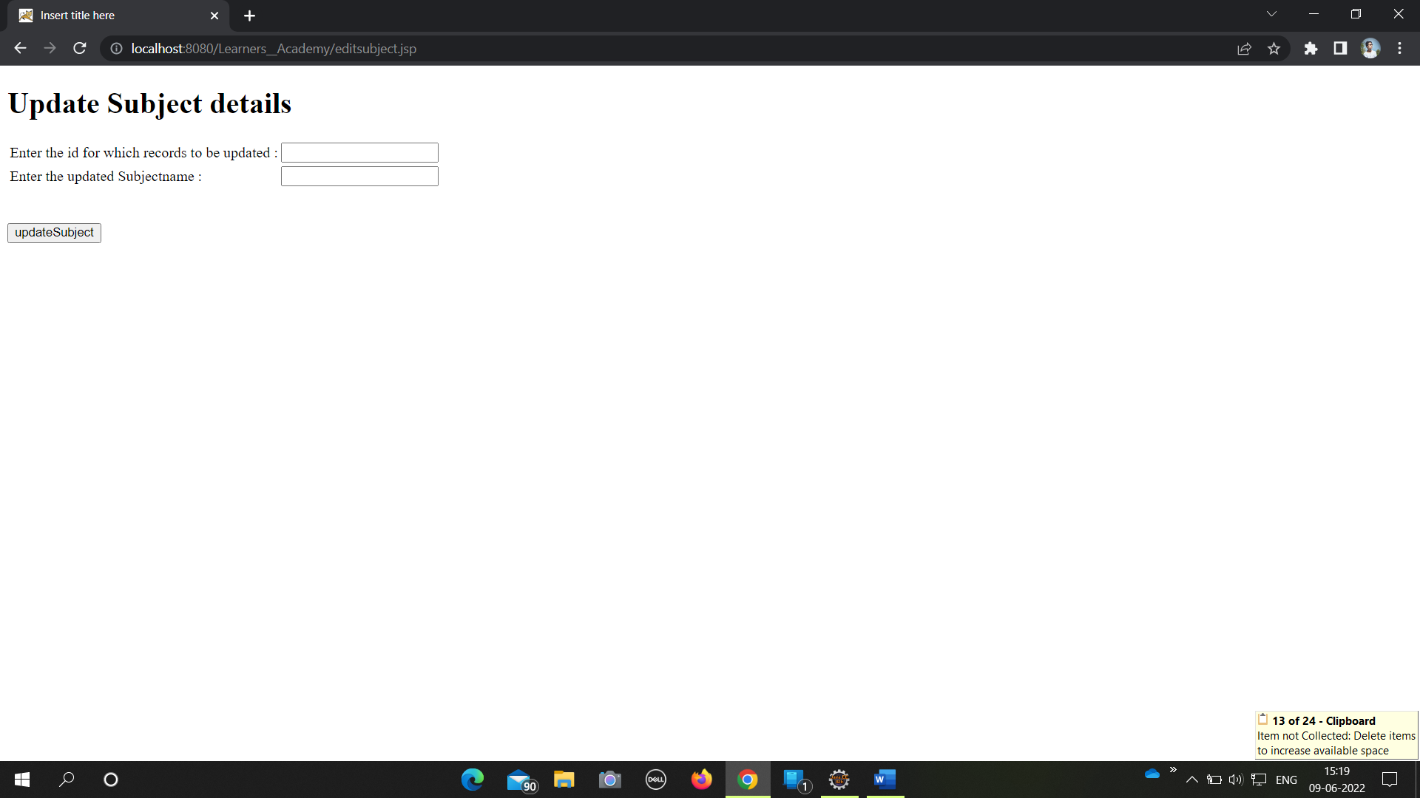

To delete the subject click on delete

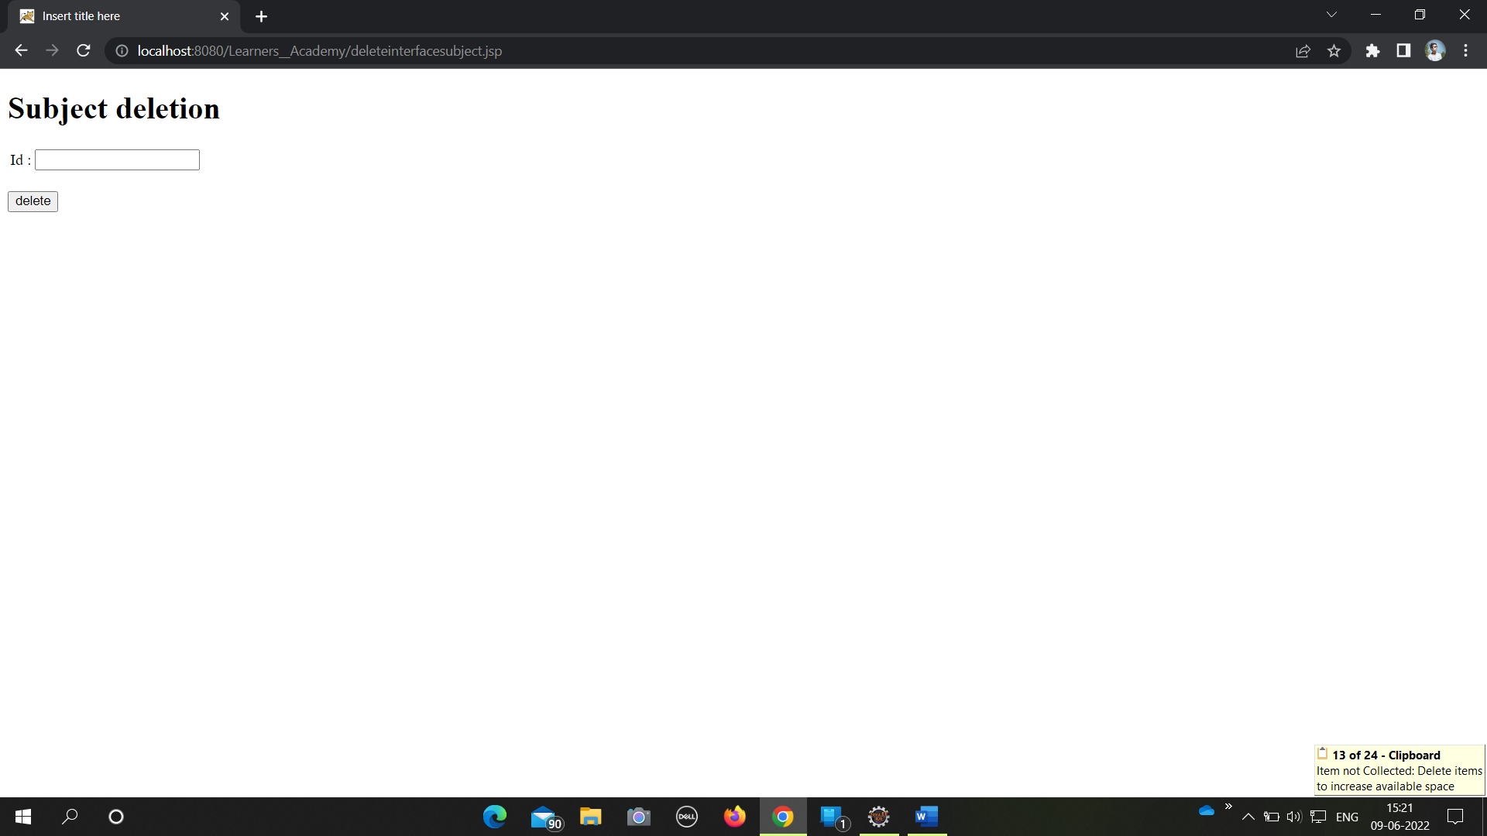

For adding a new subject click on (Add new Subject).

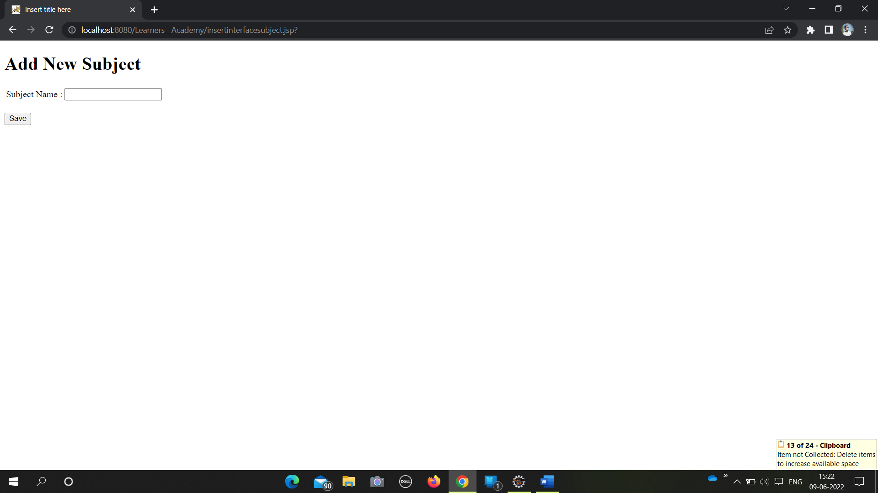

Teacher Operations

If user click on Teacher list button from the dashboard , then below list of teachers will be generated.

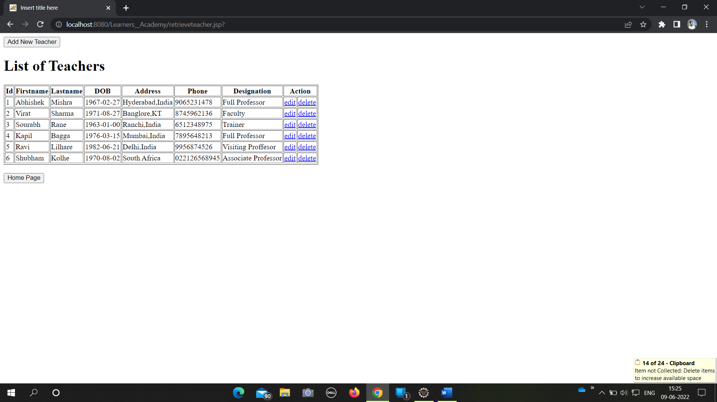

Click on edit to update the teacher details.

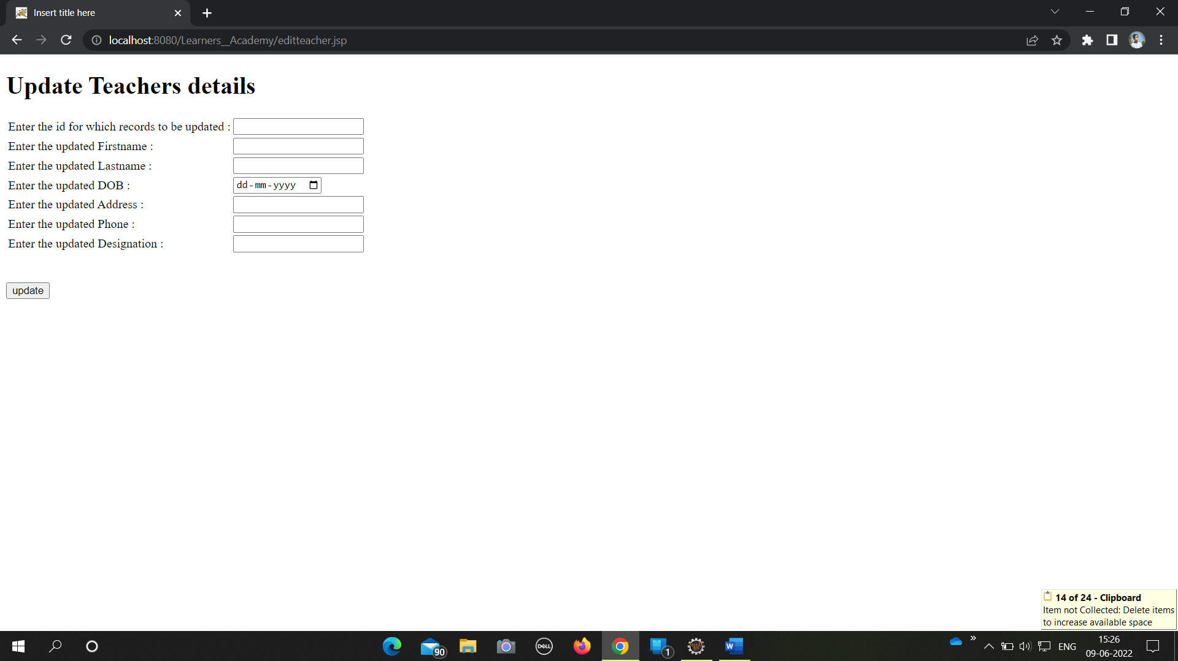

Click on delete to delete the teacher details.

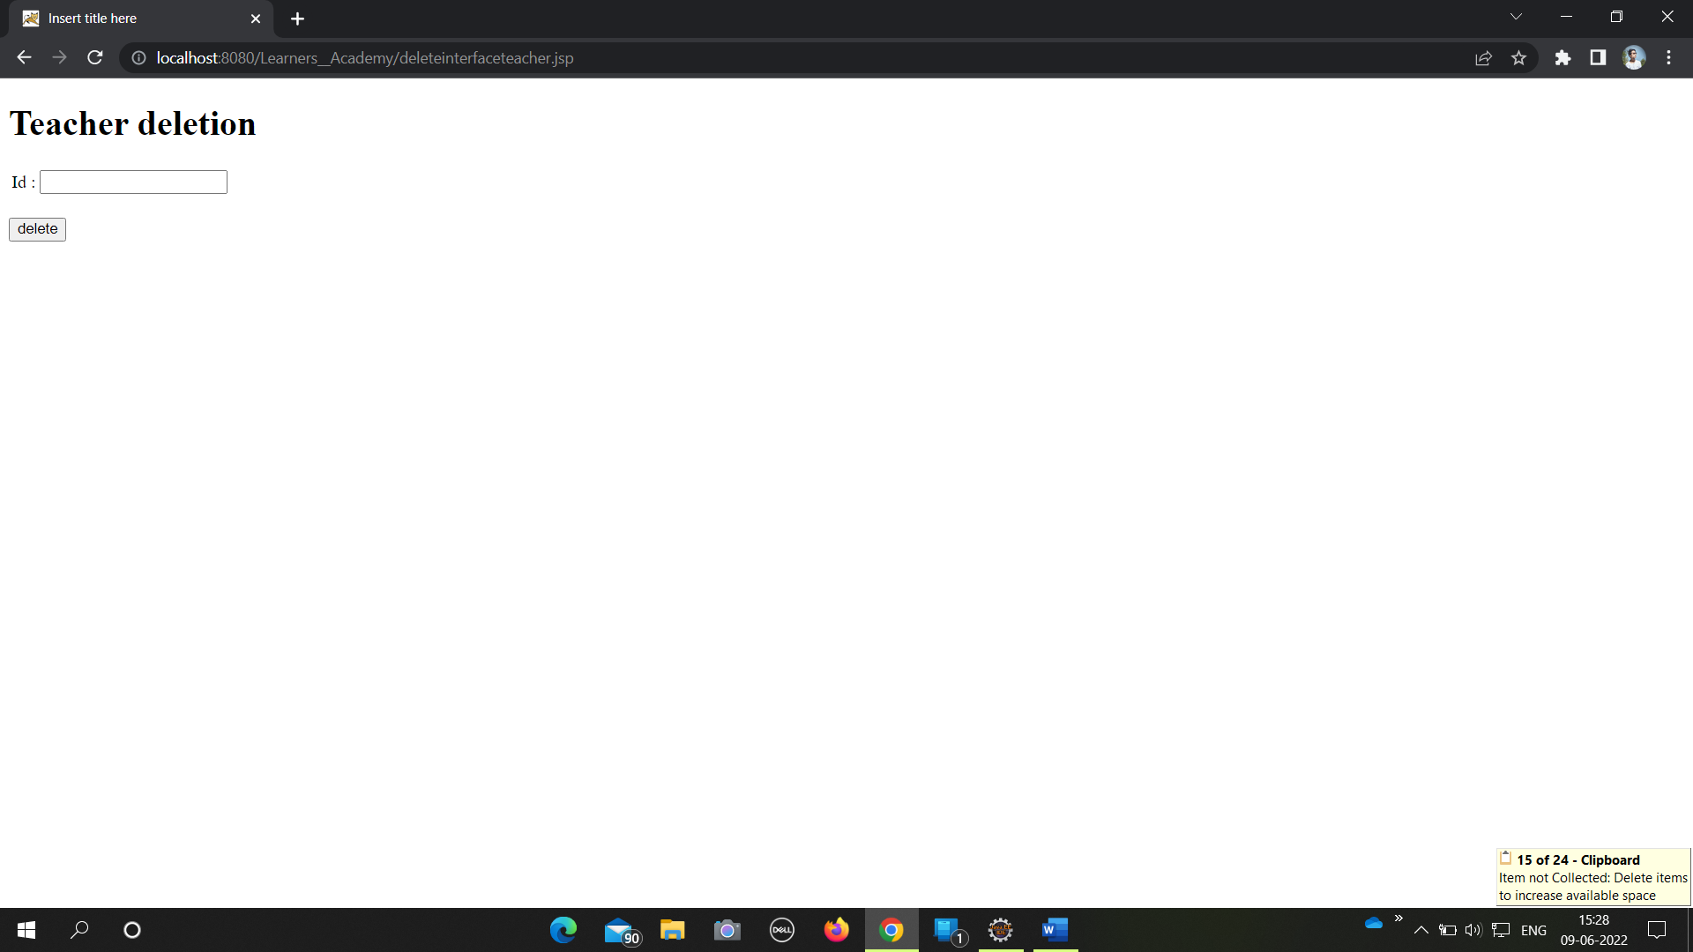

For adding a new techer record click on (Add new Teacher).

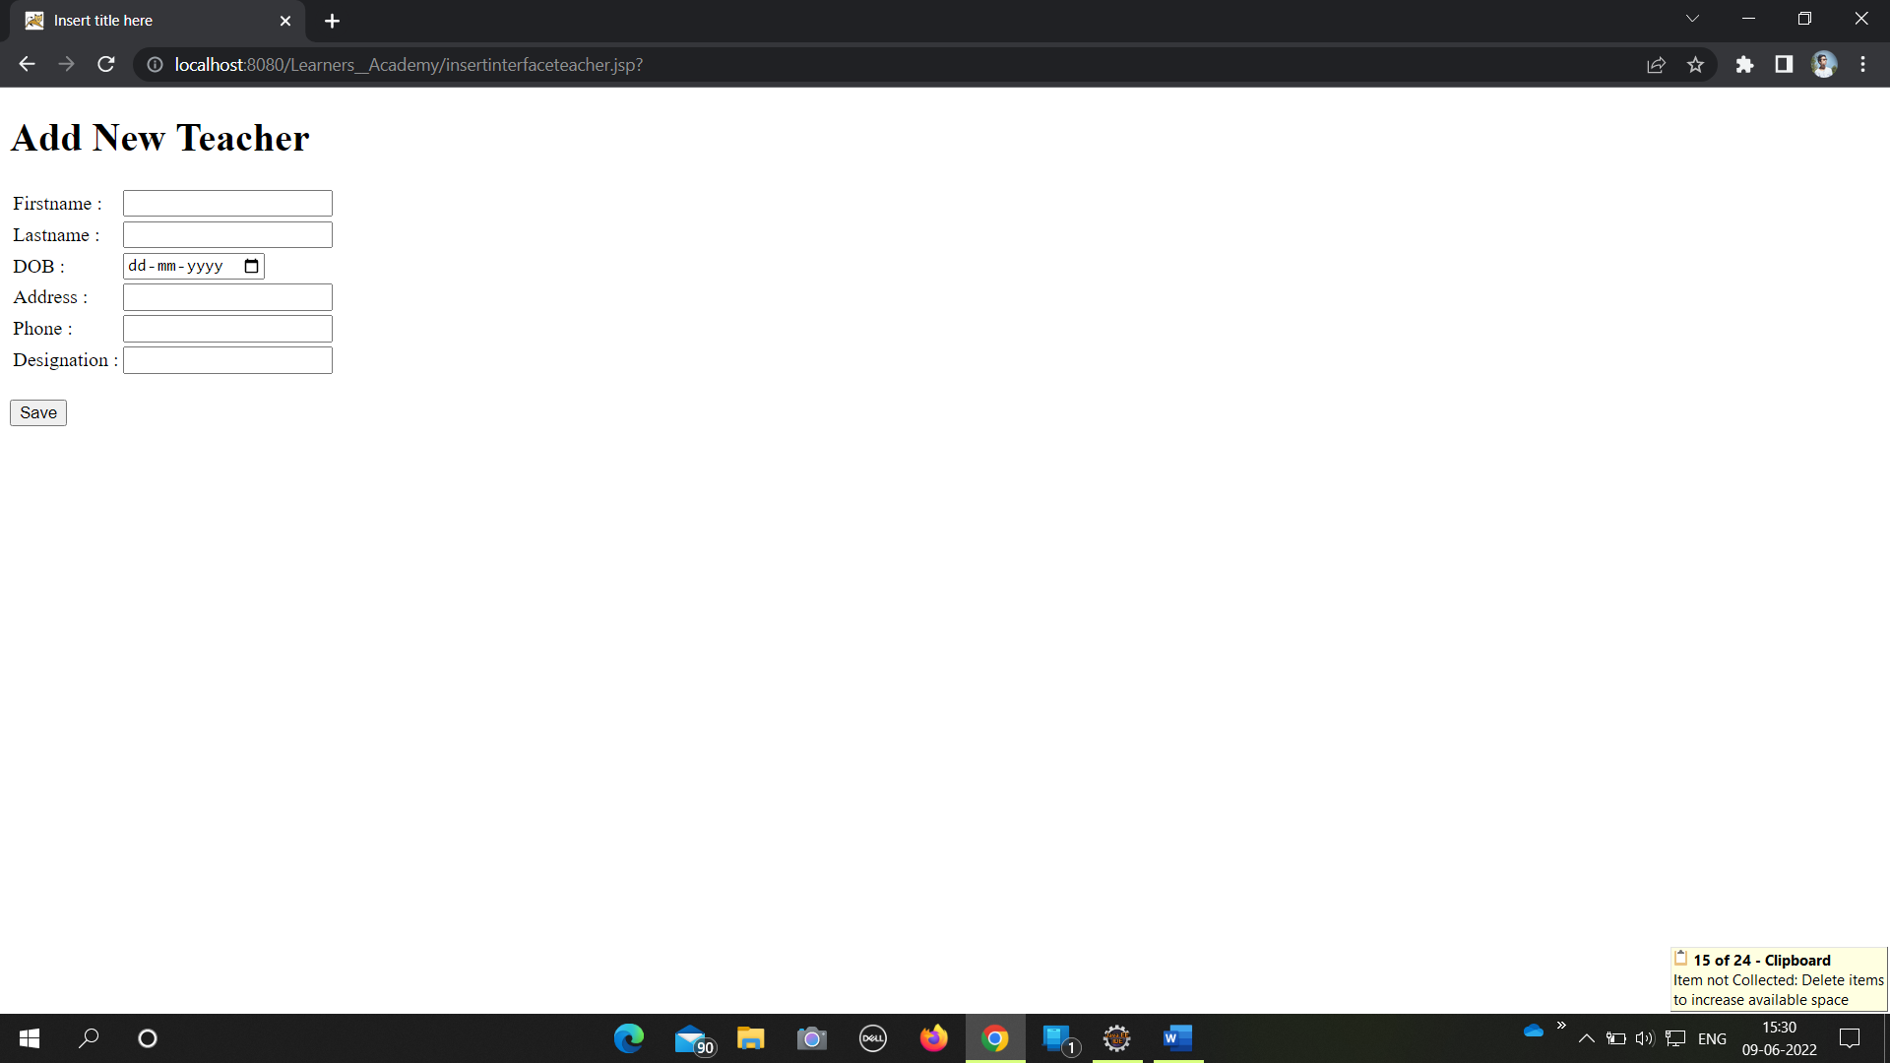

Classes Operations

If user click on Classes list button from the dashboard , then below list of classes will be generated.

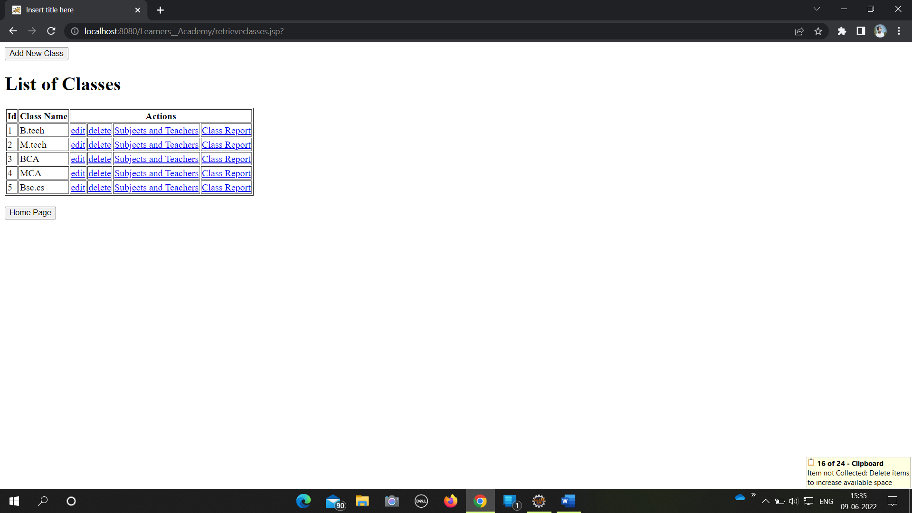

For update classes details click on edit.

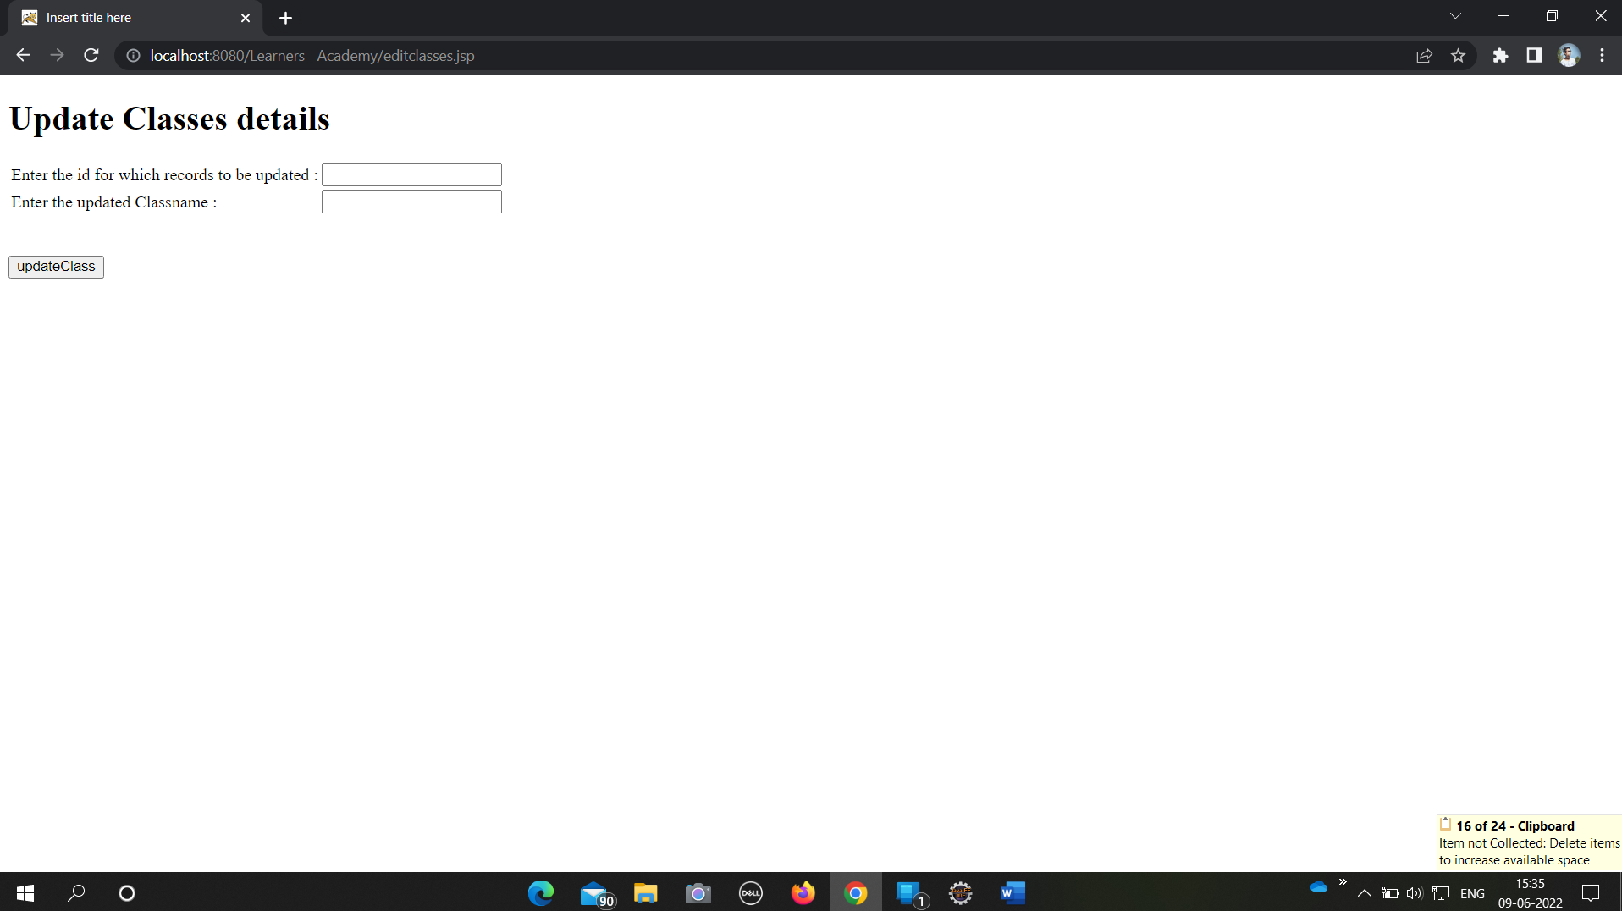

For delete classes record click on delete.

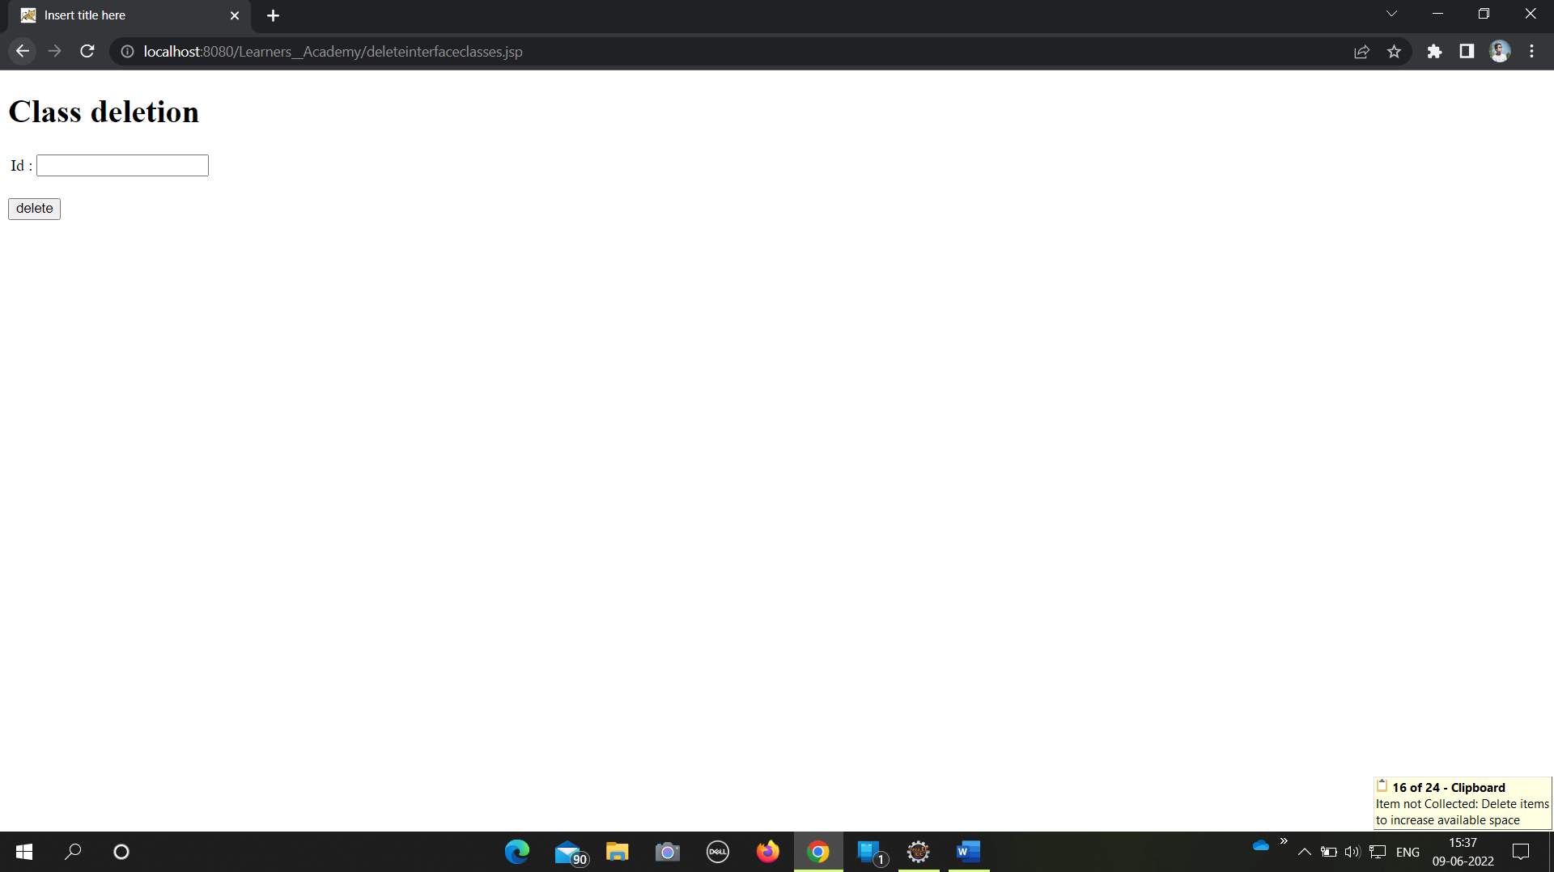

Subjects and Teachers assigned to a particular class

On the list of classes screen, if user click on Subject and Teachers then it will ask for the class name.

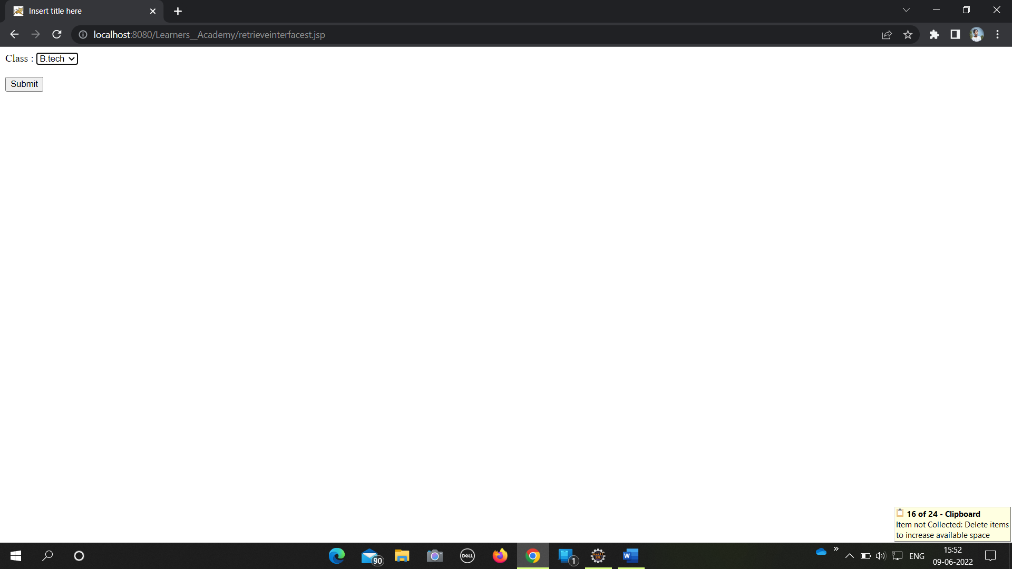

On selecting the class name , below List of subject and teachers for that class will be generated.

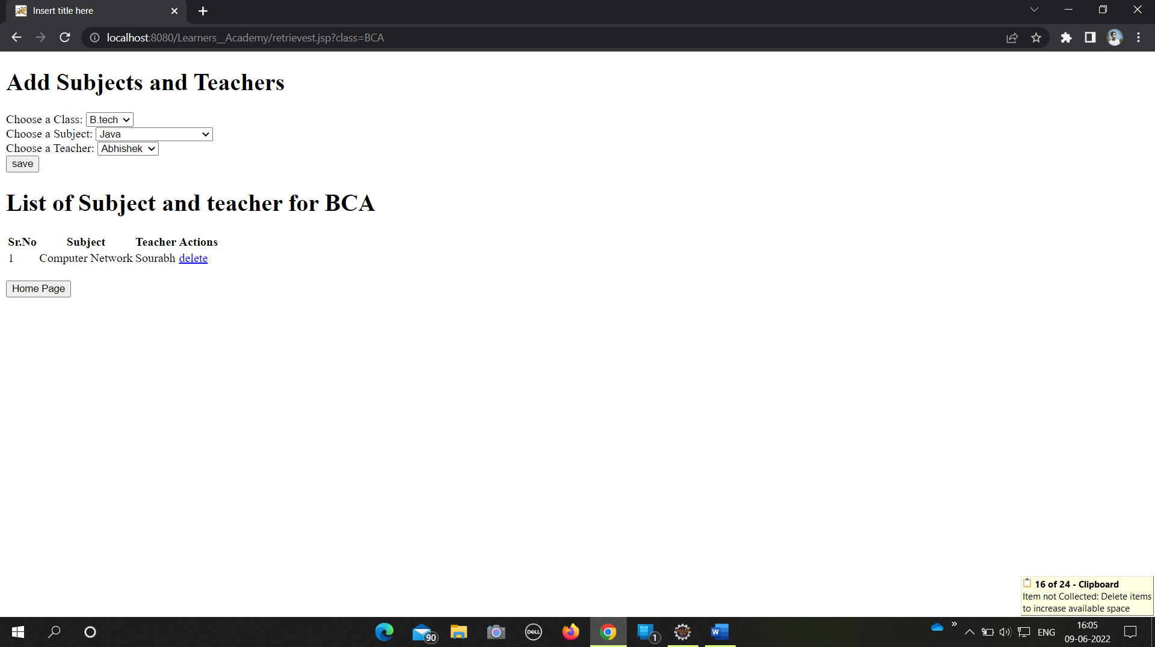

Class report

On list of classes screen, if user click on Class report , then below class report for that particular class will be generated.

