Developing a Backend Admin for Learner’s_Academy.

Project details: A backend administrative portal for the Learner’s Academy.

Developers details: *Akash Burde (*[*akash217burde@gmail.com*](mailto:akash217burde@gmail.com)*)*

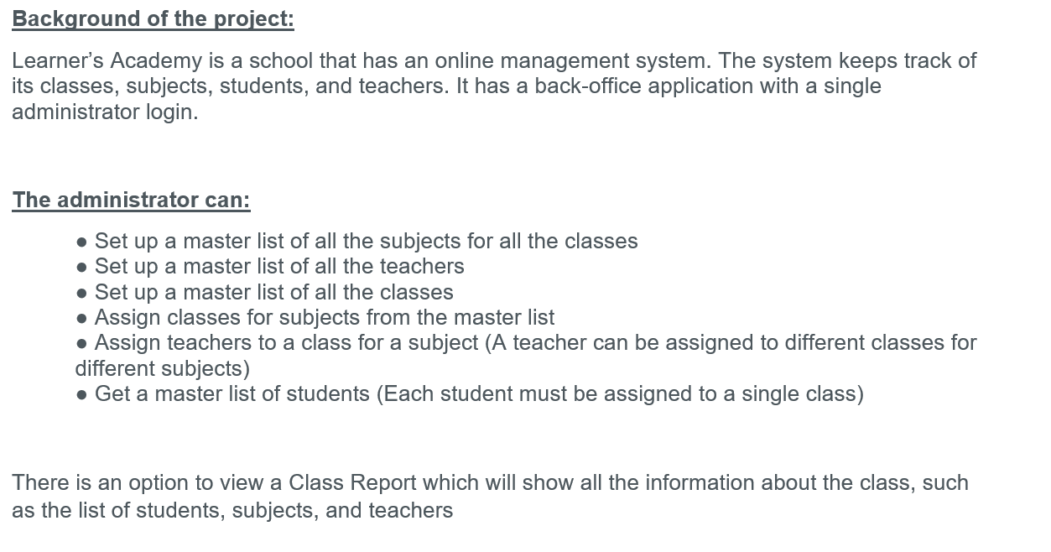

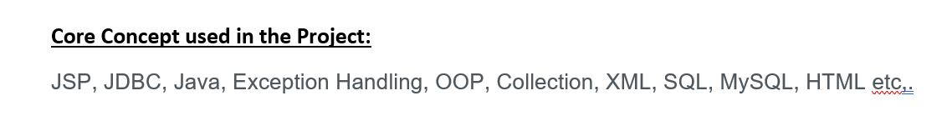

Github

Github Link : (<https://github.com/Akash12burde/Learner-s_Academy_phase_2>)

