PROJECT NAME

**SportyShoes.com**

***Developer Detail’s:***

**Developer Name:** Akash Burde .

**Email ID:** akash217burde@gmail.com

**Project Start Date:**28 june 2022

**Project End Date:**6 july 2022

***Used Technologies:***

* **Framework:** Spring Boot,Bootstrap, Hibernate.
* **For Frontend:** HTML, CSS, JSP, JavaScript.
* **For Backend :** Java, JPQL, SQL, Servlet,
* **Database :** MySql Workbench.
* **Testing Tool :** postman & Junit Testing.
* **IDE:** Spring Tool Suit(STS) Version:4.14.1

**Task for This Project:**

1. Admin can manage the website .
2. Administrator login is required for login .
3. Manage the product’s in store .
4. Categorize the Product’s .
5. Admin can List the all Sign Up User’s .
6. Admin can Search all sign up User’s .
7. Admin can see Report Filtered by purchase Date.

(Time Given for Task**:** 7 Day’s)

**Completed Task:**

* Admin can manage the website[Done]
* Administrator login is required for login[Done]
* Manage the product’s in store[Done]
* Categorize the Product’s[Done]
* Admin can List the all Sign Up User’s[Done]
* Admin can Search all sign up User’s[Done]
* Admin can see Report Filtered by purchase Date. [Done]

(Task Completed in Time**:** 9 Day’s)

**Introduction:**

This is my Simplilearn Phase-3 Project, this project mainly focus on Online Shoes Shopping. In this project we have 25 Module’s.

This project help’s for Shoes Shop owner to Sell their products online and Customer can buy this product’s online with full security.

For purchase this product User must be Sign-Up and then login with same credentials’, after this User can able to buy any product from this web site which is present in this website.

User also can see his Order list, Can add into the cart, etc. then user can logout .

**User Module’s Start:**

**Module No -- 1].**

This is first page of website this page can access anyone who comes on website.

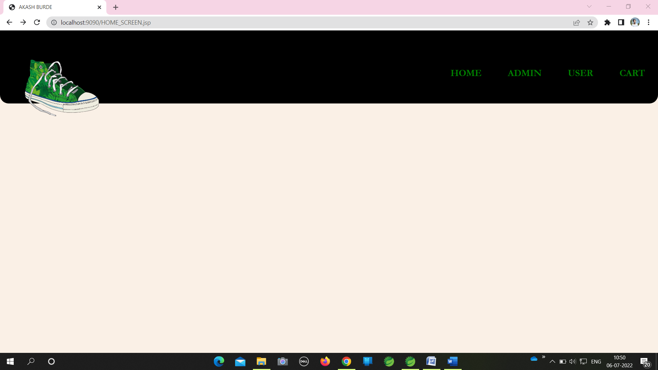

**Module No -- 2].**

When any new user comes on this website he/she need’s to register our self on this portal like user comes on home page first then click on **“User”** then he/she goes on next page.

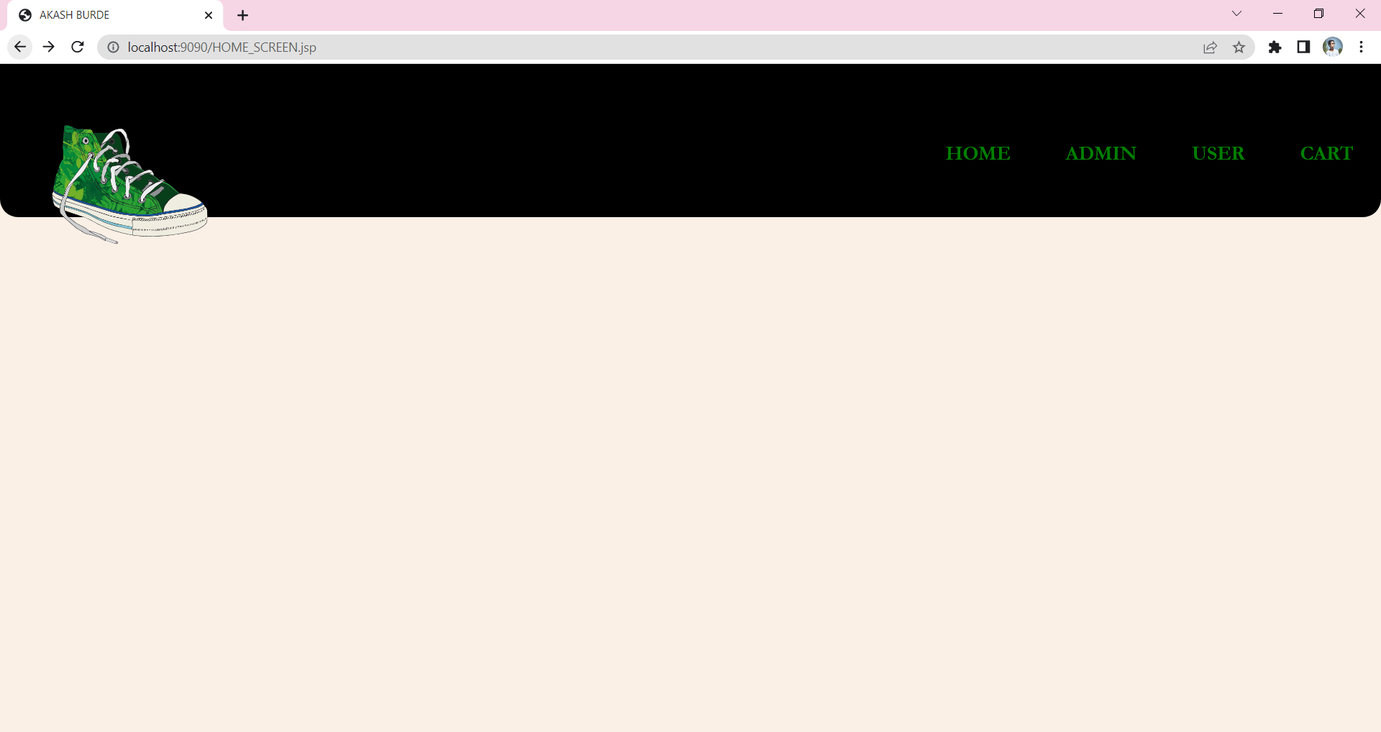

**Module No – 2.1]**

In this module “USER” must be register for further process like Purchase Product, etc. User click on **“REGISTER”** then next page will open.

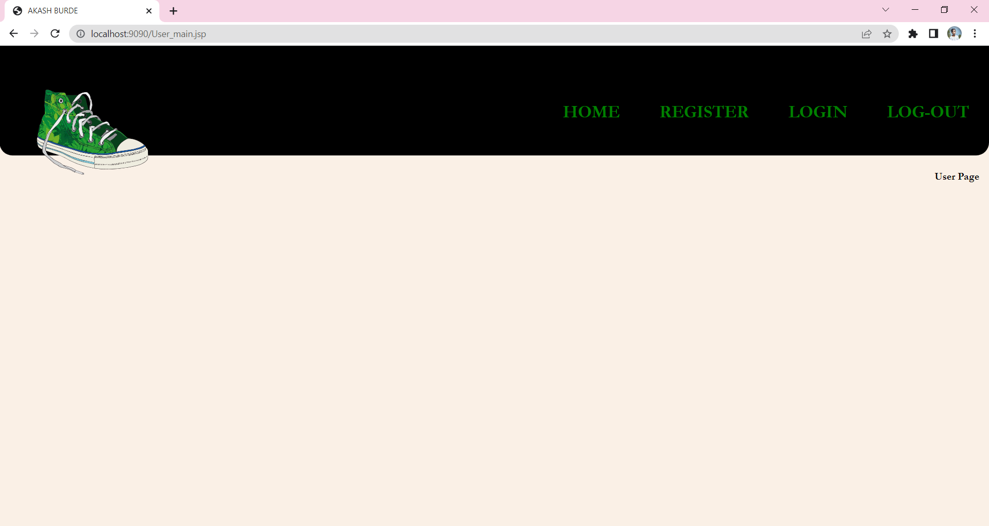

**Module No – 2.2]**

In this page User provide basic detail’s for Registration, after filling this detail’s Click on **“Register”** then Automatically User Login Credential’s will be created, But Remember First Name and Conform Password (user can forgot password using phone number).

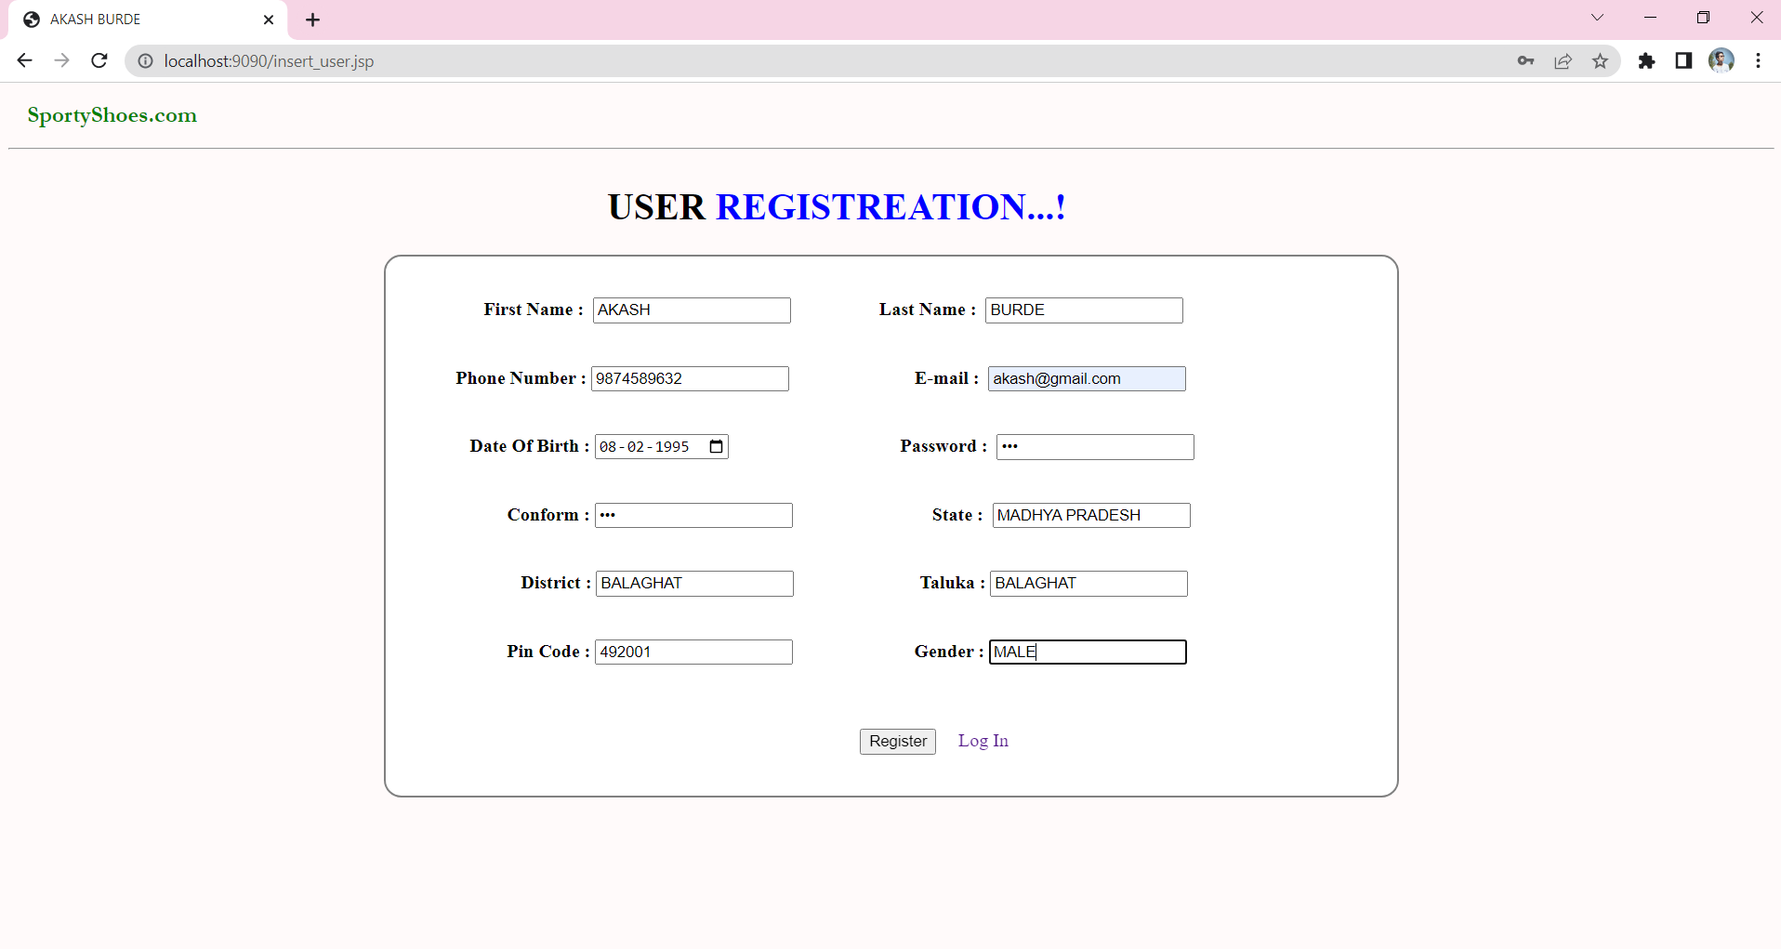 After Successfully registration user get this message-

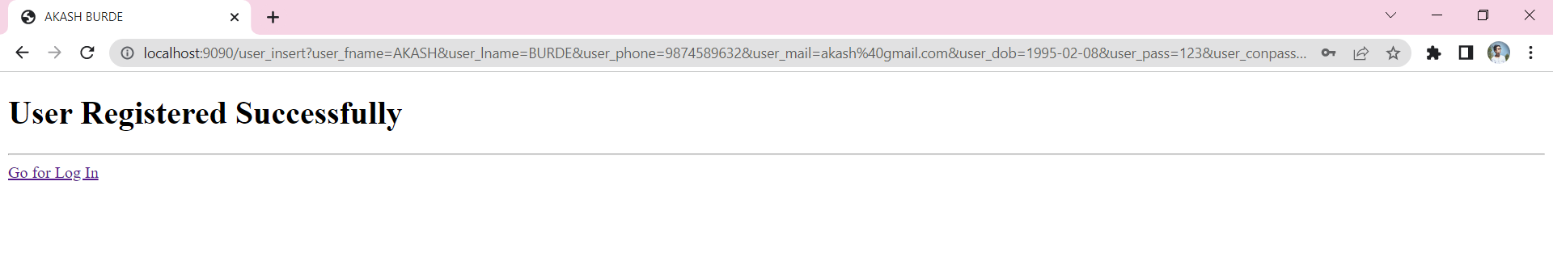

**Module No – 2.3]**

After user successfully registration user automatically Redirect to login page [2.1]. After this user click on **“login”** and go next page.

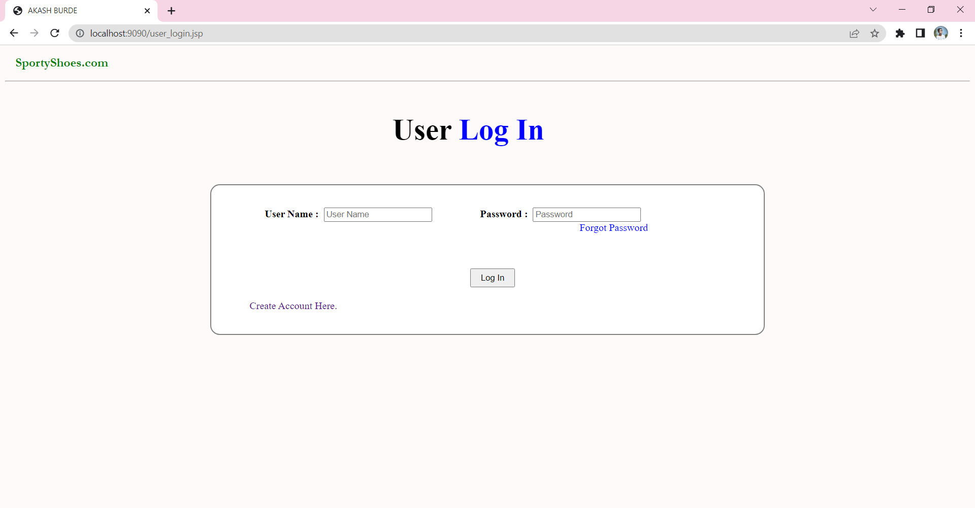

**Module No – 2.4]**

What happen when user forgot his/her password? then user can forget password by using his/her Registered Phone Number by clicking on “Forgot Password”. After click on this following screen will open and put Phone Number and Get your Password Here like**:**

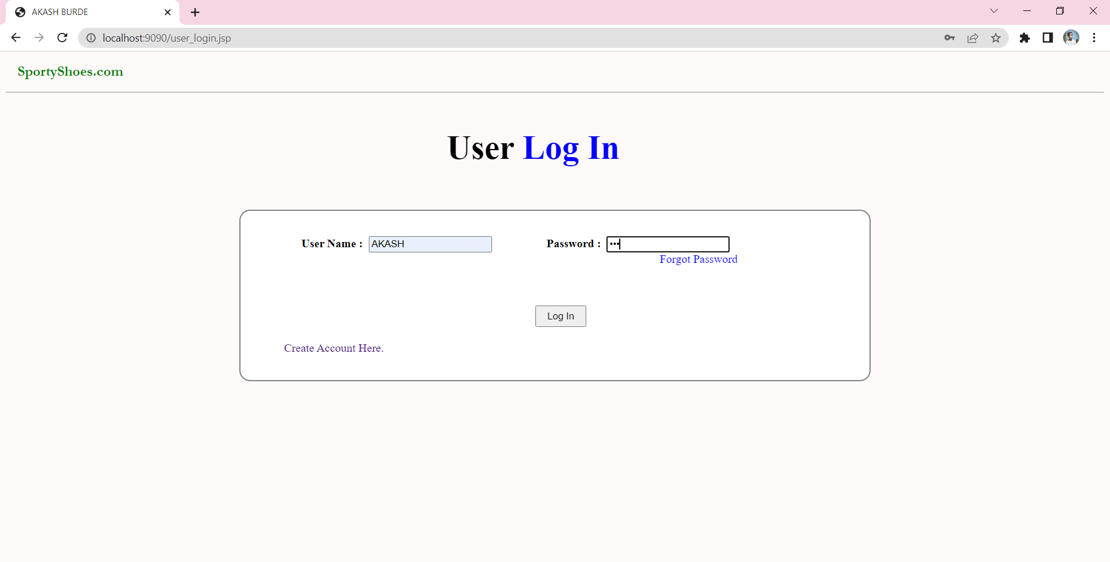

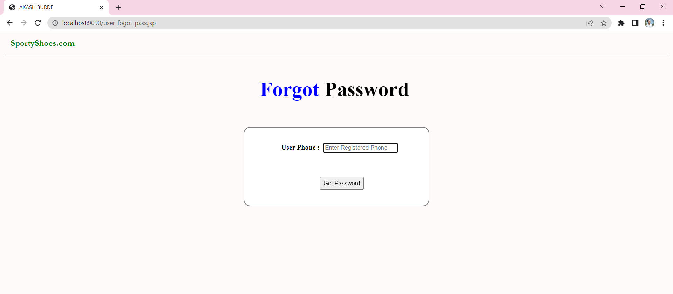

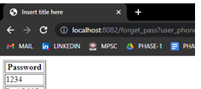

**Module No – 3]**

After user get successfully entered into his home page like following :

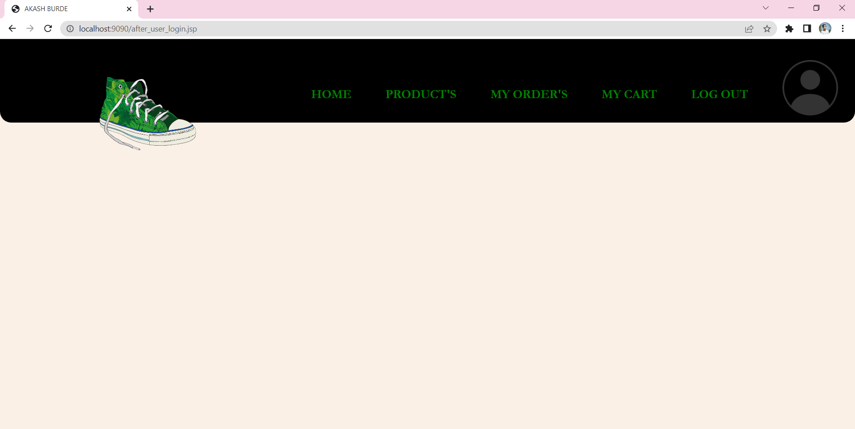 If user want`s to buy or see the product’s then user click on “PRODUCT’S”



**Module No – 4]**

When user want’s to check his order’s then user can click on “ORDER’S” then user will redirect on Order’s page :

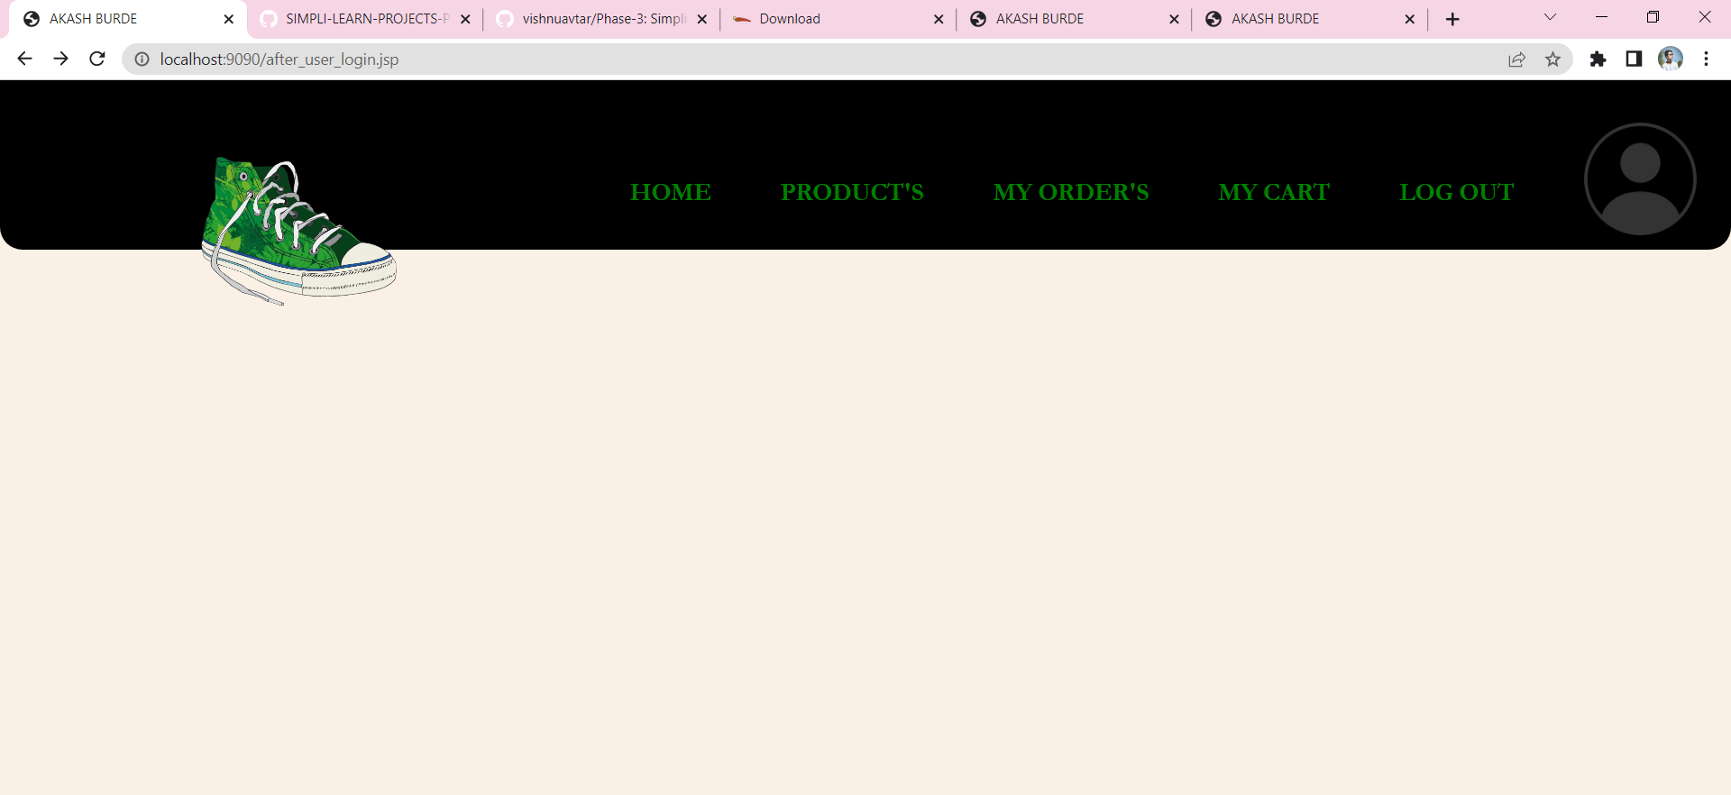

**Module No – 5]**

After user can check his “CART” also by click on cart :



**Module No – 6]**

User can logout from this page by clicking on “LOGOUT” like following :



**Admin Module’s:**

**Module No – 1]**

In admin module firstly admin need to apply for as Admin, In home Page Click on **“Admin”** then next screen will be Visible

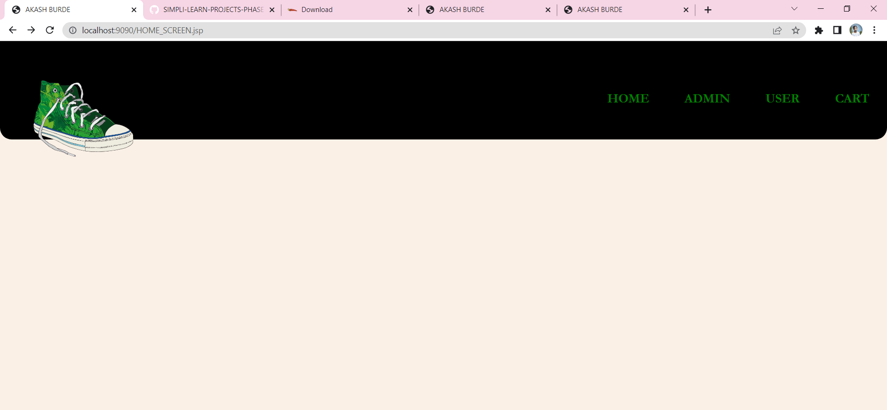

**Module No – 2]**

In this second module User Click on **“Apply”** then second Screen will open then Put here Basic Detail’s for Make Admin.

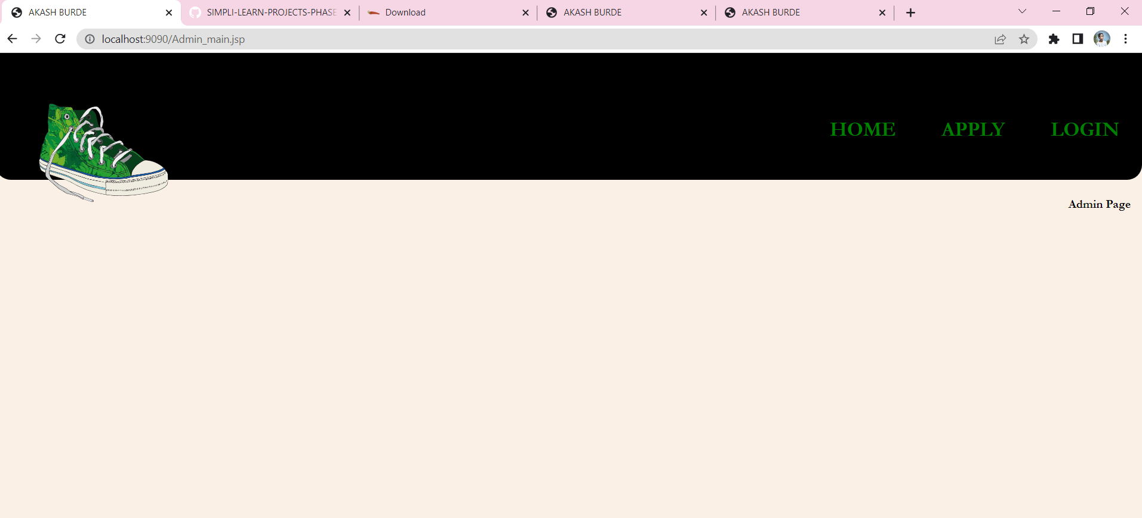

**Module No – 2.1]**

After user come’s on this page User must provide this basic detail’s and hit “Apply” then this Detail’s goes in Database and Now User can Login as a Admin

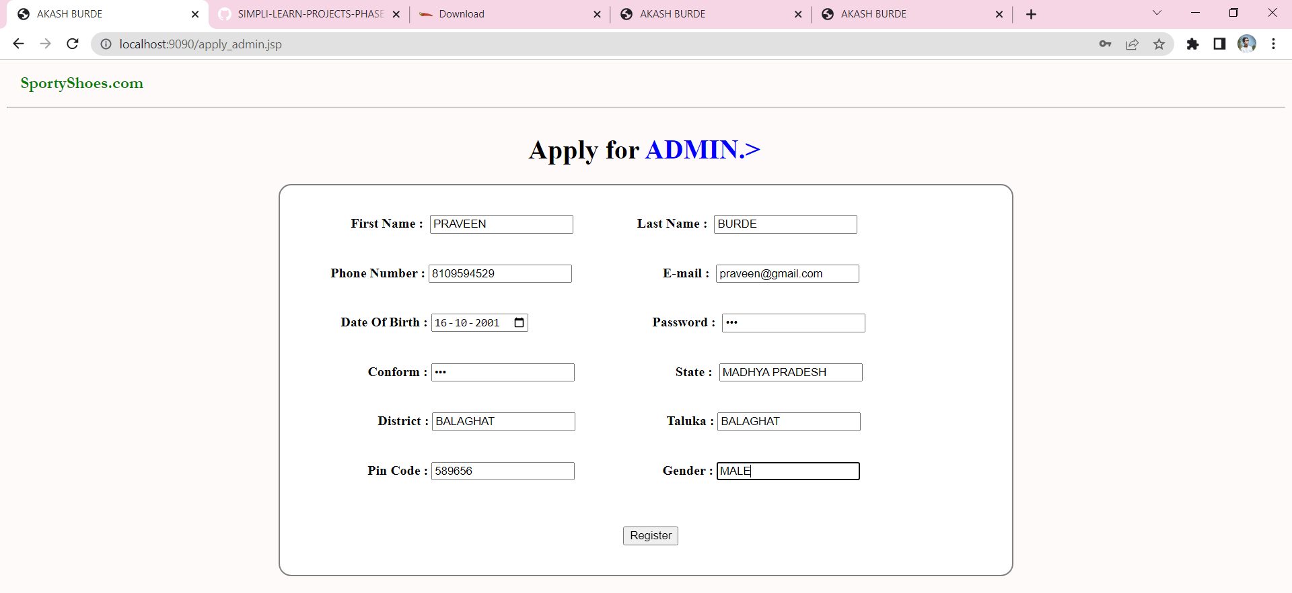

After user Successfully Register they Got following message.

**Module No – 3]**

After User Successfully registered then he will make Admin and Can Login as Admin, After registration User will automatically Redirect on Admin Login Page and Can Access Admin Page using his/her Login credentials’.

After admin gives his/her credentials’ then they will automatically redirect on Another page.

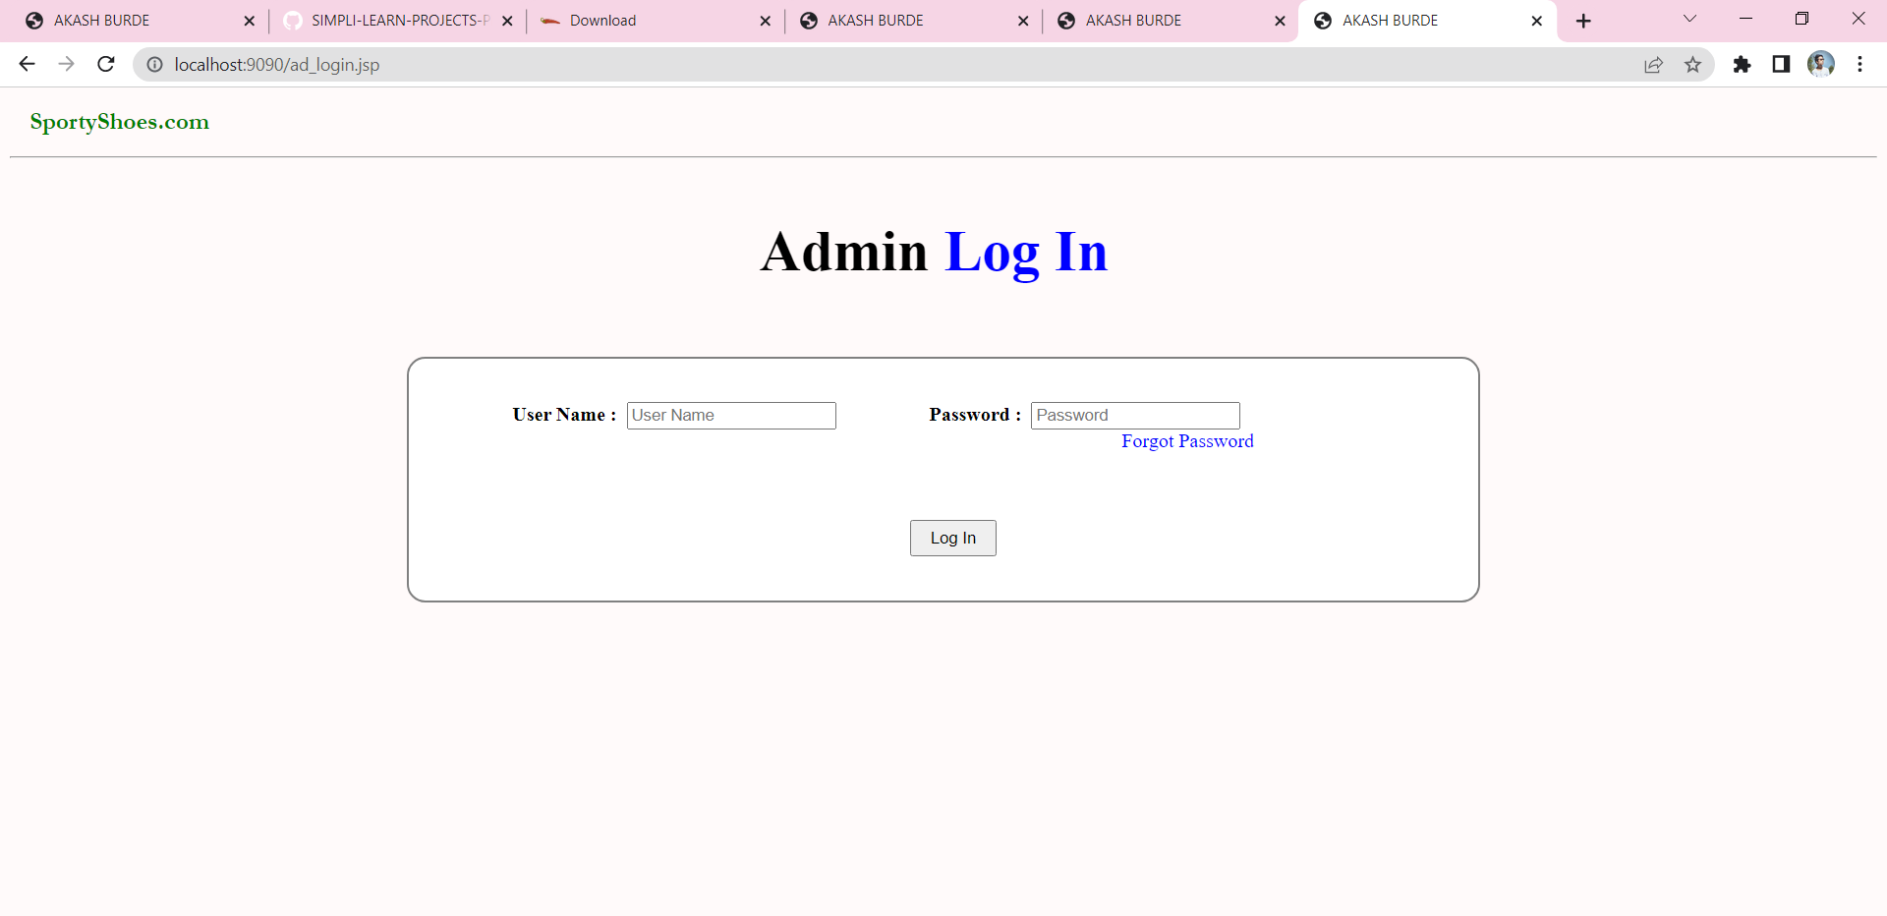

After admin Successfully Login he/she will get this Message other wise they got Error Message, if Credential’s put Wrong

**Module No – 4]**

In this module Admin must add his/her shop product’s for displaying to his/her user’s. after click on “ADD PRODUCT” admin will redirect on another screen like :

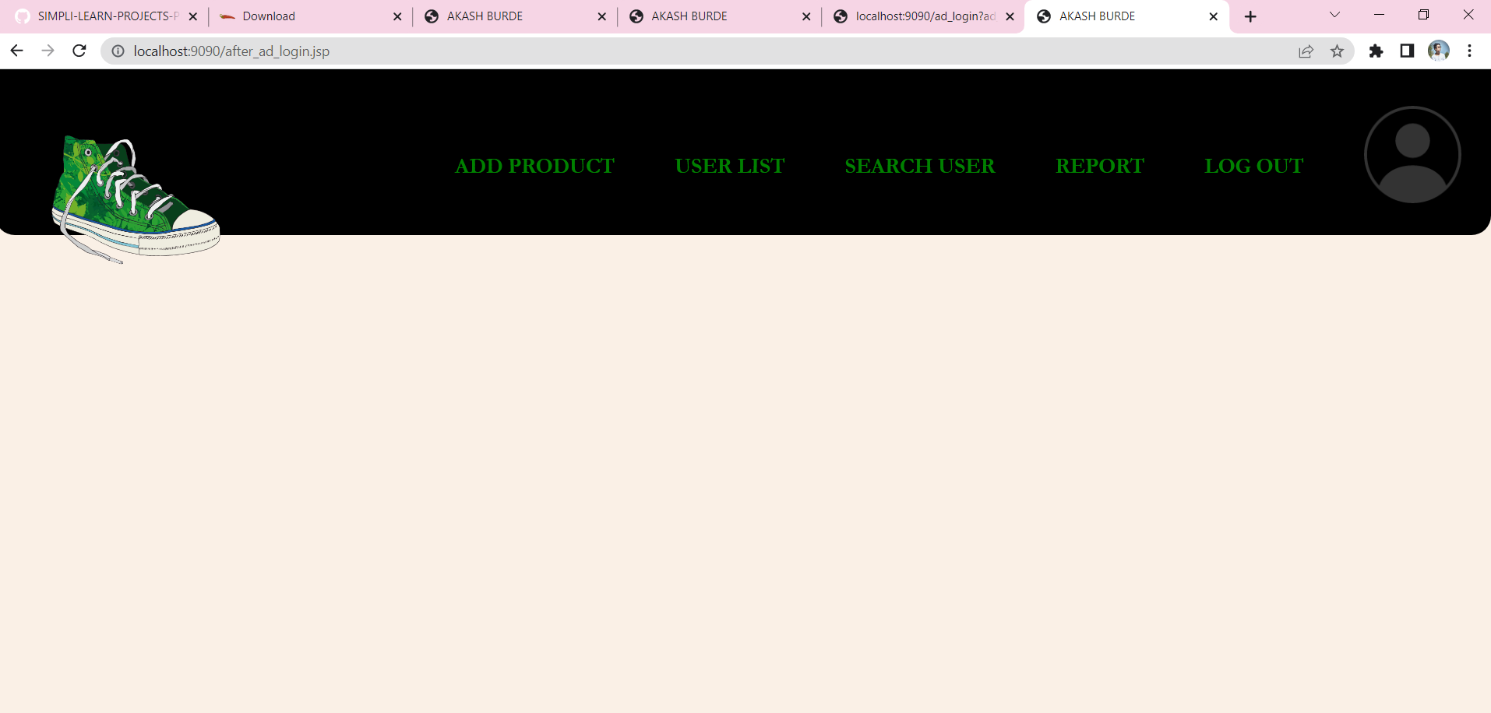

After click on that button admin redirect on this screen, on this this screen admin must fill all detail’s of product’s and click on “ADD”.

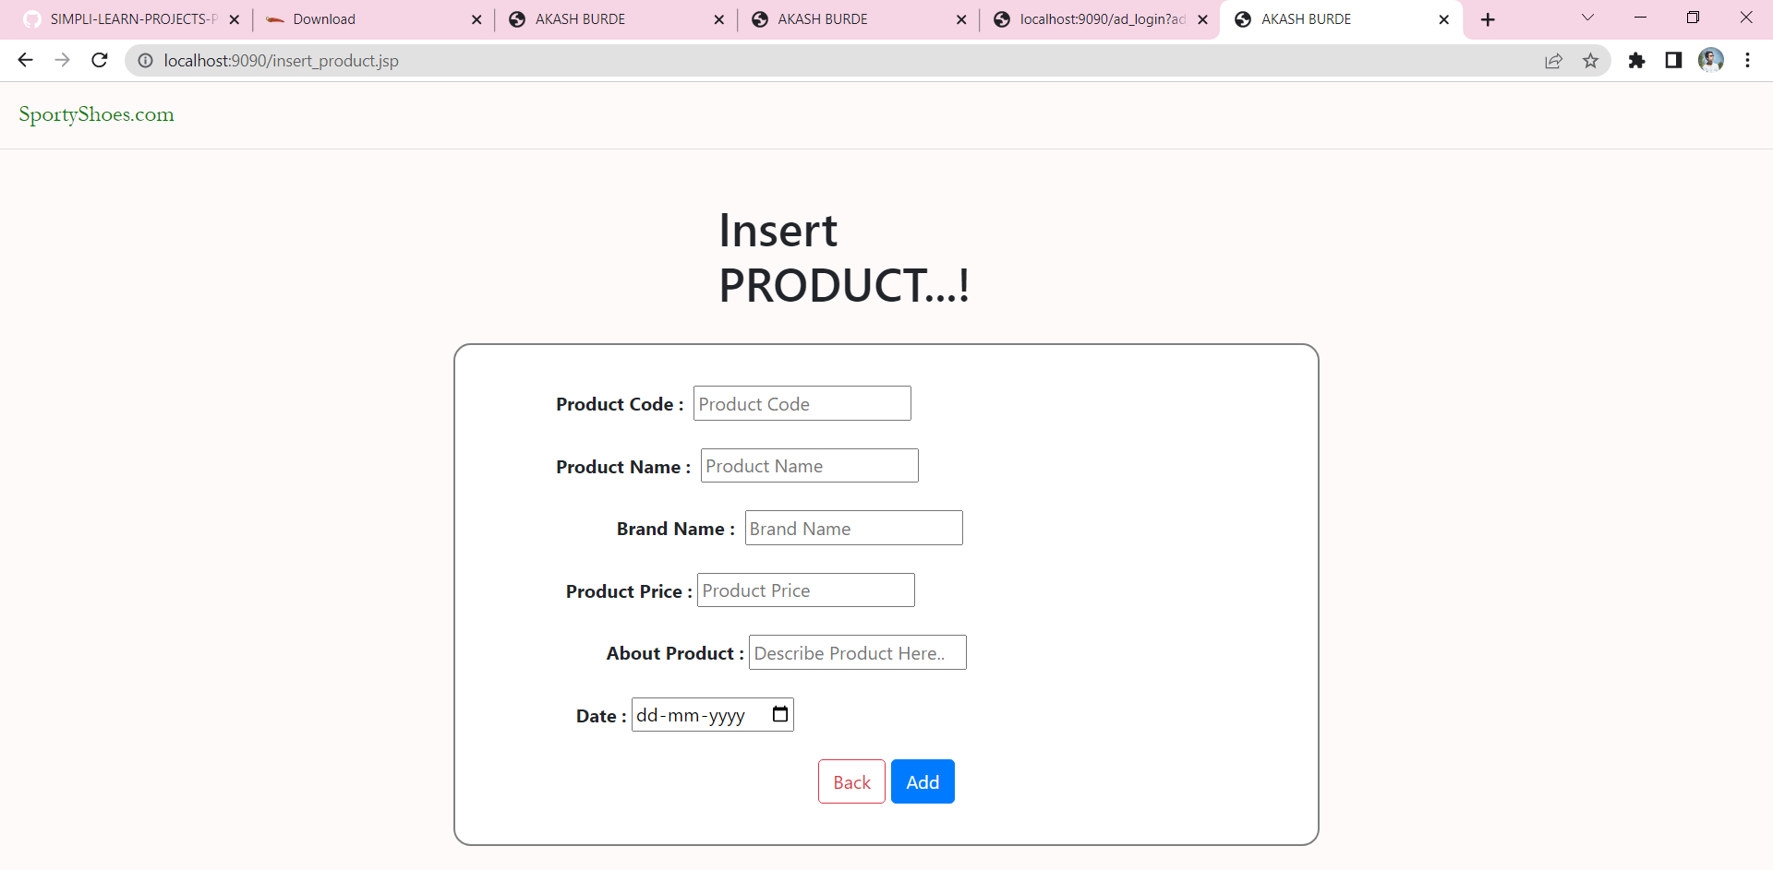

After admin add some product, then this product will shown on following user page :

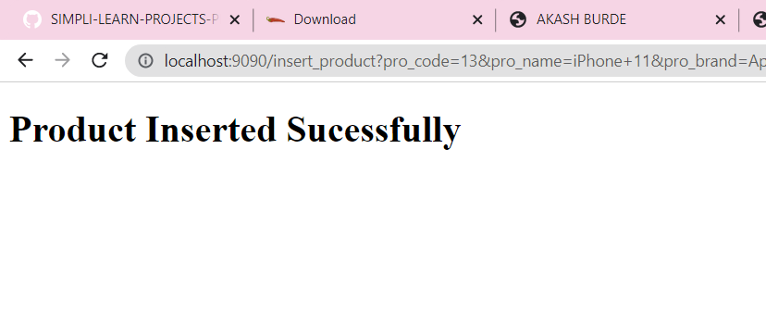

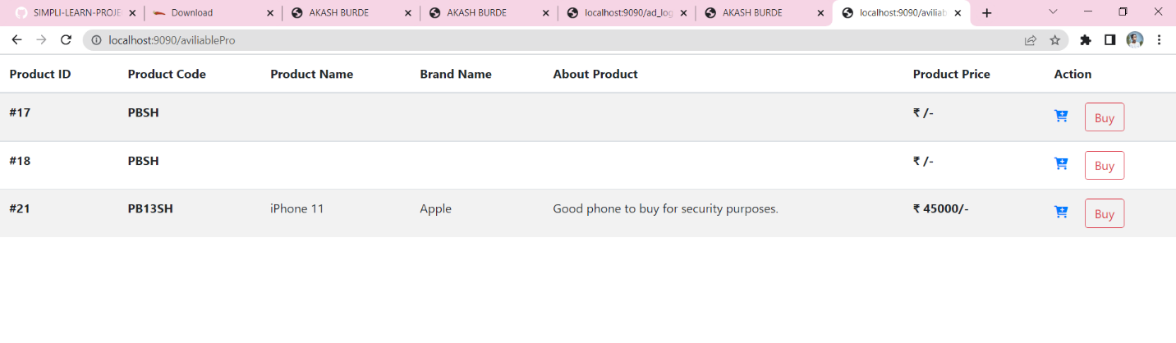

**Module No – 5]**

After admin Login successfully Admin will redirect to another Page which is Only Accessible for Authenticated Admin.

If admin want to see how many users are sign up in his/her website, then he click on **“USER LIST”**

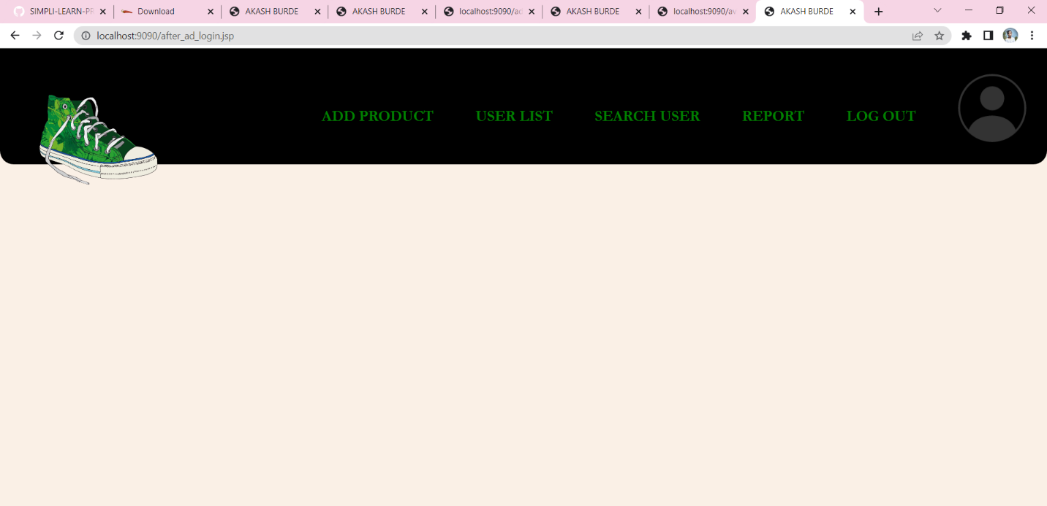

When admin Click On this option he/she will get user List’s Page like :

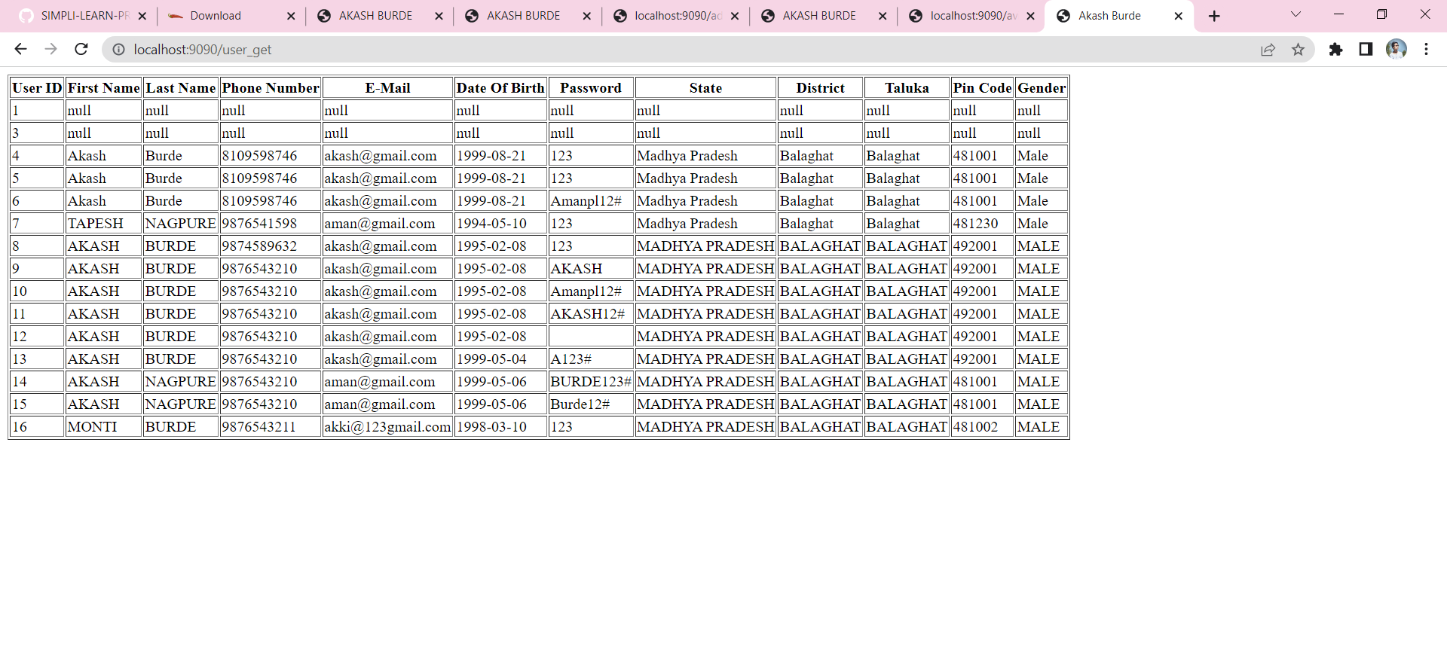

**Module No – 6]**

When admin want’s search any particular name user then he/she click on “Search User” then they redirect on Another page like :

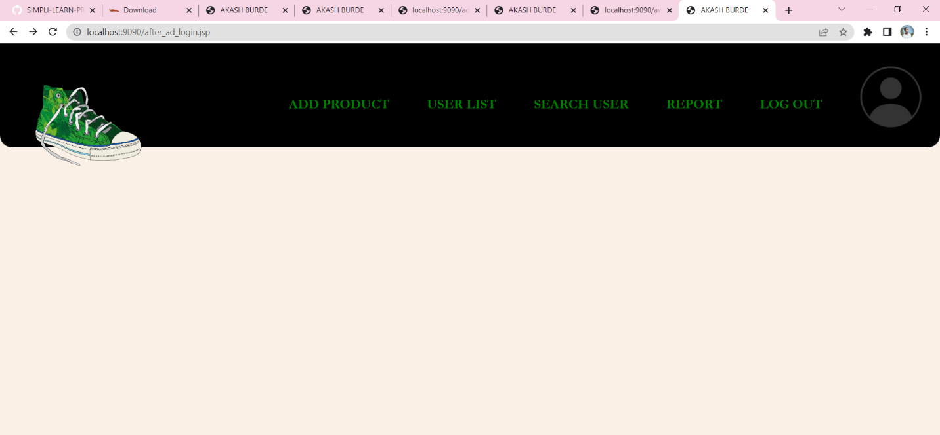

After click on that option Admin redirect on following page :

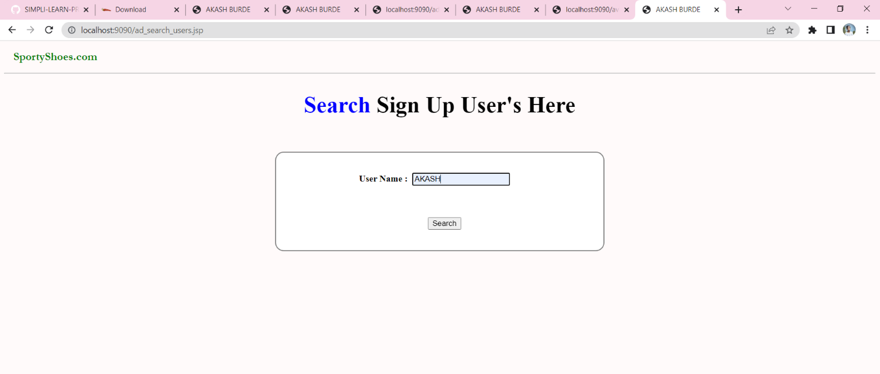

When admin Insert User Name for search and hit Enter or “Search” Admin will got Following Result Screen :

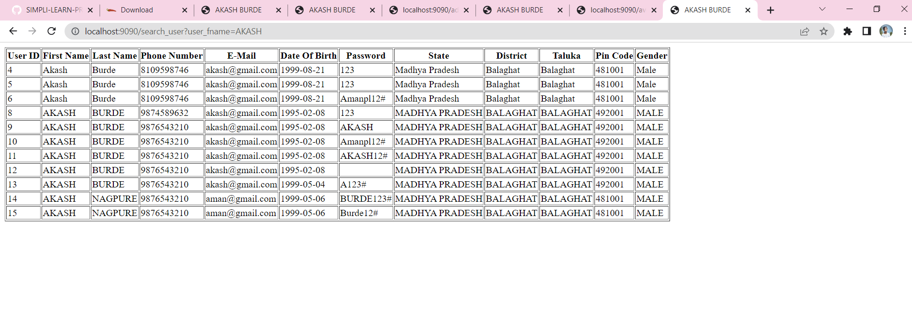

**Module No – 7]**

In this module admin can get report of product with who one buy this product, admin get this detail’s using Product purchased Date, First click on “REPORT” Like :

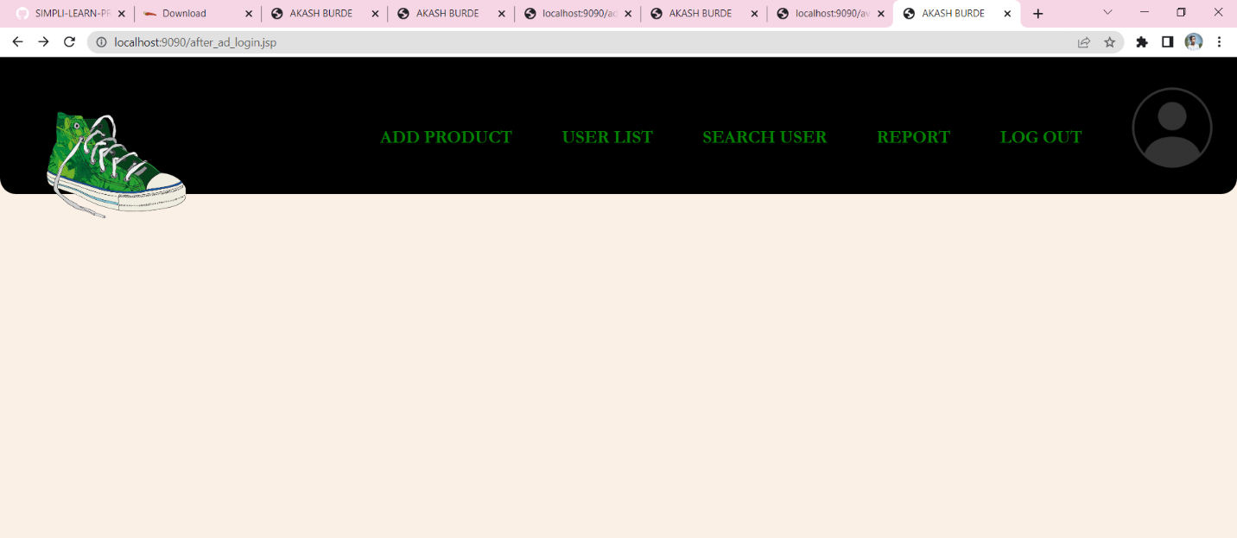

After this Admin will redirect on next screen, put that date which you want to get report, after putting Date hit on “Get Report” like follows :

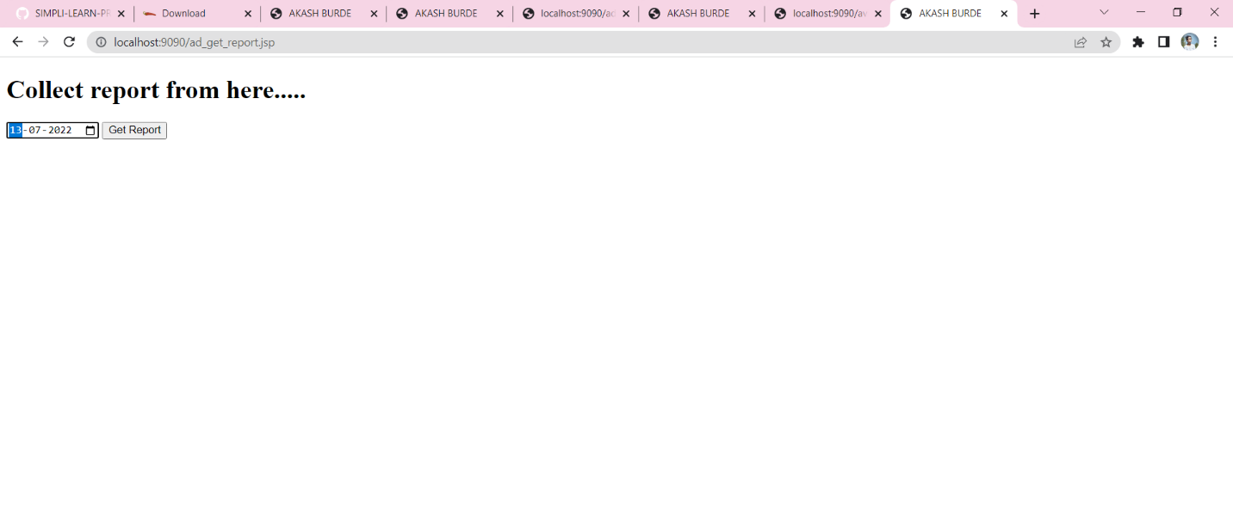

When we hit “Get Report” then this App will Gives all Record’s are present on that day Like :

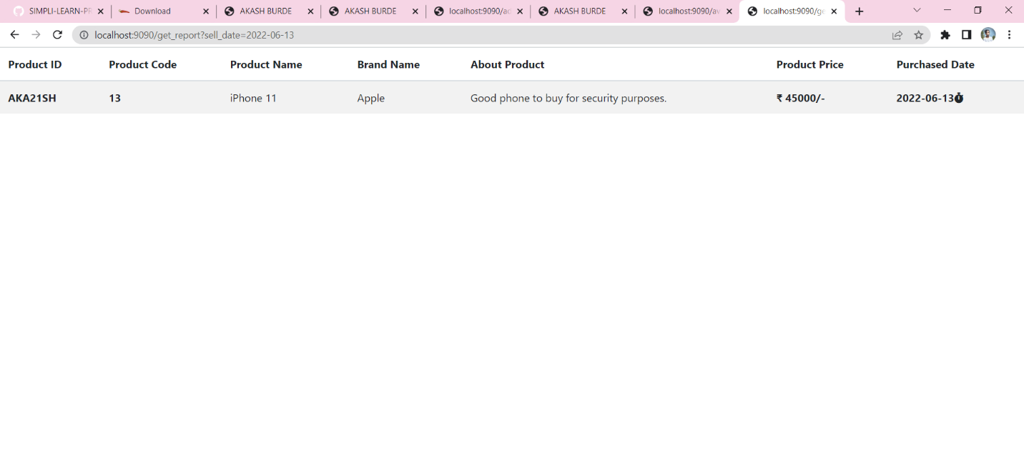

**Module No – 8]**

After admin want’s come back on or logout then admin goes with this option “LOGOUT”.

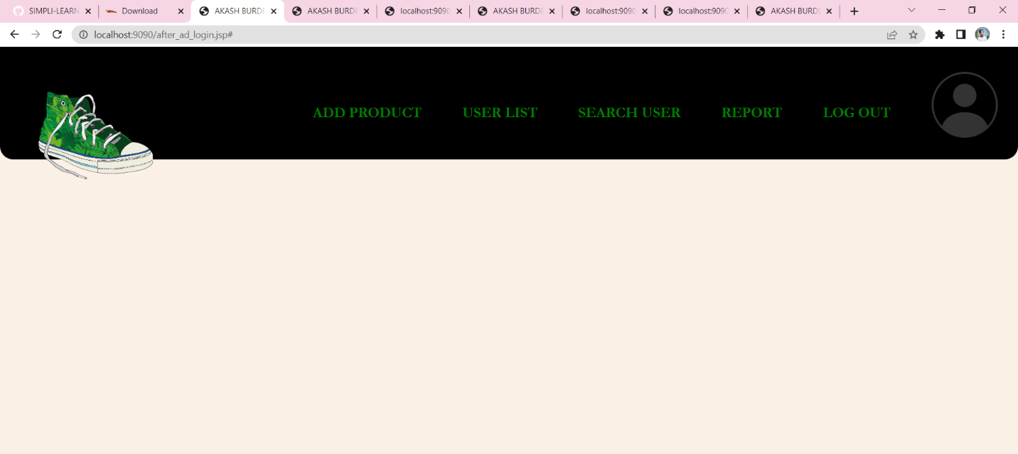

After click on logout admin will redirect on home page like :

