***Medicare …Screenshot***

***All The pages Available on github.***

***Home Page :-***

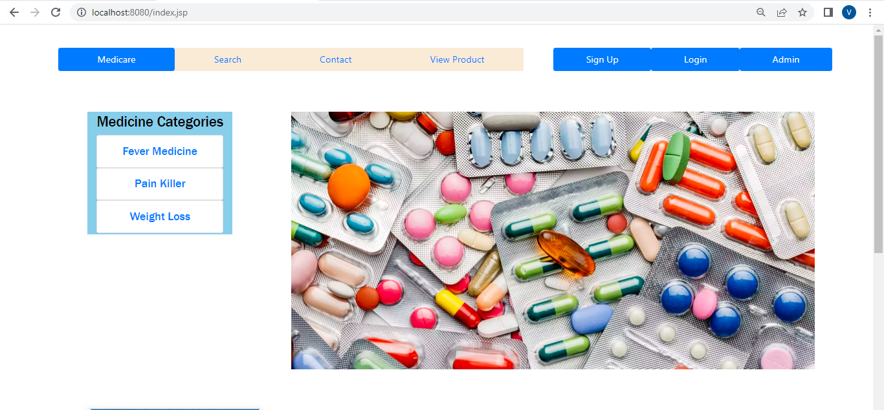



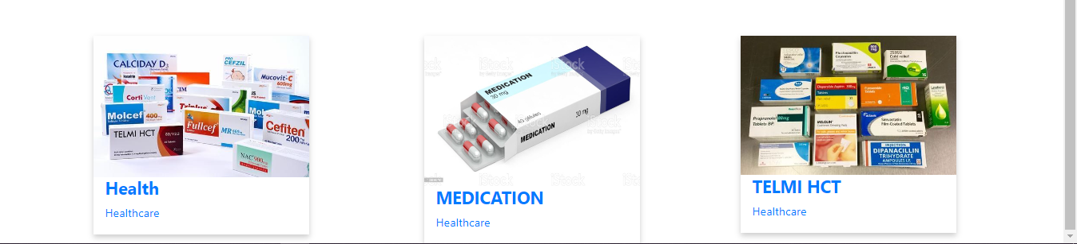

***User Register Page :-***



***Admin Login page: -***

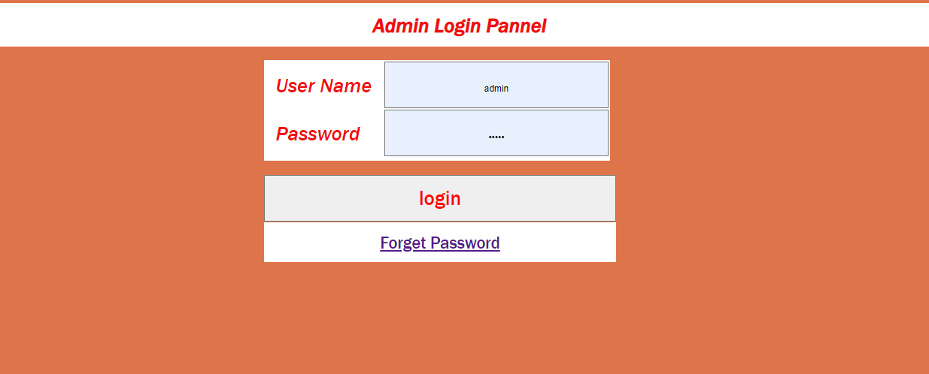

***Name:- Akash Burde***