#### **Walchand College of Engineering, Sangli.**

(An Autonomous Institute)

Department of Information Technology

A Project Report

On

E- Agro Website

Submitted by

Mr. Apsingkar Subhash (2015BIT210)

Mr. Khillare Ramdas (2015BIT219)

Mr. Zunjare Saurabh (2014BIT031)

Under the Guidance

Of

**Miss. A.M. Khot**

Dept. of Information Technology,

WCE, Sangli.

**Year: 2016-2017**



**Walchand College Of Engineering, Sangli**

*(An Autonomous Institute)*

**CERTIFICATE**

This is to certify that the Project Report entitled, **“E-agro Website”** submitted by

Mr. Apsingkar Subhash 2015BIT210

Mr. Khillare Ramdas 2015BIT219

Mr. Zunjare Saurabh 2014BIT031

to Walchand College of Engineering, Sangli, is record of bonafide Project work carried out by then under my supervision and guidance and is worthy of consideration for the award of degree of Third Year (B. Tech) in Information Technology of the Institute.

**Miss.A.M. Khot Dr.S.P. Sonavane**

Guide Head of Department

(Dept. of Information Technology) (Dept. of Information Technology)

Acknowledgement

We feel immense pleasure in submitting this Project report entitled "E-agro Website".

We are thankful to our guide **Miss. A. M. Khot** for their valuable guidance and kind help

During completion of Project and feel great to express our sincere gratitude to other all staff

Members of IT Department.

We are also thankful to the Head of the 'Department of Information Technology' **Dr. S. P.**

**Sonavane** for their valuable guidance during the completion of Project.

We would like to thank all faculty members and staff of Department of Information Technology

For their generous help in various ways for the completion of this thesis.

We would like to thank all our friends and especially our classmates for all the thoughtful

And mind stimulating discussions we had, which prompted us to think beyond the obvious. We

Have enjoyed their companionship so much during our stay at WCE, Sangli.

**Declaration**

We hereby declare that work presented in this project report titled **"E-agro Website"** submitted by me in the partial fulfillment of the requirement of the award of the Degree of **Third Year (B. Tech)** Submitted in the **Department of Information Technology,** of **Walchand College of Engineering, Sangli**, is an authentic record of my project work carried out under the guidance of Miss. A. M. Khot.

**Mr. Apsingkar Subhash (2015BIT210)**

**Mr. Khillare Ramdas (2015BIT219)**

**Mr. Zunjare Saurabh (2014BIT031)**

Date : Apsingkar Subhash

Place : Sangli. Khillare Ramdas

Zunjare Saurabh

(Signatures)

**ABSTRACT**

Agriculture is the backbone of the Indian economy. So, as there is trend increasing day by day towards the digital world. For this, there should be such system which will help to the farmers to interact their customers. By this project, we'll be going to develop such system that should be helpful to the Indian farmers

To provide a platform to the farmers to sell and purchase their products through the web.

In brief, today for selling the agricultural products farmers have to face many problems.

There is no direct platform between the farmers and the customers. With the help of this project, they can sell their products to the customers. This will help to reduce the gap between them.

We are creating a web platform to e-commerce market place for farmer and customers. We are implementing Web Interface and transaction API's which will help the seller to sell their product and we implementing recommendation System for product analysis. We also take session consideration and applying concepts of Session management and Recommendation system. We are creating simple interface for buyer and seller for Agriculture service market place.

We are going to create a web platform for services E-commerce agriculture market place for Farmer and help them sell their products efficiently.

**Table of Contents**

1. Introduction 7

2. Project Objectives 8

3. Tools and Technologies 9

4. Proposed Method 11

5. Conclusions 17

6. References 17

**1. Introduction**

Agriculture is the backbone of the Indian economy. So, as there is trend increasing day by day towards the digital world. For this, there should be such system which will help to the farmers to interact their customers. By this project, we’ll be going to develop such system that should be helpful to the Indian farmers.

We can provide direct platform to farmer to sell their product online without any brokerage

and also buy these by customer We are creating a web platform to e-commerce market place for farmer and customers. We are implementing Web Interface and transaction API's which will help the seller to sell their product and we implementing recommendation System for product analysis. We also take session consideration and applying concepts of Session management and Recommendation system. We are creating simple interface for buyer and seller for Agriculture service market place.

We are going to create a web platform for services E-commerce agriculture market place

for Farmer and help them sell their products efficiently.

**Problem Statement**

To provide a platform to the farmers to sell and purchase their products through the web. In brief, today for selling the agricultural products farmers have to face many problems. There is no direct platform between the farmers and the customers. With the help of this project, they can sell their products to the customers. This will help to reduce the gap between them.

**2 .Project Objectives**

1. Provide a platform for farmers to sell their products.

2. Bridge up the gap between farmer and customer.

3. To implement recommendation.

4. One step to Social Contribution

3**.Tools and Technologies**

* Front End- HTML CSS Bootstrap
* Back end- PHP
* Database- Mongo DB

**3.1 Front End-**

**HTML CSS Bootstrap**

**Hypertext Markup Language** (**HTML**) is the standard markup language for creating web pages and web applications. Including static and dynamic pages.

HTML elements are the building blocks of HTML pages. With HTML constructs, images and other objects, such as interactive forms, may be embedded into the rendered page. It provides a means to create structured documents by denoting structural semantics for text such as headings, paragraphs, lists, links, quotes and other items. HTML elements are delineated by *tags*, written using angle brackets. Tags such as <img /> and <input /> introduce content into the page directly.

CSS describes **how HTML elements are to be displayed on screen, paper, or in other media**.

CSS **saves a lot of work**. It can control the layout of multiple web pages all at once.

CSS can be added to HTML elements in 3 ways:

* **Inline** - by using the style attribute in HTML elements
* **Internal** - by using a <style> element in the <head> section
* **External** - by using an external CSS file

**3.2 PHP**

PHP tutorial for beginners and professionals provides deep knowledge of PHP scripting language. Our PHP tutorial will help you to learn PHP scripting language easily. This PHP tutorial covers all the topics of PHP such as introduction, control statements, functions, array, string, file handling, form handling, regular expression, date and time, object-oriented programming in PHP, math, PHP MySQL, PHP with ajax, PHP with jQuery and PHP with XML.

PHP is faster than other scripting language e.g. asp and jsp.

PHP is widely used in web development now a days. Dynamic websites can be easily developed by PHP. But you must have the basic the knowledge of following technologies for web development as well.

* HTML
* CSS
* JavaScript
* AJAX
* XML and JSON
* jQuery

**3.3 Database- Mongo DB**

MongoDB is an open-source, document database designed for ease of development and scaling. The Manual introduces key concepts in MongoDB, presents the query language, and provides operational and administrative considerations and procedures as well as a comprehensive. MongoDB stores data in flexible, JSON-like documents, meaning fields can vary from document to document and data structure can be changed over time. The document model maps to the objects in your application code, making data easy to work with Ad hoc queries, indexing, and real-time aggregation provide powerful ways to access and analyze your data. MongoDB is a **distributed database** at its core, so high availability, horizontal scaling, and geographic distribution are built in and easy to use. **MongoDB is free and open-source**, published under the GNU Affero General Public License.

**Why MongoDB?**

* Document Oriented Storage − Data is stored in the form of JSON style documents.
* Index on any attribute
* Replication and high availability
* Auto-sharding
* Rich queries
* Fast in-place updates
* Professional support by MongoDB

https://d.adroll.com/cm/index/outhttps://d.adroll.com/cm/n/out

**4. Proposed Method**

**4.1** **System Overview**

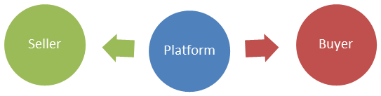

Login

Maintain Records

**4.2** **Seller Perspective**

**Register Activity:**

The seller must have an E-Agro account for placing his order on the website.

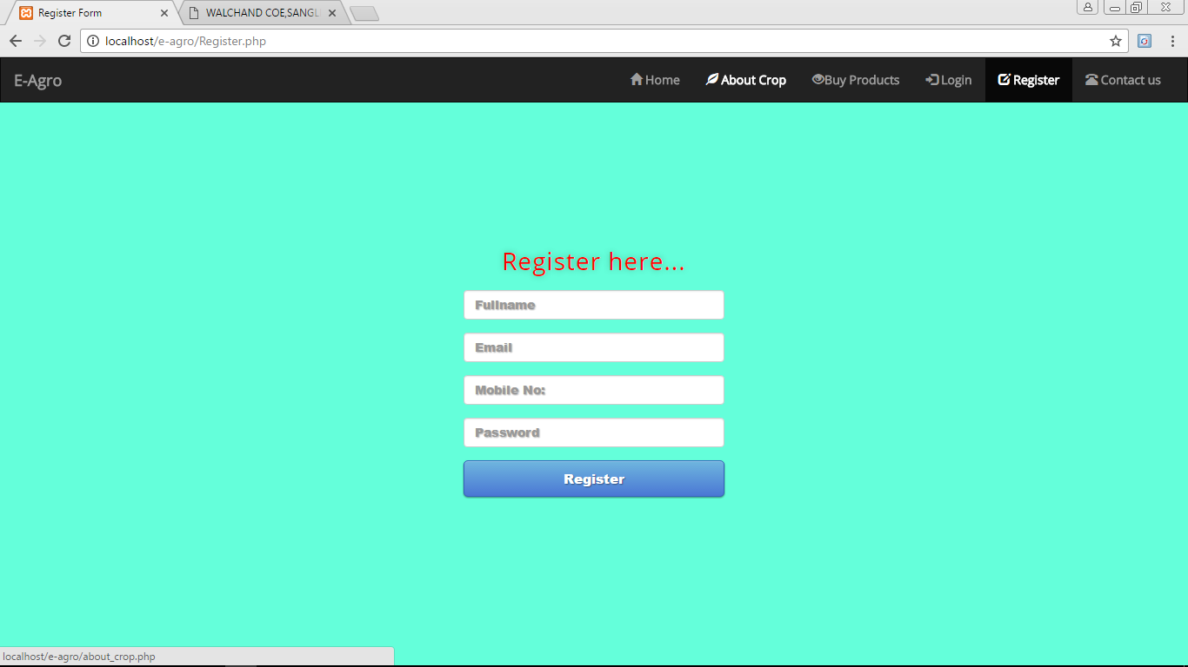

**4.3 Uploading a Product**

This is the view of the Farmer who want to sell their product. In this, the farmer can upload their product with required details such as the product name, price, contact details and the location.

When the buyer wants to buy his product he/she could make a contact with the seller and with the mutual understanding they can fix the price and make a deal.

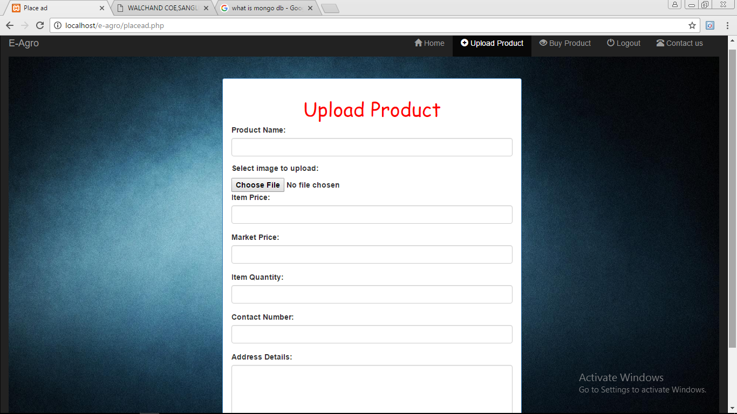

**4.4 Recommendation System**

After uploading the product, the it will be visible to the all the customers and the visitors of the website. In this activity, the site recommends the products which are in the customers budget.

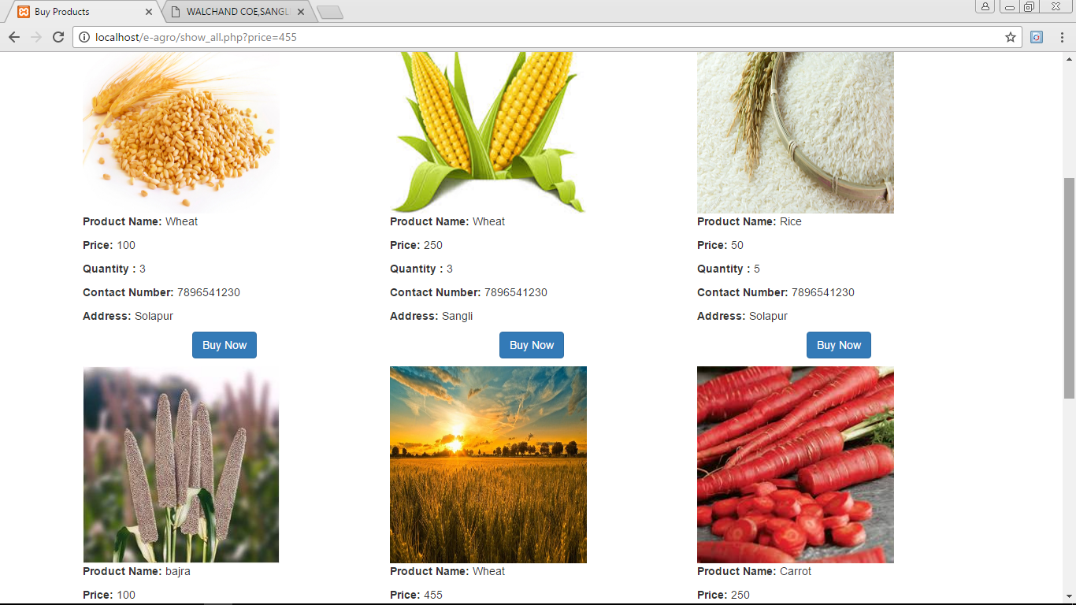

**4.5 Buyer’s View**

This is the view from the customer site. Here the customer finds his required product and make contact with the seller.

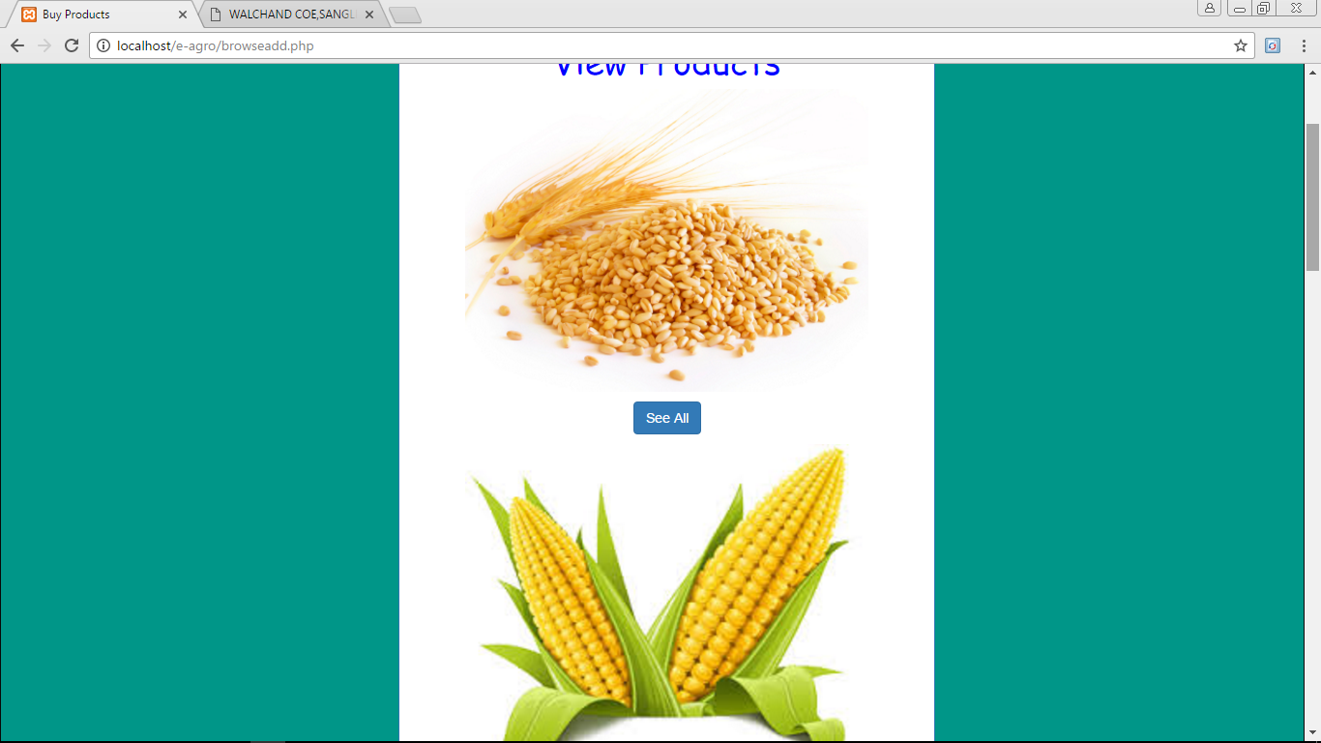

**4.6 Payment:**

Stop

Visit Website

From this activity, the buyer can make payment through the Paytm Application.

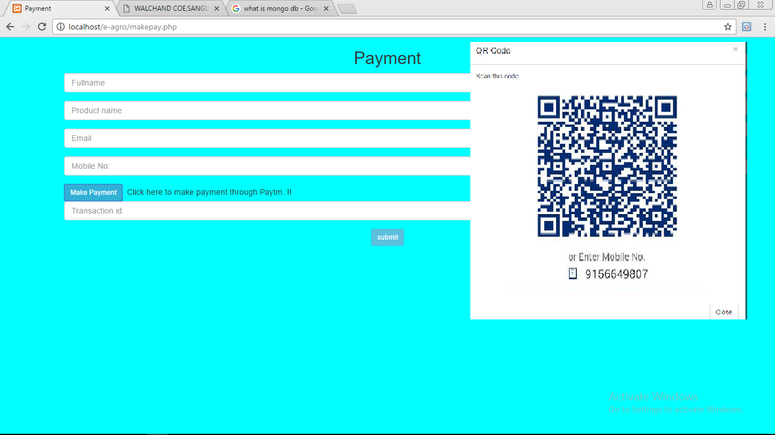

**4.7 Activity Flow for placing the Product**

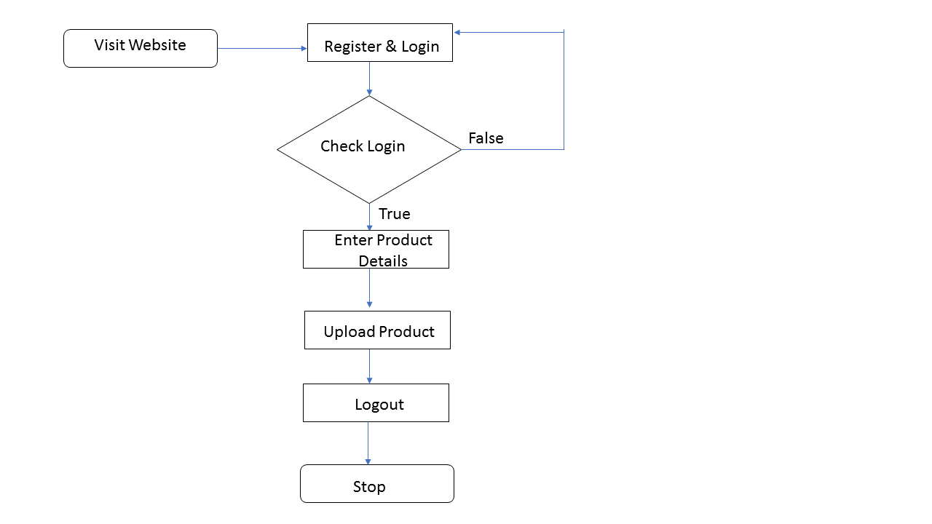

* 1. **Interface**
* Easy and Responsive.
* Crop guide.
* Common Dashboard for buyer and seller.

**5. Conclusion**

* Post your ideasand product..
* Choose the perfect product
* Pay when you are satisfied.

**6. References**

* <https://www.mongodb.com/support/index.html>
* <https://www.youtube.com/user/mongodb.html>
* <https://www.w3schools.com/bootstrap>
* <https://www.tutorialspoint.com/mongodb/>
* <http://stackoverflow.com/>
* <https://github.com/mongodb/mongo>