
+91 6392739587
1 77777 66666



ANURAG PANDEY
www.linkedin.com/in/anurag224132
1pandeyanurag1@gmail.com
SOFTWARE ENGINEER
Ambedkarnagar, Uttar Pradesh
Anurag224132

SUMMARY

Software engineer with a passion for

developing innovative program that expedite

The efficiency and effectiveness of

organizational success.well_versed in

technology and writing code to create

systems that are realiable and user friendly

.Skilled leader who has the proven ability to

Motivate ,educate and manage a team.

Confident communicator ,strategic thinker

And innovative creator.

TECHNICAL SKILLS

Programming languages: HTML,CSS, Javascript, Python, C
Data Management:
MySQL
Platforms:
Unix, MS Windows98, 2000, XP,
Window7

CERTIFICATIONS

Intelligence Tools for the Digital Age
| Northwestern University March'2023

Full Stack Web Development | Coursera |Feb’2023

POWER SKILLS
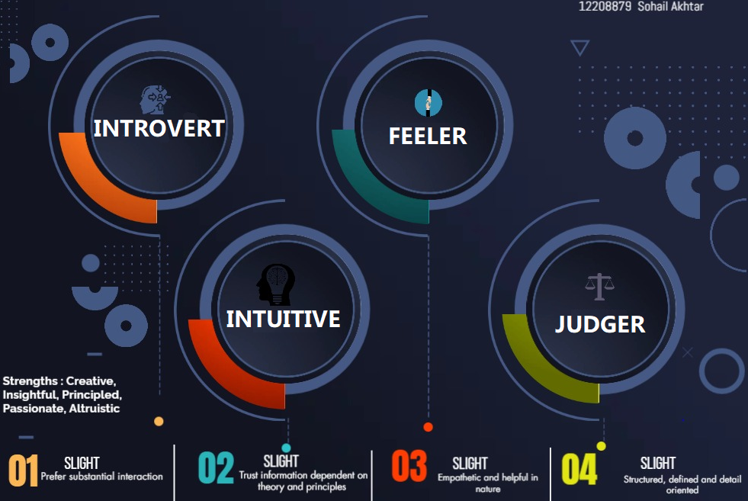

INTERNSHIP

NA

PROJECTS

Web Site on sports Dec’22
Domain: Web Application|Programming Languages: HTML,CSS,Java Script
Constructed an website to know about several sports across the india,upcoming sports events ,Tournaments etc.

ACHIEVEMENTS

5 star rating on HackerRank Sep '22 - Feb '23

EDUCATION

B.Tech. in Computer Science Aug '22 - Present Lovely Professional University | Phagwara, IN
CGPA 8.68

Higher Secondary Jun '19 - Mar '20
SVM Sultanpur | Sultanpur,UP
Percentage 87%

