**Online Test App**

Sprint

**Sprint 1:** Creating Angular Application and designing questions json files.

**Sprint 2:** Creating First Page Component and importing all dependencies.

**Sprint 3:** Creating all html pages and CSS files.

**Sprint 4:** Testing and deploying the application.

Concepts & Algorithms used.

* Angular
* Bootstrap
* HTML
* CSS
* Javascript

GitHub Link : https://github.com/Akash19121997/phase_4_project

**Project Flow**

Main Page

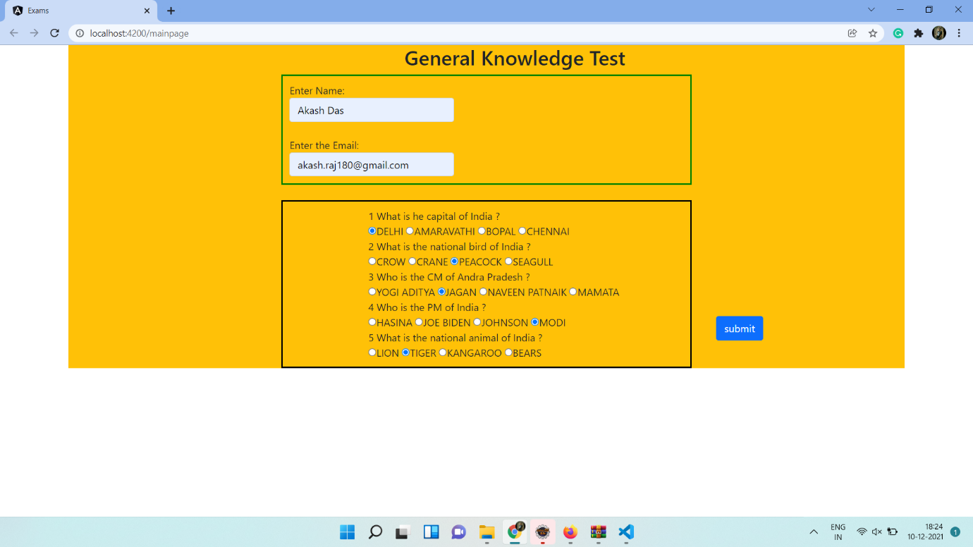

Review Page

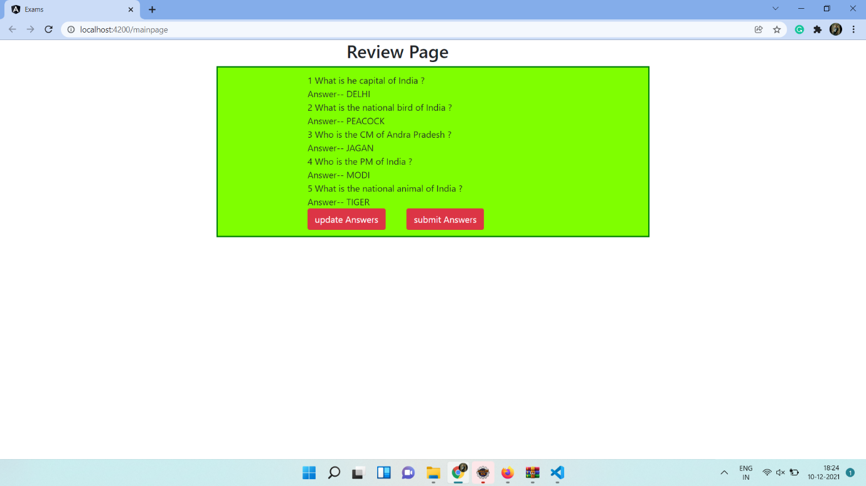

Final Page

