## **A Blood Donation Record Book**

**And GitHub tutorial**

By - Akash Shitole

## 

## **Language used:**

C++

**Code Reference:**

<https://github.com/Akash2027>

**(name-project.cpp)**

## 

## 

## **GitHub**

## 

## 

## GitHub (originally known as Logical Awesome LLC) is a web-based hosting service for version control using git. It is mostly used for computer code. It offers all of the distributed version control and source code management (SCM) functionality of Git as well as adding its own features. It provides access control and several collaboration features such as bug tracking, feature requests, task management, and wikis for every project.

## GitHub offers plans for both private repositories and free accounts[5] which are commonly used to host open-source software projects.[6] As of April 2017, GitHub reports having almost 20 million users and 57 million repositories,[7] making it the largest host of source code in the world.

## 

## **Services**

## Projects on GitHub can be accessed and manipulated using the standard Git command-line interface and all of the standard Git commands work with it. GitHub also allows registered and non-registered users to browse public repositories on the site. Multiple desktop clients and Git plugins have also been created by GitHub and other third parties that integrate with the platform.



## 

## **Installation Steps:**

## **create a new repository**

create a new directory, open it and perform a

git init

to create a new git repository.

## **checkout a repository**

create a working copy of a local repository by running the command

git clone /path/to/repository

when using a remote server, your command will be

git clone username@host:/path/to/repository

## 

## **workflow**

your local repository consists of three "trees" maintained by git. the first one is your Working Directory which holds the actual files. the second one is the Index which acts as a staging area and finally the HEAD which points to the last commit you've made.

**add & commit**

You can propose changes (add it to the **Index**) using

git add <filename>

git add *

This is the first step in the basic git workflow. To actually commit these changes use

git commit -m "Commit message"

Now the file is committed to the **HEAD**, but not in your remote repository yet.

## **pushing changes**

Your changes are now in the **HEAD** of your local working copy. To send those changes to your remote repository, execute

git push origin master

Change *master* to whatever branch you want to push your changes to.

If you have not cloned an existing repository and want to connect your repository to a remote server, you need to add it with

git remote add origin <server>

Now you are able to push your changes to the selected remote server

## 

## **branching**

Branches are used to develop features isolated from each other. The *master* branch is the "default" branch when you create a repository. Use other branches for development and merge them back to the master branch upon completion.

create a new branch named "feature_x" and switch to it using

git checkout -b feature_x

switch back to master

git checkout master

and delete the branch again

git branch -d feature_x

a branch is *not available to others* unless you push the branch to your remote repository

git push origin <branch>

## 

## 

## **update & merge**

to update your local repository to the newest commit, execute

git pull

in your working directory to *fetch* and *merge* remote changes.

to merge another branch into your active branch (e.g. master), use

git merge <branch>

in both cases git tries to auto-merge changes. Unfortunately, this is not always possible and results in *conflicts*. You are responsible to merge those *conflicts* manually by editing the files shown by git. After changing, you need to mark them as merged with

git add <filename>

before merging changes, you can also preview them by using

git diff <source_branch> <target_branch>

## 

## **log**

in its simplest form, you can study repository history using..

git log

You can add a lot of parameters to make the log look like what you want. To see only the commits of a certain author:

git log --author=bob

To see a very compressed log where each commit is one line:

git log --pretty=oneline

Or maybe you want to see an ASCII art tree of all the branches, decorated with the names of tags and branches:

git log --graph --oneline --decorate --all

See only which files have changed:

git log --name-status

These are just a few of the possible parameters you can use. For more, see

git log --help

## 

## **replace local changes**

In case you did something wrong, which for sure never happens ;), you can replace local changes using the command

git checkout -- <filename>

this replaces the changes in your working tree with the last content in HEAD. Changes already added to the index, as well as new files, will be kept.

If you instead want to drop all your local changes and commits, fetch the latest history from the server and point your local master branch at it like this

git fetch origin

git reset --hard origin/master

## **useful hints**

built-in git GUI

gitk

use colorful git output

git config color.ui true

show log on just one line per commit

git config format.pretty oneline

use interactive adding

git add -i

**Blood Donation code Information**

The blood donation record book code is written with the help of object oriented language C++. It records user entered information of the blood donor.

It stores data like name, gender, blood group, date of birth and date of donation.

In the record book editing, deletion as well as searching for a particular record is also possible.

**Concepts Used:**

The blood donation record book uses the concept of file handling to store data in a file as well as to edit, delete or add a new record. It also uses concept of functions, classes and strings (to compare while searching).

You can find the code which is named as ‘**project.cpp**’ using the link mentioned above on github.

It is a simple code for storing data. Hope it is useful and hope you like it.

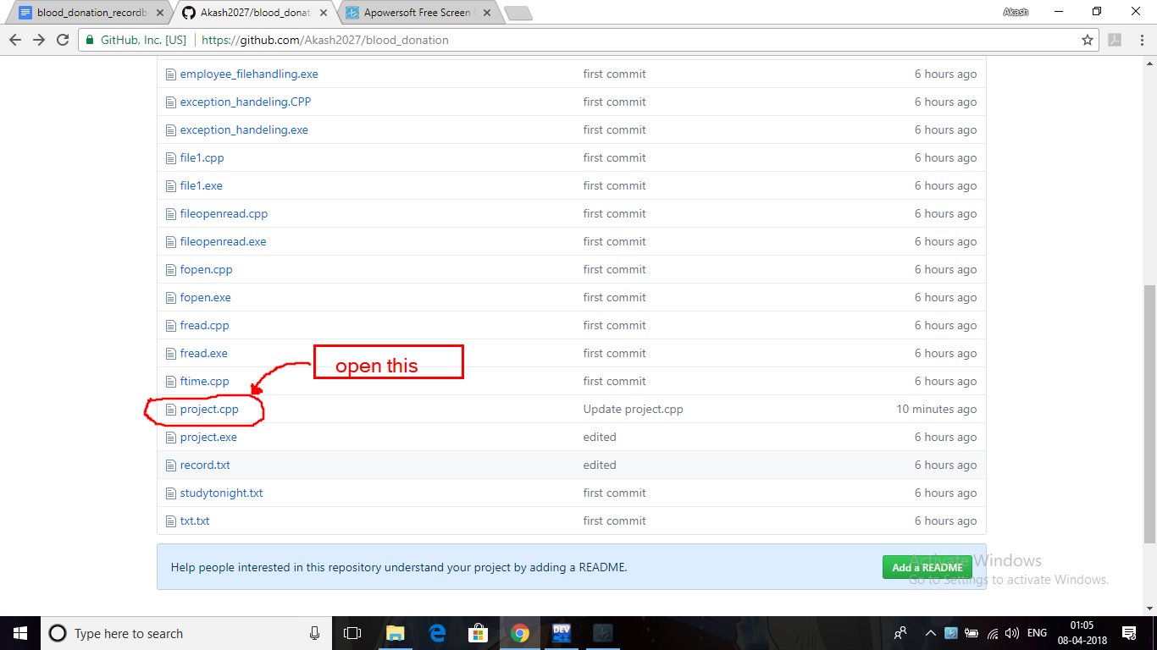

**THANK YOU :)**