**RUBIBOT DESIGN**

**Approach:**

* We need one motor to perform moves for each face, thus there would be a total of six motors, all connected to one face each. Thus, a cuboidal frame is ideal.
* In order to set the cube inside the bot, we need to offset the motors initially then fix their positions once the cube is set. Thus, the motors need to be able to move slightly from their positions.
* There has to be some sort of opening in the bot in order to insert the cube. Thus, we went for a lid that can be opened and closed.

**Prototype 1:**

**Design:**

There are six motors corresponding to each face on the cube attached to a cubical frame. Each motor’s axis is attached to a gripper that is designed to fit inside the centre piece of a side of the cube. Four motors on the vertical faces can slide in and out of the frame in order to attach the cube to the centre pieces. The bottom-most motor is fixed in its place and the cube will first attach to this motor only. The top motor is attached to a cross shaped frame that is hinged to the cubical frame. This will allow the box to open so that cube can be placed inside.

**Challenges:**

* The motors need to be held in place, in order to provide stability during the solve.
* The hinged type lid will create problems when the gripper is being inserted into the centre-piece of the top face.
* There needs to be some compartment for the Arduino and power supply.

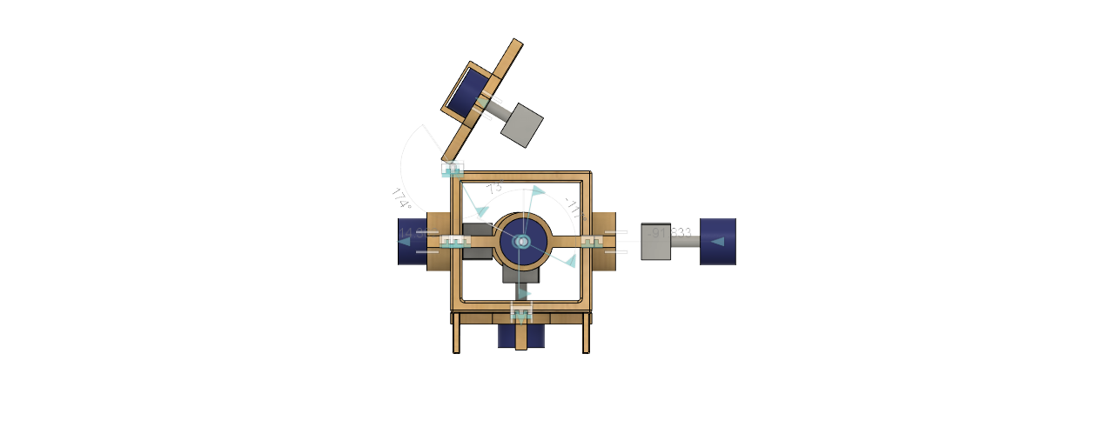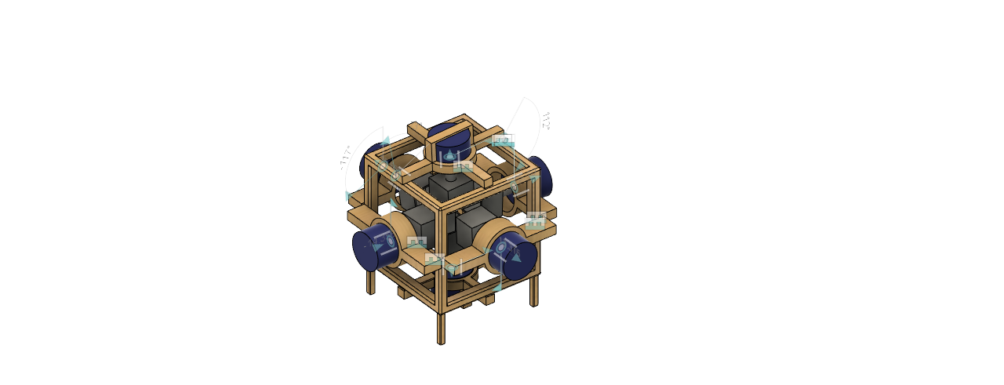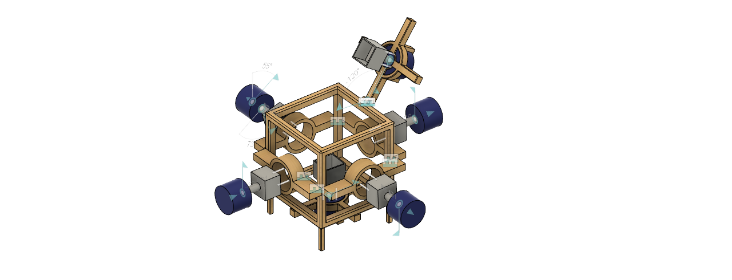

**Prototype 2:**

Major changes include:

1. Motors will now be attached onto a holder that can slide on rails. These rails are attached to sides of the bot frame. Once the cube has been placed in the bot, the holders can be closed in and screwed at place. This way we can fix the cube more accurately.
2. The top-most motor is now attached to a separate flat frame that acts as a lid onto the bot. once the cube is loaded, the lid is placed along with the motor, and small cork that holds the lid in place.
3. There is a separate compartment at the bottom of the structure which holds all electrical control systems like Arduino, power supply, etc.

**Challenges:**

* The final design is completely different from initial prototypes but is based on the same principals. Because the 3d printer can only print a small volume, the entire design needs to be made modular.
* The driver gets heated up during use, thus there needs to be proper ventilation for the driver’s heat to escape.
* Since the body is modular i.e., made of different small parts, they need to be held together firmly so that there is no stability issue during the solve.

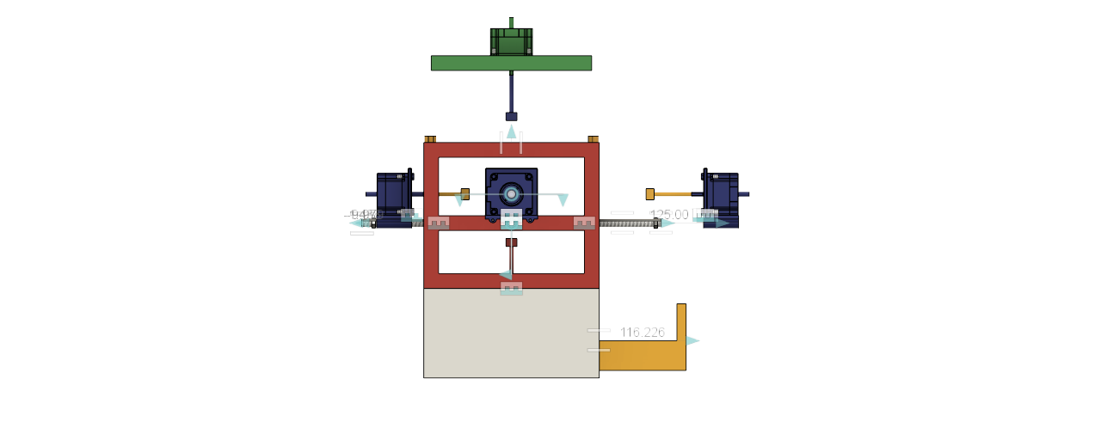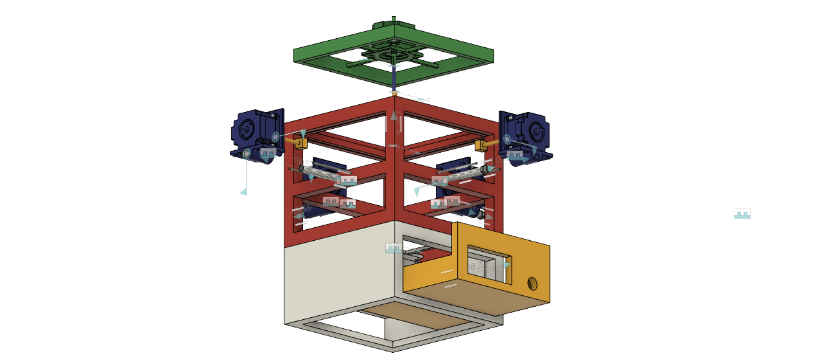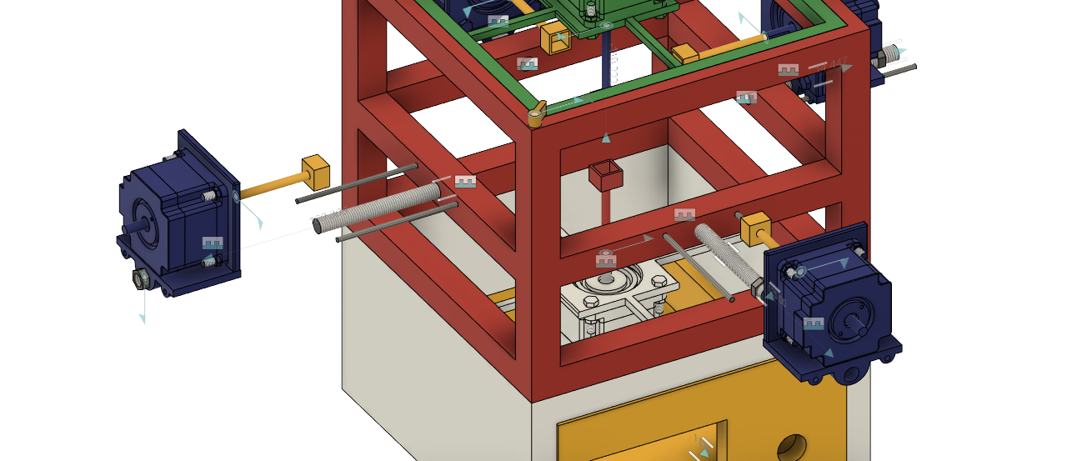

**Prototype 3:**

The structure is broken down into six major pieces:

1. A base that holds bottom-most motor, its driver and Arduino. All the wires from all six motors and power supply originate from here. All side mounts can slide into the sides of the base.
2. Four side mounts that hold a motor and its corresponding motor driver. The motor is still attached to a holder that can slide, same as in second design. The back side of the mount is perforated in order let the heat from the driver escape.
3. The upper frame has eight legs that fit into the side mounts which in turn are attached to the base. This structure holds the entire body firmly and ensure there are no stability issues. The frame also supports the top-most motor and its driver at its top.

