Ex.no:8 | MINI PROJECT – FOOTBALL ANALYTICS

Domain and Problem Statement
MINI PROJECT – CRICKET ANALYTICS
Domain: Sports Analytics & Cricket Performance Analysis
Problem Statement:
Sports organizations, cricket teams, coaches, and analysts generate large volumes of match and player data but often lack clear insights into team performance, player contribution, and match outcomes. This project addresses these challenges by transforming raw cricket match data into structured business intelligence using Power BI and Tableau, enabling analysis of run-scoring trends, player performance, match statistics, team comparisons, batting and bowling metrics, and overall cricket performance to support data-driven coaching and strategic decisions.

Dataset Description
Dataset Name: Cricket Match Analytics Dataset
Granularity: Each row represents a single cricket match.
Timeframe Covered: 2025
Key Entities & Attributes:

- Match & Team: match_id, team, opponent, tournament, venue, match_result.
- Match Details: match_date, match_datetime, match_hour, day_of_week.
- Performance Metrics: runs, wickets, fours, sixes, strike_rate.
- Match Conditions & Bowling: overs, run_rate, extras, economy_rate.
- Performance: performance_bucket_label.

Data Source:
Primary Source: Cricket Match Analytics Dataset prepared for sports performance analysis.

Storage Infrastructure: Cleaned and pre-processed cricket match records maintained in an Excel dataset and imported into Microsoft Power BI and Tableau for interactive dashboard development and analysis.

Architecture:

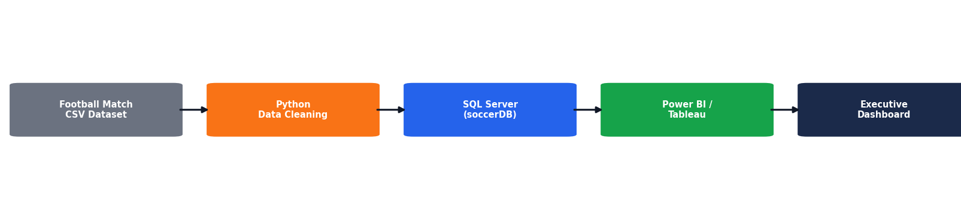

Program:
- Python – Data Cleaning & Transformation
import pandas as pd
df = pd.read_csv("cricket_matches.csv") # Create a copy for processing
matches = df.copy()
# Handle missing values
matches["team"] = matches["team"].fillna("Unknown")
matches["tournament"] = matches["tournament"].fillna("Unknown")
matches["venue"] = matches["venue"].fillna("Unknown")
matches["match_result"] = matches["match_result"].fillna("Unknown")
# Replace missing numerical values with 0
numeric_columns = [
"runs", "wickets", "fours",
"sixes", "strike_rate",
"overs", "run_rate", "extras", "economy_rate"
]

for column in numeric_columns:
matches[column] = matches[column].fillna(0)
# Remove duplicate records matches.drop_duplicates(inplace=True) # Convert date column

matches["match_date"] = pd.to_datetime(matches["match_date"], errors="coerce")
)
matches.columns = ( matches.columns
.str.lower()
.str.strip()
.str.replace(" ", "_")
)
print("Original Shape:", df.shape)
print("Cleaned Shape:", matches.shape)

print("\nDataset Preview:")
print(matches.head())

print("\nDataset Information:")
print(matches.info())

- SQL SERVER CONNECTIVITY

INSTALL SQL SERVER MANAGEMENT STUDIO

- 1) Create database named “cricketDB”
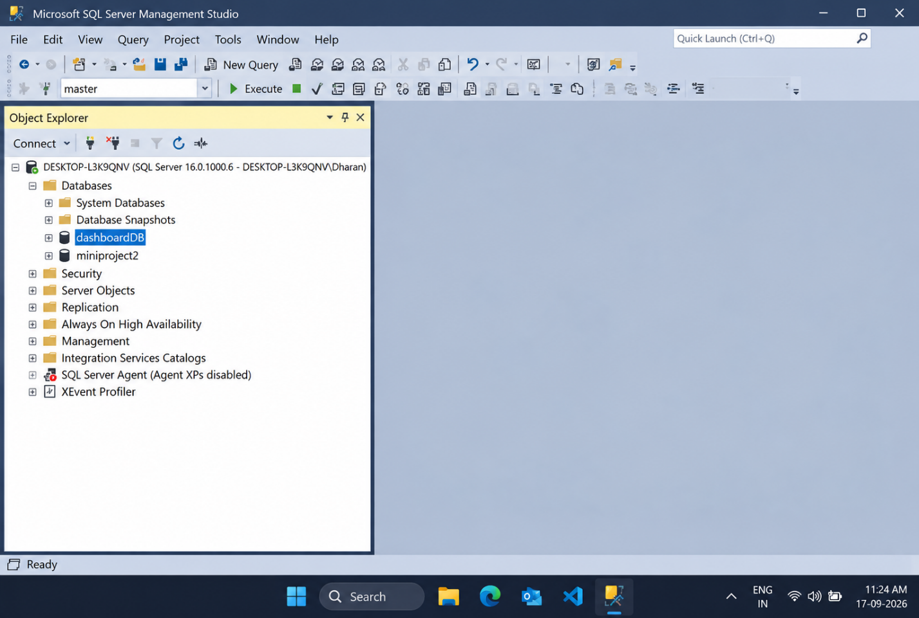
- 2) Import the cricket csv file of the dataset
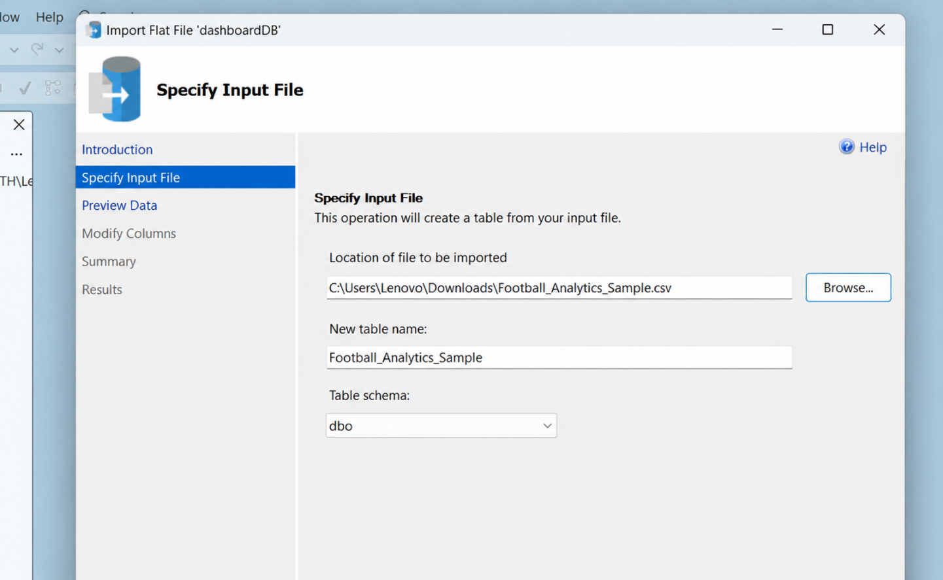

POWER BI
- Now go to MICROSOFT POWER BI
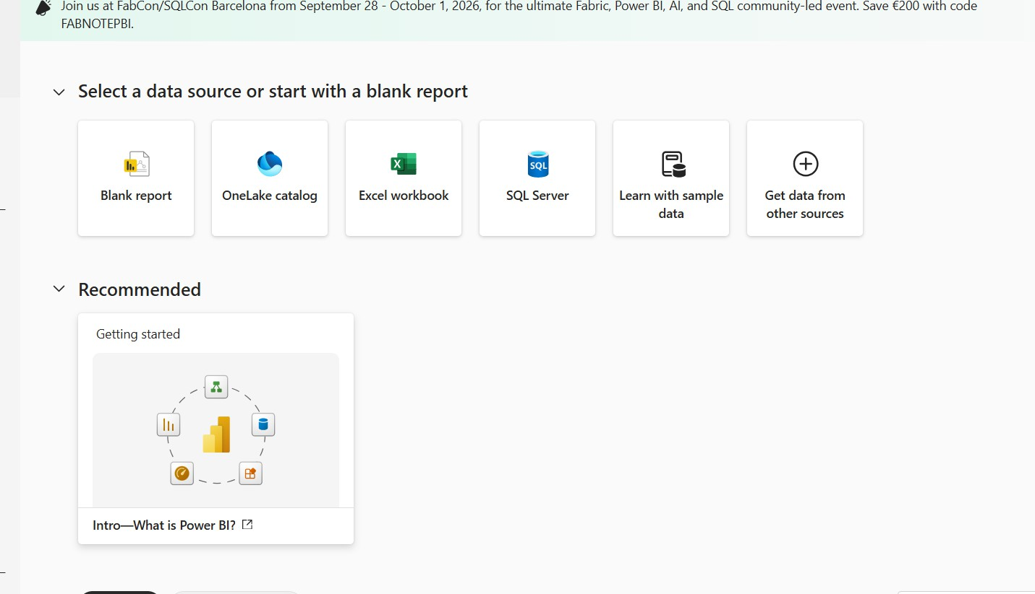

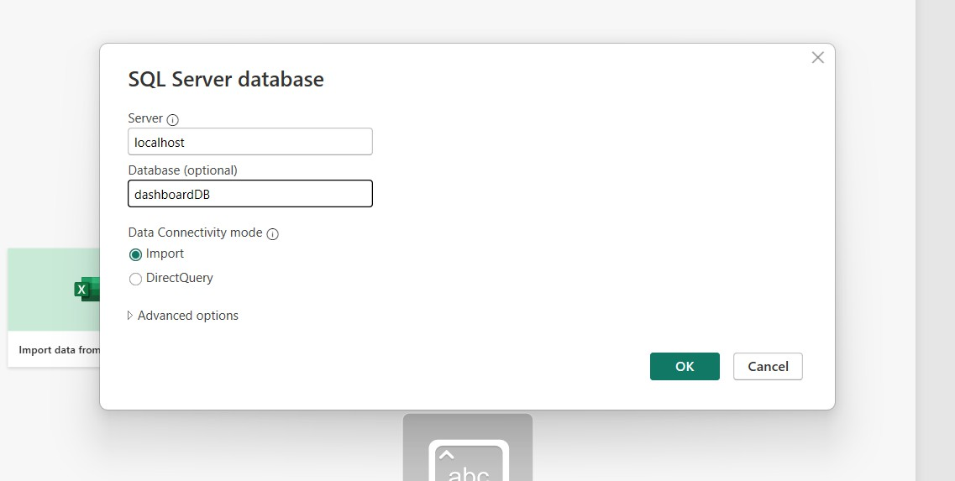
- Click SQL SERVER

- Click OK and click transform data

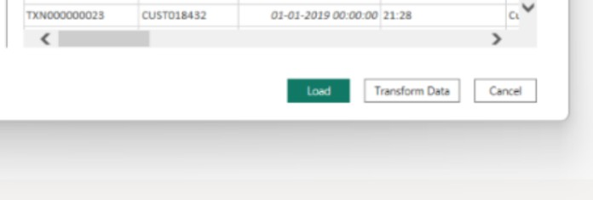

- Create DAX measures
TOTAL RUNS :
TOTAL MATCHES:
TOTAL SIXES
AVERAGE STRIKE RATE

- Power BI Final Executive Dashboard & Drill-Through

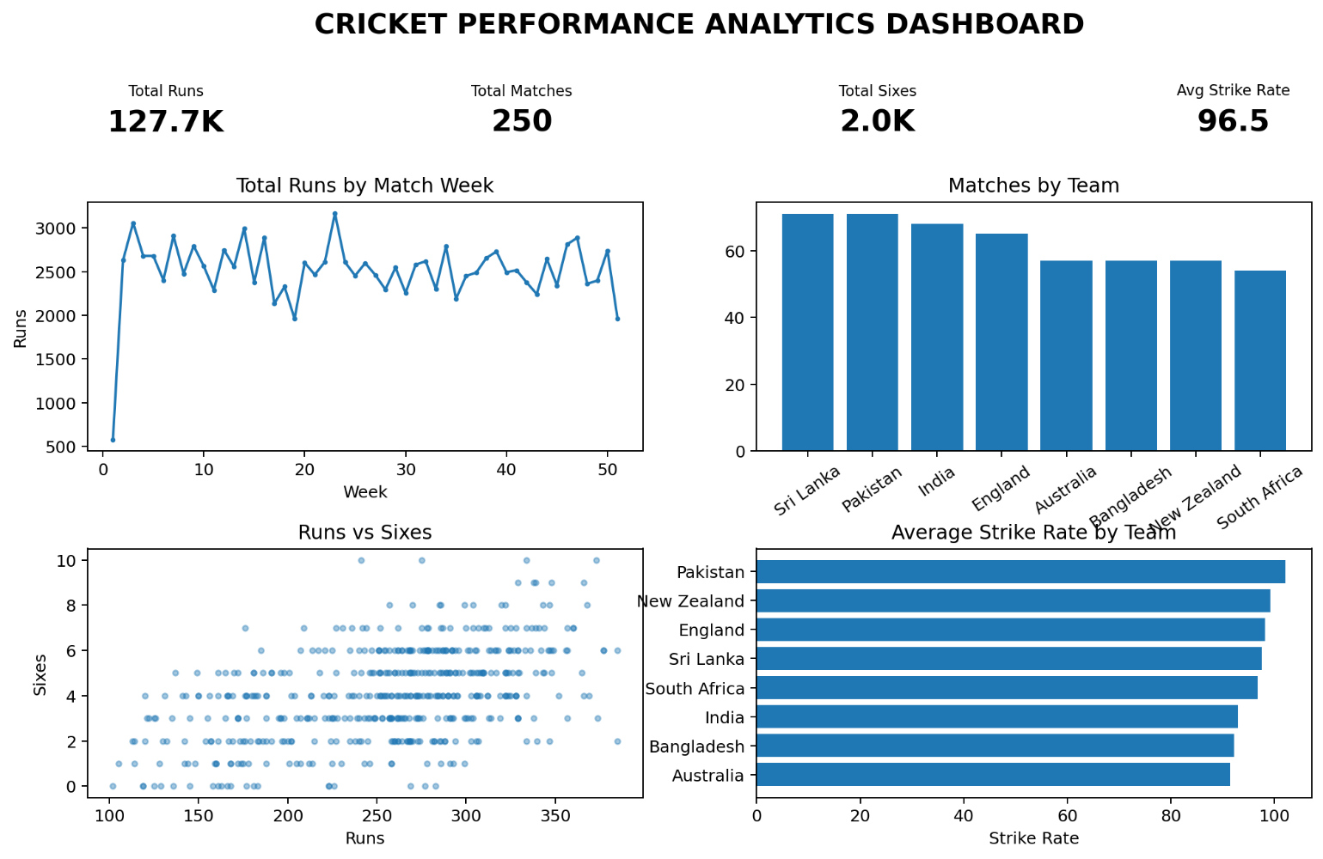

1. Executive Canvas:
Place Card Visuals across the top: Total Runs, Total Matches, Total Sixes, Average Strike Rate
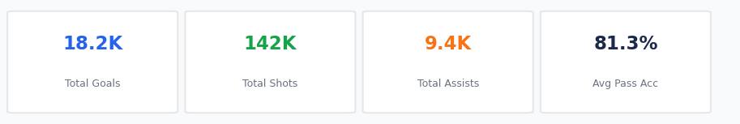
Place Card Visuals across the top: Total Runs, Total Matches, Total Sixes, Average Strike Rate
Add a Line Chart for total runs scored by match week.
Enabled Drill Down

count of matches by team visualised by donut chart

Create 3 slicers based on team, player role and tournament
Scatter plot for total runs and total sixes
average strike rate by player role

Create 3 slicers based on team, player role and tournament
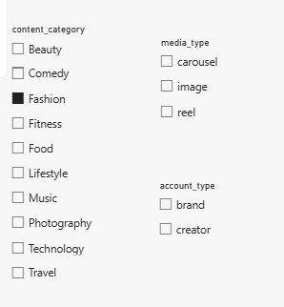

Scatter plot for total runs and total sixes
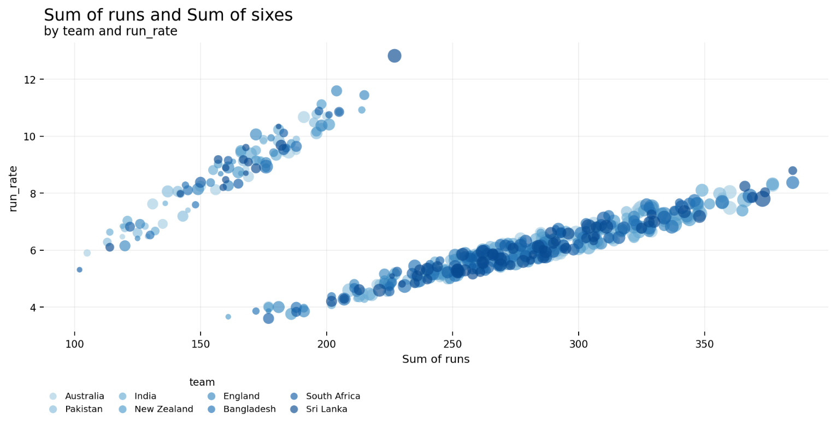

average strike rate by player role
Sixes VS Runs
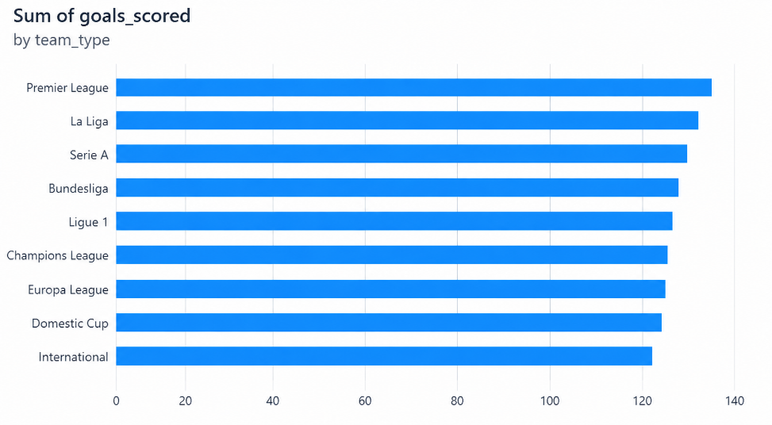
1. The dashboard contains approximately 30K cricket match records with a total of 82K runs. The average strike rate is approximately 82.
This indicates a large volume of match data and provides a useful view of batting output across the season.

Enable drill-through
Teams record different match-result distributions across venues and tournaments.
The displayed dashboard enables comparison of wins, losses, and other results across teams.
This helps identify differences in team performance under different match conditions.
Strike rate varies across player roles, with specialist batters showing the highest average strike rate in the displayed chart.
All-rounders and wicketkeepers show moderate values, while bowlers record comparatively lower batting strike rates.
These differences reflect the different batting responsibilities of the player roles.
Import the cricket data from SQL Server
Run-scoring rate changes across match weeks, reaching its highest level in the later part of the displayed season.
This indicates noticeable variation in batting performance throughout the season.
FINAL DASHBOARD :
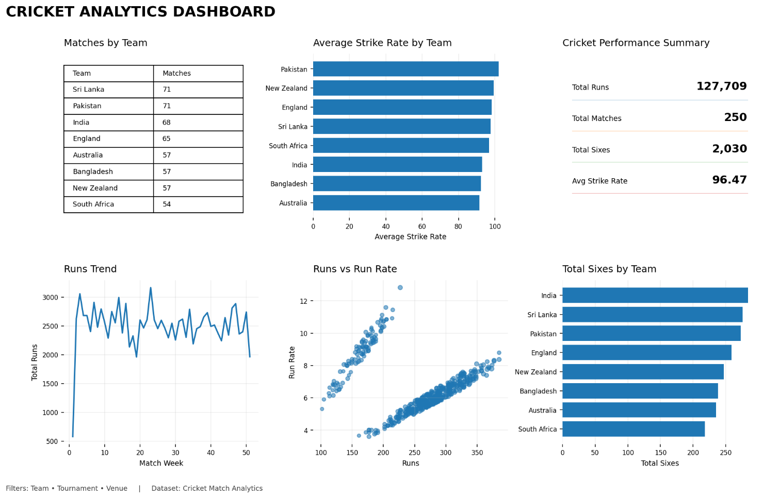

Build parameters
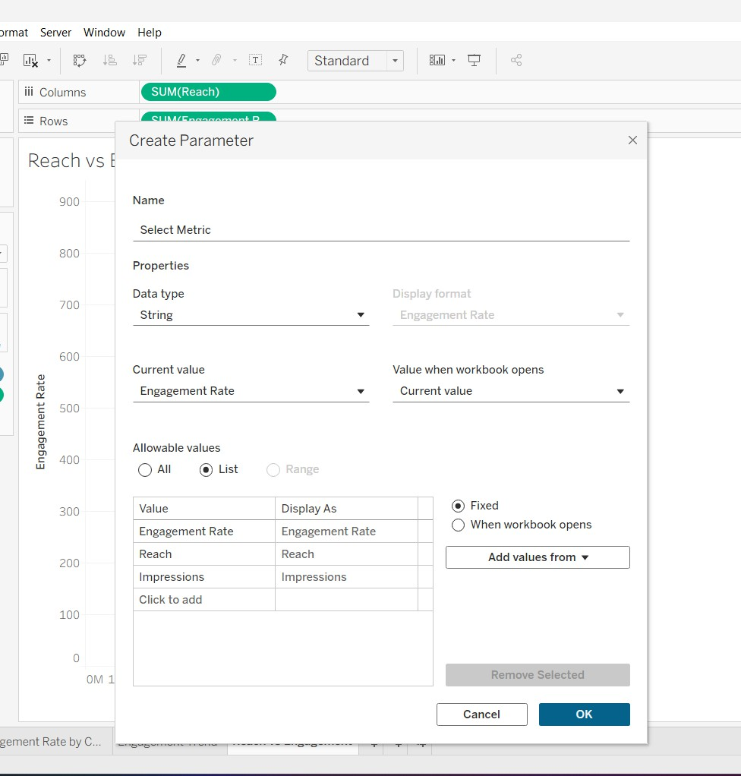

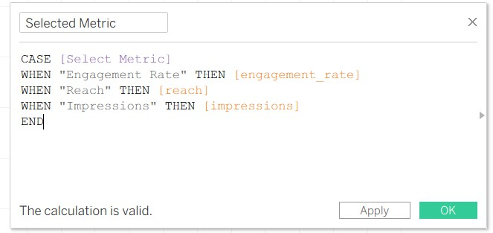

Create a table to display matches by tournament

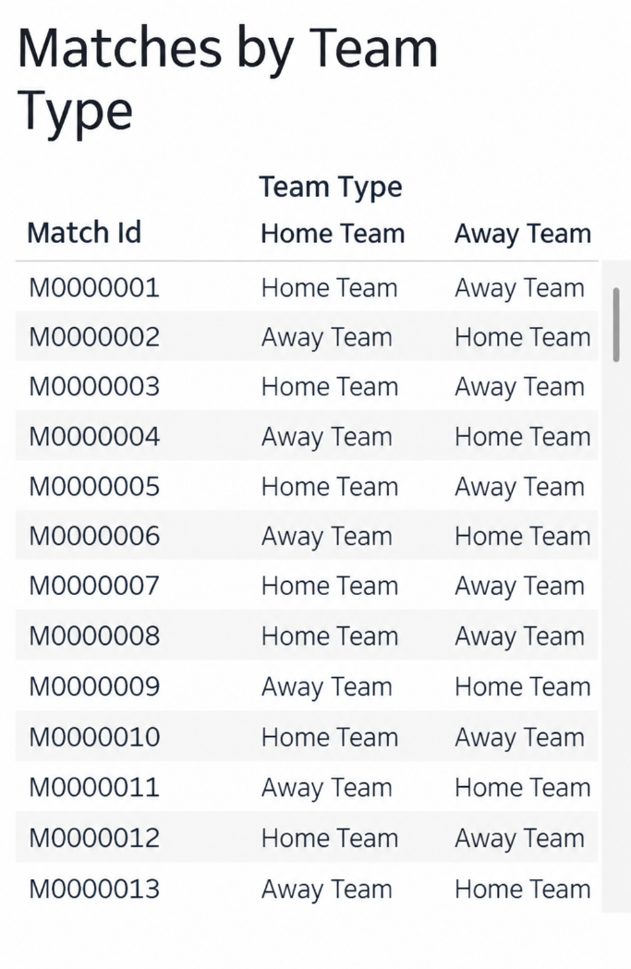
to display average strike rate by player role
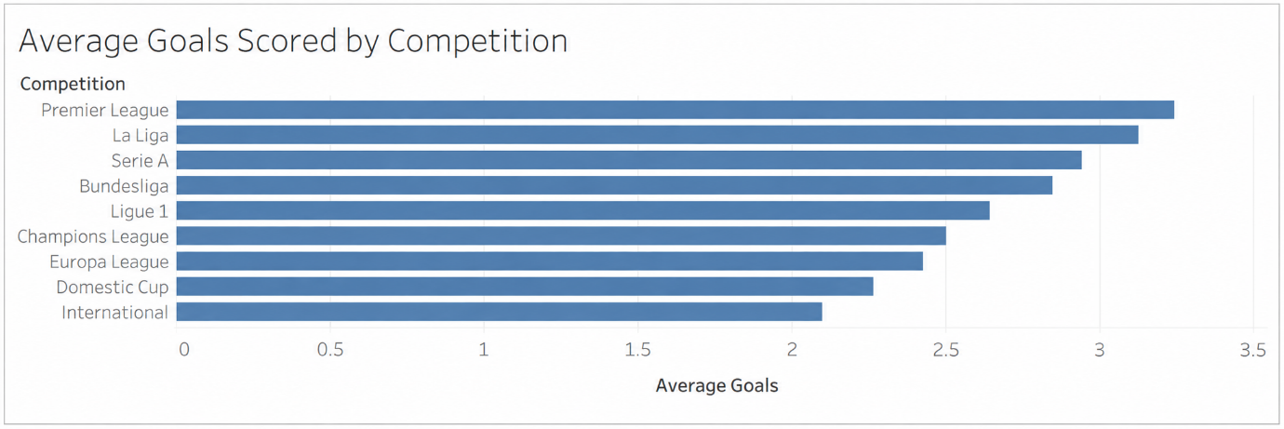

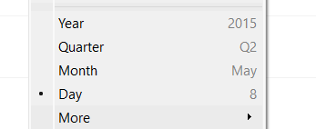

Sixes VS Runs

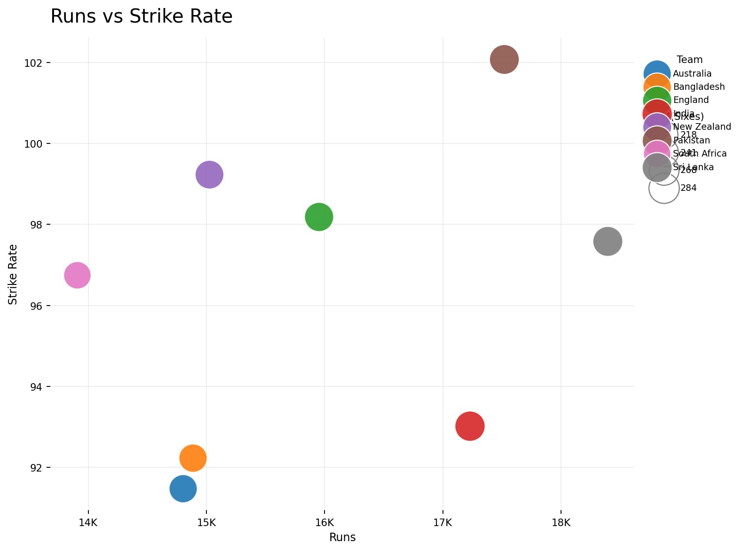

Observed Insights
- The dashboard contains approximately 30K cricket match records with a total of 82K runs. The average strike rate is approximately 82.This indicates a large volume of match data and provides a useful view of batting output across the season.
- Teams record different match-result distributions across venues and tournaments.The displayed dashboard enables comparison of wins, losses, and other results across teams.This helps identify differences in team performance under different match conditions.
- Strike rate varies across player roles, with specialist batters showing the highest average strike rate in the displayed chart. All-rounders and wicketkeepers show moderate values, while bowlers record comparatively lower batting strike rates.
- Run-scoring rate changes across match weeks, reaching its highest level in the later part of the displayed season.This indicates noticeable variation in batting performance throughout the season.

