XPT
NO:02 EDA – DATA CLEANING
AIM:
To inspect the Students Performance dataset, identify its features and missing values, analyze its basic structure, and export the data into CSV, Excel, and SQLite database formats.
PROCEDURE:
1. Import the required libraries Pandas, OS, and SQLite3.
2. Specify the dataset path and identify the CSV file.
3. Load the StudentsPerformance.csv file using pd.read_csv().
4. Display the first five and last five records.
5. Inspect the dataset using .info(), .shape, .columns, and .dtypes.
6. Generate descriptive statistical information using .describe().
7. Identify missing values using .isnull().sum().
8. Check for duplicate records using .duplicated().sum().
9. Analyze gender-wise and category-wise distributions.
10. Generate the correlation matrix for numerical attributes.
11. Export the DataFrame into CSV and Excel formats.
12. Connect to an SQLite database using sqlite3.
13. Store the DataFrame in an SQL table using .to_sql().
14. Close the database connection.
15. Display a confirmation message after successful file creation.

CODE:
import os
import pandas as pd
import sqlite3
# Dataset path
path = "/content"
print("Dataset path:", path)
# Load dataset
csv_file = "StudentsPerformance.csv"
df = pd.read_csv(csv_file)
print("\nFirst 5 rows:")
display(df.head())

print("\nLast 5 rows:")
display(df.tail())
print("\nDataset information:")
df.info()
print("\nShape:")
print(df.shape)
print("\nColumns:")
print(df.columns.tolist())
print("\nData types:")
print(df.dtypes)
print("\nStatistical description:")
display(df.describe(include="all").T)
print("\nMissing values:")
display(df.isnull().sum().sort_values(ascending=False))
print("\nDuplicate rows:")
print(df.duplicated().sum())

print("\nGender Distribution:")
display(df["gender"].value_counts())
print("\nRace/Ethnicity Distribution:")
display(df["race/ethnicity"].value_counts())
print("\nParental Level of Education:")
display(df["parental level of education"].value_counts())
print("\nTest Preparation Course:")
display(df["test preparation course"].value_counts())
print("\nCorrelation:")
display(df.corr(numeric_only=True))

# Export CSV
df.to_csv("students_performance.csv", index=False)
# Export Excel
df.to_excel("students_performance.xlsx", index=False)
# SQLite database
conn = sqlite3.connect("students_performance.db")
df.to_sql(
"student_performance",
conn,
if_exists="replace",
index=False
)
conn.close()
print("\nCSV, Excel and SQLite database files created successfully.")

OUTPUT:
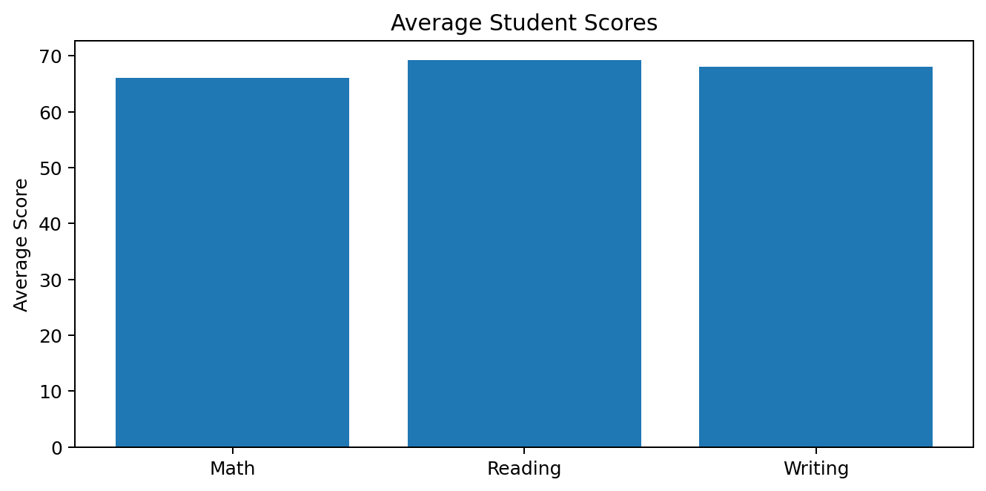

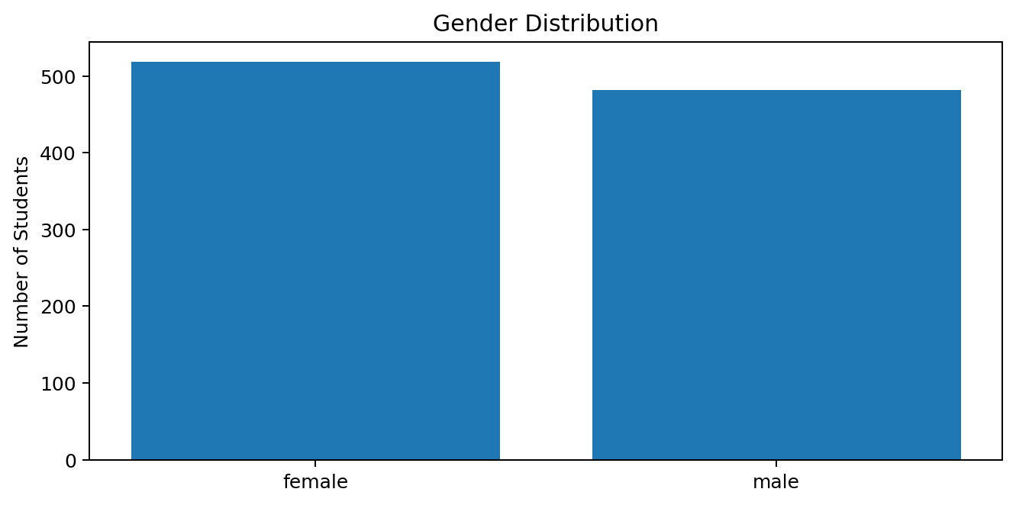
Result:
Analysis completed successfully!

