EXPT NO:03
EDA-DATA INSPECTION AND ANALYSIS
AIM:
To inspect and analyze the Students Performance dataset using Exploratory Data Analysis (EDA) by examining its structure, statistical characteristics, missing values, and by filtering students based on gender and test preparation course.
ALGORITHM
PROCEDURE:
1. Start the program.
2. Import the required libraries Pandas, NumPy, and Matplotlib.
3. Load the Students Performance dataset using Pandas.
4. Display the first five and last two records.
5. Display the shape, column names, data types, and dataset information.
6. Generate the statistical summary of numerical attributes.
7. Check for missing values in the dataset.
8. Create a DataFrame containing important student attributes such as gender, race/ethnicity, parental education, test preparation course, and scores.
9. Filter students who completed the test preparation course.
10. Filter students belonging to the female gender.
11. Display the filtered results.
12. Generate suitable charts for score distribution and gender distribution.
13. Interpret the obtained results.
14. End the program.

CODE:
import pandas as pd
import numpy as np
import matplotlib.pyplot as plt
# Load Dataset
file_path = "StudentsPerformance.csv"
df = pd.read_csv(file_path)
# Select Important Columns
student_df = pd.DataFrame({
"Gender": df["gender"].head(5).tolist(),
"Race_Ethnicity": df["race/ethnicity"].head(5).tolist(),
"Parental_Education": df["parental level of education"].head(5).tolist(),
"Test_Preparation": df["test preparation course"].head(5).tolist(),
"Math_Score": df["math score"].head(5).tolist(),
"Reading_Score": df["reading score"].head(5).tolist(),
"Writing_Score": df["writing score"].head(5).tolist()
})
print("Original DataFrame:")
display(student_df)

# 1. First 5 Rows
print("\n1. First 5 rows:")
display(student_df.head())
# 2. Last 2 Rows
print("\n2. Last 2 rows:")
display(student_df.tail(2))
# 3. Shape
print("\n3. Shape:")
print(student_df.shape)
# 4. Column Names
print("\n4. Column Names:")
print(student_df.columns)
# 5. Data Types
print("\n5. Data Types:")
print(student_df.dtypes)
# 6. Statistical Summary
print("\n6. Statistical Summary:")
display(student_df.describe())

# 7. Missing Values
print("\n7. Missing Values:")
display(student_df.isnull().sum())
# 8. Students who completed test preparation
print("\n8. Students who completed test preparation:")
completed = df[df["test preparation course"] == "completed"][[
"gender",
"race/ethnicity",
"parental level of education",
"test preparation course",
"math score",
"reading score",
"writing score"
]].head(10)
display(completed)
# 9. Female Students
print("\n9. Female Students:")
female = df[df["gender"] == "female"][[
"gender",
"race/ethnicity",
"parental level of education",
"test preparation course",
"math score",
"reading score",
"writing score"
]].head(10)
display(female)

# 10. Visualization - Average Scores
avg_scores = df[["math score", "reading score", "writing score"]].mean()
plt.figure(figsize=(10, 5))
plt.bar(["Math", "Reading", "Writing"], avg_scores.values)
plt.title("Average Student Scores")
plt.xlabel("Subject")
plt.ylabel("Average Score")
plt.tight_layout()
plt.show()
# 11. Gender Type Distribution
gender_counts = df["gender"].value_counts()
plt.figure(figsize=(9, 5))
plt.bar(gender_counts.index, gender_counts.values)
plt.title("Gender Distribution")
plt.xlabel("Gender")
plt.ylabel("Number of Students")
plt.tight_layout()
plt.show()
# End
print("\nEDA inspection and filtering completed successfully.")

OUTPUT:
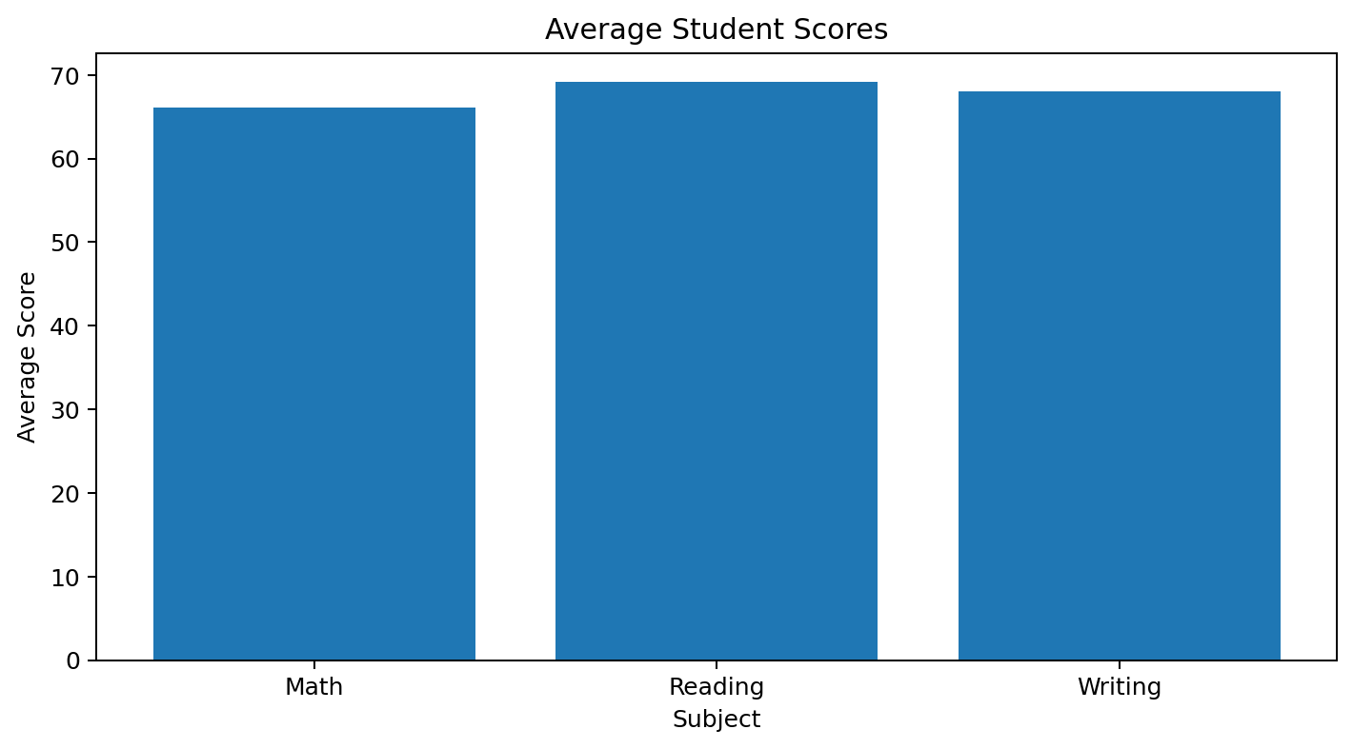

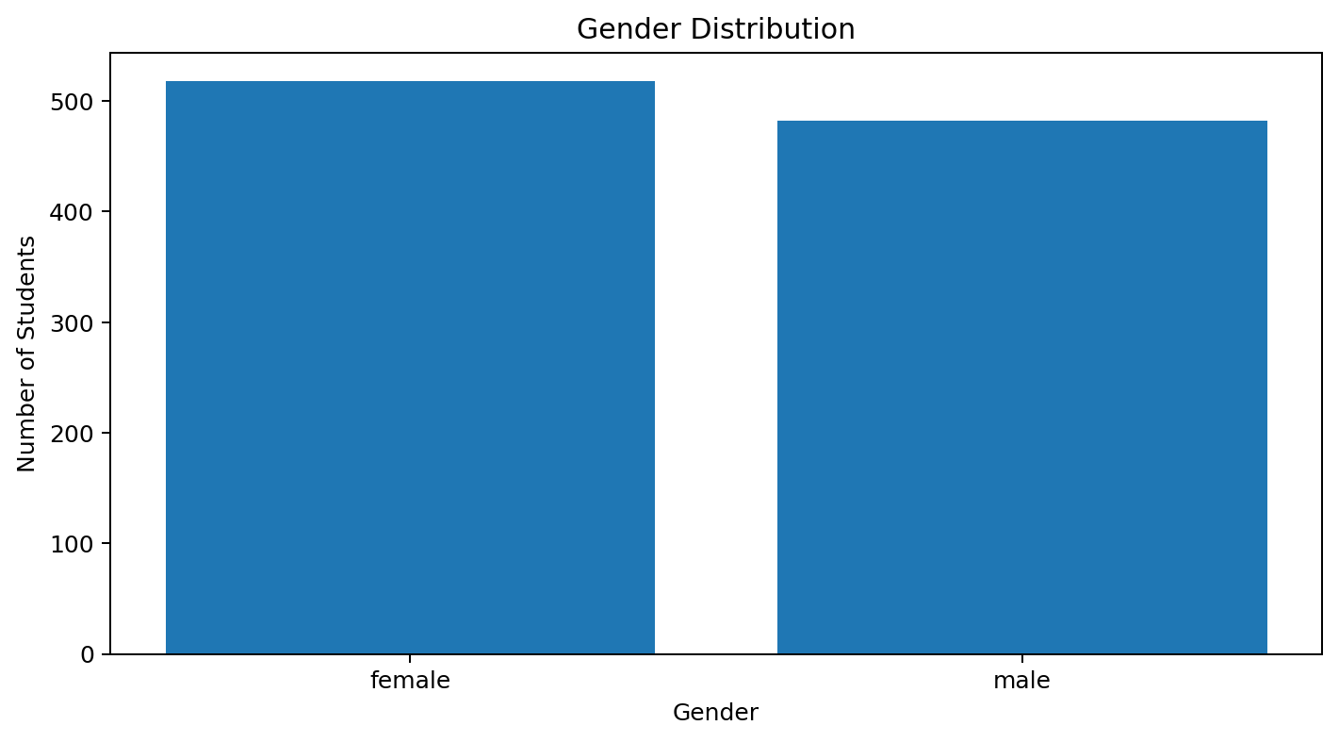
Result:

