EXPT NO:5A
DATA VISUALIZATION USING MATPLOTLIB – STUDENT PERFORMANCE DATA
Aim:
To visualize dataset features and distributions of the Students Performance dataset using line charts, bar charts, pie charts, histograms, scatter plots, and box plots using Matplotlib.
Algorithm:
ALGORITHM 1: LINE CHART
Objective: To visualize student math score trends across the first 20 records.
Steps
1. Load the Students Performance dataset.
2. Select the first 20 student records and their math scores.
3. Plot the math scores using a line chart.
4. Add title and axis labels.
5. Display the graph.
Interpretation
The line chart shows how math scores vary across the selected student records.
ALGORITHM 2: BAR CHART
Objective: To compare average scores in different subjects.
Steps
1. Calculate the average Math, Reading and Writing scores.
2. Create a bar chart using the average scores.
3. Add title and axis labels.
4. Display the chart.
Interpretation
The bar chart helps compare the average performance across the three subjects.

ALGORITHM 3: PIE CHART
Objective: To visualize the contribution of each subject to the total average score.
Steps
1. Calculate the average Math, Reading and Writing scores.
2. Create a pie chart using the average scores.
3. Display percentage labels.
4. Add a suitable title.
5. Display the chart.
Interpretation
The pie chart shows the percentage contribution of each subject to the combined average score.
ALGORITHM 4: HISTOGRAM
Objective: To visualize the distribution of math scores.
Steps
1. Select the Math Score column.
2. Divide the scores into bins.
3. Create a histogram.
4. Add title and axis labels.
5. Display the histogram.
Interpretation
The histogram shows the frequency distribution of student math scores.
ALGORITHM 5: SCATTER PLOT
Objective: To visualize the relationship between reading and math scores.
Steps
1. Select Reading Score as the X-axis variable.
2. Select Math Score as the Y-axis variable.
3. Create a scatter plot.
4. Add title and axis labels.
5. Display the graph.
Interpretation
The scatter plot shows the variation and relationship between reading and math scores.

ALGORITHM 6: BOX PLOT
Objective: To visualize the distribution of math scores.
Steps
1. Select the Math Score column.
2. Create a box plot.
3. Add a suitable title and axis label.
4. Display the plot.
Interpretation
The box plot shows the distribution of math scores and helps identify possible outliers.
ALGORITHM 7: MULTIPLE LINE CHARTS
Objective: To compare Math, Reading and Writing scores across the first 20 students.
Steps
1. Select the first 20 student records.
2. Plot Math scores using a line chart.
3. Plot Reading scores using another line chart.
4. Plot Writing scores using another line chart.
5. Add title, axis labels and legend.
6. Display the graph.
Interpretation
The multiple line chart compares the three subject scores across the selected students.

Program:
import pandas as pd
import matplotlib.pyplot as plt
# Load Students Performance dataset
df = pd.read_csv("StudentsPerformance.csv")
first20 = df.head(20)
students = list(range(1, len(first20) + 1))
math_scores = first20["math score"]
reading_scores = first20["reading score"]
writing_scores = first20["writing score"]
avg_scores = [
df["math score"].mean(),
df["reading score"].mean(),
df["writing score"].mean()
]

Program 1: Line Chart
plt.figure(figsize=(9,5))
plt.plot(students, math_scores, marker="o")
plt.title("Math Scores of First 20 Students")
plt.xlabel("Student Record")
plt.ylabel("Math Score")
plt.show()
# Program 2: Bar Chart
plt.figure(figsize=(8,5))
plt.bar(["Math", "Reading", "Writing"], avg_scores)
plt.title("Average Student Scores")
plt.xlabel("Subject")
plt.ylabel("Average Score")
plt.show()

Program 3: Pie Chart
plt.figure(figsize=(7,7))
plt.pie(avg_scores, labels=["Math", "Reading", "Writing"], autopct="%1.1f%%")
plt.title("Subject Average Score Distribution")
plt.show()
# Program 4: Histogram
plt.figure(figsize=(8,5))
plt.hist(df["math score"], bins=10)
plt.title("Math Score Distribution")
plt.xlabel("Math Score")
plt.ylabel("Frequency")
plt.show()
# Program 5: Scatter Plot
plt.figure(figsize=(8,5))
plt.scatter(df["reading score"], df["math score"])
plt.title("Math Scores vs Reading Scores")
plt.xlabel("Reading Score")
plt.ylabel("Math Score")
plt.show()

Program 6: Box Plot
plt.figure(figsize=(8,5))
plt.boxplot(df["math score"])
plt.title("Math Score Box Plot")
plt.ylabel("Math Score")
plt.show()
# Program 7: Multiple Line Charts
plt.figure(figsize=(10,5))
plt.plot(students, math_scores, label="Math", marker="o")
plt.plot(students, reading_scores, label="Reading", marker="o")
plt.plot(students, writing_scores, label="Writing", marker="o")
plt.title("Math, Reading and Writing Scores")
plt.xlabel("Student Record")
plt.ylabel("Score")
plt.legend()
plt.show()

Output:
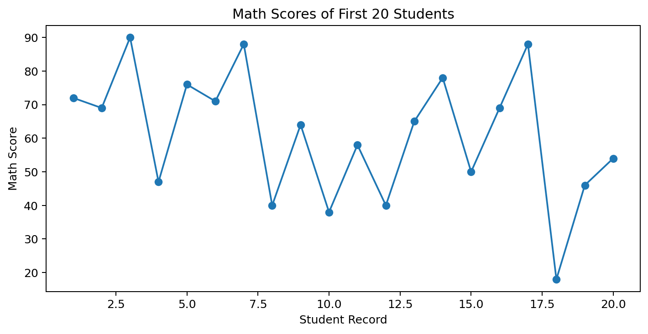
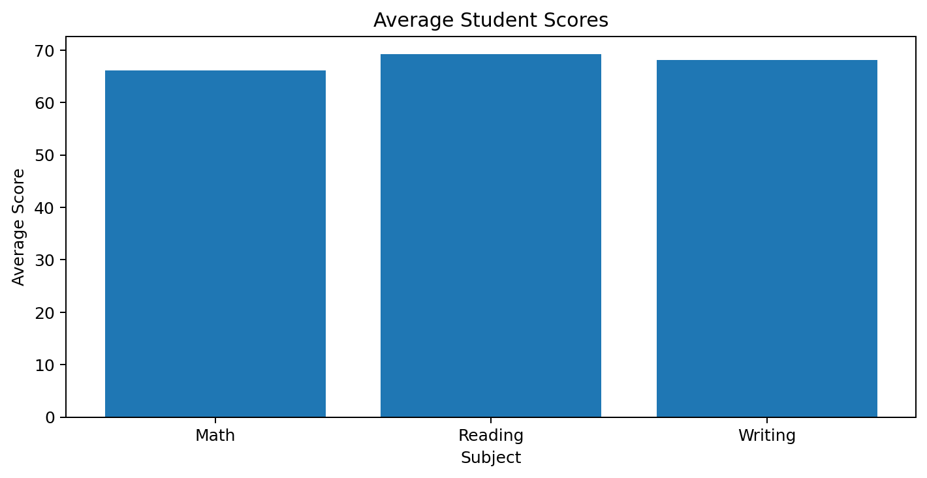

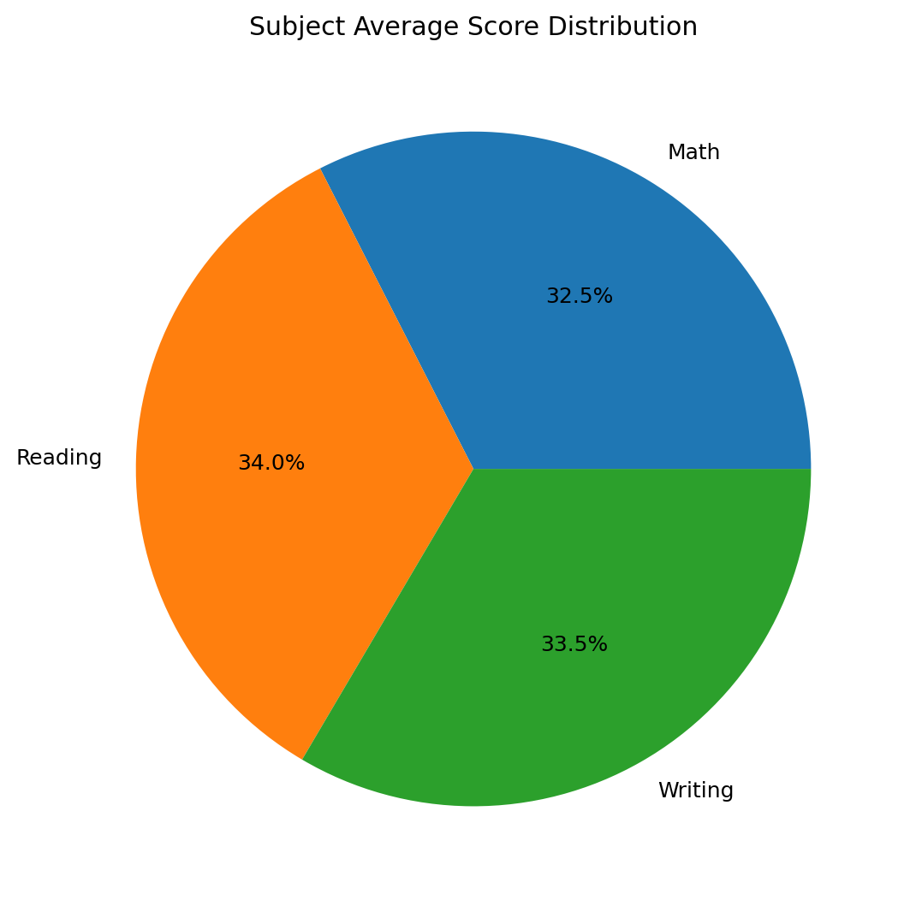
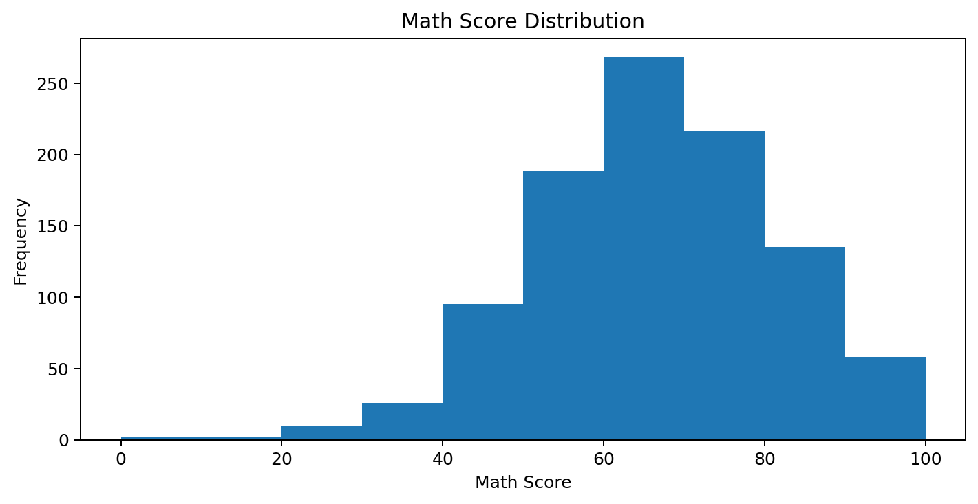

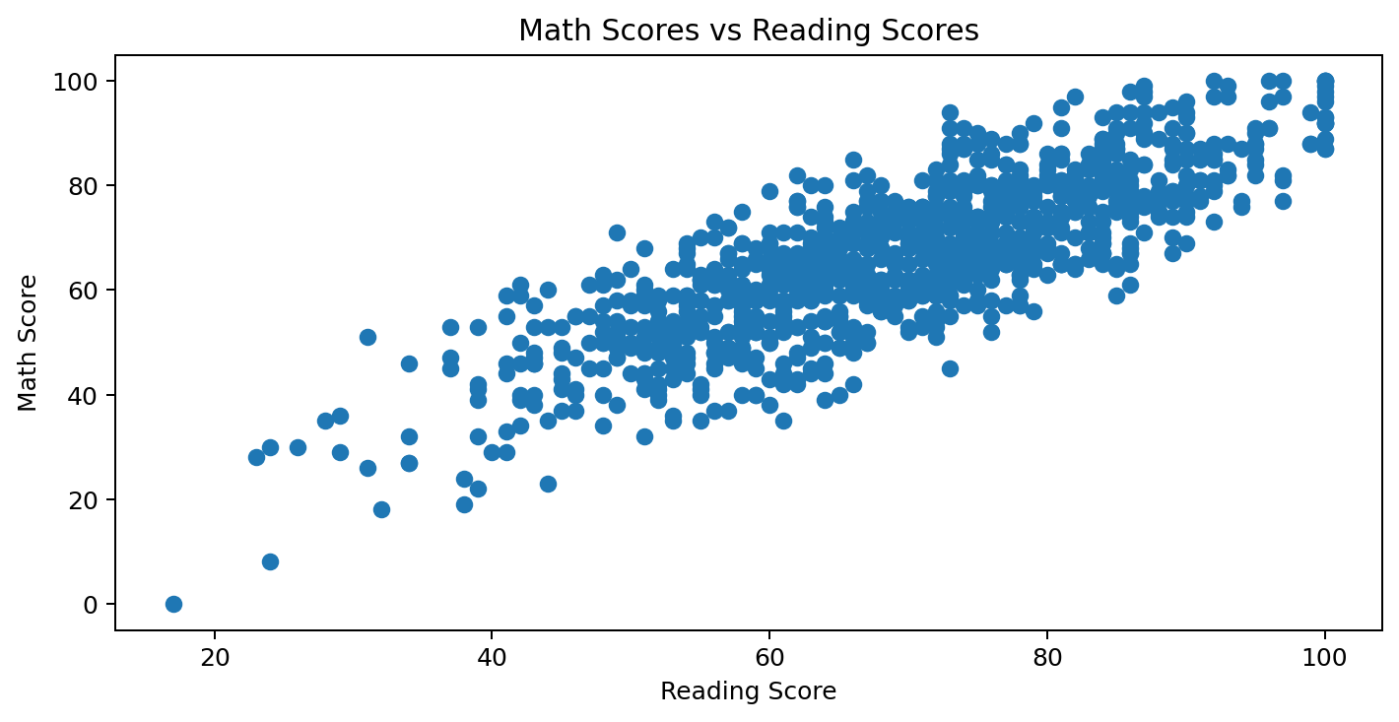
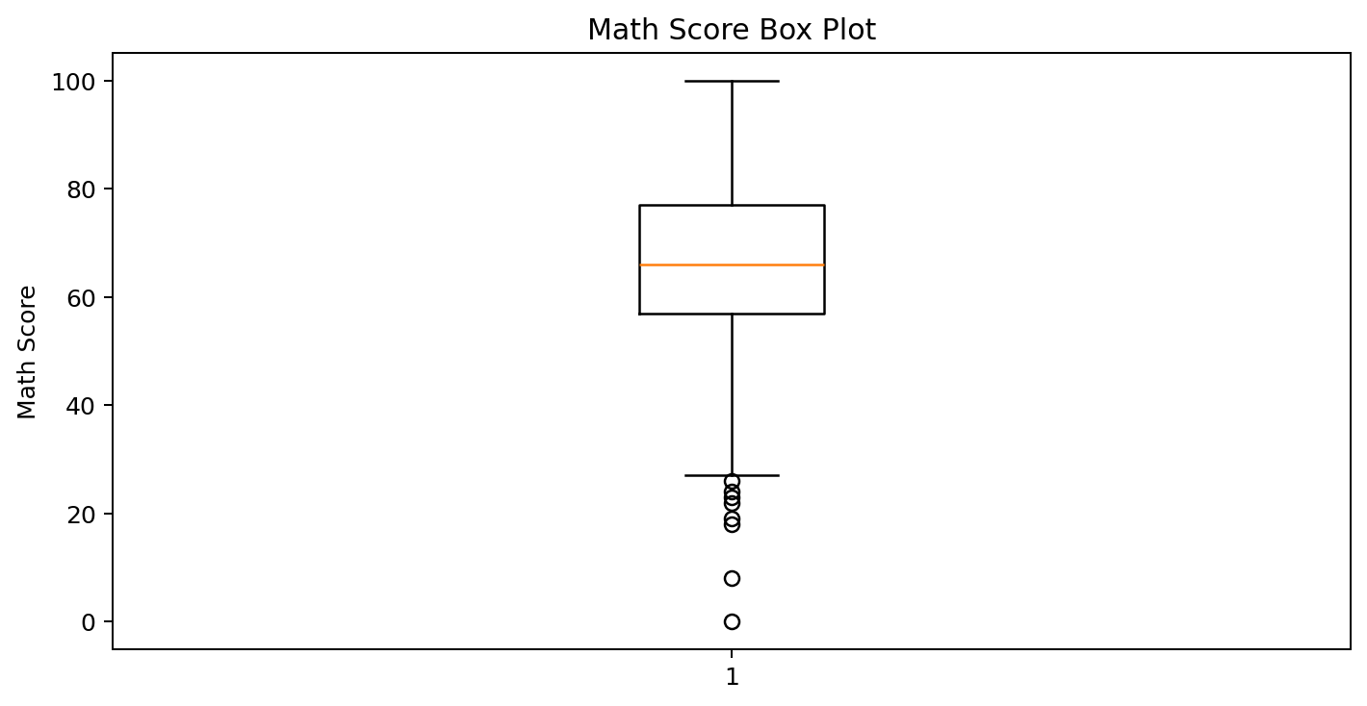

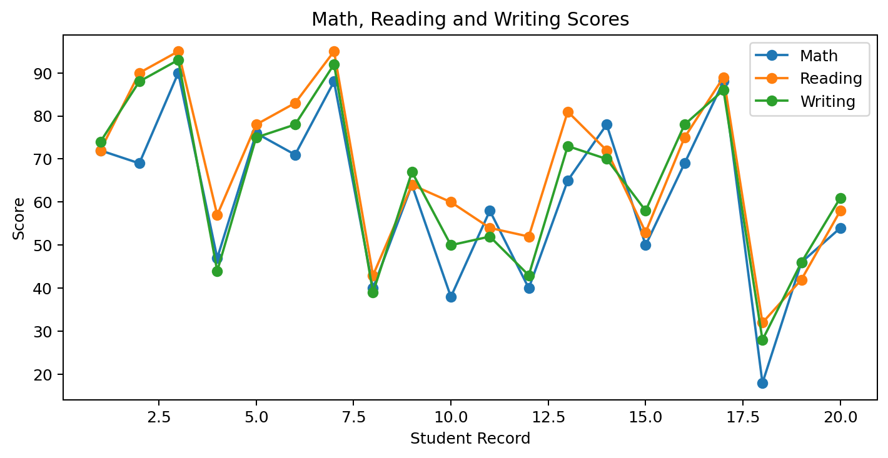
Result:
The Students Performance dataset was successfully visualized using line, bar, pie, histogram, scatter, box, and multiple line charts using Matplotlib.

