EXPT
NO:4A EXPLORATORY DATA ANALYSIS (EDA) – DATA INSPECTION, FILTERING, STATISTICAL ANALYSIS AND CORRELATION
Aim:
To perform data inspection, filtering, grouping, aggregation, descriptive statistical analysis, and correlation analysis on the Students Performance dataset using Pandas and visualize the results using Matplotlib.
Algorithm:
1. Import the required Pandas, NumPy and Matplotlib libraries.
2. Read the StudentsPerformance.csv file using Pandas.
3. Display the dataset and inspect the first few records.
4. Find the number of rows and columns and display the data types.
5. Generate the statistical summary of the dataset.
6. Filter students based on marks and test preparation conditions.
7. Sort the student records based on marks and reading scores.
8. Group the data based on gender and calculate average marks and attendance-related score information.
9. Calculate mean, median, minimum, maximum and standard deviation of marks.
10. Calculate the correlation between math, reading and writing scores.
11. Create bar chart, line chart, scatter plot, histogram and box plot using Matplotlib.
12. Display the results and interpret the obtained data.

Program:
# Import libraries
import pandas as pd
import numpy as np
import matplotlib.pyplot as plt
# Read dataset
df = pd.read_csv("StudentsPerformance.csv")
# Display dataset
print(df)
# Display first five records
print(df.head())
# Display shape
print(df.shape)
# Display data types
print(df.dtypes)

# Display statistical summary
print(df.describe())
# Filter students with math marks greater than 80
print(df[df["math score"] > 80])
# Filter students who completed test preparation
print(df[df["test preparation course"] == "completed"])
# Sort students by math marks
print(df.sort_values("math score", ascending=False))
# Sort students by reading score
print(df.sort_values("reading score", ascending=False))
# Gender-wise average math score
print(df.groupby("gender")["math score"].mean())
# Gender-wise average reading score
print(df.groupby("gender")["reading score"].mean())

# Calculate mean
print("Mean Math Marks:", df["math score"].mean())
# Calculate median
print("Median Math Marks:", df["math score"].median())
# Calculate minimum
print("Minimum Math Marks:", df["math score"].min())
# Calculate maximum
print("Maximum Math Marks:", df["math score"].max())
# Calculate standard deviation
print("Standard Deviation:", df["math score"].std())
# Display correlation matrix
print(df[["math score", "reading score", "writing score"]].corr())
# Display correlation between math and reading
print("Math-Reading Correlation:",
df["math score"].corr(df["reading score"]))

# Bar chart
plt.figure(figsize=(10,5))
plt.bar(
["Math", "Reading", "Writing"],
df[["math score", "reading score", "writing score"]].mean()
)
plt.title("Average Student Scores")
plt.xlabel("Subject")
plt.ylabel("Average Score")
plt.show()
# Line chart
plt.figure(figsize=(10,5))
plt.plot(
range(1, 21),
df["math score"].head(20),
marker="o"
)
plt.title("Math Scores of First 20 Students")
plt.xlabel("Student Record")
plt.ylabel("Math Score")
plt.grid()
plt.show()
# Scatter plot
plt.figure(figsize=(8,5))
plt.scatter(df["reading score"], df["math score"])
plt.title("Math Scores vs Reading Scores")
plt.xlabel("Reading Score")
plt.ylabel("Math Score")
plt.show()

# Histogram
plt.figure(figsize=(8,5))
plt.hist(df["math score"], bins=10)
plt.title("Math Score Distribution")
plt.xlabel("Math Score")
plt.ylabel("Number of Students")
plt.show()
# Box plot
plt.figure(figsize=(8,5))
plt.boxplot(df["math score"])
plt.title("Math Score Box Plot")
plt.ylabel("Math Score")
plt.show()

Output:
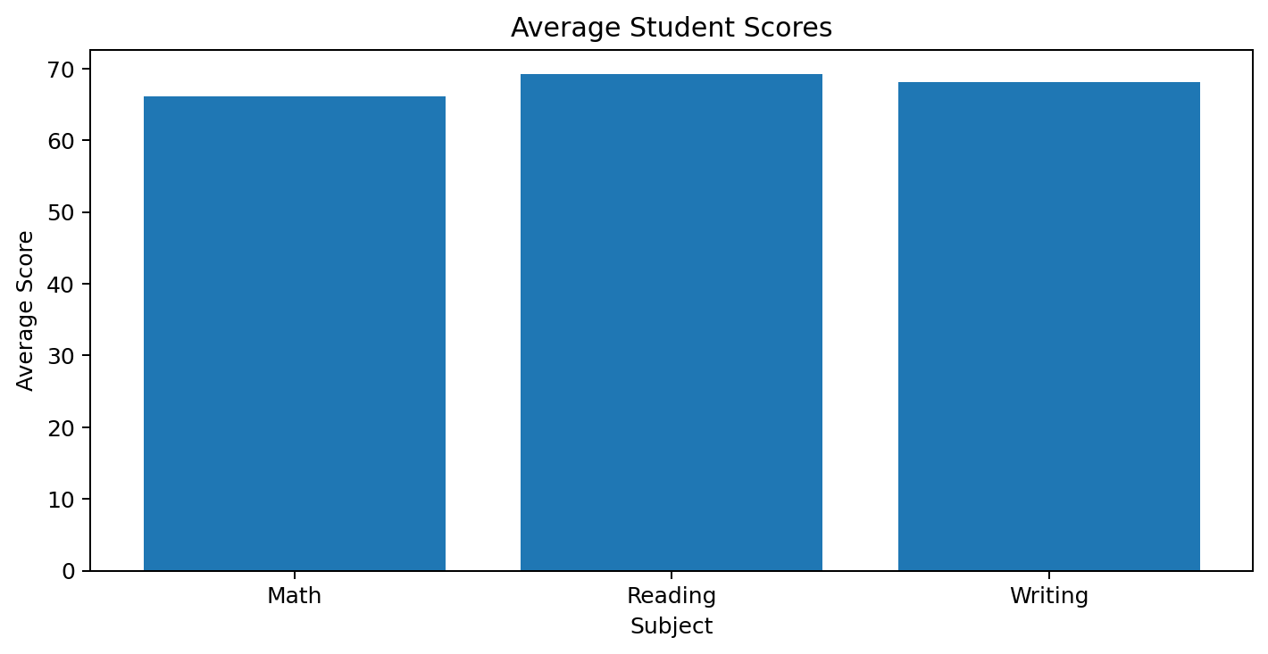
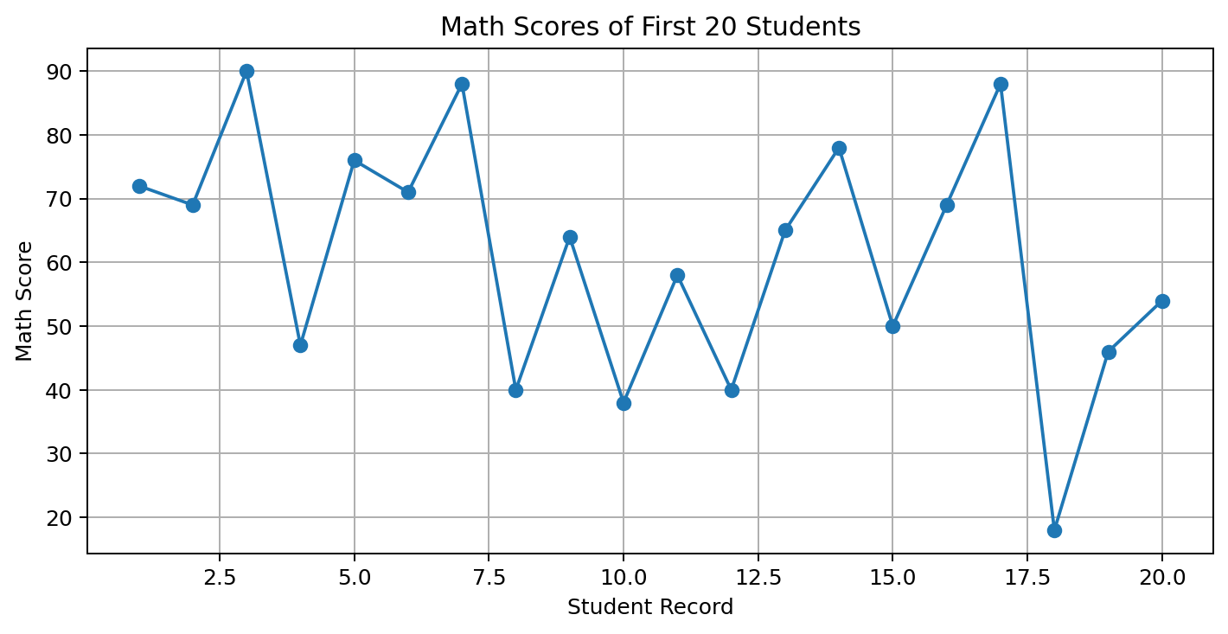

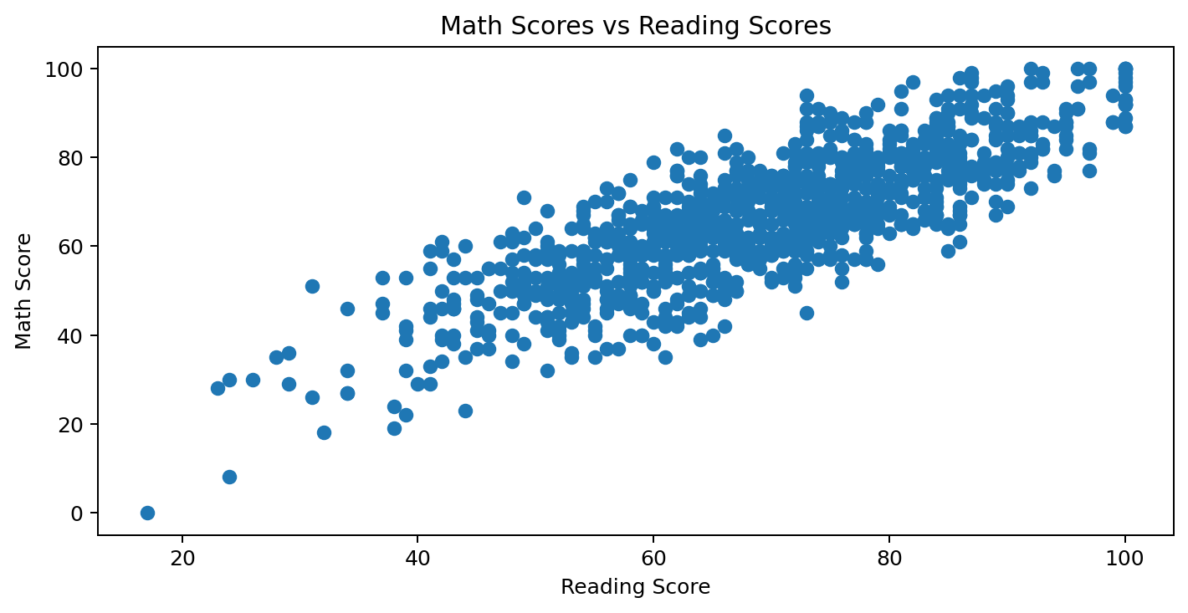
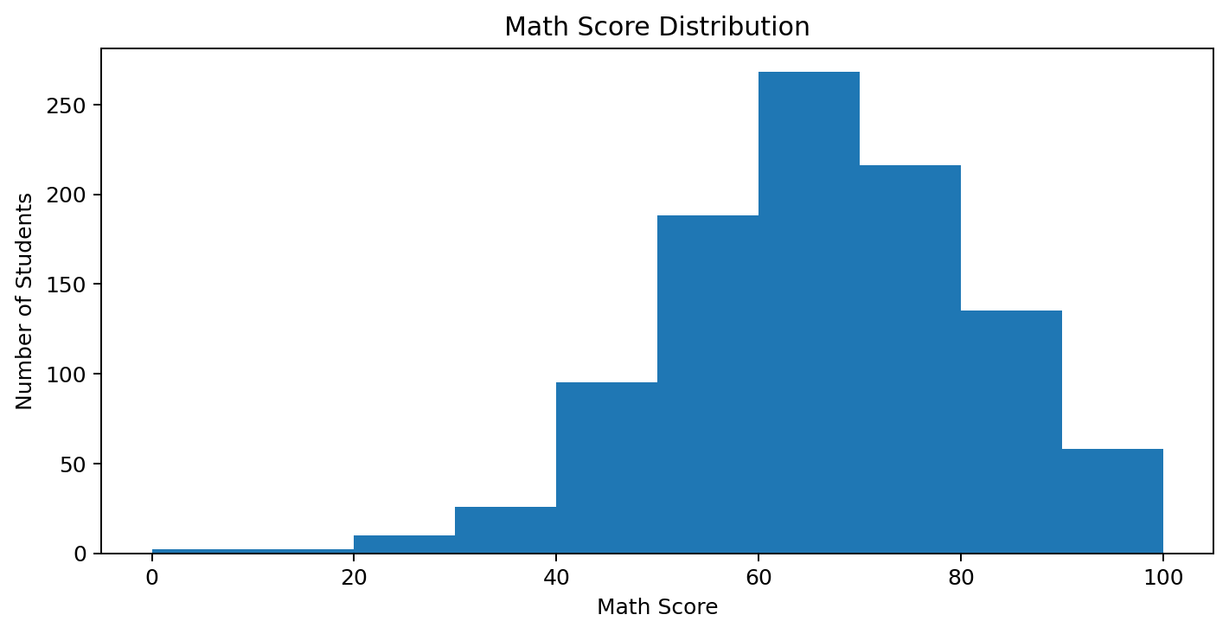

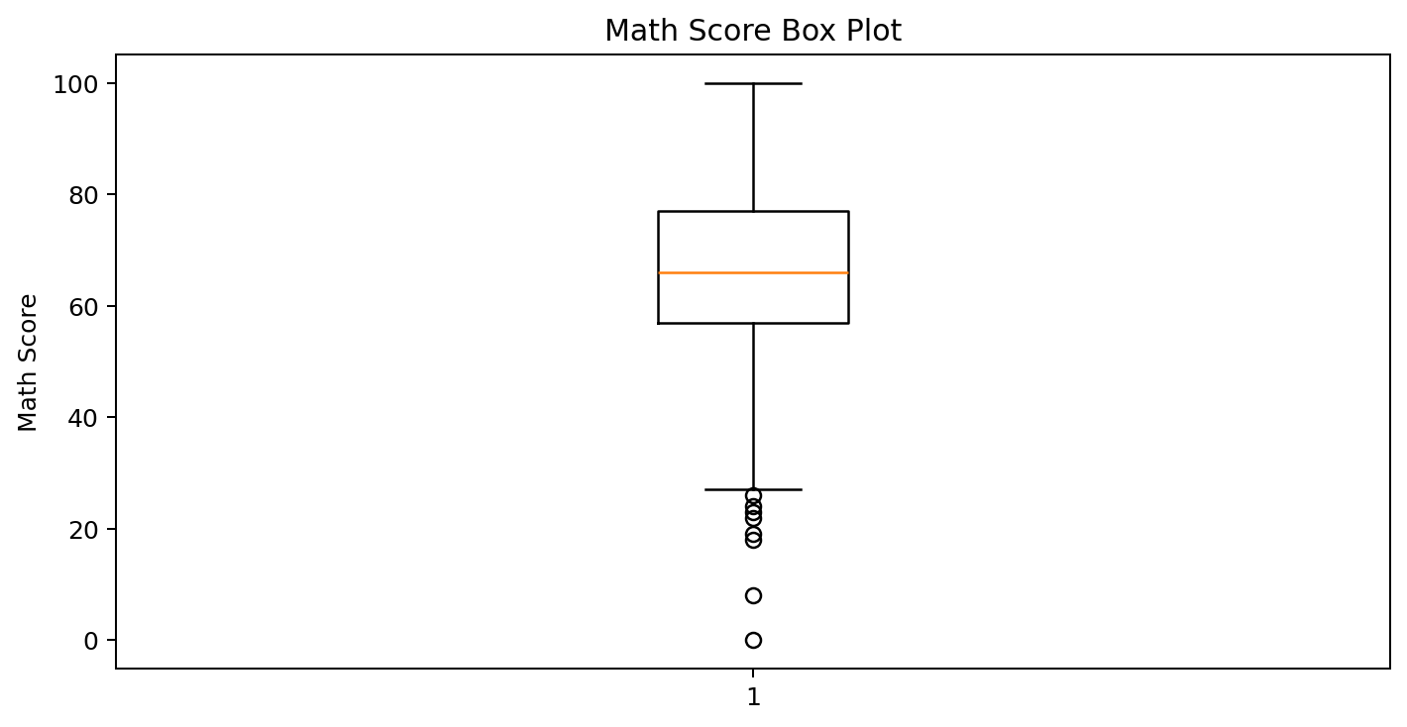
Result:
The Students Performance dataset was inspected, filtered, grouped and statistically analyzed. Correlation analysis and the required Matplotlib visualizations were successfully performed.

