Design patterns

Singleton Pattern:

* Ensures that only one instance of a class is created.
* Provide a global point of access to it
* A solution is to make the class itself responsible for keeping track of its sole instance.
  + Hide the constructor of the class(declared private).
  + Define a public static operation that returns the sole instance of the class.

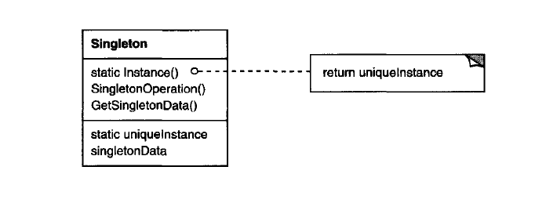

A screenshot of a cell phone

Description generated with very high confidence

With reflection it can be changed:

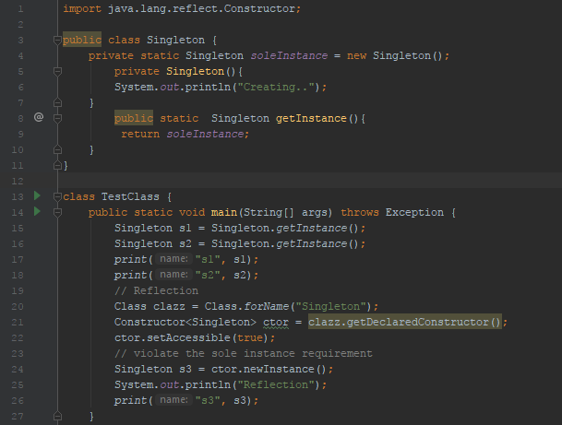

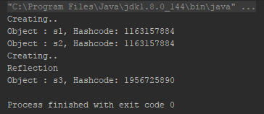

* Reflection – how to fix?

Lazily initialize and check of the instance is already created with in the constructor.

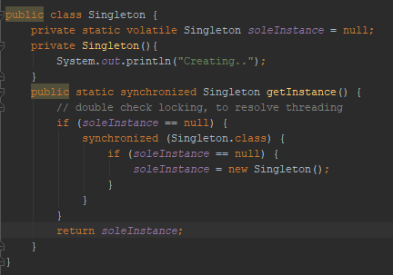

Note: synchronized is not required for the method… Also note the volatile keyword.

**Question**: Which classes in JDK uses singleton pattern?  
Answer: java.lang.Runtime : In every Java application there is only one Runtime instance that allows the application to interface with the environment it is running. The getRuntime is equivalent to the getInstance() method of the singleton class.

**Question**: Can the singleton class be subclassed?  
**Answer**: Frankly speaking singleton is just a design pattern and it can be subclassed. However it is worth to understand the logic or requirement behind subclassing a singleton class as the child class might not inherit the singleton pattern objective by extending the Singleton class. However the subclassing can be prevented by using the final keyword in the class declaration.

**Question**: Can there be multiple instance of singleton using cloning?  
**Answer**: That was a good catch! What do we do now? To prevent the another instance to be created of the singleton instance we can throw exception from inside the clone() method.

Façade design pattern:

* Provide a unified interface to a set of interfaces in a subsystem. Facade defines a higher-level interface that makes the subsystem easier to use.
* Wrap a complicated subsystem with a simpler interface.

**Advantage of Facade Pattern**

* It shields the clients from the complexities of the sub-system components.
* It promotes loose coupling between subsystems and its clients.

**Usage of Facade Pattern:**

It is used:

* When you want to provide simple interface to a complex sub-system.
* When several dependencies exist between clients and the implementation classes of an abstraction.

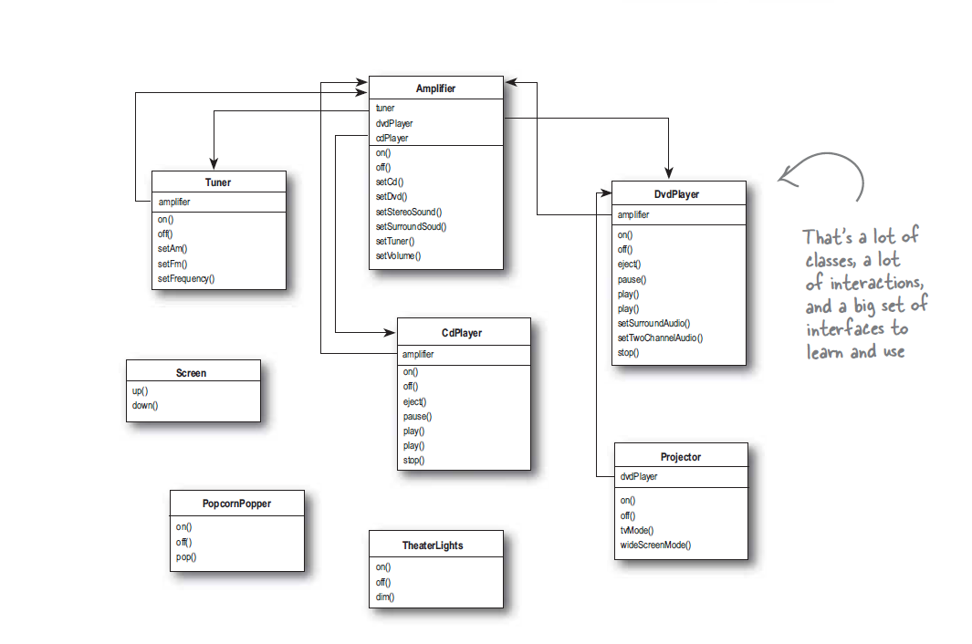

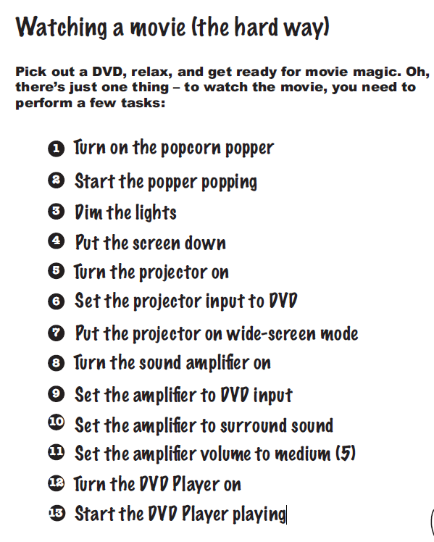

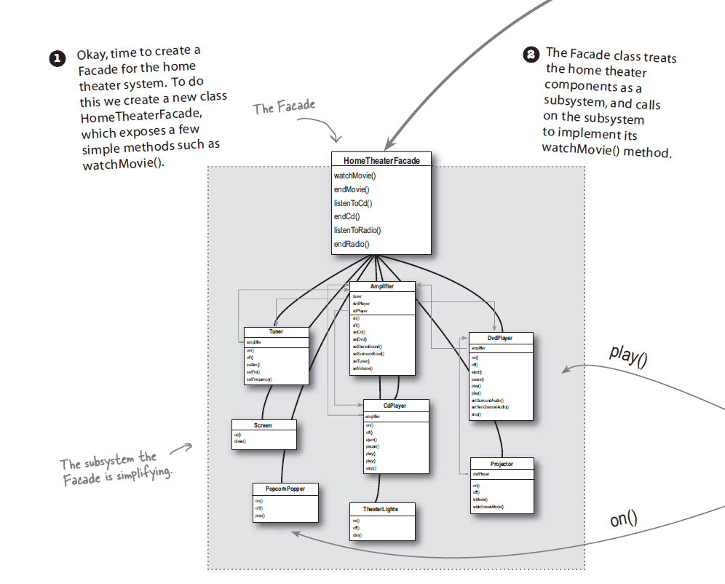

3. Adapter Pattern

***Definition:***

The adapter pattern convert the interface of a class into another interface clients expect. Adapter lets classes work together that couldn’t otherwise because of incompatible interfaces.

**ClassDiagram:**  
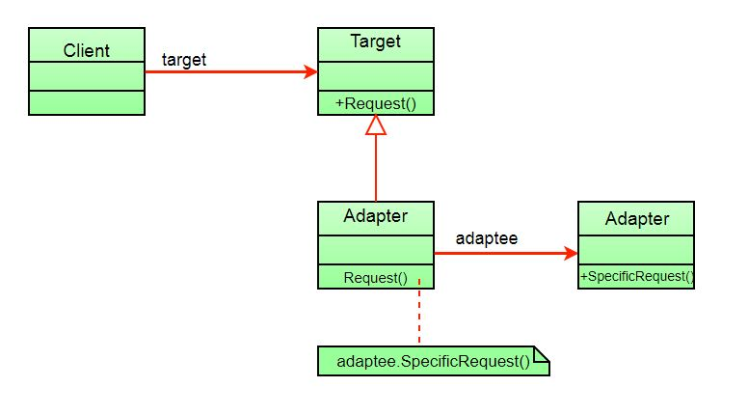

The client sees only the target interface and not the adapter. The adapter implements the target interface. Adapter delegates all requests to Adaptee.

1. The client makes a request to the adapter by calling a method on it using the target interface.
2. The adapter translates that request on the adaptee using the adaptee interface.
3. Client receive the results of the call and is unaware of adapter’s presence.

**Example:**

Suppose you have a Bird class with fly() , and makeSound()methods. And also a ToyDuck class with squeak() method. Let’s assume that you are short on ToyDuck objects and you would like to use Bird objects in their place. Birds have some similar functionality but implement a different interface, so we can’t use them directly. So we will use adapter pattern. Here our client would be ToyDuck and adaptee would be Bird.

Below is Java implementation of it.

|  |
| --- |
| // Java implementation of Adapter pattern    interface Bird  {      // birds implement Bird interface that allows      // them to fly and make sounds adaptee interface      public void fly();      public void makeSound();  }    class Sparrow implements Bird  {      // a concrete implementation of bird      public void fly()      {          System.out.println("Flying");      }      public void makeSound()      {          System.out.println("Chirp Chirp");      }  }    interface ToyDuck  {      // target interface      // toyducks dont fly they just make      // squeaking sound      public void squeak();  }    class PlasticToyDuck implements ToyDuck  {      public void squeak()      {          System.out.println("Squeak");      }  }    class BirdAdapter implements ToyDuck  {      // You need to implement the interface your      // client expects to use.      Bird bird;      public BirdAdapter(Bird bird)      {          // we need reference to the object we          // are adapting          this.bird = bird;      }        public void squeak()      {          // translate the methods appropriately          bird.makeSound();      }  }    class Main  {      public static void main(String args[])      {          Sparrow sparrow = new Sparrow();          PlasticToyDuck toyDuck = new PlasticToyDuck();            // Wrap a bird in a birdAdapter so that it          // behaves like toy duck          ToyDuck birdAdapter = new BirdAdapter(sparrow);            System.out.println("Sparrow...");          sparrow.fly();          sparrow.makeSound();            System.out.println("ToyDuck...");          toyDuck.squeak();            // bird behaving like a toy duck          System.out.println("BirdAdapter...");          birdAdapter.squeak();      }  } |