**Instructions:**

*************************************************************************************************************

1. Download and extract the file from the drive.
2. Open **Welcome.py**
3. Use Pycharm (recommended)
4. Initial Login Details

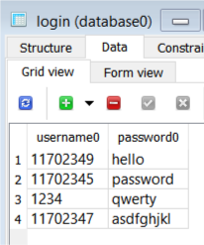

1. One can View the tables and data in the database using SQLiteStudio.
2. One can View the GUI using SpecTcl <[Download](https://sourceforge.net/projects/spectcl/)>