Lecture Note: Phase 2 – Decision Making & Logic

1. Comparison & Logical Operators
To make decisions, Python evaluates conditions as Booleans (True or False).
- Comparison Operators:
  - == (Equal to), != (Not equal to)
  - (Greater than), < (Less than)
  - >=, <= (Greater/Less than or equal to)
- Logical Operators:
  - and: True if both are true.
  - or: True if at least one is true.
  - not: Reverses the result (not True becomes False).

2. The if Statement
The most basic control structure. Code inside the block runs only if the condition is met.
Syntax:
Python
if condition:
# Code to run
Note: Indentation (4 spaces) is mandatory in Python to define the block.

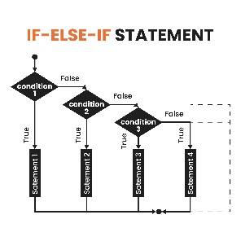
3. Branching with elif and else
Used to handle multiple mutually exclusive paths.
- elif (else if): Checks another condition if the previous ones were False.
- else: The "catch-all" that runs if no conditions were met.
Example:
Python
age = 18
if age >= 21:
print("Full access")
elif age >= 18:
print("Limited access")
else:
print("Access denied")

4. Nested Conditions
You can place an if statement inside another if statement to create complex decision trees. Use this sparingly to maintain code readability.

5. Membership Operators
A quick way to check if a value exists within a sequence (like a string).
- in: Returns True if the value is found.
- not in: Returns True if the value is absent.
- Example: "a" in "apple" is True.

Common Pitfalls
- Assignment vs. Equality: Using = (assign) instead of == (compare) inside an if statement will cause a Syntax Error.
- Missing Colons: Forgetting the : at the end of if, elif, or else lines.
- Indentation Errors: Inconsistent spacing will break the logic flow.

