- Problem1.c
- Problem1output.text (This can be a screen shot of your test case as well under a different format)
- Problem2.c
- Problem2output.text
- Problem3.c
- Problem3output.text
- Problem4.c
- Problem4output.text

- Use a stack implementation, to check that a given an arithmetic expression, that uses braces “{“ & ”}” or parenthesis ”(“ &, ”)” or brackets ”[“ & ”]” as grouping symbols, is using them in a matching and balanced way.
The book has an example function, called isBalance( ), that takes the input string as an argument and returns 0 if it is unbalanced or 1 if it is balanced.
(Examples below are given only for illustrative purposes, you may come up with your own.)

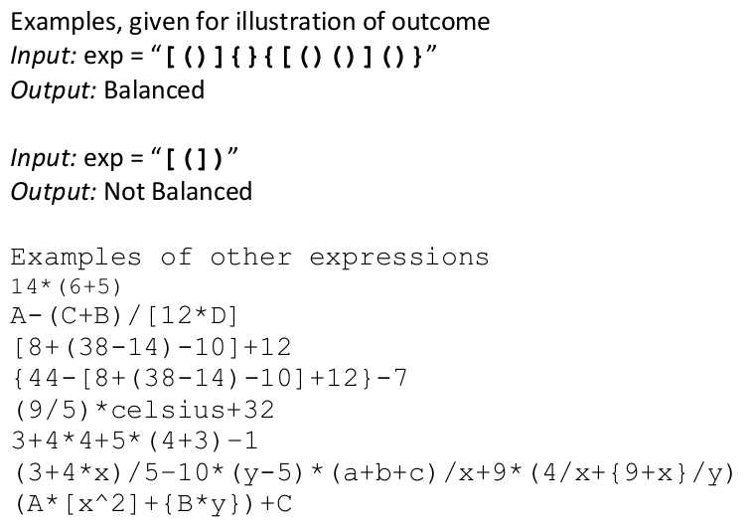

- Use a queue to generate binary number strings.

For example, enqueue "1" onto the queue.
Then dequeue "1", print it, and place "10" and "11" on the queue (add "0" and "1" at the end of the printed item "1"). Dequeue "10", print it, and add "100" and "101" onto the queue, etc. Strings only may be used and you are allowed to use string.h. You can input n from the user and count from 1 to n in binary using the queue.

Suppose you have an empty string and you want to print 1 to 9 binary numbers. Your code will generate the following output:
1
10 11
100 101
1000 1001

You can either choose an array implementation or a linked list implementation of the queue.

