# APPLICATION LAYER DISTRIBUTED DENIAL OF SERVICES ATTACK DETECTION USING DEEP LEARNING MODELS

**Group-11 Team Members**

Akash Reddy Jammula Chaitanya Swarna

# Abstract:

The resilience of application layer services against Distributed Denial of Service (DDoS) attacks is of paramount importance in maintaining the integrity and availability of online services. This study introduces a deep learning-based detection framework that leverages the strengths of Convolutional Neural Networks (CNN) and Long Short-Term Memory (LSTM) networks to identify application layer DDoS attacks. The framework utilizes the CICIDS2017 dataset, which includes a wide array of sophisticated and contemporary attack vectors, serving as a rigorous platform for model training and validation. The chosen deep learning models—CNN and LSTM—are adept at capturing spatial and temporal patterns within data, making them particularly suited for the nuanced task of DDoS detection. Our research aims to seamlessly augment existing network defenses by implementing this advanced analytical capability. Through rigorous testing and validation, the proposed models demonstrate a strong potential in effectively classifying network traffic and distinguishing between benign and malicious activities. The findings of this study contribute to the ongoing efforts to enhance cyber defense mechanisms using the power of deep learning.

# Introduction:

The cybersecurity landscape is increasingly threatened by sophisticated Distributed Denial of Service (DDoS) attacks that target multiple layers of the OSI model, exploiting vulnerabilities from the network level right up to the application layer. These attacks disrupt service availability, especially impacting the application layer due to its direct engagement with users. Our study is dedicated to developing effective detection mechanisms for these complex patterns of attacks using the CICIDS2017 dataset. We employ advanced deep learning techniques, specifically Convolutional Neural Networks (CNN) and Long Short-Term Memory (LSTM) networks, renowned for their capabilities in recognizing complex patterns and analyzing temporal sequences. Our models are designed to identify the subtle and complex behaviors characteristic of application layer DDoS attacks—behaviors that often elude traditional security measures and can closely mimic legitimate traffic, making detection particularly challenging. One of the main challenges we tackle is distinguishing these malicious activities from legitimate traffic, a task complicated by the constantly evolving and increasingly stealthy nature of DDoS strategies. By concentrating on the application layer and leveraging a deep learning-based approach, our research aims to enhance defenses and uphold the integrity of critical services against the dynamic threat posed by DDoS attacks.

## Confronting the Challenges and Limitations in DDoS Detection

Addressing application layer DDoS attacks with deep learning models, while promising, presents several challenges and limitations:

**Data Quality and Availability:** High-quality, diverse, and representative datasets like CICIDS2017 are crucial for training effective models. However, many datasets may not fully capture the latest attack patterns or might lack the variability needed to train models that can generalize well across different network environments.

**Model Complexity:** CNNs and LSTMs are computationally intensive, requiring significant resources for training and inference. This can be a limitation in environments where computational resources are constrained or where real-time response is critical.

**Adaptability:** DDoS attack vectors are continuously evolving, which means models trained on current datasets might quickly become outdated. Continuous retraining and model updating are necessary, which can be resource-intensive.

**False Positives and Negatives:** Balancing the sensitivity of the model to detect attacks without generating too many false alarms is a critical challenge. High rates of false positives can disrupt normal operations, while high rates of false negatives can allow damaging attacks to proceed undetected.

**Scalability:** Scaling these models to operate efficiently across large and diverse networks can be challenging. Ensuring that the detection system can handle large volumes of traffic without degradation in performance or speed is crucial for practical deployment.

**Integration with Existing Systems**: Integrating advanced ML/DL models into existing cybersecurity infrastructures without causing disruptions can be complex. Compatibility with existing protocols and systems must be ensured to achieve seamless operation.

**Interpretability:** Deep learning models, especially those like CNNs and LSTMs, are often considered black boxes, meaning their decision-making process is not easily interpretable. This lack of transparency can be a barrier in security settings where understanding the reason behind a detection is as important as the detection itself.

## The Significance of Mitigating DDoS Threats

Addressing the problem of DDoS attacks, particularly at the application layer, is crucial for several reasons:

**Diversion Tactics:** DDoS attacks can serve as a distraction, allowing attackers to breach data systems unnoticed, leading to theft or corruption of sensitive data.

**Data Ransom and Extortion:** Attackers might leverage DDoS attacks to extort ransom by threatening to escalate or prolong the attack, endangering data integrity and access.

**Compliance Risks:** Many industries face stringent regulations on data protection. DDoS- induced breaches could lead to non-compliance, resulting in significant fines and legal issues.

**Monitoring and Encryption:** Implementing advanced monitoring to detect unusual data patterns and encrypting data are essential. Encryption ensures that, even if data is accessed, it remains unreadable without the proper keys.

**Secure Backup and Recovery:** Maintaining secure and readily accessible backups helps to quickly restore data compromised during a DDoS attack, minimizing downtime and data loss.

# Related Work

## Existing Solutions:

* Solutions using Long Short-Term Memory (LSTM) and fuzzy logic have been developed for detection and mitigation in SDN environments, showing high accuracy but focusing only on high-volume attacks.
* Combining supervised and unsupervised ML techniques has been proposed for detecting DDoS attacks, but these did not use current datasets and were limited in the range of methods and attack types explored.
* A framework using LSTM for slow-rate DDoS detection achieved high performance with specific datasets but had reduced efficacy when applied to different datasets.
* Multilayer Perceptron (MLP) neural networks have been used to detect HTTP-based slow-rate attacks, achieving significant detection rates, although they were not as effective in distinguishing specific types of attacks.

## Limitations of Existing Solutions:

* Many existing works have not utilized up-to-date datasets, which limits their effectiveness against new threats.
* Several studies have been conducted separately on transport or application layer attacks and not on both concurrently.
* Most existing approaches performed an offline analysis of their proposals using traffic captured from testbeds, which may not accurately reflect real-world network complexities and constraints.
* The accuracy of some ML/DL models decreases when the network topology changes, suggesting a need for retraining or adaptive models that can maintain high performance in varying network environments.

## System Design:

Our system design integrates Convolutional Neural Networks (CNN) and Long Short-Term Memory (LSTM) models, tailored for the specific challenge of detecting Application Layer Distributed Denial of Service (DDoS) attacks. The flowchart outlines a structured approach from data preprocessing to model evaluation, facilitating efficient detection and mitigation of DDoS threats. Each phase of the process is meticulously designed to maintain data fidelity, model robustness, and adaptability to evolving attack patterns. Continuous refinement mechanisms ensure that the deployed models remain effective in safeguarding against the dynamic nature of DDoS attacks, enhancing network security resilience over time.

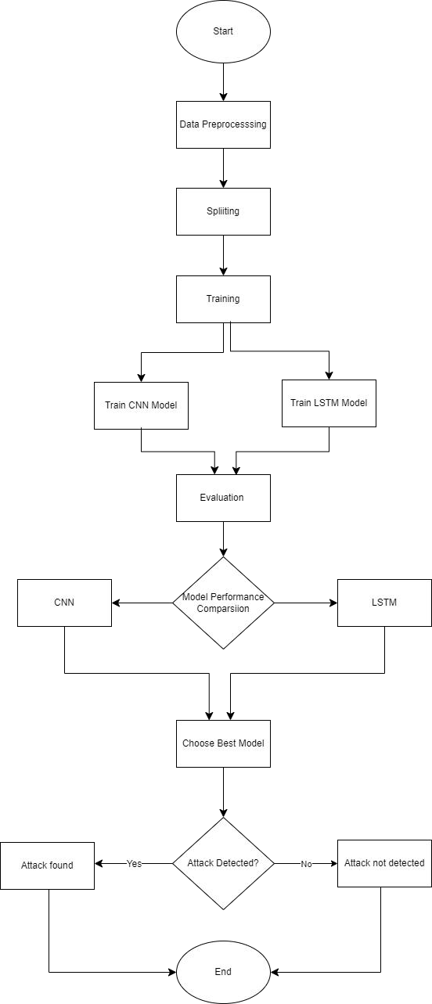

## How the system is working? Data Preprocessing:

In the preprocessing phase, several steps are undertaken to prepare the data for model training. Feature selection involves choosing relevant attributes from the dataset that capture characteristics indicative of DDoS attacks. Finally, the dataset is split into training, validation, and testing sets for model development and evaluation.

## Model Training:

Two deep learning architectures, Convolutional Neural Network (CNN) and Long Short-Term Memory (LSTM), are designed and trained using the preprocessed data. The CNN model is tailored to learn spatial patterns and features from the network traffic data, while the LSTM model is optimized to capture temporal dependencies and sequences within the data.

## Model Evaluation:

Post-training, the models undergo rigorous evaluation in the Model Evaluation Module. Here, their performance is assessed using relevant evaluation metrics such as accuracy, precision, recall, and F1-score. This step serves to quantify the effectiveness of each model in accurately identifying DDoS attacks within the application layer.

## Model Comparison:

A comparative analysis is conducted to determine which deep learning model, CNN or LSTM, performs better in detecting DDoS attacks at the application layer. Based on the evaluation results, the model with superior performance is selected for further deployment and integration.

## Detection of Attack:

It focus on alerting system administrators or security teams for further investigation and response. Once the attack is detected, the system sends an alert to the system administrator, enabling them to investigate the issue promptly and prevent potential data loss or service disruption.

In conclusion, the project demonstrates the effectiveness of utilizing deep learning models for detecting application layer DDoS attacks. By following the systematic approach outlined in this system design, the project contributes to enhancing network security and resilience against cyber threats, safeguarding critical infrastructure and services. Opportunities for future enhancements and research directions are also discussed to further improve the detection system's capabilities.

## Contributions by the Team for the Project:

Our team is currently engaged in the development of an application-layer distributed denial of service (DDoS) attack detection system. Akash Reddy spearheads the Data Preprocessing Module, focusing on optimizing the Convolutional Neural Network (CNN) architecture. Concurrently, Chaitanya is deeply involved in refining data preprocessing techniques and fine- tuning the Long Short-Term Memory (LSTM) architecture. Together, we are collaboratively establishing model selection criteria and gearing up for the execution phase.