STEP 1: Open IntelliJ IDEA Ultimate

Launch IntelliJ IDEA Ultimate from your system.

STEP 2: Create a New Web Application Project
- create a new project
- template: select web application
-project name: calculator
-App server: Tomcat

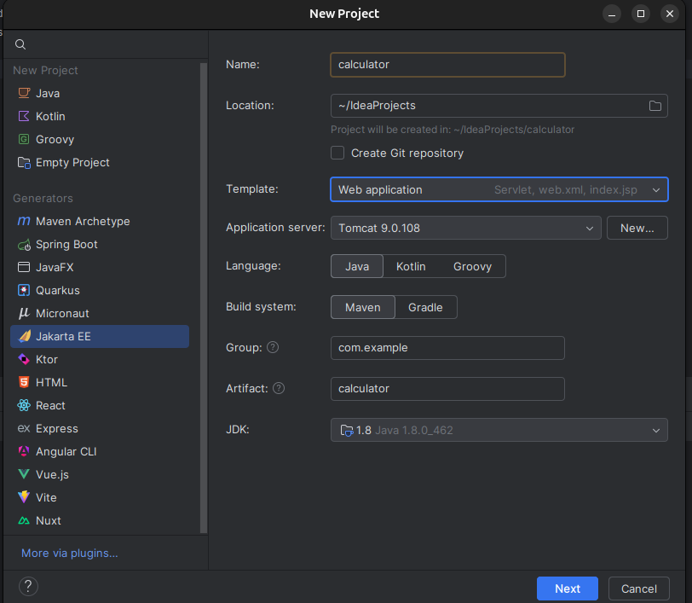
STEP 3: Create OperatorService Class

-Inside calculator→src→main→java→com.example.calculator
-Create new java class named OperatorService
-Add below code
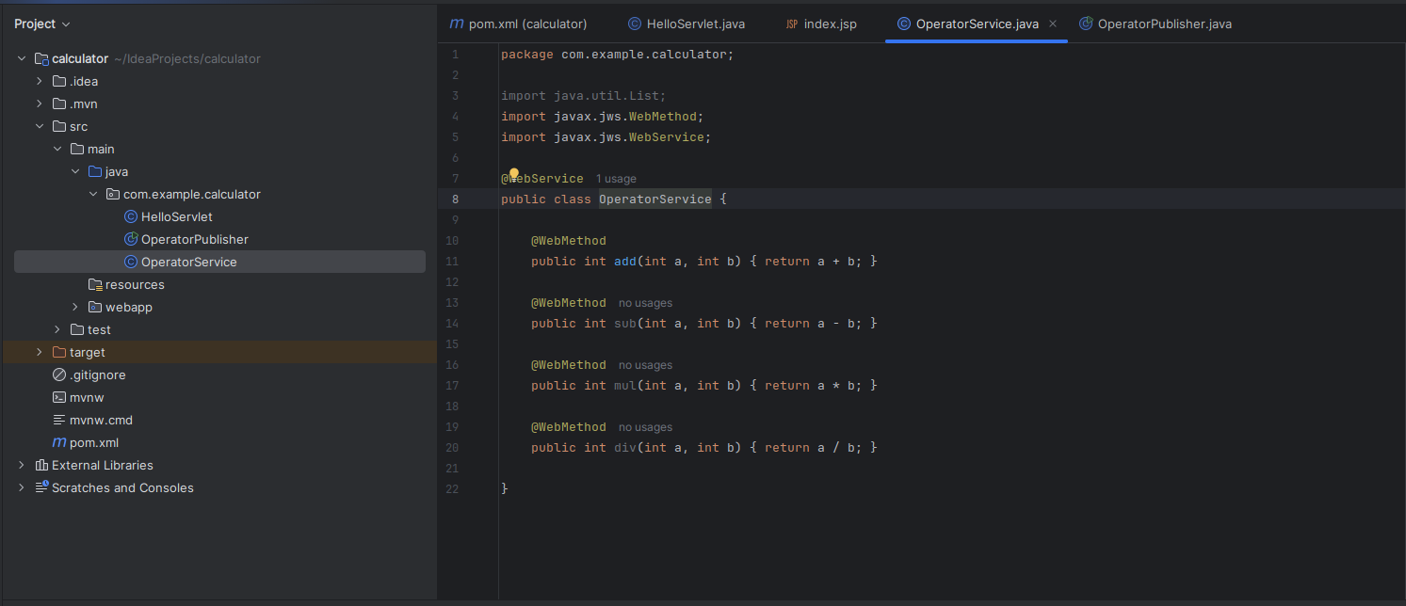
-Add below code
STEP 4: Create OperatorPublisher Class

-Inside calculator→src→main→java→com.example.calculator
-Create new java class named OperatorPublisher
-Add below code

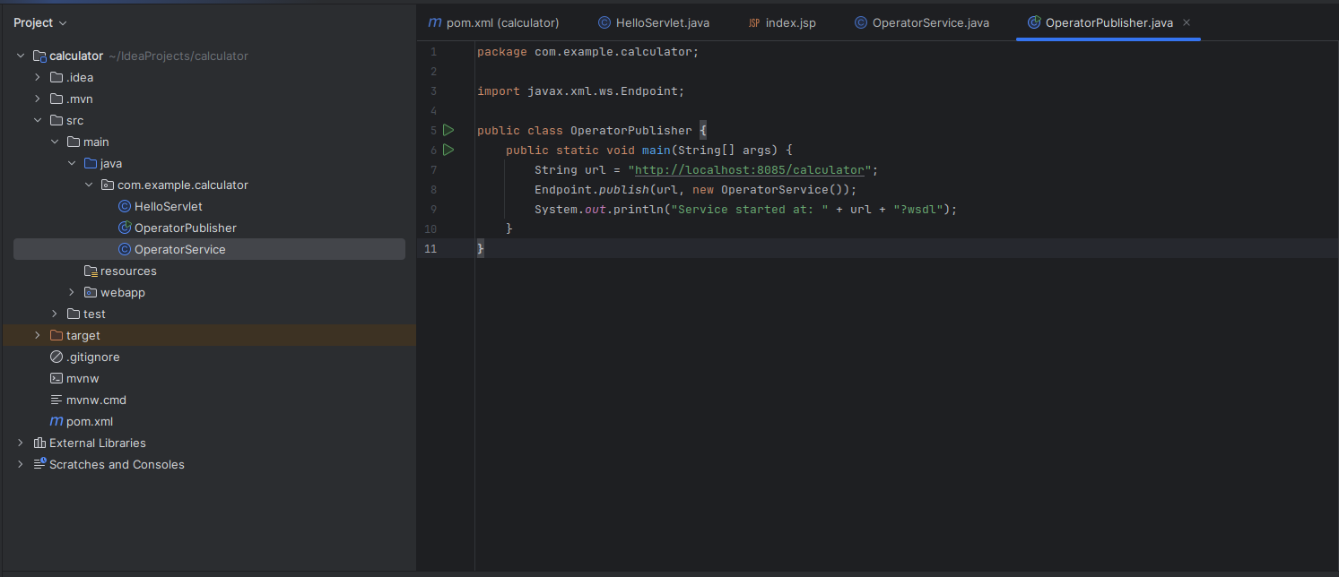
STEP 5: Configure Project Settings Properly

-In the File->Project Structure,
-Click modules (on left side), under sources->language level it should be 8 - Lambdas, type annotations, etc. and under dependencies, Module SDK Should be Project SDK 1.8

-In File->Settings->Build, Execution, Deployment -> compiler-> Java compiler, in Per-module bytecode version, select your module (for e.g calculator) and Target byte code should be 8

-In File->Settings->Build, Execution, Deployment -> compiler-> Java compiler, under Build Tools-> Maven-> Runner, JRE should be Java 1.8
- In pom.xml target as maven compiler target 1.8 →
- In Jakarta version as 4.0.4

-HelloServlet.java is showing errors, make jarkata to javax in that file.

-Run operatorPublisher, u can access at port:8085

STEP 6: Create Client

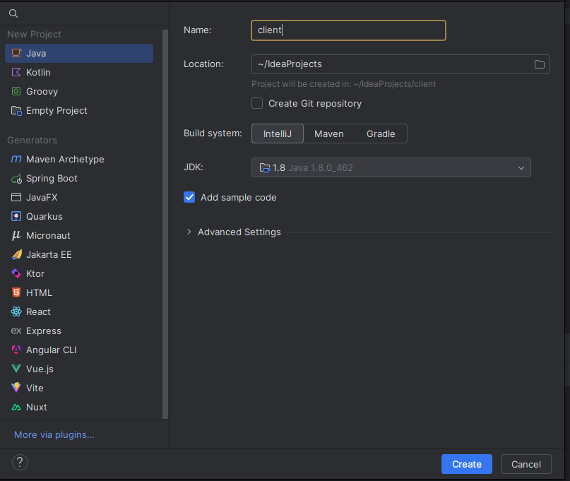
STEP 7: Run Client to See Output
- Code it as written below.
- Run the current file to see O/P.
