

Student Name: Akash Malik
Registration No. : 11803994
Course code: CSE 316
Course Title: Operating Systems
GitHub link: https://github.com/Akash463/OS-project.git

Problem Statement:
Sudesh Sharma is a Linux expert who wants to have an online system where he can handle student queries. Since there can be multiple requests at any time he wishes to dedicate a fixed amount of time to every request so that everyone gets a fair share of his time. He will log into the system from 10am to 12am only. He wants to have separate requests queues for students and faculty. Implement a strategy for the same. The summary at the end of the session should include the total time he spent on handling queries and average query time.

Assumption while solving the problem:
1. As per the scenario given in the question the best practice that should bee used here is "Round-Robin Algorithm".(Time sharing system)
2. Separate queues for handling the
3. We have considered that faculty query will be given more preference than student’s query.

Important points: ----
1. Criteria: Time Quantum
2. Mode: Pre-emptive
3. Turn Around Time = Completion Time - Arrival Time
4. Waiting time= TAT - BT(Burst time)
5. Response Time = CPU given to process first time - Arrival time
6. Context switching - save running process and loading the new process (it is so fast that we cannot feel it as ex. music and video simultaneously.

Code:
#include<stdio.h>
#include<string.h>
#include<stdbool.h>
struct information{

//int completiontime;
int remainingtime;//rbt
int turnaroundtime;//+
int waitingtime;
int processid;
int arrivaltime;
int bursttime;

};
struct information facultyqueue[100];//f
struct information studentqueue[100];//s
struct information readyqueue[100];//merger
int n, fc=0,sc=0, readycount=0;//facultycount,studentcount,no of process

int time;//total time of execution +
int totalwaiting=0;
int totalturnaroundtime=0;

void roundrobin_implementation(){
int timequantum;
printf("\nEnter time quantum\n");
scanf("%d",&timequantum);
int queriesleft=n;

bool cpustate=0;
printf("\nOverall Summary of process execution\n");
for(time=readyqueue[0].arrivaltime,readycount=0;queriesleft!=0;){
if(readyqueue[readycount].remainingtime<=timequantum && readyqueue[readycount].remainingtime!=0){
time += readyqueue[readycount].remainingtime;
readyqueue[readycount].remainingtime=0;
cpustate=1;

readyqueue[readycount].waitingtime += time-(readyqueue[readycount].arrivaltime+readyqueue[readycount].bursttime);
readyqueue[readycount].turnaroundtime += time-(readyqueue[readycount].arrivaltime);
totalwaiting += readyqueue[readycount].waitingtime;
totalturnaroundtime += readyqueue[readycount].turnaroundtime;
queriesleft--;
printf("%d ",readyqueue[readycount].processid);
}
else if(readyqueue[readycount].remainingtime>timequantum){
time += timequantum;
readyqueue[readycount].remainingtime -= timequantum;
printf("%d",readyqueue[readycount].processid);
cpustate=0;

}
if(readycount==n-1){
readycount=0;

}
else if(readyqueue[readycount+1].arrivaltime<time){
readycount++;

}
else if(cpustate==1 && readyqueue[readycount+1].arrivaltime>time && readyqueue[readycount-1].remainingtime==0){
time=readyqueue[readycount+1].arrivaltime;
readycount++;

}
else{
readycount=0;
}
}
}

////

///
void putting_data_of_both_queues(){
int studentiterator=0, facultyiterator= 0;
if( fc!=0 && sc!=0){
while( facultyiterator<fc && studentiterator<sc ){
if(facultyqueue[facultyiterator].arrivaltime == studentqueue[studentiterator].arrivaltime){
readyqueue[readycount] = facultyqueue[facultyiterator];
readycount++;
facultyiterator++;
// readyqueue[readycount]= studentqueue[studentiterator];
// readycount++;
// studentiterator++;
}
else if(facultyqueue[facultyiterator].arrivaltime > studentqueue[studentiterator].arrivaltime){
readyqueue[readycount]= studentqueue[studentiterator];
readycount++;
studentiterator++;
}

else if(facultyqueue[facultyiterator].arrivaltime < studentqueue[studentiterator].arrivaltime){
readyqueue[readycount]= facultyqueue[facultyiterator];
readycount++;
facultyiterator++;
}

}
if(fc==facultyiterator)
{
while(studentiterator!=sc)
{
readyqueue[readycount]=studentqueue[studentiterator];
studentiterator++;
readycount++;
}
}
else if(sc==studentiterator)
{
while(facultyiterator!=fc)
{
readyqueue[readycount]=facultyqueue[facultyiterator];
facultyiterator++;
readycount++;
}
}
}

else if(fc==0)
{
while(studentiterator!=sc)
{
readyqueue[readycount]=studentqueue[studentiterator];
studentiterator++;
readycount++;
}
}
else if(sc==0)
{
while(facultyiterator!=fc)
{
readyqueue[readycount]=facultyqueue[facultyiterator];
facultyiterator++;
readycount++;
}
}
}

void allinputhere(){

int querytype, i;
printf("Enter total no of queries: ");
scanf("%d", &n);

printf("\nEnter 1 for faculty and 2 for student\n");
for(i=0; i<n; i++){
printf("\n:Press 1(faculty) or 2(student) ");
scanf("%d", &querytype);
if(querytype==1){

facultyqueue[fc].processid=i;
printf("Arrival Time: "); scanf("%d", &facultyqueue[fc].arrivaltime);
if(facultyqueue[fc].arrivaltime<1000 || facultyqueue[fc].arrivaltime>1200){
printf("\n Entered wrong slot time.Enter again ");
i--;//to go at same iteration
continue;
}
//else{facultyqueue[fc].arrivaltime= t-1000;}
printf("Burst time: "); scanf("%d", &facultyqueue[fc].bursttime);
facultyqueue[fc].remainingtime= facultyqueue[fc].bursttime;
fc++;
}
else if(querytype==2){
//printf("Query Id: "); scanf("%d", &studentqueue[sc].processid);
studentqueue[sc].processid=i;
printf("Arrival Time: "); scanf("%d", &studentqueue[sc].arrivaltime);
if(studentqueue[sc].arrivaltime<1000 || studentqueue[sc].arrivaltime>1200){
printf("\nEntered wrong slot time\n");
i--;
continue;
}
//else {studentqueue[sc].arrivaltime= t-1000; }
printf("Burst time: "); scanf("%d", &studentqueue[sc].bursttime);
studentqueue[sc].remainingtime= studentqueue[sc].bursttime;
sc++;
}
else{
printf("Please choose only from 1 and 2");
i--;

}
}
}

void main(){
puts("...................................................Good Morning.......................................................\n");
puts("Important points are as follows ------\n");
puts("*** Mr.Sharma will be available from 10am to 12 am only and respond to your query shortly.");
puts("*** Please enter arrival time of process in format 1000 to 1200 and in bw this slot only otherwise your query will not be handled.");
puts("*** Faculty query will be given more preference. So please have patience till your turn comes...");
puts("*** Time units are in minutes.\n\n\n");

allinputhere();

//combining both queues
putting_data_of_both_queues();
//implementation of round robin
roundrobin_implementation();
//summary

int z;
printf("\nProcess id\t\tBurst Time\t\tArrival Time\t\tWaiting Time\t\tTurnaround Time\n");
for(z=0;z<n;z++)
{
printf("\n%d\t\t\t%d\t\t\t%d\t\t\t%d\t\t\t%d",readyqueue[z].processid,readyqueue[z].bursttime,readyqueue[z].arrivaltime,readyqueue[z].waitingtime,readyqueue[z].turnaroundtime);
}
printf("\n\nTime Spent :%d\n\n", (time-readyqueue[readycount].arrivaltime));
printf("\nAvg Waiting Time:%d\n\n",(totalwaiting/n));
printf("\nAvg Turnaround Time:%d\n\n",(totalturnaroundtime/n));
puts("\nThanks, for your patience...");

}

1. Problem description in terms of operating system.
As Mr. Sudesh wanted to handle the query of students and teachers b/w the time slot of 10am to 12 am. And also wanted to dedicate a fixed amount of time to every request so that everyone gets a fair share of his time.
To implement the same we have used Round Robin Scheduling as in this scheduling we could allot a fixed amount of time to the process. Named as time quantum .

What is Round Robin Scheduling?
Round Robin Scheduling is a scheduling algorithm used by the system to schedule CPU utilization. This is a pre-emptive algorithm. There exist a fixed time slice associated with each request called the quantum. The job scheduler saves the progress of the job that is being executed currently and moves to the next job present in the queue when a particular process is executed for a given time quantum.
No process will hold the CPU for a long time. The switching is called a context switch. It is probably one of the best scheduling algorithms. The efficiency of this algorithm depends on the quantum value.

2. Algorithm for solving the problem.:
1. Take input.
Take input for different variables like arrival time, burst time, time quantum.
2. Bring together both student and faculty queue.
2. Call roundrobin_implementation()
//for scheduling the process
3. Call printing_information()
//for showing summary and avg time etc.

3. Complexities Summary:
Function name NLOC Complexity
roundrobin_implementation | 40 | 10
putting_data_of_both_queues | 58 | 16
allinputhere | 38 | 8
main | 21 | 2

4. Boundary Conditions:
a. Input value for time should be b/w 1000 to 1200 only.
So boundary conditions are 999, 1000, 1001 and 1199, 1200, 1201 when giving arrival time.
b. For query type boundary conditions are 0,1,2,3

5. Constraints:
1. Time should be b/w 10 am (1000) to 12am (1200).
2. Value should be in minutes.
3. Choose value 1 or 2 only while selecting query type.

6. Screenshots( These screenshots shows how I have handled all the constraints i.e. time should bw 1000 to 1200 and input for query type should be 1 or 2)
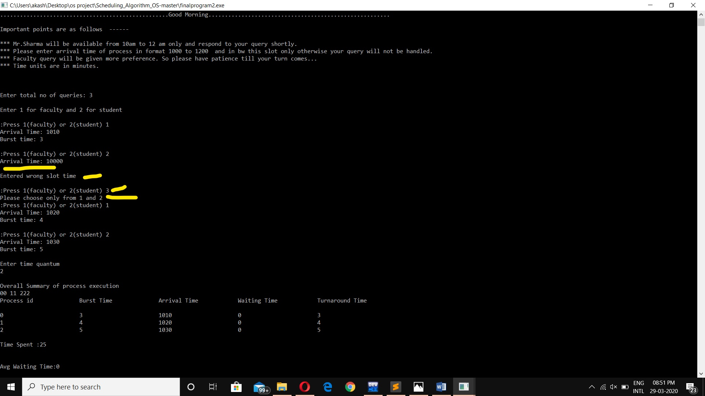

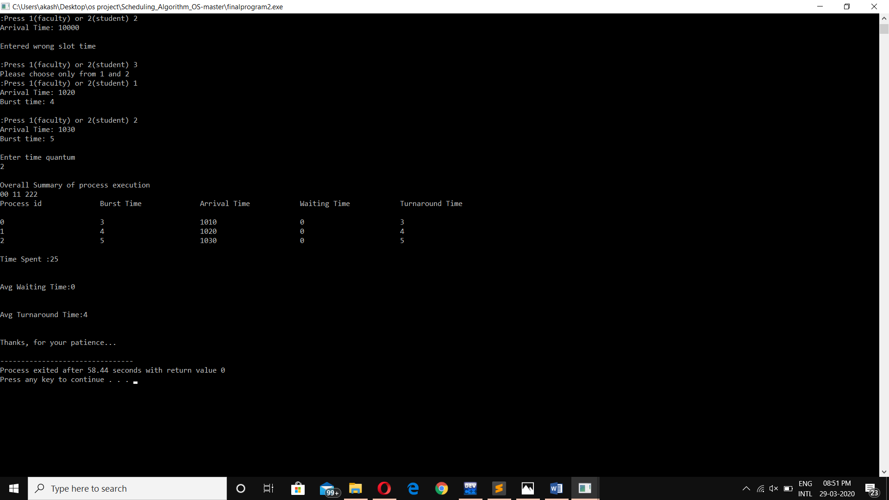

7. GitHub Revision link: (7 commits)
https://github.com/Akash463/OS-project.git
