**INTERNSHIP REPORT**

**B.Tech in Computer Science Engineering DIVISION OF COMPUTER SCIENCE ENGINEERING**

**SCHOOL OF ENGINEERING CUSAT**



**RISHI KRISHNA S**

20223083

***Internship Details:***

### National Health Mission Kozhikode(NHM)

Civil Station Kozhikode, Kerala, India

***Mentor Details:***

Mr. SANEESH

PROJECT MANAGER, NATIONAL HEALTH MISSION

[dpmkkd1@gmail.com](mailto:dpmkkd1@gmail.com) 9447385449

## MAY 2024

### DIVISION OF COMPUTER SCIENCE AND ENGINEERING SCHOOL OF ENGINEERING

COCHIN UNIVERSITY OF SCIENCE AND TECHNOLOGY

CERTIFICATE

Certified that this is a Bonafide record of the internship done by

RISHI KRISHNA S (20223083)

of III Semester, Computer Science and Engineering in the year 2024 in partial fulfilment requirements for the award of Degree of Bachelor of Technology in Computer Science and Engineering of Cochin University of Science and Technology.

DR. Pramod Pavithran Ms. Sheena S

Head Of Division Class Co-ordinator

## Acknowledgement

I would like to express my heartfelt gratitude to all those who have supported me throughout my internship project on the Pain And Palliative mobile application. First and

foremost, I would like to thank my teachers for their invaluable guidance and encouragement, which inspired me to explore the depths of mobile app development and healthcare

technology.

I extend my sincere appreciation to my family for their unwavering support and belief in my abilities. Their constant motivation and encouragement have been instrumental in

helping me navigate the challenges of this project.

I am especially grateful to Mrs. Deepa and Mr. Saneesh from the National Health Mission (NHM) for their exceptional support and insights. Their expertise and

encouragement provided me with a deeper understanding of the healthcare landscape and its challenges, significantly enriching my learning experience.

Thank you all for being an integral part of this journey. Your support has made this project not only possible but also deeply fulfilling.

## Abstract

The **Pain And Palliative** mobile application is a cutting-edge solution developed to enhance the collection and management of data related to pain and palliative care within healthcare facilities. Created using **Flutter**, the application serves healthcare workers in various settings, including Local Self Government Departments (LSGD), Primary Health Centers (PHC), Community Health Centers (CHC), and Taluk Hospitals. The primary objective of the application is to streamline data collection processes, enabling healthcare professionals to record critical patient information, such as pain severity, medication usage, and treatment history, in an efficient and user-friendly manner.

A significant feature of this application is its **offline-first** capability, allowing data to be stored locally on users' devices when internet connectivity is unavailable. This approach addresses the challenges faced by healthcare workers in remote areas, ensuring that they can continue to collect vital data without interruptions. Once the internet is available, the application synchronizes the collected data with **Firebase Cloud Firestore**, providing real- time updates and ensuring that patient records are accessible to authorized personnel.

The integration of **Google Apps Script** automates the process of transferring data from Firestore to **Google Sheets**, facilitating comprehensive reporting and analysis. This feature empowers healthcare professionals to assess trends and make data-driven decisions, ultimately improving patient care and outcomes.

Throughout this project, various technical skills were acquired, including mobile app development using Flutter, cloud data management with Firebase, and version control using GitHub. By combining these technologies, the **Pain And Palliative** app not only improves data management in healthcare settings but also demonstrates the potential of innovative solutions to enhance the quality and efficiency of patient care. The insights gained from this project emphasize the critical role of technology in addressing healthcare challenges and

improving the overall patient experience.

## Contents

Abstract

Chapter 1: Introduction

* 1. Overview
  2. Scope of the project Chapter 2: Organization Overview
  3. Background
  4. Institutional Framework
  5. Internship Role and Responsibilities Chapter 3: Project Overview
  6. Purpose of the Application
  7. Targeted Healthcare Facilities
     1. Local Self Government Departments
     2. Primary Health Centres
     3. Community Health Centres
     4. Taluk Hospitals Chapter 4: Tools and Technologies Used
  8. Flutter
  9. Cloud Firestore: Firebase
  10. Google Apps Script
  11. Figma
  12. Version Control
      1. Git
      2. GitHub Chapter 5: Application Features
  13. Data Collection
      1. Data Collection in Action: Screenshots
  14. Reporting and Analysis
  15. UI Design and Usability Chapter 6: Development Process
  16. Requirement Gathering
  17. Design and Implementation
  18. Testing and Debugging
  19. Deployment

Chapter 7: Challenges and Solutions

* 1. Technical Challenges
  2. Collaborating with Team Using GitHub Chapter 8: Learning and Experience
  3. Key Technical Skills Acquired
  4. Into Healthcare Data Management Chapter 9: Conclusion

Reference

# Chapter 1: Introduction

## Overview

The Pain And Palliative mobile application was developed during my internship using Flutter, with the integration of Firebase and Google Apps Script. This project aimed to streamline the collection of data related to pain management and palliative care across various healthcare facilities such as Local Self Government Departments (LSGD), Primary Health Centres (PHC), Community Health Centres (CHC), and Taluk Hospitals. The app was designed to assist healthcare professionals in accurately recording and managing patient data, thereby improving care delivery and patient outcomes.

The primary objective of the application was to simplify and digitize the data collection process. The app provides healthcare professionals with a mobile-friendly interface, allowing them to efficiently record essential patient information, such as pain severity, medication usage, and treatment history. This digitization reduces manual errors and ensures that healthcare workers can provide timely and effective care. Moreover, the application supports the generation of detailed reports, which aid in the analysis of patient data and help healthcare professionals make informed decisions regarding treatment plans.

Several technologies and tools were employed to develop this application. Flutter, a cross-platform framework, was used to build the mobile app, ensuring compatibility across Android and iOS devices. Firebase played a vital role in providing real-time data updates and user authentication, ensuring that the collected data was secure and accessible to authorized personnel. Google Apps Script was integrated to automate backend workflows, such as generating reports from the collected data, further enhancing the app's efficiency. Additionally, the user interface was designed using Figma, ensuring a simple and intuitive experience for healthcare professionals. The interface's layout focused on accessibility and ease of use, crucial for professionals working in busy healthcare environments.

For managing the code and collaborating with the development team, we utilized Git and GitHub. These tools ensured that the version control process was seamless, allowing for collaborative development and effective management of the project's codebase. Throughout the development, GitHub served as a central repository, enabling the team to track changes, resolve issues, and maintain code quality.

Overall, the development of the Pain And Palliative app provided valuable hands-on experience in mobile app development, backend integration, UI/UX design, and team collaboration. This project enhanced my technical skills and allowed me to work on a real- world application that has the potential to improve healthcare services in the field of pain management and palliative care.

## Scope of the project

The scope of the Pain And Palliative mobile application project extends to the development and deployment of a comprehensive tool designed for healthcare professionals across various medical facilities, including Local Self Government Departments (LSGD), Primary Health Centers (PHC), Community Health Centers (CHC), and Taluk Hospitals.

The application is tailored to streamline the collection, storage, and reporting of data related to pain management and palliative care, improving the efficiency of patient care and reducing the manual workload of healthcare workers. By providing a real-time, cloud-based platform using Firebase, the app ensures that patient data is easily accessible and securely managed, allowing for timely decision-making.

Additionally, the integration of automated reporting through Google Apps Script enhances the ability to analyse trends in patient care. The project also includes designing an intuitive user interface (UI) using Figma, focusing on ease of use in busy healthcare environments. The app's scalability allows for future integration with more healthcare facilities and potential expansions into other areas of patient data management. Moreover, the collaboration tools used in development, like Git and GitHub, ensure that the project can be maintained and expanded efficiently by multiple teams in the future.

# Chapter 2: Organization Overview

## Background

*(Fig 2.1.1 NHM Logo*)

The **National Health Mission** (**NHM**) was launched by the government of India in 2013 subsuming the National Rural Health Mission and National Urban Health Mission. It was further extended in March 2018, to continue until March 2020.It is headed by Mission Director and monitored by National Level Monitors appointed by the Government of

India. Rural Health Mission (NRHM) and the recently launched National Urban Health Mission (NUHM). Main program components include Health System Strengthening in rural and urban areas- Reproductive-Maternal- Neonatal-Child and Adolescent Health, and Communicable and Non-Communicable Diseases. NHM envisages achievement of universal access to equitable, affordable and quality health care services that are accountable and responsive to the needs of the people.

## Institutional Framework

At the State level, the Mission functions under the overall guidance of the State Health Mission (SHM) headed by the Hon’ble Chief Minister of Kerala. The State Health & Family Welfare Society (SH&FWS) would carry the functions under the Mission. The Governing Body of the SH&FWS is headed by the Hon’ble Minister for Health and the Executive Committee of SH&FWS by the Additional Chief Secretary / Principal Secretary / Secretary (Health & Family Welfare)

Every district will have a District Health & Family Welfare Society (DH&FWS). The Governing Body of the District Health Mission (DHM) is be headed by Chair Person, District Panchayat. The Executive Committee of the District Health Mission (DHM) is be headed by the District Collector.

The State Program Management Unit (SPMU) acts as the main secretariat of the SH& FWS. The constitution and functioning of the SPMU and Executive Committee of the SH&FWS shall be such that there is no hiatus between the Directorate of Health and Family Welfare services and the SPMU.

State Health System Resource Centres (SHSRC) serve as the apex body for technical support to the State. Technical support focuses on problem identification, analysis and problem solving in the process of implementation. It also includes capacity building for district/city planning, and organization of community processes and over all dimensions of institutional capacity, of which skills is only a part.

## Internship Role and Responsibilities

During my internship, my primary role was as a **mobile app developer**, responsible for designing, developing, and deploying the **Pain And Palliative** mobile application using **Flutter**. My key responsibilities included integrating **Firebase** for real-time data management and user authentication, ensuring that the app provided a secure and efficient platform for collecting and storing patient data and also fetch real-time data from Google App Scripts to simultaneously update Google Sheets with firebase, I worked closely with healthcare professionals to understand their needs and translated these requirements into functional features within the app, such as **data collection forms** and **automated reporting** systems.

Another significant responsibility was the **UI/UX design** of the application. Using **Figma**, I designed an intuitive and user-friendly interface tailored to the workflow of healthcare workers. This involved creating wireframes and prototypes, followed by testing and refining the interface to enhance accessibility and ease of use.

In addition to development, I was responsible for automating backend processes using **Google Apps Script**, particularly for generating reports of the above-mentioned institutions to a google sheets, which helped healthcare providers make informed decisions. I also worked on ensuring the scalability of the application by incorporating best practices in code management.

A vital aspect of my role was **collaborating with my team** using **Git** and **GitHub**. I managed version control, tracked issues, and ensured smooth collaboration with other developers by handling code reviews and resolving conflicts. This experience strengthened my teamwork and project management skills, as I had to coordinate effectively to meet deadlines and deliver a fully functional app. Overall, my internship responsibilities encompassed both the technical aspects of app development and the practical aspects of working in a collaborative team environment.

# Chapter 3: Project Overview

## Purpose of the Application

The Pain And Palliative application addresses a significant challenge faced by healthcare professionals working in rural and remote areas—inconsistent internet access. Healthcare workers often need to collect data in regions where reliable internet connectivity is not available, making traditional web-based solutions impractical. The purpose of this mobile app is to provide a more effective and flexible way to collect and manage patient data, even when offline.

The app is designed to store data locally on the mobile device, allowing healthcare professionals to record patient information, such as pain levels and treatment details, without needing an active internet connection onsite hence making the data collection from different healthcare facilities easy. Once the mobile device is back in an area with internet access, the stored data is automatically uploaded to the Firebase database, ensuring that all information is synced and accessible across healthcare facilities.

This approach streamlines the data collection process, enabling healthcare workers to perform their duties efficiently regardless of connectivity issues. It not only eliminates the delays caused by internet unavailability but also ensures that no critical patient data is lost or mismanaged during field visits. By storing data locally first and synchronizing it later.

## Targeted Healthcare Facilities

The Pain And Palliative mobile application is designed to cater to a wide range of healthcare facilities, each playing a crucial role in delivering pain management and palliative care services. These targeted healthcare facilities include:

* + 1. **Local Self Government Departments (LSGD):** The LSGD plays a pivotal role in local governance, especially in rural areas. Through collaboration with healthcare initiatives, LSGDs ensure that essential healthcare services, such as pain management and palliative care, reach remote and underserved communities. The Pain And Palliative app enables LSGD-associated healthcare workers to efficiently collect and manage patient data, ensuring that even the most rural areas are covered without relying on constant internet connectivity.
    2. **Primary Health Centres (PHC):** PHCs serve as the first point of contact for patients in rural areas. These centres focus on providing basic healthcare services, including pain relief and early-stage palliative care. With limited resources and intermittent internet access, the Pain And Palliative app allows healthcare providers at PHCs to store patient data locally on their mobile devices, ensuring that crucial information is captured during field visits and uploaded to the centralized database when connectivity is restored.
    3. **Community Health Centres (CHC):** CHCs offer more advanced care than PHCs and are responsible for a larger catchment area, often dealing with more complex medical cases. They provide secondary healthcare services, including palliative care for chronic and terminal illnesses. The Pain And Palliative app streamlines the collection of detailed patient data, such as treatment history and pain management plans, allowing CHC staff to efficiently monitor and report on patient outcomes. The app's offline capabilities ensure that even in areas with poor internet coverage, critical patient data can be recorded and later synced.
    4. **Taluk Hospitals**: Taluk Hospitals function as referral hospitals and offer both primary and secondary care services. They handle more complex medical cases referred from PHCs and CHCs and play a vital role in administering specialized palliative care. The Pain And Palliative app supports healthcare professionals at Taluk Hospitals by enabling them to gather comprehensive data, analyse patient trends, and make data- driven decisions to improve care. Given their role as a hub for medical services, Taluk Hospitals benefit greatly from the app's ability to consolidate patient data across various facilities and field locations, improving the overall quality of care provided to patients.

# Chapter 4: Tools and Technologies Used

## Flutter



*(Fig 4.1.1 Flutter Logo)*

Flutter is an open-source UI software development kit (SDK) developed by Google, which enables developers to create natively compiled applications for mobile, web, and desktop from a single codebase. It has become a popular choice for app development due to its cross-platform capabilities, meaning developers can write one set of code

and deploy it across multiple platforms such as Android and iOS. This drastically reduces development time and effort, making it highly efficient *for* projects that require quick iteration and wide accessibility, like the Pain And Palliative mobile application.

In the development of the Pain And Palliative app, Flutter was chosen because of its ability to deliver a consistent and intuitive user experience across different devices, ensuring that healthcare workers using either Android or iOS could access the app without any performance or interface issues. Flutter's widget-based architecture allowed for the creation of a highly customizable and responsive user interface (UI), ensuring that the app met the specific needs of healthcare professionals.

One of the most important aspects of using Flutter for this project was its real-time development capabilities. The hot-reload feature enabled rapid testing and iteration, allowing developers to make changes on the fly and see the results immediately without the need for lengthy recompilation processes. This was particularly beneficial for refining the user interface and functionality based on feedback from healthcare professionals during the development cycle.

## Cloud Firestore: Firebase

Cloud Firestore, a key component of the Firebase platform, is a highly scalable and flexible NoSQL database that provides real-time data synchronization along with powerful offline capabilities. In the Pain And

*(Fig 4.2.1 Firestore Logo)* Palliative mobile application, Cloud Firestore is essential for managing and storing the critical patient data that healthcare workers collect during field visits, particularly in areas with unreliable or intermittent internet access.

Firestore’s offline-first functionality allows healthcare professionals to enter patient information—such as pain levels, medication use, and treatment history—on their mobile

devices without worrying about immediate connectivity. This data is temporarily stored locally on the device, ensuring that healthcare workers can continue their tasks uninterrupted, even in remote regions where internet access is unavailable.

Once the healthcare worker regains access to the internet, Cloud Firestore automatically syncs the locally stored data with the cloud database. This synchronization process is seamless, requiring no manual intervention, and ensures that the data collected in the field is securely uploaded to the central Firestore database. The real-time synchronization offered by Firestore means that once the data is uploaded, it is instantly accessible across multiple devices and to authorized personnel in other healthcare facilities.

This centralized, real-time access to patient data ensures that medical teams, regardless of location, have the most current information to make informed decisions about patient care. Additionally, Firestore provides strong security features such as role-based access control and encrypted data transmission, which safeguard sensitive patient information during both storage and transfer.

## Google Apps Script

Google Apps Script is a powerful scripting language based on JavaScript that allows users to automate tasks and enhance the functionality of Google Workspace applications, such as Google Sheets, Google Docs, and Google Forms.

*(Fig 4.3.1 AppScripts Logo)*

In the context of the Pain And Palliative mobile application, Google Apps Script is utilized to automate the process of transferring

data from Cloud Firestore to Google Sheets. This integration simplifies the workflow for healthcare professionals and administrators by enabling seamless data updates without the need for manual input. By leveraging Google Apps Script, the application can schedule automated tasks that push the latest patient data from Firestore into a structured format in Google Sheets.

## Figma



*(Fig 4.4.1 Figma Logo)*

**Figma** is a cloud-based UI design tool widely recognized for its collaborative features, enabling teams to design, prototype, and iterate on user interfaces in real time. In the development of the **Pain And Palliative**

mobile application, Figma was utilized to create an intuitive and user-friendly interface tailored specifically for healthcare professionals.

The tool's vector graphics editor and prototyping capabilities allowed designers to develop interactive mock-ups that accurately represented the app's functionality and flow. Figma's collaborative nature facilitated seamless communication among team members, enabling designers, developers, and stakeholders to provide feedback and make adjustments in real time, regardless of their physical location.

This collaborative approach not only accelerated the design process but also ensured that the final product met the needs of its users effectively. Additionally, Figma’s design systems and reusable components helped maintain consistency across the app, ensuring a cohesive user experience. By leveraging Figma in the design phase, the team was able to create a polished, efficient, and aesthetically pleasing interface that enhances usability and supports healthcare workers in their mission to provide quality palliative care.

## Version Control

### Git



*(Fig 4.5.1 Git Logo*)

**Git** is a robust and widely adopted distributed version control system that plays a crucial role in modern software development by enabling developers to track changes in their codebase while facilitating collaboration across teams. Unlike traditional version control systems, Git allows multiple contributors to work on the same project simultaneously without the risk of overwriting each other's changes.

This is achieved through its branching and merging capabilities, which empower developers to create isolated environments for new features or bug fixes. In the context of the Pain And Palliative mobile application, Git was instrumental in managing the project's source code, providing a structured workflow that enhanced collaboration among team members with diverse skill sets and responsibilities.

Each developer could work on their own branch, ensuring that the main codebase remained stable and production-ready while new features were being developed. This branching strategy not only allowed for parallel development but also

enabled easy integration of new features through pull requests. When a developer completed their work on a branch, they could submit a pull request to the main branch, prompting discussions and reviews among team members. This process ensured that every change was scrutinized for quality and compatibility before being merged, thereby maintaining the integrity of the codebase.

### GitHub



*(Fig 4.5.2 GitHub Icon*)

**GitHub**, a powerful web-based platform built on top of Git, further enhances collaboration by providing a centralized repository for the project. It serves as a hub for code sharing, issue tracking, and project management, making it easier for team members to communicate and coordinate their efforts effectively. On GitHub,

developers can document their work through README files that outline the purpose of the project, its features, and instructions for usage.

This documentation is invaluable for new contributors or stakeholders who want to understand the project quickly. GitHub also maintains detailed commit histories, which allow team members to review past changes, understand the evolution of the codebase, and identify when and why specific changes were made. Furthermore, GitHub’s issue tracking system enables the team to monitor bugs, feature requests, and task assignments, ensuring that all members are aware of ongoing challenges and priorities.

# Chapter 5: Application Features

## Data Collection

The **Pain And Palliative** mobile application is designed to facilitate the efficient collection of patient data from various healthcare settings, including Local Self Government Departments (LSGD), Primary Health Centres (PHC), Community Health Centres (CHC), and Taluk Hospitals. Healthcare professionals utilizing the app can easily input essential information related to patient care, such as pain severity, medication usage, treatment history, and other relevant medical details.

Once connectivity is restored, the app automatically syncs the locally stored data with the central database in **Cloud Firestore**, ensuring that all collected information is securely uploaded and accessible to authorized personnel.

### Data Collection in Action: Screenshots

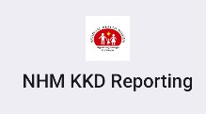

*Fig 5.1.1 :*

*App Icon*

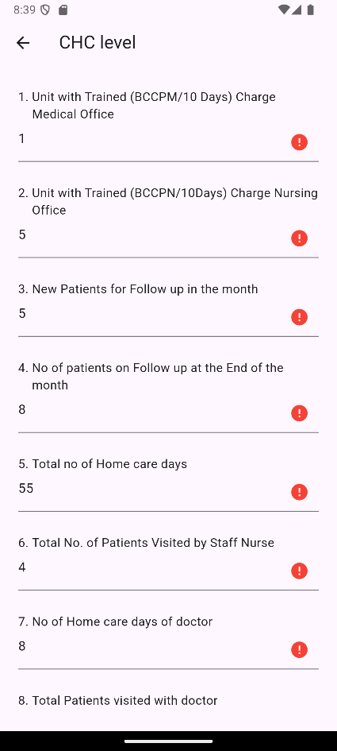*Fig 5.1.2 Screenshot: Form View*

*Fig 5.1.3 Screenshot: Institution Selection*

The application features a user-friendly interface that allows for quick data entry, ensuring that healthcare workers can capture information accurately and promptly, even in low

internet environments. Moreover, the app is built with offline functionality, enabling users to record data even in remote areas where internet connectivity is limited or non-existent. This ensures that valuable patient information is not lost, as the data is stored locally on the device until a stable internet connection is available.

## Reporting and Analysis

The **Pain And Palliative** mobile application leverages **Firebase** to streamline the reporting and analysis of patient data collected from various healthcare facilities. Once the data is uploaded to **Cloud Firestore**, Firebase's powerful backend services facilitate real-time access and organization of the data, making it readily available for comprehensive reporting. Healthcare administrators and decision-makers can generate detailed reports based on the data collected, including trends in pain severity, medication effectiveness, and patient outcomes.

**Cloud Firestore** is essential for the **Pain And Palliative** app as it serves as the primary database for securely storing patient data collected by healthcare workers. Its ability to handle real-time synchronization and offline data storage ensures that patient information is always up-to-date, even in areas with limited internet connectivity.

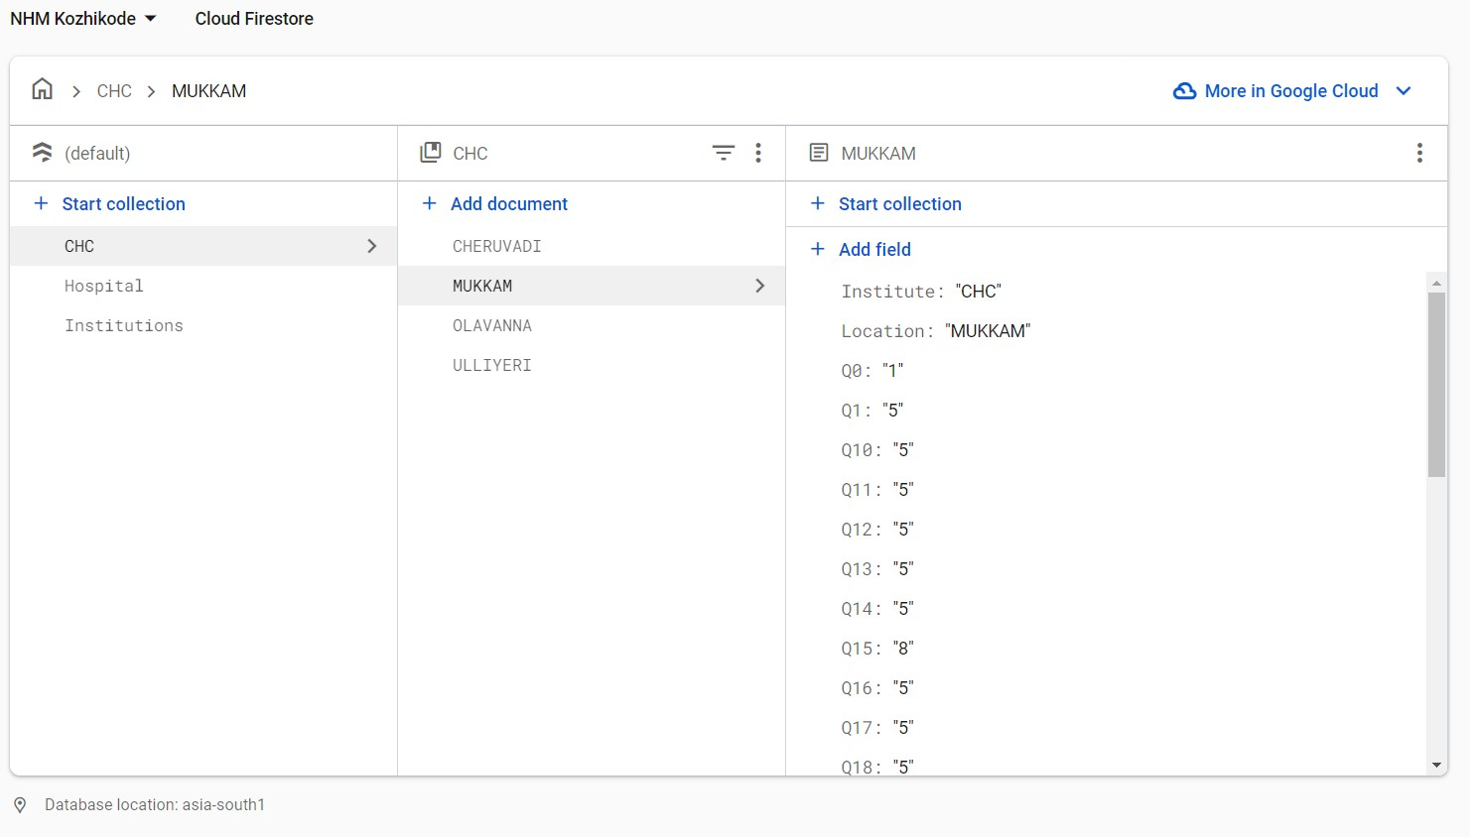

*Fig 5.2.1 Screenshot: Firestore Database*

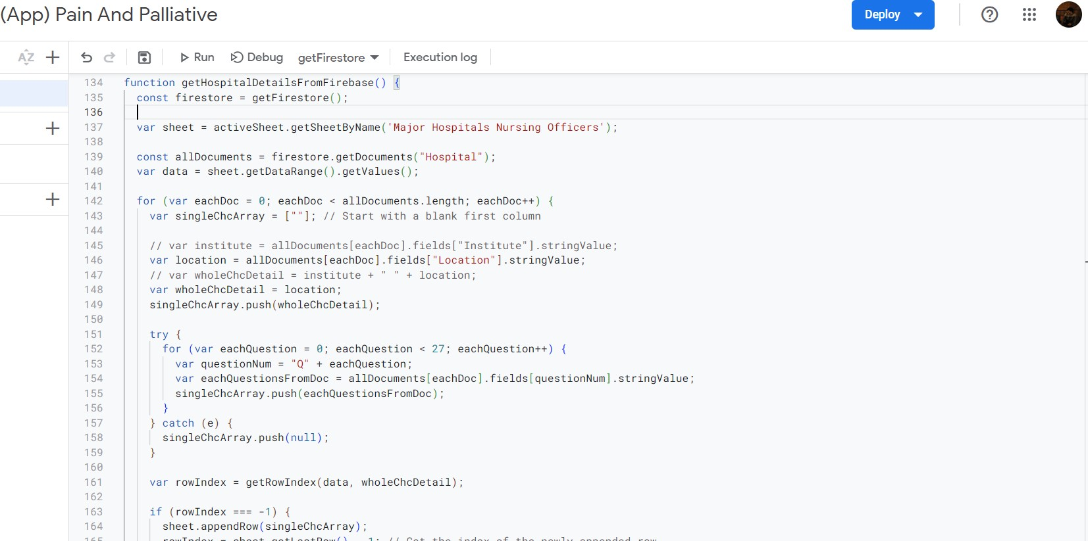These reports are crucial for analysing the effectiveness of treatments and care plans, as they provide valuable insights that help improve overall care quality. Furthermore, through the integration with **Google Apps Script**, patient data is automatically pushed from Firestore to **Google Sheets**, allowing for further data manipulation, visualization, and sharing across teams.

*Fig 5.2.2 Screenshot: Google App Script*

**Google Sheets** is used in the **Pain And Palliative** app to view and manipulate patient data that has been automatically transferred from **Cloud Firestore**. It provides healthcare administrators with a flexible, accessible platform for analysing and organizing data, allowing them to generate reports and track trends easily. This integration is vital for real-time decision- making and effective care management.

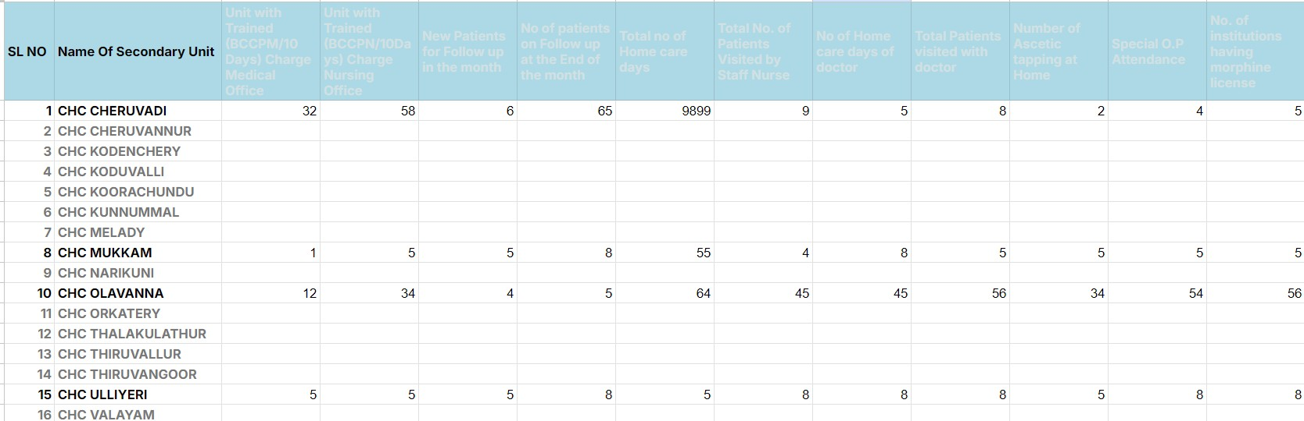

*Fig 5.2.3 Screenshot: Google Sheets*

## UI Design and Usability

The **UI design** of the **Pain And Palliative** mobile application was crafted with a focus on simplicity and usability, ensuring that healthcare professionals can easily navigate the app during their busy routines.

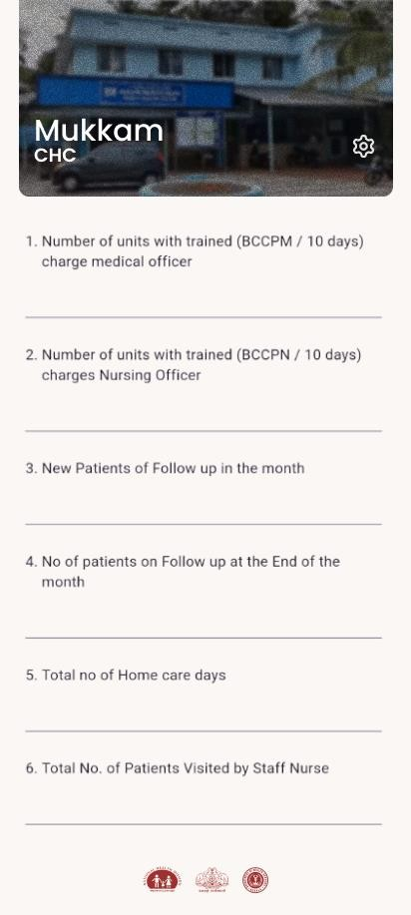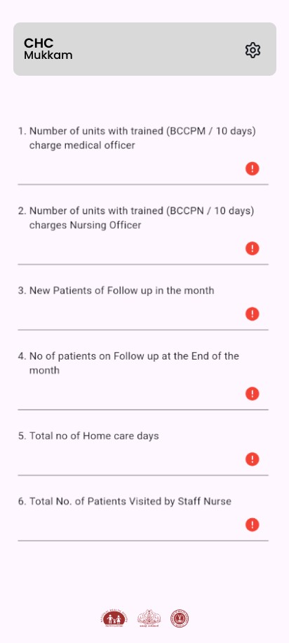

*Fig 5.3.1 Screenshot: App V1.1.0 beta Fig 5.3.1 Screenshot: App V1.0.0 beta*

Designed using **Figma**, the interface prioritizes user-friendly layouts, clear icons, and intuitive workflows, making it accessible even to users with limited technical expertise. Each section of the app is designed to minimize the number of steps required to input patient data, reducing time spent on administrative tasks and allowing healthcare workers to focus more on patient care.

Overall, the UI enhances the usability of the app by streamlining data entry, improving workflow, and supporting fast, accurate decision-making in the field.

# Chapter 6: Development Process

## Requirement Gathering

In the development of the Pain And Palliative mobile application, the process of understanding the specific needs of healthcare professionals was critical. Collaborating with stakeholders from LSGD, PHC, CHC, and Taluk Hospitals helped to identify the key challenges they faced, particularly in collecting and managing patient data in areas with limited internet access.

The goal was to create a solution that would streamline data collection while accommodating these unique operational constraints. By gathering detailed insights into the workflows and requirements of healthcare workers, the team was able to design features such as offline data storage, real-time synchronization with Firebase, and automated reporting via Google Sheets.

## Design and Implementation

The app’s user interface was designed for simplicity and ease of use, allowing healthcare professionals to quickly input and manage patient data. Behind the scenes, the implementation integrates multiple systems to ensure that data collected on the phone is first stored locally, allowing for uninterrupted usage even in areas with poor internet connectivity.

Once the internet is available, the app automatically syncs the data with Firebase's Cloud Firestore for secure cloud storage. The integration of Google Apps Script further automates the transfer of this data into Google Sheets, where it can be viewed and analysed for reporting purposes.

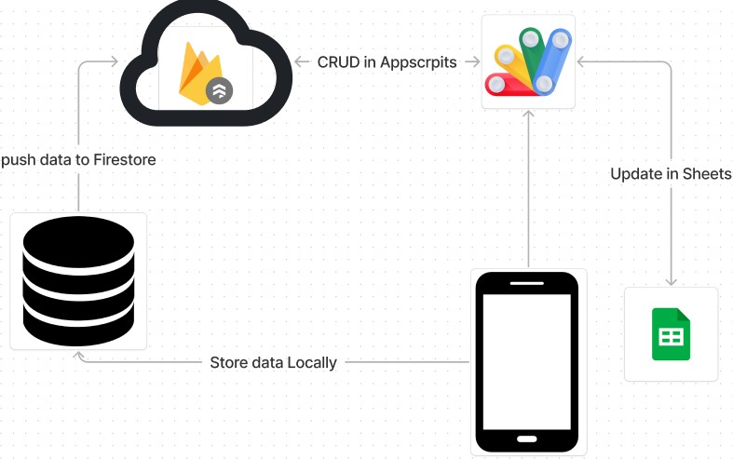*Fig 6.2.1 Flow chart: Data from phone to database*

can access up-to-date reports for decision-making.

The attached flowchart visualizes this entire process, showcasing the data flow between the mobile device, Firebase, and Google Sheets, ensuring real-time updates and efficient data management. This design ensures that healthcare workers have reliable tools for data entry, while administrators

## Testing and Debugging

For debugging the **Pain And Palliative** mobile application, **VS Code** has been an invaluable tool. Its integrated development environment (IDE) provides powerful debugging capabilities that allow for efficient identification and resolution of issues within the code. With features like breakpoints, variable inspection, and real-time code execution feedback, VS Code makes it easier to troubleshoot both frontend and backend components of the app.

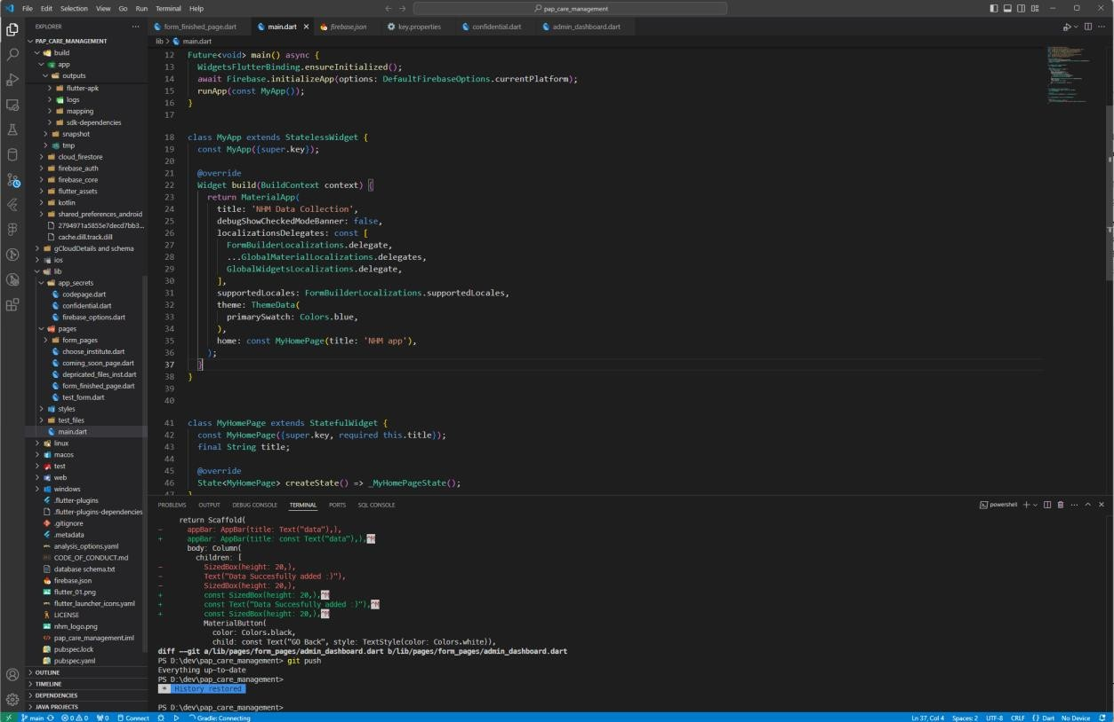

*Fig 6.3.1 Screenshot: VS Code User Interface*

Whether it's tracking down an error in the data synchronization with **Firebase** or testing the UI responsiveness across different devices, VS Code's versatile debugging tools streamline the development process. The ability to use extensions, such as the **Flutter** and **Dart** plugins, further enhances its functionality, making it a go-to tool for efficient debugging and overall code management during the app's development.

## Deployment

The deployment of the **Pain And Palliative** mobile application was a carefully planned process to ensure seamless functionality across different devices and environments. After extensive testing and debugging using tools like **VS Code**, the app was prepared for deployment on both **Android** and **iOS** platforms.

The deployment strategy involved setting up the backend infrastructure with **Firebase**, which manages data storage, synchronization, and real-time updates. Firebase also facilitates easy scalability, ensuring that the app can handle increased usage as more healthcare facilities adopt it.

For testing purposes, the app was first deployed in a staging environment to allow for real-world simulation and performance monitoring. After validating the app's functionality, it was then released to the production environment, ensuring that all user data flows smoothly between the mobile devices, **Cloud Firestore**, and **Google Sheets**. This multi-phase deployment ensures that the app is reliable, secure, and optimized for field use by healthcare workers.

# Chapter 7: Challenges and Solutions

## Technical Challenges

One of the key technical challenges in developing the Pain And Palliative app was ensuring reliable data collection in areas with limited or no internet connectivity. The solution was to implement an offline-first architecture, where data is initially stored locally on the device and then synced with Cloud Firestore when an internet connection becomes available.

Another challenge involved automating the data transfer from Firestore to Google Sheets for reporting purposes, which was addressed by integrating Google Apps Script to streamline the process. These solutions ensured that the app could function effectively in challenging environments while maintaining seamless data flow.

## Collaborating with Team Using GitHub

During the development of the Pain And Palliative mobile application, effective collaboration was achieved through the use of GitHub for version control and team coordination. GitHub allowed multiple developers to work on different parts of the project simultaneously, ensuring that changes were tracked and merged efficiently.

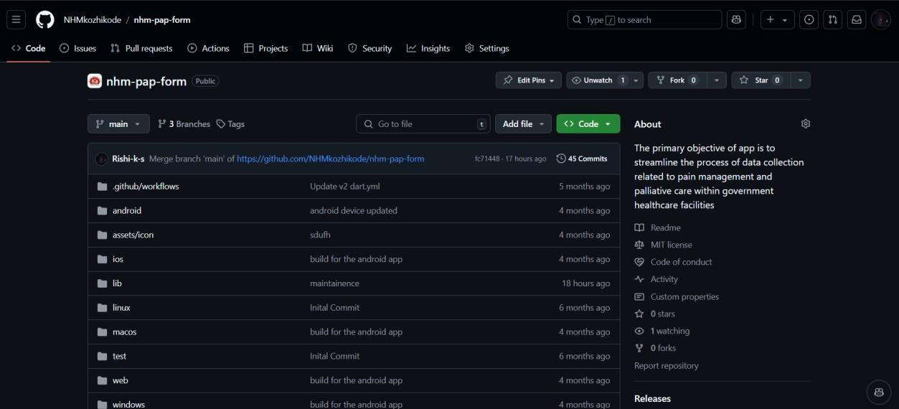

*Fig 7.2.1 Screenshot: GitHub Repository*

By using Git, team members could create branches for individual features or fixes, making it easy to collaborate without disrupting the main codebase. This also facilitated code reviews and debugging, as team members could identify and resolve issues collectively. Regular updates and commits helped maintain a clear development timeline, while GitHub’s pull requests ensured that all code was thoroughly tested and reviewed before being integrated into the main project. This collaborative approach using GitHub enhanced productivity, improved code quality, and ensured smooth progress throughout the app’s development.

# Chapter 8: Learning and Experience

## Key Technical Skills Acquired

As an intern working on the Pain And Palliative mobile application, I acquired several key technical skills that significantly enhanced my development expertise. I became proficient in Flutter for cross-platform mobile app development, gaining hands-on experience in building intuitive user interfaces and ensuring seamless performance across both Android and iOS devices.

I deepened my understanding of Firebase, particularly Cloud Firestore, by implementing real-time data synchronization and offline-first architecture. Additionally, I developed skills in automating workflows using Google Apps Script to integrate Firestore with Google Sheets for reporting purposes.

I also honed my abilities in Git and GitHub for version control, collaborating with a team, managing code branches, and resolving merge conflicts. These technical skills not only contributed to the success of the project but also broadened my knowledge of full-stack mobile application development.

## Into Healthcare Data Management

Working on the **Pain And Palliative** app provided key insights into **healthcare data management**, particularly the challenges of collecting and storing sensitive patient data in areas with poor internet access.

Implementing an **offline-first** approach was crucial for ensuring uninterrupted data entry, while real-time synchronization with **Firebase** kept patient records up-to-date. I also learned how integrating **Google Sheets** for reporting aids in data-driven decision-making and improving patient care. This experience highlighted the importance of secure, reliable data management in enhancing the efficiency and effectiveness of healthcare services.

# Chapter 9: Conclusion

The development of the **Pain And Palliative** mobile application has emerged as a significant advancement in streamlining healthcare data management specifically tailored for pain and palliative care. This project showcased the effectiveness of using **Flutter** for cross- platform mobile development, enabling the creation of a user-friendly interface that healthcare workers can easily navigate, even in challenging environments.

The implementation of **Firebase** for real-time data storage proved essential, allowing for seamless synchronization of patient records, regardless of internet availability. By adopting an **offline-first** approach, we ensured that healthcare professionals could continue to collect vital data without interruption, which is critical in remote areas with unreliable connectivity.

Additionally, the integration of **Google Apps Script** facilitated the automatic transfer of data to **Google Sheets**, enhancing reporting capabilities and enabling healthcare administrators to make informed decisions based on real-time insights. This integration not only streamlined data analysis but also improved communication among healthcare teams, ensuring that patient information is readily accessible and up-to-date.

Throughout this project, I significantly enhanced my technical skills in mobile app development, cloud integration, and version control using **GitHub**. More importantly, I gained a profound understanding of the complexities involved in healthcare data management and the critical role that efficient data collection and reporting play in improving patient care.

The **Pain And Palliative** application exemplifies how technology can bridge gaps in healthcare delivery, ensuring that timely, accurate data is available for enhancing decision- making and ultimately improving patient outcomes. As we move forward, the insights gained from this project will inform future innovations aimed at further enhancing healthcare efficiency and effectiveness, ultimately contributing to better care for patients in need.

# Reference

* + 1. Flutter Documentation

Flutter Dev. (n.d.). Flutter Documentation. Retrieved from https://flutter.dev/docs

* + 1. Firebase Documentation

Firebase. (n.d.). Firebase Documentation. Retrieved from https://firebase.google.com/docs

* + 1. Google Apps Script Documentation

Google Developers. (n.d.). Google Apps Script. Retrieved from https://developers.google.com/apps-script

* + 1. GitHub Documentation

GitHub. (n.d.). GitHub Guides. Retrieved from https://guides.github.com

* + 1. Cloud Firestore Documentation

Firebase. (n.d.). Cloud Firestore. Retrieved from https://firebase.google.com/docs/firestore

* + 1. Google Sheets Documentation

Google Workspace. (n.d.). Google Sheets. Retrieved from https://support.google.com/docs/topic/1361475

* + 1. Data Management in Healthcare

EHR Intelligence. (2020). The Importance of Data Management in Healthcare. Retrieved from https://ehrintelligence.com/news/the-importance-of-data-

management-in-healthcare

* + 1. Offline Data Synchronization

Firebase. (n.d.). Offline Capabilities. Retrieved from

https://firebase.google.com/docs/database/android/offline-capabilities