Dynamic Table Builder Project Reference
Salesforce configuration model and feature flows
Version 1.1 | 5 October 2026 | Prepared for Akash Rajendra Gaikwad
This reference documents the current repository implementation so future work can identify the correct components, configuration records, field definitions and extension points. It covers the Admin Configurator and the Simple Data Table runtime separately, including features that have settings but no runtime execution.
Baseline | Value
Repository | https://github.com/Akash76803/dynamicTableBuilder
Branch | main
Commit | eb5009dfaa22223a00a0cb8f17a482083d076c2f
API version | 67.0
Evidence | Pinned source and XML metadata; no live org compilation or UI test performed
Inventory | 7 Apex classes; 5 LWC bundles; 14 object and custom metadata definitions; 157 custom fields
Sections 1 through 9 preserve the original source inventory. Section 10 adds subsequent implemented changes and the selected bulk export scope and architecture, with planned components clearly identified.

Contents
1 Product scope and feature status
2 Architecture and ownership
3 Apex class and method reference
4 LWC components and event contracts
5 Objects and relationships
6 Feature flow diagrams
7 Behavior limitations and development guidance
8 Complete field dictionary
9 Source references and maintenance
10 Bulk CSV export scope and architecture

1 Product scope and feature status
Feature | Status | Implementation
Configuration create edit clone delete | Implemented | Configurator controller and service save Table records, columns and actions
Object and relationship field selection | Implemented | Schema describe and getObjectInfo supply fields and parent field options
Search filters sorting | Implemented | Server SOQL; 300ms search debounce; filters combine with AND
Pagination | Implemented with cap | Client pages over at most 2000 fetched rows; default 50 per page
Totals | Implemented in browser | Sum Average Count Min Max over all fetched rows, not only current page
Column manager | Implemented | Visibility/order, localStorage and columnupdate event
Table and card view | Implemented | Card view uses up to the first four visible columns
Picklist and multipicklist filter UI | Implemented | Custom searchable dropdown with multi-selection pills
Record page parent filtering | Implemented logic | Parent Id and matching lookup; auto-detection fallback
Actions and feature overrides | Configuration only | Admin can persist settings; Simple runtime does not execute action/override policies
Default filters | Configuration only in runtime | Admin stores defaults; Simple runtime does not read/apply those default-filter fields
Inline editing and record save | Not implemented in Simple runtime | Editable flag is configuration, no runtime save endpoint
Import export matrix saved views | Metadata/settings only | No corresponding Simple runtime execution
Custom formulas cart Data Packs | Not implemented | Additional-column metadata does not provide a formula engine

2 Architecture and ownership
Admin and runtime use separate Apex paths. The Admin path saves configuration; the runtime path reads configuration and returns record DTOs. Runtime does not consume every option exposed by the Admin editor.
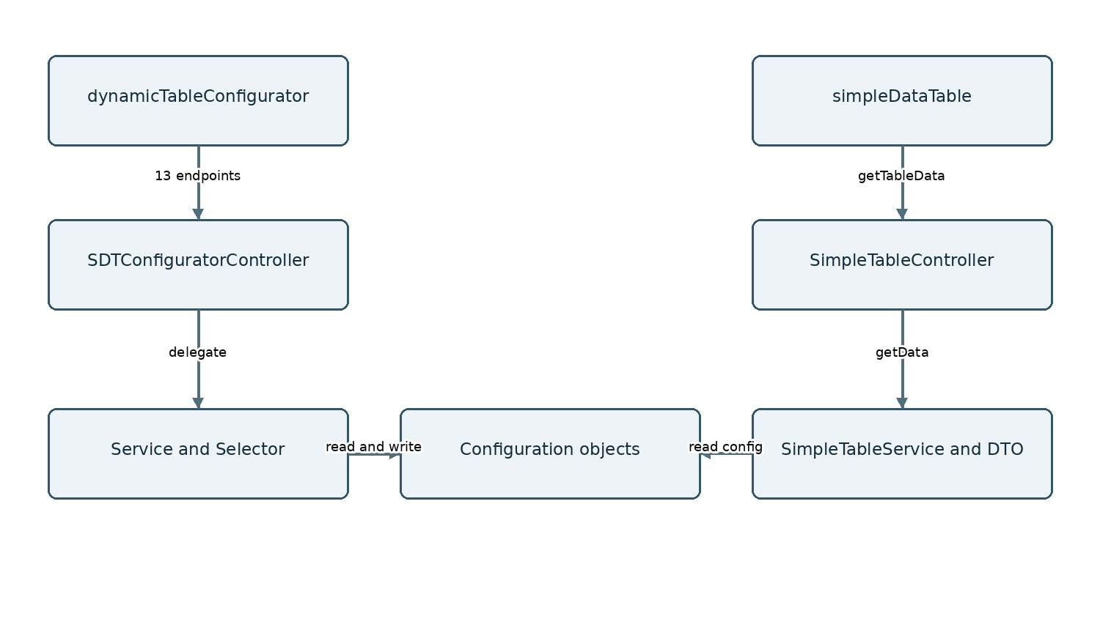

3 Apex class and method reference

SDTConfiguratorController
Admin entry points and exception translation; direct user-mode CRUD for overrides and deletion.
Method | Reference purpose
getAllTables | List configuration records
getTableMetadata | Return table, columns and actions
getObjectFields | Accessible schema fields and relationship metadata
saveMetadata | Upsert header and children; delete removed columns/actions
deleteTableConfig | Delete table using user-mode DML
cloneTableConfig | Copy table header, columns and actions
saveFeatureOverride | Upsert override
getFeatureOverrides | Read overrides for table
deleteFeatureOverride | Delete override
getImportMetadata | Return descriptors only; not import execution
getPicklistOptions | Resolve field picklist entries
searchLookupRecords | Search lookup choices
getRecordNames | Resolve selected record labels grouped by object

SDTConfiguratorService
Schema resolution, lookup search, import metadata descriptors, save and clone configuration.
Method | Reference purpose
getSObjectType | Cached schema object resolution
getFieldMap | Cached field describe map
searchLookupRecords | Search lookup choices
resolveRelationshipField | Resolve a related field through a dot path
resolvePicklistValues | Read active picklist entries
getImportMetadata | Return descriptors only; not import execution
getExternalIdOptions | List eligible external-ID fields for descriptors
saveMetadata | Upsert header and children; delete removed columns/actions
cloneTableConfig | Copy table header, columns and actions

SDTConfiguratorSelector
Queries table headers, columns and actions; lookup record query.
Method | Reference purpose
getTableByName | Query configuration by Name
resolveTableConfig | Resolve config using name or Id
getColumnsByTableId | Read configured child columns
searchLookup | Query lookup choices with user access
getAllTables | List configuration records
getTableById | Read configuration header by Id
getActionsByTableId | Read configured child actions

SDTConfiguratorDTO
Admin response types; retains broader DTO definitions that do not imply implemented runtime features.
Declared response types: SDTConfiguratorDTO, TableResult, TableAction, ActionResponse, ColumnConfig, RowData, CellData, LookupSearchResult, SaveRequest, SaveResult, FilterCriteria, FilterPayload, MatrixParams, ImportResult, ImportError, ImportMetadata, ImportFieldInfo, ImportMapping, ExportRequest, ExportColumnConfig, ExportFilterConfig, ExportResult, BrowserDownloadResult, PaginationCursorDTO, TableChunkDTO, MatrixRequest, MatrixGroupField, MatrixSummaryField, MatrixResult, MatrixResponse, MatrixJobStatus, MatrixExecutionDecision, MatrixCell, UserViewDTO

SimpleTableController
Single runtime endpoint getTableData; delegates to SimpleTableService.
Method | Reference purpose
getTableData | Runtime table data response

SimpleTableService
Fetch visible configuration, build SOQL, resolve relationships, map record rows.
Method | Reference purpose
getData | Configuration to query to DTO orchestration
fetchTableConfig | Resolve runtime header by Name
fetchColumnConfigs | Read only visible columns in index order
buildColumnDef | Construct column flags and relationship picklist options
buildQuery | AND conditions, search OR, sort and LIMIT 2000
buildFilterCondition | Operator to SOQL condition
mapRecords | Record Id and col-key values
resolveFieldValue | Traverse related SObjects and return field value
getObjectTypeFromId | Resolve parent object from Salesforce Id
autoDetectParentLookup | Select a matching reference to parent object
getFieldMap | Cached field describe map

SimpleTableDTO
Runtime ColumnDef, RowData, TableResult, FilterDef and picklist option response contracts.
Declared response types: SimpleTableDTO, ColumnDef, PicklistOption, FilterDef, RowData, TableResult

4 LWC components and event contracts
Bundle | Role | Main communication
dynamicTableConfigurator | Admin editor, fields, columns, actions, default filters, overrides | 13 SDTConfiguratorController imports; lightning/uiObjectInfoApi
simpleDataTable | Fetch state, paging, formatting, aggregate row, view switches | SimpleTableController.getTableData; child filterchange and columnupdate
sdtFilterPanel | Build typed filter rows and submit criteria | filterchange detail {logic: AND, filters}; close
sdtColManager | Local order and visibility editor | columnupdate detail [{key, visible}]; close; localStorage
sdtMultiSelect | Search choices, multi-select and pills | change detail {value: semicolon-delimited string}

simpleDataTable public properties
tableName, recordId, pageSize

sdtColManager public properties
columns, tableName, refreshColumns

sdtFilterPanel public properties
columns, activeFilters

sdtMultiSelect public properties
label, placeholder, options, value
simpleDataTable targets App, Home and Record pages. tableName is required; pageSize defaults to 50; recordId is provided by a record page. Runtime tableName currently resolves by Table__c.Name rather than a general ID-or-name resolver.

5 Objects and relationships
API name | Definition | Current use
DataTableColumn__mdt | DataTableColumn | Retained metadata; no active Simple runtime feature confirmed
DataTableConfig__mdt | DataTableConfig | Retained metadata; no active Simple runtime feature confirmed
Dynamic_Table_Error_Log__c | Dynamic Table Error Log | Retained metadata; no active Simple runtime feature confirmed
Table_Action_Override__c | Table Action Override | Retained metadata; no active Simple runtime feature confirmed
Table_Action__c | Table Action | Admin action configuration; runtime execution absent
Table_Columns__c | Table Columns | Column definitions; runtime and Admin
Table_Export_Log__c | Table Export Log | Retained metadata; no active Simple runtime feature confirmed
Table_Export_Setting__mdt | Table Export Setting | Retained metadata; no active Simple runtime feature confirmed
Table_Feature_Override__c | Table Feature Override | Admin override persistence; runtime enforcement absent
Table_Matrix_Job__c | Table Matrix Job | Retained metadata; no active Simple runtime feature confirmed
Table_Matrix_Summary__c | Table Matrix Summary | Retained metadata; no active Simple runtime feature confirmed
Table_User_View__c | Table User View | Retained metadata; no active Simple runtime feature confirmed
Table_Virtual_Setting__mdt | Table Virtual Setting | Retained metadata; no active Simple runtime feature confirmed
Table__c | Table | Core table header; runtime and Admin
Child field | Parent | Type | Relationship name
Dynamic_Table_Error_Log__c.User__c | User | Lookup | Dynamic_Table_Error_Logs
Table_Action_Override__c.Table_Action__c | Table_Action__c | MasterDetail | Action_Overrides
Table_Action__c.Table__c | Table__c | MasterDetail | Table_Actions
Table_Columns__c.Table_Name__c | Table__c | MasterDetail | Table_Columns
Table_Export_Log__c.User__c | User | Lookup | Table_Export_Logs
Table_Feature_Override__c.Table__c | Table__c | MasterDetail | Feature_Overrides
Table_Matrix_Job__c.Table__c | Table__c | Lookup | Matrix_Jobs
Table_Matrix_Job__c.User__c | User | Lookup | Table_Matrix_Jobs
Table_Matrix_Summary__c.Job__c | Table_Matrix_Job__c | Lookup | Matrix_Summaries
Master-detail relationships connect columns, actions and feature overrides to Table__c; action overrides are children of Table_Action__c. Matrix jobs reference a table and user; summaries reference their job. User views identify the table with Table_Name__c text, not a metadata-defined lookup. The runtime target business object is selected by API-name text and is not a fixed relationship to Table__c.
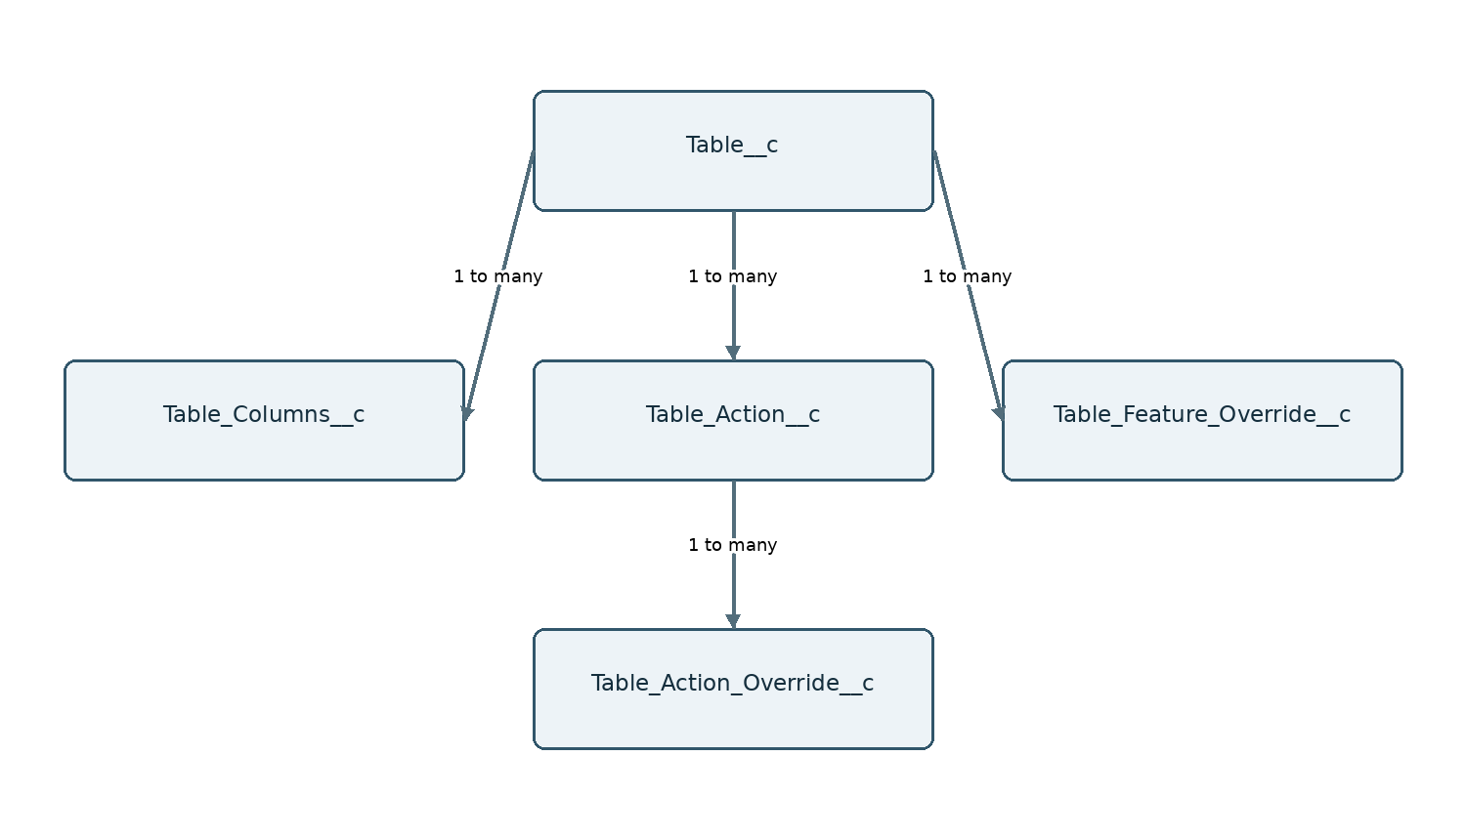

6A Configuration save
Admin changes are persisted independently from runtime record data.
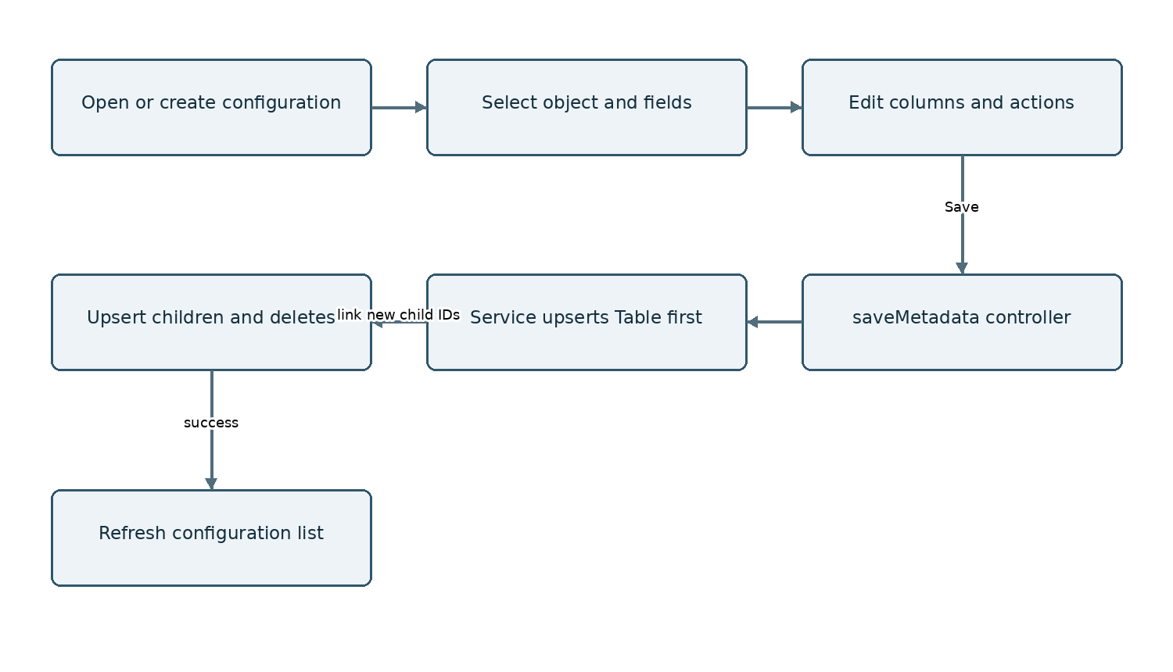
Source: dynamicTableConfigurator; SDTConfiguratorController.saveMetadata; SDTConfiguratorService.saveMetadata

6B Clone delete and overrides
Clone copies the header, columns and actions. Feature overrides are separate CRUD; clone does not copy them in this baseline.
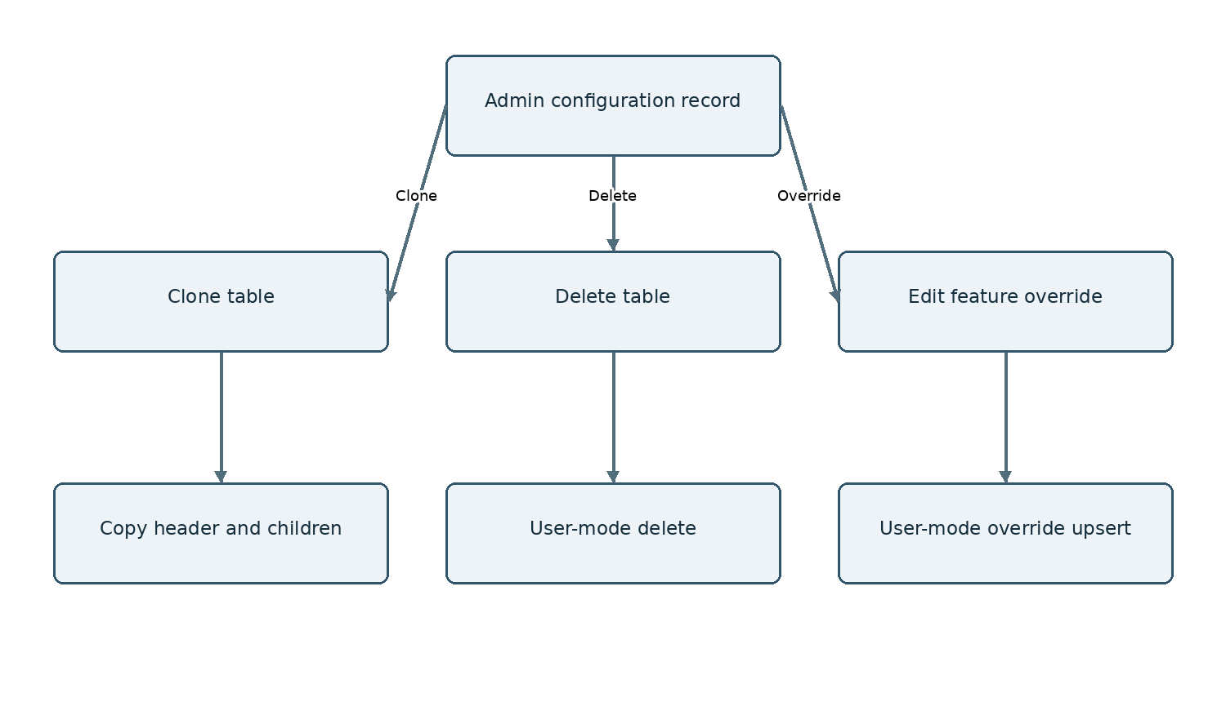
Source: SDTConfiguratorController; SDTConfiguratorService.cloneTableConfig

6C Initial table load
The server returns at most 2000 rows. The browser handles pagination, formatting and totals.
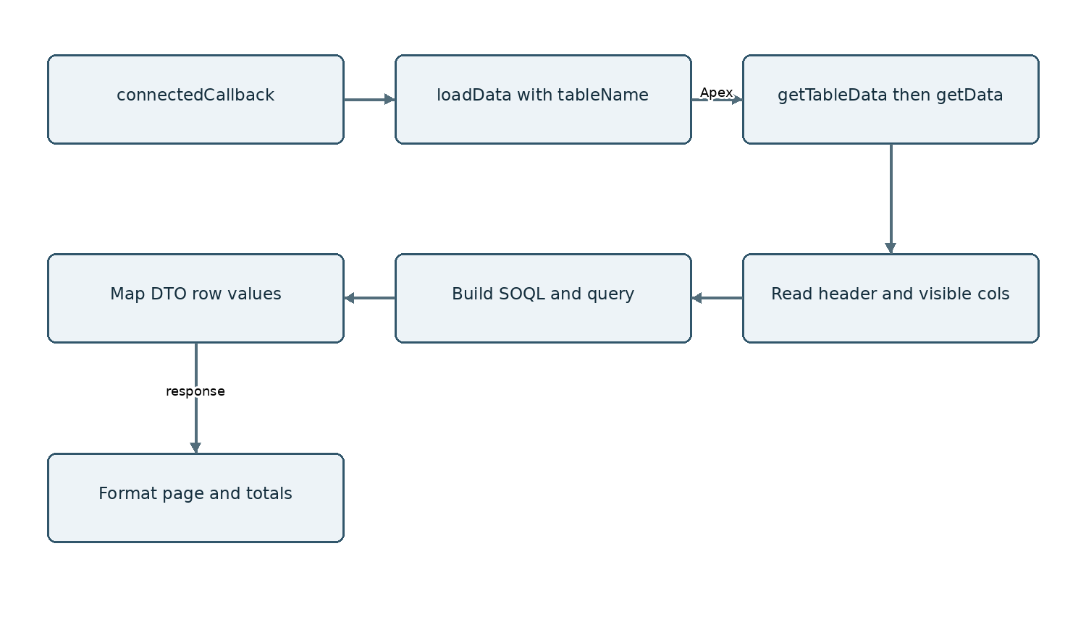
Source: simpleDataTable.loadData; SimpleTableService.getData

6D Search and sort
Search is debounced; sort triggers an immediate reload. Search matches configured searchable fields using LIKE.
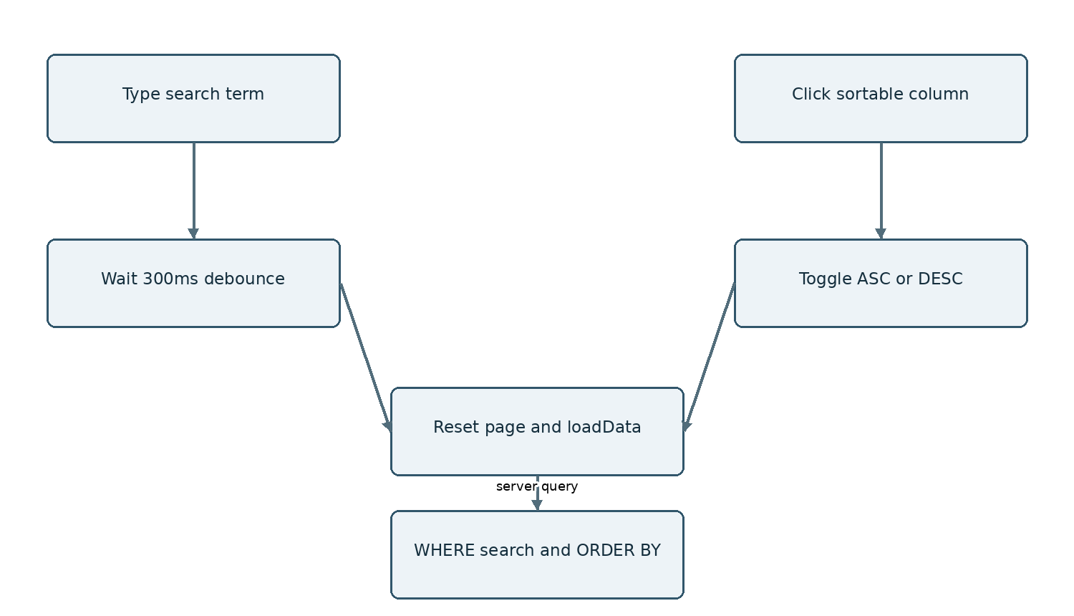
Source: simpleDataTable.handleSearch and handleSort; SimpleTableService.buildQuery

6E Typed filters and multi select
The panel emits filter definitions. The backend resolves keys to configured paths and combines valid conditions with AND.
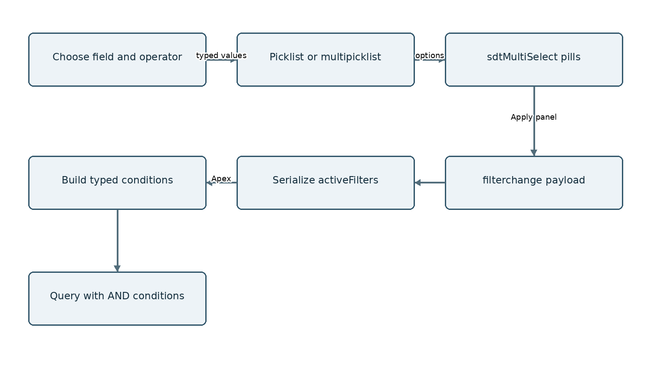
Source: sdtFilterPanel.handleApply; sdtMultiSelect; SimpleTableService.buildFilterCondition

6F Relationship fields and parent context
Parent field traversal and record-page filtering are related but separate operations. Configuration supplies dot paths; record context supplies parentId.
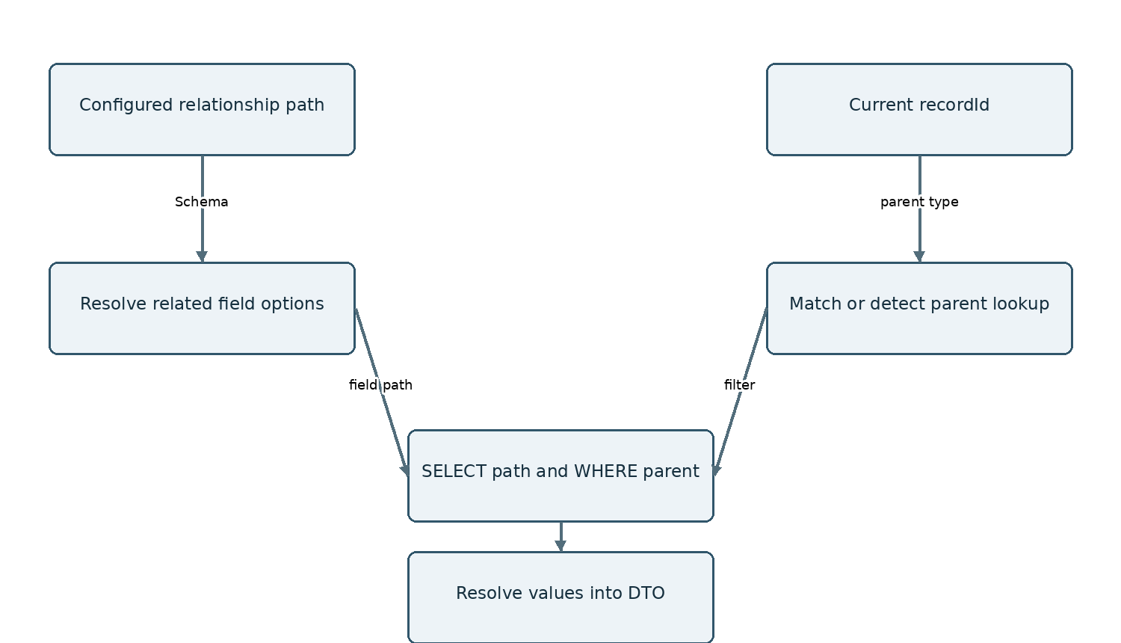
Source: resolveRelationshipField; buildColumnDef; autoDetectParentLookup; resolveFieldValue

6G Columns pagination totals and views
These browser operations use the fetched dataset. Changing page or view does not fetch additional server rows.
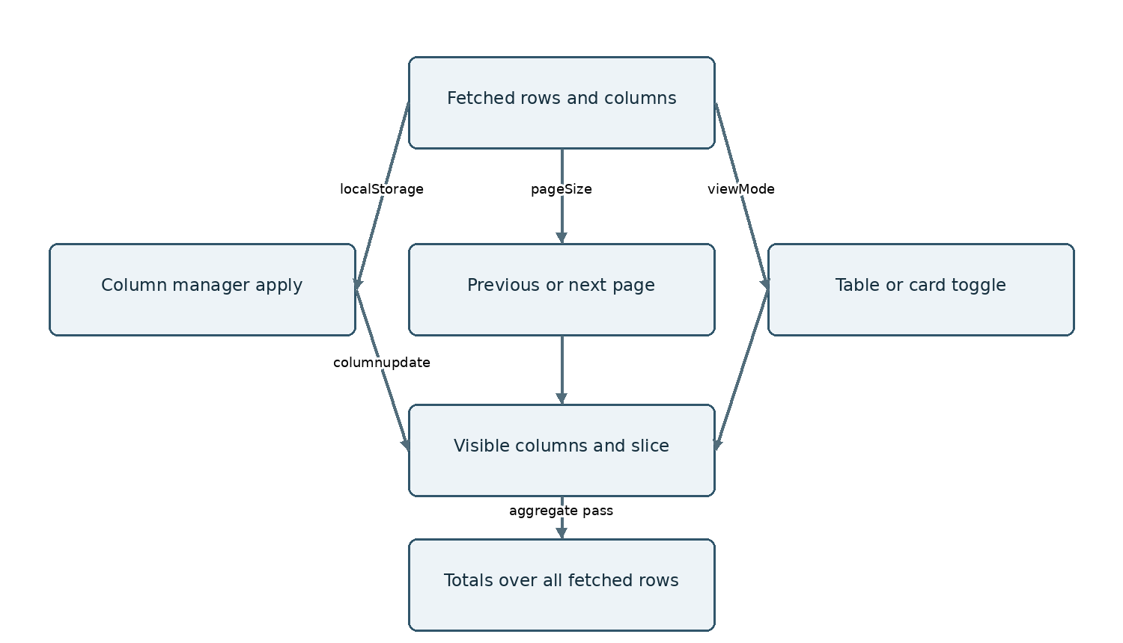
Source: sdtColManager.handleApply; simpleDataTable._applyFiltersAndFormat

6H Lookup choices and schema metadata
Admin lookup values are fetched through the Configurator backend; runtime filter picklist options are supplied by runtime column definitions.
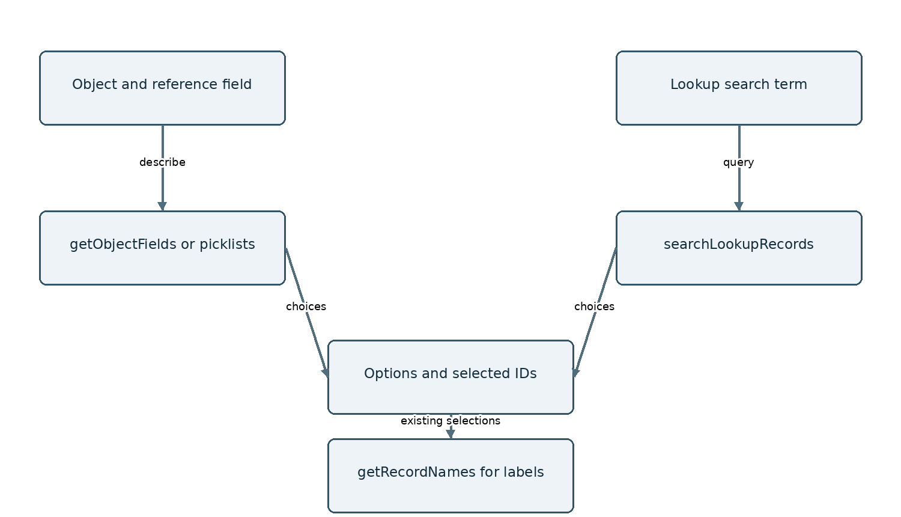
Source: SDTConfiguratorController and Service; SimpleTableService.buildColumnDef

7 Behavior limitations and development guidance
The current runtime is a configurable record viewer. Its API does not provide record edits, import/export, action execution, formula evaluation or Data Pack publishing. Adding flags or DTO fields alone does not implement a feature.
Area | Baseline behavior or concern | Development implication
Dataset cap | LIMIT 2000; paging and totals use returned records | Use true server pagination and separate aggregate/count queries for larger datasets
Aggregation | JS supports Min/Max but column picklist XML lists only None/Sum/Average/Count; null rows affect averages | Align picklist options with runtime; define null handling and Count semantics
Formatting | USD and en-US hardcoded | Use Salesforce/user locale and currency configuration
Search types | LIKE permitted for searchable columns except date/datetime/boolean | Validate supported SOQL field types; numeric or multipicklist LIKE may fail
Filter errors | Malformed filter JSON is caught and ignored | Prefer actionable errors if filter correctness matters
Dynamic SOQL | Quotes escaped; numeric/date values interpolated without typed binding | Review typed input parsing, schema validation and USER_MODE enforcement
Admin and runtime flags | Runtime reads a limited subset of configuration fields | Wire each supported flag explicitly and test enabled/disabled states
Column identity | col0 col1 keys depend on configuration order | Consider durable column IDs for persisted preferences
Concurrent fetches | Imperative request callbacks share runtime state | Add stale-response protection if rapid interactions show out-of-order data
Related record detection | Fallback chooses a matching lookup | Expose explicit parent lookup selection for ambiguous relationships
Clone scope | Header columns and actions copied; overrides not copied | Decide whether override cloning belongs in future scope
Deployment evidence | Static dependency check only; no live validation | Run full org validation and scenario QA before declaring release ready

Future feature routing
New requirement | Primary modules to extend | Metadata impact
Inline edit and multi-row save | simpleDataTable; SimpleTableController and Service | Use Is_Editable__c with permission and validation handling
Server pagination and full totals | SimpleTableService and DTO; simpleDataTable | Cursor/count contract and aggregate semantics
Formula columns and row validation | Dedicated model module plus runtime integration | Explicit formula/rule configuration required
Saved user views | Simple runtime and view endpoint | Table_User_View__c exists; define ownership and lookup strategy
Action execution | Runtime action UI and backend executor | Table_Action__c exists; define allowed handler contract
Import export | Separate runtime endpoints and UI | Metadata retained; no current implementation
Data Pack events | simpleDataTable event contract | Specify row identity, payload and publishing semantics
Recommended change process: pin a new commit; compare affected source and metadata; update feature status, contracts, field dictionary and diagrams; validate deployment; record focused runtime scenarios. Keep this document under the same version baseline as the release being discussed.

8 Complete field dictionary
Every custom field XML present in the pinned repository is listed below. Id, Name and standard audit fields are platform fields and are not custom-field XML entries. Field presence does not prove active runtime usage. Required and default values are metadata definitions; omitted values mean no explicit declaration in the XML.

DataTableColumn__mdt
Stores column definitions for Dynamic Data Table component Source: force-app/main/default/objects/DataTableColumn__mdt
Field API name and label | Type | Required | Definition
Alignment__c  Alignment | Picklist | false | Options: left, center, right
Column_Type__c  Column Type | Picklist | false | Options: text, currency, date, url, phone, email, percent, badge
Display_Order__c  Display Order | Number | true | precision=3; scale=0; externalId=false; unique=false; Column position left to right.  1 = first column, 2 = second etc
Field_API_Name__c  Field API Name | Text | true | length=80; externalId=false; unique=false; Salesforce field API name. Example: Name, Phone, AnnualRevenue
Label__c  Label | Text | true | length=120; externalId=false; unique=false; Column header text shown to user
Sortable__c  Sortable | Checkbox | not declared | defaultValue=true
Table_Name__c  Table Name | Text | true | length=80; externalId=false; unique=false; Must match TableName__c in DataTableConfig__mdt exactly
Width__c  Width | Number | false | precision=4; scale=0; defaultValue=150; externalId=false; unique=false; Column width in pixels

DataTableConfig__mdt
Retained object or custom metadata definition. Source: force-app/main/default/objects/DataTableConfig__mdt
Field API name and label | Type | Required | Definition
Enable_Search__c  Enable Search | Checkbox | not declared | defaultValue=true
Enable_Sort__c  Enable Sort | Checkbox | not declared | defaultValue=true
Object_API_Name__c  Object API Name | Text | true | length=80; externalId=false; unique=false; Salesforce Object API Name.  Example: Account, Case, Opportunity
Records_Per_Page__c  Records Per Page | Number | true | precision=3; scale=0; defaultValue=10; externalId=false; unique=false
Table_Name__c  Table Name | Text | true | length=80; externalId=false; unique=true; Unique key used by LWC to load config.  Example: Account_List, Case_Queue
Title__c  Title | Text | false | length=120; externalId=false; unique=false; Table heading shown in card header

Dynamic_Table_Error_Log__c
Stores sanitized unexpected backend exception details for debugging without exposing raw details to the UI. Source: force-app/main/default/objects/Dynamic_Table_Error_Log__c
Standard Name field: AutoNumber; label Error Log Name ; display format ERR-{0000000}
Field API name and label | Type | Required | Definition
Class_Name__c  Class Name | Text | false | length=255; externalId=false; unique=false
Context_JSON__c  Context JSON | LongTextArea | not declared | length=32768
Error_Reference__c  Error Reference | Text | true | length=255; externalId=true; unique=true
Exception_Message__c  Exception Message | LongTextArea | not declared | length=32768
Exception_Type__c  Exception Type | Text | false | length=255; externalId=false; unique=false
Method_Name__c  Method Name | Text | false | length=255; externalId=false; unique=false
Occurred_On__c  Occurred On | DateTime | false | No additional constraints declared
Severity__c  Severity | Text | false | length=255; externalId=false; unique=false
Stack_Trace__c  Stack Trace | LongTextArea | not declared | length=32768
User__c  User | Lookup | false | Parent: User; relationship Dynamic_Table_Error_Logs

Table_Action_Override__c
Stores access control overrides for Table Action Override. Source: force-app/main/default/objects/Table_Action_Override__c
Standard Name field: AutoNumber; label Table Action Override Name ; display format TFO-{000000}
Field API name and label | Type | Required | Definition
Action_Visibility__c  Action Visibility | Picklist | false | Options: Default, Visible, Hidden
Context_Type__c  Context Type | Picklist | true | Options: User, Profile, Role, Public Group
Context_Value__c  Context Value | Text | true | length=255; externalId=false; unique=false
Table_Action__c  Table Action | MasterDetail | not declared | Parent: Table_Action__c; relationship Action_Overrides

Table_Action__c
Defines custom actions (Buttons) for the DynamicMetaTable component. Source: force-app/main/default/objects/Table_Action__c
Standard Name field: Text; label Action Name
Field API name and label | Type | Required | Definition
Action_Type__c  Action Type | Picklist | true | Options: Flow, Apex, Navigation, LWC, VF Page; Determines how the action is processed.
Display_Order__c  Display Order | Number | false | precision=18; scale=0; externalId=false; unique=false; Determines the horizontal order of the button in the toolbar.
Icon__c  Icon | Text | false | length=255; externalId=false; unique=false; SLDS Icon name (e.g., utility:email).
Label__c  Label | Text | true | length=255; externalId=false; unique=false; The text displayed on the action button.
Requires_Selection__c  Requires Selection | Checkbox | not declared | defaultValue=true; If checked, the action is only visible/active when at least one row is selected.
Table__c  Table | MasterDetail | not declared | Parent: Table__c; relationship Table_Actions; The parent Table configuration this action belongs to.
Target__c  Target | Text | true | length=255; externalId=false; unique=false; API name of the Flow, Apex Class, or URL to execute.

Table_Columns__c
Column definitions; runtime and Admin Source: force-app/main/default/objects/Table_Columns__c
Standard Name field: Text; label Table Columns Name
Field API name and label | Type | Required | Definition
Additional_Column__c  Additional Column? | Checkbox | not declared | defaultValue=false
Aggregate__c  Aggregate | Picklist | false | Options: None, Sum, Average, Count
Column_API_Name__c  Column API Name | Text | true | length=255; externalId=false; unique=false
Data_Type__c  Data Type | Text | true | length=80; externalId=false; unique=false
Default_Filter_Value__c  Default Filter Value | Text | false | length=255; externalId=false; unique=false; Filter_Type__c | Format | Example  text string Acme  exact string Closed Won  starts_with string John  range JSON with min/max {"min":1000,"max":50000}  date_range JSON with from/to ISO dates {"from":"2025-01-01","to":"2025-12-31"}  multi_select JSON array of values ["Prospecting","Qualification"]  boolean true or false  none Leave blank
Filter_Type__c  Filter_Type | Picklist | false | Options: text, exact, starts_with, range, multi_select, date_range, boolean, none
Index__c  Index | Number | false | precision=2; scale=0; externalId=false; unique=false
Is_Editable__c  Is Editable? | Checkbox | not declared | defaultValue=false
Is_Filterable__c  Is Filterable | Checkbox | not declared | defaultValue=false
Is_Groupable__c  Is Groupable | Checkbox | not declared | defaultValue=false
Is_Required__c  Is Required | Checkbox | not declared | defaultValue=false
Is_Searchable__c  Is Searchable | Checkbox | not declared | defaultValue=false
Is_Sortable__c  Is Sortable? | Checkbox | not declared | defaultValue=false
Is_Visible__c  Is Visible | Checkbox | not declared | defaultValue=true
Lookup_Field_API_Name__c  Lookup Field API Name | Text | false | length=255; externalId=false; unique=false
Max_Length__c  Max_Length | Number | false | precision=18; scale=0; externalId=false; unique=false
Max_Value__c  Max Value | Number | false | precision=18; scale=2; externalId=false; unique=false
Min_Value__c  Min_Value | Number | false | precision=18; scale=2; externalId=false; unique=false
Object_Reference__c  Object Reference | Text | false | length=255; externalId=false; unique=false
Table_Name__c  Table Name | MasterDetail | not declared | Parent: Table__c; relationship Table_Columns
Wrap_Text__c  Wrap Text | Checkbox | not declared | defaultValue=false

Table_Export_Log__c
Retained object or custom metadata definition. Source: force-app/main/default/objects/Table_Export_Log__c
Standard Name field: AutoNumber; label Export Log Name ; display format TEL-{00000}
Field API name and label | Type | Required | Definition
Completed_Time__c  Completed Time | DateTime | false | No additional constraints declared
Decision_Reason__c  Decision Reason | LongTextArea | not declared | length=32768
Error_Code__c  Error Code | Text | false | length=80; externalId=false; unique=false
Error_Detail__c  Error Detail | LongTextArea | not declared | length=32768
Error_Message__c  Error Message | LongTextArea | not declared | length=32768
Export_Type__c  Export Type | Picklist | false | Options: Client, Server, Matrix
Matrix_Downgraded__c  Matrix Downgraded | Checkbox | not declared | defaultValue=false
Output_Format__c  Output Format | Picklist | false | Options: CSV, XLSX
Progress_Percentage__c  Progress Percentage | Percent | false | precision=5; scale=2
Record_Count__c  Record Count | Number | false | precision=18; scale=0; externalId=false; unique=false
Row_Count__c  Row Count | Number | false | precision=18; scale=0; externalId=false; unique=false
Started_Time__c  Started Time | DateTime | false | No additional constraints declared
Status__c  Status | Picklist | false | Options: Processing, Completed, Completed - Email Failed, Failed
Table_Name__c  Table Name | Text | false | length=255; externalId=false; unique=false
User__c  User | Lookup | false | Parent: User; relationship Table_Export_Logs

Table_Export_Setting__mdt
Retained object or custom metadata definition. Source: force-app/main/default/objects/Table_Export_Setting__mdt
Field API name and label | Type | Required | Definition
Batch_Chunk_Size__c  Batch Chunk Size | Number | false | precision=18; scale=0; defaultValue=500; externalId=false; unique=false
Client_Export_Threshold__c  Client Export Threshold | Number | false | precision=18; scale=0; defaultValue=2000; externalId=false; unique=false
Export_Retention_Days__c  Export Retention Days | Number | false | precision=18; scale=0; defaultValue=30; externalId=false; unique=false
Matrix_Aggregate_Limit__c  Matrix Aggregate Limit | Number | false | precision=18; scale=0; defaultValue=45000; externalId=false; unique=false
Matrix_Cursor_Chunk_Size__c  Matrix Cursor Chunk Size | Number | false | precision=18; scale=0; defaultValue=1000; externalId=false; unique=false
Matrix_Max_Distinct_Cells__c  Matrix Max Distinct Cells | Number | false | precision=18; scale=0; defaultValue=3000; externalId=false; unique=false
Matrix_Max_Interactive_Cells__c  Matrix Max Interactive Cells | Number | false | precision=18; scale=0; defaultValue=50000; externalId=false; unique=false
Matrix_XLSX_Safe_Limit__c  Matrix XLSX Safe Limit | Number | false | precision=18; scale=0; defaultValue=5000; externalId=false; unique=false
Max_CSV_Chunk_Size_MB__c  Max CSV Chunk Size (MB) | Number | false | precision=18; scale=0; defaultValue=4; externalId=false; unique=false
Max_Standard_Export_Rows__c  Max Standard Export Rows | Number | false | precision=18; scale=0; defaultValue=1000000; externalId=false; unique=false
Sync_Row_Limit__c  Sync Row Limit | Number | false | precision=18; scale=0; defaultValue=2000; externalId=false; unique=false

Table_Feature_Override__c
Stores access control overrides for Table Feature Override. Source: force-app/main/default/objects/Table_Feature_Override__c
Standard Name field: AutoNumber; label Table Feature Override Name ; display format TFO-{000000}
Field API name and label | Type | Required | Definition
Context_Type__c  Context Type | Picklist | true | Options: User, Profile, Role, Public Group
Context_Value__c  Context Value | Text | true | length=255; externalId=false; unique=false
Override_Enable_Column_Manager__c  Override Enable Column Manager | Picklist | false | Options: Default, Enabled, Disabled
Override_Enable_Export__c  Override Enable Export c | Picklist | false | Options: Default, Enabled, Disabled
Override_Enable_Filters__c  Override Enable Filters c | Picklist | false | Options: Default, Enabled, Disabled
Override_Enable_Import__c  Override Enable Import c | Picklist | false | Options: Default, Enabled, Disabled
Override_Enable_Matrix_View__c  Override Enable Matrix View | Picklist | false | Options: Default, Enabled, Disabled
Override_Enable_Views__c  Override Enable Views | Picklist | false | Options: Default, Enabled, Disabled
Override_Hide_Row_Actions__c  Override Hide Row Actions c | Picklist | false | Options: Default, Enabled, Disabled
Override_New_Record__c  Override New Record c | Picklist | false | Options: Default, Enabled, Disabled
Table__c  Table | MasterDetail | not declared | Parent: Table__c; relationship Feature_Overrides

Table_Matrix_Job__c
Retained object or custom metadata definition. Source: force-app/main/default/objects/Table_Matrix_Job__c
Standard Name field: AutoNumber; label Matrix Job Name ; display format TMJ-{00000}
Field API name and label | Type | Required | Definition
Cell_Count__c  Cell Count | Number | false | precision=18; scale=0; externalId=false; unique=false
Completed_Time__c  Completed Time | DateTime | false | No additional constraints declared
Config_Hash__c  Config Hash | Text | false | length=64; externalId=true; unique=false
Error_Message__c  Error Message | LongTextArea | not declared | length=32768
Expires_At__c  Expires At | DateTime | false | No additional constraints declared
Grouped_Row_Count__c  Grouped Row Count | Number | false | precision=18; scale=0; externalId=false; unique=false
Normalized_Request_JSON__c  Normalized Request JSON | LongTextArea | not declared | length=131072
Object_API_Name__c  Object API Name | Text | false | length=80; externalId=false; unique=false
Processed_Row_Count__c  Processed Row Count | Number | false | precision=18; scale=0; externalId=false; unique=false
Progress_Percentage__c  Progress Percentage | Number | false | precision=3; scale=0; externalId=false; unique=false
Request_JSON__c  Request JSON | LongTextArea | not declared | length=131072
Request_Version__c  Request Version | Text | false | length=40; externalId=false; unique=false
Result_JSON__c  Result JSON | LongTextArea | not declared | length=131072
Source_Row_Count__c  Source Row Count | Number | false | precision=18; scale=0; externalId=false; unique=false
Started_Time__c  Started Time | DateTime | false | No additional constraints declared
Status__c  Status | Picklist | false | Options: Queued, Processing, Completed, Failed, Expired
Table_Name__c  Table Name | Text | false | length=255; externalId=false; unique=false
Table__c  Table | Lookup | false | Parent: Table__c; relationship Matrix_Jobs
User__c  User | Lookup | false | Parent: User; relationship Table_Matrix_Jobs

Table_Matrix_Summary__c
Retained object or custom metadata definition. Source: force-app/main/default/objects/Table_Matrix_Summary__c
Standard Name field: AutoNumber; label Matrix Summary Name ; display format TMS-{00000}
Field API name and label | Type | Required | Definition
Aggregate_Field__c  Aggregate Field | Text | false | length=255; externalId=false; unique=false
Aggregate_Function__c  Aggregate Function | Text | false | length=40; externalId=false; unique=false
All_Dimensions_JSON__c  All Dimensions JSON | LongTextArea | not declared | length=131072
Column_Dimensions_JSON__c  Column Dimensions JSON | LongTextArea | not declared | length=131072
Column_Key__c  Column Key | LongTextArea | not declared | length=32768
Config_Hash__c  Config Hash | Text | false | length=64; externalId=true; unique=false
Job__c  Job | Lookup | false | Parent: Table_Matrix_Job__c; relationship Matrix_Summaries
Row_Dimensions_JSON__c  Row Dimensions JSON | LongTextArea | not declared | length=131072
Row_Key__c  Row Key | LongTextArea | not declared | length=32768
Summary_Alias__c  Summary Alias | Text | false | length=80; externalId=false; unique=false
Summary_Key__c  Summary Key | Text | false | length=255; externalId=true; unique=true
Value__c  Value | Number | false | precision=18; scale=6; externalId=false; unique=false

Table_User_View__c
Retained object or custom metadata definition. Source: force-app/main/default/objects/Table_User_View__c
Standard Name field: Text; label View Name
Field API name and label | Type | Required | Definition
Column_State_JSON__c  Column State JSON | LongTextArea | not declared | length=131072
Description__c  Description | LongTextArea | not declared | length=1000
Filter_Payload_JSON__c  Filter Payload JSON | LongTextArea | not declared | length=131072
Is_Default__c  Is Default | Checkbox | not declared | defaultValue=false
Matrix_Config_JSON__c  Matrix Config JSON | LongTextArea | not declared | length=32768
Sort_Direction__c  Sort Direction | Text | false | length=10; externalId=false; unique=false
Sort_Key__c  Sort Key | Text | false | length=255; externalId=false; unique=false
Table_Name__c  Table Name | Text | true | length=255; externalId=false; unique=false

Table_Virtual_Setting__mdt
Retained object or custom metadata definition. Source: force-app/main/default/objects/Table_Virtual_Setting__mdt
Field API name and label | Type | Required | Definition
Cache_Window_Size__c  Cache Window Size | Number | false | precision=18; scale=0; externalId=false; unique=false; Maximum number of chunks to keep in memory at one time.
Chunk_Size__c  Chunk Size | Number | false | precision=18; scale=0; externalId=false; unique=false; Number of records per chunk in Virtual Browse Mode.
Matrix_Max_Summary_Fields__c  Matrix Max Summary Fields | Number | false | precision=18; scale=0; externalId=false; unique=false; Maximum number of Matrix summary fields allowed in an interactive or exported Matrix configuration.
Matrix_Preview_Row_Limit__c  Matrix Preview Row Limit | Number | false | precision=18; scale=0; externalId=false; unique=false; Maximum number of grouped Matrix rows rendered interactively in the browser. Matrix exports continue to use the full filtered data set.
Prefetch_Threshold__c  Prefetch Threshold | Number | false | precision=18; scale=0; externalId=false; unique=false; Scroll buffer threshold before fetching the next chunk.
Virtual_Mode_Threshold__c  Virtual Mode Threshold | Number | false | precision=18; scale=0; externalId=false; unique=false; Number of records above which the table automatically switches to Virtual Browse Mode.

Table__c
Core table header; runtime and Admin Source: force-app/main/default/objects/Table__c
Standard Name field: Text; label Table Name
Field API name and label | Type | Required | Definition
Aggregate_Field__c  Aggregate Field | Text | false | length=255; externalId=false; unique=false
Aggregate_Function__c  Aggregate Function | Picklist | false | Options: SUM, COUNT, AVG, MIN, MAX
Col_Grouping_Fields__c  Col Grouping Fields | LongTextArea | not declared | length=32768
Data_Load_Mode__c  Data Load Mode | Picklist | false | Options: Standard, Virtual, Auto; Mode for loading data (Standard, Virtual, Auto).
Empty_State_Illustration__c  Empty State Illustration | Text | false | length=100; defaultValue="desert:empty_list"; externalId=false; unique=false; The SLDS illustration name to show when no records are found (e.g., desert:empty_list, cart:noitems).
Enable_Column_Manager__c  Enable Column Manager | Checkbox | not declared | defaultValue=true; If checked, the "Columns" button for managing visibility and order will be visible.
Enable_Export__c  Enable Export | Checkbox | not declared | defaultValue=true; If checked, the "Export" button for CSV data will be visible.
Enable_Filters__c  Enable Filters | Checkbox | not declared | defaultValue=true; If checked, the filter panel and filter toggle button will be visible.
Enable_Grouping__c  Enable Grouping | Checkbox | not declared | defaultValue=false
Enable_Import__c  Enable Import | Checkbox | not declared | defaultValue=true; If checked, the "Import" button for CSV data will be visible.
Enable_Infinite_Scroll__c  Enable Infinite Scroll | Checkbox | not declared | defaultValue=false; Enable infinite scrolling for large datasets.
Enable_Matrix_View__c  Enable Matrix View | Checkbox | not declared | defaultValue=true; If checked, the Matrix/Pivot mode toggle button will be visible.
Enable_New_Record__c  Enable New Record | Checkbox | not declared | defaultValue=true; If checked, a primary "New" button will be visible in the toolbar for creating new records.
Enable_Views__c  Enable Views | Checkbox | not declared | defaultValue=true; If checked, the saved Views button will be visible.
Hide_Row_Actions__c  Hide Row Actions | Checkbox | not declared | defaultValue=false; If checked, the standard per-row actions menu (View, Edit, Delete) will be hidden.
Object_API_Name__c  Object API Name | Text | false | length=80; externalId=false; unique=false
Object_Name__c  Object Name | Text | true | length=80; externalId=false; unique=false
Row_Grouping_Fields__c  Row Grouping Fields | LongTextArea | not declared | length=32768

9 Source references and maintenance
Repository: https://github.com/Akash76803/dynamicTableBuilder
Pinned tree: https://github.com/Akash76803/dynamicTableBuilder/tree/eb5009dfaa22223a00a0cb8f17a482083d076c2f
Code paths below are relative to the repository root. All statements and field definitions derive from the pinned commit; source behavior takes priority over README claims.
force-app/main/default/classes/SDTConfiguratorController.cls
force-app/main/default/classes/SDTConfiguratorDTO.cls
force-app/main/default/classes/SDTConfiguratorSelector.cls
force-app/main/default/classes/SDTConfiguratorService.cls
force-app/main/default/classes/SimpleTableController.cls
force-app/main/default/classes/SimpleTableDTO.cls
force-app/main/default/classes/SimpleTableService.cls
force-app/main/default/lwc/dynamicTableConfigurator/dynamicTableConfigurator.js
force-app/main/default/lwc/sdtColManager/sdtColManager.js
force-app/main/default/lwc/sdtFilterPanel/sdtFilterPanel.js
force-app/main/default/lwc/sdtMultiSelect/sdtMultiSelect.js
force-app/main/default/lwc/simpleDataTable/simpleDataTable.js
Metadata source: force-app/main/default/objects/<ObjectAPIName>/<ObjectAPIName>.object-meta.xml and fields/<FieldAPIName>.field-meta.xml. The complete dictionary includes all 157 custom field files across 14 definitions.
Version history: 1.0 — initial code-grounded project reference, 5 October 2026, baseline eb5009d. Future revisions must include commit, changed feature scope, validation evidence and diagram/dictionary updates.

10A Export scope and decisions
Status: architecture selected for implementation on 5 October 2026. Export components, worker and metadata extensions described in Section 10 are planned; this document update does not implement or deploy them.
Build a reusable sdtDataExport LWC with its own SDTExportController and SDTExportService. Support CSV for Current page, Loaded results and All matching records. Current page and Loaded results use already-loaded data when supplied; All matching always creates a background job. No claim of unlimited rows or a guaranteed completion time is made.
Default to visible columns in current order; optionally include all permitted configured columns. Preserve labels, parent context, search, validated AND or OR or custom filter logic and supported server sort. Lookup columns export their readable configured display value. Record IDs are an optional explicit output option. CSV uses escaped quotes, commas and line breaks, spreadsheet formula protection, consistent date formats and numeric values without currency decoration.
Initial scope includes file-part downloads, processed-row and byte counters, owner-only job access, status polling, cancellation between transactions, bounded retry, cleanup and tests. Optional totals use persisted partial sum, count, minimum and maximum; average is derived from total sum and applicable count. A final summary is a separate CSV part, never a recombination of all output.
Excluded: XLSX, PDF, matrix or pivot export, single huge CSV assembled in Apex, ZIP assembly, external streaming or Bulk API integration, arbitrary client SOQL, point-in-time data snapshots, email delivery and automatic restart with changed configuration. These require separate scope.
The first implementation delivers the complete bounded background CSV route. The earlier suggestion to defer all bulk export to a later phase is superseded. Local page and loaded exports are conveniences; they do not replace the bulk route.
Decision | Selected behaviour
Output | One or more independently readable CSV parts with headers
Worker state | Only export job ID and small expected checkpoint or generation
Transactions | Commit output part and checkpoint together; next worker gets fresh limits
Capacity | Configured row and file limits; production cap follows representative load tests
UI lifecycle | Closing the page does not cancel a submitted background job

10B Component architecture
The table passes export context to sdtDataExport. The exporter can also be used by another host that supplies a table configuration and context. It must not import table internals or own the table filter UI. Browser export may accept a bounded rows input; bulk export always fetches server data.
Extract validated configuration and query construction from SimpleTableService into SDTQueryService with a regression-tested table adapter. Table and export use the same query semantics but different fetch policies: the table keeps its existing LIMIT 2000 and the export uses bounded continuation queries. Do not invoke getData repeatedly as a substitute for a bulk engine.
Freeze column keys, labels, types, display paths, lookup paths, filters, parent context, sort and settings version in the persisted request. Resolve keys against saved configuration before storing the snapshot. Recheck permissions during worker reads; the frozen request does not grant extra access.
Proposed component | Responsibility
sdtDataExport | Scope and column options, job progress, cancel and file download
sdtCsvBuilder | Bounded browser CSV conversion and escaping
SDTExportController and DTO | startExport, getExportStatus, listParts, cancelExport and retryExport contracts
SDTExportService and Selector | Request validation, job lifecycle, owner access and persistence
SDTQueryService | Shared configured query, access checks and continuation predicates
SDTExportWorker | One bounded Queueable transaction; job ID constructor
SDTExportFinalizer | Separate transaction for failed-job reporting and bounded recovery
SDTExportDispatcher and Cleanup | Resume eligible jobs within async capacity; expire retained files

Export component flow
The export UI submits a validated request and reads job status and file references. The worker uses the shared query layer and writes bounded output parts. Finalizer and dispatcher recover failed or waiting jobs from persisted checkpoints.
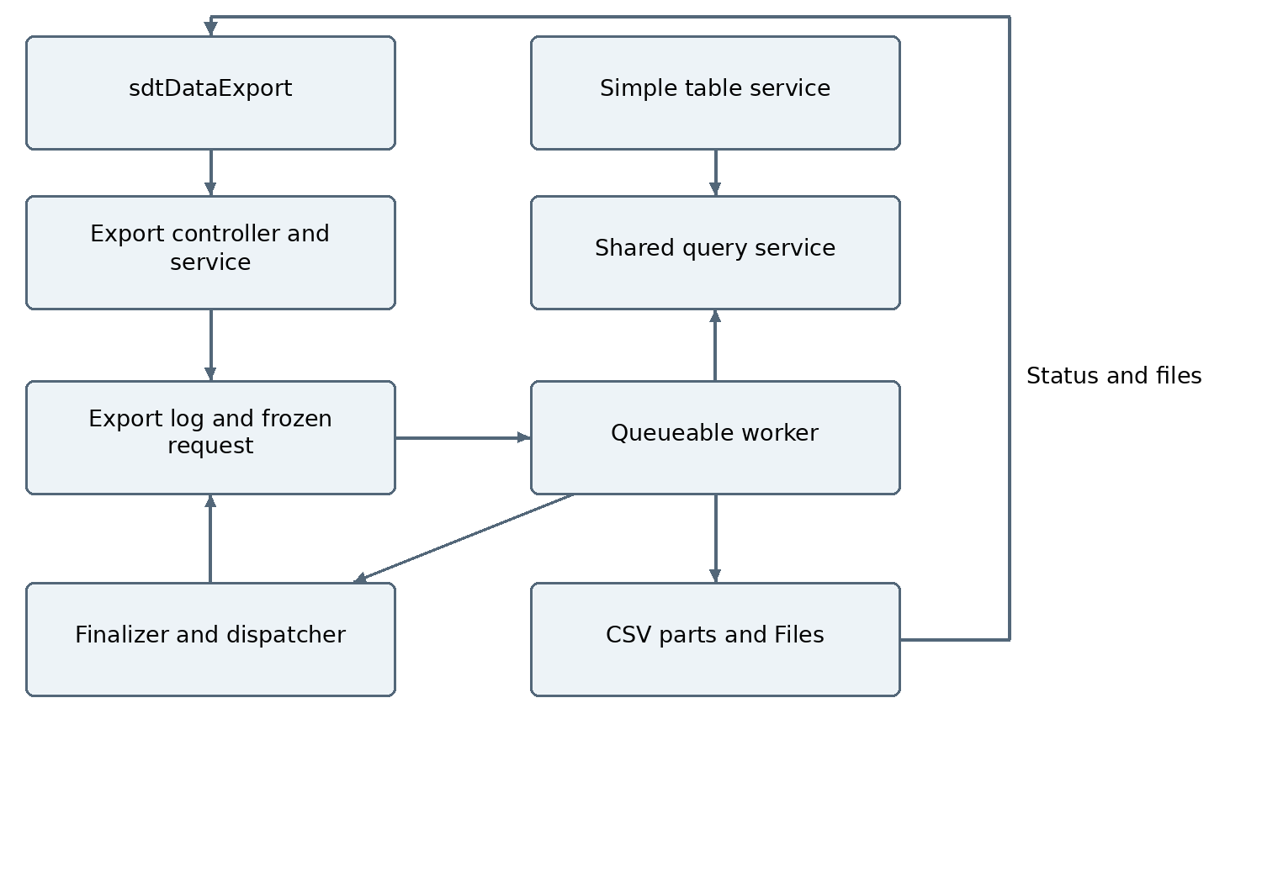

10C Transaction and checkpoint flow
Submission validates access and configured limits, persists an immutable request and enqueues a worker in one transaction. The worker attaches a lightweight finalizer, locks the job, checks status and expected generation, then fetches a small page. Keep all record and CSV buffers local to this execute method.
Process rows while measuring heap, CPU and estimated output bytes. Flush before the soft thresholds when a complete row can be committed safely. Persist ContentVersion, the part manifest, counters, partial totals and the last processed sort tuple in the same transaction. Advance the checkpoint only for rows included in a successfully saved part.
If rows remain, enqueue at most one child worker and return. A fresh transaction begins when Salesforce schedules that job, not immediately inside the current method. If capacity or chain-depth rules prevent continuation, leave a resumable Waiting state for the dispatcher. Never pass the current records, Blob or CSV buffer to another job.
Do not use OFFSET for bulk continuation. Use the validated sort field plus Id as a deterministic tie breaker, with an explicit null phase and typed checkpoint values. Support only scalar sortable fields for which a correct continuation predicate can be generated. Reject unsupported bulk sorts with an actionable message instead of silently changing order.
This is a live export: request settings are frozen, but record values and membership can change during execution. A created-time upper bound excludes newly created records where supported; updates and deletions may still change results. It is not a database snapshot. Retry guarantees concern committed parts and checkpoints, not historical consistency.
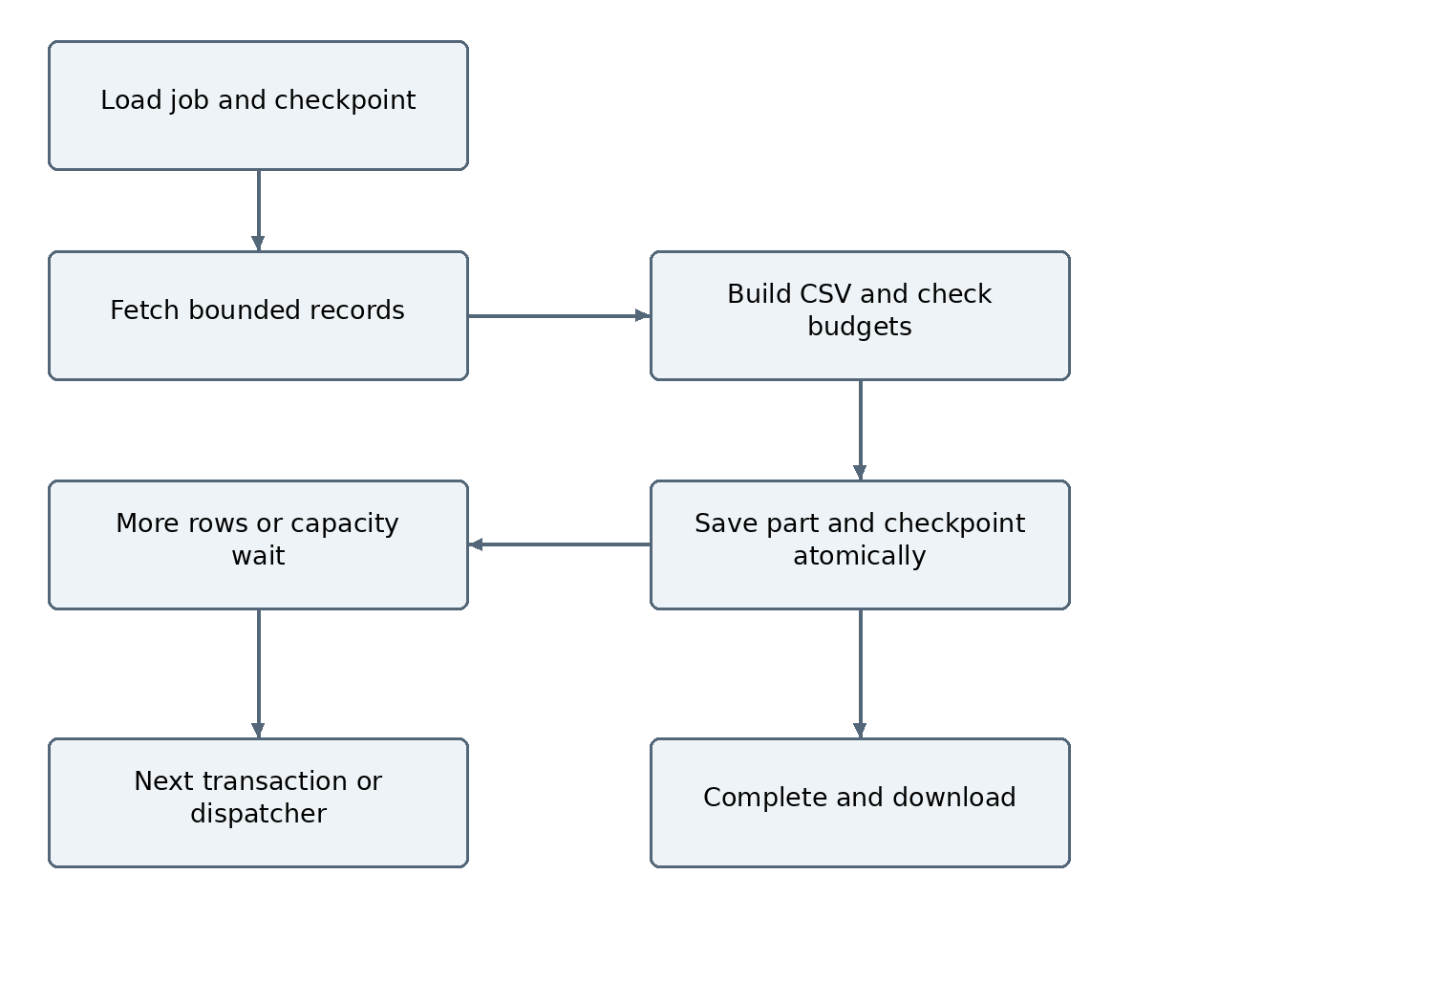

10D Limits and bounded execution
Read Limits.getHeapSize and getLimitHeapSize during processing. Also monitor getCpuTime, getLimitCpuTime, query rows, DML and async enqueue capacity. Hard limits remain platform-enforced; monitoring does not guarantee that a single query, record or allocation cannot exceed them before the next check.
Provisional tuning values are 100 fetched rows per worker, adaptive range 1 to 500 rows, 40 percent heap and 50 percent CPU soft thresholds, and a 1 MiB target CSV part. These are engineering starting points, not Salesforce limits or tested capacity promises. Lower them when long text, wide columns, conversion or file-insert automation consumes more resources.
Reserve memory for the current records, escaped row, joined CSV, Blob conversion, File DML and automation. Estimate output bytes before expanding buffers; do not rely on string length alone as an exact memory measurement. Saving a part or setting variables to null does not create a new transaction or guarantee immediate garbage collection.
A row that cannot fit within the configured safe budget must fail explicitly with the field or row context, or require the user to reduce columns. Do not silently truncate data or loop forever retrying an oversized row. Fetch count reduction is bounded and cannot rescue every possible record.
Resolve the actual target-org limits at runtime. Older heap allowances are 6 MB synchronous and 12 MB asynchronous; Winter 27 release notes increase them to 10 MB and 25 MB where available. CPU allowances are 10 seconds synchronous and 60 seconds asynchronous. CPU time is not a wall-clock completion promise.
Async daily allocations, configured chain depth, worker concurrency, query selectivity and Files storage must also be respected. UI polling reports Queued, Processing, Waiting, Completed, Failed or Cancelled; elapsed UI time alone must not mark a still-running job failed. A lease and finalizer or dispatcher detect abandoned execution.
Risk | Required control
Heap or instance too large | Job ID only in worker; bounded local buffers; no Database.Stateful CSV
Query and CPU pressure | Selected fields only, selective filters, bounded fetch and no row-level SOQL
File or total-size limit | Per-part byte cap and configured maximum rows, bytes and parts
Resource starvation | Per-user active-job cap, concurrency control and dispatcher backoff

10E Persistence and relationships
Reuse Table_Export_Log__c as the job record and Table_Export_Setting__mdt for existing export policies. Both exist in the baseline metadata but are not a working runtime export engine. Add a proposed Table_Export_Part__c child linked to the log. Naming and field extensions below are a design contract, not deployed metadata.
Keep the existing User lookup as the requester. Existing log fields cover status, counts, start and completion times, errors, output format and chunk size. Existing settings include Client_Export_Threshold, Sync_Row_Limit, Max_Standard_Export_Rows, Max_CSV_Chunk_Size_MB and Export_Retention_Days. Extend these only for missing policies, rather than introducing a competing settings object.
Files attach to the private export log through ContentDocumentLink. A part stores ContentVersionId for the exact generated version; a Text field is an identifier reference, not a custom lookup to ContentVersion. Requester access to the log, manifest and File must be consistent. Cleanup deletes only export-owned documents that are eligible under retention and sharing rules.
Record | Proposed field additions and relations
Table_Export_Log__c | Table_Config lookup to Table__c; Request_JSON; Checkpoint_JSON; Next_Part_Number; Output_Bytes; Part_Count; Retry_Count; Generation; Active_Async_Job_Id; Last_Heartbeat; Lease_Expires_At; Cancel_Requested; Expires_At
Table_Export_Part__c | Master-detail Export_Log to Table_Export_Log__c; Part_Number; unique Job_Part_Key; Content_Version_Id Text 18; Row_Count; Byte_Count; First_Checkpoint_JSON; Last_Checkpoint_JSON; Partial_Totals_JSON; Part_Type
Table_Export_Setting__mdt | Additional heap and CPU soft percentages; Fetch_Row_Limit; Max_Output_Bytes; Max_Parts; Max_Retry_Count; Max_Active_Jobs_Per_User; Poll_Interval_Seconds
User and Files | User -> export log -> part manifests; export log -> ContentDocumentLink -> ContentDocument -> ContentVersion
Payload/checkpoint Long Text Area lengths must be chosen explicitly and validated before DML. Reject an oversized frozen request. Persist only bounded per-part totals and checkpoint tuples, never a full result list or accumulated output string.

10F Retry security and cancellation
All server methods verify that the caller owns the job or has explicitly granted admin access. Execute record reads with sharing and explicit object and field access enforcement. Validate export fields against the saved configuration; use bound continuation values where supported. Never trust client field paths, URLs or SOQL.
The same transaction writes the file part, unique job-and-part key and checkpoint. A failure rolls these changes back together. Workers lock and verify the expected generation or checkpoint so duplicate submissions and retries cannot advance the same part twice. Retry from the last committed checkpoint; never advance for an unsaved row.
The finalizer runs separately and can record failures that rolled back the worker transaction. Recover transient failures using a proposed maximum of three attempts, resource-aware smaller fetches and backoff. Permanent validation, permission, oversized-row or storage failures require user action. The finalizer must remain lightweight and is not an unlimited recovery guarantee.
Cancellation is checked at transaction boundaries and before output persistence. It does not kill an already-running transaction immediately. Completed parts on Failed or Cancelled jobs are labelled partial and are not offered as a successful full export. A corrected request starts a new job; a retry preserves the original request.
Polling stops when the UI disconnects; the job continues. Fetch status with a proposed five-second interval and backoff while waiting, without repeated full-data requests. Download only authorized persisted Files; do not expose a global public file link by default.
CSV formula protection covers leading spreadsheet formula markers and relevant control characters. Escape every textual cell and quote according to CSV rules. Keep numeric output typed before formatting so negative numbers are not accidentally converted to formula-like text. Log operational context without retaining unnecessary sensitive row values.
Status | Meaning
Queued or Waiting | Accepted; scheduling or capacity prevents immediate processing
Processing | Worker is executing; processed count reflects committed rows
Completed | All required parts are persisted and accessible
Failed | Terminal failure; partial parts are clearly identified
Cancelled or Expired | User stopped continuation, or retained output was cleaned up

10G Implementation and acceptance plan
Step 1: inspect the latest branch metadata and target package ownership; confirm log/settings reuse, field sizes, status picklist extensions and new part-object deployment. Add permission sets and tests. Freeze the DTO contract and build the request/job selectors.
Step 2: extract the shared query layer while preserving existing table requests and results. Test search, parent context, AND or OR or custom logic, relationship paths, permissions, sorting and LIMIT 2000. Implement sort-aware checkpoint predicates with tie and null cases before using them for bulk export.
Step 3: build the Queueable worker, CSV formatter, atomic manifest/checkpoint writes, finalizer, dispatcher, cancellation and cleanup. Simulate rollback, repeated dispatch, stalled workers and permission changes. Keep the worker constructor restricted to the job identifier and small control values.
Step 4: build the independent export UI and table integration. Add Current page and Loaded results using bounded inputs, bulk start/status/download, explicit part labels and optional final totals. Validate downloads with Excel and another CSV parser.
Step 5: perform representative target-org load tests before publishing a row cap. Measure transaction heap and CPU, query duration, CSV bytes, File insertion, queue delay, total runtime, part count and retry outcomes. Test both namespace and independent deployment paths.
Acceptance area | Required evidence
Data correctness | Column order, lookup labels, parent filters, custom logic, escaping and totals
Continuation | Repeated sort values, nulls, ascending/descending, last partial page and live-data caveat
Recovery | No duplicate committed parts; no skipped checkpoint rows on retry; explicit terminal errors
Limits | Wide and long-text records; threshold headroom; oversized-row handling; async capacity
Security | Unauthorized job/file access denied; object/field access enforced
Regression | Existing table pagination, resize, links, filters, cards and aggregates remain correct
Release gates: Apex semantic compilation and tests, LWC compilation, metadata/permission deployment, UI smoke tests and measured capacity must pass. No governor-limit safety or production capacity claim is made solely from a syntax check.

10H Branches status and sources
Section 1 through 9 retains the original eb5009d source inventory. This revision adds an implementation delta and the selected export design; the export components and field additions remain planned. The older AND-only and plain-text descriptions are superseded by the implemented features listed below.
Implemented since the original baseline: independent and namespace/shree-tech branches; horizontal scrolling and resizable persistent column widths; wrap/clip and refresh controls; improved numbered filter UI with validated AND, OR and custom logic; table/card record hyperlinks; configured lookup ID path priority; case-insensitive SOQL field deduplication; sticky table header CSS.
Code baseline for this document: independent da817ad67e840558e6594605be00c7cb8400ada0 and namespace/shree-tech 9ff58c0aa960c802f772a64e6f5f53e1a297937d. User confirmed filter and hyperlink fixes working; live verification of the newest sticky-header change and the proposed export implementation is not recorded.
Both branches receive the same reference DOCX, export architecture Markdown and Mermaid sources under doc. The namespace branch uses Shree_Tech__ configuration object and field references; the independent branch uses unprefixed APIs. New fields on namespaced package objects must be provisioned through the package-owned metadata workflow; the existing code-only namespace manifest cannot provision missing fields or the new part object.
The proposed exporter does not introduce another namespace branch or modify main. Implementation will follow the sequence in Section 10G after this scope record is committed. Future revisions must update the planned/implemented status, object dictionary, class inventory, tests and supported capacity together.
Apex limits: https://developer.salesforce.com/docs/atlas.en-us.apexcode.meta/apexcode/apex_gov_limits.htm
Heap monitoring: https://help.salesforce.com/s/articleView?id=000385712&language=en_US&type=1
Winter 27 heap update: https://help.salesforce.com/s/articleView?id=release-notes.rn_apex_heap_limit.htm&language=en_US&type=5
Queueable architecture: https://trailhead.salesforce.com/content/learn/modules/asynchronous_apex/async_apex_queueable
Finalizer transaction boundary: https://developer.salesforce.com/blogs/2020/01/learn-moar-in-spring-20-introducing-transaction-finalizers

