Kyiri Bug Bounty Program
Vulnerability Submission Report

Report ID | KBB-2026-001 | Submission Date | 2026-03-18
Severity | Medium | Status | New

1. Researcher Information

Researcher Name | Akash Athare
Alias / Handle | NA
Email | thebugbountyhunter151@gmail.com
Phone / WhatsApp | 7719031618
Telegram / Discord | @reasearcherr
Country | India

2. Vulnerability Details

Vulnerability Title | Azure AD Domain/Tenant Enumeration via UserRealm JSON API
Affected Asset / URL | https://login.microsoftonline.com/common/userrealm/{email}?api-version=2.0
Affected Feature | Home Realm Discovery (HRD) — Azure AD / Microsoft Entra ID Authentication
Tools Used | cURL

3. Summary

The /common/userrealm/ JSON API endpoint on login.microsoftonline.com accepts any email address as a path parameter and returns a JSON response that deterministically reveals whether the associated domain is enrolled in Azure AD. The NameSpaceType field returns Managed for Azure AD-managed domains, Federated for federated/consumer domains, and Unknown for non-existent domains. This unauthenticated endpoint leaks tenant branding, federation brand names, and domain configuration details for valid tenants.

4. Steps to Reproduce

- Send request with a valid Azure AD email domain:
curl -s "https://login.microsoftonline.com/common/userrealm/test@microsoft.com?api-version=2.0"

- Send request with a non-existent domain:
curl -s "https://login.microsoftonline.com/common/userrealm/test@thisfakedomain999xyz.com?api-version=2.0"

- Compare the NameSpaceType field in both responses to observe the deterministic signal difference.

5. Proof of Concept / Evidence

Test Case 1 — Valid Azure AD Managed Domain (microsoft.com)

{
"NameSpaceType": "Managed",
"Login": "test@microsoft.com",
"DomainName": "microsoft.com",
"FederationBrandName": "Microsoft",
"TenantBrandingInfo": [{ "Locale": 0, "BannerLogo": "https://aadcdn...", "BackgroundColor": "#0078D4", "KeepMeSignedInDisabled": true }],
"cloud_instance_name": "microsoftonline.com",
"is_dsso_enabled": true,
"force_login_hint": true
}

Test Case 2 — Federated Consumer Domain (gmail.com)

{
"NameSpaceType": "Federated",
"federation_protocol": "WSTrust",
"Login": "randomuser@gmail.com",
"AuthURL": "https://login.live.com/login.srf?username=randomuser%40gmail.com...",
"DomainName": "live.com",
"FederationBrandName": "Windows Live",
"ConsumerDomain": true
}

Test Case 3 — Non-existent / Unregistered Domain

{
"NameSpaceType": "Unknown",
"Login": "test@thisfakedomain999xyz.com",
"cloud_instance_name": "microsoftonline.com"
}

Screenshot — Live Terminal PoC (microsoft.com vs thisfakedomain999xyz.com)

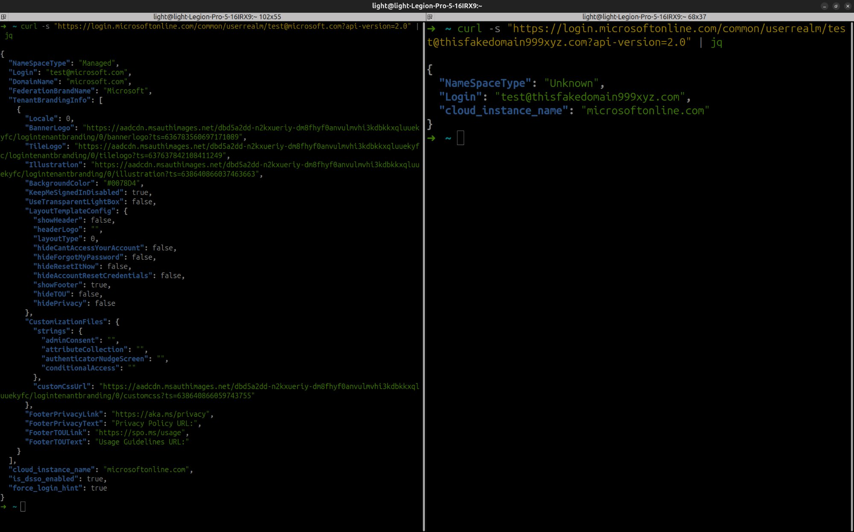

Figure 1: Left — Managed response for microsoft.com | Right — Unknown response for non-existent domain

Signal Comparison Table

Domain Type | NameSpaceType Value | Extra Fields Leaked
Azure AD Managed | Managed | DomainName, TenantBrandingInfo, FederationBrandName, is_dsso_enabled
Federated (consumer) | Federated | AuthURL, federation_protocol, ConsumerDomain
Non-existent domain | Unknown | None (minimal ~100 byte response)

6. Impact

- Enumerate which organizations use Azure AD / Microsoft 365 by testing domain names against this API.
- Determine authentication type (Managed vs. Federated) to tailor targeted phishing attacks.
- Harvest tenant branding data (logos, background colors, CSS URLs) to build convincing phishing pages.
- Discover federation endpoints (e.g., ADFS AuthURLs) for federated domains, enabling further attack surface mapping.
- Perform reconnaissance at scale — no authentication, no CAPTCHA, cached responses allow high-speed enumeration.

7. Suggested Fix (Optional)

- Implement rate limiting and CAPTCHA on the UserRealm endpoint.
- Return a uniform response for all domains (remove NameSpaceType differentiation in unauthenticated context).
- Require at minimum a valid client session or flow context token before returning tenant details.

8. Researcher Declaration

[X] I confirm that this report is original and submitted in good faith.
[X] I confirm that I did not intentionally harm users, data, or service availability.
[X] I understand that reward eligibility depends on validation by the Kyiri team.

Researcher Signature:  Akash Athare | Date:  18 March 2026

Reviewed By: | Decision:  [ ] Valid [ ] Duplicate [ ] Rejected

