**Assignment Description**:

For this task, I began with a dated triangle categorization that had flaws. I corrected the bugs until the application worked after adding the required test cases to the unit testing program.

**Akash Adarsh**

**Summary:**

I identified 6 defects with my test program. Using a unit test program is helpful, especially with a program like this, where there are multiple possible outputs. Being able to see which tests are failing makes isolating the problem easier.

Summary Matrix

|  |  |  |  |  |
| --- | --- | --- | --- | --- |
|  |  | Test Run 1 | Test Run 2 | Test Run 3 |
| Tests Planned |  | 13 | 13 | 13 |
| Tests Executed |  | 13 | 13 | 13 |
| Tests Passed |  | 0 | 7 | 13 |
| Defects Found |  | 6 | 0 | 0 |
| Defects Fixed |  | 5 | 1 | 0 |

I pledge my honor that I have abided by the Stevens Honor System.

**Detailed Results:**

Testing Legacy Program’s Defects:

|  |  |  |  |  |
| --- | --- | --- | --- | --- |
| Test ID | Input | Expected Results | Actual Result | Pass Or Fail |
| testInvalidTriangles | 1 3 5 | NotATriangle | InvalidInput | Fail |
| testInvalidTriangles2 | 1 4 5 | NotATriangle | InvalidInput | Fail |
| testInvalidTriangles3 | 1 0 1 | NotATriangle | InvalidInput | Fail |
| testRightTriangles | 3 4 5 | Right | InvalidInput | Fail |
| testRightTriangles2 | 5 3 4 | Right | InvalidInput | Fail |
| testRightTriangles3 | 4 5 3 | Right | InvalidInput | Fail |
| testEquilateralTriangles | 1 1 1 | Equilateral | InvalidInput | Fail |
| testEquilateralTriangles2 | 3 3 3 | Equilateral | InvalidInput | Fail |
| testIsoscelesTriangles | 5 5 1 | Isosceles | InvalidInput | Fail |
| testIsoscelesTriangles2 | 5 1 5 | Isosceles | InvalidInput | Fail |
| testIsoscelesTriangles3 | 1 5 5 | Isosceles | InvalidInput | Fail |
| testScaleneTriangles | 5 7 1 | Scalene | InvalidInput | Fail |
| testScaleneTriangles2 | 10 3 5 | Scalene | InvalidInput | Fail |
|  |  |  |  |  |

After Fixing Defects:

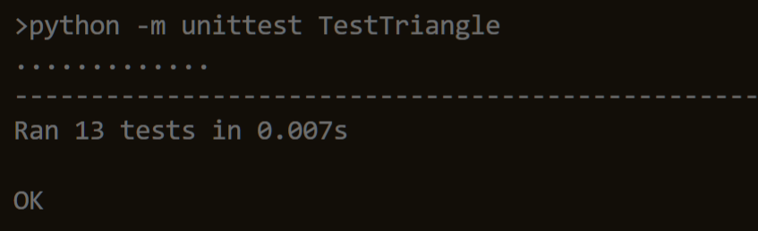

|  |  |  |  |  |
| --- | --- | --- | --- | --- |
| Test ID | Input | Expected Results | Actual Result | Pass Or Fail |
| testInvalidTriangles | 1 3 5 | NotATriangle | NotATriangle | Pass |
| testInvalidTriangles2 | 1 4 5 | NotATriangle | NotATriangle | Pass |
| testInvalidTriangles3 | 1 0 1 | NotATriangle | NotATriangle | Pass |
| testRightTriangles | 3 4 5 | Right | Right | Pass |
| testRightTriangles2 | 5 3 4 | Right | Right | Pass |
| testRightTriangles3 | 4 5 3 | Right | Right | Pass |
| testEquilateralTriangles | 1 1 1 | Equilateral | Equilateral | Pass |
| testEquilateralTriangles2 | 3 3 3 | Equilateral | Equilateral | Pass |
| testIsoscelesTriangles | 5 5 1 | Isosceles | Isosceles | Pass |
| testIsoscelesTriangles2 | 5 1 5 | Isosceles | Isosceles | Pass |
| testIsoscelesTriangles3 | 1 5 5 | Isosceles | Isosceles | Pass |
| testScaleneTriangles | 5 7 1 | Scalene | Scalene | Pass |
| testScaleneTriangles2 | 10 3 5 | Scalene | Scalene | Pass |

https://github.com/AkashAdarsh/SSW567hw02