FRS — Bangladesh Betar Audio Archive Platform
FUNCTIONAL REQUIREMENTS SPECIFICATION
(FRS)
Bangladesh Betar Audio Archive Platform
Digital Audio Archive, Management and Public Streaming System
Version 1.1 (Draft)
July 2026
Prepared for: Bangladesh Betar

Document Control
Item | Detail
Document Title | Functional Requirements Specification – Bangladesh Betar Audio Archive Platform
Version | 1.1 (Draft)
Date | 20 July 2026
Status | For review
Prepared By | <Author name>
Reviewed By | <Reviewer name>
Approved By | <Approver name>

Revision History
Version | Date | Author | Description of Change
0.1 | — | <Author> | Initial draft
1.0 | 19 Jul 2026 | <Author> | First complete draft with module DFDs
1.1 | 20 Jul 2026 | <Author> | Added Spotify-style playback features (queue, shuffle, repeat, sleep timer, crossfade, equalizer, follow artist, albums, recently played, comments, ratings); expanded audio visualization across Admin Portal, archive screens and public app; expanded AI features (semantic search, speaker identification, language detection, mood/genre classification); new modules M24 Content Curation & Homepage Management, M25 Recommendations & Personalization, M26 Listener Engagement & Moderation, M27 Advertisement Management & Serving; freemium additions (free trial, app-store billing compliance, refunds); guest listening; accessibility and device-compatibility NFRs; live public streaming recorded as an explicit scope exclusion.

Table of Contents

1. Introduction

1.1 Purpose
This Functional Requirements Specification (FRS) defines the functional behaviour of the proposed Bangladesh Betar Audio Archive Platform. It is intended for Bangladesh Betar stakeholders, project managers, system architects, developers, testers and vendors, and forms the baseline against which the delivered system will be verified.

1.2 Scope
The platform is a centralized digital system for storing, preserving, digitizing, editing, searching, managing, distributing and analysing Bangladesh Betar's audio content — songs, radio programmes, podcasts, Bhoot FM and similar event programmes, news, interviews, drama, historical recordings, speeches, advertisements, marketing voice-overs, jingles, public-service announcements and recorded broadcasts.
The solution consists of two coordinated applications sharing one backend:
- Admin Web Portal (back office): used by Bangladesh Betar staff to upload, digitize, catalogue, edit, review, approve, protect, curate, moderate and publish archive content, and to manage subscriptions, advertisements and analytics.
- Public Listening Application (web + Android/iOS mobile apps): a Spotify-style consumer experience through which the public browses, searches and streams published archive content under a freemium model — free listening with limitations and advertisements, and a paid premium subscription for ad-free, full, high-quality and offline listening — with playlists, queue, favourites, albums, artist following, comments, ratings, personalized recommendations and rich audio visualization.

1.2.1 Explicit Scope Exclusions
- Live streaming of Bangladesh Betar broadcast channels to the public is out of scope for this version. Continuous recording of live broadcasts into the archive (FR-ING-05) remains in scope. The streaming layer and player shall be designed so that public live streaming can be added in a future version without architectural rework.
- Third-party commercial music store / purchase-per-track functionality is out of scope.
- User-to-user social features (direct messaging, friend feeds, group sessions) are out of scope; listener engagement is limited to comments, ratings and sharing as specified in M26 and M17.

1.3 Definitions and Abbreviations
Term | Meaning
FRS | Functional Requirements Specification
DFD | Data Flow Diagram (Gane–Sarson notation)
RBAC | Role-Based Access Control
Preservation Master | The original, immutable, lossless copy of an audio asset
Proxy / Online Version | Compressed derived copy used for listening and streaming
Freemium | Business model combining a limited free tier and a paid premium tier
MFS | Mobile Financial Service (e.g., bKash, Nagad, Rocket)
IAP | In-App Purchase (Google Play Billing / Apple App Store billing)
QC | Quality Control
EDL | Edit Decision List
ASR | Automatic Speech Recognition (speech-to-text)
UGC | User-Generated Content (e.g., listener comments, ratings, story submissions)
EQ | Equalizer (frequency-band audio adjustment)
MoSCoW | Priority scheme: M = Must have, S = Should have, C = Could have

1.4 References
- “Summary – Bangladesh Betar Audio Archive Platform” (source requirements document).
- “Elaborately – Bangladesh Betar Audio Archive Platform: Core Features and Functional Requirements” (source requirements document).
- Stakeholder direction: Spotify-style public application with freemium subscription model.
- Stakeholder feature list (July 2026): Spotify-style playback features, AI/archive features and platform-wide audio visualization.

2. Overall System Description

2.1 Product Perspective
The platform is a new, self-contained system that integrates with Bangladesh Betar's existing studio, broadcast automation, website and directory infrastructure. Conceptually it behaves like a broadcast-grade Digital/Media Asset Management system on the back office side and a music/podcast streaming service on the consumer side. A single content pipeline connects the two: content is ingested and enriched in the Admin Portal, passes QC, rights and management approval, and only then becomes visible in the public application, where curation, recommendations, advertisements and subscription entitlements shape what each listener experiences.

2.2 User Classes
User Class | Application | Summary of Capabilities
Super Administrator | Admin Portal | Full system configuration, users, roles, storage, workflows, integrations, audit
Archive Administrator | Admin Portal | Collections, classification, preservation copies, retention, duplicates
Audio Archivist / Digitization Operator | Admin Portal | Digitization, uploads, metadata entry, QC support, restoration notes
Audio Editor | Admin Portal | Non-destructive editing, clips, versions; cannot touch masters
Programme Producer | Admin Portal | Series/episodes, playlists, scripts, submission for approval, performance monitoring
Podcast Manager | Admin Portal | Channels, seasons, episodes, RSS, scheduling, podcast analytics
Music Library Manager | Admin Portal | Songs, albums, artists, lyrics, versions, playlists, song analytics
Content Curator | Admin Portal | Home-screen sections, banners, curated collections, featured content, scheduling
Moderator | Admin Portal | Comment/rating moderation, reported-content queue, takedown handling
Advertisement Manager | Admin Portal | Ad assets, campaigns, insertion rules, advertiser reporting
Marketing User | Admin Portal | Voice search, campaigns, scripts, usage rights, downloads of approved assets
Copyright Officer | Admin Portal | Rights records, contracts, validation, expiry management, complaint/takedown records
Approver / Management | Admin Portal | Approvals, rejections, dashboards, reports
Researcher / General Viewer | Admin Portal | Search permitted content, previews, access requests
Guest Listener (anonymous) | Public App | Browse, search and stream free published content with ads/limits; no library or premium features
Public Free Listener | Public App | Browse, search, stream with ads/limits, playlists, queue, favourites, follows, comments, ratings
Public Premium Listener | Public App | All free features plus ad-free, full-length, high-quality, equalizer and offline listening

2.3 Assumptions and Constraints
- The user interface and metadata must fully support Bangla (Unicode) and English.
- Preservation masters are immutable; all public delivery uses derived versions.
- Payment processing uses licensed Bangladeshi payment gateways / MFS providers; in-app subscription purchases on mobile follow the applicable app-store billing policies.
- Internet conditions vary widely; the public app must remain usable on low bandwidth.
- Rights-restricted or unapproved content must never be exposed publicly.
- All AI-generated metadata is draft until verified by an authorized user.

2.4 DFD Notation
All diagrams use Gane–Sarson notation: external entities are blue rectangles, processes are numbered yellow rounded rectangles, data stores are green open rectangles labelled D1…Dn, and labelled arrows are data flows. Level 0 (context) shows the whole system as one process; Level 1 diagrams decompose the system and each module.

3. System-Level Data Flow Diagrams

3.1 Context Diagram (Level 0)
The context diagram shows the platform as a single process exchanging data with its external entities: archive staff, management/approvers, public listeners, studio and broadcast systems, the payment gateway, advertisers and external distribution platforms.
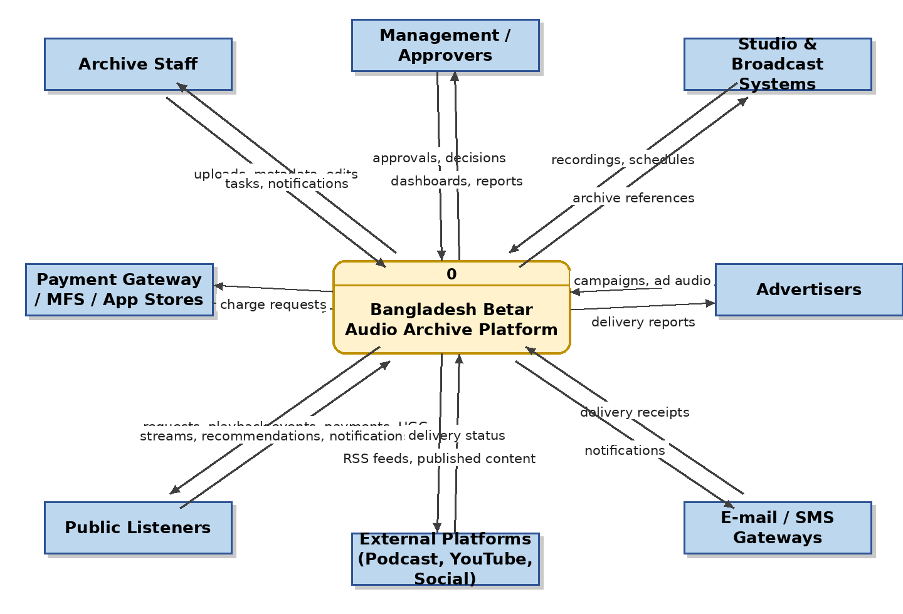
Figure 1: Context Diagram (Level 0) – Bangladesh Betar Audio Archive Platform

3.2 System Level 1 DFD
At Level 1 the system decomposes into seven macro-processes: (1) ingest and digitize audio, (2) manage repository and metadata, (3) review, QC and approve, (4) publish and stream, (5) manage freemium subscriptions and advertisements, (6) engage, curate and recommend, and (7) analyse usage and report. Sections 4.1–4.27 decompose these into module-level DFDs.
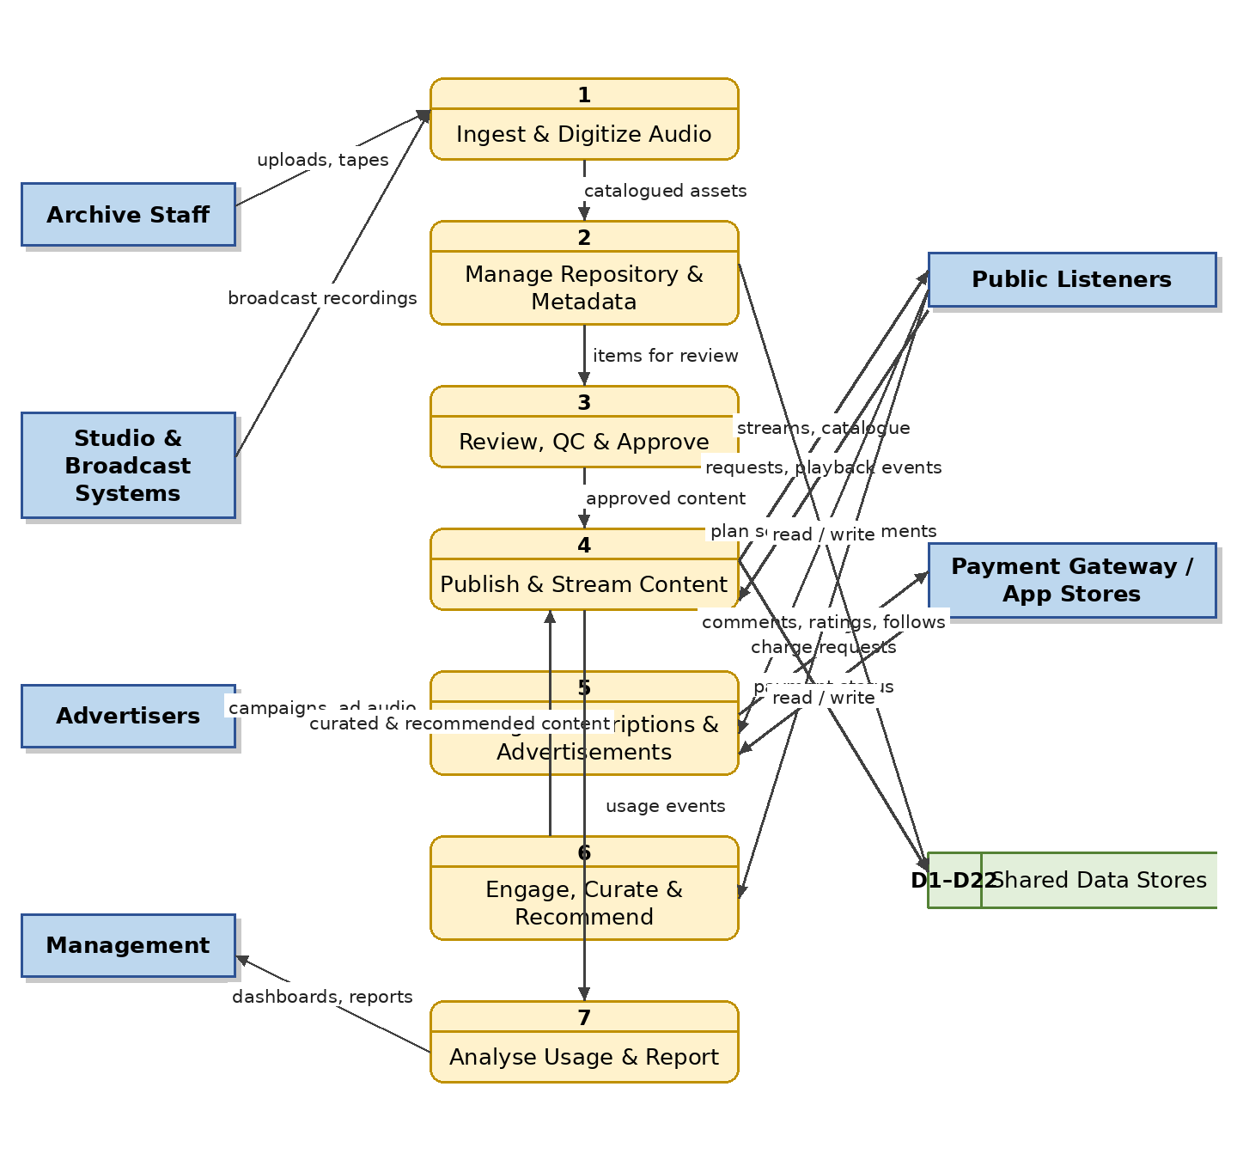
Figure 2: System Level 1 DFD

4. Functional Requirements by Module
Each module below is specified with an overview, a table of numbered functional requirements, and its data flow diagram. Priorities follow MoSCoW: M = Must have, S = Should have, C = Could have. Requirement IDs use the pattern FR-<module code>-<number> and are intended to be stable for traceability into design and testing. Modules M24–M27 are new in version 1.1.

4.1 M01 — User, Role and Access Management Module

4.1.1 Module Overview
This module manages all system accounts for both applications: back-office staff accounts on the Admin Web Portal (super administrator, archive administrator, archivist, digitization operator, audio engineer, editor, producer, podcast manager, music librarian, content curator, moderator, advertisement manager, copyright officer, marketing user, management user, researcher) and public listener accounts on the mobile/web listening app. It provides authentication, guest access, role-based access control (RBAC), and integration with Bangladesh Betar's Active Directory / LDAP for staff single sign-on.

4.1.2 Functional Requirements
Req. ID | Requirement Description | Priority
FR-USR-01 | The system shall allow the Super Administrator to create, modify, deactivate and delete staff user accounts. | M
FR-USR-02 | The system shall support public self-registration via e-mail, phone number (OTP) and social login for the listener app. | M
FR-USR-03 | The system shall implement role-based access control with configurable roles and granular permissions (view, listen, upload, edit, download, approve, publish, share, delete, export, curate, moderate). | M
FR-USR-04 | The system shall authenticate staff users against Active Directory / LDAP where configured, with local accounts as fallback. | S
FR-USR-05 | The system shall enforce strong password policy, account lockout after repeated failures, and session timeout. | M
FR-USR-06 | The system shall support two-factor authentication for administrative roles. | S
FR-USR-07 | The system shall restrict every user's visibility of stations, departments and collections according to assigned scope. | M
FR-USR-08 | The system shall log every login, logout, failed login and permission change in the audit trail. | M
FR-USR-09 | The system shall allow public users to manage their profile, linked devices, notification preferences and subscription plan. | M
FR-USR-10 | The system shall allow researchers to request access to restricted materials, routed to an approver for decision. | S
FR-USR-11 | The system shall allow guest (anonymous) access to browse, search and stream free published content in the public app without an account; account sign-in shall be required for playlists, favourites, follows, comments, ratings, downloads, cross-device sync and premium subscription. | M
FR-USR-12 | The system shall record acceptance of the current Terms of Service and Privacy Policy at registration, re-prompt on material changes, and version each acceptance. | S

4.1.3 Data Flow Diagram
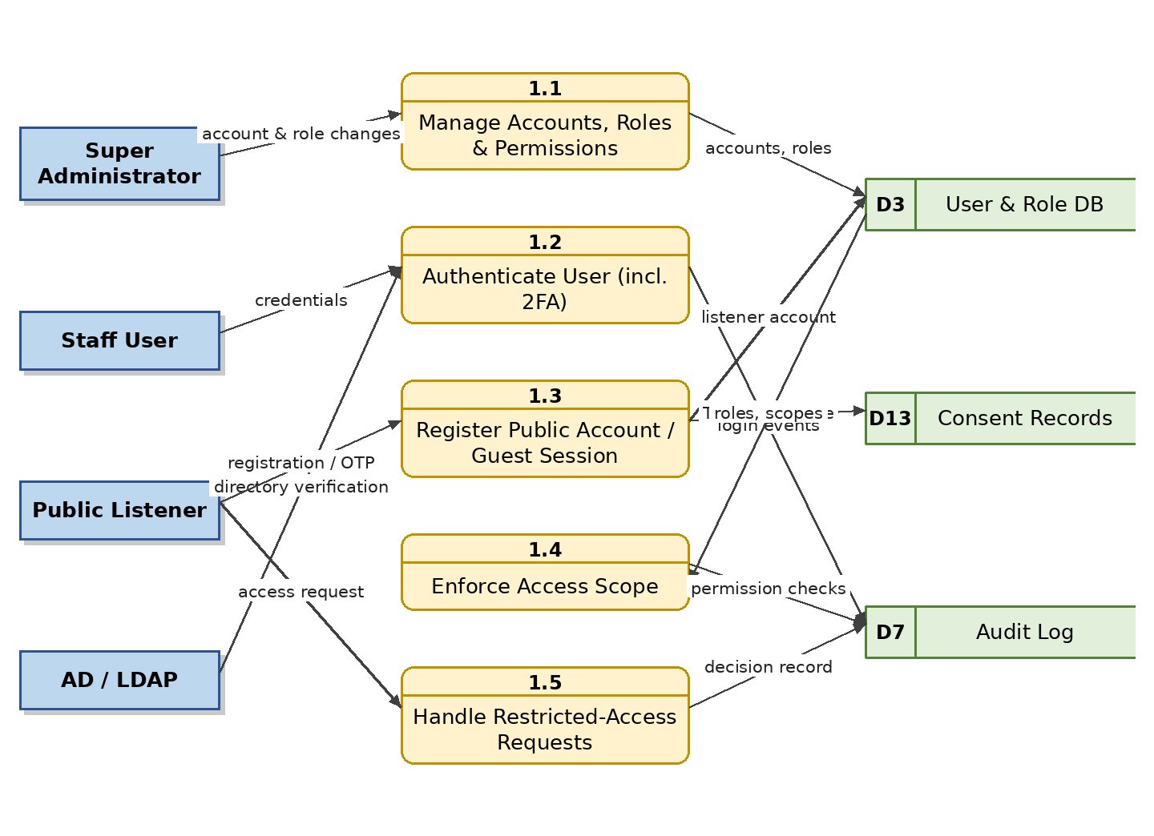
Figure 3: Level 1 DFD – User, Role and Access Management

4.2 M02 — Audio Ingestion and Upload Module

4.2.1 Module Overview
This module brings audio into the platform from every source: manual uploads through the Admin Web Portal, bulk uploads with CSV/Excel metadata, automated ingestion from studio recording systems, broadcast playout servers, FTP/SFTP and network folders, and continuous live broadcast recording of selected Bangladesh Betar channels. All incoming files are validated, virus-scanned, checked for duplicates and processed into preservation masters plus compressed listening copies.

4.2.2 Functional Requirements
Req. ID | Requirement Description | Priority
FR-ING-01 | The system shall support single, multiple, folder and drag-and-drop uploads with progress indication. | M
FR-ING-02 | The system shall support pause/resume and automatic retry for large-file uploads over unstable connections. | M
FR-ING-03 | The system shall support bulk upload with metadata supplied through CSV or Excel mapping files. | S
FR-ING-04 | The system shall automatically ingest content from configured studio systems, broadcast servers, network folders and FTP/SFTP locations. | M
FR-ING-05 | The system shall record selected live broadcast channels continuously (24/7) or on schedule, splitting files automatically by programme schedule and linking each recording to its programme, presenter and station. (Note: recording is for archival purposes; public live streaming is out of scope per §1.2.1.) | S
FR-ING-06 | The system shall accept WAV, BWF, FLAC, MP3, AAC, M4A, OGG and AIFF input formats and reject unsupported or corrupted files with a clear error message. | M
FR-ING-07 | The system shall virus-scan every uploaded file before storage. | M
FR-ING-08 | The system shall detect duplicate audio using checksums and audio fingerprints before final commitment. | M
FR-ING-09 | The system shall automatically extract technical metadata (duration, codec, bitrate, sample rate, bit depth, channels, loudness, peak level, silence percentage, checksum). | M
FR-ING-10 | The system shall preserve the lossless master and automatically generate compressed streaming proxies (e.g., MP3/AAC at multiple bitrates) and pre-computed waveform data for visualization. | M
FR-ING-11 | The system shall notify the uploader of success, failure or rejection, and queue failed uploads for retry. | M

4.2.3 Data Flow Diagram
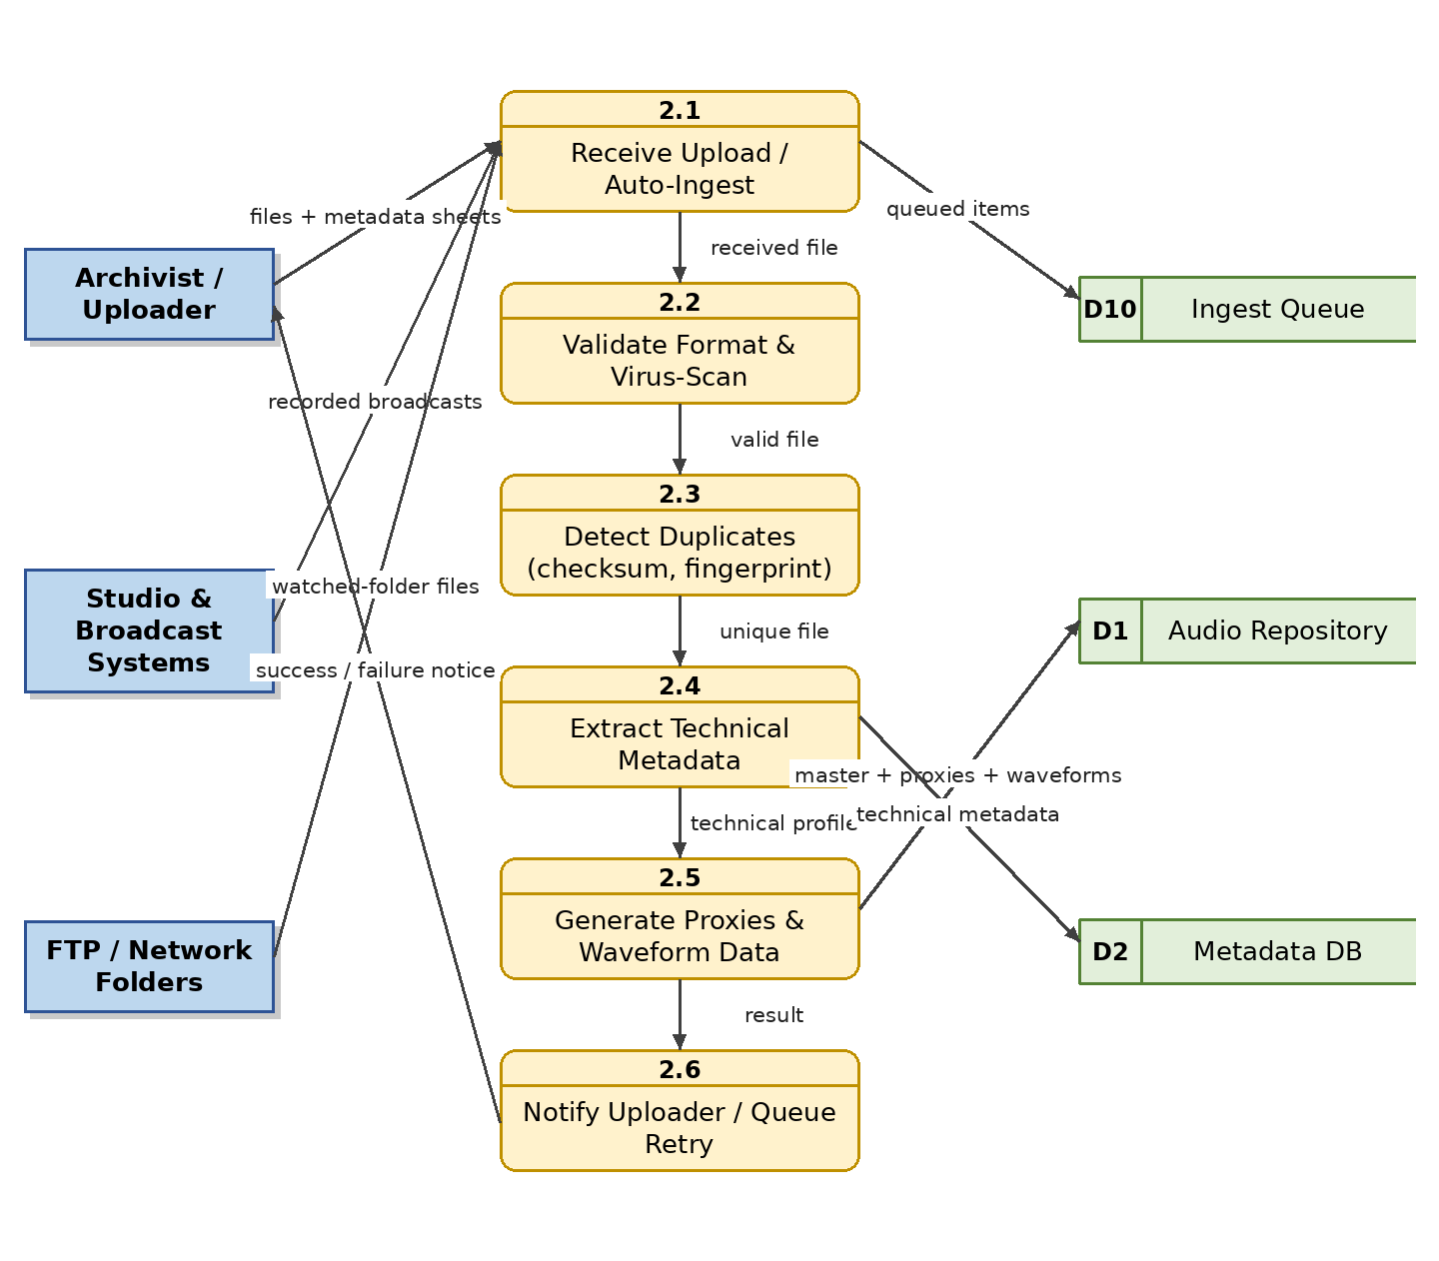
Figure 4: Level 1 DFD – Audio Ingestion and Upload

4.3 M03 — Audio Digitization Module

4.3.1 Module Overview
Bangladesh Betar holds decades of audio on reel-to-reel tape, cassette, DAT, vinyl and CD. This module manages the digitization pipeline: registering each physical item and its condition, capturing audio at archival quality through digitization workstations, applying restoration (noise, hiss, click removal), and linking the digitized master to a catalogued archive record with digitization history.

4.3.2 Functional Requirements
Req. ID | Requirement Description | Priority
FR-DIG-01 | The system shall register each physical media item with identifier, format, condition, location and priority. | M
FR-DIG-02 | The system shall track digitization status per item (registered, in progress, captured, restored, QC passed, archived). | M
FR-DIG-03 | The system shall capture digitized audio as WAV/BWF preservation masters at archival sample rates and bit depths. | M
FR-DIG-04 | The system shall record restoration notes and keep both the raw capture and the restored version. | S
FR-DIG-05 | The system shall require a quality-control pass before a digitized item is accepted into the archive. | M
FR-DIG-06 | The system shall report digitization progress (items completed, pending, failed) on the digitization dashboard. | S
FR-DIG-07 | The system shall preserve the link between the digital asset and its physical source item. | M
FR-DIG-08 | The system shall display waveform and spectrogram visualizations of captured and restored audio side by side to support restoration and QC review. | S

4.3.3 Data Flow Diagram
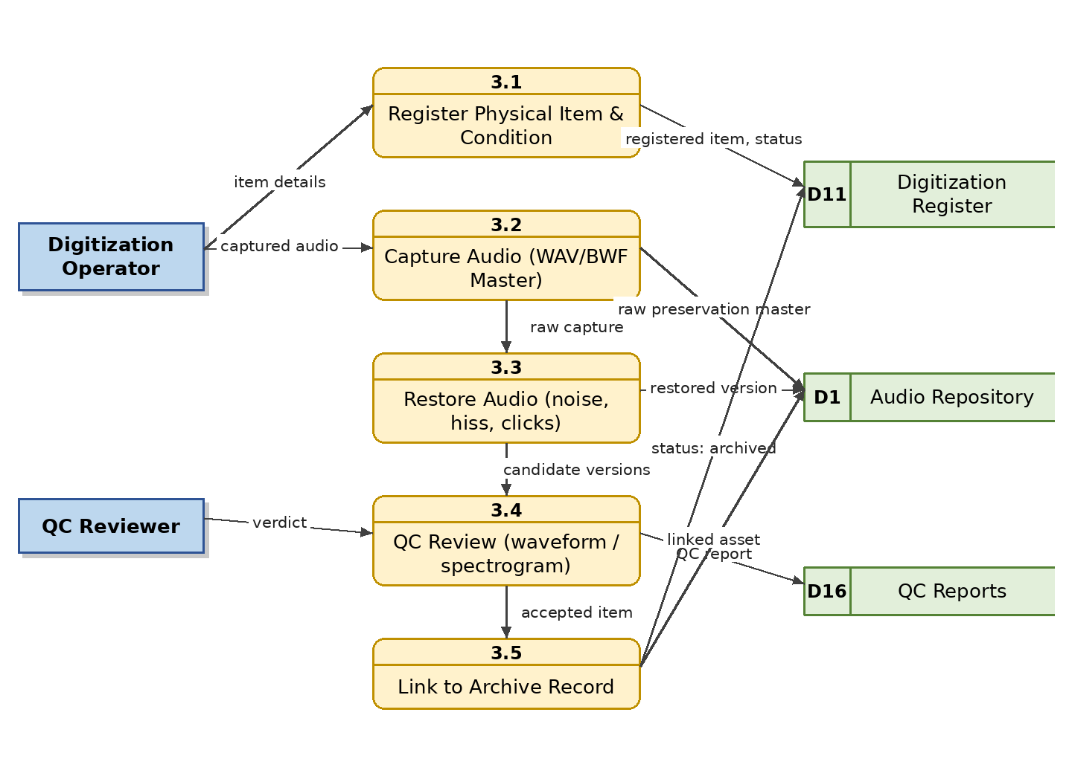
Figure 5: Level 1 DFD – Audio Digitization

4.4 M04 — Central Repository, Master File and Version Management Module

4.4.1 Module Overview
The central repository is the organizational heart of the archive. Every asset receives a unique archive ID and lives in the hierarchy Station → Department → Programme/Collection → Season/Year → Episode → Segment → Audio File. The module enforces the master-file rule — the preservation master is immutable — while managing derived versions: production master, broadcast version, online version, preview version and social-media version, together with retention policies and multi-tier storage placement.

4.4.2 Functional Requirements
Req. ID | Requirement Description | Priority
FR-REP-01 | The system shall assign a unique, permanent archive ID to every audio asset. | M
FR-REP-02 | The system shall organize assets in the configurable hierarchy Station → Department → Programme → Season/Year → Episode → Segment. | M
FR-REP-03 | The system shall never allow the preservation master to be overwritten, edited in place or deleted without super-administrator authority. | M
FR-REP-04 | The system shall manage named derived versions per asset: production master, broadcast version, online version, preview/clip version and social-media version. | M
FR-REP-05 | The system shall record the derivation chain (which version came from which source and by whom). | M
FR-REP-06 | The system shall apply retention categories and storage-tier policies (hot, warm, cold/archive) per asset class. | S
FR-REP-07 | The system shall support moving assets between collections without changing their archive ID. | S
FR-REP-08 | The system shall handle merge/decision workflows for duplicate records identified after ingestion. | S

4.4.3 Data Flow Diagram
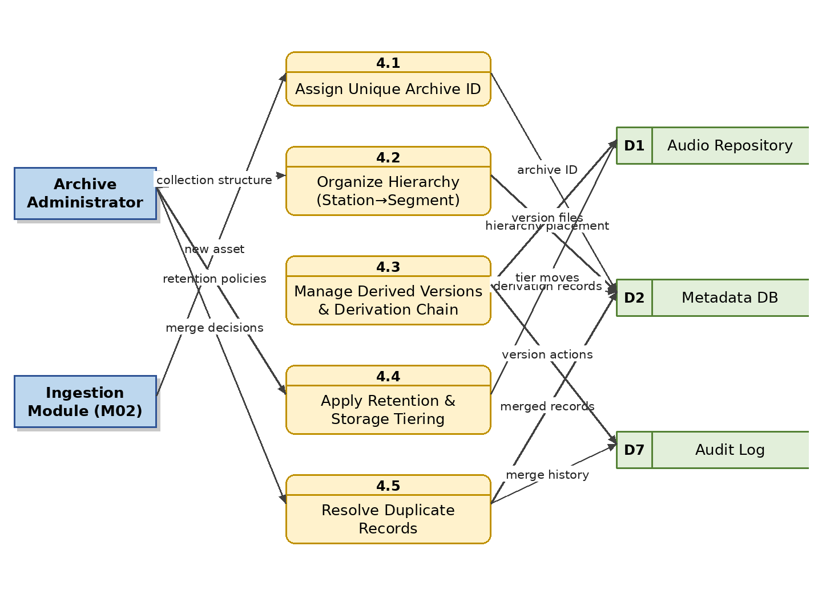
Figure 6: Level 1 DFD – Central Repository, Master File and Version Management

4.5 M05 — Metadata Management Module

4.5.1 Module Overview
This module stores complete descriptive, administrative and technical metadata for every asset in Bangla and English: titles, programme name, category, description, recording and broadcast dates, station/department, language and dialect, presenter, producer, singer, composer, lyricist, voice artist, keywords, genre, mood, duration, copyright owner, access level and publication status. Administrators can extend the schema with custom fields and controlled vocabularies, and every change is indexed for search.

4.5.2 Functional Requirements
Req. ID | Requirement Description | Priority
FR-MET-01 | The system shall store all core descriptive metadata fields for every asset with Bangla and English values where applicable. | M
FR-MET-02 | The system shall enforce mandatory metadata fields per content type before an asset can enter the approval workflow. | M
FR-MET-03 | The system shall allow administrators to define custom metadata fields and controlled vocabularies without code changes. | M
FR-MET-04 | The system shall support person/entity records (singer, composer, lyricist, presenter, producer, voice artist) reusable across assets. | M
FR-MET-05 | The system shall validate dates, controlled values and duplicates during metadata entry. | M
FR-MET-06 | The system shall version metadata changes and record who changed what and when. | M
FR-MET-07 | The system shall re-index changed records into the search index within a configurable interval. | M
FR-MET-08 | The system shall support bulk metadata editing across selected assets. | S
FR-MET-09 | The system shall support full Unicode Bangla input, display and sorting. | M
FR-MET-10 | The system shall store album/collection records (title, artwork, year, description, track ordering) linkable to songs and episodes. | M

4.5.3 Data Flow Diagram
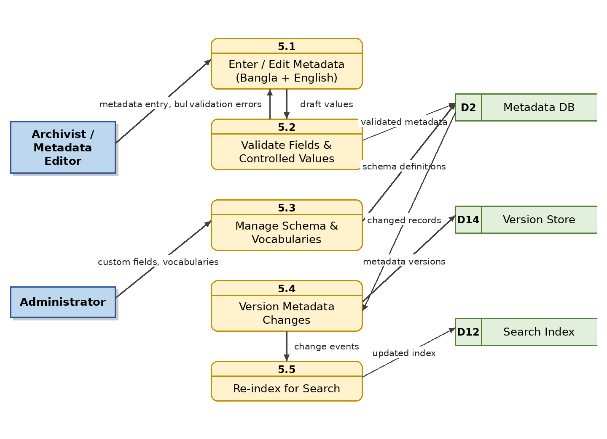
Figure 7: Level 1 DFD – Metadata Management

4.6 M06 — Search and Discovery Module

4.6.1 Module Overview
Users on both the Admin Portal and the public app must find audio in seconds. Search covers all metadata fields (title, programme, singer, presenter, producer, composer, lyricist, album, episode, keyword, archive ID, rights status), date ranges, language, genre, mood and station, plus full-text search inside transcripts — including Bangla text — and AI-powered semantic search over meaning rather than exact keywords. Results are always filtered by the searcher's permissions and, for public users, by publication status and subscription entitlement.

4.6.2 Functional Requirements
Req. ID | Requirement Description | Priority
FR-SRC-01 | The system shall provide a single search box with type-ahead suggestions across titles, people, albums and programmes. | M
FR-SRC-02 | The system shall provide advanced search with combinable filters: content type, station, programme, people, album, date range, language, genre, mood, duration, rights status and archive ID. | M
FR-SRC-03 | The system shall support Bangla-language search including partial matching and transliteration assistance. | M
FR-SRC-04 | The system shall support full-text search inside transcripts and lyrics, returning the matching timestamp so playback can start at the spoken word. | S
FR-SRC-05 | The system shall filter every result set by the user's role, scope, access level and (for public users) publication and plan entitlement. | M
FR-SRC-06 | The system shall let users save searches, view recent searches and subscribe to saved-search alerts. | S
FR-SRC-07 | The system shall export result lists to CSV/Excel for authorized staff. | S
FR-SRC-08 | The system shall return the first page of results for a simple query in under 2 seconds for a catalogue of at least 1 million assets. | S
FR-SRC-09 | The system shall support semantic (natural-language) search in Bangla and English, matching queries to content by meaning using AI embeddings (e.g., “speeches about independence from the 1970s”), integrated with the standard permission and entitlement filters. (See FR-AIF-08.) | S
FR-SRC-10 | The system shall log searches that return zero results and expose a zero-result report to administrators to guide cataloguing and digitization priorities. | S

4.6.3 Data Flow Diagram
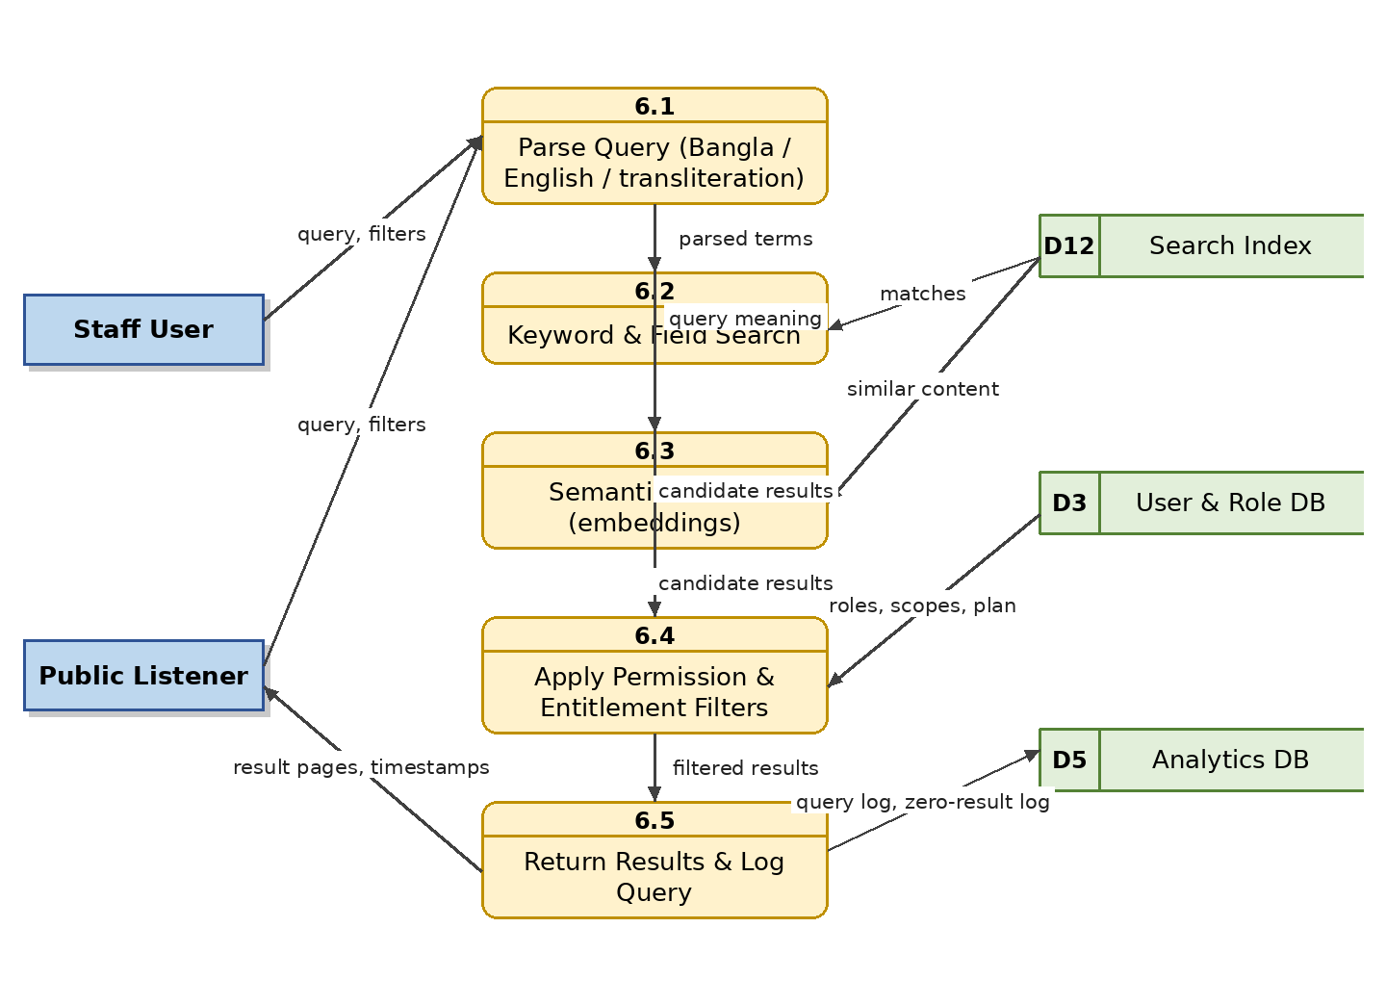
Figure 8: Level 1 DFD – Search and Discovery

4.7 M07 — Audio Player, Playback Experience and Visualization Module

4.7.1 Module Overview
Every asset has an interactive player used on both applications: play/pause/seek, click-to-seek waveform, playback-speed and volume control, chapter and segment markers, loop selection, synchronized transcripts and lyrics, and full Spotify-style playback controls — queue, shuffle, repeat, sleep timer, crossfade and equalizer.
Audio visualization is a platform-wide capability. Waveforms are pre-computed at ingestion and rendered wherever audio appears: interactive waveforms and spectrograms in the Admin Portal and archive/digitization/QC screens for professional review, waveform thumbnails in lists and search results, and real-time animated visualizers (waveform, frequency bars, spectrum) in the public web and mobile players. All playback interactions (play, pause, seek, replay, skip, completion) are captured as events feeding the analytics and heat-map module.

4.7.2 Functional Requirements
Req. ID | Requirement Description | Priority
FR-PLY-01 | The player shall provide play, pause, seek, current time/total duration, volume and playback-speed control (0.5×–2×). | M
FR-PLY-02 | The player shall render an interactive waveform; clicking a position shall start playback from that point. | M
FR-PLY-03 | The player shall display a real-time frequency spectrum and per-channel level meters in the Admin Portal for professional monitoring. | S
FR-PLY-04 | The player shall display chapter/segment markers and jump to them on click. | S
FR-PLY-05 | The player shall display synchronized transcripts and lyrics, highlighting the current line. | S
FR-PLY-06 | The player shall support looping a selected region. | C
FR-PLY-07 | The player shall stream adaptively, including a low-bandwidth mode for poor connectivity. | M
FR-PLY-08 | The player shall emit playback events (start, pause, seek, replay, skip, progress, completion) to the analytics service. | M
FR-PLY-09 | The player shall resume playback from the last position per user per asset (Continue Listening), synchronized across the user's devices. | M
FR-PLY-10 | The player shall only ever stream derived online/preview versions to public users, never master files. | M
FR-PLY-11 | The player shall provide a playback queue: view the queue, add items (“play next” / “add to queue”), remove items and reorder by drag-and-drop; the queue shall persist across sessions for signed-in users. | M
FR-PLY-12 | The player shall provide shuffle mode and repeat modes (off, repeat-all, repeat-one) for playlists, albums and queues. | M
FR-PLY-13 | The public player shall provide a sleep timer (preset durations and end-of-track/episode) that stops playback when it elapses. | S
FR-PLY-14 | The public player shall support configurable crossfade (0–12 seconds) between tracks and gapless playback where the content permits. | C
FR-PLY-15 | The public mobile player shall provide an equalizer with presets and custom band adjustment; availability may be limited to premium subscribers per plan configuration. | C
FR-PLY-16 | The system shall pre-compute and store waveform data for every playable version at ingestion and display waveform thumbnails in Admin Portal lists, archive records and search results. | S
FR-PLY-17 | The Admin Portal shall provide a spectrogram view of any audio version for QC, restoration and editorial review. | S
FR-PLY-18 | The public player shall offer real-time animated audio visualizations (e.g., waveform, frequency bars) with a user toggle and a battery/data-saver fallback to a static waveform. | S
FR-PLY-19 | Playback controls, waveform interaction and visualization behaviour shall be consistent across the Admin Portal, public web player and mobile apps, adapted to each screen size. | M
FR-PLY-20 | The mobile player shall support background playback, lock-screen/notification controls and Bluetooth/headset media-key controls. | M

4.7.3 Data Flow Diagram
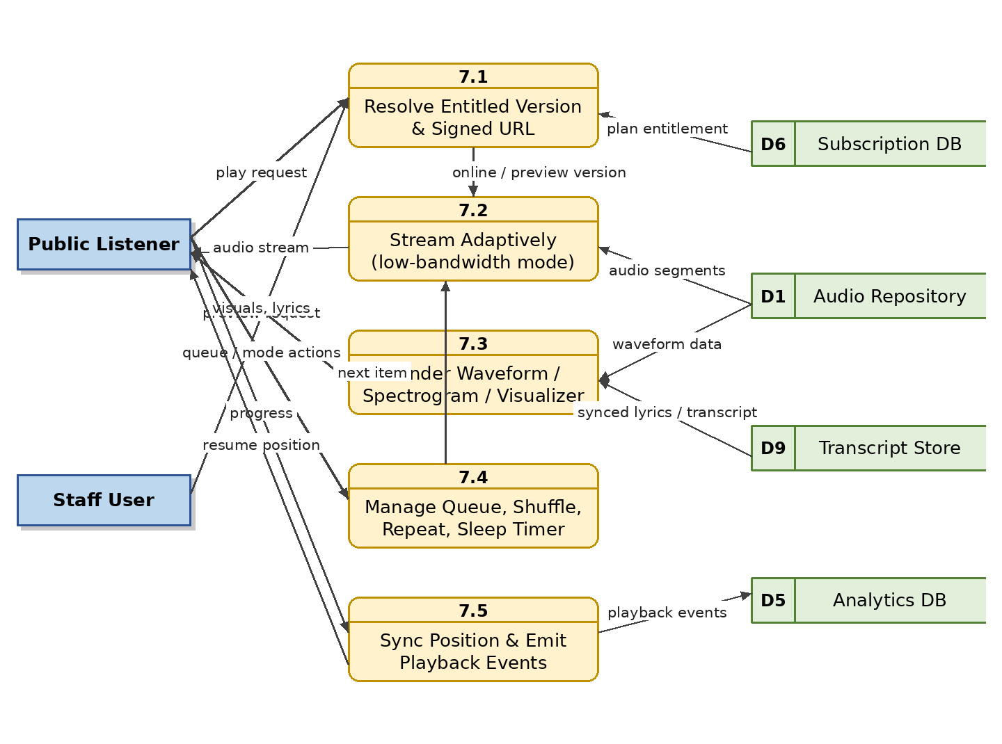
Figure 9: Level 1 DFD – Audio Player, Playback Experience and Visualization

4.8 M08 — Song, Album and Music Library Management Module

4.8.1 Module Overview
A dedicated module manages Bangladesh Betar's song collection across genres (modern Bangla, folk, Rabindra Sangeet, Nazrul Sangeet, classical, patriotic, regional, instrumental, children's, religious and international music). It maintains singer/composer/lyricist profiles, album and film information, lyrics, version families (original, live, remastered, instrumental), rights links, playlists, and popularity outputs such as most-played ranking, trending songs and per-song listening heat maps. Albums are first-class browsable entities with artwork and track ordering, and songs carry AI-assisted mood/genre classifications (M16) once verified.

4.8.2 Functional Requirements
Req. ID | Requirement Description | Priority
FR-SNG-01 | The system shall maintain song records with singer, composer, lyricist, album/film, genre, mood, language and lyrics. | M
FR-SNG-02 | The system shall maintain artist profiles reusable across songs, with biography and photo, exposed as public artist pages that listeners can follow. | M
FR-SNG-03 | The system shall group song versions (original, live, remastered, instrumental, cover) under one master song entity. | M
FR-SNG-04 | The system shall link each song to its copyright and broadcast-rights record and display rights status inline. | M
FR-SNG-05 | The system shall support playlist creation, editing, ordering and sharing for programming and for listeners. | M
FR-SNG-06 | The system shall compute most-played (top played) and trending song rankings over configurable time windows. | M
FR-SNG-07 | The system shall display a per-song listening heat map with completion, replay and skip rates. | M
FR-SNG-08 | The system shall mark restricted songs and prevent their publication or broadcast selection. | M
FR-SNG-09 | The system shall manage albums as browsable entities (artwork, year, description, ordered track list) and support browsing songs by album in both applications. | M
FR-SNG-10 | The system shall record verified mood and genre classifications per song (manual or AI-suggested via FR-AIF-11) for use in browsing, curation and recommendations. | S

4.8.3 Data Flow Diagram
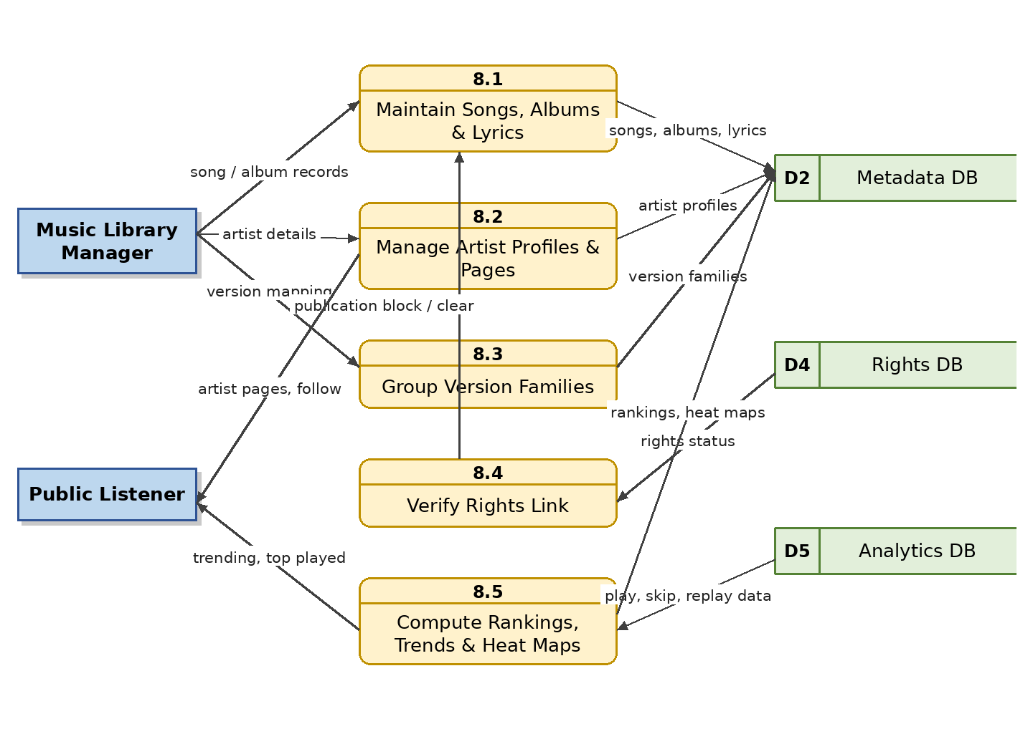
Figure 10: Level 1 DFD – Song, Album and Music Library Management

4.9 M09 — Podcast Management Module

4.9.1 Module Overview
This module manages the full podcast lifecycle in the structure Channel → Series → Season → Episode → Chapter: host and guest profiles, cover art, transcripts, scheduled publication, RSS feed generation for external platforms (Spotify, Apple Podcasts, etc.), promotional clips, and listener analytics with completion and drop-off reporting.

4.9.2 Functional Requirements
Req. ID | Requirement Description | Priority
FR-POD-01 | The system shall manage podcast channels, series, seasons, episodes and chapters with cover images. | M
FR-POD-02 | The system shall manage host and guest profiles per episode. | S
FR-POD-03 | The system shall support scheduled publication of episodes at a set date/time. | M
FR-POD-04 | The system shall generate standards-compliant RSS feeds per channel for distribution to external podcast platforms; external feeds shall contain only free (non-premium-flagged) episodes or preview versions per channel configuration. | M
FR-POD-05 | The system shall publish episodes simultaneously to the public portal and mobile app. | M
FR-POD-06 | The system shall support creation of promotional clips from episodes (via the editing module). | S
FR-POD-07 | The system shall attach transcripts to episodes and expose them to search and the player. | S
FR-POD-08 | The system shall report per-episode plays, unique listeners, completion rate and drop-off curve. | M
FR-POD-09 | The system shall notify subscribed listeners when a new episode is published. | S

4.9.3 Data Flow Diagram
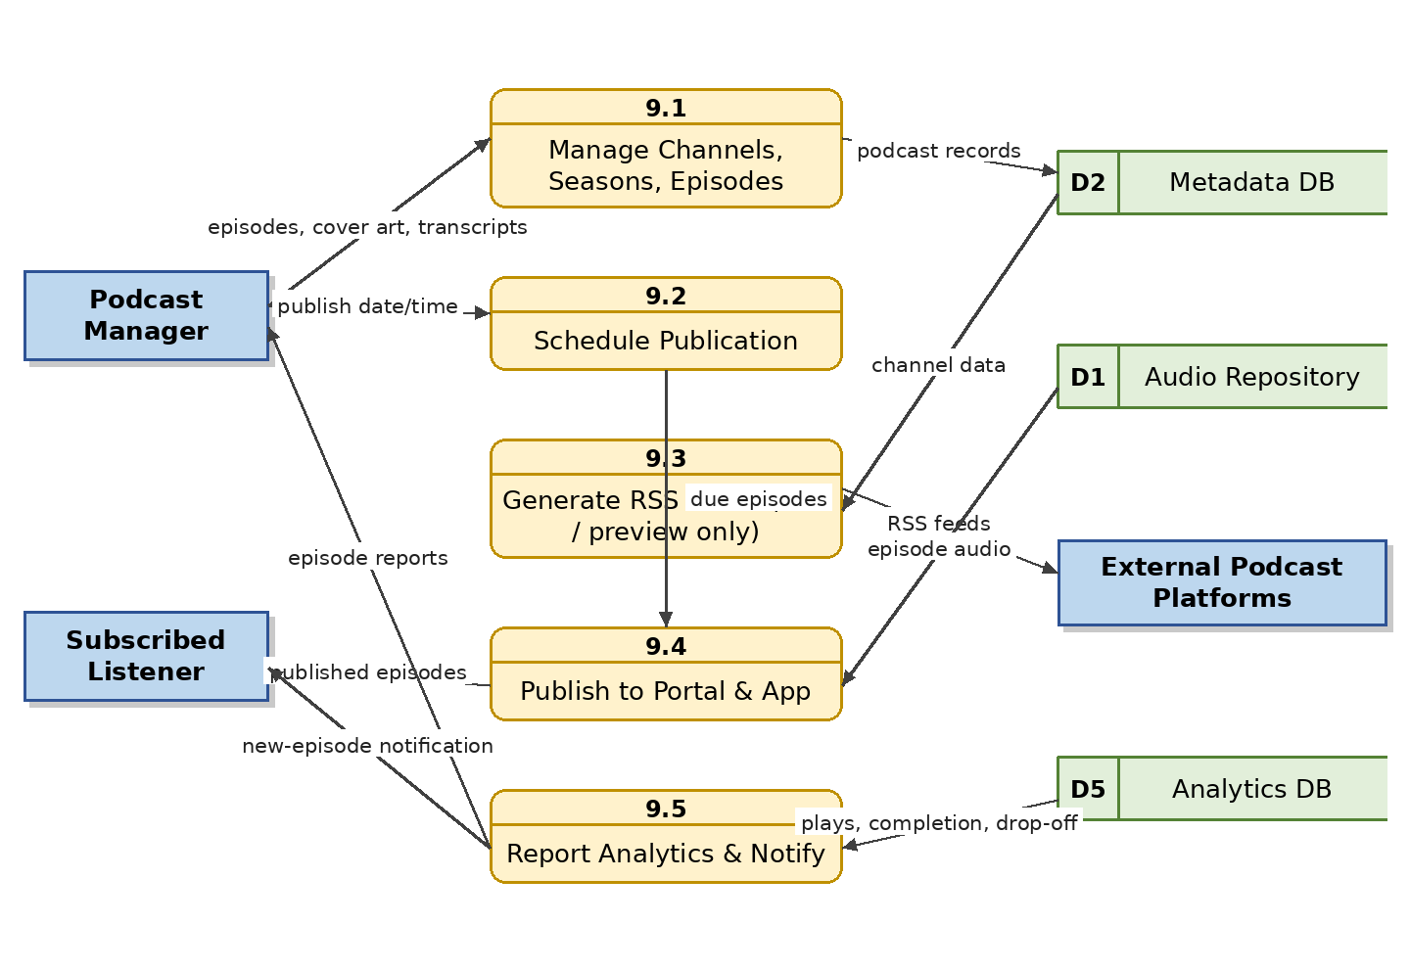
Figure 11: Level 1 DFD – Podcast Management

4.10 M10 — Event Programme (Bhoot FM) Management Module

4.10.1 Module Overview
Story-based programmes such as Bhoot FM need story-level treatment because one episode contains several independent stories. The module records episode and story-level metadata (story title, summary, storyteller/caller, narrator, location and district, category, timestamps, content warnings), supports listener story submissions with consent records and an anonymous-storyteller option, and provides story-level analytics including most-replayed sections.

4.10.2 Functional Requirements
Req. ID | Requirement Description | Priority
FR-EVT-01 | The system shall store episode records with number, title, broadcast date, presenter, duration and artwork. | M
FR-EVT-02 | The system shall divide an episode into individually addressable stories with start/end timestamps. | M
FR-EVT-03 | The system shall store per-story metadata: title, summary, storyteller/caller, narrator, location/district, category, language and content warning. | M
FR-EVT-04 | The system shall support an anonymous-storyteller option that hides submitter identity from public display. | M
FR-EVT-05 | The system shall accept listener story submissions (audio or text) with an explicit consent record retained by the system. | S
FR-EVT-06 | The system shall allow browsing by year, episode number, story category, location, guest and popularity. | M
FR-EVT-07 | The system shall display content warnings before playback of flagged stories. | M
FR-EVT-08 | The system shall provide story-level heat maps and most-replayed story rankings. | S

4.10.3 Data Flow Diagram
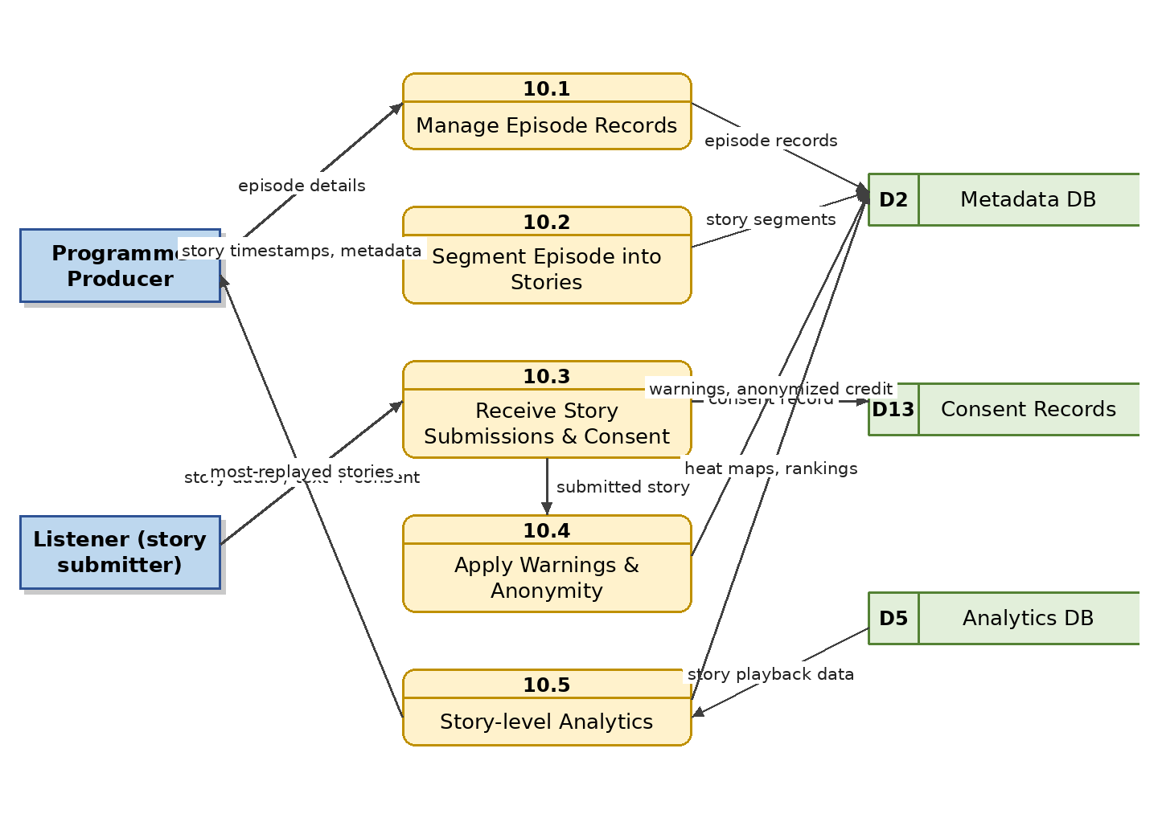
Figure 12: Level 1 DFD – Event Programme (Bhoot FM) Management

4.11 M11 — Marketing Voice and Advertisement Production Module

4.11.1 Module Overview
This module serves marketing teams in producing voice and advertisement content: voice-artist profiles with searchable samples (by language, accent, tone, style, gender, age range), script management with version control, multiple recording takes with side-by-side comparison, campaign management with client and management approval, usage-right periods with expiry alerts, and channel-specific versions (radio, television, social media) with a final approved master per campaign. (Serving of advertisements to public listeners is handled by M27.)

4.11.2 Functional Requirements
Req. ID | Requirement Description | Priority
FR-MKT-01 | The system shall maintain voice-artist profiles with samples, voice category, age range, language, accent, tone and availability. | M
FR-MKT-02 | The system shall allow searching and filtering voices by language, accent, tone, style, gender and previous campaign usage. | M
FR-MKT-03 | The system shall support side-by-side audition and comparison of shortlisted voice samples. | S
FR-MKT-04 | The system shall manage scripts with version control and link each recording take to its script version. | M
FR-MKT-05 | The system shall manage campaigns with client/management approval steps and a designated final approved master. | M
FR-MKT-06 | The system shall record usage-right periods per campaign asset and alert stakeholders before expiry. | M
FR-MKT-07 | The system shall store channel variants (radio, TV, social media) of each campaign asset. | S
FR-MKT-08 | The system shall track where and when each campaign asset has been used. | S

4.11.3 Data Flow Diagram
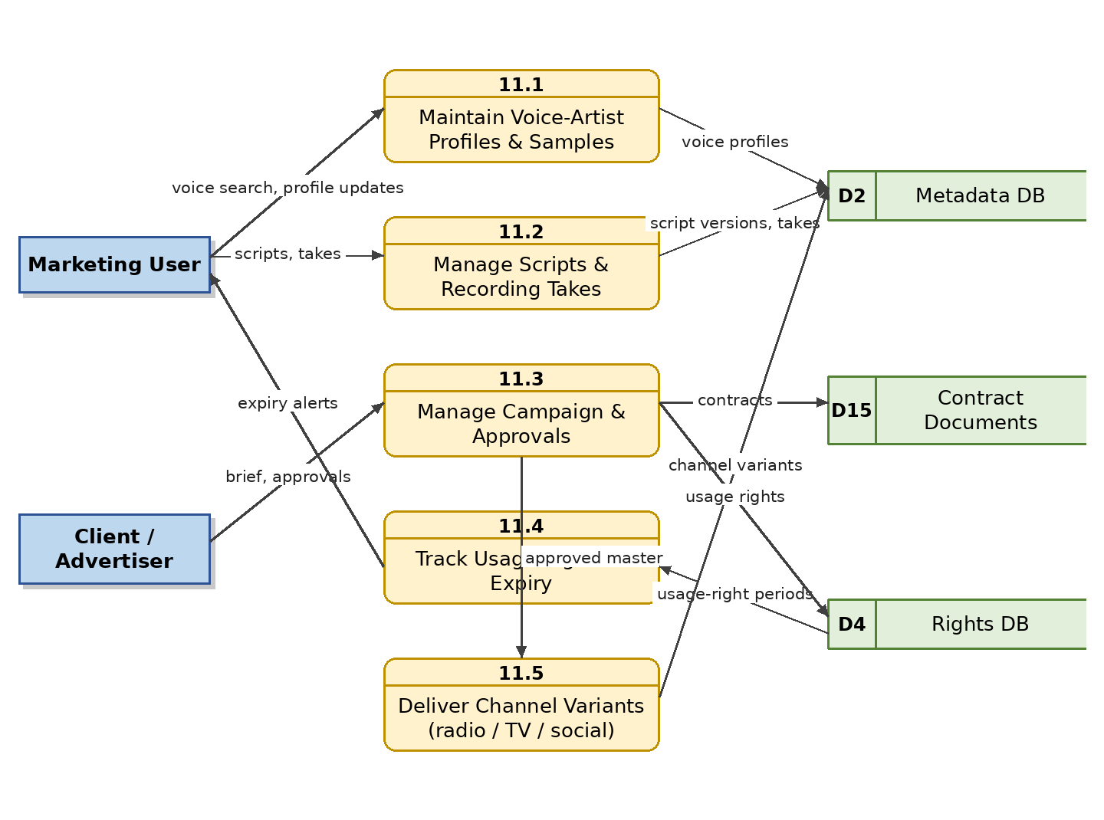
Figure 13: Level 1 DFD – Marketing Voice and Advertisement Production

4.12 M12 — Audio Editing and Clip Creation Module

4.12.1 Module Overview
Authorized users perform non-destructive, browser-based editing on working copies: trim, split, join, fade-in/out, normalize, silence removal, marker insertion, clip and social-preview creation, and export of selected sections, working over interactive waveform and spectrogram views. The original master is never touched; every edit session is versioned and restorable, and finished edits are submitted into the approval workflow.

4.12.2 Functional Requirements
Req. ID | Requirement Description | Priority
FR-EDT-01 | The system shall open edits on a working proxy copy only; the preservation master shall never be modified. | M
FR-EDT-02 | The system shall provide trim, split, join, fade-in/out, volume normalization and silence-removal operations over an interactive waveform editor. | M
FR-EDT-03 | The system shall allow markers and named regions to be added to the timeline. | S
FR-EDT-04 | The system shall create clips and podcast/social-media previews from selected regions and export them as new versions. | M
FR-EDT-05 | The system shall store an edit decision list per session and maintain full editing history. | M
FR-EDT-06 | The system shall allow restoring any previous edited version. | M
FR-EDT-07 | The system shall route completed edits into the configured approval workflow before publication. | M
FR-EDT-08 | The system shall watermark or restrict exports according to the editor's permissions. | C

4.12.3 Data Flow Diagram
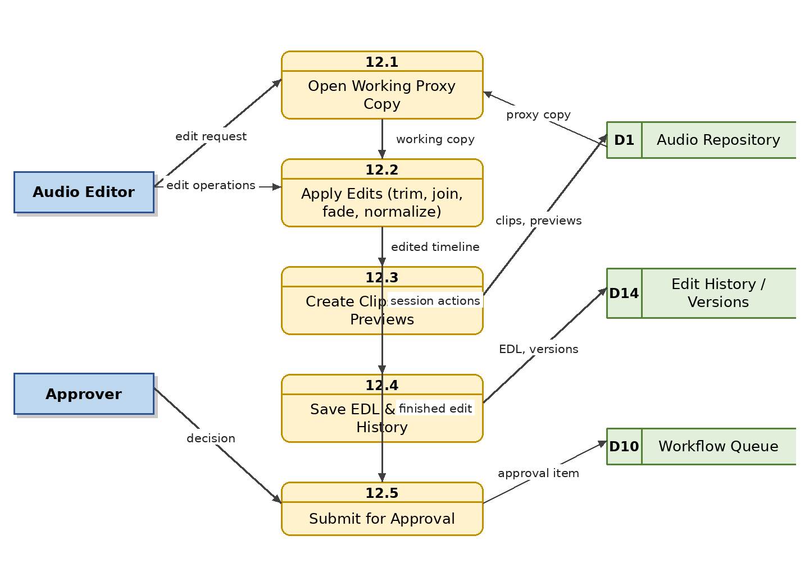
Figure 14: Level 1 DFD – Audio Editing and Clip Creation

4.13 M13 — Workflow and Approval Module

4.13.1 Module Overview
Every asset follows a controlled, configurable process — typically Upload → Metadata Entry → Technical Quality Check → Editorial Review → Copyright Review → Management Approval → Publication/Archive. The module assigns reviewers, sends notifications, records approve/reject/correction decisions with comments, tracks pending approvals, and keeps complete approval history. Different workflows can be configured for songs, podcasts, advertisements and historical recordings.

4.13.2 Functional Requirements
Req. ID | Requirement Description | Priority
FR-WRK-01 | The system shall support administrator-configurable multi-stage workflows per content type. | M
FR-WRK-02 | The system shall assign reviewers automatically by role/round-robin or manually, and notify them by e-mail/in-app message. | M
FR-WRK-03 | The system shall let reviewers approve, reject or request corrections, with mandatory comments on rejection. | M
FR-WRK-04 | The system shall return items requiring correction to the submitter and resume the workflow after resubmission. | M
FR-WRK-05 | The system shall show each user a queue of their pending approvals with ageing indicators. | M
FR-WRK-06 | The system shall keep the full approval history (who, what, when, comments) for every asset. | M
FR-WRK-07 | The system shall enforce that only fully approved items can be published or broadcast. | M
FR-WRK-08 | The system shall escalate items pending beyond a configurable time limit. | S

4.13.3 Data Flow Diagram
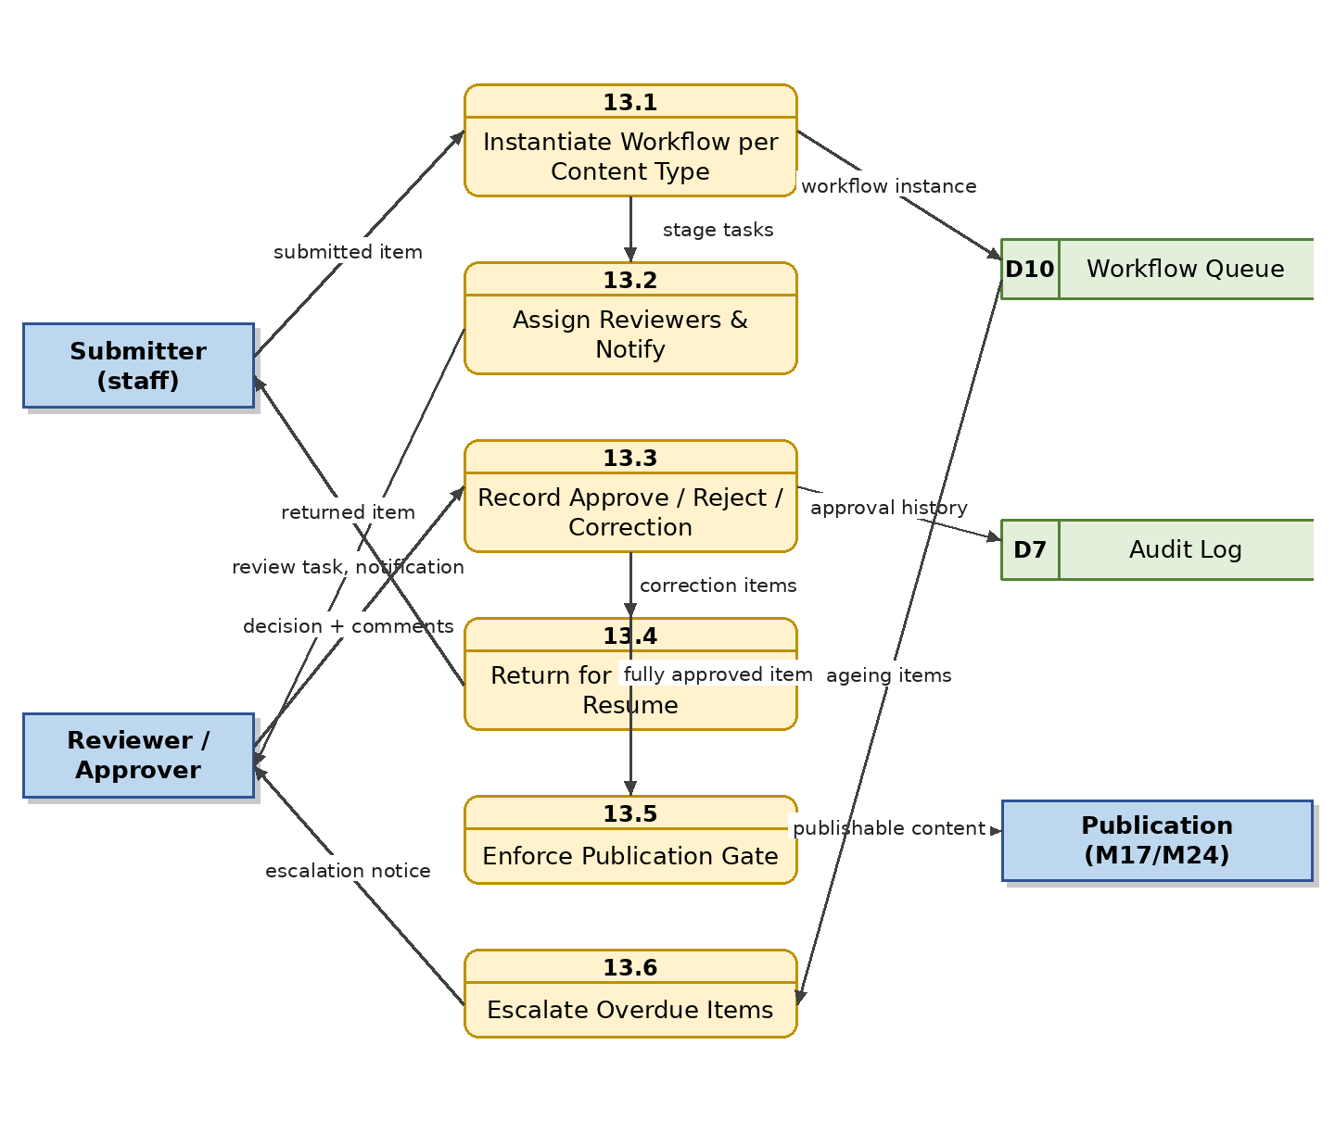
Figure 15: Level 1 DFD – Workflow and Approval

4.14 M14 — Copyright and Rights Management Module

4.14.1 Module Overview
Before any broadcast, publication or commercial use, rights must be verified. The module manages copyright owner, performer/composer/lyricist rights, broadcast/streaming/download/commercial-use rights, consent forms, contract documents, usage territory, validity dates, and royalty requirements. It automatically validates rights at the point of use, blocks unauthorized or expired content from publication, and sends expiry notifications. It also records external rights-holder complaints and their resolution (workflow in M26).

4.14.2 Functional Requirements
Req. ID | Requirement Description | Priority
FR-CPR-01 | The system shall record rights holders and rights types (broadcast, streaming, download, commercial use) per asset. | M
FR-CPR-02 | The system shall store consent forms and contract documents attached to the rights record. | M
FR-CPR-03 | The system shall record usage territory, start and expiry dates, and royalty requirements per right. | M
FR-CPR-04 | The system shall validate rights automatically whenever content is selected for publication, broadcast or download. | M
FR-CPR-05 | The system shall automatically block publication/streaming of unauthorized or expired content and un-publish content whose rights lapse. | M
FR-CPR-06 | The system shall notify the copyright officer before rights expiry at configurable intervals (e.g., 90/30/7 days). | M
FR-CPR-07 | The system shall record rights-change history in the audit trail. | M
FR-CPR-08 | The system shall support rights states such as cleared, restricted, pending clearance, disputed and expired, visible throughout the UI. | S

4.14.3 Data Flow Diagram
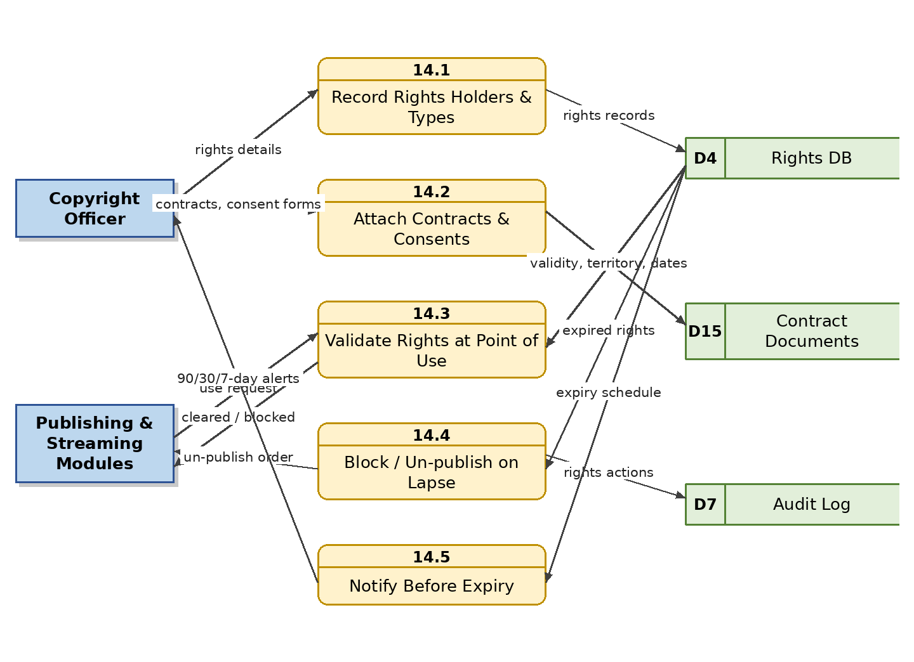
Figure 16: Level 1 DFD – Copyright and Rights Management

4.15 M15 — Audio Quality-Control Module

4.15.1 Module Overview
Every uploaded or edited file is automatically analysed for silence, clipping, low or excessive volume, background noise, missing channels, channel imbalance, corruption, incorrect duration, unsupported format and loudness-standard problems (e.g., EBU R128). Flagged items go to a technical reviewer who approves or rejects with a stored QC report, using waveform and spectrogram evidence views.

4.15.2 Functional Requirements
Req. ID | Requirement Description | Priority
FR-QCM-01 | The system shall automatically analyse every ingested and edited file against the configured QC checks. | M
FR-QCM-02 | The system shall detect silence, clipping, low/high volume, background noise, missing channel, channel imbalance and corruption. | M
FR-QCM-03 | The system shall verify loudness against a configurable broadcast standard and report deviations. | S
FR-QCM-04 | The system shall flag failed items for manual review and present the analysis evidence, including waveform and spectrogram views, to the reviewer. | M
FR-QCM-05 | The system shall allow the technical reviewer to approve, reject or request re-processing, recording the verdict. | M
FR-QCM-06 | The system shall store a QC report per file version and expose QC failure statistics on the dashboard. | S

4.15.3 Data Flow Diagram
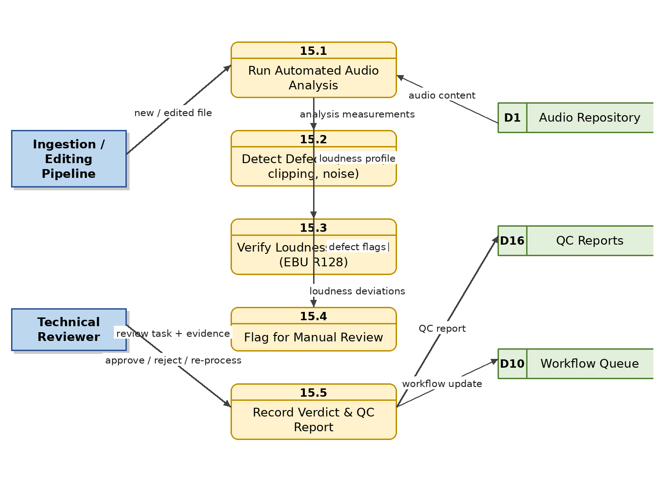
Figure 17: Level 1 DFD – Audio Quality-Control

4.16 M16 — AI-Assisted Features Module

4.16.1 Module Overview
AI services accelerate archival work and enrich discovery: automatic speech-to-text in Bangla and English producing timed transcripts and subtitles, AI-generated summaries and tag suggestions, semantic search embeddings, speaker identification, language detection, mood/genre classification for music, audio fingerprinting for duplicate and match detection, and AI-based audio quality analysis. All AI output is treated as draft until verified by a human archivist. (Personalized recommendations built on these signals are specified in M25.)

4.16.2 Functional Requirements
Req. ID | Requirement Description | Priority
FR-AIF-01 | The system shall generate timed transcripts from audio in Bangla and English via automatic speech recognition. | S
FR-AIF-02 | The system shall generate subtitles/captions from transcripts for video or social versions. | C
FR-AIF-03 | The system shall generate draft summaries and keyword/tag suggestions per asset (automatic tagging and metadata generation). | S
FR-AIF-04 | The system shall fingerprint audio and report probable duplicates or matches across the archive. | S
FR-AIF-05 | The system shall run AI-based quality scoring to prioritise restoration candidates. | C
FR-AIF-06 | The system shall mark all AI-generated metadata as unverified until reviewed and confirmed by an authorized user. | M
FR-AIF-07 | The system shall feed verified transcripts into the search index for spoken-word search. | S
FR-AIF-08 | The system shall generate and maintain semantic embeddings of assets (from transcripts, lyrics, summaries and metadata) to power natural-language semantic search (FR-SRC-09) and content-similarity for recommendations (M25). | S
FR-AIF-09 | The system shall perform speaker diarization (who spoke when) and suggest speaker identification against a registry of known Betar voices (presenters, artists, dignitaries); identifications become searchable metadata only after human verification. | S
FR-AIF-10 | The system shall automatically detect the spoken language(s) and, where feasible, dialect of ingested audio and propose the corresponding metadata values. | S
FR-AIF-11 | The system shall classify music by mood and genre using AI analysis and propose classifications for librarian verification (feeding FR-SNG-10, browsing and recommendations). | S

4.16.3 Data Flow Diagram
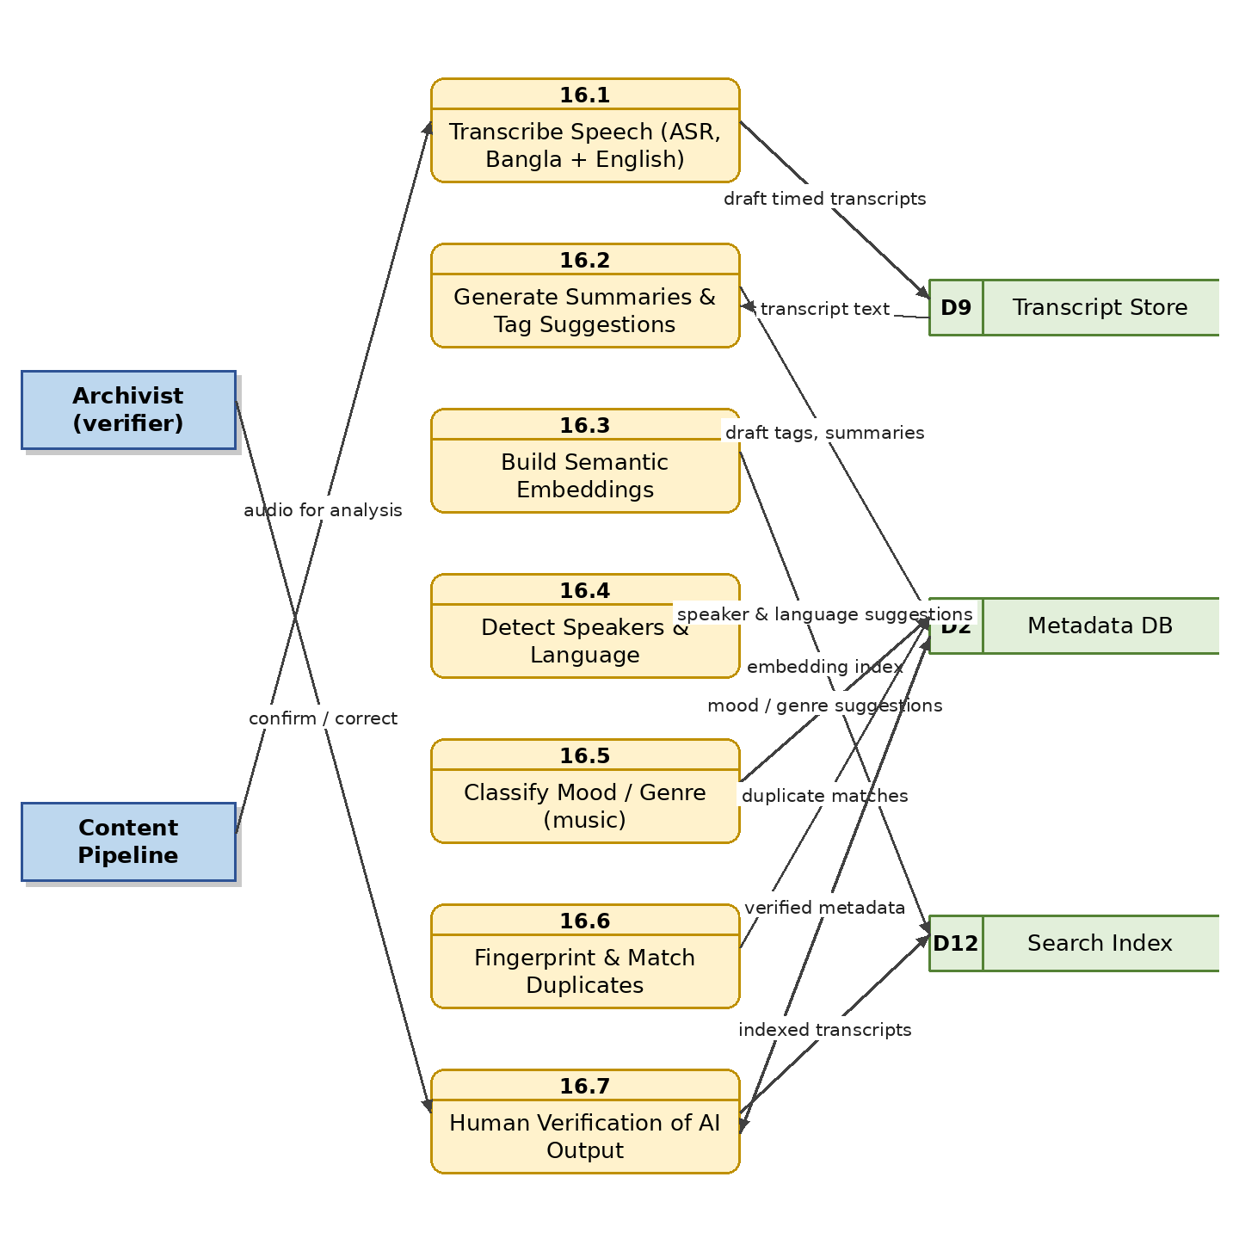
Figure 18: Level 1 DFD – AI-Assisted Features

4.17 M17 — Public Portal and Mobile Listening Application Module

4.17.1 Module Overview
The consumer-facing side of the platform — comparable to a Spotify-style experience — is delivered through a public website and mobile apps (Android/iOS). Listeners browse programmes, songs, albums, artists, podcasts, Bhoot FM and the historical archive; search and stream published audio; view lyrics and transcripts; manage playlists, queue, favourites and follows; see Recently Played and Continue Listening; receive personalized recommendations (M25) and curated sections (M24); comment on and rate content (M26); and enjoy visual, animated players (M07). Only approved, published online versions are ever exposed; master and restricted files are never accessible. Free-tier and premium behaviour is enforced through the Freemium module (M18), and audio advertisements for free listeners are served by M27.

4.17.2 Functional Requirements
Req. ID | Requirement Description | Priority
FR-PUB-01 | The public app shall present browsable sections: programmes, songs, albums, artists, podcasts, Bhoot FM, historical archive, categories/genres, trending, top played and new releases, with section content manageable via M24. | M
FR-PUB-02 | The public app shall provide search across the published catalogue with the filters defined in M06, including semantic search. | M
FR-PUB-03 | The public app shall stream only approved online/preview versions; master and restricted files shall never be reachable from public endpoints. | M
FR-PUB-04 | The public app shall support user playlists (create, edit, reorder, delete, share), favourites/likes, listening history and resume-playback, synchronized across the user's devices. | M
FR-PUB-05 | The public app shall display synchronized lyrics and transcripts where available. | S
FR-PUB-06 | The public app shall support sharing links to published content on social media with rich preview cards and app deep links. | S
FR-PUB-07 | The public app shall support low-bandwidth streaming and a data-saver mode. | M
FR-PUB-08 | The public app shall send push/e-mail notifications for new episodes of followed programmes and new content from followed artists. | S
FR-PUB-09 | The public app shall provide Bangla and English user interfaces. | M
FR-PUB-10 | The mobile application shall support Android and iOS with feature parity for core listening functions. | M
FR-PUB-11 | The public app shall support offline downloads for premium users only, with encrypted local storage and automatic invalidation when the subscription lapses. | S
FR-PUB-12 | The public app shall provide artist pages (biography, photo, songs, albums, appearances) and allow signed-in listeners to follow/unfollow artists. | M
FR-PUB-13 | The public app shall provide album pages with artwork and ordered track lists, playable as a unit with shuffle/repeat. | M
FR-PUB-14 | The public app home screen shall include Recently Played and Continue Listening rows reflecting the listener's activity across devices. | M
FR-PUB-15 | The public app shall operate in guest mode per FR-USR-11, prompting sign-in only when an account-dependent feature is used. | M
FR-PUB-16 | The public app shall let listeners view and post comments and ratings on published content where enabled, subject to the moderation rules of M26. | S
FR-PUB-17 | The public app and portal shall meet the accessibility requirements of NFR-11 (screen readers, contrast, font scaling, captioned/transcribed audio where available). | S

4.17.3 Data Flow Diagram
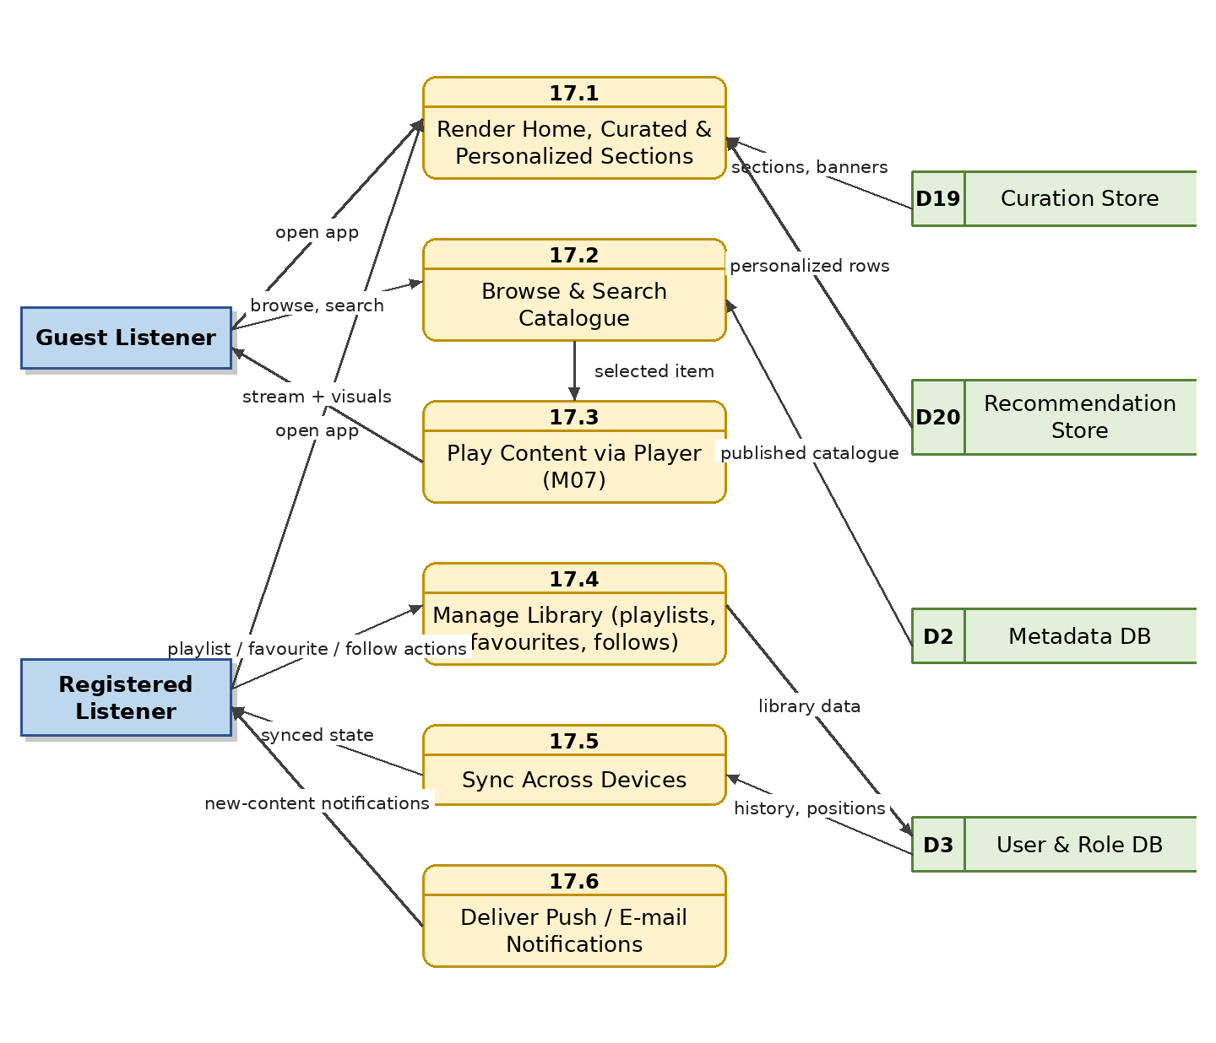
Figure 19: Level 1 DFD – Public Portal and Mobile Listening Application

4.18 M18 — Freemium Subscription and Payment Module

4.18.1 Module Overview
The platform operates a freemium model. Free users can listen with limitations (advertisements/announcements between tracks, preview-length access to premium-flagged content, standard audio quality, limited skips, no offline downloads). Premium subscribers pay a recurring fee for ad-free, full-length, high-quality and offline listening. The module presents plans, offers configurable free trials, processes payments through local gateways (bKash, Nagad, Rocket, cards) and app-store billing where required, activates and renews entitlements, enforces free-tier limits at streaming time, handles cancellation/expiry/grace periods and refunds, and produces revenue reports.

4.18.2 Functional Requirements
Req. ID | Requirement Description | Priority
FR-SUB-01 | The system shall define at least two plans — Free and Premium — with administrator-configurable limits and pricing (including monthly/annual options, promotional codes and a configurable free-trial period for Premium). | M
FR-SUB-02 | The system shall present a plan-comparison screen and upgrade prompts at appropriate touch points in the public app. | M
FR-SUB-03 | The system shall process payments through Bangladeshi mobile financial services (bKash, Nagad, Rocket) and debit/credit cards via a payment gateway. | M
FR-SUB-04 | The system shall record every payment transaction with status, amount, method, and gateway reference. | M
FR-SUB-05 | The system shall activate premium entitlements immediately on successful payment and renew automatically where authorized. | M
FR-SUB-06 | The system shall enforce free-tier limits at streaming time: audio ads/station announcements insertion (served by M27), preview-only access to premium-flagged content, capped audio quality and limited skips. | M
FR-SUB-07 | The system shall restrict offline downloads to active premium subscribers. | M
FR-SUB-08 | The system shall handle cancellation, payment failure, expiry and a configurable grace period, then downgrade the account to Free automatically. | M
FR-SUB-09 | The system shall send renewal reminders and payment receipts/invoices to subscribers. | S
FR-SUB-10 | The system shall provide revenue, subscriber-count, churn and conversion reports to management. | M
FR-SUB-11 | The system shall keep certain public-service content (news, emergency announcements) free for all users regardless of plan. | M
FR-SUB-12 | Where app-store policies require it, in-app subscription purchases on Android and iOS shall be processed through Google Play Billing and Apple In-App Purchase respectively, with entitlements unified with gateway-purchased subscriptions; alternatively a policy-compliant web-purchase flow shall be provided. | M
FR-SUB-13 | The system shall support refunds and payment-dispute handling: authorized staff shall be able to issue full/partial refunds via the gateway, adjust entitlements manually, and record the reason; all such actions shall be audit-logged. | M

4.18.3 Data Flow Diagram
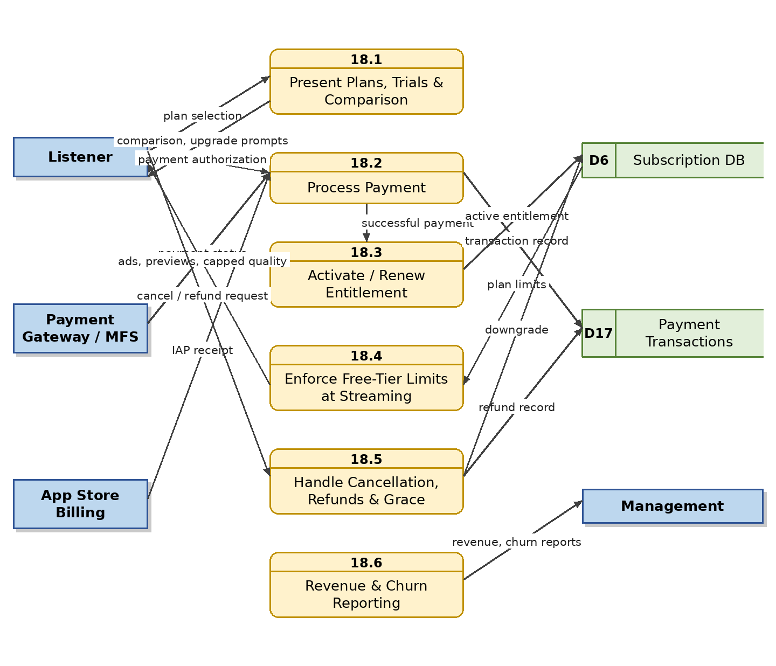
Figure 20: Level 1 DFD – Freemium Subscription and Payment

4.18.4 Free vs Premium Plan Comparison
Capability | Free Tier | Premium Tier
Streaming access | Published catalogue with ads/announcements | Full published catalogue, ad-free
Premium-flagged content | Preview only (e.g., 60–90 seconds) | Full length
Audio quality | Standard (capped bitrate) | High quality
Skips per hour | Limited | Unlimited
Offline downloads | Not available | Available (encrypted)
Equalizer | Not available (configurable) | Available
Playlists, queue & favourites | Yes (account required) | Yes
Comments & ratings | Yes (account required) | Yes
Free trial of Premium | Configurable trial period | —
News & emergency PSAs | Always free | Always free
Price | ৳0 | Configurable monthly / annual fee

4.19 M19 — Listener Analytics and Heat-Map Module

4.19.1 Module Overview
Playback events from all clients are collected and aggregated into: total plays, unique listeners, average listening time, completion/replay/skip rates, most-played and most-replayed sections, drop-off points, platform and device data, date-wise trends and geographic summaries. Every song, episode and Bhoot FM story has a second-by-second listening heat map. Engagement signals (favourites, follows, ratings, comments, shares) are also aggregated, and the module supplies behavioural data to the recommendation engine (M25).

4.19.2 Functional Requirements
Req. ID | Requirement Description | Priority
FR-ANL-01 | The system shall collect playback events (play, pause, seek, replay, skip, progress, completion) with timestamp, asset, user/anonymous ID, platform, device and coarse location. | M
FR-ANL-02 | The system shall aggregate total plays, unique listeners, average listening time, completion rate, replay rate and skip rate per asset. | M
FR-ANL-03 | The system shall generate a second-by-second listening-density heat map per song, episode and story. | M
FR-ANL-04 | The system shall identify most-played and most-replayed sections and listener drop-off points. | M
FR-ANL-05 | The system shall provide date-wise trends, platform/device breakdowns and geographic summaries. | S
FR-ANL-06 | The system shall compute trending and top-played rankings over configurable windows and expose them to dashboards and the public app. | M
FR-ANL-07 | The system shall anonymize or pseudonymize listener data in line with the privacy policy. | M
FR-ANL-08 | The system shall aggregate engagement metrics (favourites, follows, ratings, comments, shares) per asset, artist and collection and expose them on dashboards. | S
FR-ANL-09 | The system shall make per-user listening signals available to the recommendation engine (M25) in accordance with the privacy policy and the user's personalization settings. | S

4.19.3 Data Flow Diagram
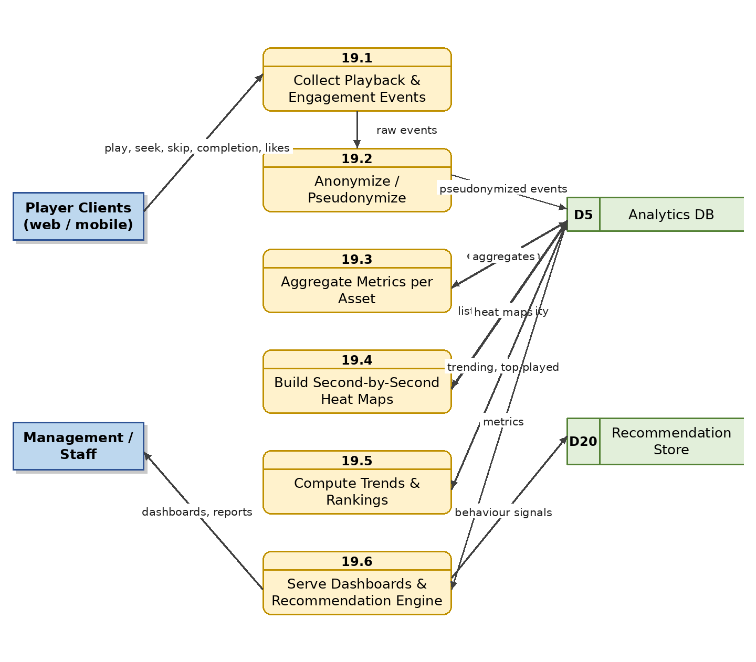
Figure 21: Level 1 DFD – Listener Analytics and Heat-Map

4.20 M20 — Dashboard, Reporting and Notification Module

4.20.1 Module Overview
Role-based dashboards summarise what each user needs: executives see totals, storage, trends and revenue; archivists see uploads, failures and digitization progress; podcast/music/marketing managers see their own performance views; curators see section performance; moderators see queue status; approvers see pending queues; copyright officers see rights expiring soon; the advertisement manager sees campaign delivery. All reports export to PDF, Excel and CSV, and the notification service delivers alerts by e-mail, SMS and in-app messages.

4.20.2 Functional Requirements
Req. ID | Requirement Description | Priority
FR-DSH-01 | The system shall provide role-based dashboards (executive, archive, podcast, song, marketing, digitization, curation, moderation, advertising). | M
FR-DSH-02 | The dashboards shall show, as applicable: total assets and duration, storage usage, recent uploads, failed uploads, pending approvals, rights expiring soon, most-played content, trending items, digitization progress, QC failures, moderation queue size and ad-campaign delivery. | M
FR-DSH-03 | The system shall export all reports to PDF, Excel and CSV. | M
FR-DSH-04 | The system shall support scheduled report delivery by e-mail. | S
FR-DSH-05 | The system shall deliver notifications via in-app, e-mail and SMS gateways with per-user preferences. | M
FR-DSH-06 | The system shall provide subscription/revenue widgets on the executive dashboard fed by M18. | S

4.20.3 Data Flow Diagram
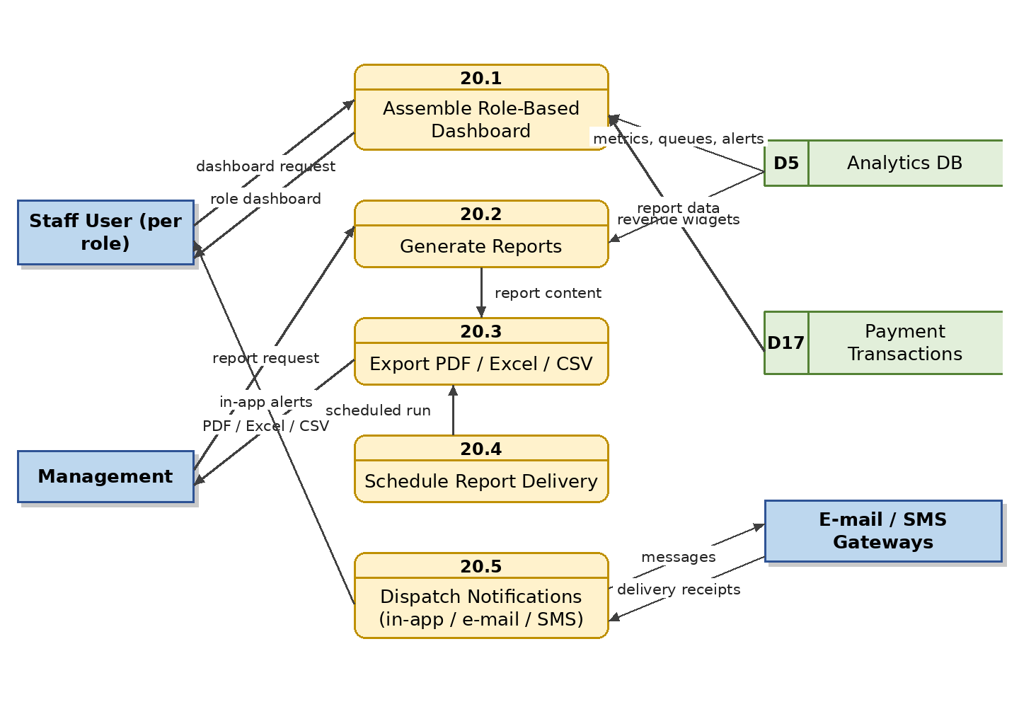
Figure 22: Level 1 DFD – Dashboard, Reporting and Notification

4.21 M21 — Audit Trail and Version Control Module

4.21.1 Module Overview
Every important action is recorded immutably: user, action, date/time, affected asset, previous and new values — covering uploads, downloads, metadata changes, edits, approvals and rejections, publications, rights changes, curation changes, moderation actions, subscription/refund adjustments and ad-campaign changes. The module also versions metadata, audio edits, scripts, transcripts, lyrics and rights documents so any earlier state can be inspected or restored.

4.21.2 Functional Requirements
Req. ID | Requirement Description | Priority
FR-AUD-01 | The system shall log every significant action with user, action, timestamp, asset and before/after values. | M
FR-AUD-02 | The audit log shall be append-only and protected against modification or deletion. | M
FR-AUD-03 | The system shall version metadata, audio edit sessions, scripts, transcripts, lyrics and rights documents. | M
FR-AUD-04 | The system shall provide searchable, filterable audit views by user, asset, action type and date range. | M
FR-AUD-05 | The system shall retain audit records for a configurable statutory period. | S

4.21.3 Data Flow Diagram
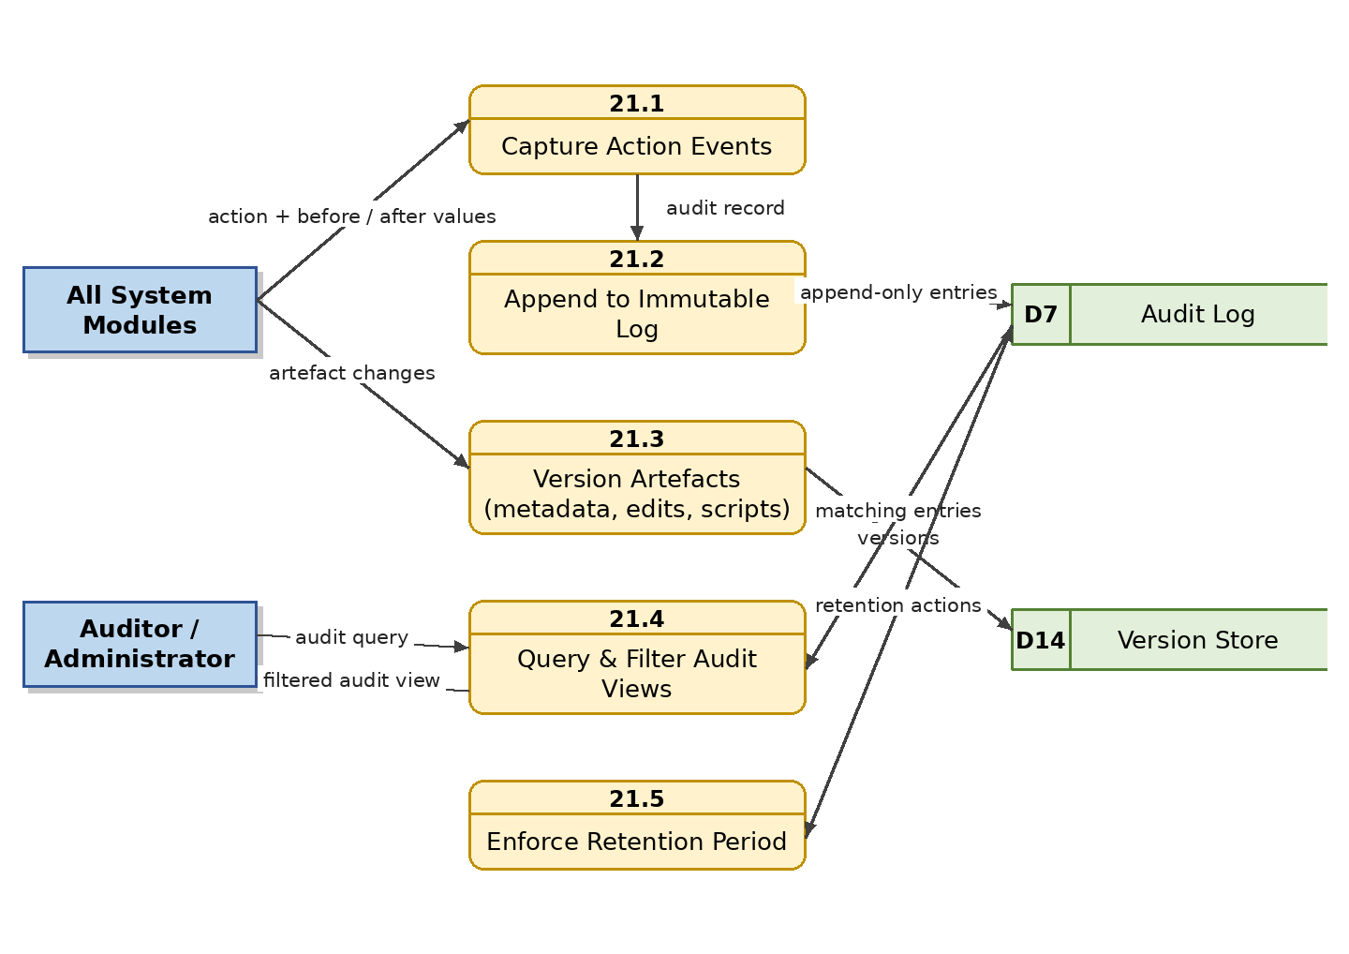
Figure 23: Level 1 DFD – Audit Trail and Version Control

4.22 M22 — Preservation, Backup and Recovery Module

4.22.1 Module Overview
Irreplaceable historical recordings demand a strict preservation regime: at least three copies (operational, local backup, off-site backup), scheduled automatic backups, disaster-recovery replication, checksum generation and scheduled integrity checking, corruption detection, restore testing, file-migration history and multi-tier storage.

4.22.2 Functional Requirements
Req. ID | Requirement Description | Priority
FR-BCK-01 | The system shall maintain at least three copies of every preservation master: operational, local backup and off-site backup. | M
FR-BCK-02 | The system shall run scheduled automatic backups of audio, database and metadata. | M
FR-BCK-03 | The system shall replicate to an off-site/disaster-recovery location. | M
FR-BCK-04 | The system shall generate checksums at ingest and re-verify file integrity on schedule, alerting on corruption. | M
FR-BCK-05 | The system shall alert administrators on backup failure. | M
FR-BCK-06 | The system shall support restore operations and periodic restore testing with recorded results. | M
FR-BCK-07 | The system shall keep a migration history when files move between storage tiers or formats. | S
FR-BCK-08 | The system shall support one-time migration of Bangladesh Betar's existing digital audio files and catalogue data (spreadsheets/databases) into the platform per an agreed field mapping, with a migration report of successes, failures and unmapped fields. | S

4.22.3 Data Flow Diagram
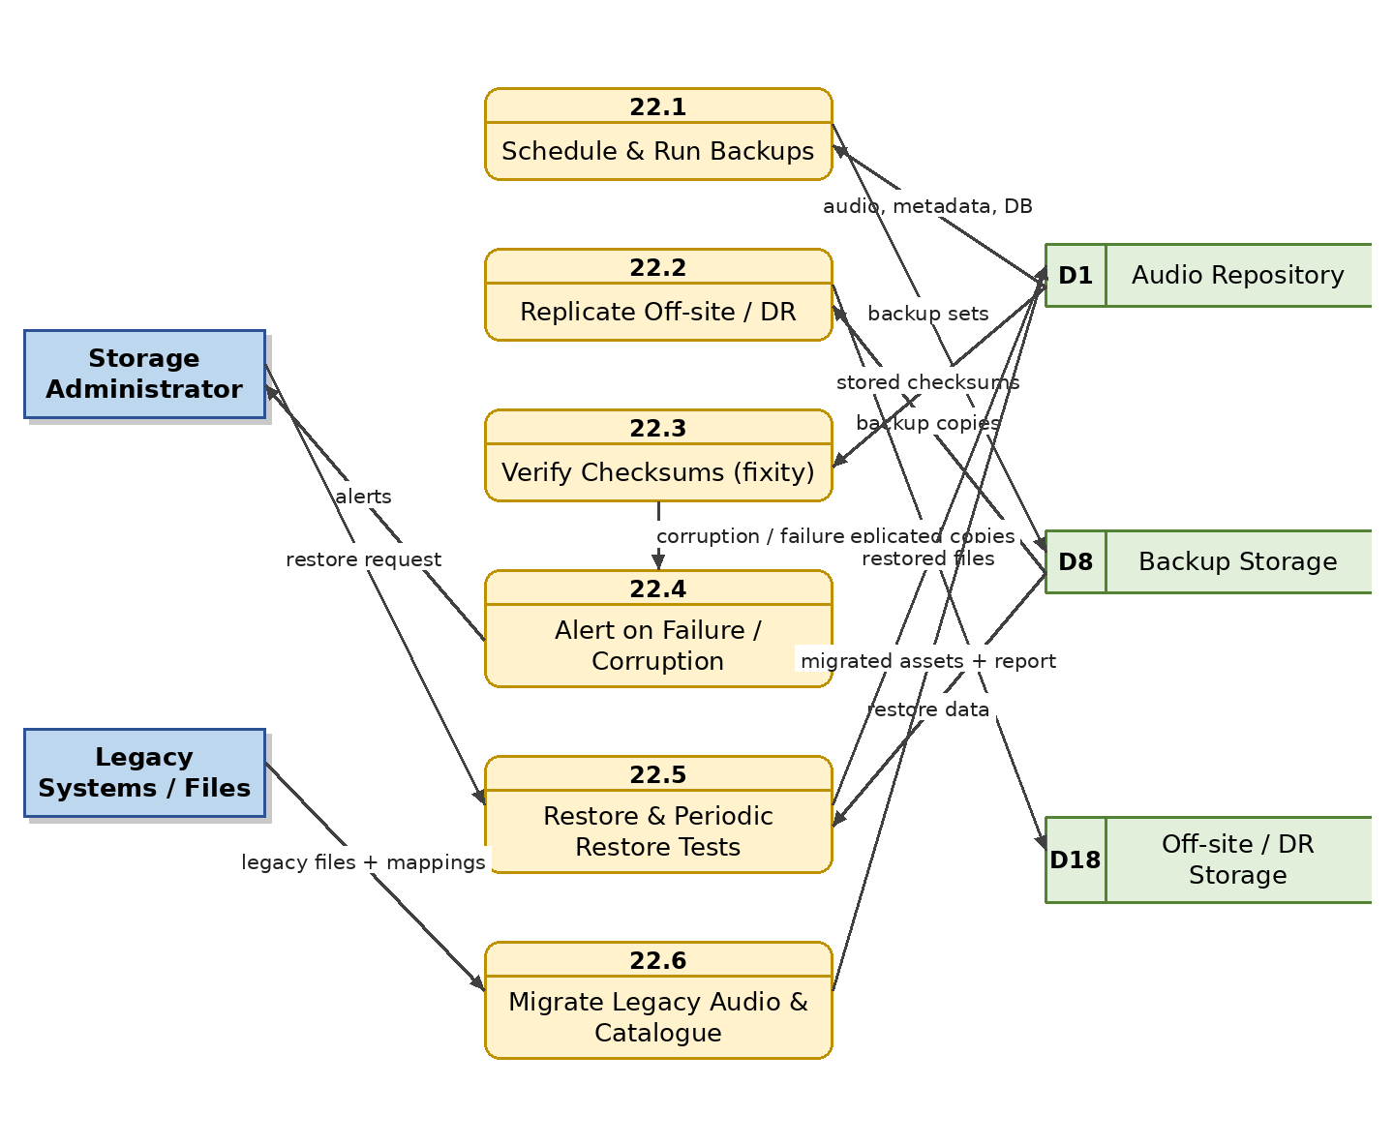
Figure 24: Level 1 DFD – Preservation, Backup and Recovery

4.23 M23 — Integration and API Module

4.23.1 Module Overview
The platform integrates with broadcast automation and studio recording systems, the Bangladesh Betar website, the mobile application, podcast platforms, YouTube, social media, Active Directory/LDAP, e-mail and SMS gateways, payment gateways and app-store billing, cloud/network storage and newsroom/scheduling systems. A secured REST API exposes search, streaming, metadata retrieval, publishing, playlist access and rights validation to authorized clients.

4.23.2 Functional Requirements
Req. ID | Requirement Description | Priority
FR-API-01 | The system shall expose secured REST APIs for search, metadata retrieval, streaming URLs, publishing, playlist access, recommendations and rights validation. | M
FR-API-02 | The API shall authenticate clients with API keys and/or OAuth 2.0 and enforce per-client scopes. | M
FR-API-03 | The system shall integrate with broadcast automation and studio recording systems for ingestion and schedule linking. | M
FR-API-04 | The system shall publish selected content to YouTube and social platforms via their APIs. | C
FR-API-05 | The system shall integrate with e-mail and SMS gateways for notifications. | M
FR-API-06 | The API shall be rate-limited and all calls logged to the audit trail. | M
FR-API-07 | The API shall be versioned and documented (OpenAPI specification). | S

4.23.3 Data Flow Diagram
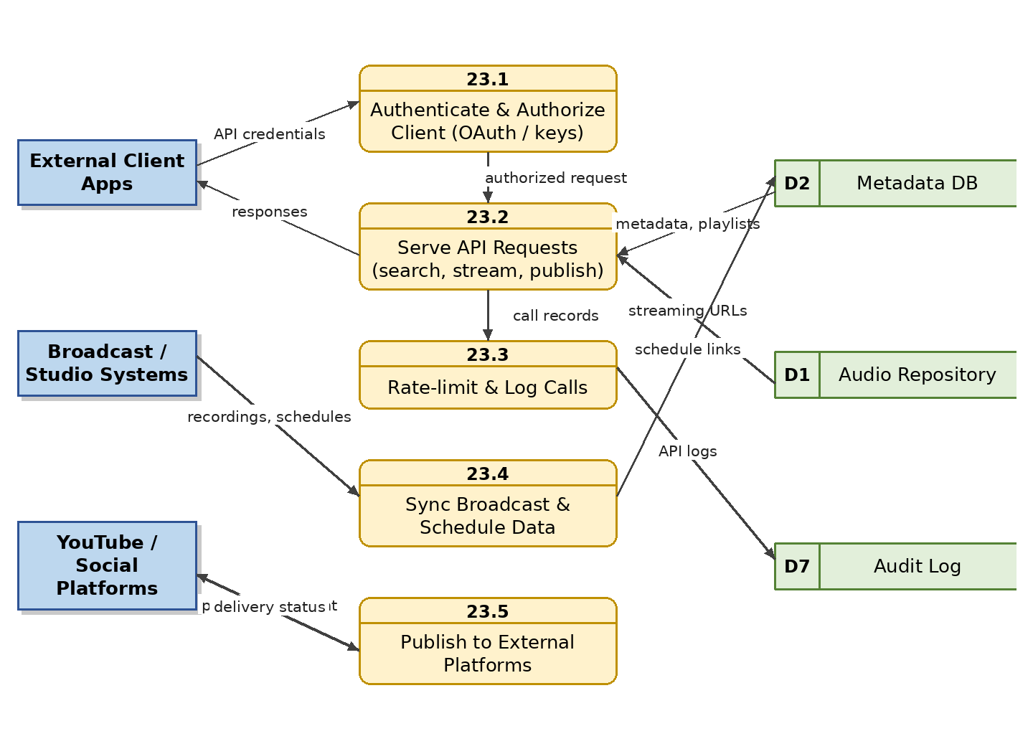
Figure 25: Level 1 DFD – Integration and API

4.24 M24 — Content Curation and Homepage Management Module (New in v1.1)

4.24.1 Module Overview
Human curation is the primary discovery engine of a national archive. This module gives Content Curators full control of what the public app presents: home-screen sections and their ordering, promotional banners, editorially curated collections and playlists (e.g., “Songs of 1971”, “Golden Age of Radio Drama”), featured artists, albums and programmes, scheduled publication of seasonal/national-day specials, and an automatic “On This Day” feature that surfaces content by historical broadcast date. Only published, rights-cleared content can be curated.

4.24.2 Functional Requirements
Req. ID | Requirement Description | Priority
FR-CUR-01 | The system shall allow curators to create, order, enable/disable and target home-screen sections and promotional banners of the public app without code changes. | M
FR-CUR-02 | The system shall support editorially curated collections and playlists with title (Bangla/English), artwork, description and ordered content, publishable to the public app. | M
FR-CUR-03 | The system shall support scheduling curated sections, banners and collections to appear and disappear at set dates/times (e.g., Independence Day, Victory Day, Ekushey February specials). | M
FR-CUR-04 | The system shall provide an “On This Day” capability that automatically surfaces published content whose original broadcast date matches the current date, with curator override. | S
FR-CUR-05 | The system shall allow featuring artists, albums, programmes and podcast channels in dedicated spotlight placements. | S
FR-CUR-06 | The system shall provide a preview of the public home screen as it will appear to listeners before curation changes are published. | S
FR-CUR-07 | The system shall permit only published, rights-cleared content in curated placements and shall automatically remove items that become unpublished or rights-blocked. | M
FR-CUR-08 | The system shall record all curation changes in the audit trail and report per-section engagement (impressions, plays) via M19/M20. | S

4.24.3 Data Flow Diagram
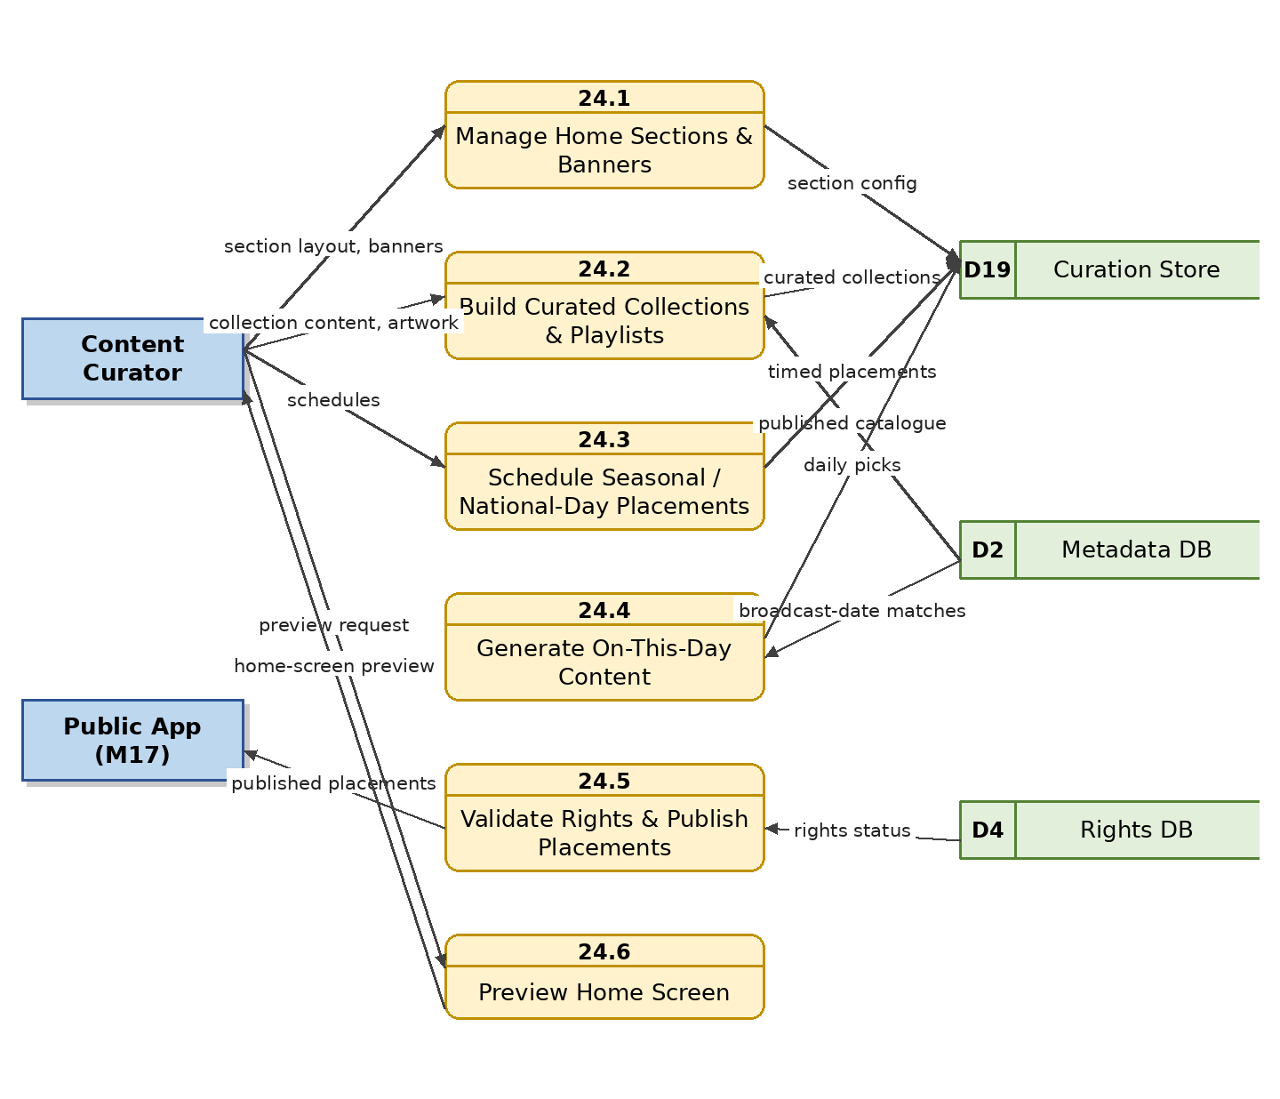
Figure 26: Level 1 DFD – Content Curation and Homepage Management Module (New in v1.1)

4.25 M25 — Recommendation and Personalization Module (New in v1.1)

4.25.1 Module Overview
This module delivers personalized recommendations in the public app, combining collaborative signals (listening history, favourites, follows, completion/skip behaviour from M19) with content-based signals (verified genre, mood, artist, era, semantic embeddings from M16). New and anonymous listeners receive curated and trending content as a cold-start fallback. Recommendations always respect publication status, rights and plan entitlements, and listeners can opt out of personalization.

4.25.2 Functional Requirements
Req. ID | Requirement Description | Priority
FR-REC-01 | The system shall generate personalized recommendation rows in the public app (e.g., “Recommended for you”, “Because you listened to …”, “More from artists you follow”) for signed-in listeners. | M
FR-REC-02 | The system shall compute content-to-content similarity using verified metadata (genre, mood, artist, era) and semantic embeddings (FR-AIF-08) to power “similar songs/episodes” suggestions and autoplay continuation. | S
FR-REC-03 | The system shall generate periodically refreshed personalized mixes (e.g., daily/weekly mixes by taste cluster). | C
FR-REC-04 | The system shall fall back to curated (M24), trending and top-played content for guests, new users and users who opt out of personalization. | M
FR-REC-05 | Recommendations shall include only published, rights-cleared content and shall respect the listener's plan entitlements and content warnings. | M
FR-REC-06 | The system shall allow administrators to configure recommendation weightings, pin or exclude specific content, and disable personalization globally or per section. | S
FR-REC-07 | The system shall let listeners opt out of personalized recommendations and clear their recommendation profile, in line with the privacy policy. | M
FR-REC-08 | The system shall report recommendation performance (impressions, click-through, play-through) to dashboards (M20). | S

4.25.3 Data Flow Diagram
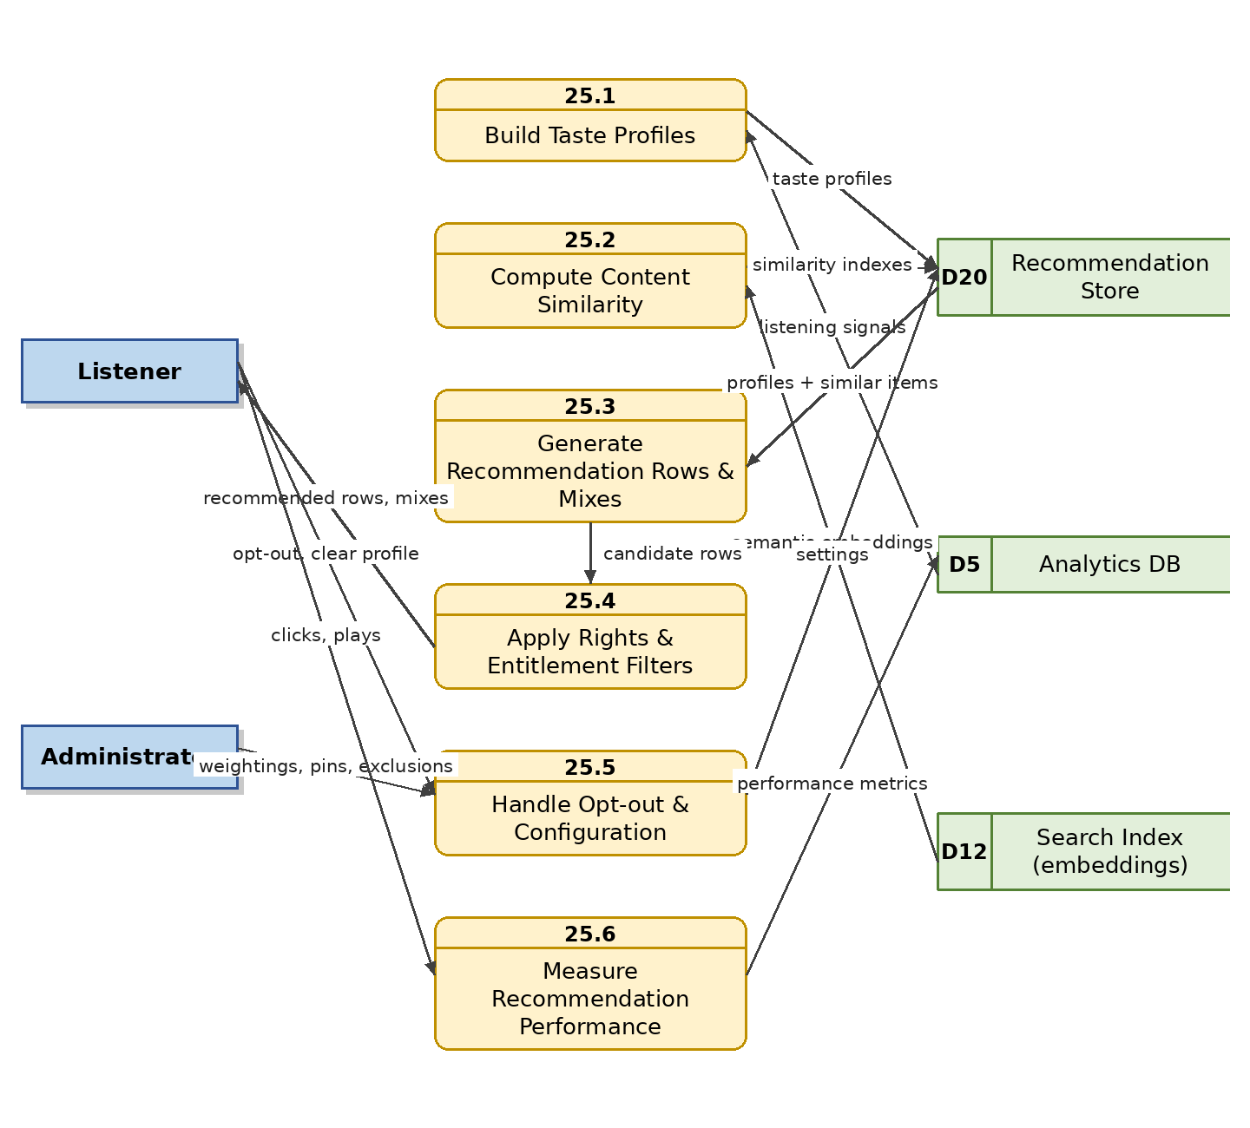
Figure 27: Level 1 DFD – Recommendation and Personalization Module (New in v1.1)

4.26 M26 — Listener Engagement, Moderation and Feedback Module (New in v1.1)

4.26.1 Module Overview
This module manages all user-generated interaction on published content — comments and ratings — together with the safeguards a state broadcaster requires: configurable pre-/post-moderation, Bangla and English profanity filtering, a reported-content queue, and moderator actions with full audit. It also handles listener feedback of a different kind: reports of broken audio or wrong metadata routed to archive staff, and external rights-holder complaints with a takedown workflow.

4.26.2 Functional Requirements
Req. ID | Requirement Description | Priority
FR-ENG-01 | The system shall allow signed-in listeners to post, edit and delete their own comments on published content where commenting is enabled. | S
FR-ENG-02 | The system shall allow signed-in listeners to rate published content (e.g., 1–5 stars or like-based), displaying aggregate ratings; one rating per user per item, changeable. | S
FR-ENG-03 | The system shall support configurable moderation modes per content area (pre-moderation, post-moderation, disabled) and automatic filtering of profanity and prohibited terms in Bangla and English. | M
FR-ENG-04 | The system shall allow any listener to report a comment or content item, with a reason, feeding the moderation queue. | M
FR-ENG-05 | The system shall provide moderators a queue to approve, hide or remove comments, and to warn, mute or ban abusive accounts, with all actions audit-logged. | M
FR-ENG-06 | The system shall allow administrators to enable/disable comments and ratings globally, per collection or per asset (e.g., disabled on sensitive historical recordings). | M
FR-ENG-07 | The public app shall provide a “report an issue” action on any playable item (broken audio, wrong metadata, inappropriate content), routed to an admin triage queue with status tracking. | M
FR-ENG-08 | The system shall support an external rights-holder complaint/takedown workflow: record the complaint, temporarily unpublish the item where warranted, route to the Copyright Officer for investigation, and log the resolution. | M
FR-ENG-09 | The system shall provide a general feedback/contact channel in the public app with categorized submissions viewable by authorized staff. | S

4.26.3 Data Flow Diagram
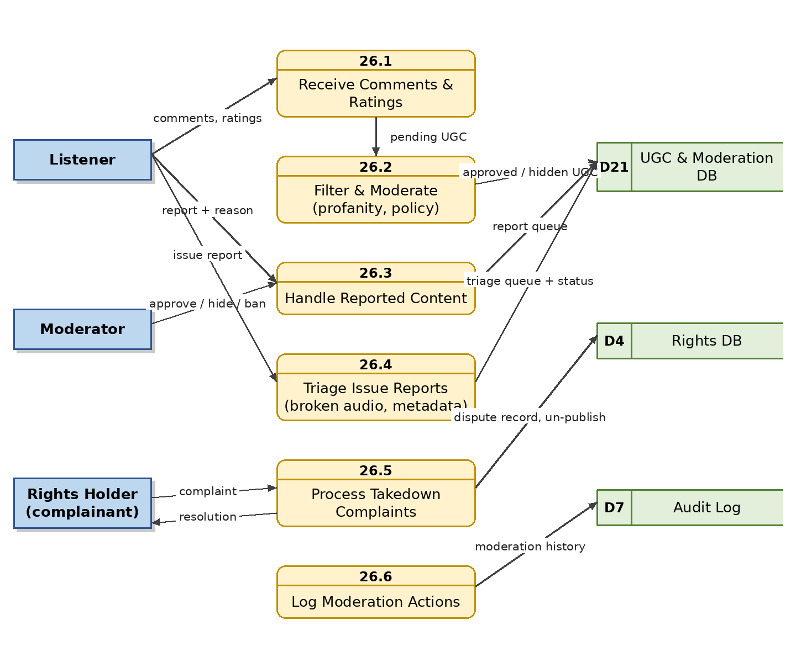
Figure 28: Level 1 DFD – Listener Engagement, Moderation and Feedback Module (New in v1.1)

4.27 M27 — Advertisement Management and Serving Module (New in v1.1)

4.27.1 Module Overview
The freemium model (M18) depends on audio advertisements and announcements for free-tier listeners; this module owns them. It manages the ad asset library (commercial spots produced via M11, station announcements, public-service messages), advertiser and campaign records, scheduling and targeting, server-side insertion rules (pre-roll and between-track slots, frequency capping), delivery to free-tier streams only, and impression/completion reporting for advertisers and management. When no commercial campaign is eligible, house announcements and PSAs fill the slots.

4.27.2 Functional Requirements
Req. ID | Requirement Description | Priority
FR-ADV-01 | The system shall maintain an ad asset library of approved audio spots and announcements with duration, language, category and validity period. | M
FR-ADV-02 | The system shall manage advertisers and campaigns with flight dates, budget/impression goals, priority, and targeting by content category, time of day and platform. | M
FR-ADV-03 | The system shall insert audio ads into free-tier playback server-side at configured points (pre-roll and between tracks/episodes) with per-listener frequency capping; premium listeners shall never receive ads. | M
FR-ADV-04 | The system shall require approval of ad content through the workflow module (M13) before it becomes eligible for serving. | M
FR-ADV-05 | The system shall fall back to Bangladesh Betar house announcements and public-service messages when no eligible campaign exists for a slot. | M
FR-ADV-06 | The system shall log ad impressions and completions and provide campaign delivery reports (impressions, completion rate, reach) to the Advertisement Manager and management. | M
FR-ADV-07 | The system shall never insert ads into designated public-service content (news, emergency announcements) per FR-SUB-11. | M
FR-ADV-08 | The system shall support pacing and even rotation of campaigns sharing the same targeting. | S

4.27.3 Data Flow Diagram
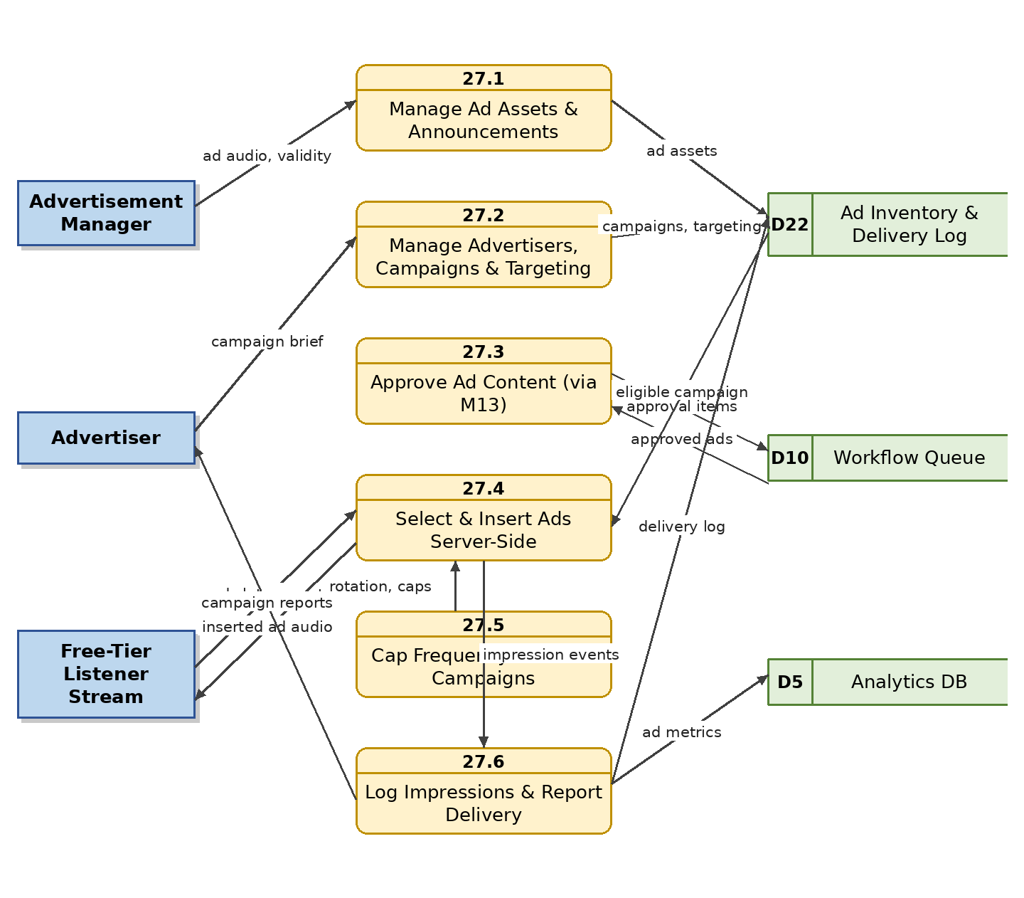
Figure 29: Level 1 DFD – Advertisement Management and Serving Module (New in v1.1)

5. Non-Functional Requirements (Summary)
The following non-functional requirements constrain all modules. A full NFR specification should be maintained separately.
ID | Category | Requirement
NFR-01 | Security | TLS for all traffic; encryption at rest for masters and personal data; OWASP-aligned secure development; signed, expiring streaming URLs; encrypted offline downloads.
NFR-02 | Performance | Search results < 2 s; stream start < 3 s on 3G-class connections; ingestion pipeline processes files in background without blocking users; waveform data pre-computed so visualization adds no perceptible playback delay.
NFR-03 | Availability | 99.5% availability for the public streaming service; graceful degradation of non-critical features (visualizer, recommendations, comments) under load.
NFR-04 | Scalability | Support at least 1 million catalogued assets and 100,000 concurrent public listeners, horizontally scalable.
NFR-05 | Localization | Full Bangla and English UI and metadata support, including Bangla search, transliteration and sorting.
NFR-06 | Usability | Admin tasks (upload + metadata) achievable by trained staff without technical assistance; public app usable without training.
NFR-07 | Data Protection | Listener data anonymized/pseudonymized for analytics; consent captured for story submissions and personalization; recommendation opt-out honoured; compliance with applicable Bangladeshi law.
NFR-08 | Auditability | Every state-changing action attributable to a user and reconstructable from the audit trail.
NFR-09 | Preservation | Three-copy rule for masters; periodic fixity checks; documented disaster-recovery objectives (RPO/RTO).
NFR-10 | Interoperability | Open, versioned, documented APIs; standard formats (BWF, RSS, OpenAPI).
NFR-11 | Accessibility | Public portal and mobile apps conform to WCAG 2.1 Level AA: screen-reader compatibility, sufficient contrast, scalable fonts, keyboard navigation on web, and transcripts/captions where available.
NFR-12 | Compatibility | Mobile apps support Android 8.0+ and iOS 14+ including low-RAM devices common in Bangladesh; web portal supports current versions of Chrome, Firefox, Safari and Edge; app size and memory footprint optimized for entry-level devices.
NFR-13 | Content Safety | User-generated content (comments, ratings, story submissions) is never publicly visible without passing the configured moderation policy; content warnings are enforced before playback of flagged items.

6. Appendix A — Data Store Catalogue
Data stores referenced across the DFDs:
Store | Name | Content
D1 | Audio Repository | Preservation masters, derived versions, proxies, clips, pre-computed waveform data
D2 | Metadata DB | Descriptive/technical metadata, hierarchy, songs, albums, podcasts, stories, voice profiles, playlists
D3 | User & Role DB | Staff and public accounts, roles, permissions, saved searches, libraries, follows
D4 | Rights DB | Rights holders, licences, usage scope, validity dates, royalties, complaints
D5 | Analytics DB | Playback events, aggregates, heat maps, trends, engagement metrics
D6 | Subscription DB | Plans, entitlements, trials, renewal state
D7 | Audit Log | Immutable action log, API logs, approval history, moderation history
D8 | Backup Storage | Local backup sets
D9 | Transcript Store | Timed transcripts, lyrics, subtitles, speaker labels
D10 | Workflow / Ingest Queue | Workflow instances, pending stages, ingest queue
D11 | Digitization Register | Physical items, condition, digitization status
D12 | Search Index | Full-text and field indexes (Bangla + English), semantic embedding index
D13 | Consent Records | Listener submission consent forms, ToS/privacy acceptances
D14 | Edit History / Version Store | Edit decision lists, artefact versions
D15 | Contract Documents | Scanned contracts and consent documents
D16 | QC Reports | Automated analysis results and reviewer verdicts
D17 | Payment Transactions | Charges, refunds, disputes, gateway/app-store references, invoices
D18 | Off-site / DR Storage | Off-site and disaster-recovery copies
D19 | Curation Store | Home-screen sections, banners, curated collections, schedules, On-This-Day overrides
D20 | Recommendation Store | Listener taste profiles, similarity indexes, generated mixes, opt-out flags
D21 | UGC & Moderation DB | Comments, ratings, reports, moderation queue and actions, issue reports, complaints
D22 | Ad Inventory & Delivery Log | Ad assets, advertisers, campaigns, insertion rules, impression/completion logs

7. Appendix B — Recommended Development Phases
Phase | Scope | Key Modules
Phase 1 — Core Archive | Foundation: accounts, ingestion, repository, metadata, search, player & visualization, basic workflow | M01, M02, M04, M05, M06, M07, M13
Phase 2 — Governance & Quality | Rights, QC, editing, audit, backup & migration, digitization | M03, M12, M14, M15, M21, M22
Phase 3 — Content Verticals | Songs & albums, podcasts, Bhoot FM, marketing voice production | M08, M09, M10, M11
Phase 4 — Public Launch | Public portal + mobile apps, freemium subscriptions & payments, curation, engagement & moderation, advertisements, notifications | M17, M18, M20, M24, M26, M27
Phase 5 — Intelligence | AI features (transcription, semantic search, speaker ID, classification), analytics/heat maps at full depth, recommendations & personalization, external integrations | M16, M19, M23, M25
Note: basic playback analytics (FR-PLY-08, core FR-ANL aggregates) should be instrumented from Phase 1 so that historical listening data exists when trending, heat maps and recommendations launch in later phases.

