SYSTEM OVERVIEW
Bangladesh Betar Audio Archive Platform
Executive Summary • Short Requirements • System Flowchart
Version 1.0 (Draft) • July 2026
Companion document to the full Functional Requirements Specification (FRS v1.0)

1. What the System Is
The Bangladesh Betar Audio Archive Platform is a centralized digital system that preserves, manages and publishes Bangladesh Betar's complete audio collection — songs, radio programmes, podcasts, Bhoot FM episodes, news, interviews, dramas, advertisements, marketing voice-overs and historical recordings. It replaces scattered tapes, discs and folders with one searchable, rights-controlled, professionally governed archive, and then delivers approved content to the public through a modern streaming experience.
The solution is one platform with two faces:
- Admin Web Portal (back office): where Bangladesh Betar staff upload and digitize audio, enter Bangla/English metadata, edit non-destructively, run quality checks, clear copyrights, approve content and monitor performance dashboards. The original preservation master is never modified; the public only ever receives derived streaming copies.
- Public Listening App (website + Android/iOS): a Spotify-style consumer app where the public browses and streams the published archive — with playlists, favourites, resume playback, synced lyrics/transcripts and new-episode notifications — under a freemium model: free listening with ads and limits, or a paid Premium plan (via bKash/Nagad/cards) for ad-free, full-length, high-quality and offline listening.
A single content pipeline connects the two: nothing reaches the public app until it has passed validation, quality control, rights clearance and management approval. Listener activity flows back as analytics — play counts, completion rates, heat maps and trending rankings — that guide programming decisions.

2. Major System Components
Component | Purpose (in one line)
Ingestion & Digitization | Bring audio in from uploads, studios, broadcast servers, live recording and tape/CD digitization
Central Repository | Store immutable preservation masters plus broadcast/online/preview versions under unique archive IDs
Metadata & Search | Rich Bangla + English cataloguing with fast field, filter and in-transcript search
Audio Player | Interactive waveform player with speed control, chapters, synced lyrics and transcripts
Content Modules | Dedicated management for songs, podcasts (RSS), Bhoot FM stories and marketing voices
Editing & QC | Non-destructive trimming, clips and automatic audio quality analysis
Workflow & Rights | Configurable approval chains and automatic blocking of unauthorized or expired content
Public App & Freemium | Consumer streaming with Free vs Premium plans, payments and entitlement enforcement
Analytics & Dashboards | Heat maps, trending, drop-off analysis, role-based dashboards and exportable reports
Protection Layer | Role-based access, audit trail, three-copy backup and disaster recovery
Integration & API | Secure REST APIs plus connections to broadcast systems, LDAP, YouTube and podcast platforms

3. Short Requirement List
The twenty most important requirements, condensed from the full FRS (which contains the complete numbered set with priorities):
# | Requirement | FRS Ref.
R-01 | Upload audio in bulk with resumable transfers, virus scanning and duplicate detection | M02
R-02 | Digitize tapes, cassettes, CDs and reels into archival WAV/BWF masters with tracked status | M03
R-03 | Keep preservation masters immutable; auto-generate compressed streaming copies | M02, M04
R-04 | Organize everything as Station → Programme → Season → Episode → Segment with unique archive IDs | M04
R-05 | Store full Bangla and English metadata with custom fields and mandatory-field enforcement | M05
R-06 | Find any asset in seconds — by field, filter, date, archive ID or words spoken in transcripts | M06
R-07 | Play audio with interactive waveform, chapters, speed control and synced lyrics/transcripts | M07
R-08 | Manage songs with artist profiles, version families, lyrics, playlists and popularity rankings | M08
R-09 | Run podcasts end-to-end: seasons, episodes, artwork, scheduling and RSS distribution | M09
R-10 | Handle Bhoot FM at story level: timestamps, locations, content warnings and consented submissions | M10
R-11 | Let marketing search voices by tone/language, manage scripts, takes, campaigns and usage rights | M11
R-12 | Edit non-destructively (trim, fade, normalize, clips) with full version history and restore | M12
R-13 | Route all content through Upload → QC → Editorial → Rights → Management Approval → Publish | M13
R-14 | Record rights and contracts; automatically block expired or unauthorized content from publication | M14
R-15 | Auto-check every file for silence, clipping, noise, channel faults and loudness compliance | M15
R-16 | Stream published content publicly on web, Android and iOS — masters never publicly reachable | M17
R-17 | Operate freemium: free tier with ads/previews/quality caps; Premium (bKash/Nagad/card) removes them and enables offline | M18
R-18 | Track plays, completion, replays and skips; build per-asset second-by-second heat maps and trending lists | M19
R-19 | Give every role its own dashboard with PDF/Excel/CSV report export and expiry alerts | M20
R-20 | Protect the archive: RBAC, immutable audit trail, three-copy backup, checksums and disaster recovery | M01, M21, M22

4. End-to-End System Flowchart
The flowchart below shows the complete life of a piece of audio across both applications. The upper lane is the Admin Web Portal: content is ingested, validated, catalogued, quality-checked, optionally edited, rights-cleared and management-approved before publication. The lower lane is the Public Listening App: listeners sign up, browse the published catalogue and stream either on the Free tier (with ads and limits) or on Premium (after payment). Playback events feed the analytics engine, which powers dashboards for staff and trending recommendations for listeners.
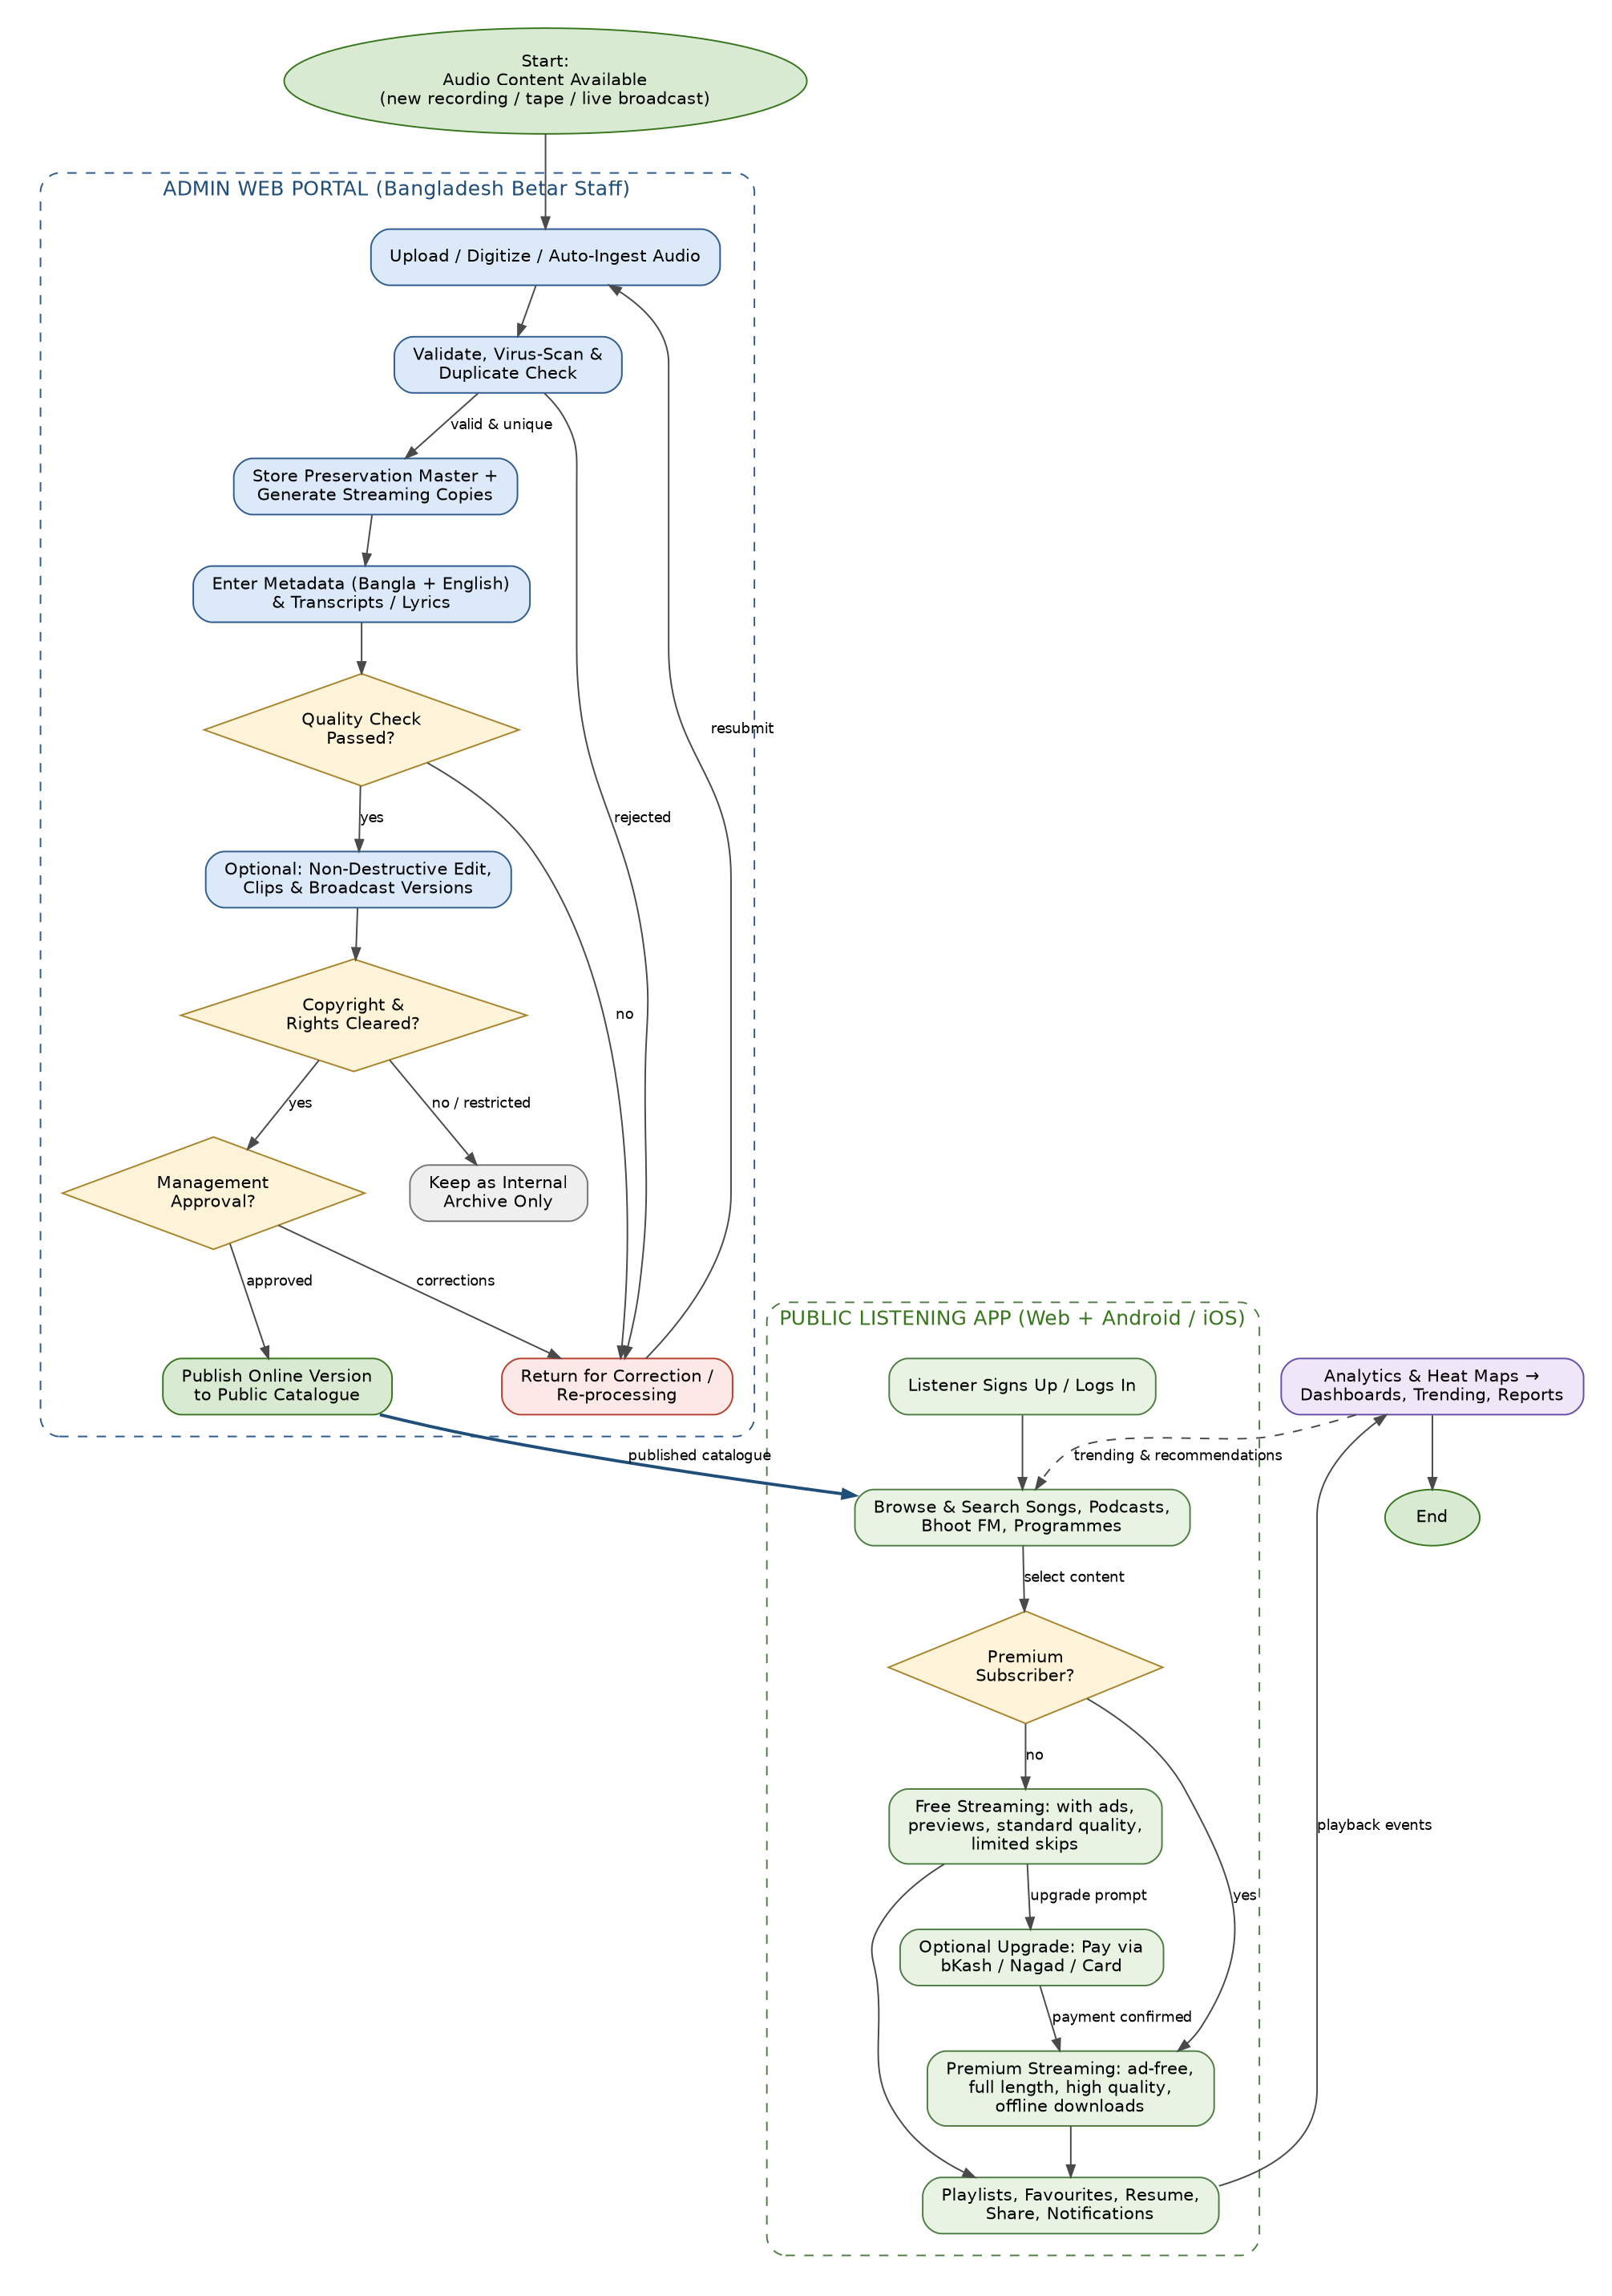
Figure 1: End-to-end flowchart — Admin Web Portal and Public Listening App

Reading the Flowchart
- Blue boxes = staff activities in the Admin Web Portal; green boxes = listener activities in the Public App.
- Yellow diamonds = decision points (quality check, rights clearance, management approval, subscription plan).
- Any failure returns content for correction; restricted content stays internal-only and never reaches the public.
- The bold arrow from “Publish” to “Browse & Search” is the single gateway between the two applications.
- The purple analytics block closes the loop: listening behaviour becomes dashboards, reports and trending content.

