MD. Akramul Islam

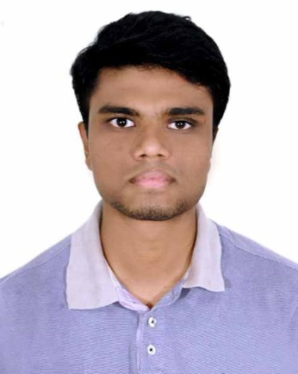

**House No. 31, Road No. 02, Block-A;**

**Keranigonj Model Town,**

**Dhaka-1310**.

# OBJECTIVES

I am a fast learner. Love to explore new technologies. I like to work under pressure and strict timeline. I like challenges. It helps me to learn new things and also to push my limits. I am willing to establish my carrier in Web Development. I prefer PHP as development language.

Currently, learning Laravel framework as it is the most complete and advanced PHP framework.

# 

# MY CURRENT PROJECT'S

* Online-Shopping-Store using Laravel
* Project link : <https://github.com/AkashAkram/ecommerce_laravel>
* Live Demo : <http://ecommerce.akashakram.xyz>
* Blog Site using Laravel
* Project link : <https://github.com/AkashAkram/amarblog_laravel>
* Live Demo : <http://amarblog.akashakram.xyz>
* Blog Site using Object Oriented PHP
* Project link : <https://github.com/AkashAkram/amarblog-raw>
* Live Demo : <http://blog.akashakram.xyz>

# PERSONAL INFORMATION

Born on December 10th, 1993 in Dhaka.

Citizenship: Bangladeshi.

Religion: Islam (Sunni)

Marital status: Unmarried.

# CONTACT INFORMATION

* **Phone No.**
* 01685121214
* 01557191408
* **Email ID.**
* [akashakram@outlook.com](mailto:akashakram@outlook.com)
* [akashakrambd@gmail.com](mailto:mdakashakram@gmail.com)

# EDUCATION

|  |  |  |  |  |
| --- | --- | --- | --- | --- |
| Degree | Department / group | Institute / University | Year of passing | CGPA |
| B.Sc. | Computer Science & Engineering | Bangladesh University of Business & Technology | 2016 | 2.86 |
| H.S.C | Science | Western College | 2010 | 3.40 |
| S.S.C | Science | Armanitola Govt High School | 2008 | 4.69 |

# DEVELOPING SKILLS

* **Languages & Skills :**
* **I am comfortable in HTML, CSS,Raw-PHP, Laravel framework, JavaScript, jquery.**
* **I also have basic Knowledge in C# and asp.net .**
* **Operating Systems :**
* Windows, Linux .

# STRENGTHS

* Determined to learn with practical approach
* Good communication skills
* Enthusiastic and can produce results under deadline constraints

# TRAINING SUMMARY

* I participated on National Hackathon, 2016.
* I have completed a basic course on ASP.net from BASIS in 2015.
* I participated various programming Camp organized by Bangladesh Association of Problem setters (BAPS).

# ACHIEVEMENTS

* Participated in various National Programming Contests.
* Solved more than 500 problems in UVA, lightOJ, Codeforces etc.