Create a table named Managers with fields : 

* Manager_Id
* First_name
* Last_Name
* DOB
* Age ->Use check constraint
* Last_update
* Gender
* Department
* Salary -> NOT NULL

1. Insert 10 rows.   
2. Write a query that retrieves the name and date of birth of the manager with Manager_Id 1.   
3. Write a query to display the annual income of all managers.   
4. Write a query to display records of all managers except ‘Aaliya’.   
5. Write a query to display details of managers whose department is IT and earns more than 25000 per month.   
6. Write a query to display details of managers whose salary is between 10000 and 35000.

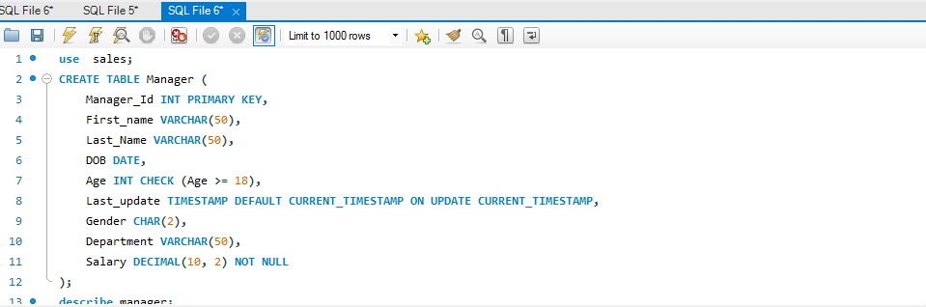

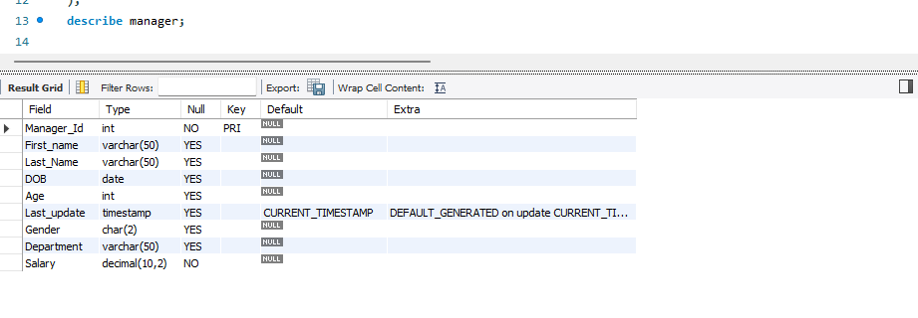

1. Insert 10 rows.

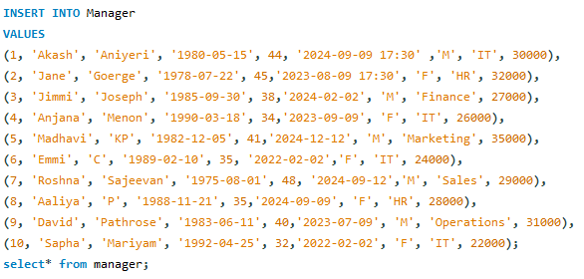

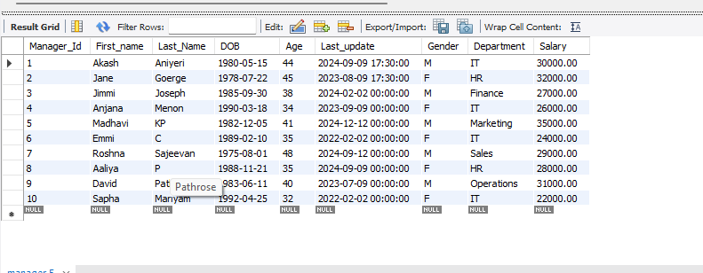

2. Write a query that retrieves the name and date of birth of the manager with Manager_Id 1.

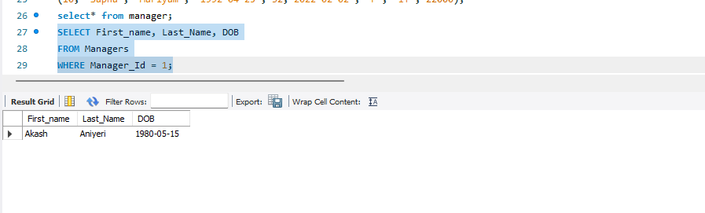

3. Write a query to display the annual income of all managers. 

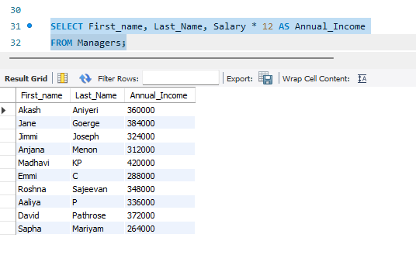

4. Write a query to display records of all managers except ‘Aaliya’.

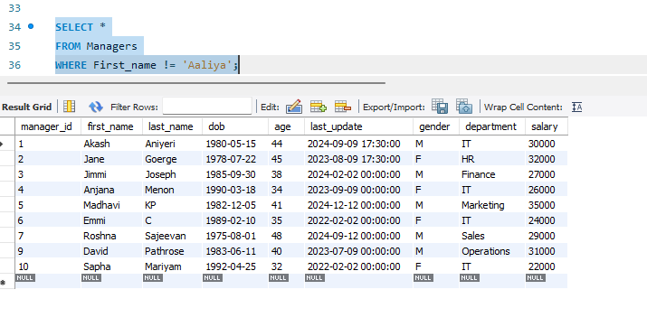

5. Write a query to display details of managers whose department is IT and earns more than 25000 per month. 

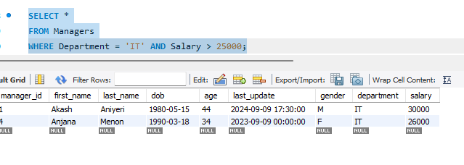

6. Write a query to display details of managers whose salary is between 10000 and 35000.



