**Created with a trial version of Syncfusion Word library or registered the wrong key in your application. Click [here](https://www.syncfusion.com/account/claim-license-key?pl=ZmlsZWZvcm1hdHM=&vs=MjYuMS40MA==) to obtain the valid key.**

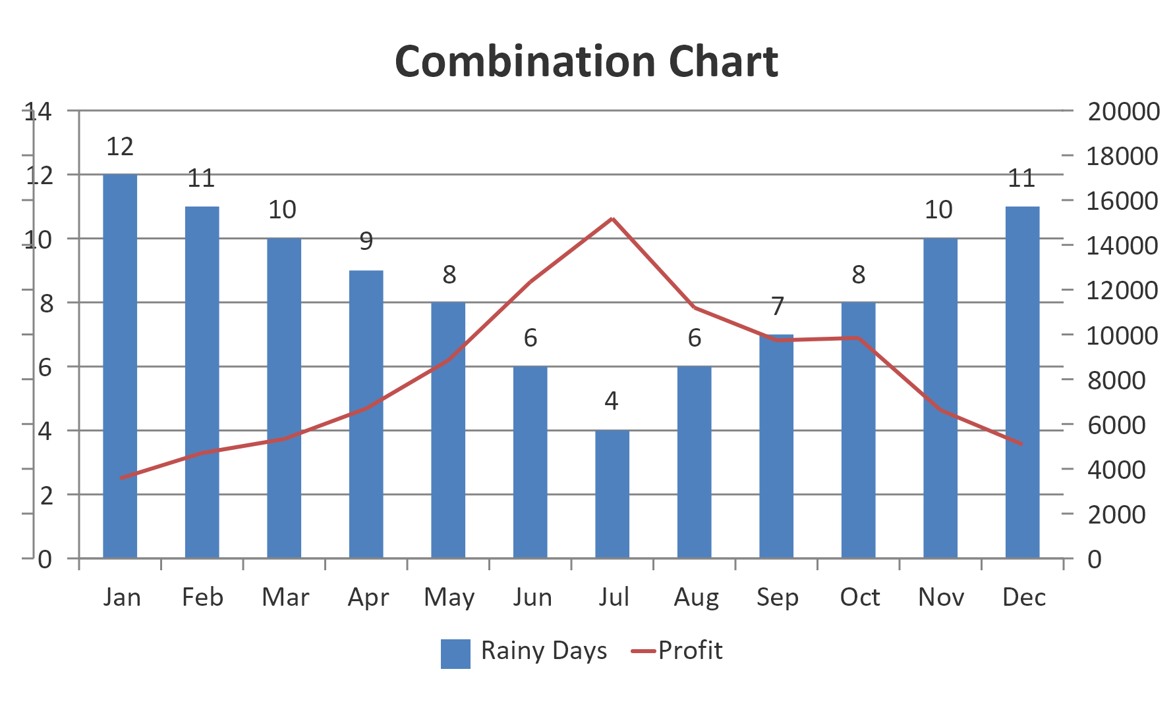

**Created with a trial version of Syncfusion Word library or registered the wrong key in your application. Click [here](https://www.syncfusion.com/account/claim-license-key?pl=ZmlsZWZvcm1hdHM=&vs=MjYuMS40MA==) to obtain the valid key.**