HospitalCare — AWS Cloud Infrastructure
High Availability • Secure Networking • Storage • Monitoring
Practical Implementation Documentation

1. Objective
Design and implement secure, highly available AWS infrastructure for HospitalCare, an appointment-management application for patients and hospital staff. The design uses VPC, EC2, Amazon RDS for MySQL with Multi-AZ deployment, S3, IAM roles, security groups, and CloudWatch.

2. Proposed Architecture
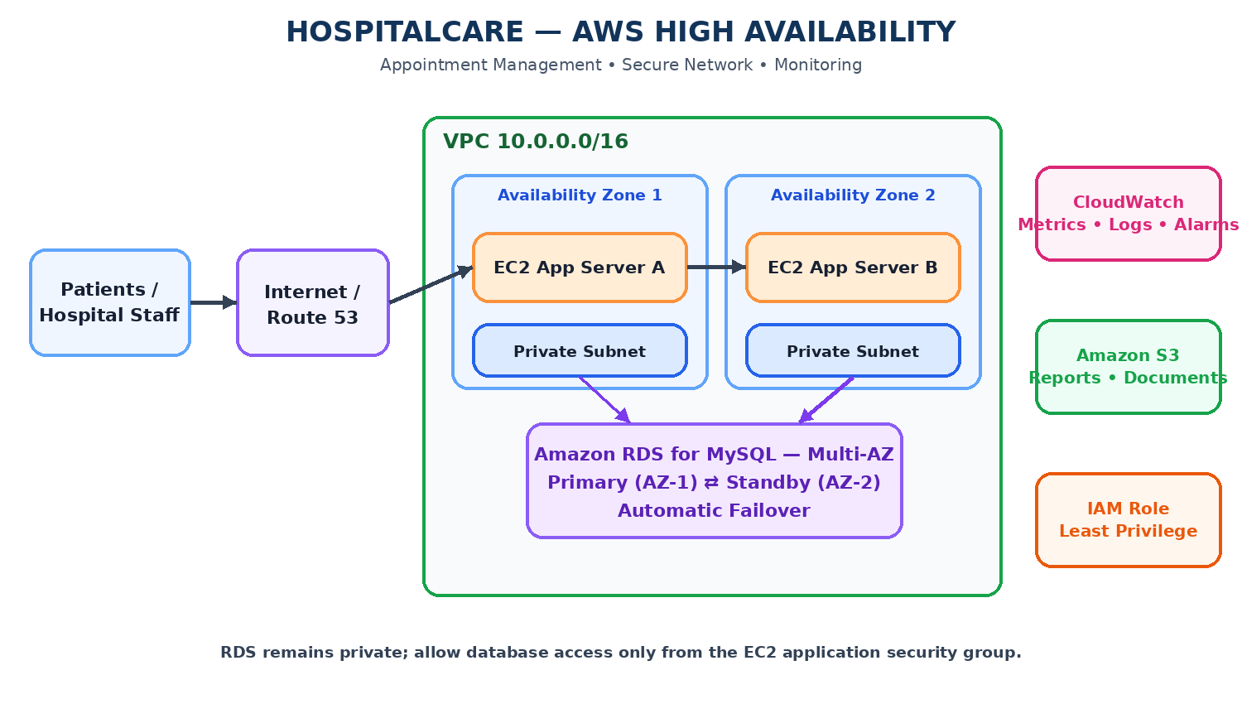
This diagram is an illustrative architecture, not proof that every AWS resource has already been configured. Keep RDS private and allow database traffic only from the application security group.

3. Current Implementation Notes
- IAM role HospitalCare-EC2-S3-Role was created; the supplied IAM screenshot shows EC2 as the trusted service.
- EC2 launch was initiated successfully. The supplied launch screen showed instance ID i-0d63b9593c862e91c; verify its final state under EC2 → Instances.
- The EC2 screenshot showed the AWS Region as Europe (Stockholm). Keep connected services in the same region for this practical.
- Sample files prepared for S3/data integration: patients.csv, appointments.csv, database_schema.sql, appointment_report.txt, and README.txt.
- RDS Multi-AZ, VPC/subnets, CloudWatch alarms, and end-to-end tests should be marked complete only after console verification.

4. Implementation Procedure

Step 1: Create IAM Role
Purpose: Grant the EC2 application controlled AWS access.
Procedure:
- IAM → Roles → Create role → AWS service → EC2.
- Attach required S3 permissions; prefer a bucket-scoped policy instead of broad S3 full access.
- Name it HospitalCare-EC2-S3-Role and create it.
- Attach it to EC2 through Actions → Security → Modify IAM role.
Expected verification: Role exists and is attached to the intended instance.
Status: Role creation is confirmed in the supplied screenshot; attachment still needs verification.

Step 2: Launch EC2
Purpose: Host the HospitalCare application.
Procedure:
- EC2 → Instances → Launch instance; choose an approved Linux AMI and instance type.
- Select the intended VPC and subnet; enable public IP only if required for the demo.
- Allow HTTP 80 as required and SSH 22 from My IP only.
- Under Advanced details, attach HospitalCare-EC2-S3-Role.
Expected verification: Instance is Running and status checks pass.
Status: Launch initiation is confirmed; verify final state.

Step 3: Create VPC and Subnets
Purpose: Isolate application and database resources.
Procedure:
- Create VPC 10.0.0.0/16.
- Create two public subnets in separate AZs, e.g. 10.0.1.0/24 and 10.0.2.0/24.
- Create two private subnets in separate AZs, e.g. 10.0.3.0/24 and 10.0.4.0/24.
- Attach an Internet Gateway and configure route tables; add NAT only if private resources need outbound internet.
Expected verification: VPC, subnets, route tables, and AZs are configured.
Status: Verify in the console.

Step 4: Create RDS MySQL Multi-AZ
Purpose: Provide database redundancy and automatic failover.
Procedure:
- RDS → Databases → Create database → Standard create → MySQL.
- Set identifier hospitalcare-db and select Multi-AZ DB instance deployment.
- Use the same VPC and a DB subnet group spanning private subnets in two AZs.
- Set Public access to No; create/select an RDS security group.
- Allow TCP 3306 from the EC2 security group only; save credentials securely.
Expected verification: RDS is Available, Multi-AZ is enabled, and public access is disabled.
Status: Do not report completion until confirmed in RDS.

Step 5: Create S3 Bucket
Purpose: Store reports, sample data, and application files.
Procedure:
- S3 → Create bucket; use a globally unique name such as hospitalcare-storage-<unique-suffix>.
- Use the same AWS Region as connected resources.
- Keep Block all public access enabled; enable Versioning and server-side encryption.
- Create prefixes patient-documents/, appointment-reports/, hospital-reports/, and backups/.
- Upload the provided CSV, SQL, TXT sample files.
Expected verification: Files appear in the bucket and remain private.
Status: Files are prepared; upload and settings must be verified.

Step 6: Configure Security Groups
Purpose: Restrict network access.
Procedure:
- EC2 security group: HTTP 80 as needed; SSH 22 from My IP only.
- RDS security group: MySQL TCP 3306 with source set to EC2 security group.
- Do not expose RDS publicly or allow 3306 from 0.0.0.0/0.
Expected verification: Only authorized application servers can connect to RDS.
Status: Verify inbound rules.

Step 7: Integrate Application, RDS and S3
Purpose: Test data movement and persistence.
Procedure:
- Configure the application with the RDS endpoint and database credentials using a secure method.
- From EC2, test TCP connectivity to RDS on port 3306.
- Create/import the database schema and sample appointment data.
- Use the EC2 IAM role for S3; do not store long-lived AWS keys in source code.
- Upload and download a test object from S3.
Expected verification: Database query and S3 object access succeed.
Status: Record results only after running the tests.

Step 8: Configure CloudWatch
Purpose: Monitor database and application health.
Procedure:
- Review RDS metrics: CPUUtilization, DatabaseConnections, FreeStorageSpace, ReadLatency, WriteLatency.
- Create an alarm for a meaningful threshold such as sustained high CPU.
- Configure relevant logs and SNS notification if required.
Expected verification: Metrics are visible and alarm configuration is saved.
Status: Verify actual metrics and alarm state.

Step 9: Test Multi-AZ Failover
Purpose: Demonstrate database high availability.
Procedure:
- Confirm RDS is Available and Multi-AZ is enabled.
- RDS → Actions → Reboot; choose Reboot with failover if available.
- Review RDS events and wait for recovery.
- Reconnect from the application and run a test query.
Expected verification: Failover event is recorded and the application reconnects after recovery.
Status: Perform only after Multi-AZ setup; do not claim success without evidence.

5. Data Flow and Validation
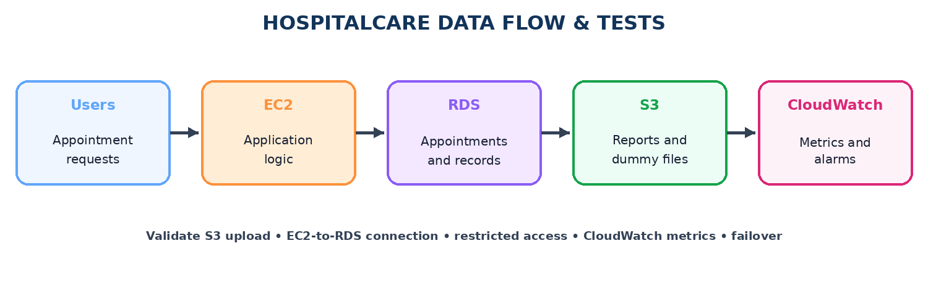
Use dummy data for the practical. Do not upload real patient health information unless authorized and appropriately protected.

6. Included Data Files
- patients.csv — sample patient records.
- appointments.csv — sample appointments.
- database_schema.sql — starter MySQL schema.
- appointment_report.txt — sample S3 report object.
- README.txt — file descriptions.

7. Final Verification Checklist
☐ IAM role exists and is attached to EC2.
☐ EC2 is Running and status checks pass.
☐ VPC/subnets span the required Availability Zones.
☐ S3 public access is blocked; encryption and versioning are enabled.
☐ Sample files are uploaded and test object access works.
☐ RDS MySQL is Available, Multi-AZ enabled, and public access disabled.
☐ RDS inbound TCP 3306 source is the EC2 security group only.
☐ Application can connect to RDS and run a test query.
☐ CloudWatch metrics and alarms are configured.
☐ Failover test is completed and connectivity is verified afterward.

8. Result
The HospitalCare solution is designed to combine secure application hosting, private RDS database access, S3 object storage, IAM-based permissions, and CloudWatch monitoring. Final success should be claimed only after the verification checklist and Multi-AZ failover test are completed.

9. Conclusion
This practical demonstrates how AWS networking, compute, database, storage, identity, and monitoring services can support a highly available appointment-management application. Database access is restricted to the application tier, while CloudWatch provides operational visibility.

