**Hands on 1**

**Create a Spring Web Project using Maven**

**Objective:**

To create and run a Spring Boot web application using Maven and understand the folder structure, configuration files, and annotations involved in the project.

**Project Setup and Execution:**

**Project Initialization**

* Navigated to: <https://start.spring.io>
* Set the following metadata:
  + Group: com.cognizant
  + Artifact: spring-learn
* Selected the following dependencies:
  + Spring Web
  + Spring Boot DevTools
* Clicked **Generate** to download the project as a ZIP file.
* Extracted the ZIP file to the location: C:\EclipseWorkspace\spring-learn

**Maven Build via Command Line**

Navigated to the extracted project folder in Command Prompt:

*cd C:\EclipseWorkspace\spring-learn*

Executed the following Maven build command with proxy settings:

*mvn clean package ^*

*-Dhttp.proxyHost=proxy.cognizant.com ^*

*-Dhttp.proxyPort=6050 ^*

*-Dhttps.proxyHost=proxy.cognizant.com ^*

*-Dhttps.proxyPort=6050 ^*

*-Dhttp.proxyUser=123456*

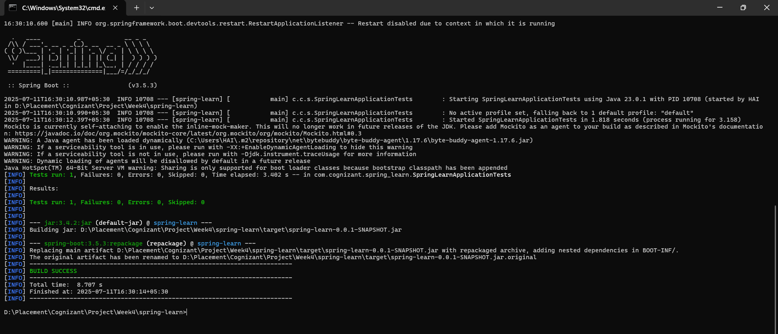

**Import Project into Eclipse**

* Opened Eclipse IDE.
* Selected: File > Import > Maven > Existing Maven Projects.
* Browsed to and selected: C:\EclipseWorkspace\spring-learn.
* Clicked **Finish** to import the project

Modifying the Main Class for Verification:

package com.cognizant.spring_learn;

import org.springframework.boot.SpringApplication;

import org.springframework.boot.autoconfigure.SpringBootApplication;

*@SpringBootApplication*

public class SpringLearnApplication {

public static void main(String[] args) {

SpringApplication.*run*(SpringLearnApplication.class, args);

System.***out***.println("SpringLearnApplication started successfully");

}

}

**Output:**

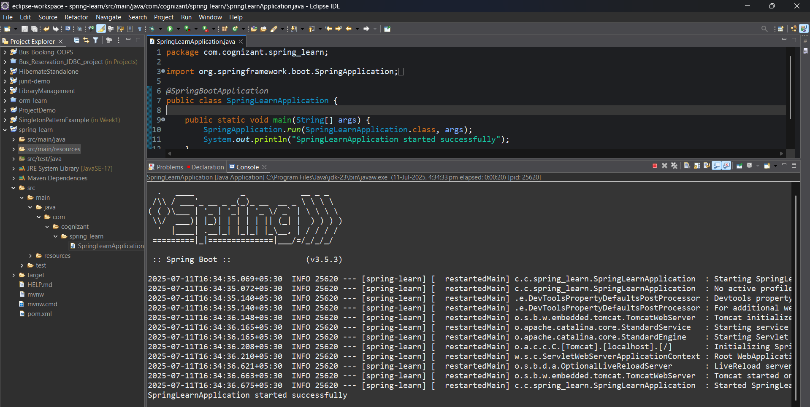

**Hands on 2**

**Spring Core – Load Country from Spring Configuration XML**   
  
An airlines website is going to support booking on four countries. There will be a drop down on the home page of this website to select the respective country. It is also important to store the two-character ISO code of each country.

**Objective:**

Configure a Country object using Spring XML and load it using ApplicationContext.

**Spring Context Dependency to pom.xml:**

<dependencies>

<dependency>

<groupId>org.springframework</groupId>

<artifactId>spring-context</artifactId>

<version>5.3.34</version> <!-- or the latest stable version -->

</dependency>

<!-- SLF4J for logging -->

<dependency>

<groupId>org.slf4j</groupId>

<artifactId>slf4j-api</artifactId>

<version>1.7.36</version>

</dependency>

<dependency>

<groupId>org.slf4j</groupId>

<artifactId>slf4j-simple</artifactId>

<version>1.7.36</version>

</dependency>

<dependency>

<groupId>org.springframework.boot</groupId>

<artifactId>spring-boot-starter-web</artifactId>

</dependency>

<dependency>

<groupId>org.springframework.boot</groupId>

<artifactId>spring-boot-devtools</artifactId>

<scope>runtime</scope>

<optional>true</optional>

</dependency>

<dependency>

<groupId>org.springframework.boot</groupId>

<artifactId>spring-boot-starter-test</artifactId>

<scope>test</scope>

</dependency>

</dependencies>

**country.xml Configuration File:**

<?**xml** version=*"1.0"* encoding=*"UTF-8"*?>

<**beans** xmlns=*"http://www.springframework.org/schema/beans"*

xmlns:xsi=*"http://www.w3.org/2001/XMLSchema-instance"*

xsi:schemaLocation=*"http://www.springframework.org/schema/beans*

*http://www.springframework.org/schema/beans/spring-beans.xsd"*>

<**bean** id=*"country"* class=*"com.cognizant.spring_learn.Country"*>

<**property** name=*"code"* value=*"IN"* />

<**property** name=*"name"* value=*"India"* />

</**bean**>

</**beans**>

**Country Class:**

package com.cognizant.spring_learn;

import org.slf4j.Logger;

import org.slf4j.LoggerFactory;

public class Country {

private static final Logger ***LOGGER*** = LoggerFactory.*getLogger*(Country.class);

private String code;

private String name;

public Country() {

***LOGGER***.debug("Inside Country Constructor.");

}

public String getCode() {

***LOGGER***.debug("Inside getCode");

return code;

}

public void setCode(String code) {

***LOGGER***.debug("Inside setCode");

this.code = code;

}

public String getName() {

***LOGGER***.debug("Inside getName");

return name;

}

public void setName(String name) {

***LOGGER***.debug("Inside setName");

this.name = name;

}

*@Override*

public String toString() {

return "Country [code=" + code + ", name=" + name + "]";

}

}

**SpringLearnApplication.java:**

package com.cognizant.spring_learn;

import org.slf4j.Logger;

import org.slf4j.LoggerFactory;

import org.springframework.context.ApplicationContext;

import org.springframework.context.support.ClassPathXmlApplicationContext;

public class SpringLearnApplication {

private static final Logger ***LOGGER*** = LoggerFactory.*getLogger*(SpringLearnApplication.class);

public static void main(String[] args) {

***LOGGER***.info("START");

*displayCountry*();

***LOGGER***.info("END");

}

public static void displayCountry() {

ApplicationContext context = new ClassPathXmlApplicationContext("country.xml");

Country country = context.getBean("country", Country.class);

System.***out***.println("Country : " + country.toString());

***LOGGER***.debug("Country : {}", country.toString());

}

}

**Output:**  
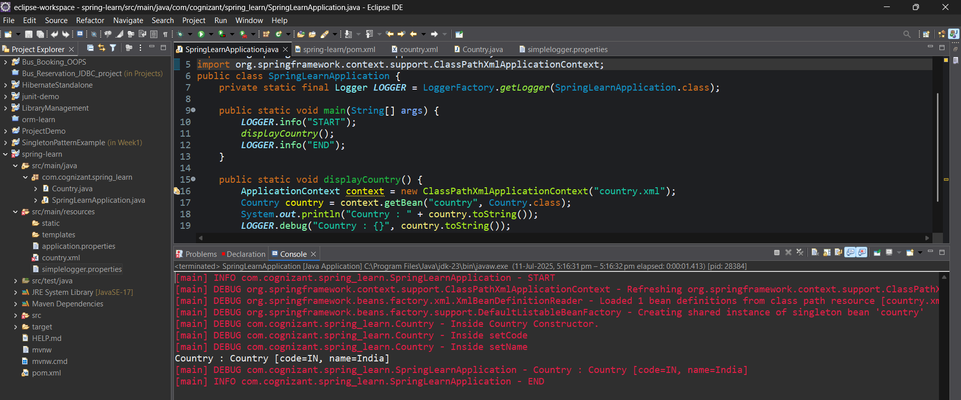

**Hands-on 3:**

**Hello World RESTful Web Service**

**Objective:**  
To build and test a simple RESTful web service in Spring that returns the message "Hello World!!" via a GET request to /hello.

**Pom.xml:**<dependencies>

<dependency>

<groupId>org.springframework.boot</groupId>

<artifactId>spring-boot-starter-web</artifactId>

</dependency>

<dependency>

<groupId>org.springframework.boot</groupId>

<artifactId>spring-boot-starter-test</artifactId>

<scope>test</scope>

</dependency>

</dependencies>

**HelloController.java:**

package com.cognizant.spring_learn.controller;

import org.springframework.web.bind.annotation.GetMapping;

import org.springframework.web.bind.annotation.RestController;

*@RestController*

public class HelloController {

*@GetMapping*("/hello")

public String sayHello() {

String message = "Hello World!!";

return message;

}

}

**application.properties:**

spring.application.name=spring-learn

server.port=8083

**Output: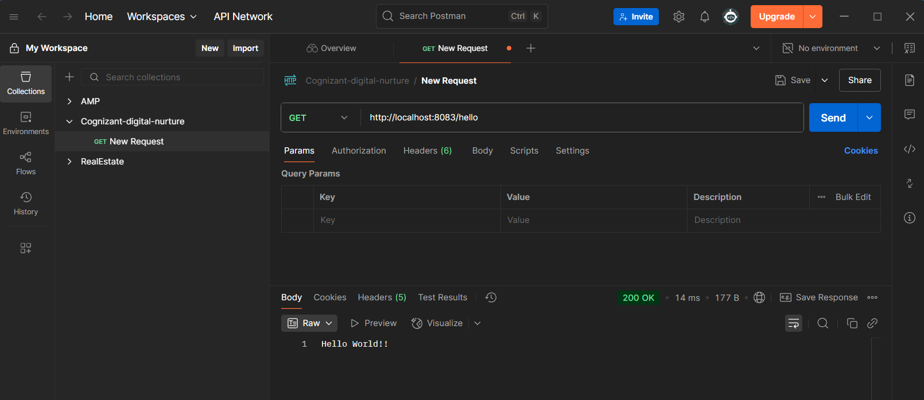 HTTP Request/Response Details:**

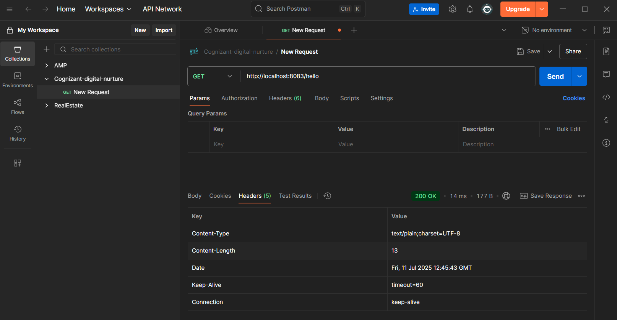

**Hand-on: 4  
REST - Country Web Service**Write a REST service that returns India country details in the earlier created spring learn application.

**Objective:**

Expose a REST API endpoint (/country) that returns the India country details defined in the Spring XML configuration**.  
  
country.xml:**

<?**xml** version=*"1.0"* encoding=*"UTF-8"*?>

<**beans** xmlns=*"http://www.springframework.org/schema/beans"*

xmlns:xsi=*"http://www.w3.org/2001/XMLSchema-instance"*

xsi:schemaLocation=*"*

*http://www.springframework.org/schema/beans*

*http://www.springframework.org/schema/beans/spring-beans.xsd"*>

<**bean** id=*"country"* class=*"com.cognizant.spring_learn.model.Country"*>

<**property** name=*"code"* value=*"IN"*/>

<**property** name=*"name"* value=*"India"*/>

</**bean**>

</**beans**>

**model/Country.java:**

package com.cognizant.spring_learn.model;

public class Country {

private String code;

private String name;

public Country() {}

public String getCode() {

return code;

}

public void setCode(String code) {

this.code = code;

}

public String getName() {

return name;

}

public void setName(String name) {

this.name = name;

}

}

**controller/CountryController.java:**

package com.cognizant.spring_learn.controller;

import org.springframework.web.bind.annotation.GetMapping;

import org.springframework.web.bind.annotation.RequestMapping;

import org.springframework.web.bind.annotation.RestController;

import org.springframework.context.ApplicationContext;

import org.springframework.context.support.ClassPathXmlApplicationContext;

import com.cognizant.spring_learn.model.Country;

*@RestController*

public class HelloController {

*@RequestMapping*("/country")

public Country getCountryIndia() {

ApplicationContext context = new ClassPathXmlApplicationContext("country.xml");

Country country = context.getBean("country", Country.class);

return country;

}

*@GetMapping*("/hello")

public String sayHello() {

String message = "Hello World!!";

return message;

}

}

**Output:**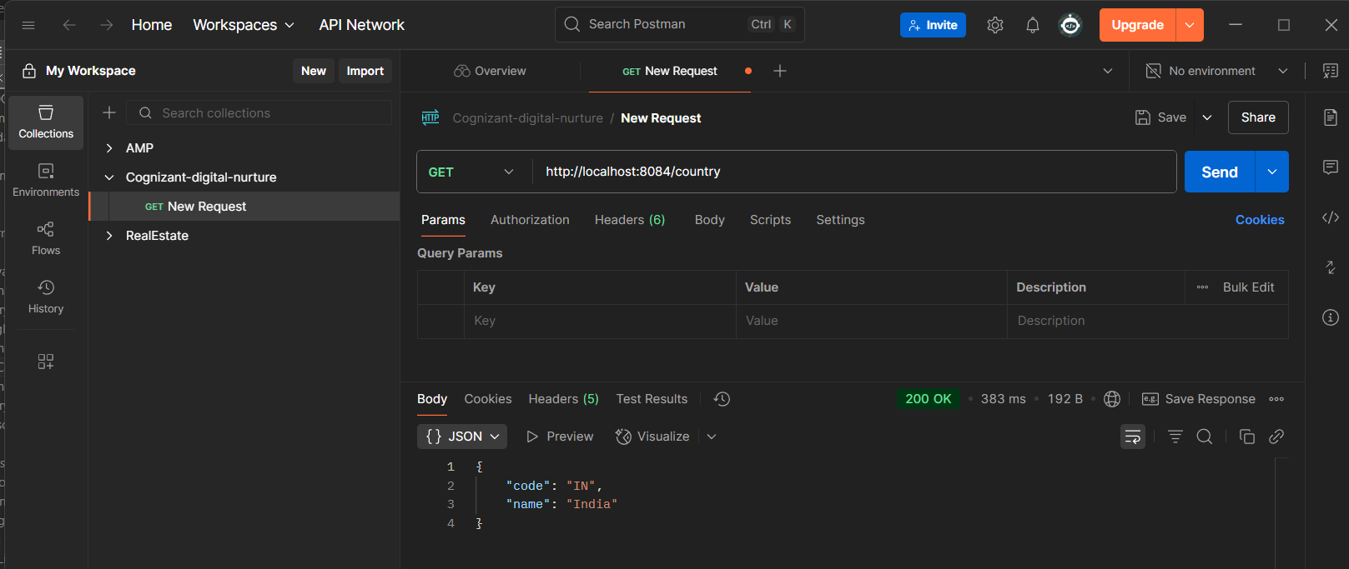

**HTTP Request/Response Details: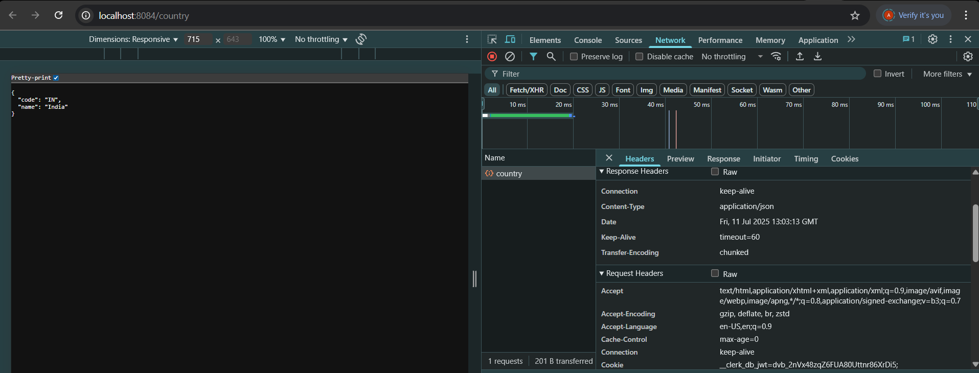 Hands-On:5  
  
REST - Get country based on country code**   
  
Write a REST service that returns a specific country based on country code. The country code should be case insensitive.  
  
**Objective:**

Create a REST endpoint to return country details based on the country code (like IN, us, De) using Spring Web, Spring XML configuration, and @PathVariable.  
  
**country.xml:**

<?**xml** version=*"1.0"* encoding=*"UTF-8"*?>

<**beans** xmlns=*"http://www.springframework.org/schema/beans"*

xmlns:xsi=*"http://www.w3.org/2001/XMLSchema-instance"*

xsi:schemaLocation=*"*

*http://www.springframework.org/schema/beans*

*http://www.springframework.org/schema/beans/spring-beans.xsd"*>

<**bean** id=*"country"* class=*"com.cognizant.spring_learn.model.Country"*>

<**property** name=*"code"* value=*"IN"*/>

<**property** name=*"name"* value=*"India"*/>

</**bean**>

<**bean** id=*"countryList"* class=*"java.util.ArrayList"*>

<**constructor-arg**>

<**list**>

<**bean** class=*"com.cognizant.spring_learn.model.Country"*>

<**property** name=*"code"* value=*"IN"*/>

<**property** name=*"name"* value=*"India"*/>

</**bean**>

<**bean** class=*"com.cognizant.spring_learn.model.Country"*>

<**property** name=*"code"* value=*"US"*/>

<**property** name=*"name"* value=*"United States"*/>

</**bean**>

<**bean** class=*"com.cognizant.spring_learn.model.Country"*>

<**property** name=*"code"* value=*"DE"*/>

<**property** name=*"name"* value=*"Germany"*/>

</**bean**>

<**bean** class=*"com.cognizant.spring_learn.model.Country"*>

<**property** name=*"code"* value=*"JP"*/>

<**property** name=*"name"* value=*"Japan"*/>

</**bean**>

</**list**>

</**constructor-arg**>

</**bean**>

</**beans**>

**service/CountryService.java:**

package com.cognizant.spring_learn.service;

import com.cognizant.spring_learn.model.Country;

import org.springframework.context.ApplicationContext;

import org.springframework.context.support.ClassPathXmlApplicationContext;

import org.springframework.stereotype.Service;

import java.util.List;

*@Service*

public class CountryService {

public Country getCountry(String code) {

ApplicationContext context = new ClassPathXmlApplicationContext("country.xml");

List<Country> countries = context.getBean("countryList", List.class);

for (Country country : countries) {

if (country.getCode().equalsIgnoreCase(code)) {

return country;

}

}

// If not found, return null

return null;

}

}

**controller/CountryController.java:**

package com.cognizant.spring_learn.controller;

import com.cognizant.spring_learn.model.Country;

import com.cognizant.spring_learn.service.CountryService;

import org.springframework.beans.factory.annotation.Autowired;

import org.springframework.web.bind.annotation.*;

*@RestController*

public class CountryController {

*@Autowired*

private CountryService countryService;

*@GetMapping*("/country/{code}")

public Country getCountry(*@PathVariable* String code) {

Country country = countryService.getCountry(code);

return country;

}

}

**Output:  
  
