***“Image Search Engine”***

Bachelor of Engineering

in

Computer Engineering

by

Akash Barve 13CE1003

Aakash Barve 13CE1066

Saiprakash Butee 13CE3009

Siddhesh Badhe 13CE1053

Supervisor

Prof. Namita Pulgam

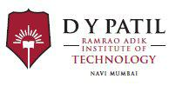

Department of Computer Engineering

RamraoAdik Institute of Technology

Dr. D. Y. Patil Vidyanagar, Sector 7, Nerul, Navi Mumbai 400706

(Affiliated to University of Mumbai)

April – 2017