

**Name- Akash Bhardwaj**

**RegNo- 11019210034**

**Subject- Python**

**Exercise on List**

Write a Python program to sum all the items in a list.

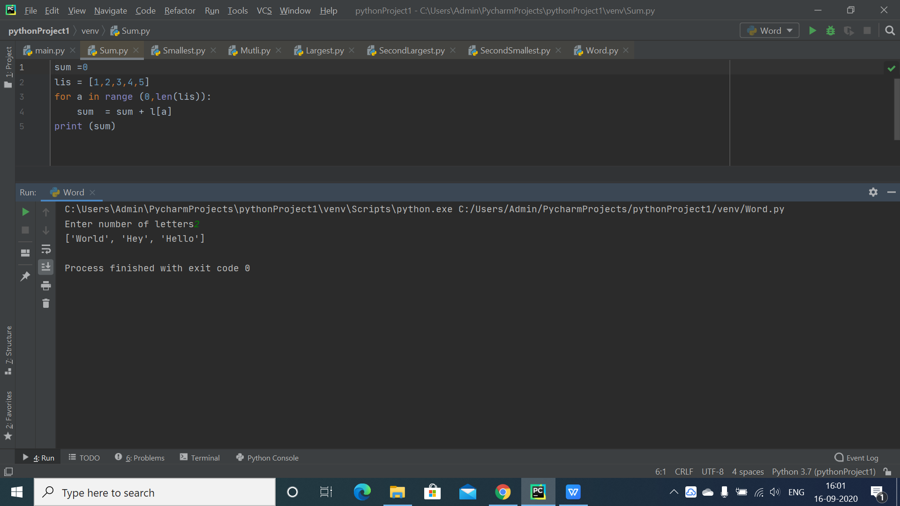

Write a Python program to multiplies all the items in a list.

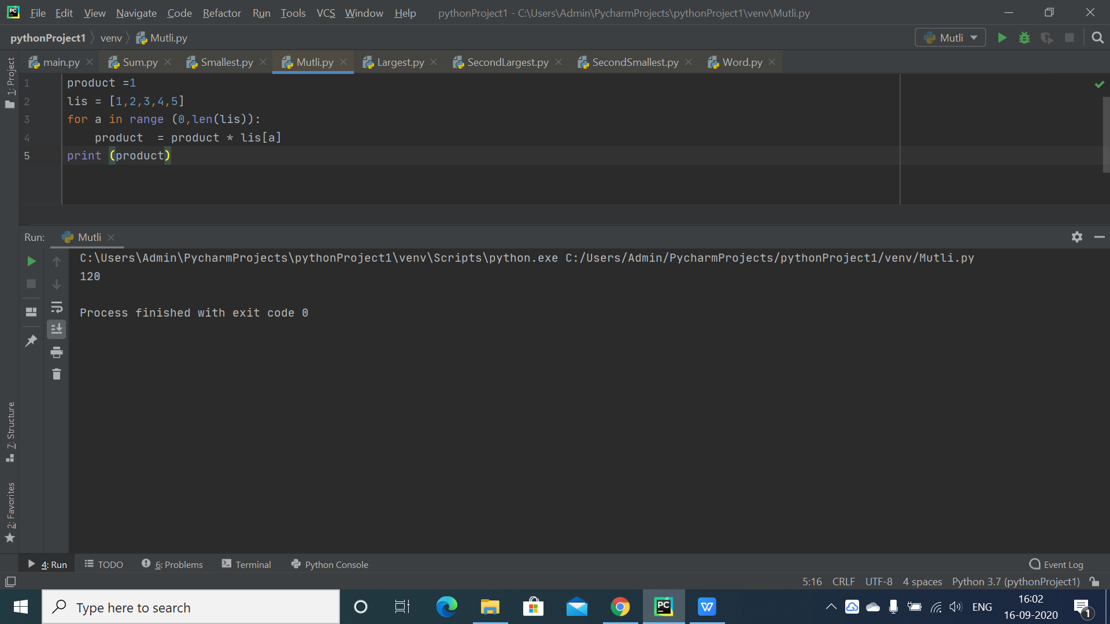

Write a Python program to find the smallest number in a list

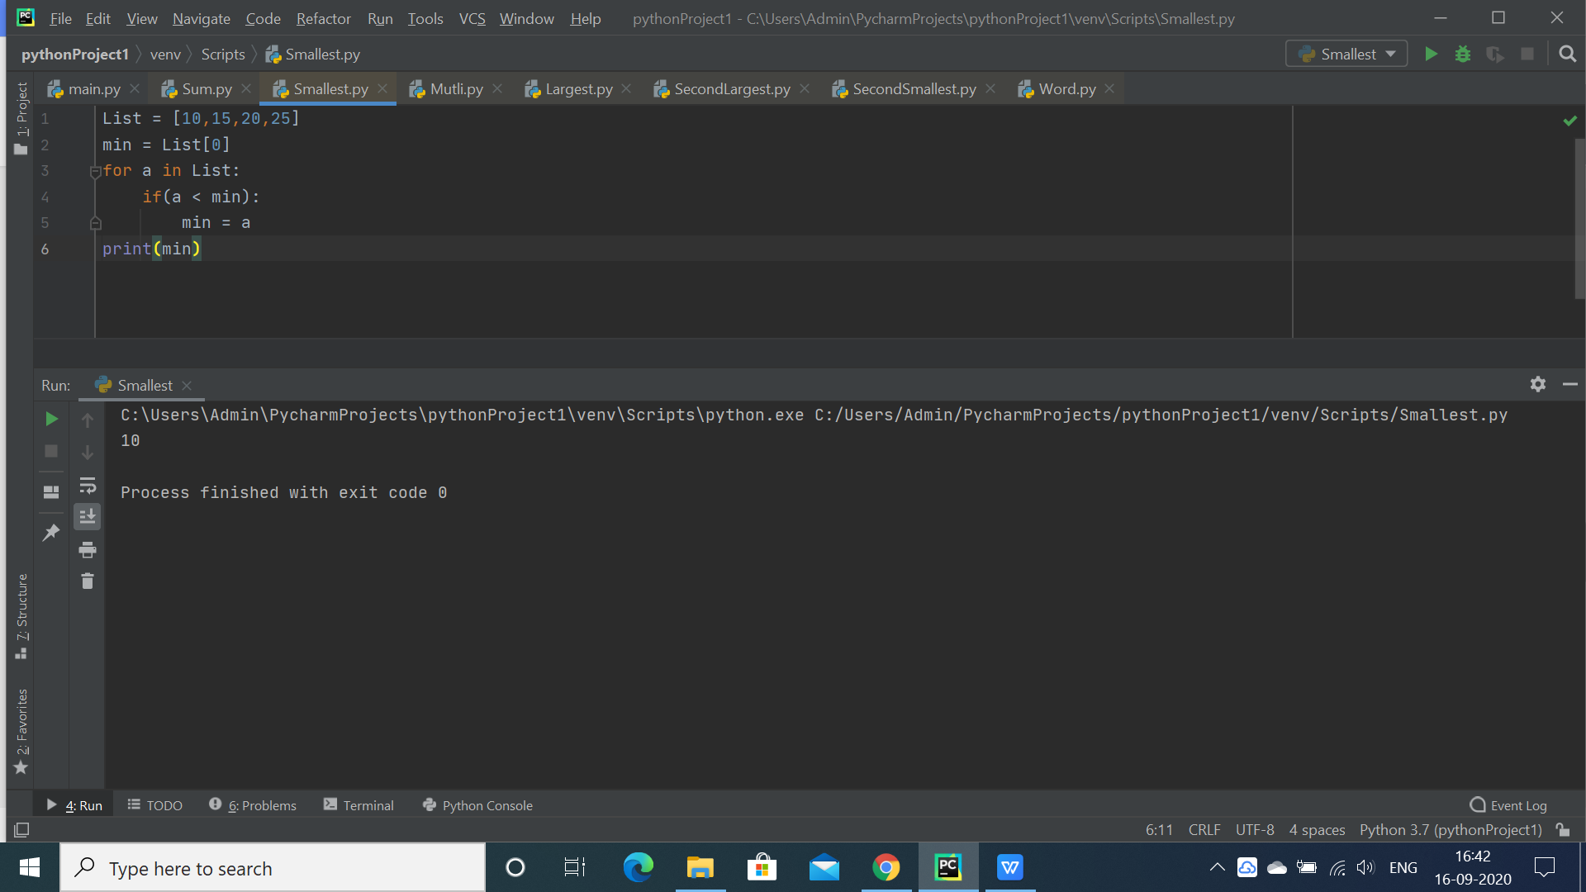

Write a Python program to find the largest number in a list

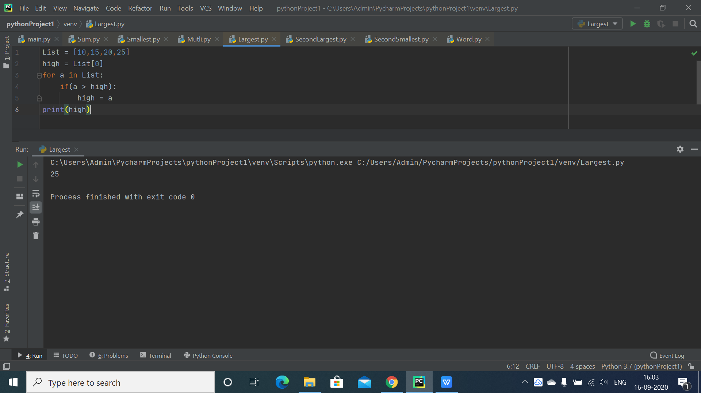

Write a Python program to find the list of words that are longer than n from a given list of words.

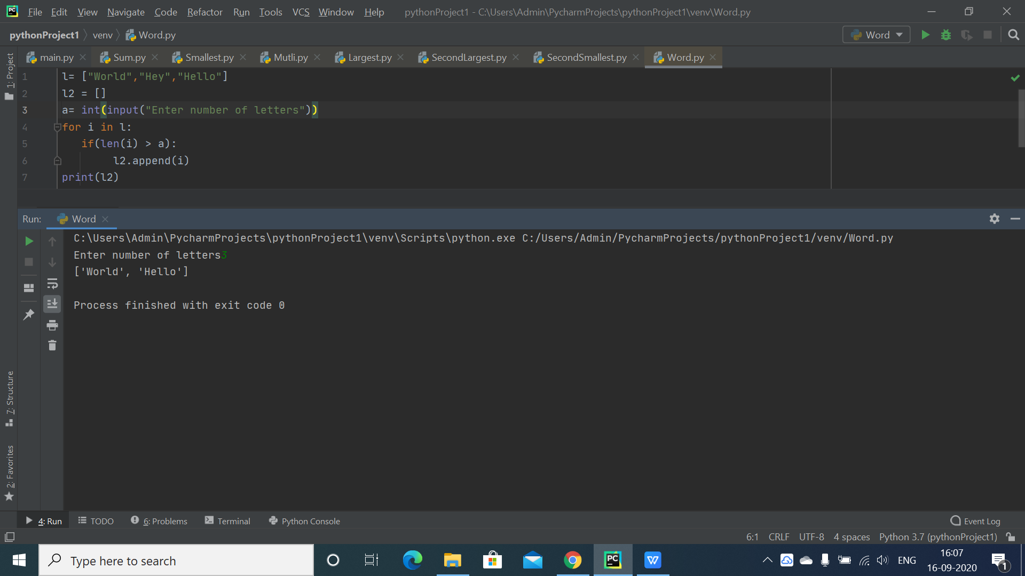

Write a Python program to find the second largest number in a list.

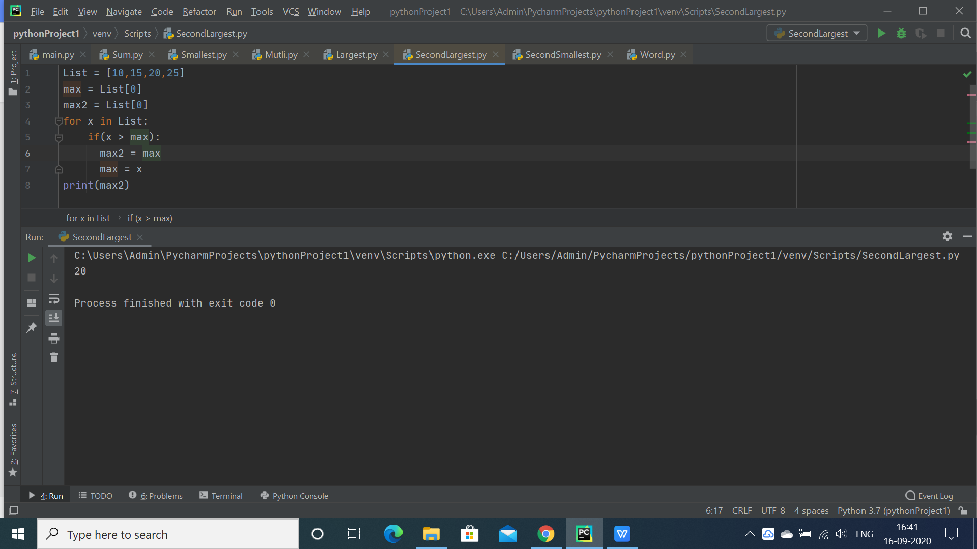

Write a Python program to find the second smallest number in a list

\