# D.Y.PATIL COLLEGE OF ENGINEERING & TECHNOLOGY,

**KASABA BAWADA, KOLHAPUR**

**DEPARTMENT OF COMPUTER SCIENCE & ENGINEERING (2020-2021)**



**A**

**Mini Project Report on**

NETWORK DESIGN FOR NETSURF ORGANIZATION

**Submitted by:**

**Roll No. Name of Student**

143 Mr.Nikhil Pawar

1. Miss.Pranoti Jadhav
2. Miss.Vaishnavi Saudagar

146 Mr.Akash Bhosale

**Under the guidance of**

Prof.Dhanashree Patil

**Class: SY (CSE) Div.: B Batch: S4 (B16)**

**D.Y. PATIL COLLEGE OF ENGINEERING & TECHNOLOGY**

**DEPARTMENT OF COMPUTER SCIENCE & ENGINEERING KOLHAPUR**



# CERTIFICATE

This is to certify that the mini project group consisting the following members have satisfactorily completed the Mini Project work entitled **“Network Design For Netsurf Organization”** at SY (CSE) semester IV as prescribed in the syllabus of Shivaji University for the academic year 2020-2021.

**Name Roll No.**

1. Mr.Nikhil Pawar 143
2. Miss.Pranoti Jadhav 144
3. Miss.Vaishnavi Saudagar 145
4. Mr.Akash Bhosale 146

**Date:**

**Place:** Kolhapur

Prof.Dhanashree Patil Prof.DR.B.D.Jitkar Prof.DR.S.D.Chede

(Project Guide) (H.O.D) (Principal)

**External Examiner:**

# ACKNOWLEDGEMENT

This project work entitled “Network Design for Netsurf Organization” was a formidable task, but with collective effort of our group and active guidance made it possible for us to complete.

First of all, we would like to thank Prof.DR.B.D.Jitkar (H.O.D), Department of Computer Science and Engineering) delineating us with this project work.

We would also like to express our most humble and deepest gratitude to Prof.Dhanashree Patil, for providing us with the right guidance at the time of need it was for her presence and active guidance that we were able to complete the project work.

We would like to thank all our friends for their help, ideas, criticism and also their encouragement for preparation of this project work. Any further ideas and constructive criticism on our work shall be highly welcomed.

**Date:**

**Place:** Kolhapur

**Name Sign**

* 1. Mr.Nikhil Pawar
  2. Miss.Pranoti Jadhav
  3. Miss.Vaishnavi Saudagar
  4. Mr.Akash Bhosale

## **INDEX**

|  |  |
| --- | --- |
| TITLE | PAGE NO. |
| 1. Introduction | 1 |
| 1. Problem Statement | 2 |
| 1. Objective | 3 |
| 1. Control Flow Diagram | 4 |
| 1. Commands for firewall | 5 |
| 1. Modules | 6 |
| 1. Algorithm | 7 |
| 1. Input and Output | 8-14 |
| 1. System requirements | 15-16 |
| 1. Conclusion | 17 |
| 1. Reference | 18 |

**1.INTRODUCTION:**

This document contains the information behind the thought process and planning behind the creation of Network Design for NETSURF Enterprise.

The purpose of the project is to smoothen all the business communication and block the unhealthy sites based on the network policy defined by the enterprise.

## **2.PROBLEM STATEMENT:**

To develop a network infrastructure (Wired or Wireless) that is able to facilitate the traffic and filters based on the network policies by NETSURF campus for smooth functioning of all business processes.

## **3.Objective:**

* To create a network infrastructure to send or receive files between clients.
* To create their own firewall.
* To block the unhealthy sites based on the network policy defined by the enterprise.

## **4.Control Flow Diagram:**

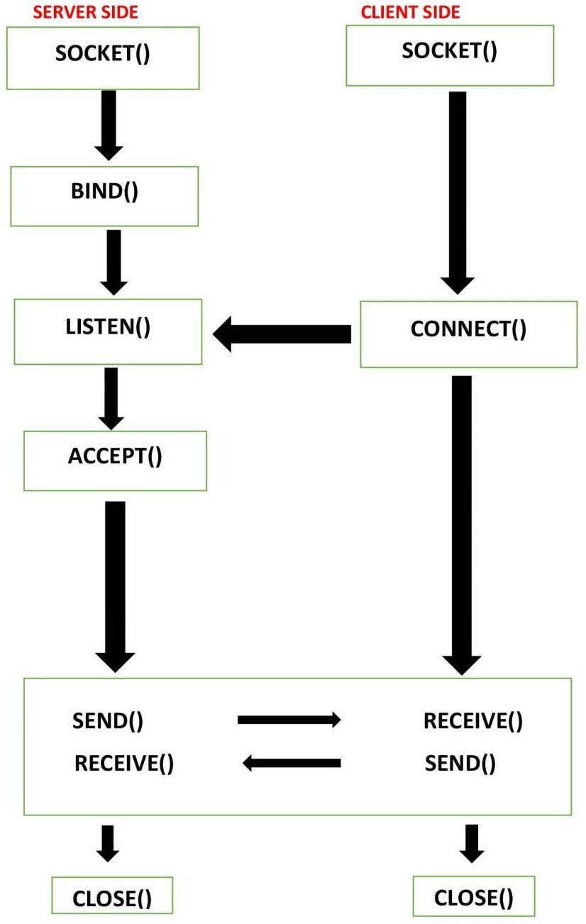

**5.Commands (for firewall):**

## To check whether firewall is installed in the system or not:

Command.; $ sudo apt –get install ufw

## For checking the status:

Command.; $ sudo ufw status

## To activate the firewall:

Command.; $ sudo ufw enable

## To deactivate the firewall:

Command.; $ sudo ufw disable

**6.Modules:-** 1.socket():

Activate nodes of client as well as server.

1. bind():

Associates the IP address and port number.

1. listen():

It waits or remains in passive mode until the client sends the request.

1. connect():

Client uses connect() system call to establish connection with the server.

1. accept():

The server uses accept system call to accept the connection request from the client.

1. send():

Sends the required file from the server or sends the request from client to server for file request.

1. receive():

Receives the file or acknowledgement from server or client.

1. close():

It tells the system to terminate the use of socket.

## **7.Algorithm:**

SERVER:

STEP 1: Start

STEP 2: Declare the variables for the socket

STEP 3: Specify the family, protocol, IP address and port number

STEP 4: Create a socket using socket() function

STEP 5: Bind the IP address and Port number

STEP 6: Listen and accept the client’s request for the connection

STEP 7: Establish the connection with the client

STEP 8: Close the socket STEP 9: Stop

CLIENT:

STEP 1: Start

STEP 2: Declare the variables for the socket

STEP 3: Specify the family, protocol, IP address and port number

STEP 4: Create a socket using socket() function

STEP 5: Call the connect() function STEP 6: Close the socket

STEP 7: Stop

## **8.Input and Output:**

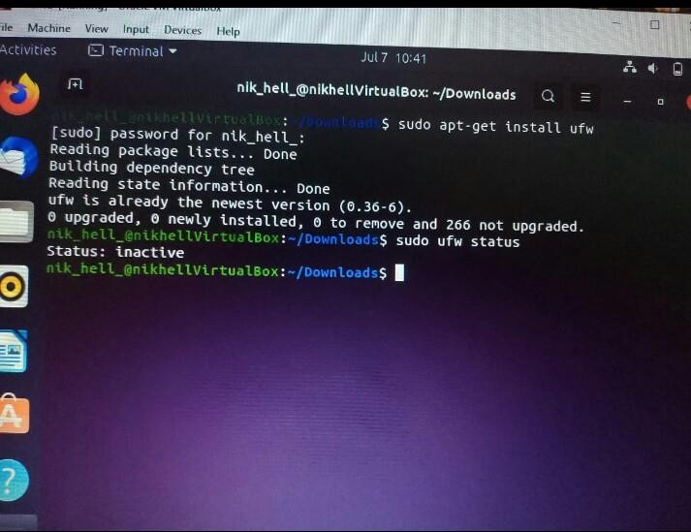

Fig 8.1: To check whether Firewall is installed in the system or not

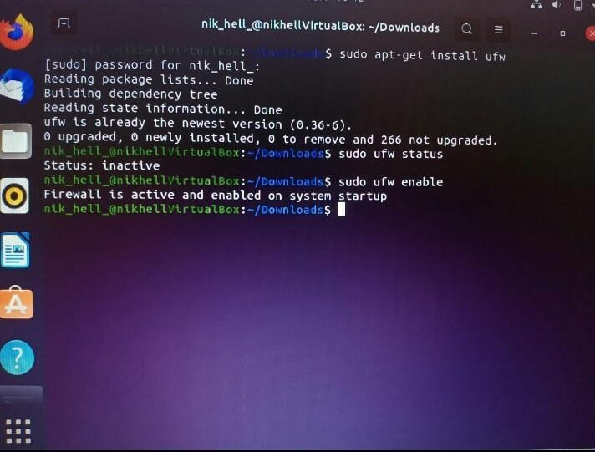

## Fig 8.2: To activate Firewall

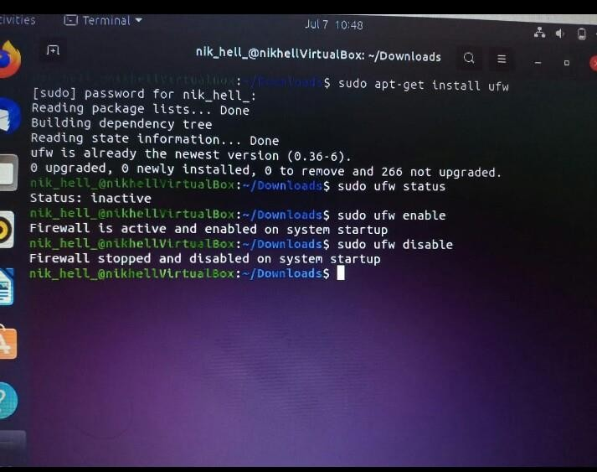

Fig 8.3: To deactivate Firewall

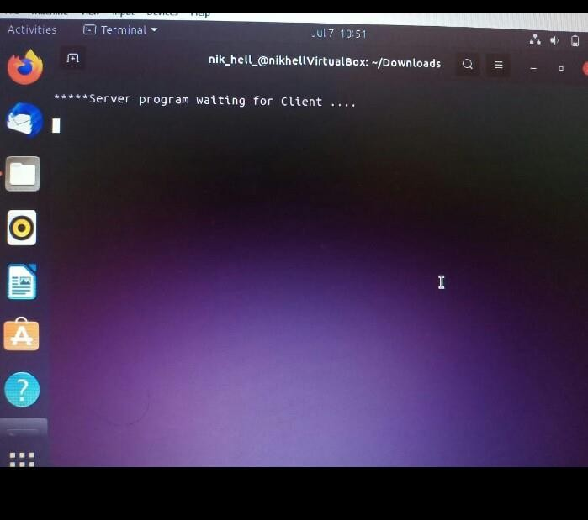

## Fig 8.4: After node gets activated

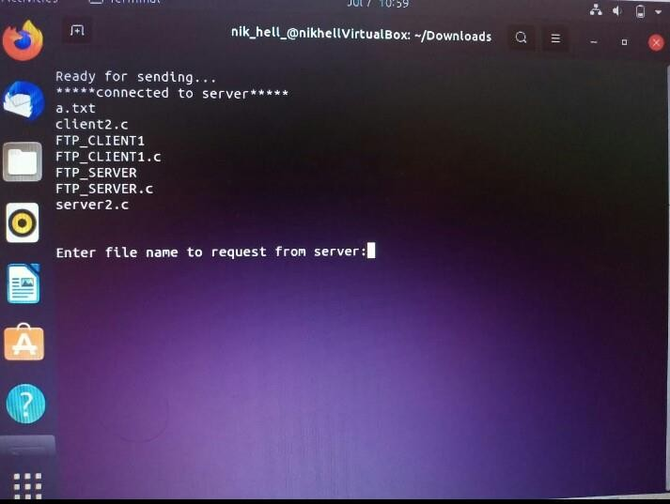

Fig 8.5: After Program execution

**Organization Requirements:**

Total number of employees: 420

Total number of systems: 440

An FTP server for sharing of files between client and server.

|  |  |  |
| --- | --- | --- |
| Sr. no. | Name of department | No. of systems |
| 1. | Research and Development | 35 |
| 2. | Science | 35 |
| 3. | Engineering | 250 |
| 4. | Manufacturing | 30 |
| 5. | Direct Selling | 40 |
| 6. | Customer Care | 50 |

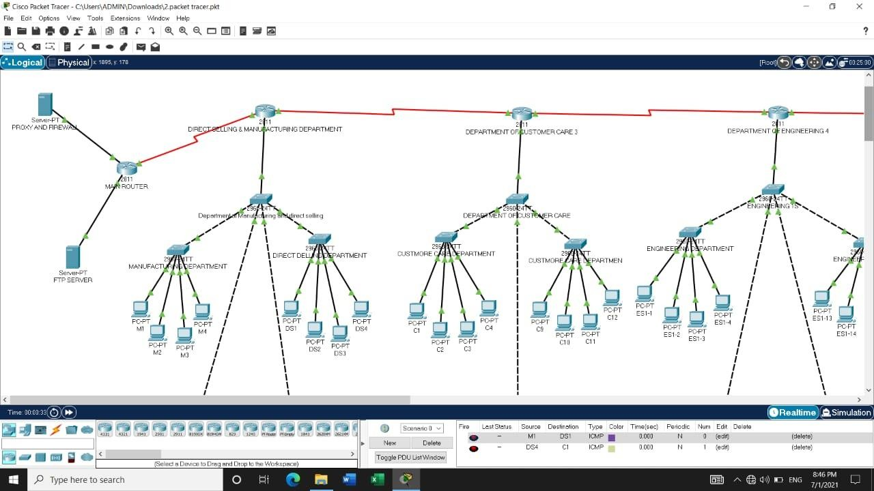

## Fig 8.6 Packet tracer method

**9.System Requirement:**

## Software Requirement:

* + Firewall - FIREPOWER ufw
  + Operating System – UBUNTU
  + Programming language – C
  + Cisco Packet Tracer

## Hardware Requirement:

|  |  |
| --- | --- |
| **Sr. No.** | **Device Name** |
| 1. | FTP Server |
| 2. | Router |
| 3. | Switch |
| 4. | Connecting cable |

**10.Conclusion:**

In this project, the program provides secure communication while satisfying the security requirements of the company or the user using FTP protocol which is the basic need any organization.

## **11.Reference:**

1. tcp_ip-protocol-suite-4th-ed-b-forouzan-mcgraw-hill-2010
2. <https://www.educba.com/ftp-commands/>
3. http[s://www.jav](http://www.javatpoint.com/computer-network-ftp)atpo[int.com/computer-network-ftp](http://www.javatpoint.com/computer-network-ftp)