//3-tier project

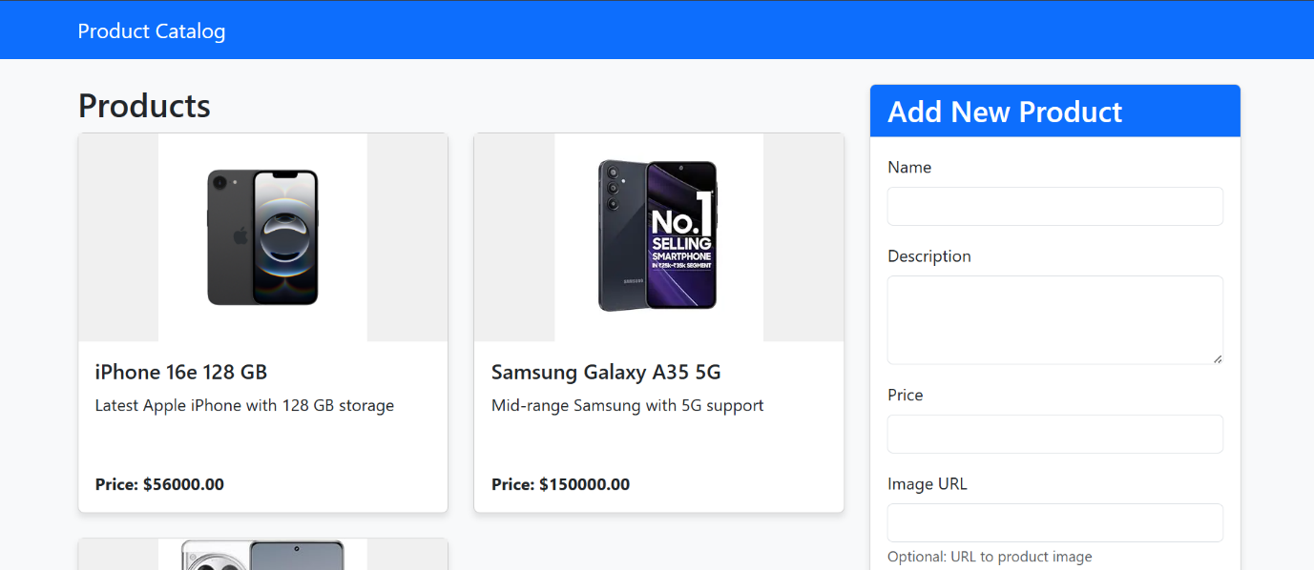

The Project contains the frontend as a JavaScript and the backend is written in Dotnet and the db used is Microsoft SQL server. The project shows the product catalogue, and you can showcase the product you have The project mainly concentrate on the AWS Three tier architecture where we will deploy the application in the EKS cluster and the RDS service in the AWS to be the Database

-Custom VPC

-2 Public & 2 Private Subnet

-EKS cluster

-RDS [Microsoft SQL server]

-Application Loadbalacer

-Route53

Vpc

A VPC stands for Virtual Private Cloud. It’s a virtual network that you create within a cloud provider’s infrastructure (like AWS, Google Cloud, or Azure) to isolate and control your cloud resources in a secure, private environment.

Subnets

A subnet is basically a smaller, segmented piece of a larger network — like dividing a big network into smaller, manageable chunks.

Internet-Gateway

An Internet Gateway (IGW) is a VPC component in AWS that allows communication between resources in your Virtual Private Cloud (VPC) and the internet.

NAT-Gateway

A NAT Gateway (Network Address Translation Gateway) in AWS is used to enable instances in a private subnet to access the internet (e.g., download software updates), without exposing those instances to inbound internet traffic.

EKS Cluster

Amazon EKS is a managed Kubernetes service from AWS. It lets you run Kubernetes without needing to install, manage, or maintain the Kubernetes control plane

RDS

RDS stands for Relational Database Service, and it’s a managed database service provided by AWS

ALB

ALB distributes incoming HTTP and HTTPS traffic across multiple targets (like EC2 instances, containers, or IP addresses) in one or more Availability Zones

Route53

Amazon Route 53 is a highly available and scalable DNS (Domain Name System) web service from AWS

**WHY Cloud for application Deployment?**

-Scalability

-Cost Efficiency

-Global Accessibility

-High Availability and Reliability

-Security

**INFRA for the project**

-VPC

-Subnets [public and private]

-Internet gateway

-Route Tables

-EKS

-ECR

-RDS

Application Build And Deployment [Us-east-1]

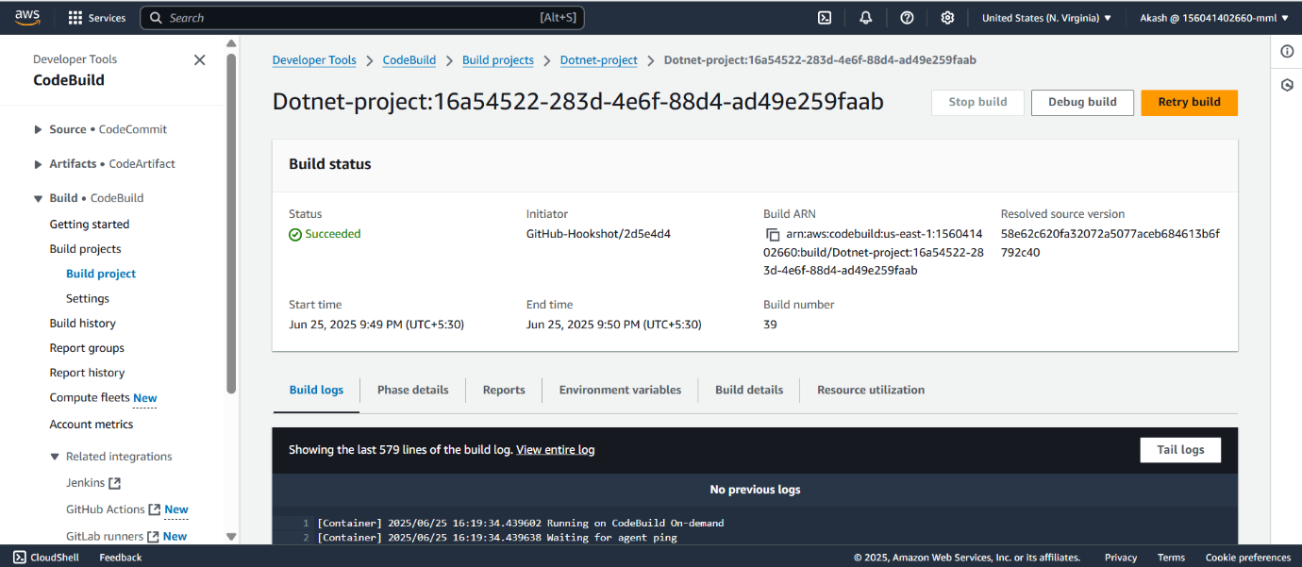

AWS CodeBuild is a fully managed continuous integration (CI) service provided by Amazon Web Services. It compiles source code, runs tests, and produces software packages that are ready to deploy.

The buildspec tell the code build to what it needs to do

+------------------+

| Source Code |

| (GitHub / S3 / |

| CodeCommit) |

+--------+---------+

|

v

+----------+-----------+

| AWS CodeBuild |

| - Pulls Code |

| - Runs buildspec.yml |

| - Compiles & Tests |

+----------+-----------+

|

v

+-----------+-----------+

| Artifacts |

| (S3 / ECR / Output) |

+-----------+-----------+

In the Build spec its creating Docker file and its pushing the Docker file into an ECR. Then we can use that ECR to be used in the deployments which will be deployed

If the code is build and we want to push the artifact into Some other registry that is also possible by using the buildspec.yml

To push into the ecr the build role needs the **AmazonEC2ContainerRegistryPowerUser** permission

-CodeDeploy

AWS CodeDeploy is a deployment service from Amazon Web Services that automates the process of deploying code to EC2 instances containers, Lambda functions, On-premises servers

-CodePipeline

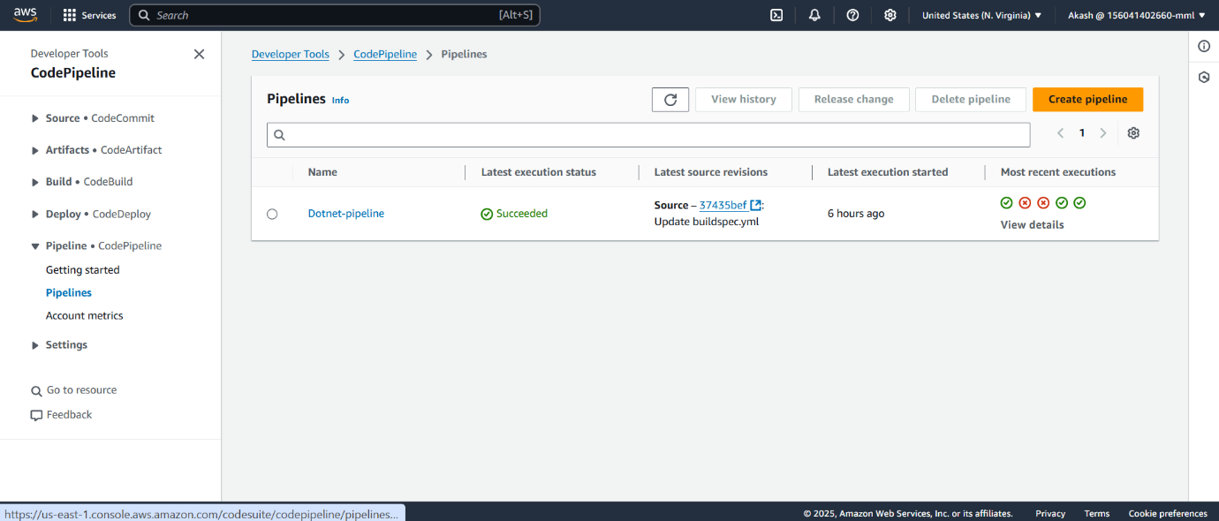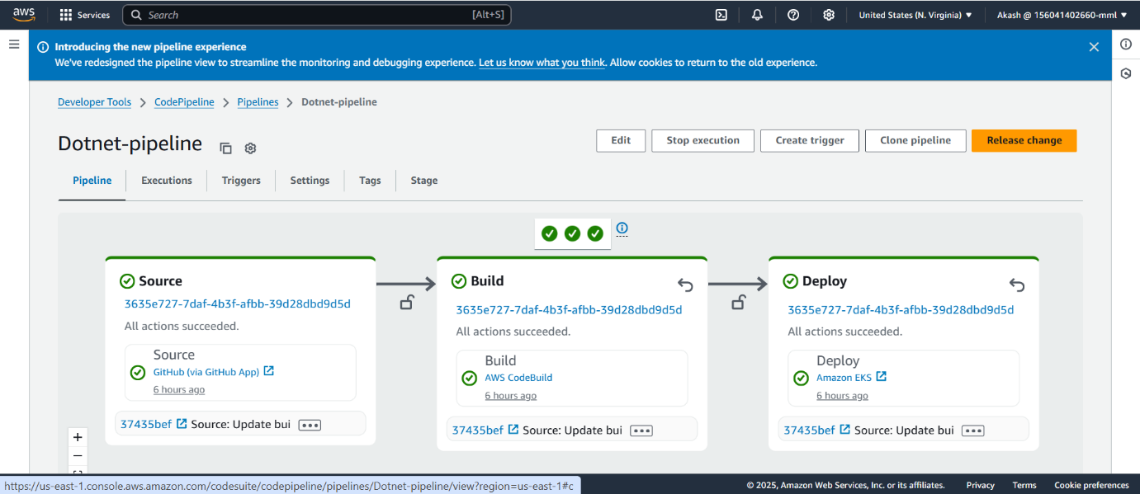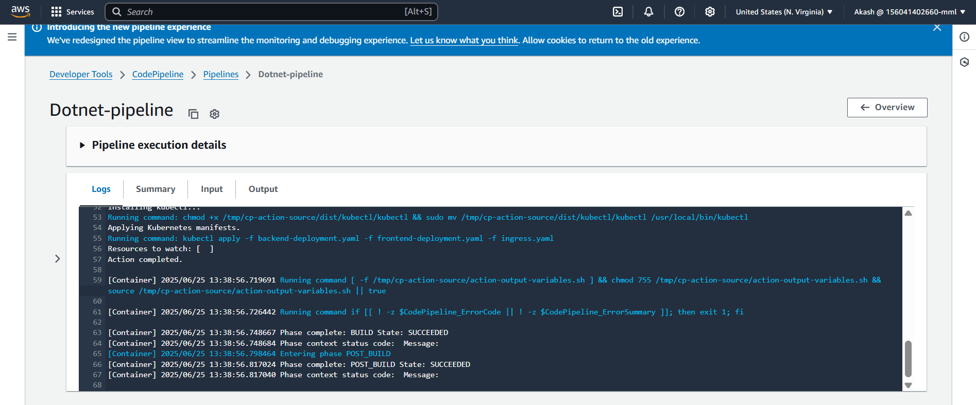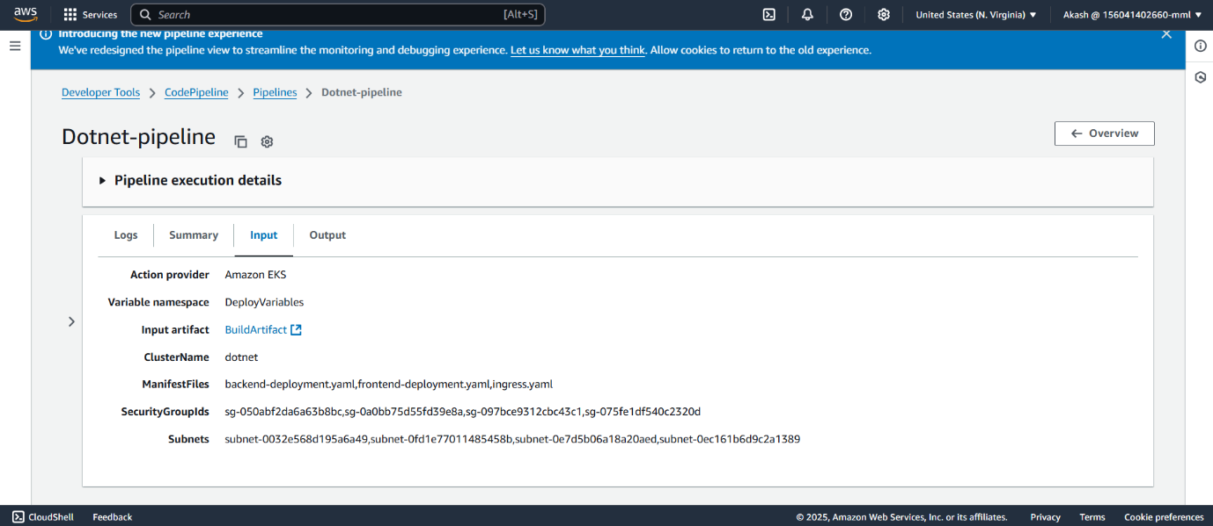

[Source Code]

|

v

[Build] —> [Test] —> [Package] —> [Deploy] —> [Monitor]

A Build Pipeline (often part of a CI/CD pipeline) is an automated series of steps that takes your source code, builds it, tests it, packages it, and prepares it for deployment.

EKS

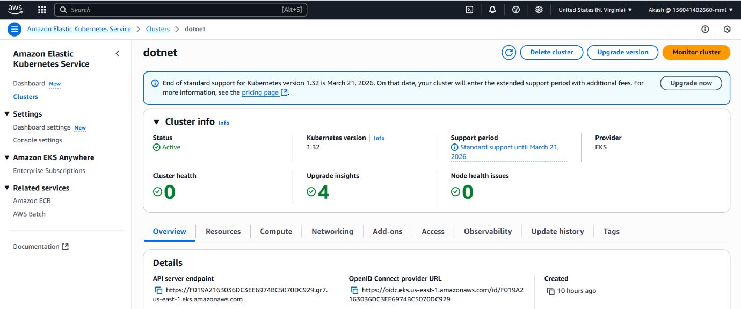

For the pipeline to have access to the eks we need to give the arn of the pipeline to the access entry and provide the Access policy

Add the user in the Trusted relationship of the role for the cloudfrmation

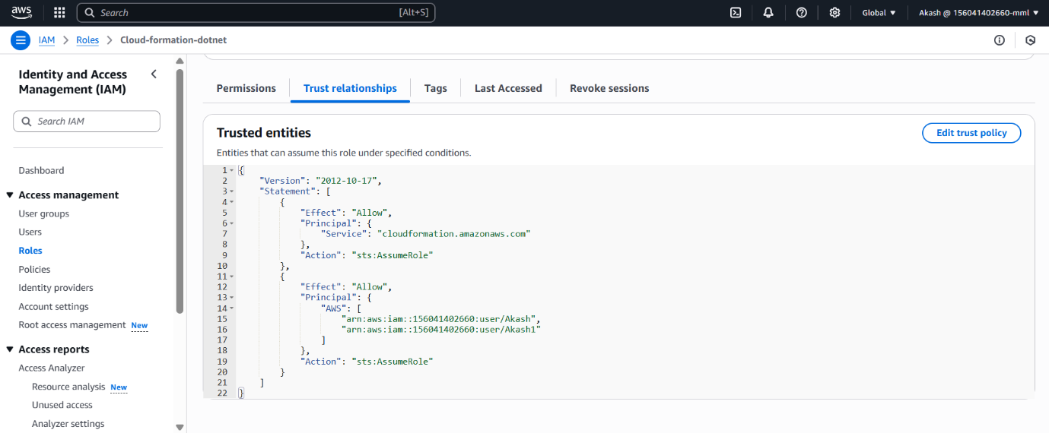

Add the CloudFormation permission for the user

Pods in the EKS after deploy

Another Way of deployment is ArgoCD

Argo CD (Argo Continuous Delivery) is a GitOps-based Continuous Delivery tool for Kubernetes. It automates application deployment and lifecycle management using Git as the single source of truth.

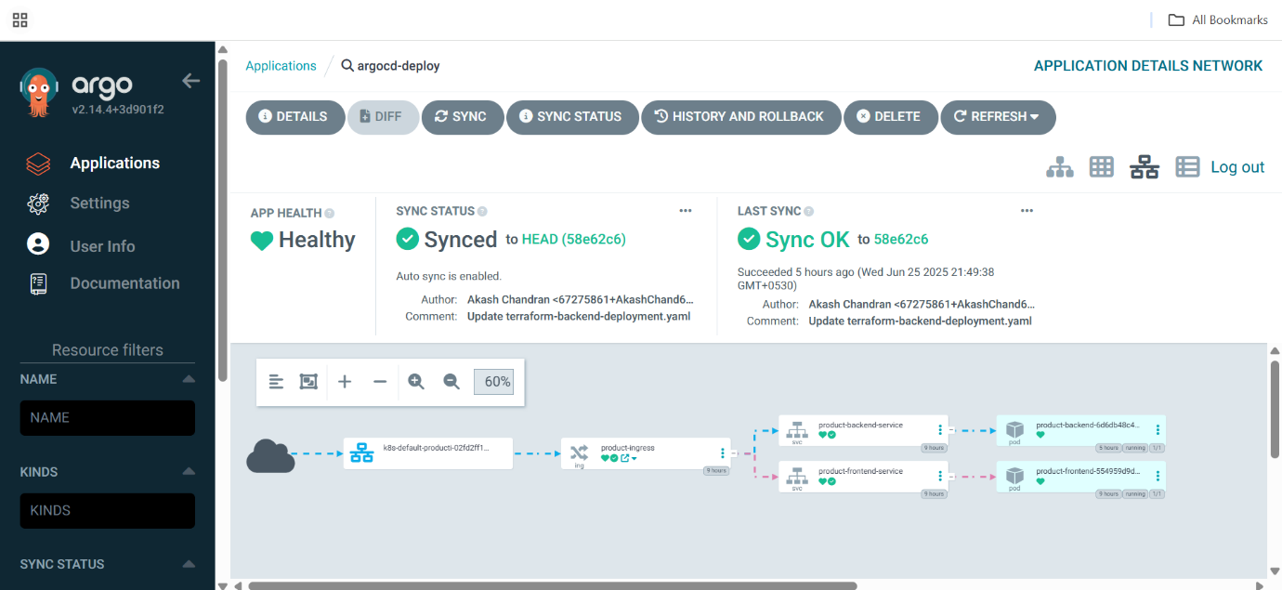

After the deployment to let the users to access we are giving the ingress.



SonarQube

SonarQube is a powerful open-source tool used to inspect, analyse, and improve code quality automatically. It supports continuous inspection of codebases to detect Bugs, Code smells Security vulnerabilities ,Duplicated code

Trivy

Trivy is a simple and comprehensive security scanner for Container images, File systems, Git repositories, Kubernetes clusters

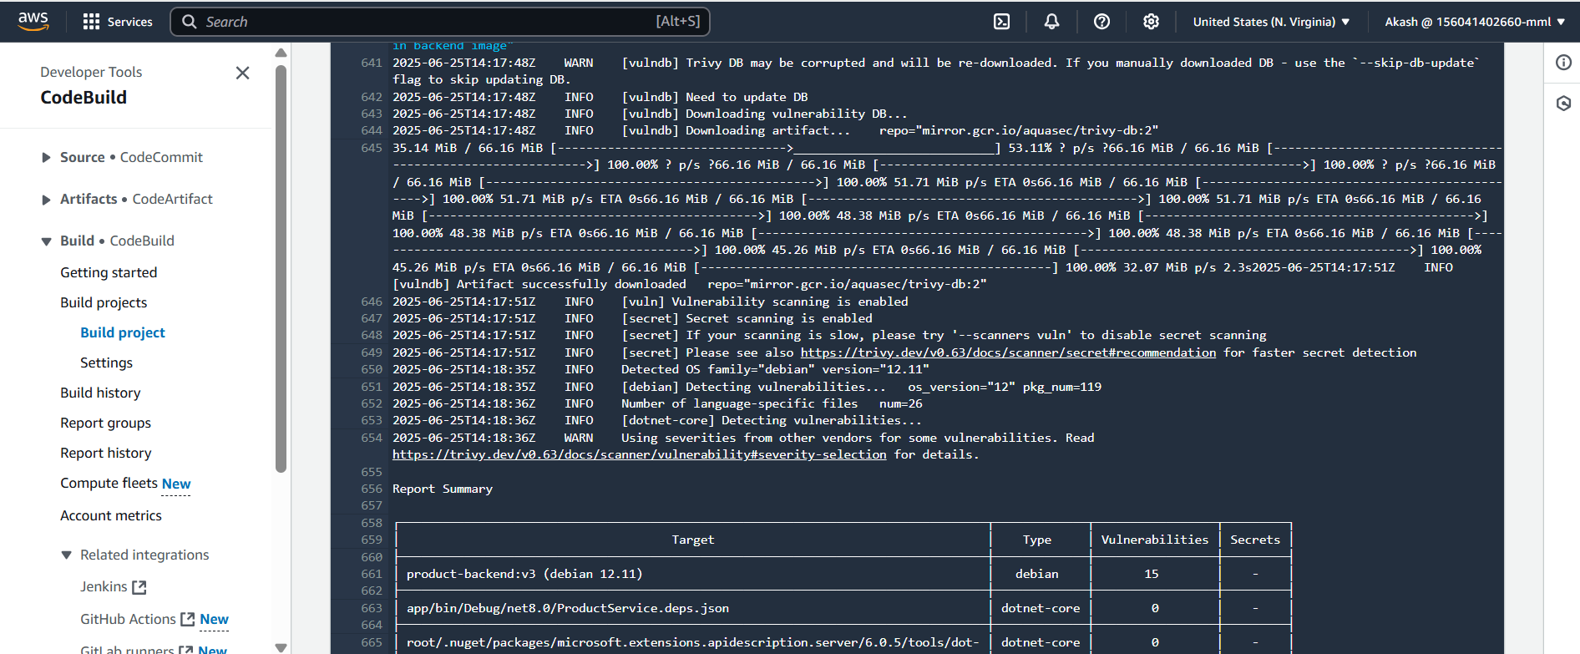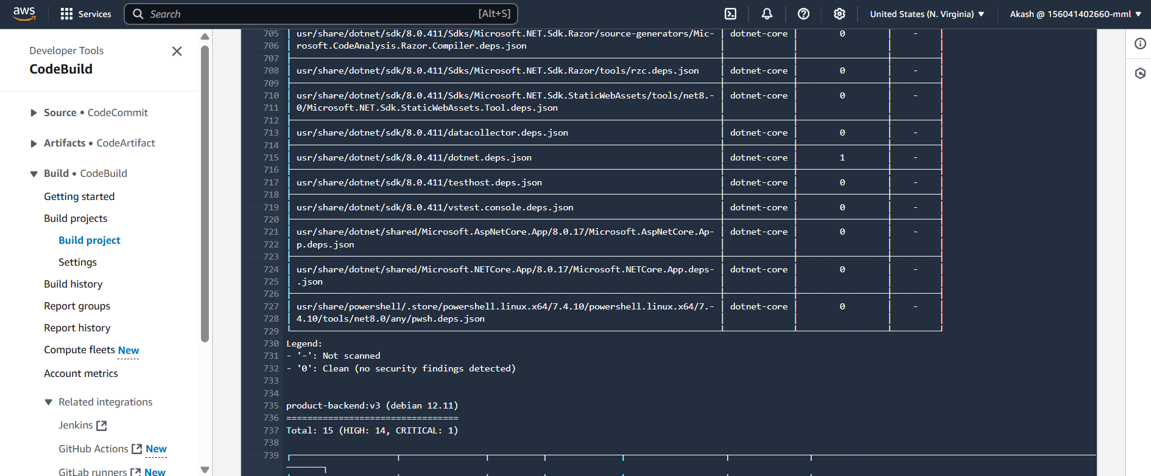

Cloudwatch

Amazon CloudWatch is a monitoring and observability service provided by AWS. It collects metrics, logs, and events from your AWS resources, applications, and services, and allows you to monitor, analyze, and react to them in near real time.

Route53

Amazon Route 53 is AWS’s Domain Name System (DNS) web service

