Personal Finance
Operating System (FinOS)

Software Requirements Specification
Product Requirements Document

Version 1.0
May 2026
Confidential

Table of Contents

1. Executive Summary 1
2. Problem Statement 2
3. Business Goals 2
3.1 Horizon 1: Foundation (0-12 Months) 2
3.2 Horizon 2: Growth (12-24 Months) 3
3.3 Horizon 3: Market Leadership (24-36 Months) 4
4. User Personas 4
4.1 Persona: Rajesh Sharma - Salaried IT Professional 5
4.2 Persona: Priya Patel - Young Investor 5
4.3 Persona: Amit Kumar - Home Loan Customer 5
4.4 Persona: Meera Reddy - Freelancer 5
5. User Journey 5
5.1 Onboarding Phase (Day 1) 5
5.2 Data Entry Phase (Week 1) 6
5.3 Engagement Phase (Month 1) 6
5.4 Optimization Phase (Months 2-6) 6
5.5 Advocacy Phase (6+ Months) 6
6. Functional Requirements 7
6.1 User Management (FR-UM) 7
6.2 Expense Tracking (FR-ET) 7
6.3 Income Tracking (FR-IT) 7
6.4 Loan Management (FR-LM) 7
6.5 Investment Management (FR-IM) 7
6.6 Budget Management (FR-BM) 7
6.7 Goal Management (FR-GM) 8
6.8 Retirement and EPF (FR-EP) 8
6.9 AI Assistant (FR-AI) 8
6.10 Analytics Dashboard (FR-AD) 8
7. Non-Functional Requirements 8
8. System Features 8
8.1 Module Overview 8
8.2 Feature Interaction Matrix 9
9. Detailed Module Breakdown 9
9.1 User Profile Module 9
9.2 Expense Tracking Module 9
9.3 Loan Management Module 10
9.4 Investment Management Module 10
9.5 AI Assistant Module 11
10. Database Entity Design 11
10.1 Core Tables Schema 12
10.1.1 Users Table 12
10.1.2 Expenses Table 12
10.1.3 Loans Table 12
10.1.4 Investments Table 12
11. API Requirements 12
11.1 Authentication APIs 13
11.2 User Profile APIs 13
11.3 Expense APIs 13
11.4 Loan APIs 13
11.5 Investment APIs 13
11.6 Budget APIs 13
11.7 Goal APIs 13
11.8 AI Assistant APIs 13
11.9 Analytics APIs 14
12. Microservice Architecture 14
12.1 Service Communication Patterns 14
12.2 Event Flow Between Services 15
13. Security Requirements 15
13.1 Application Security 15
13.2 Data Security 16
13.3 Infrastructure Security 17
14. Authentication and Authorization 18
14.1 Authentication Flow 18
14.2 Authorization Model 19
15. Privacy and Financial Data Protection 19
15.1 Data Classification 19
15.2 User Rights Implementation 19
16. AI Features 20
16.1 AI Recommendation Logic 20
16.2 Sample AI Prompts and Expected Responses 21
Prompt: Can I afford a new car? 21
Prompt: Should I prepay my home loan? 21
Prompt: Why are my expenses high? 21
17. Notification System 22
17.1 Notification Types and Channels 22
17.2 Notification Architecture 22
18. Reports and Analytics 22
18.1 Financial Health Score 23
18.2 Report Generation 23
19. User Stories 23
20. Acceptance Criteria 24
20.1 Net Worth Calculation (US-001) 24
20.2 Loan Prepayment Simulation (US-002) 24
20.3 AI Affordability Analysis (US-006) 25
21. Edge Cases 25
22. Future Roadmap 26
22.1 Phase 2: Enhanced Intelligence (Months 12-18) 26
22.2 Phase 3: Ecosystem Platform (Months 18-24) 27
22.3 Phase 4: Market Leadership (Months 24-36) 27
23. Monetization Strategy 28
23.1 Subscription Tiers 28
23.2 Revenue Projections 28
24. Risks and Constraints 29
24.1 Technical Constraints 29
24.2 Business Constraints 30
Appendix A: Sequence Diagrams 31

Note: Right-click on the Table of Contents and select 'Update Field' to refresh page numbers.

1. Executive Summary
FinOS (Personal Finance Operating System) is a comprehensive personal finance management platform designed specifically for Indian users. The application aims to serve as a complete financial operating system where users can track, analyze, and improve their finances using automation and artificial intelligence. Unlike simple expense trackers, FinOS provides an integrated ecosystem that encompasses expense tracking, income management, loan and EMI management, investment portfolio tracking, EPF and retirement planning, goal-based savings, budget management, and AI-driven financial insights.
The platform targets a diverse user base in India, including salaried employees, software professionals, families managing household finances, home loan customers seeking to optimize their repayments, young investors building their portfolios, freelancers with variable income streams, and individuals focused on growing their savings and investments. The Indian financial landscape presents unique challenges: fragmented financial data across banks, mutual funds, EPF, PPF, and insurance; complex tax structures under the Income Tax Act; cultural nuances around gold investments and family financial planning; and a rapidly evolving digital payments ecosystem through UPI and other platforms.
FinOS addresses these challenges by providing a unified platform with intelligent automation, culturally relevant financial advice, and compliance with Indian regulatory frameworks including RBI guidelines on data protection, SEBI regulations for investment tracking, and EPFO standards for provident fund integration. The technology stack comprises a Vue 3 frontend with Vite for build tooling, .NET 8 backend microservices architecture, SQL Server as the primary database, Redis for caching and session management, Elasticsearch for search and analytics, Hangfire for background job scheduling, and RabbitMQ for event-driven inter-service communication. The system is designed to scale to millions of users with a robust microservice architecture deployed on cloud infrastructure.

2. Problem Statement
Indian consumers face significant challenges in managing their personal finances effectively. Despite the rapid digitization of financial services in India, there is no comprehensive platform that addresses the full spectrum of personal finance needs specific to the Indian context. Current solutions are fragmented: expense tracking apps exist in isolation from investment platforms, loan management tools operate independently from retirement planners, and tax optimization remains a separate discipline altogether. This fragmentation forces users to maintain multiple applications, spreadsheets, and manual records, leading to incomplete financial visibility and suboptimal decision-making.
The average Indian salaried professional manages between 5 to 8 distinct financial accounts, including salary accounts, savings accounts, fixed deposits, mutual fund portfolios, EPF accounts, PPF accounts, insurance policies, and one or more loan accounts. Tracking net worth across these accounts requires manual aggregation, which is time-consuming and error-prone. Furthermore, the lack of intelligent guidance means that users often miss opportunities for loan prepayment optimization, tax-saving investments under Section 80C and 80D, and goal-based financial planning that aligns with their risk appetite and life stage requirements.
Home loan customers in India, who represent a rapidly growing segment due to the booming real estate market, particularly struggle with understanding the impact of prepayments on their loan tenure and interest burden. Similarly, young investors entering the mutual fund and stock markets through platforms like SIP (Systematic Investment Plan) lack the analytical tools to evaluate portfolio performance through metrics like XIRR, assess asset allocation health, or receive rebalancing recommendations. The absence of a unified financial health score that considers debt-to-income ratio, emergency fund adequacy, insurance coverage, and investment diversification further compounds the problem, leaving users without a clear picture of their overall financial well-being.

3. Business Goals
The business goals for FinOS are structured across three horizons, encompassing immediate product-market fit, medium-term growth, and long-term market leadership in the Indian personal finance management space.

3.1 Horizon 1: Foundation (0-12 Months)
- Achieve 100,000 registered users within the first 12 months through organic growth and targeted marketing campaigns focusing on salaried professionals in Tier 1 and Tier 2 cities
- Establish 30% monthly active user (MAU) retention rate by delivering consistent value through automated expense categorization, net worth tracking, and budget alerts
- Onboard 5,000 premium subscribers within the first year through a freemium model that demonstrates clear value in the free tier while offering advanced analytics and AI features in premium plans
- Achieve a Net Promoter Score (NPS) of 40+ by focusing on user experience, data security, and the accuracy of AI-driven financial recommendations

3.2 Horizon 2: Growth (12-24 Months)
- Scale to 500,000 registered users with a 40% MAU rate through referral programs, content marketing, and strategic partnerships with financial institutions
- Launch bank account integration via Account Aggregator (AA) framework regulated by RBI, enabling automatic transaction import from major Indian banks
- Introduce family finance management features allowing shared expense tracking, joint goal setting, and family-level financial health scoring
- Establish partnerships with at least 3 mutual fund houses and 2 insurance providers for embedded financial product recommendations

3.3 Horizon 3: Market Leadership (24-36 Months)
- Reach 2 million registered users and become the top-rated personal finance app on Indian app stores with a 4.5+ rating
- Launch API marketplace allowing third-party financial tools to integrate with FinOS, creating a financial ecosystem platform
- Introduce AI-powered robo-advisory services registered with SEBI as an investment advisor, providing regulated financial advice
- Achieve profitability through a combination of premium subscriptions, financial product marketplace commissions, and enterprise B2B partnerships

4. User Personas
The following personas represent the primary target users of FinOS, each with distinct financial management needs, pain points, and expectations from a personal finance platform.

4.1 Persona: Rajesh Sharma - Salaried IT Professional
Attribute | Details
Age / Location | 32 years, Bangalore
Occupation | Software Engineer, mid-level
Monthly Income | INR 1,50,000 (take-home)
Financial Profile | Home loan EMI INR 35,000, SIP INR 30,000, Car loan EMI INR 12,000
Pain Points | Cannot track net worth across 6 accounts; unsure about loan prepayment; no consolidated investment view
Goals | Optimize home loan repayment, track EPF growth, plan for child education fund
Tech Comfort | High - uses 5+ financial apps, comfortable with digital tools

4.2 Persona: Priya Patel - Young Investor
Attribute | Details
Age / Location | 26 years, Mumbai
Occupation | Data Analyst, entry-level
Monthly Income | INR 65,000 (take-home)
Financial Profile | SIP INR 10,000, no loans, limited savings, freelance income INR 15,000/month
Pain Points | No budgeting discipline, confused about asset allocation, wants to start investing smartly
Goals | Build emergency fund, start retirement planning early, optimize tax savings
Tech Comfort | Very high - early adopter, uses fintech apps daily

4.3 Persona: Amit Kumar - Home Loan Customer
Attribute | Details
Age / Location | 38 years, Delhi NCR
Occupation | Marketing Manager
Monthly Income | INR 1,20,000 (take-home)
Financial Profile | Home loan INR 45L (EMI 42,000), car loan EMI 15,000, FD INR 5L, EPF 12L
Pain Points | Wants to know if prepaying home loan is better than investing surplus; DTI ratio is high
Goals | Reduce home loan tenure, maintain emergency fund, plan for children higher education
Tech Comfort | Medium - uses WhatsApp, banking apps, basic spreadsheets

4.4 Persona: Meera Reddy - Freelancer
Attribute | Details
Age / Location | 29 years, Hyderabad
Occupation | Freelance UI/UX Designer
Monthly Income | INR 80,000 (variable, ranges 40K-1.2L)
Financial Profile | No EPF, variable income, PPF INR 1.5L/year, gold INR 3L
Pain Points | Irregular income makes budgeting hard, no employer benefits, needs self-funded retirement plan
Goals | Create stable monthly budget from variable income, build 6-month emergency fund, plan retirement without EPF
Tech Comfort | High - works remotely, relies on digital tools for everything

5. User Journey
The user journey for FinOS is designed to provide immediate value from the first interaction, gradually introducing more sophisticated features as the user becomes comfortable with the platform. The journey is structured in five phases, each building on the previous one to deepen engagement and demonstrate increasing value.

5.1 Onboarding Phase (Day 1)
The user discovers FinOS through app stores, social media, or word-of-mouth recommendations. After downloading and registering with email or phone number via OTP verification (compliant with Indian telecom regulations), the user is guided through a quick setup wizard. This wizard collects essential information: monthly salary, existing loans, primary bank accounts, and financial goals. The system uses this information to personalize the dashboard and provide immediate, relevant insights. The onboarding flow is designed to be completed in under 3 minutes, with progress indicators and skip options for optional fields. After setup, the user sees their first personalized dashboard with a preliminary financial health score and three quick-win recommendations.

5.2 Data Entry Phase (Week 1)
During the first week, the user begins populating their financial data. The expense tracking module prompts the user to add their first expense manually or via CSV import from bank statements. The auto-categorization engine immediately demonstrates its value by accurately tagging transactions based on merchant names, amounts, and patterns. The user adds their loan details, and the system generates a complete EMI schedule with principal-interest breakdown. Investment accounts are added, and the portfolio summary instantly calculates current value, returns, and XIRR. Each data addition triggers a recalculation of the net worth and financial health score, providing tangible feedback that encourages continued engagement.

5.3 Engagement Phase (Month 1)
By the end of the first month, the user has established a regular pattern of expense logging, set up budget alerts, and received their first weekly AI insight report. The budget system has learned spending patterns and begins generating spending predictions for the current month. The AI assistant proactively identifies anomalies, such as unusually high spending in a category or a subscription the user may have forgotten about. Goal-based savings trackers show visual progress, and the user receives nudges to increase contributions when surplus funds are detected at month-end.

5.4 Optimization Phase (Months 2-6)
The optimization phase is where FinOS delivers its most significant value. With two to six months of financial data, the AI engine has sufficient context to generate personalized recommendations. The home loan prepayment simulator shows the user exactly how much interest they would save by making additional payments. The investment analyzer identifies portfolio imbalances and suggests rebalancing strategies. The retirement planner projects the user's EPF corpus at retirement age and recommends additional savings needed to meet their target retirement lifestyle. Budget predictions become increasingly accurate, and the financial health score shows month-over-month improvement.

5.5 Advocacy Phase (6+ Months)
After six months, the user has developed strong financial habits supported by FinOS automation. The platform has become an integral part of their financial decision-making process. Users at this stage are most likely to upgrade to premium tiers for advanced features, refer friends and family through the referral program, and engage with community features like financial challenges and leaderboards. The advocacy phase is characterized by high NPS scores, organic word-of-mouth growth, and increasing lifetime value per user.

6. Functional Requirements
The functional requirements for FinOS are organized by module, with each requirement following a standardized format that includes a unique identifier, description, priority, and acceptance criteria reference.

6.1 User Management (FR-UM)
ID | Requirement | Priority
FR-UM-001 | User registration with email and phone number via OTP verification | P0
FR-UM-002 | Secure login with JWT access tokens and refresh token rotation | P0
FR-UM-003 | OAuth 2.0 social login via Google and Microsoft accounts | P0
FR-UM-004 | Password reset via email link with 15-minute expiry | P0
FR-UM-005 | Multi-factor authentication (MFA) using TOTP authenticator apps | P1
FR-UM-006 | User profile management with salary, family, and financial preferences | P0
FR-UM-007 | Risk appetite assessment quiz with dynamic profile generation | P1
FR-UM-008 | Account deactivation and data export in compliance with Indian data protection laws | P1

6.2 Expense Tracking (FR-ET)
ID | Requirement | Priority
FR-ET-001 | Manual expense entry with amount, date, category, description, and tags | P0
FR-ET-002 | CSV file import with column mapping, validation, and error reporting | P0
FR-ET-003 | Auto-categorization engine using ML.NET with 90%+ accuracy for common merchants | P0
FR-ET-004 | Recurring expense detection and automation with configurable frequency | P1
FR-ET-005 | Subscription detection algorithm identifying regular monthly charges | P1
FR-ET-006 | Monthly spending trend visualization with category-wise breakdown | P0
FR-ET-007 | Expense splitting for shared expenses among family members | P2
FR-ET-008 | Receipt photo capture with OCR for automatic data extraction | P2

6.3 Income Tracking (FR-IT)
ID | Requirement | Priority
FR-IT-001 | Salary income tracking with CTC breakdown (basic, HRA, DA, allowances) | P0
FR-IT-002 | Freelance income logging with project-level tracking and invoicing | P1
FR-IT-003 | Rental income tracking with property-level association | P1
FR-IT-004 | Other income sources (dividends, interest, gifts, capital gains) | P0
FR-IT-005 | Recurring income automation for regular salary and rent credits | P1
FR-IT-006 | Income trend analysis with year-over-year growth calculations | P1

6.4 Loan Management (FR-LM)
ID | Requirement | Priority
FR-LM-001 | Home loan, car loan, and personal loan registration with full EMI details | P0
FR-LM-002 | EMI schedule generation with month-wise principal and interest breakdown | P0
FR-LM-003 | Remaining principal calculator with real-time outstanding balance | P0
FR-LM-004 | Prepayment simulator showing tenure reduction and interest savings | P0
FR-LM-005 | Interest savings calculator comparing part-prepayment vs investment scenarios | P1
FR-LM-006 | EMI payment reminders and tracking with auto-marking from bank transactions | P1
FR-LM-007 | Loan comparison tool for evaluating refinancing options | P2

6.5 Investment Management (FR-IM)
ID | Requirement | Priority
FR-IM-001 | Mutual fund tracking with NAV-based daily valuation and SIP management | P0
FR-IM-002 | Stock portfolio tracking with real-time price updates via market data APIs | P0
FR-IM-003 | Fixed deposit tracking with maturity alerts and interest calculation | P0
FR-IM-004 | Gold investment tracking with live gold rate integration | P1
FR-IM-005 | Cryptocurrency portfolio tracking with exchange API integration | P2
FR-IM-006 | Portfolio analytics with asset allocation visualization and rebalancing suggestions | P0
FR-IM-007 | XIRR calculation for portfolio returns with benchmark comparison | P1
FR-IM-008 | Capital gains tracking with short-term and long-term classification per IT Act | P1

6.6 Budget Management (FR-BM)
ID | Requirement | Priority
FR-BM-001 | Category-wise budget creation with monthly and custom period options | P0
FR-BM-002 | Budget utilization alerts at 50%, 75%, 90%, and 100% thresholds | P0
FR-BM-003 | Spending prediction engine based on historical patterns and current trends | P1
FR-BM-004 | Budget rollover for unused amounts with configurable rules | P2
FR-BM-005 | Zero-based budgeting mode where every rupee is allocated | P2

6.7 Goal Management (FR-GM)
ID | Requirement | Priority
FR-GM-001 | Predefined goal templates: Emergency Fund, House, Car, Vacation, Retirement | P0
FR-GM-002 | Custom goal creation with target amount, date, and monthly contribution plan | P0
FR-GM-003 | Goal progress tracking with milestone celebrations and visual indicators | P0
FR-GM-004 | Goal priority ranking and conflict resolution when goals compete for funds | P1
FR-GM-005 | SIP-like automated contribution suggestions based on goal timeline and risk profile | P1

6.8 Retirement and EPF (FR-EP)
ID | Requirement | Priority
FR-EP-001 | EPF balance tracking with employee and employer contribution breakdown | P0
FR-EP-002 | Retirement corpus prediction using inflation-adjusted growth models | P0
FR-EP-003 | EPF contribution simulator showing impact of voluntary contributions (VPF) | P1
FR-EP-004 | PPF account tracking with 15-year maturity schedule | P1
FR-EP-005 | NPS (National Pension System) tracking with tier-level details | P2
FR-EP-006 | Retirement readiness score with gap analysis and recommended actions | P1

6.9 AI Assistant (FR-AI)
ID | Requirement | Priority
FR-AI-001 | Natural language financial query processing with intent recognition | P0
FR-AI-002 | Affordability analysis answering questions like 'Can I afford a new car?' | P0
FR-AI-003 | Loan prepayment advisory with mathematical comparison of options | P1
FR-AI-004 | Expense analysis identifying categories with unusual spending patterns | P0
FR-AI-005 | Savings potential calculator based on income, expenses, and goals | P1
FR-AI-006 | Personalized financial improvement recommendations with actionable steps | P1
FR-AI-007 | Weekly AI insight reports delivered via push notification and email | P1
FR-AI-008 | Conversational context retention across multiple interactions within a session | P2

6.10 Analytics Dashboard (FR-AD)
ID | Requirement | Priority
FR-AD-001 | Net worth graph with monthly progression and trend analysis | P0
FR-AD-002 | Savings rate calculation and monthly trend visualization | P0
FR-AD-003 | Expense trend analysis with category drill-down capabilities | P0
FR-AD-004 | Income trend visualization with source-wise breakdown | P0
FR-AD-005 | Financial health score (0-100) based on 6 financial dimensions | P0
FR-AD-006 | Debt-to-income ratio calculation with historical trend | P1
FR-AD-007 | Exportable reports in PDF and Excel formats for tax filing | P1

7. Non-Functional Requirements
Category | Requirement | Target
Performance | API response time for dashboard load | < 500ms (p95)
Performance | Concurrent user support without degradation | 10,000 concurrent users
Performance | Database query response for complex analytics | < 200ms (p95)
Scalability | Horizontal scaling via container orchestration | Auto-scale from 3 to 50 pods
Scalability | Database read replica support | 1 primary + 2 read replicas
Scalability | Cache hit ratio for frequently accessed data | > 90%
Availability | System uptime SLA | 99.9% (8.76 hours downtime/year)
Availability | Disaster recovery RTO/RPO | RTO < 4 hours, RPO < 1 hour
Security | Data encryption at rest | AES-256 for sensitive fields
Security | Data encryption in transit | TLS 1.3 mandatory
Security | Penetration testing frequency | Quarterly by certified third party
Compliance | Indian data protection compliance | DPDPA 2023 compliant
Compliance | RBI data localization | All financial data stored in India
Compliance | PCI DSS | Level 1 compliance for payment data
Usability | Time to value for new users | < 3 minutes to first insight
Usability | Accessibility | WCAG 2.1 Level AA
Maintainability | Deployment frequency | Multiple deployments per day
Maintainability | Mean time to recovery (MTTR) | < 30 minutes

8. System Features
The system features of FinOS are organized into core modules that interact through well-defined APIs and event-driven communication patterns. Each feature module is designed as an independent microservice with its own data store, business logic, and API surface, enabling independent development, deployment, and scaling.

8.1 Module Overview
The FinOS platform comprises twelve core microservices, each responsible for a specific business domain. The User Profile module manages identity, preferences, and risk assessment. The Expense Tracking module handles transaction capture, categorization, and pattern analysis. The Income module tracks all income streams with tax-relevant categorization. The Loan Management module provides EMI scheduling, prepayment simulation, and debt optimization. The Investment module delivers portfolio analytics, XIRR calculations, and asset allocation insights. The Budget module enables category-based spending limits with predictive alerts. The Goal module manages financial targets with milestone tracking. The EPF module tracks provident fund balances and retirement readiness. The Analytics module aggregates all financial data into comprehensive dashboards. The Notification module delivers timely alerts through multiple channels. The AI Assistant module provides conversational financial guidance. The Reporting module generates exportable financial summaries.

8.2 Feature Interaction Matrix
The following matrix describes how primary features interact with each other. An entry marked 'Y' indicates a direct data dependency or event-driven interaction between the row and column modules. Understanding these interactions is critical for designing the event flow and ensuring data consistency across services.
Module | Expense | Income | Loan | Invest | Budget | Goal | EPF | Analytics | AI
Expense | - | N | N | N | Y | N | N | Y | Y
Income | N | - | Y | Y | Y | Y | Y | Y | Y
Loan | N | Y | - | Y | Y | Y | N | Y | Y
Invest | N | Y | Y | - | N | Y | Y | Y | Y
Budget | Y | Y | Y | N | - | Y | N | Y | Y
Goal | N | Y | Y | Y | Y | - | Y | Y | Y
EPF | N | Y | N | Y | N | Y | - | Y | Y
Analytics | Y | Y | Y | Y | Y | Y | Y | - | Y
AI | Y | Y | Y | Y | Y | Y | Y | Y | -

9. Detailed Module Breakdown

9.1 User Profile Module
The User Profile module is the foundation of personalization in FinOS. It stores comprehensive information about the user including salary details, family composition, financial preferences, and risk appetite. The salary information captures the full CTC breakdown following Indian compensation structures: basic salary, House Rent Allowance (HRA), Dearness Allowance (DA), special allowances, and employer PF contribution. This granular breakdown enables accurate tax computation and take-home pay calculation.
Family member management allows users to add dependents and their financial details, enabling family-level financial planning. Each family member record includes name, relationship, date of birth (for insurance and education planning), dependency status, and individual income. The financial preferences capture the user's preferred investment style (aggressive, moderate, conservative), insurance coverage preferences, tax regime choice (old vs new), and notification preferences. The risk appetite assessment uses a standardized questionnaire covering investment experience, time horizon, loss tolerance, and financial knowledge to generate a risk profile that informs AI recommendations and investment suggestions throughout the platform.

9.2 Expense Tracking Module
The Expense Tracking module provides multiple input methods to minimize friction in expense logging. Manual entry supports amount, date, category, description, payment method, and tags. The CSV import feature supports column mapping from various Indian bank statement formats (HDFC, SBI, ICICI, Axis) and auto-detects date formats, amount columns, and transaction descriptions. The auto-categorization engine uses ML.NET with a trained model that achieves over 90% accuracy for common Indian merchants, recognizing patterns in transaction descriptions like 'SWIGGY', 'ZOMATO', 'AMAZON', 'FLIPKART', 'DMRC', and 'PETROL'.
Recurring expense detection identifies patterns in transaction history, flagging subscriptions (Netflix, Hotstar, gym memberships), utility bills, and insurance premiums that occur at regular intervals. The subscription detection feature specifically identifies monthly auto-debits and presents them in a dedicated view, allowing users to see their total monthly subscription burden at a glance. Monthly spending trends are visualized through interactive charts showing category-wise breakdowns, month-over-month comparisons, and year-over-year growth rates. The expense module publishes events to RabbitMQ whenever a new expense is created, triggering downstream updates to budget utilization, net worth snapshots, and AI insight caches.

9.3 Loan Management Module
The Loan Management module supports three primary loan types prevalent in the Indian market: home loans (typically 20-30 year tenure with 8-9% interest rates), car loans (3-7 year tenure with 9-11% rates), and personal loans (1-5 year tenure with 12-18% rates). For each loan, the system captures the principal amount, outstanding balance, interest rate, tenure, start date, and lender details. The EMI schedule generator creates a complete amortization table showing month-by-month principal and interest components, outstanding balance after each payment, and cumulative interest paid.
The prepayment simulator is one of the most valuable features for Indian home loan customers. It allows users to model lump-sum prepayments and see their impact on either tenure reduction (keeping EMI constant) or EMI reduction (keeping tenure constant). The simulator calculates total interest savings, new tenure or EMI amount, and break-even period for the prepayment decision. The interest savings calculator extends this by comparing the returns from investing the surplus amount versus using it for loan prepayment, factoring in expected investment returns, tax benefits on home loan interest under Section 24(b), and the user's risk appetite. This comparison helps users make data-driven decisions about the optimal use of surplus funds.

9.4 Investment Management Module
The Investment Management module tracks five asset classes relevant to Indian investors: mutual funds, stocks, fixed deposits, gold, and cryptocurrency. Mutual fund tracking supports both lump-sum and SIP investments, with daily NAV-based valuation from APIs like MFAPI or AMFI data feeds. The system tracks folio numbers, AMC details, fund category (equity, debt, hybrid, ELSS), and benchmark index for each holding. Stock tracking supports both NSE and BSE listed securities with real-time price feeds, sector classification, and capital gains calculation with short-term and long-term classification as per the Income Tax Act.
Portfolio analytics provides a comprehensive view of asset allocation across equity, debt, gold, real estate (via home equity), and cash. The asset allocation visualization uses pie charts and bar graphs to show current allocation versus recommended allocation based on the user's risk profile and age. XIRR (Extended Internal Rate of Return) calculation handles irregular cash flows typical of SIP investments, providing an accurate annualized return figure that accounts for the timing and amount of each investment. The module also tracks capital gains with proper classification (short-term vs long-term) and applicable tax rates, enabling users to make tax-efficient redemption decisions.

9.5 AI Assistant Module
The AI Assistant module is the intelligence layer that transforms FinOS from a passive tracking tool into an active financial advisor. It uses natural language processing to understand user queries and generate contextually relevant responses based on the user's complete financial profile. The AI recommendation logic follows a multi-step process: intent recognition identifies the type of question (affordability, optimization, analysis, or general), context assembly gathers relevant financial data from multiple services, rule-based analysis applies financial formulas and heuristics, and response generation crafts a personalized answer with specific numbers and actionable recommendations.
The affordability analysis for questions like 'Can I afford a new car?' evaluates the user's current debt-to-income ratio, monthly surplus after expenses and existing obligations, emergency fund adequacy, impact on financial goals, and available down payment from savings. The loan prepayment advisory for 'Should I prepay my home loan?' compares the guaranteed interest savings from prepayment against potential investment returns, factoring in tax benefits under Section 24(b) and Section 80C, the user's risk appetite, and the remaining loan tenure. The expense analysis for 'Why are my expenses high?' identifies categories with significant month-over-month increases, compares spending against regional and income-level benchmarks, highlights subscription creep, and suggests specific reduction targets. The savings potential calculator for 'How much can I save this month?' projects month-end surplus based on current spending pace, pending recurring expenses, and expected income, providing a confidence interval rather than a single number. The financial improvement recommendations for 'How can I improve my finances?' generate a prioritized action list based on the financial health score dimensions where the user scores lowest.

10. Database Entity Design
The database design follows a normalized relational model optimized for SQL Server. The schema is organized around the user entity as the central hub, with all financial data associated through foreign key relationships. The design supports multi-tenancy at the user level, ensuring complete data isolation between users. All primary keys use UNIQUEIDENTIFIER (GUID) type for distributed generation compatibility, and all monetary values use DECIMAL(18,2) for INR precision. Sensitive fields like account numbers are encrypted at the application level before storage.
The following Entity-Relationship diagram illustrates the complete data model for FinOS, showing all entities, their attributes, and relationships. The diagram uses standard ER notation with crow's foot notation for cardinality.
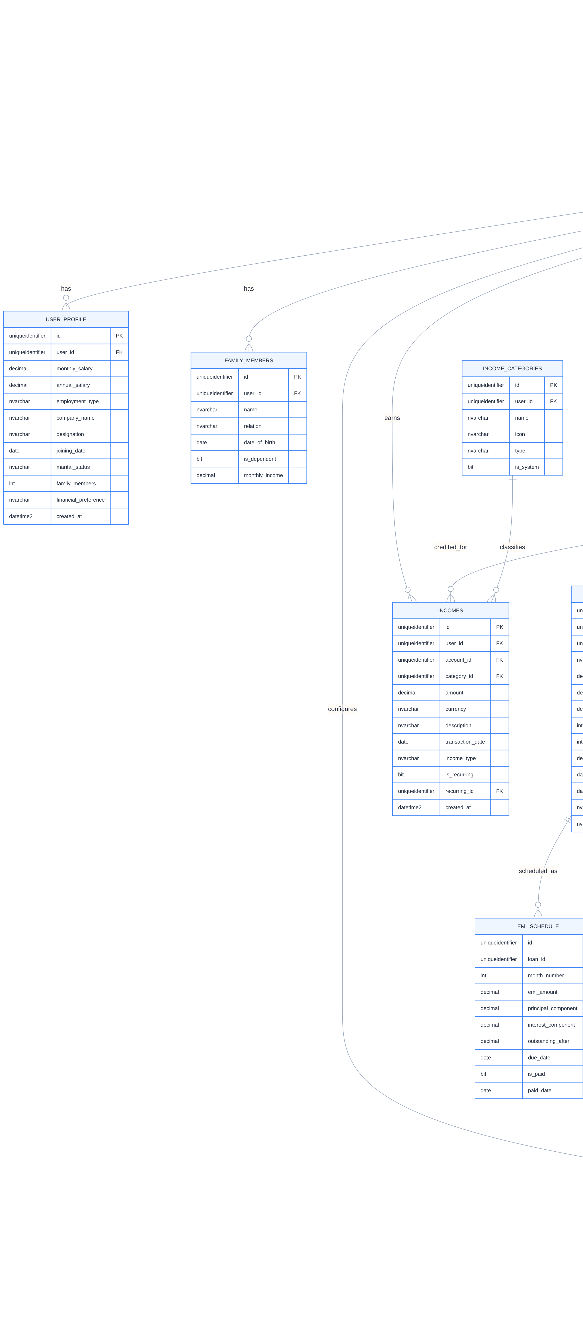
Figure 1: FinOS Entity-Relationship Diagram

10.1 Core Tables Schema
The following table provides the complete SQL Server schema definition for the core entities in the FinOS database. Each table includes column names, data types, constraints, and index recommendations for optimal query performance.

10.1.1 Users Table
Column | Data Type | Constraints | Description
id | UNIQUEIDENTIFIER | PK, DEFAULT NEWID() | Unique user identifier
email | NVARCHAR(256) | UK, NOT NULL | User email address
password_hash | NVARCHAR(512) | NOT NULL | Bcrypt hashed password
full_name | NVARCHAR(128) | NOT NULL | User full name
phone | NVARCHAR(15) | NULL | Indian mobile number
date_of_birth | DATE | NULL | For age-based calculations
pan_number | NVARCHAR(10) | UK, ENCRYPTED | PAN for tax calculations
aadhaar_hash | NVARCHAR(64) | UK, ENCRYPTED | Hashed Aadhaar reference
risk_appetite | NVARCHAR(20) | DEFAULT 'moderate' | aggressive/moderate/conservative
currency | NVARCHAR(3) | DEFAULT 'INR' | Base currency
timezone | NVARCHAR(50) | DEFAULT 'Asia/Kolkata' | User timezone
is_email_verified | BIT | DEFAULT 0 | Email verification status
is_active | BIT | DEFAULT 1 | Account active flag
created_at | DATETIME2 | DEFAULT GETUTCDATE() | Creation timestamp
updated_at | DATETIME2 | DEFAULT GETUTCDATE() | Last update timestamp

10.1.2 Expenses Table
Column | Data Type | Constraints | Description
id | UNIQUEIDENTIFIER | PK | Unique expense identifier
user_id | UNIQUEIDENTIFIER | FK->Users, NOT NULL | Owning user
account_id | UNIQUEIDENTIFIER | FK->Accounts | Debited account
category_id | UNIQUEIDENTIFIER | FK->ExpenseCategories | Expense category
amount | DECIMAL(18,2) | NOT NULL, CHECK>0 | Expense amount in INR
currency | NVARCHAR(3) | DEFAULT 'INR' | Transaction currency
description | NVARCHAR(500) | NULL | Transaction description
transaction_date | DATE | NOT NULL | Date of expense
source | NVARCHAR(20) | DEFAULT 'manual' | manual/csv/auto
is_recurring | BIT | DEFAULT 0 | Recurring expense flag
recurring_id | UNIQUEIDENTIFIER | FK->RecurringTransactions | Parent recurring entry
tags | NVARCHAR(500) | NULL | Comma-separated tags
created_at | DATETIME2 | DEFAULT GETUTCDATE() | Creation timestamp

10.1.3 Loans Table
Column | Data Type | Constraints | Description
id | UNIQUEIDENTIFIER | PK | Unique loan identifier
user_id | UNIQUEIDENTIFIER | FK->Users, NOT NULL | Owning user
account_id | UNIQUEIDENTIFIER | FK->Accounts | Linked account
loan_type | NVARCHAR(20) | NOT NULL | home/car/personal/education
principal | DECIMAL(18,2) | NOT NULL | Original loan amount
outstanding_principal | DECIMAL(18,2) | NOT NULL | Remaining principal
interest_rate | DECIMAL(5,2) | NOT NULL | Annual interest rate %
tenure_months | INT | NOT NULL | Original tenure in months
remaining_months | INT | NOT NULL | Remaining tenure
emi_amount | DECIMAL(18,2) | NOT NULL | Monthly EMI amount
start_date | DATE | NOT NULL | Loan start date
end_date | DATE | NOT NULL | Expected end date
lender_name | NVARCHAR(128) | NULL | Bank/NBFC name
status | NVARCHAR(20) | DEFAULT 'active' | active/closed/prepaid

10.1.4 Investments Table
Column | Data Type | Constraints | Description
id | UNIQUEIDENTIFIER | PK | Unique investment identifier
user_id | UNIQUEIDENTIFIER | FK->Users, NOT NULL | Owning user
account_id | UNIQUEIDENTIFIER | FK->Accounts | Linked account
investment_type | NVARCHAR(20) | NOT NULL | mf/stock/fd/gold/crypto
name | NVARCHAR(256) | NOT NULL | Investment name/scheme
folio_number | NVARCHAR(50) | NULL | MF folio or DP ID
quantity | DECIMAL(18,4) | NULL | Units/shares held
avg_purchase_price | DECIMAL(18,2) | NULL | Average buy price
current_value | DECIMAL(18,2) | NOT NULL | Current market value
invested_amount | DECIMAL(18,2) | NOT NULL | Total amount invested
returns_amount | DECIMAL(18,2) | COMPUTED | current_value - invested_amount
returns_percentage | DECIMAL(8,2) | COMPUTED | returns/invested*100
xirr | DECIMAL(8,4) | NULL | Annualized XIRR return
last_valuation | DATETIME2 | NULL | Last price update time

11. API Requirements
The FinOS API follows RESTful design principles with a consistent URL structure, HTTP method semantics, and JSON request/response format. All API endpoints are versioned (currently v1) and protected by JWT authentication. The API gateway handles rate limiting, request validation, and authentication before routing to the appropriate microservice. The following table lists the primary API endpoints organized by service domain.

11.1 Authentication APIs
Method | Endpoint | Description | Auth
POST | /api/v1/auth/register | Register new user with email/phone | None
POST | /api/v1/auth/login | Login with email + password | None
POST | /api/v1/auth/refresh | Refresh access token | Refresh Token
POST | /api/v1/auth/logout | Invalidate refresh token | JWT
POST | /api/v1/auth/forgot-password | Send password reset link | None
POST | /api/v1/auth/verify-email | Verify email with token | None
POST | /api/v1/auth/mfa/enable | Enable TOTP-based MFA | JWT
POST | /api/v1/auth/mfa/verify | Verify MFA code during login | None

11.2 User Profile APIs
Method | Endpoint | Description | Auth
GET | /api/v1/users/me | Get current user profile | JWT
PUT | /api/v1/users/me | Update user profile | JWT
GET | /api/v1/users/me/profile | Get financial profile | JWT
PUT | /api/v1/users/me/profile | Update financial profile | JWT
POST | /api/v1/users/me/risk-assessment | Submit risk assessment quiz | JWT
GET | /api/v1/users/me/risk-profile | Get computed risk profile | JWT
GET | /api/v1/users/me/family | List family members | JWT
POST | /api/v1/users/me/family | Add family member | JWT
PUT | /api/v1/users/me/family/{id} | Update family member | JWT
DELETE | /api/v1/users/me/family/{id} | Remove family member | JWT

11.3 Expense APIs
Method | Endpoint | Description | Auth
GET | /api/v1/expenses | List expenses with pagination and filters | JWT
POST | /api/v1/expenses | Create new expense | JWT
GET | /api/v1/expenses/{id} | Get expense detail | JWT
PUT | /api/v1/expenses/{id} | Update expense | JWT
DELETE | /api/v1/expenses/{id} | Soft delete expense | JWT
POST | /api/v1/expenses/import | Import from CSV file | JWT
GET | /api/v1/expenses/trends | Get monthly spending trends | JWT
GET | /api/v1/expenses/subscriptions | Detected subscriptions list | JWT
GET | /api/v1/expense-categories | List expense categories | JWT
POST | /api/v1/expense-categories | Create custom category | JWT

11.4 Loan APIs
Method | Endpoint | Description | Auth
GET | /api/v1/loans | List all loans | JWT
POST | /api/v1/loans | Add new loan | JWT
GET | /api/v1/loans/{id} | Get loan details | JWT
PUT | /api/v1/loans/{id} | Update loan | JWT
GET | /api/v1/loans/{id}/emi-schedule | Get complete EMI schedule | JWT
POST | /api/v1/loans/{id}/prepayment/simulate | Simulate prepayment impact | JWT
POST | /api/v1/loans/{id}/prepayment | Record actual prepayment | JWT
GET | /api/v1/loans/{id}/interest-savings | Compare prepayment vs investment | JWT

11.5 Investment APIs
Method | Endpoint | Description | Auth
GET | /api/v1/investments | List all investments | JWT
POST | /api/v1/investments | Add new investment | JWT
GET | /api/v1/investments/{id} | Get investment details | JWT
PUT | /api/v1/investments/{id} | Update investment | JWT
DELETE | /api/v1/investments/{id} | Remove investment | JWT
GET | /api/v1/investments/portfolio/summary | Portfolio summary with allocation | JWT
GET | /api/v1/investments/portfolio/xirr | XIRR calculation for portfolio | JWT
GET | /api/v1/investments/portfolio/allocation | Asset allocation breakdown | JWT
GET | /api/v1/investments/capital-gains | Capital gains summary for tax | JWT

11.6 Budget APIs
Method | Endpoint | Description | Auth
GET | /api/v1/budgets | List budgets for current period | JWT
POST | /api/v1/budgets | Create or update budget | JWT
GET | /api/v1/budgets/{id} | Get budget with utilization | JWT
GET | /api/v1/budgets/prediction | Spending prediction for period | JWT
GET | /api/v1/budgets/alerts | List triggered budget alerts | JWT

11.7 Goal APIs
Method | Endpoint | Description | Auth
GET | /api/v1/goals | List all goals with progress | JWT
POST | /api/v1/goals | Create new goal | JWT
GET | /api/v1/goals/{id} | Get goal details with milestones | JWT
PUT | /api/v1/goals/{id} | Update goal | JWT
DELETE | /api/v1/goals/{id} | Archive goal | JWT
POST | /api/v1/goals/{id}/contribute | Add contribution to goal | JWT
GET | /api/v1/goals/templates | Get predefined goal templates | JWT

11.8 AI Assistant APIs
Method | Endpoint | Description | Auth
POST | /api/v1/ai/ask | Submit natural language question | JWT
GET | /api/v1/ai/insights | Get latest AI insights | JWT
GET | /api/v1/ai/recommendations | Get personalized recommendations | JWT
GET | /api/v1/ai/weekly-report | Get weekly AI-generated report | JWT
GET | /api/v1/ai/conversations | List conversation history | JWT

11.9 Analytics APIs
Method | Endpoint | Description | Auth
GET | /api/v1/analytics/dashboard | Complete dashboard data | JWT
GET | /api/v1/analytics/net-worth | Net worth history with trends | JWT
GET | /api/v1/analytics/savings-rate | Monthly savings rate trend | JWT
GET | /api/v1/analytics/financial-score | Financial health score with breakdown | JWT
GET | /api/v1/analytics/debt-to-income | DTI ratio history | JWT
GET | /api/v1/analytics/expense-trends | Category-wise expense trends | JWT
GET | /api/v1/analytics/income-trends | Income trend by source | JWT
GET | /api/v1/analytics/reports/monthly | Monthly financial report | JWT
GET | /api/v1/analytics/reports/annual | Annual financial summary | JWT
GET | /api/v1/analytics/reports/export | Export report as PDF/Excel | JWT

12. Microservice Architecture
The FinOS microservice architecture is designed for horizontal scalability, fault isolation, and independent deployment. Each service owns its data and communicates through well-defined APIs and asynchronous events. The architecture follows the Database-per-Service pattern, where each microservice has its own SQL Server schema or database, ensuring loose coupling and allowing services to evolve independently. Inter-service communication uses two patterns: synchronous REST/gRPC calls for request-response interactions, and asynchronous event-driven messaging via RabbitMQ for fire-and-forget notifications and data synchronization.
The following diagram illustrates the complete microservice architecture, showing the client layer, API gateway, core services, processing engines, data stores, and infrastructure components.
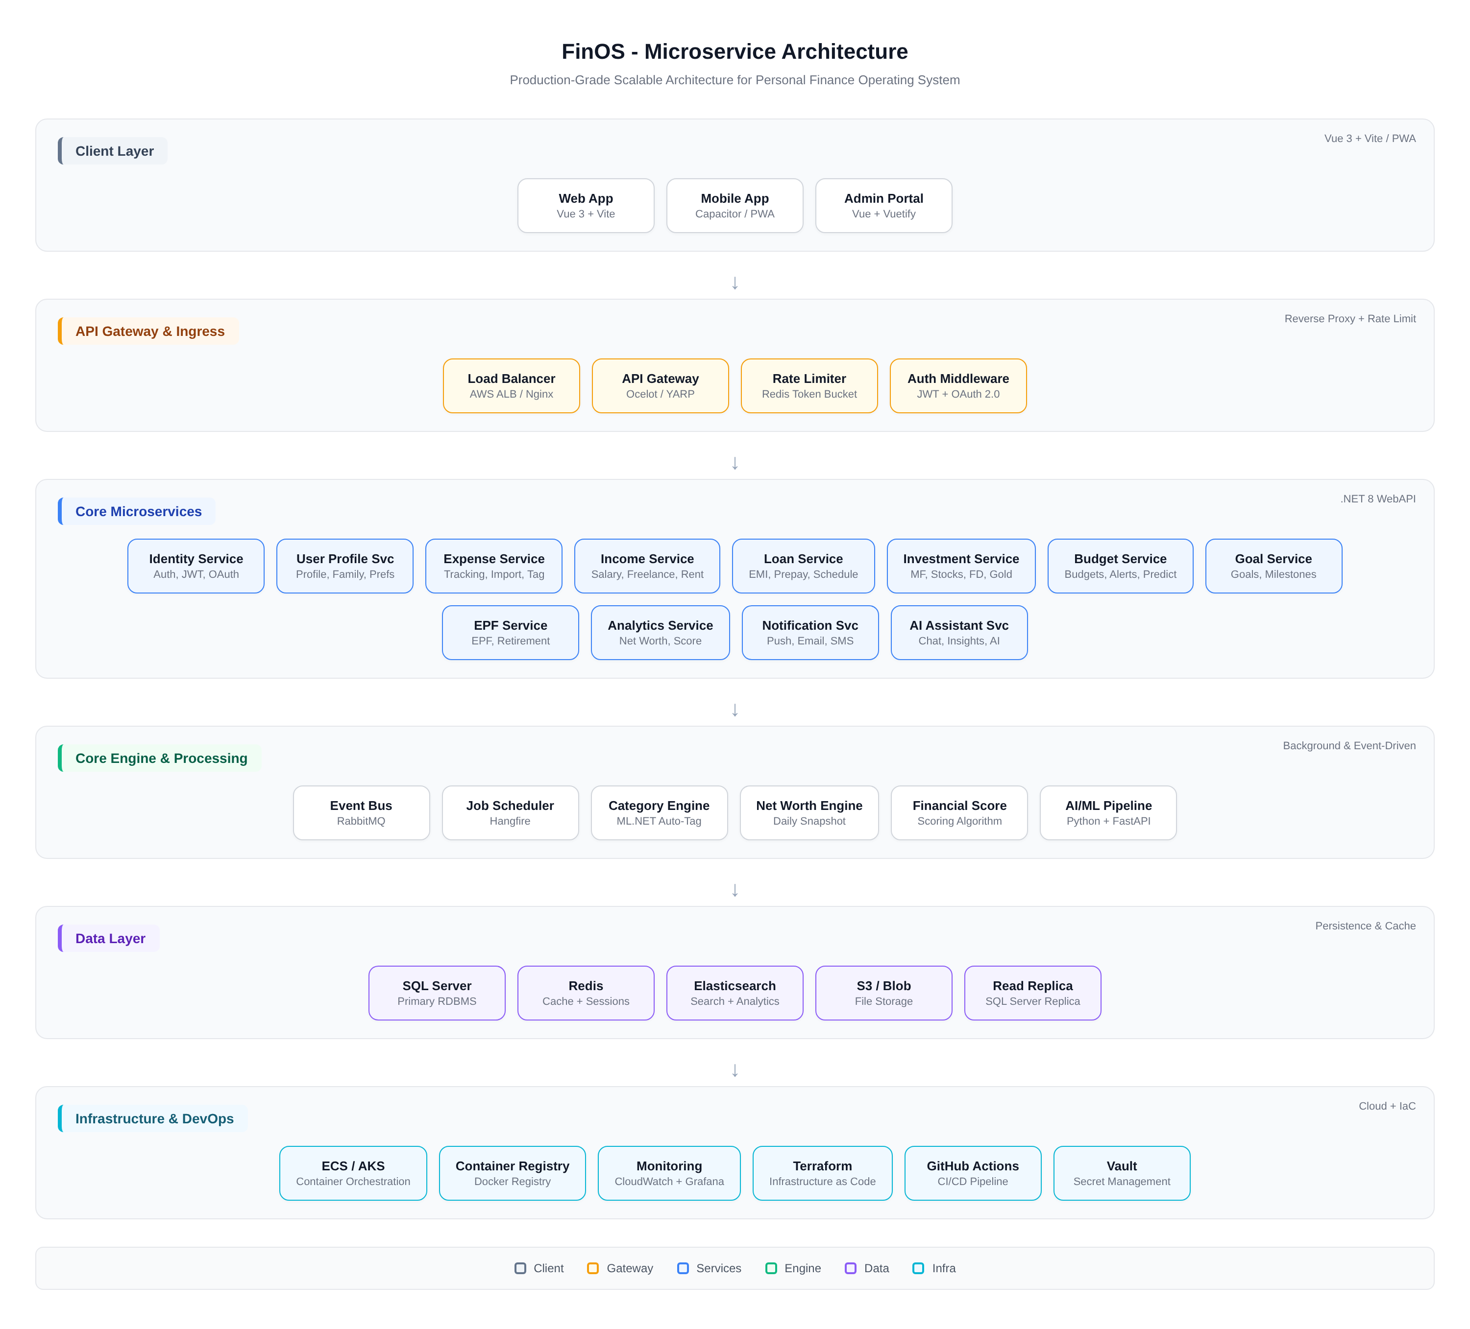
Figure 2: FinOS Microservice Architecture

12.1 Service Communication Patterns
Synchronous communication is used for operations that require immediate responses, such as user authentication, data retrieval, and real-time calculations. These calls go through the API gateway, which handles routing, rate limiting, and authentication. Asynchronous communication via RabbitMQ is used for event propagation, ensuring eventual consistency across services. When an expense is created, the Expense Service publishes an ExpenseCreatedEvent, which the Budget Service consumes to update budget utilization, the Analytics Service consumes to recalculate net worth, and the AI Service consumes to invalidate its insight cache. This event-driven pattern ensures that services remain decoupled while maintaining data consistency.

12.2 Event Flow Between Services
The event flow diagram below illustrates the key events that flow between services via RabbitMQ, along with the scheduled background jobs managed by Hangfire.
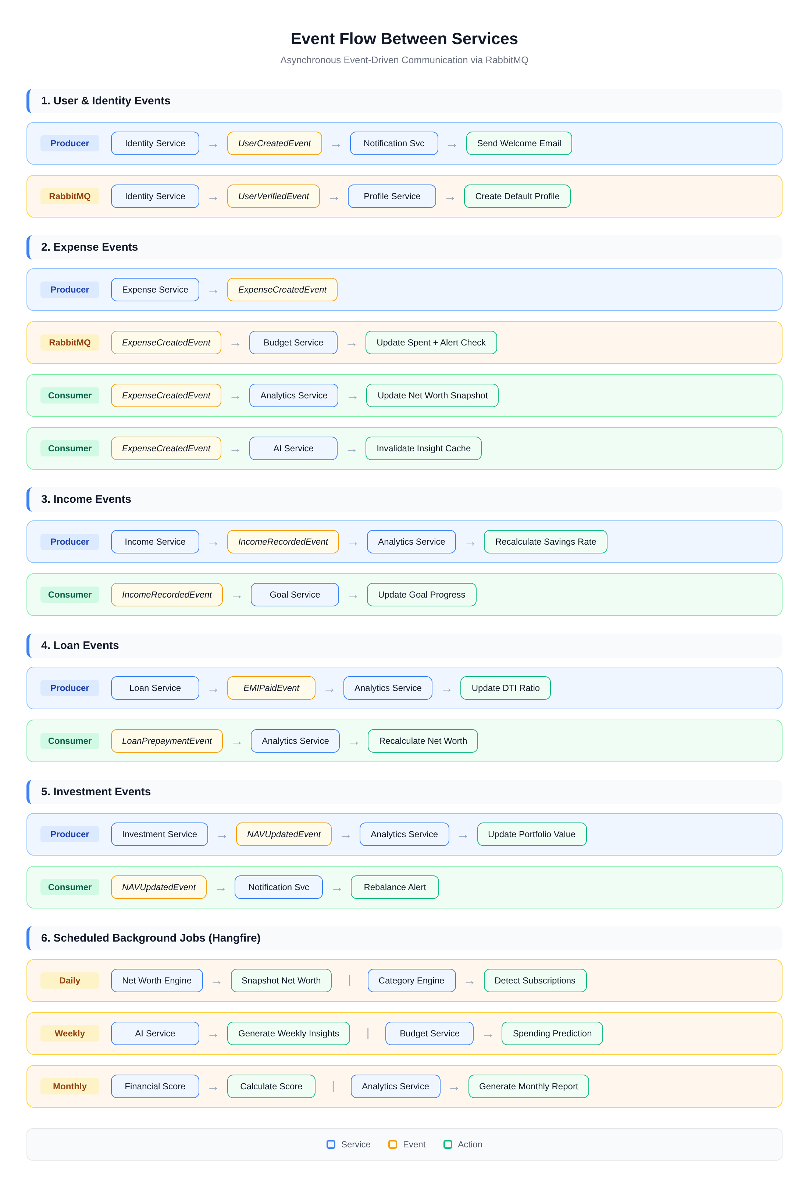
Figure 3: Event Flow Between Services via RabbitMQ

13. Security Requirements
Given the sensitive nature of financial data, FinOS implements a defense-in-depth security strategy with multiple layers of protection. The security architecture is designed to comply with the Digital Personal Data Protection Act (DPDPA) 2023, Reserve Bank of India (RBI) guidelines on data storage and processing, and industry best practices for fintech applications.

13.1 Application Security
- Input validation and sanitization on all API endpoints to prevent SQL injection, XSS, and command injection attacks
- Parameterized queries and stored procedures in SQL Server to eliminate SQL injection vectors
- Content Security Policy (CSP) headers on all frontend responses to prevent cross-site scripting
- CORS policy restricted to trusted domains only (finos.app and subdomains)
- Rate limiting on all API endpoints: 100 requests/minute for authenticated users, 20/minute for unauthenticated
- Request payload size limits (max 10MB for CSV imports, 1MB for other endpoints)
- Dependency scanning in CI/CD pipeline using Snyk or Snyk Code for vulnerability detection

13.2 Data Security
- AES-256 encryption at rest for sensitive fields (account numbers, PAN, Aadhaar references) using SQL Server Always Encrypted
- TLS 1.3 mandatory for all client-server and inter-service communication
- Database credentials stored in HashiCorp Vault, never in configuration files or environment variables
- Key rotation policy: encryption keys rotated every 90 days with zero-downtime re-encryption
- Database backups encrypted with separate encryption keys stored in Vault
- PII data masked in logs and non-production environments

13.3 Infrastructure Security
- Network segmentation with separate VPCs for application tier, data tier, and management tier
- Web Application Firewall (WAF) at the edge for OWASP Top 10 protection
- DDoS protection via cloud provider's native services (AWS Shield or equivalent)
- Intrusion Detection System (IDS) monitoring all network traffic
- Container image scanning before deployment, with only signed images allowed in production
- Least-privilege IAM roles for all service accounts with regular access reviews

14. Authentication and Authorization
FinOS implements a comprehensive authentication and authorization system based on JWT (JSON Web Tokens) and OAuth 2.0 protocols. The identity service is the central authority for all authentication operations, issuing and validating tokens, managing user sessions, and enforcing access policies.

14.1 Authentication Flow
The authentication flow begins with user registration, where the email and phone number are verified through OTP. Passwords are hashed using BCrypt with a work factor of 12 before storage. Upon successful login, the identity service issues a short-lived JWT access token (15-minute expiry) and a long-lived refresh token (30-day expiry) stored in Redis with the user's session metadata. The refresh token supports rotation, where each use generates a new refresh token and invalidates the previous one, preventing token replay attacks. For enhanced security, users can enable TOTP-based multi-factor authentication using authenticator apps like Google Authenticator or Microsoft Authenticator.
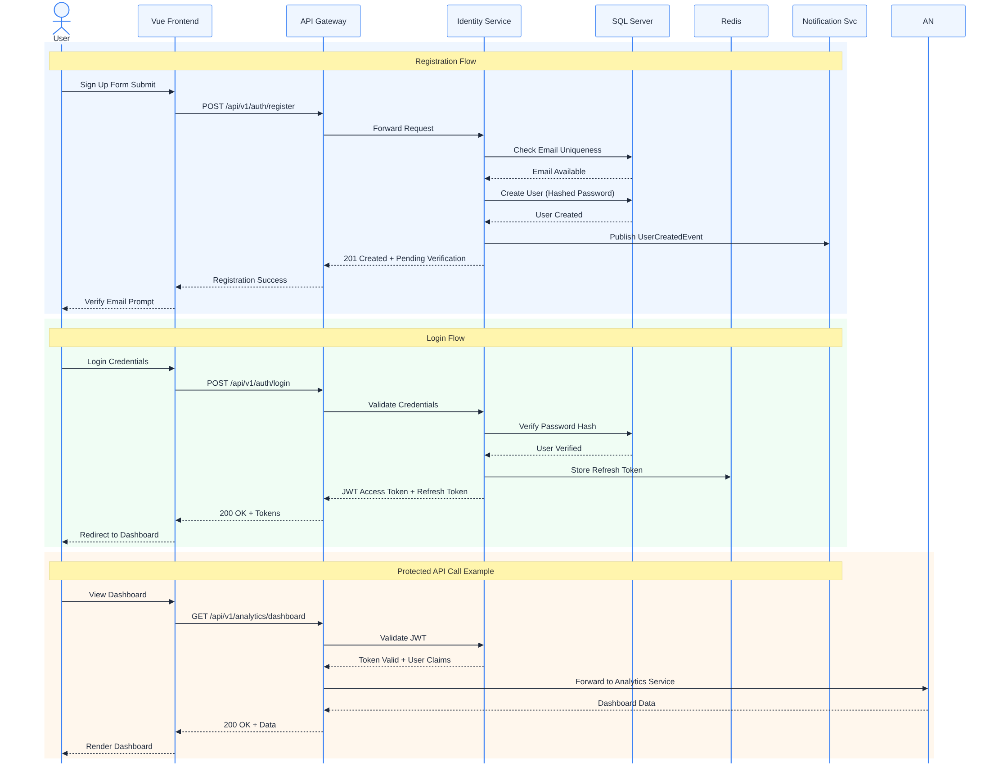
Figure 4: Authentication Sequence Diagram

14.2 Authorization Model
Authorization follows a role-based access control (RBAC) model with three primary roles: User (standard access to own data), Admin (system administration and user management), and Support (read-only access for customer support with audit logging). Each API endpoint enforces authorization at the gateway level by extracting user claims from the JWT and verifying role permissions. Data-level authorization ensures that users can only access their own financial data, implemented through a tenant filter that automatically appends user_id conditions to all database queries. Family finance features use a shared access model where the primary account holder can grant view-only or edit access to family members, with all actions logged in an audit trail.

15. Privacy and Financial Data Protection
FinOS is designed with privacy as a foundational principle, adhering to the Digital Personal Data Protection Act (DPDPA) 2023 and RBI's data localization requirements. All financial data is stored exclusively within Indian data centers, with cross-border data transfer prohibited for any personally identifiable information or financial transaction data.

15.1 Data Classification
Classification | Examples | Storage | Access
Highly Sensitive | Aadhaar, PAN, account numbers, passwords | Encrypted at rest + in transit, Vault-managed keys | Need-to-know, MFA required
Sensitive | Transaction amounts, loan details, investment holdings | Encrypted at rest, row-level security | User + authorized family only
Internal | Categories, tags, budget limits, goals | Standard encryption at rest | User + authorized family
Public | App metadata, feature flags, help content | Standard encryption at rest | No restriction

15.2 User Rights Implementation
- Right to Access: Users can export all their data in machine-readable format (JSON/CSV) through the account settings page, completed within 72 hours of request
- Right to Correction: Users can update any personal or financial data at any time, with change history maintained for audit purposes
- Right to Erasure: Account deletion triggers a 30-day grace period, after which all personal data is permanently deleted from primary and backup systems, with deletion certificates generated
- Right to Data Portability: Full data export in standard formats enabling migration to competing platforms
- Consent Management: Granular consent framework where users explicitly approve data collection purposes, with ability to withdraw consent without service degradation for core features

16. AI Features
The AI features in FinOS represent the platform's most differentiated capability, transforming raw financial data into actionable intelligence. The AI system operates on a hybrid architecture combining rule-based financial logic with machine learning models, ensuring that recommendations are both mathematically sound and contextually relevant.

16.1 AI Recommendation Logic
The recommendation engine follows a five-stage pipeline: Data Aggregation collects real-time financial data from all services; Feature Engineering computes derived metrics like savings rate trend, expense volatility, and goal progress velocity; Rule Engine applies financial best practices and regulatory constraints; ML Model generates probabilistic predictions for future financial states; and Response Generator crafts personalized, actionable recommendations with specific numbers and timelines. The rule engine encodes Indian financial regulations, such as Section 80C limits, Section 24(b) home loan interest deductions, and tax regime comparisons, ensuring that all recommendations are tax-aware and regulation-compliant.

16.2 Sample AI Prompts and Expected Responses

Prompt: Can I afford a new car?
The AI evaluates the following data points: current DTI ratio (including proposed car loan EMI), monthly surplus after all expenses and EMIs, emergency fund coverage in months, impact on existing financial goals (calculated as delay in months for each affected goal), and available down payment from liquid savings. The response includes a binary affordability verdict (Yes/Conditional/No), the maximum recommended car budget, suggested down payment amount, projected EMI at current interest rates, and a comparison of the financial impact of buying now versus waiting 6 months. If the verdict is Conditional, specific actions are recommended to improve affordability, such as increasing emergency fund by X months or reducing existing DTI by Y%.

Prompt: Should I prepay my home loan?
The AI performs a comparative analysis between three options: Option A is prepaying the home loan with the surplus amount, Option B is investing the surplus in a diversified portfolio, and Option C is splitting between prepayment and investment. For each option, it calculates the guaranteed interest savings (for prepayment), expected investment returns based on the user's risk profile and historical market data, tax impact including loss of Section 24(b) deduction and Section 80C principal deduction, net benefit after tax adjustments, and the break-even period. The recommendation factors in the remaining loan tenure (prepayment is more beneficial in the early years of a loan when the interest component is higher), the interest rate differential between the loan rate and expected investment returns, and the user's risk appetite.

Prompt: Why are my expenses high?
The expense analysis identifies the top three categories contributing to the increase compared to the 3-month average, calculates the absolute and percentage deviation for each elevated category, detects new spending patterns (subscriptions added, dining frequency increase), compares spending against benchmarks for the user's income level and city, and identifies specific transactions that are outliers. The response includes a ranked list of categories with excess spending, the total excess amount, specific actionable suggestions for each high category (e.g., 'Your dining out expense increased by 35% this month, primarily from 8 additional restaurant visits'), and a projected month-end total if the current pace continues.
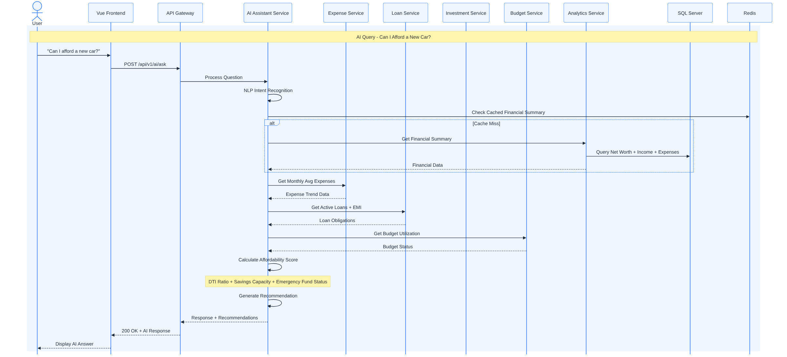
Figure 5: AI Assistant Query Processing Sequence

17. Notification System
The notification system delivers timely, relevant alerts through multiple channels based on urgency and user preference. The system is designed for high throughput and low latency, capable of processing millions of notifications daily across the user base.

17.1 Notification Types and Channels
Type | Channel | Priority | Example
Budget Alert | Push + In-App | High | You have used 90% of your dining budget
EMI Reminder | Push + Email + SMS | Critical | Home loan EMI of INR 35,000 due in 3 days
Goal Milestone | Push + In-App | Medium | Congratulations! Emergency fund reached 50%
AI Insight | In-App + Email (weekly) | Low | Your savings rate improved by 5% this month
Subscription Alert | Push + In-App | Medium | Netflix renewal of INR 649 detected for tomorrow
Loan Prepayment | In-App | Low | Prepaying INR 1L could save INR 2.3L in interest
Security Alert | Push + Email + SMS | Critical | Login detected from new device
Investment Alert | Push + In-App | Medium | Your equity allocation exceeds 75% threshold

17.2 Notification Architecture
The notification service consumes events from RabbitMQ and determines the appropriate channel and timing for each notification based on user preferences, notification priority, and quiet hours settings. Push notifications are sent via Firebase Cloud Messaging (FCM) for Android and APNs for iOS. Email notifications use AWS SES with templated HTML emails. SMS notifications are sent through Indian SMS gateways like MSG91 or Exotel for critical alerts only, respecting TRAI's Do Not Disturb (DND) registry compliance. The service maintains a notification history for each user, allowing them to review past alerts and mark notifications as read or snooze them for later.

18. Reports and Analytics
The analytics engine is the brain of the FinOS dashboard, aggregating data from all financial modules to provide a comprehensive view of the user's financial health. The analytics service pre-computes frequently accessed metrics and caches them in Redis, with cache invalidation triggered by financial data change events. This ensures that dashboard loads are consistently fast even as the user's financial history grows.
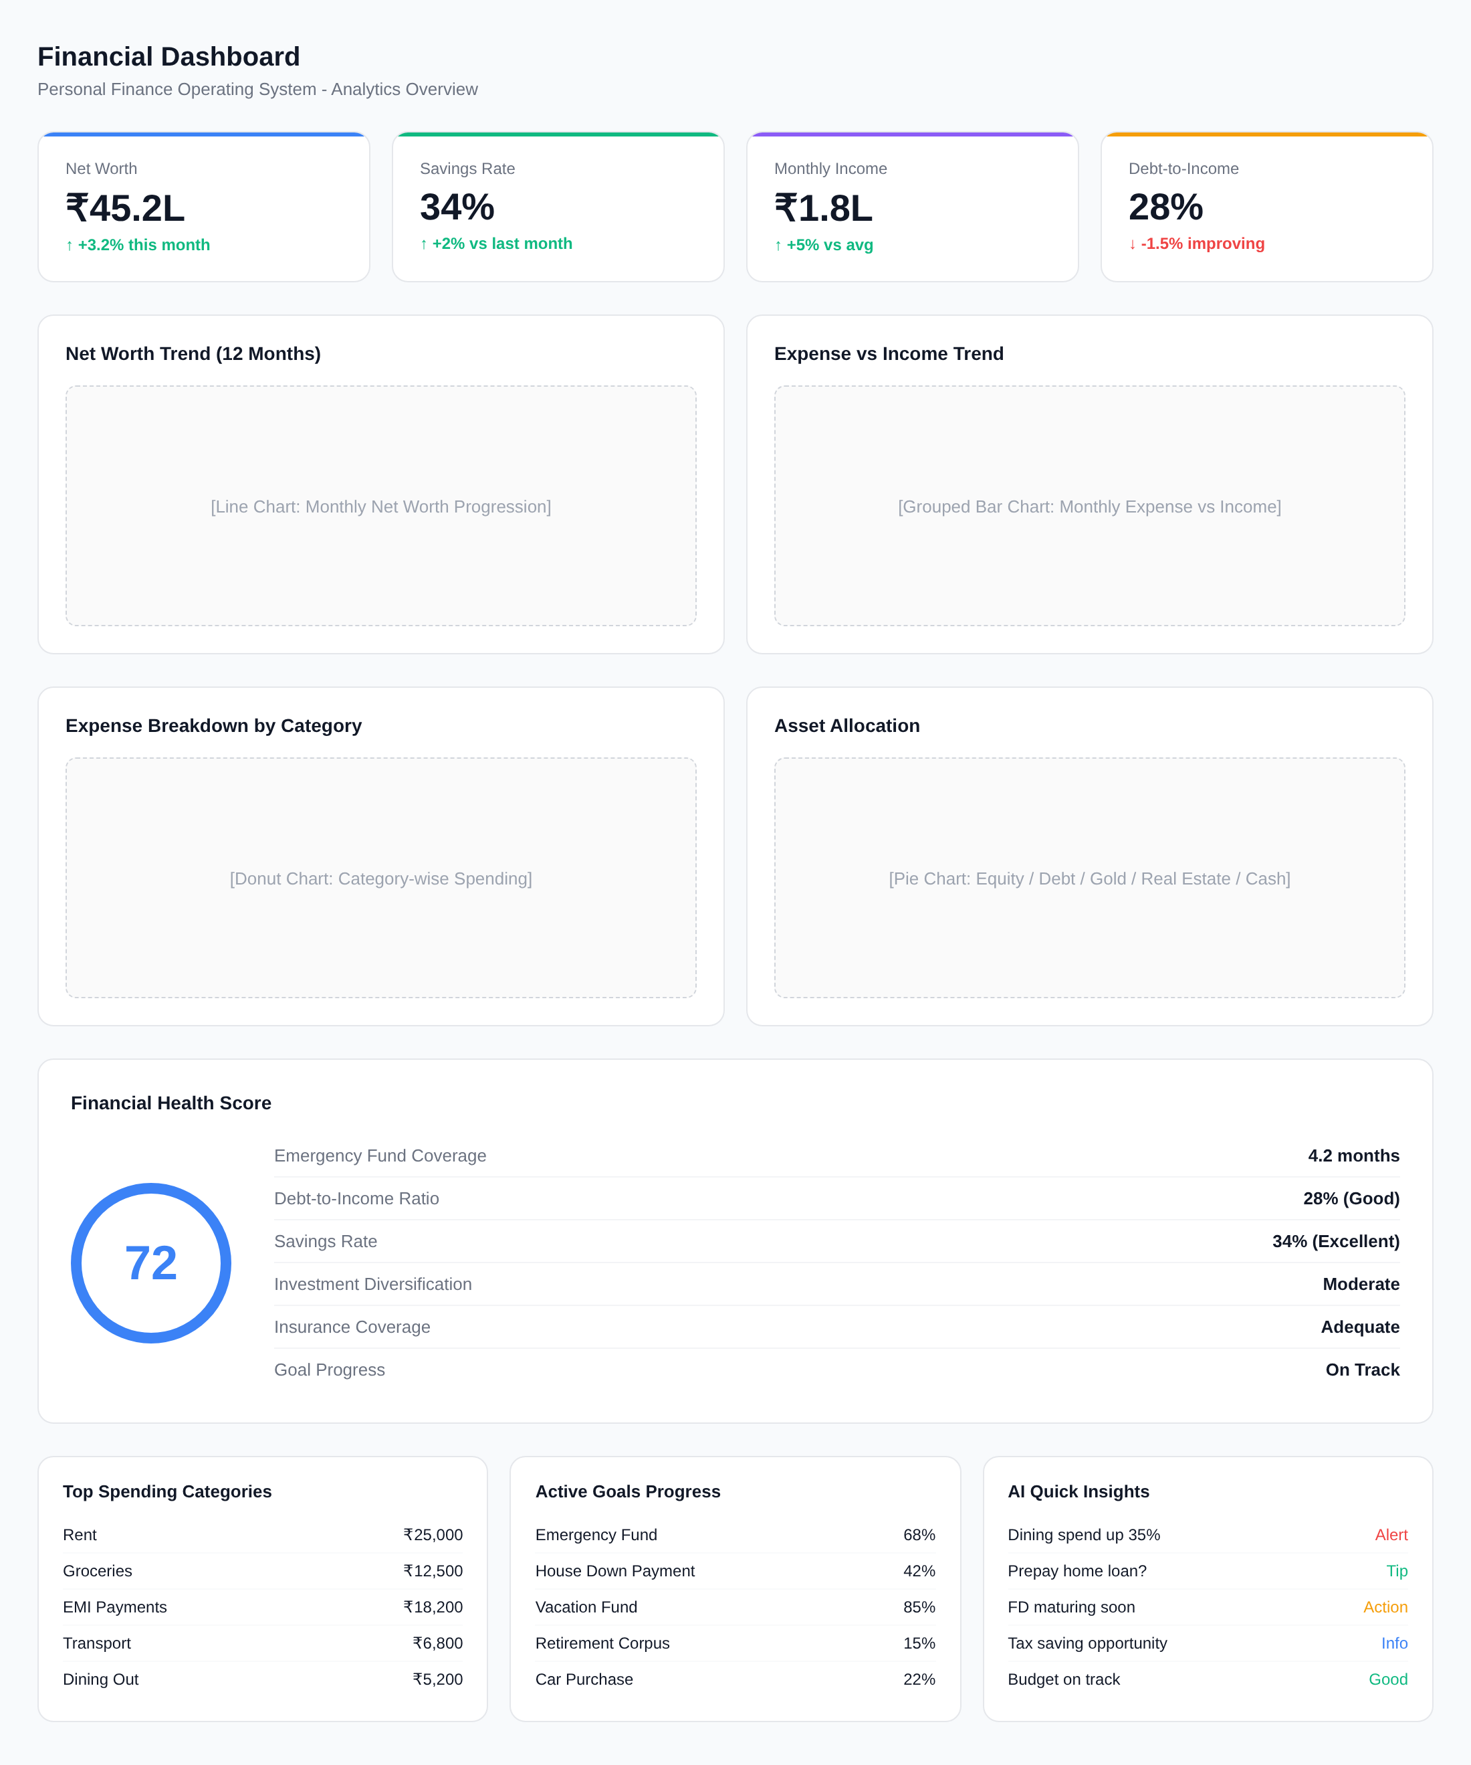
Figure 6: Analytics Dashboard Wireframe

18.1 Financial Health Score
The Financial Health Score is a composite metric ranging from 0 to 100, calculated from six weighted dimensions that collectively represent the user's overall financial well-being. The dimensions and their weights are: Emergency Fund Adequacy (20%) measures how many months of expenses the emergency fund covers, with 6+ months scoring maximum points; Debt-to-Income Ratio (20%) evaluates the proportion of income consumed by debt obligations, with DTI below 20% scoring maximum; Savings Rate (20%) measures the percentage of income saved and invested, with 30%+ scoring maximum; Investment Diversification (15%) assesses asset allocation across equity, debt, gold, and real estate relative to the user's risk profile; Insurance Coverage (15%) evaluates whether life, health, and asset insurance are adequate for the user's family size and obligations; and Goal Progress (10%) measures the trajectory of financial goals relative to their timelines. Each dimension is scored from 0 to 100, and the weighted average produces the overall score. The score is recalculated daily by a Hangfire scheduled job and stored as a snapshot for historical trend analysis.

18.2 Report Generation
The reporting module generates three primary report types: Monthly Financial Summary, Annual Financial Year Report, and Tax Readiness Report. The Monthly Financial Summary provides a consolidated view of income, expenses, savings, investment performance, and net worth change for the month. The Annual Financial Year Report (April-March per Indian FY convention) provides comprehensive year-in-review analytics including total income by source, expense breakdown by category with year-over-year comparison, investment returns with XIRR, tax liability estimate, and financial health score progression. The Tax Readiness Report generates all the data needed for income tax filing, organized by salary income, capital gains (short-term and long-term separated), Section 80C eligible investments, Section 80D insurance premiums, home loan interest and principal components, and HRA exemption calculation. Reports can be exported as PDF documents or Excel spreadsheets with formatted tables and embedded charts.

19. User Stories
The following user stories capture the key interactions between users and the FinOS platform, organized by module. Each story follows the standard format: As a [role], I want to [action], so that [benefit].
ID | User Story | Priority
US-001 | As a salaried employee, I want to see my complete net worth across all accounts in one place, so that I understand my true financial position | P0
US-002 | As a home loan customer, I want to simulate the impact of a lump-sum prepayment on my loan tenure and interest, so that I can make an informed decision | P0
US-003 | As a young investor, I want to see my portfolio's XIRR alongside a benchmark index, so that I can evaluate whether my investments are performing well | P0
US-004 | As a freelancer, I want the system to create a stable monthly budget from my variable income, so that I can manage expenses even in low-income months | P1
US-005 | As a family manager, I want to track shared expenses and split them between family members, so that household budgeting is transparent | P1
US-006 | As a user, I want to ask the AI assistant 'Can I afford a new car?' and get a data-backed answer with specific numbers, so that I make financially sound decisions | P0
US-007 | As a salaried professional, I want to track my EPF balance and predict my retirement corpus, so that I can plan for retirement adequately | P1
US-008 | As a user, I want to receive alerts when my spending in any category exceeds 80% of my budget, so that I can control my expenses proactively | P0
US-009 | As a user, I want to import my bank statement via CSV and have transactions auto-categorized, so that I save time on manual data entry | P0
US-010 | As an investor, I want to see my asset allocation and receive rebalancing suggestions, so that my portfolio stays aligned with my risk profile | P1
US-011 | As a user, I want to set financial goals with target dates and track progress visually, so that I stay motivated to save | P0
US-012 | As a user, I want to generate a tax readiness report with all deduction categories, so that filing my income tax return is easier | P1
US-013 | As a user, I want to see a financial health score that improves over time, so that I have a clear measure of my financial progress | P0
US-014 | As a home loan customer, I want the AI to tell me whether prepaying my loan or investing the surplus is better, with calculations shown | P0
US-015 | As a user, I want all my financial data encrypted and stored in India, so that my privacy and regulatory compliance are ensured | P0

20. Acceptance Criteria
Acceptance criteria define the conditions that must be met for each feature to be considered complete and ready for release. The following criteria cover the most critical user stories from the previous section.

20.1 Net Worth Calculation (US-001)
- GIVEN the user has at least one account, loan, and investment record, WHEN the dashboard loads, THEN net worth is calculated as (sum of account balances + current investment values) - (sum of outstanding loan principals)
- GIVEN the user has financial data spanning multiple months, WHEN viewing net worth trends, THEN a 12-month line chart is displayed with month-over-month change percentages
- GIVEN any financial data changes, WHEN the change is saved, THEN the net worth is recalculated within 5 seconds and the dashboard reflects the updated value

20.2 Loan Prepayment Simulation (US-002)
- GIVEN the user has an active home loan, WHEN a prepayment amount is entered, THEN the system displays: new tenure (if EMI unchanged), new EMI (if tenure unchanged), total interest saved, and break-even period
- GIVEN a prepayment simulation is run, WHEN the prepayment amount exceeds the outstanding principal, THEN the system shows an error message and suggests the maximum prepayment amount
- GIVEN the prepayment amount is valid, WHEN the user confirms, THEN the loan schedule is regenerated and the outstanding principal is updated

20.3 AI Affordability Analysis (US-006)
- GIVEN the user asks 'Can I afford a 10L car?', WHEN the AI processes the query, THEN it returns: affordability verdict (Yes/Conditional/No), maximum recommended budget, suggested down payment, projected EMI, and impact on goals
- GIVEN the user's DTI would exceed 50% with the new car loan, WHEN the AI evaluates, THEN the verdict is 'No' with specific actions to reduce DTI before reconsidering
- GIVEN the user's emergency fund is below 3 months, WHEN evaluating any major purchase, THEN the AI recommends building emergency fund first regardless of affordability

21. Edge Cases
The following edge cases identify unusual or boundary conditions that the system must handle gracefully. Each edge case includes the condition, expected behavior, and severity level.
ID | Edge Case | Expected Behavior | Severity
EC-001 | User tries to add an expense with date in the future | Reject with error message; allow dates up to today only | Medium
EC-002 | CSV import contains duplicate transactions with existing records | Detect duplicates using date+amount+description hash; skip and report count of duplicates | High
EC-003 | User attempts prepayment simulation with negative amount | Reject with validation error; enforce positive numeric input on frontend | Low
EC-004 | Investment XIRR calculation encounters only outflows (no redemptions) | Display 'XIRR unavailable - requires at least one redemption transaction'; show absolute return instead | Medium
EC-005 | Budget period crosses financial year boundary (March to April) | Split budget tracking into two FY periods for tax reporting; display unified view for user | Medium
EC-006 | User deletes their only income source | Show confirmation warning about impact on savings rate and AI recommendations; allow deletion but recalculate dependent metrics | Low
EC-007 | Two family members add the same shared expense independently | Detect potential duplicates using date+amount+category proximity; flag for user review | Medium
EC-008 | Loan interest rate changes (floating rate home loan) | Allow interest rate update with effective date; regenerate EMI schedule from effective date forward, preserving paid history | High
EC-009 | Net worth calculation results in negative value | Display negative net worth clearly with red indicator; provide specific debt reduction recommendations via AI | Low
EC-010 | User changes tax regime from old to new mid-year | Recalculate all tax projections from start of FY; preserve old regime calculations for comparison; update AI recommendations | High
EC-011 | SIP transaction fails on scheduled date (insufficient balance) | Log failed SIP attempt; notify user; retry after configurable days; mark as failed if still unsuccessful after retry | High
EC-012 | User account locked after 5 failed MFA attempts | Lock account for 30 minutes; send email notification; allow unlock via email verification link | Critical

22. Future Roadmap
The product roadmap for FinOS is organized into three phases, each building on the previous to expand capabilities and market reach.

22.1 Phase 2: Enhanced Intelligence (Months 12-18)
- Bank account integration via RBI's Account Aggregator (AA) framework for automatic transaction import from 100+ Indian banks and NBFCs, eliminating manual entry entirely
- UPI payment tracking through UPI Collect APIs, automatically categorizing UPI transactions from Paytm, PhonePe, Google Pay, and other UPI apps
- Tax filing integration with direct export to IT Return utilities, supporting ITR-1 and ITR-2 forms with pre-populated income, deduction, and capital gains data
- Insurance portfolio tracking for life, health, vehicle, and term insurance policies with premium reminders and coverage adequacy analysis
- Family finance dashboard with shared view, expense splitting, and family-level financial health scoring

22.2 Phase 3: Ecosystem Platform (Months 18-24)
- Financial product marketplace offering mutual fund SIPs, insurance products, and fixed deposits with comparison tools and embedded onboarding
- SEBI-registered robo-advisory service providing regulated investment advice with automated portfolio rebalancing
- Community features including financial challenges (e.g., 'Save INR 50,000 in 6 months'), peer benchmarking (anonymized), and expert AMAs
- Business finance module for freelancers and small business owners with invoicing, expense categorization for tax purposes, and GST compliance
- Open API platform enabling third-party developers to build on FinOS data (with user consent) for specialized financial tools

22.3 Phase 4: Market Leadership (Months 24-36)
- Voice-first financial assistant supporting Hindi, Tamil, Telugu, and other Indian languages for financial queries via voice input
- Predictive financial modeling using advanced ML to forecast major life events (marriage, children, home purchase) and proactively suggest financial preparations
- Enterprise version for HR departments offering financial wellness as an employee benefit, with aggregated (anonymized) workforce financial health analytics
- International expansion to Southeast Asian markets (Singapore, UAE) with multi-currency and cross-border investment tracking

23. Monetization Strategy
FinOS employs a freemium model with clear value demonstration in the free tier and compelling premium features that justify the subscription cost. The monetization strategy is designed to maximize user acquisition through the free tier while converting engaged users to premium through demonstrated value.

23.1 Subscription Tiers
Feature | Free | Premium (INR 299/month) | Family (INR 499/month)
Expense Tracking | Up to 50 transactions/month | Unlimited | Unlimited per member
Manual Categorization | Yes | Yes + AI auto-categorize | Yes + AI auto-categorize
CSV Import | 1 import/month | Unlimited | Unlimited per member
Loan Management | 1 loan | Unlimited loans | Unlimited per member
Prepayment Simulator | 3 simulations/month | Unlimited | Unlimited
Investment Tracking | Up to 5 investments | Unlimited | Unlimited per member
XIRR Calculation | No | Yes | Yes
Budget Alerts | Email only | Push + Email + SMS | Push + Email + SMS
AI Assistant | 3 questions/month | Unlimited | Unlimited per member
Financial Health Score | Basic (3 dimensions) | Complete (6 dimensions) | Complete + Family score
Reports Export | No | PDF + Excel | PDF + Excel
Family Members | Not available | Up to 2 | Up to 6
Data History | 6 months | Unlimited | Unlimited
Priority Support | Community | Email (24h response) | Chat (4h response)

23.2 Revenue Projections
Revenue is projected across three streams: subscription revenue, financial product marketplace commissions, and enterprise partnerships. Subscription revenue is expected to contribute 60% of total revenue by Year 3, with marketplace commissions at 25% and enterprise partnerships at 15%. The conversion funnel targets are: 5% free-to-premium conversion rate in Year 1, increasing to 8% by Year 3 as premium features become more differentiated. Average revenue per premium user (ARPU) is estimated at INR 3,588/year (INR 299 x 12), with the family plan at INR 5,988/year. With 500,000 registered users and 8% conversion by Year 2, annual subscription revenue is projected at INR 14.35 crore. Marketplace commissions at 0.5-1% on mutual fund SIPs and insurance premiums are projected to contribute INR 5-8 crore annually by Year 3.

24. Risks and Constraints
The following risks and constraints have been identified through stakeholder analysis, market research, and technical assessment. Each risk includes a probability assessment, impact rating, and mitigation strategy.
Risk | Probability | Impact | Mitigation
Data breach exposing financial information | Low | Critical | AES-256 encryption, quarterly penetration testing, bug bounty program, incident response plan with 4-hour RTO
Regulatory changes (DPDPA/RBI) requiring architecture modifications | Medium | High | Modular architecture enabling rapid compliance changes, dedicated compliance officer, regulatory monitoring service
Low free-to-premium conversion rate (<3%) | Medium | High | A/B testing of premium features, user behavior analytics, progressive feature gating, value demonstration emails
Bank integration via Account Aggregator delayed | Medium | Medium | Alternative data import methods (CSV, manual), partnership with screen-scraping tools as interim, manual entry UX optimization
AI recommendation accuracy below user expectations | Medium | Medium | Regular model retraining with user feedback loops, confidence scoring on recommendations, transparency in methodology
Scalability bottleneck during peak usage (month-end, tax season) | Low | High | Auto-scaling infrastructure, Redis caching for hot paths, database read replicas, CDN for static assets
Competition from well-funded fintech players | High | Medium | Focus on Indian-specific features, community building, rapid iteration based on user feedback, data moat through user financial history
SQL Server licensing costs scaling with user growth | Medium | Medium | Evaluate PostgreSQL migration for non-critical services, optimize queries and indexing, consider Azure SQL managed instance with auto-tiering
Elasticsearch and Redis infrastructure cost at scale | Low | Medium | Use only if free tier available initially; implement circuit breakers to degrade gracefully; evaluate open-source alternatives
User trust deficit for financial data sharing | High | High | SOC 2 Type II certification, transparent privacy policy, financial data encryption visibility, regular security audits published

24.1 Technical Constraints
- SQL Server is the primary database per user requirement; migration to PostgreSQL may be considered for cost optimization at scale but is not planned for Phase 1
- Redis and Elasticsearch usage is conditional on free/open-source tiers being sufficient for initial scale; production architecture must be designed to function (with degraded features) if these services are unavailable
- Background job processing via Hangfire must be designed with idempotency guarantees, as job retries may occur during infrastructure failures
- The Vue 3 frontend must support PWA mode for mobile access without a native app in Phase 1; native mobile apps via Capacitor are planned for Phase 2
- All financial calculations must use decimal arithmetic (not floating-point) to prevent rounding errors in INR amounts, consistent with RBI's precision requirements
- API rate limits must be enforced at the gateway level to prevent abuse, with separate thresholds for free and premium users

24.2 Business Constraints
- Product launch timeline is aggressive at 6 months for MVP, requiring parallel development streams for core modules
- Initial budget allocation prioritizes core tracking and analytics features over advanced AI and bank integration capabilities
- Team size is constrained to 8-12 engineers in Phase 1, necessitating technology choices that maximize productivity (e.g., .NET ecosystem consistency, shared libraries)
- Marketing budget for Year 1 is limited, requiring organic growth strategies through content marketing, SEO, and referral programs
- Compliance certification (SOC 2, ISO 27001) is targeted for Year 2; Year 1 relies on internal security practices and third-party penetration testing

Appendix A: Sequence Diagrams
This appendix contains the detailed sequence diagrams illustrating the primary interaction flows in the FinOS system.
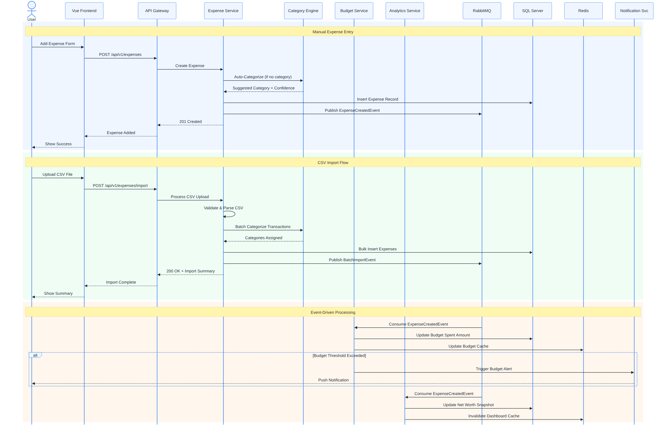
Figure 7: Expense Creation and Event Processing Sequence Diagram

