Jenkins Assignment No. 1

A. Jenkins Execute Shell Script
- Install Apache HTTP Server.
- Start the HTTPD service.
- Create and deploy a custom index.html page on the httpd server.

B. Script
sudo yum update -y
sudo yum install -y httpd
sudo systemctl enable httpd
sudo systemctl start httpd
sudo cp index.html /var/www/html/
echo "Deployment completed successfully."

C. Output
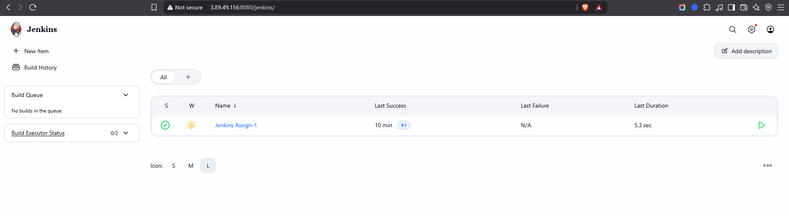
Figure 1: Jenkins Dashboard
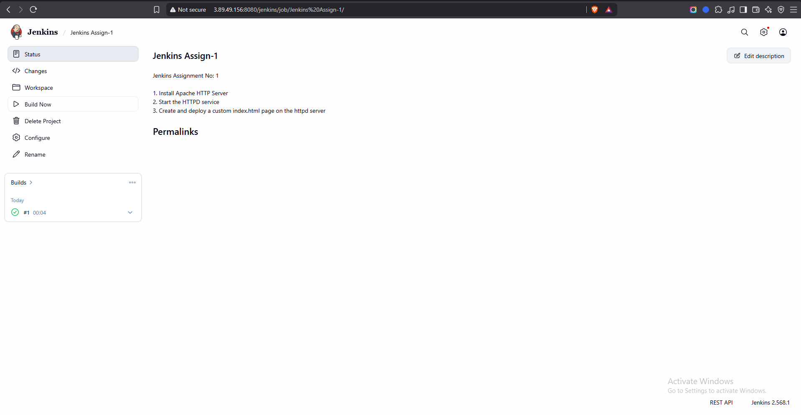
Figure 2: Jenkins Job
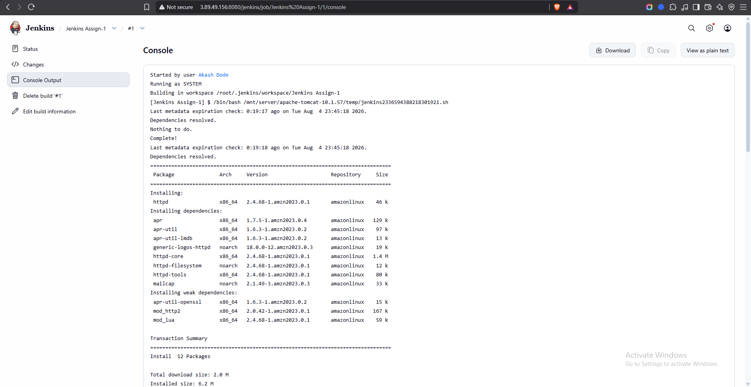
Figure 3: Console Output
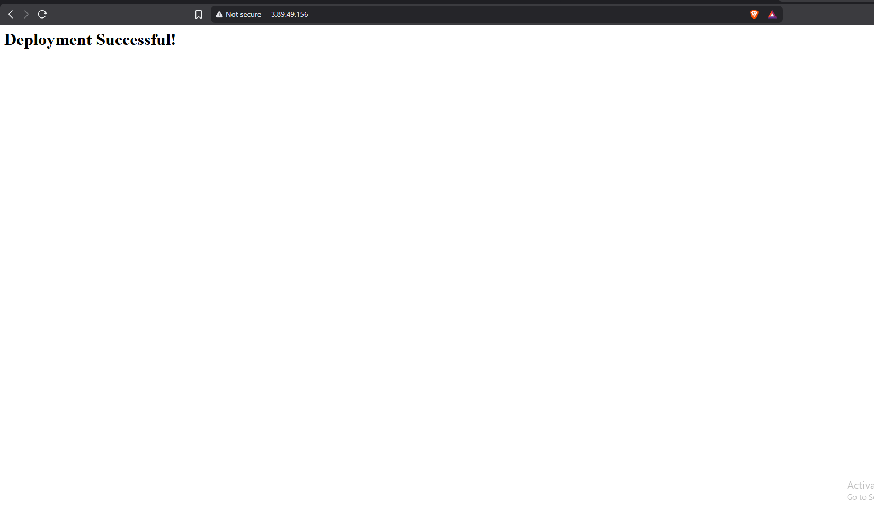
Figure 4: Deployment Result

