**Don Bosco Institute of Technology, Mumbai**

Department of Computer Engineering

NETWORK PROGRAMMING LABORAOTORY



Mini Project Report

On

NETWORK ACCESS CONTROL

**Team Members:**

**Arushi-Anne D’souza(21)**

**Akash Garule(24)**

**Jaffrey Joy(33)**

|  |  |  |  |  |
| --- | --- | --- | --- | --- |
| **Quality and Completion (5)** | **Not Submitted** | **Project objective partially achieved and idea lacks innovation.** | **Project objective achieved but lacks innovation** | **Project Objective achieved & innovative idea** |
| 0 points | 3 points | 4 points | 5 points |
| **Presentation and Report (5)** | **Incomplete content & no proper documentation** | **Relevant content but lacks documentation.** | **Relevant content, all points covered** | **Relevant content, all points covered, References included** |
| 0 points | 3 points | 4 points | 5 points |
| **Attendance (3)** | **Below 70%** | **Between 70%-75%** | **Between 76% -89%** | **Above 90 %** |
| 0 points | 1 points | 2 points | 3 points |
| **Individual Contribution (2)** | **Poor** | **Satisfactory** | **Good** | |
|  | 0 points | 1 points | 2 points | |

INDEX

|  |  |  |
| --- | --- | --- |
| Sr. No. | Contents | Page No. |
| 1 | Abstract | 4 |
| 2 | Introduction |  |
| 3 | Requirement Specification |  |
| 4 | Implementation |  |
| 5 | Conclusion |  |
| 6 | References |  |

*ABSTRACT*

*Currently all the staff in DBIT have to call the authorized person in the server room when they have a lab session to enable net access for the lab. This process is manual, time consuming as well as also dependent on the availability of the person in server room at that time. A more automated but secure process is desired to ease this activity wherein the teachers do not have to unnecessarily waste time in procuring net access. The main aim of this project is to reduce the time spent by the teachers and students by immediate access to the internet with the click of one button.*

INTRODUCTION

REQUIREMENT SPECIFICATION

HARDWARE REQUIREMENTS:

1. Client Machine

The client machine is any machine whose internet access can be enabled or disabled through the squid proxy server. Here, for internet access, the client machine must use the proxy and port number of the server machine.

1. Server Machine

The server machine stores the IP addresses of the client machines to which it is providing internet access. In order that it is able to enable or disable internet access to multiple clients, it must have the IP addresses of all the client machines that it is controlling.

SOFTWARE REQUIREMENTS:

1. Squid Server

Squid is a full-featured web proxy cache server application which provides proxy and cache services for Hyper Text Transport Protocol (HTTP), File Transfer Protocol (FTP), and other popular network protocols.

1. Android Studio

Android Studio is the official IDE for android application development.

1. Express server

IMPLEMENTATION

One machine is configured as a server. We install squid server on this machine. All client machines have to use the server's IP in their network configuration settings in the browser to connect to this server. The server has an ACL (access control list) file that consists of all client machine IPS in that LAN. These client machines can be configured to be in separate network (Virtual LAN) using ACL directive command in the ‘squid.conf’ file and net can be enabled or disabled for each machine or each LAN by manipulating the ‘conf’ file and then restarting the squid server.

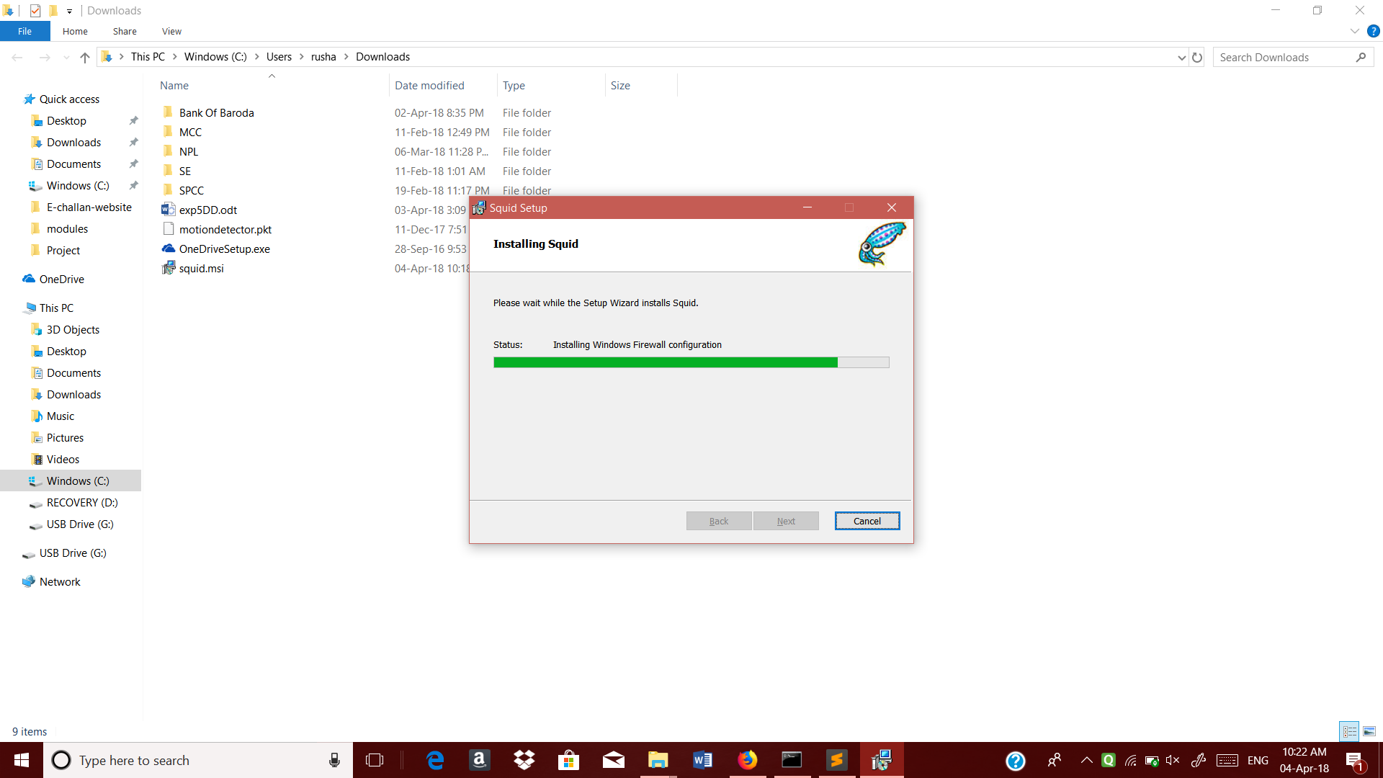

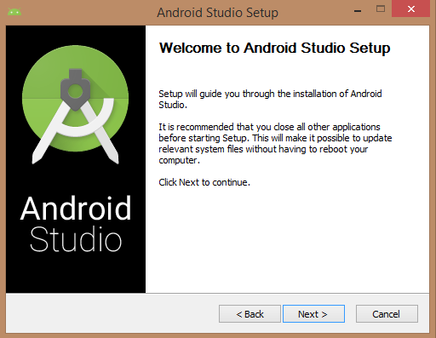

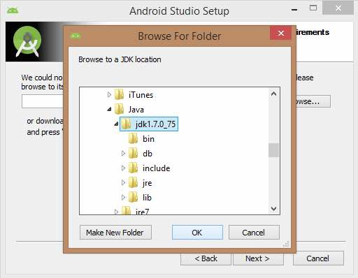

CONCLUSION

The proposed solution consists of an android app which only the faculties will be authorized to use. The app will accept the timetable of all the faculties as input for every semester. Depending on whether the faculty has a lab at a given time, the faculty can simple open the app and click one button to enable net access for the lab and also be able to specify the duration for which net should be enabled.

REFERENCES

1. https://www.tecmint.com/configure-squid-server-in-linux/